Lactose-appended schizophyllan is a potential candidate for hepatocyte-targetted antisense carrier
Teruaki Hasegawa,ª Mariko Umeda,ª Takahiro Matsumoto,ª Munenori Numata,ª Masami Mizu,^{b} Kazuya Koumoto,^{b} Kazuo Sakurai^{b} and Seiji Shinkai*ª
ªDepartment of Chemistry and Biotechnology, Graduate School of Engineering, Kyushu University, Hakozaki, 6-10-1, Higashi-ku, Fukuoka 812-8581, Japan
^{b}Department of Chemical Processes and Environments, Faculty of Environmental Engineering, The University of Kitakyushu, Hibikino, 1-1, Wakamatsu-ku, Kitakyushu, Fukuoka 808-0135, Japan

Supporting Information

1-O-(2-Bromoethyl)-hepta-O-acetyl-β-lactoside
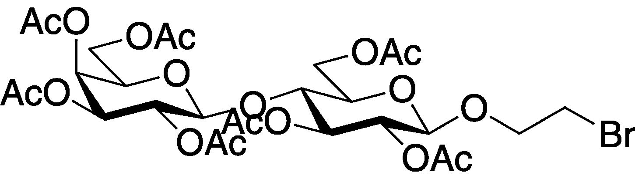
To octa-O-acetyl-lactose (10.2 g) and 2-bromoethanol (3.0 ml) in anhydrous CH₂Cl₂ (50 ml) BF₃OEt₂ was added at room temperature and the stirring was continued for 40 h under nitrogen atmosphere. The resulting mixture was diluted with ethylacetate and washed with NaHCO₃ saturated aqueous solution. The organic layer was dryed over anhydrous MgSO₄, filtered, and evaporated. Although the residues was subjected to the purification by silica-gel colomun chromatography (hexane only ~ hexane/ethylacetate(1/1)), the R_{f} values of the starting material and the product were so close that we could not obtain the pure product. Structural proof was given by the MALDI-TOF mass spectrum of the crude product. [M+Na]⁺=768.3 (calc. 765.1).

1-(2-Azidoethyl)-hepta-O-acetyl-β-lactoside
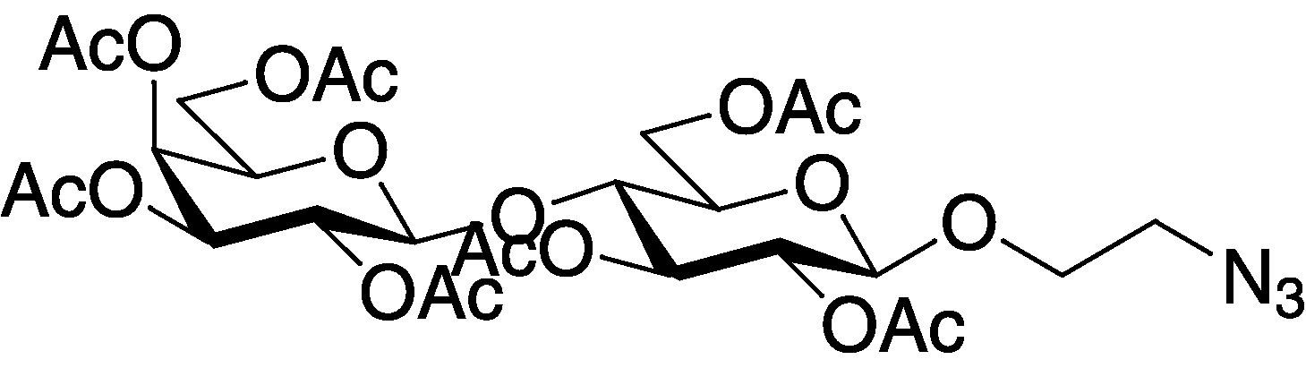
1-O-(2-Bromoethyl)-hepta-O-acetyl-β-lactoside (1.21 g, crude) was dissolved in 50 ml of dimethylformamide and then sodium azide (0.13 g) was added. The mixture was stirred at 80 °C for 1.5 h, cooled to ambient temperature, poured into ethylacetate and washed with water and NaCl saturated aqueous solution several times. The organic layer was dried over anhydrous magnesium sulfate, filtered and evaporated to dryness. The product was purified by chromatography on a silica gel column (30 cm long; 3 cm i.d.; toluene-ethylacetate = 3 : 2 in v/v) to give the product as a colorless solid. ¹H-NMR(CDCl₃, TMS): 5.34 (d, J = 3.3 Hz, 1H), 5.20 (t, J = 9.2 Hz, 1H), 5.10 (dd, J = 8.1 and 10.4 Hz, 1H), 4.97 (dd, J = 3.3 and 10.4 Hz, 1H), 4.92 (t, J = 8.7 Hz, 1H), 4.57 (d, J = 7.9 Hz, 1H), 4.52 (d, J = 7.9 Hz, 1H), 4.52 (dd, J = 1.5 and 8.0 Hz, 1H), 4.14-4.07 (m, 3H), 4.00-3.97 (m, 1H), 3.90 (t, J = 6.7 Hz, 1H), 3.83 (t, J = 9.5 Hz, 1H), 3.70-3.67 (m, 1H), 3.65-3.62 (m, 1H), 3.49-3.45 (m, 1H), 3.29-3.25 (m, 1H), 2.15 (s, 3H), 2.12 (s, 3H), 2.06 (s, 3H), 2.05 (s, 6H), 2.04 (s, 3H), 1.96 (s, 3H) ; IR (KBr,cm⁻¹) 1753 ( _{C=O} acetyl) and 2110 (azide); [M+H]⁺=706.2 (calc. 706.2).

1-(2-Aminoethyl)-hepta-O-acetyl-β-D-lactoside
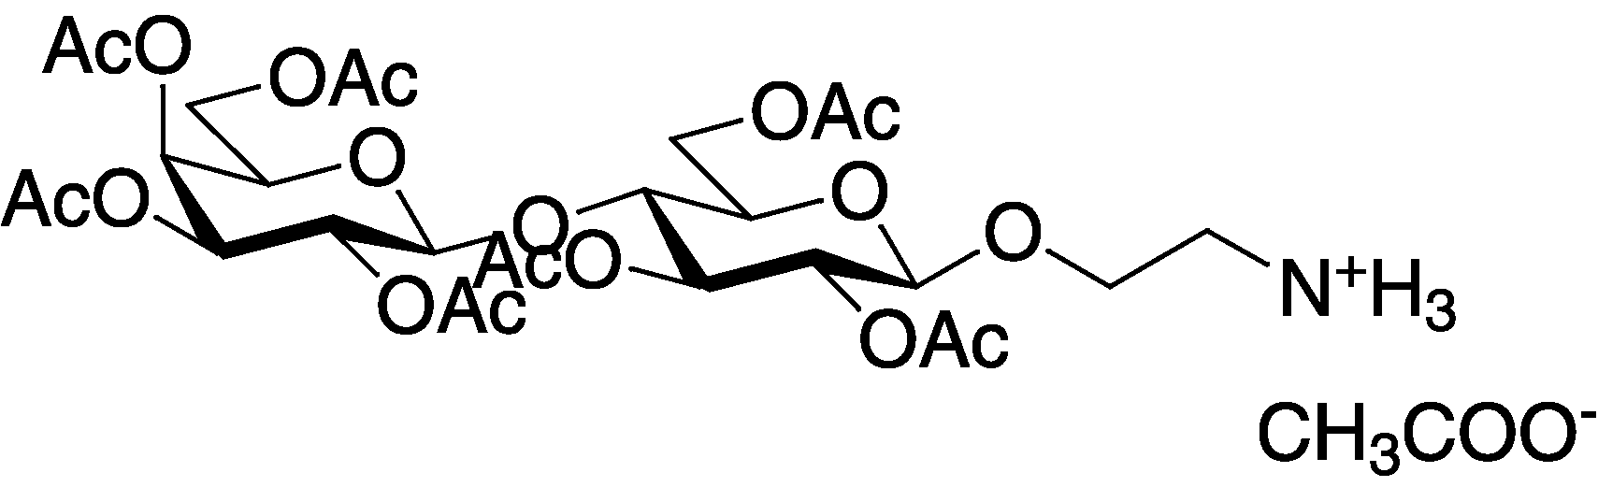
1-(2-Azidoethyl)-hepta-O-acetyl-β-D-lactoside (0.35 g) was dissolved in 20 ml of ethanol and then 5 % palladium on carbon (0.09 g) was added. The mixture was vigorously stirred under hydrogen atmosphere at room temperature for 3 h until TLC (chloroform : methanol = 4 : 1) indicated complete conversion of the substrate. After acetic acid was added to protect amino function, the catalytic palladium on carbon was removed by filtration, and the filtrate was evaporated to dryness. The product was purified by chromatography on a silica gel column (30 cm long; 3 cm i.d.; chloroform-methanol = 4 : 1 in v/v) to give the pure product in a colorless solid. ¹H-NMR(CDCl₃, TMS): 6.38 (br s, 3H), 5.35 (d, J = 1.5 Hz, 1H), 5.18 (t, J = 9.2 Hz, 1H), 5.10 (t, J = 9.8 Hz, 1H), 5.00 (dd, J = 2.5 and 10.3 Hz, 1H), 4.89 (t, J = 8.5 Hz, 1H), 4.70 (d, J = 11.7 Hz, 1H), 4.61 (d, J = 7.8 Hz, 1H), 4.58 (d, J = 7.8 Hz, 1H),4.16-4.03 (m, 5H), 3.93 (t, J = 6.6 Hz, 1H), 3.93 (t, J = 6.6 Hz, 1H), 3.84 (t, J = 9.4 Hz, 1H), 3.73 (m, 1H), 3.22 (m, 1H), 3.15 (m, 1H), 2.17 (s, 3H), 2.15 (s, 3H), 2.112 (s, 3H, OCOCH₃), 2.07-2.04 (m, 12H), 1.97 (s, 3H) ; IR (KBr,cm⁻¹) 1751 ( _{C=O} acetyl); [M+H]⁺=680.0 (calc. 680.2).

1-(2-Aminoethyl)-lactoside
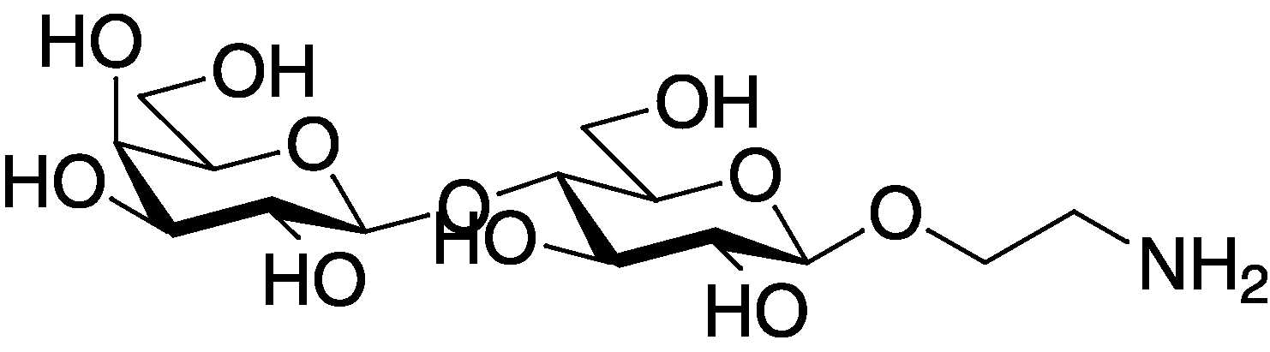
1-(2-Aminoethyl)-hepta-O-acetyl-β-D-lactoside (2.51g) was dissolved in 50 ml of ethanol and 10 ml of aqueous ammonia was added. The mixture was stirred at room temperature for 15 h, concentrated, and lyophylized to give the pure product without any purification procedure. ¹H-NMR(D₂O): 4.38 (d, J = 8.0 Hz, 1H), 4.28 (d, J = 7.8 Hz, 1H), 3.98-3.95 (m, 1H), 3.83-3.75 (m, 3H), 3.71-3.55 (m, 4H), 3.52-3.45 (m, 4H), 3.38 (d, J = 8.9 Hz, 1H), 3.21 (d, J = 7.4 Hz, 1H), 3.11-3.09 (m, 1H); [M+H]⁺=386.4 (calc. 386.2).

Preperation of SPG-Lac
Native-schizophyllan (233.8 mg) in water (233.8 ml) was refluxed for 8 h to give homogeneous SPG aqueous solution. The solution was kept at 4 °C for 2 h and then, NaIO₄ (23.7 mg) dissolved in the minimum amount of water was added and stirring was continued at 4 °C for 2 days. After dialysis (cut-off:Mw=8000), aminoethyl-lactoside was added to the resulting mixture and then, stirring was continued for one day. Aminoethyl-lactoside was added and the stirring was continued for one day again. The solution was lyophilized to dryness and re-dissolved into 35 ml of dimethylformamide (DMSO). After additional aminoethyllactoside was added and stirring was continued for 2 days, the reduction step was carried out by adding NaBH₄ (2.0 g) and keeping stirring for 2 days at room temperature. The resulting mixture was poured into ethanol and the white precipitate was filtered, washed with methanol and acetone repeatingly, re-dissolved into water, dialysed (cut-off:Mw=8000) and lyophilized to give pure SPG-Lac as a white powder.

Confocal fluorescent microscopic measurements of RCA₁₂₀-agarose beads
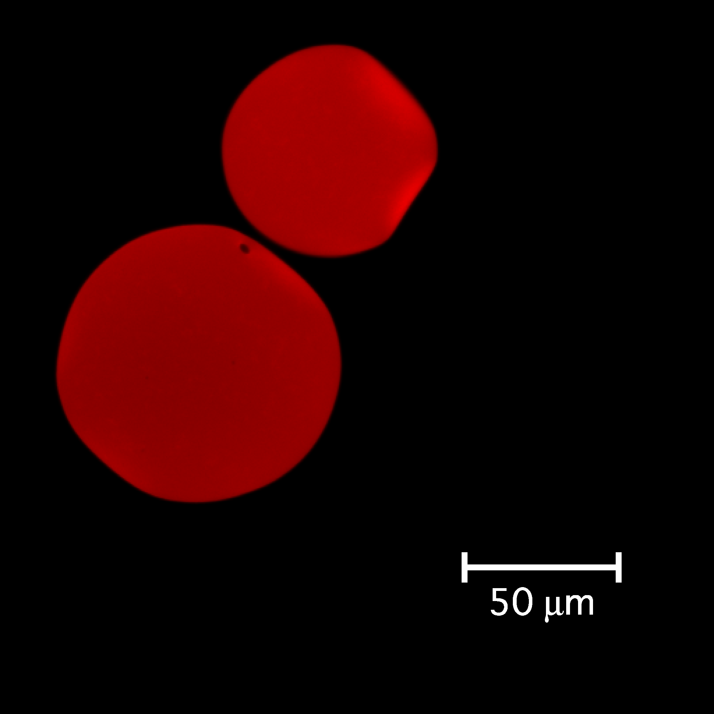
Fig. S1 Confocal fluorescent microscopic image of RCA₁₂₀-agarose beads stained by SPG-Lac/Rho-(dA)₄₅: 25 °C, Tris-buffer (20 mM, pH 7.2), Ex = 548 nm.

