Supporting Information
Materials. Monomers: glycidyl methacrylate (GMA), and styrene (St). Initiator: water-soluble 2,2’-azobis(2-amidinopropane) 2HCl (V-50). Cross-linker: divinylbenzene (DVB, ca. 55% m- and p- isomer). Chain transfer agent: 2-mercaptoethanol (ME). Solvent: toluene. All the reagents except for DVB supplied by Tokyo Kasei Industry Co. Ltd. were purchased from Wako Pure Chemical Industry Co. Ltd. All monomers were distilled under reduced pressure before use. Other reagents were used without further purification.
Ammonia solution (28 %), acetic anhydride, methanol, isopropanolamine, acetonitrile (dehydrated), 5-(n-succinimidyloxycarbonyl)pentyl d-biotinamide (Biotin-X-NHS), dimethylaminopyridine, phosphate buffer powder (pH 7.4), pyruvate kinase suspension (PK, source: rabbit muscle, 200 units/mg), D-lactate dehydrogenase (from lenconostoc mesenteroides, 1000 unites/mg), phosphoenolpyruvate (PEP), adenosine-5’-diphosphate monosodium trihydrate (ADP), β-diphosphopyridine nucleotide disodium salt (reduced form, NADH), pyruvic acid, potassium chloride (commercial grade), and magnesium sulfate (anhydrous, commercial grade) were supplied by Wako Pure Chemical Industry Co. Ltd. Streptavidin 10 nm colloidal gold, BCA protein assay kit, 7-methoxycoumarin-3-carbonyl azide (M-1445) and ninhydrin test reagents (peptide synthesis grade, monitor 1: 76% w/w phenol/ethanol; monitor 2: 0,002 M potassium cyanide/pyridine; monitor 3: 0.28 M nihydrin/ethanol) were purchased from Sigma chemical Co., PIERCE Co., Molecular probes and Applied biosystems, respectively. Rabbit anti-sheep, f(ab’)₂ specific-gold colloidal particles (15 nm) and polyclonal IgG fraction were purchased from EY Laboratories, INC. (SAN MATEO, CA, USA) and Nordic immunology laboratories (Tilburg, the Netherlands). All the reagents, unless stated otherwise, were biochemistry grade. Water used in all experiment was distilled and deionized (DDI) by employing a Milli-Q water purification system with the conductivity of 18.3 M Ω ·cm⁻¹ and measured pH value of 6.7 (Millipore).

Preparation of positive charged hetero-functional latex beads. The hetero-functional latex bead was prepared by soap-free seeded emulsion polymerization. At first, the P(GMA-DVB) seed latex was prepared by soap-free emulsion polymerization. The polymerizations were carried out in a four-necked 300 mL separator-flask, equipped with a stirrer, a spiral condenser, a dropping funnel with a nitrogen inlet, and a nitrogen inlet. After 7.37 g GMA, 0.63g DVB and 275 g DDI water were charged into the reactor, the system was bubbled with nitrogen gas for 60 min under stirring at an agitation speed of 200 rpm. At the same time, 15 mL of the initiator aqueous solution containing 0.27 g V50 was also bubbled with nitrogen gas for 60 min after being fed in the dropping funnel. Then, the monomer mixture was heated to 70 °C in 30 min with a programmed heating device. The initiator solution was added into the reactor when the reaction temperature reached up 70 °C. In order to increase the hydrophilicity and the epoxy group amount of latex bead surface, 1 g GMA was added in the reactor after 2 h of polymerization and then the polymerization was continued for 22 h under the nitrogen blanket. After the polymerization, the seed latex was filled in a seamless cellulose tube and dialyzed under flowing tap water for 24 h, and thereafter in DDI water for 24 h at ambient temperature, in order to remove the remaining monomer, oligomer and initiator.
The P(GMA-DVB)/PSt composite latex beads were prepared by soap-free seeded emulsion polymerization by using P(GMA-DVB) seed latex. After 66.7 g P(GMA-DVB) seed latex (2 g solid beads), 1 g styrene, 0.02 g 2-mercaptoethanol, 4 g toluene and 128 g DDI water were first charged into the reactor, the system was bubbled with nitrogen gas for 60 min under stirring at an agitation speed of 200 rpm. At the same time, 15 mL of the initiator aqueous solution containing 0.02 g V50 was bubbled with nitrogen gas for 60 min after being fed in the dropping funnel. Then, reaction mixture was heated to 70 °C in 30 min with a programmed heating device. The initiator solution was added into the reactor when the reaction temperature reached up 70 °C. The polymerizations were performed for 24 h at 70 °C under the nitrogen blanket.

Characterization of hetero-bifunctional latex beads surface Quantitative measurement of epoxy groups on the surface of latex beads was carried out as follows. Ammonia solution (28 %) (5 g) was added into 10 g latex and the mixture was incubated at 70 °C for 24 h, and then the beads were washed three times with DDI water. Ninhydrin test was used for quantitative assay of epoxy group on the surface of latex beads, assuming that the epoxy group was quantitatively reacted with ammonium. Isopropanolamine was used as a standard agent to draw a calibration curve. Moreover, the amino-modified latex bead was reacted with acetic anhydride in the methanol at room temperature for 1 h, and the formed acetamide group (KBr) was identified by a FT-IR 7300 spectrometer (JAPAN Spectroscopic Co. Ltd.).
Hydroxyl groups on the surface of latex beads were qualified by fluorescent measurement. A hydroxyl-reactive fluorophore, 7-methoxycoumarin-3-carbonyl azide (M-1445) (1 g), was dissolved in 10 mL toluene, and the mixture was refluxed at 110 °C for 1 h under argon gas. At the same time, 1 g latex (0.015g polymer beads) was washed three times by toluene, and the latex beads were dispersed in 10 mL toluene. The florescent reagent and the polymer beads solution were then mixed, which was refluxed at 60 °C for 24 h under argon gas. The fluorophore bound latex beads were then measured by a CytoFluor System (Biosearch Co. Ltd.)

Biotinylation of hydroxyl groups on the hetero-bifunctional latex beads 5-(n-Succinimidyloxycarbonyl)pentyl d-biotinamide (Biotin-X-NHS) was used in the biotinylation of hydroxyl group on the latex beads in the presence of dimethylaminopyridine (DMAP). The latex (10 g) was washed three times by dehydrated acetonitrile and dispersed into 20 mL acetonitrile, then 10 mL acetonitrile solution containing 2 mg Biotin-X-NHS and 0.05 g DMAP was added into latex beads acetonitrile solution. The mixture was refluxed at 65 °C for 24 h with continuous stirring under argon gas. After the biotinylation, the biotinlated latex beads were washed three times by DDI water and suspended in 10g DDI water. To confirm the biotinylation, streptavidin 10 nm colloidal gold was specifically bonded to the biotinylated latex beads in phosphate buffer (pH 7.4) at room temperature for 24 h with continuous stirring. The latex beads labeled by streptavidin-colloidal gold were observed by TEM without any treatment.

Immobilization of enzyme pyruvate kinase (PK) onto biotinylated latex beads PK was directly immobilized to the biotinylated latex beads via the epoxy groups of latex bead surface. The latex (1 g) was washed two times by phosphate buffer (PB, pH 7.4), and then dispersed in 2 mL PB. Different amount of PK was added to the latex. The immobilization reaction was carried out for 16 h at room temperature (about 25 °C) in a rotate reactor. After immobilization the latex beads were separated and washed four times with 1 M KCl solution to remove the unbound PK. The PK-immobilized beads were dispersed in PB and stored at 4 °C until use.

Determination of the amount of bound PK After the enzyme immobilization and the separation of the latex beads, the supernatant and the washed solution were collected. The amount of unbound PK was determined from the absorbance at 280 nm and at 562 nm using the BCA protein assay kit with a EMC-418 UV-Vis spectrophotometer (JAPAN Spectroscopic Co. Ltd.).

Assay of activity of immobilized PK Activity of immobilized PK was evaluated by the initial rate of the pyruvate (PYR) formation. At first, PEP and ADP was converted to PYR and ATP in the presence of pyruvate kinase, PYR was then converted to lactate and NAD in the present of NADH and lactate dehydrogenase. The PYR concentration was spectrophotometrically monitored from the decrease in UV absorbance at 340 nm due to the disappearance of NADH. PEP (26.5 mg), ADP (50.3 mg), and NADH (70.9 mg) were mixed well into 1 L of PB solution (pH 7.4) containing 37 mM KCl and 10 mM MgSO₄, and the UV absorbance of reaction mixture was measured. Lactate dehydrogenase (100 μg, 1000 units/mg) and free PK (110 μg, 200 units/mg) or the immobilized PK (PK content is 110 μg) were added into the reactor, and the reaction was performed at 25 °C with continuous stirring in a water-bath. The samples were withdrawn by a syringe equipped with a 0.1 μm sized filter at definite time intervals. The PYR concentration was calculated from a calibration curve.

Determination of the kinetic parameters, V_{max} and K_{M} V_{max} and K_{M} values of the immobilized PK were determined by measuring the initial rates in the range of 10 μM-100 μM PEP concentration, while the concentrations of ADP, NADH, KCl, MgSO₄, lactate dehydrogenase and immobilized PK were fixed. The procedures of reaction were same as described above.

Labeling of immobilized PK by colloidal gold Polyclonal antiserum IgG fraction (100 μL containing 1 mg) was added into about 200 μL latex, which was diluted to 2 mL by PB solution (pH7.4). The reaction was carried out at room temperature for 2 h with continuous rotation, and the beads were washed three times with PB solution (pH7.4). About 200 μL of rabbit anti-sheep f(ab’)₂ specific-gold colloidal particles (15 nm) was then added into the antibody-bound latex beads, which was diluted to 2 mL by PB solution (pH7.4). The reaction was performed at ambient temperature for 4 h with continuous rotation, and the beads were washed three times with DDI water. The labeling of immobilized PK onto the latex bead surface by colloidal gold was observed by TEM without any treatment.

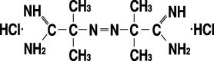

Scheme 1. Chemical structure of 2,2’-azobis(2-amidinopropane)2HCl (V-50) for preparation of P(GMA-DVB)/PSt composite latex beads.

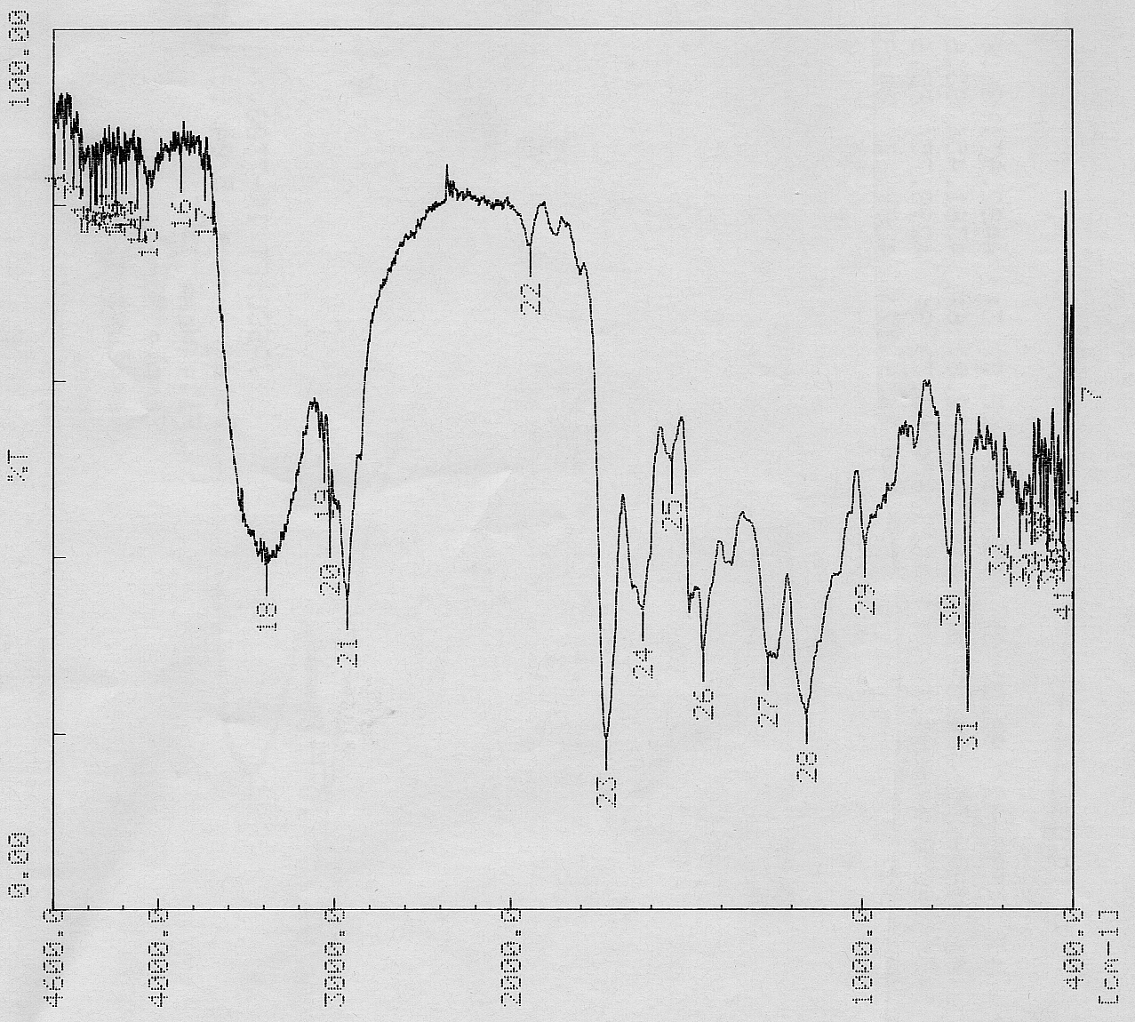

Figure 1. FT-IR spectra of acetylated P(GMA-DVB)/PSt latex beads

