Reactions of N-Heterocyclic Carbenes (NHCs) With One Electron Oxidants: Possible Formation of a Carbene Cation Radical
Taramatee Ramnial, Iain McKenzie, Brian Gorodetsky, Emily M. W. Tsang, and Jason A. C. Clyburne*

Department of Chemistry, Simon Fraser University, 8888 University Drive, Burnaby BC V5A 1S6, Canada. E-mail: clyburne@sfu.ca

Experimental Section

The ¹H and ¹³C NMR spectra were recorded on a Bruker AMX 400 MHz spectrometer. Chemical shifts, δ, are reported relative to the internal standard tetramethylsilane (TMS) for both ¹H and ¹³C NMR spectra. Infrared spectra were obtained using a Bomem MB Spectrometer with the % transmittance values reported in cm⁻¹. Elemental analyses were obtained on a Carlo Erba Model 1106 CHN analyzer. Melting points were measured using a Mel-Temp apparatus and are uncorrected.

Reaction of 1,3-bis-(2,4,6-trimethylphenyl)imidazol-2-ylidene with tetracyanoethylene.

To a solution of 1,3-bis-(2,4,6-trimethylphenyl)imidazol-2-ylidene (1.00 g, 3.29 mmol) in 20 ml THF, tetracyanoethylene (0.42 g, 3.29 mmol) dissolved in 20 ml THF was added drop-wise. The solution immediately turned dark red. After being stirred for 30 minutes, the solvent was removed under vacuum to give a dark red solid. Recrystallisation of the solids was attempted from a variety of solvents (toluene, diethylether, dichloromethane, and tetrahydrofuran), but all attempts were unsuccessful.
Isolated yield: (1.99 g, 70 %, mp. 115-116 ºC): Anal. Calcd for C₅₄H₄₈N₁₂: C, 74.98; H, 5.59; N, 19.43. Found: C, 72.08; H, 5.69; N, 18.73. (Electrospray, THF) m/z 304 amu.
¹H NMR (THF-d₈) δ 2.2 (s, 24 H, o-CH₃), 2.4 (s, 12 H, p-CH₃), 7.2 (s, 8 H,Ar-H), 7.3 (s, 4 H, C=CH).
¹³C NMR (CD₂Cl₂) δ 17.6 (s, 2,6-CH₃), 21.1 (s, 4-CH₃), 68.0 (TCNE, C-1), 114.0 (TCNE, C≡N), 116.8 (s, NCC), 125.5 (s, Mes C-3,5), 130.3 (s, Mes C-2,6), 130.5 (s, Mes C-4), 134.3 (s, Mes C-1), 142.5 (NCN).
IR (nujol) 2147 (m), 1688(w), 1607 (w), 1455 (s), 1229 (m), 853 (s), 723 (w) cm⁻¹.
The data are consistent with [1-1][(TCNE)₂].

Reaction of 1,3-bis-(isopropyl)-4,5-dimethylimidazol-2-ylidene with tetracyanoethylene.

A stirred solution of 1,3-bis-(isopropyl)-4,5-dimethylimidazol-2-ylidene (0.25 g, 1.39 mmol) in 10 ml THF was treated with a solution of tetracyanoethylene (0.18 g, 1.39 mmol) in 20 ml of THF and left to stir for 2 hours. The yellow solution rapidly changed to dark red colour. The solvent was removed under vacuum leaving a sticky dark red. Attempts for recrystallisation from a variety of solvents (toluene, diethylether, dichloromethane, and tetrahydrofuran) were unsucessful.
Isolated yield: (0.5 g, 59%); Anal. Calcd for C₃₄H₄₀N₁₂ : C, 66.21; H, 6.54; N, 27.25. Found: C, 66.17; H, 6.69; N, 27.39; m/z (Electrospray, THF) 180 amu.
¹H NMR (THF-d₈) δ 1.6 (d, 24 H,CHMe₂), 2.4 (s, 12 H, 4,5-Me), 4.6 (sept, 4 H,CHMe₂).
¹³C NMR (CD₃OD) δ 9.3 (s, 4,5-CH₃), 23.7 (s, CHMe₂), 52.7 (s, CHMe₂), 60.0 (TCNE, C-1), 114.3 (s, TCNE, C≡N), 128.50 (s, NCN), 132.5 (s, C -4,5).
IR (nujol) 2985 (s), 2937 (s), 2195 (s), 2147 (m),1597(w), 1462 (s), 1376 (m), 1231(s), 895 (s), 799 (m).
The data are consistent with [2-2][TCNE]₂.

Reaction of 1,3-bis-(2,4,6-trimethylphenyl)imidazol-2-ylidene with ferrocenium hexafluorophosphate.

1,3-bis-(2,4,6-trimethylphenyl)imidazol-2-ylidene (0.5 g, 1.64 mmol) was dissolved in 20 ml THF and slowly treated with a solution of ferrocenium hexafluorophosphate (0.54 g, 1.64 mmol) in 20 ml of THF. The yellow solution turned reddish brown. It was stirred for 24 hours and then the solvent was removed under vaccum to give a reddish brown powder. After washing thoroughly with hexane, a dark powder was isolated whose principle component was characterised as the imidazolium hexafluorophosphate, [1-H][PF₆].
Isolated yield: (1.49 g, 71%, mp. 170-172 ºC).
¹H NMR (THF-d₈) δ 2.2 (s,12H, o-CH₃), 2.4 (s, 6H, p-CH₃), 7.2 (s, 4H,Ar-H), 7.3 (s, 2H, C=CH), 9.1 (s, 1H, C₂-H).
¹³C NMR (THF-d₈) δ 17.8 (s, 2,6-CH₃), 21.2(s, 4-CH₃), 126.7 (s, NCC), 130.5 (s, Mes C-3,5), 132.1 (s, Mes C-2,6), 135.4 (s, C-4), 139.2 (s, C-1), 142.0 (NCN).
IR (nujol) 2951(s), 1638(m), 1462(m), 1377(m), 1226(s), 837(s), 739(m).

Reaction of 1,3-bis-(isopropyl)-4,5-dimethylimidazol-2-ylidene with ferrocenium hexafluorophosphate.

To a solution of 1,3-bis-(isopropyl)-4,5-dimethylimidazol-2-ylidene (0.3 g, 1.67 mmol) in 10 ml THF, a solution of ferrocenium hexafluorophosphate (0.55 g, 1.67 mmol) in 10 ml of THF was added slowly and left to stir for three days. The colour of the solution changed to dark green. The solvent was removed under vacuum and then washed thoroughly with hexane to remove the ferrocene, leaving a dark green powder whose principle component was characterised as the imidazolium hexafluorophosphate, [2-H][PF₆].
Isolated yield: (0.47 g, 86%, mp. 154-156 ^{ο}C).
¹H NMR (THF-d₈) δ 1.4 (d,12H, CHMe₂), 2.2 (s, 6H, 4,5-Me), 4.5 (sept, 2H, CHMe₂), 8.5 (s, 1H, C₂-H).
¹³C NMR (THF-d₈) δ 7.9 (4,5- Me), 22.1 (CHMe₂), 51.2 (CHMe₂), 127.4 (C-4,5) 130.4 (NCN). IR (nujol) 3141 (s), 2951 (s), 2853 (s), 1742 (m), 1678 (m), 1608 (m), 1462 (m), 1456 (m) 1226 (m), 1162 (s), 837 (m), 739 (m), 556 (w).

Reaction of 1,3-bis-(isopropyl)-4,5-dimethylimidazol-2-ylidene with ferrocenium tetrafluoroborate.

Excess ferrocenium tetrafluoroborate (0.5 g, 1.83 mmol) was added slowly to a solution of 1,3-bis-(isopropyl)-4,5-dimethylimidazol-2-ylidene (0.3 g, 1.67 mmol) in 10ml THF. The solution was left to stir for three days and was then filtered. A reddish green solution was obtained after pumping the solvent under vacuum. The reddish green powder was then washed with hexane to remove ferrocene leaving a green powder whose principle component was characterised as the imidazolium tetrafluoroborate, [2-H][BF₄].
Isolated yield: ( 0.35 g, 79%, mp. 115-117 ºC).
¹H NMR (THF-d₈) δ 1.6 (d,12H, CHMe₂), 2.3 (s, 6H, 4,5-Me), 4.6 (sept, 2H, CHMe₂), 9.0 (s, 1H, C₂-H).
¹³C NMR (THF-d₈) δ 7.8 (4,5- Me), 21.9 (CHMe₂), 51.0 (CHMe₂), 127.2 (C-4,5), 130.3 (NCN). IR (nujol) 3150 (s), 2952 (s), 2853 (m), 1676 (m), 1655 (m), 1460 (m), 1377 (w),1189 (m), 1057 (m), 800 (s).

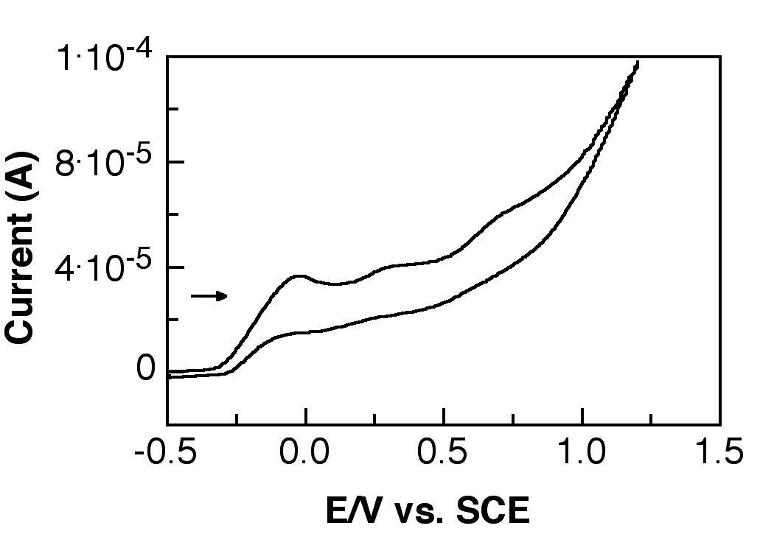
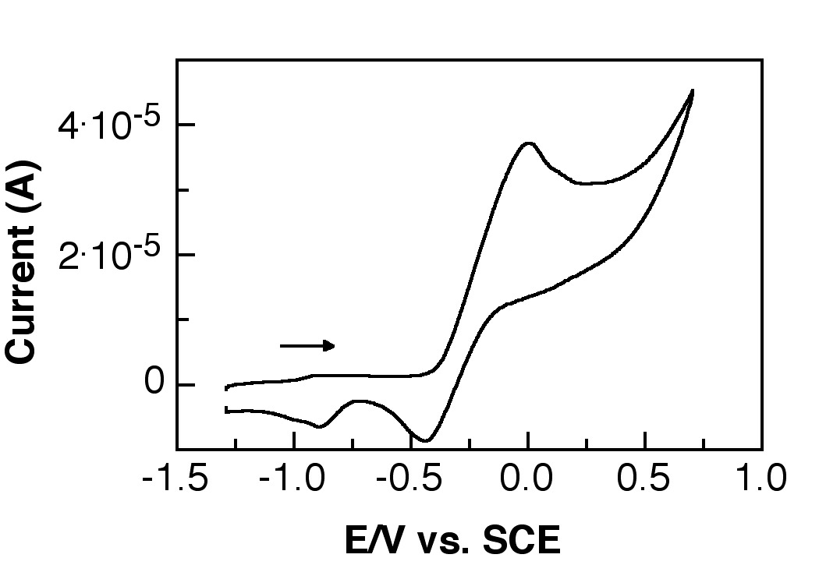

Fig. 1 The cyclic voltammograms of 1 (Left; C = 0.042 M,υ = 0.3 V/s) and 2 (Right; C = 0.053M,υ = 0.3 V/s ) in a solution of THF and 0.1 M tetrabutyl ammonium hexafluorophosphate electrolyte. The voltammograms were referenced to SCE using ferrocene (0.40 V vs. SCE).

General Electrochemistry:

Electrochemical experiments were performed on a Pine AFCBP1 bipotentiostat. All cyclic voltammetry experiments were performed with a standard three electrode system using a glassy carbon disk working electrode (5mm diameter), a Pt wire counter electrode and a Ag/AgCl (in saturated NaCl) reference electrode. All of the glassware used was flame dried and maintained under a positive pressure of nitrogen and all solutions were prepared in a glovebox to minimize contact with water and oxygen. The working electrode was polished,sonicated, rinsed with ethanol and dried prior to each experiment The THF used in the experiments was of greater than 99% purity and purchased from aldrich in “sure- sealed” containers packaged under nitrogen and the solvent was further deoxygenated by bubbling nitrogen gas through the system. The supporting electrolyte was 0.1 M tetrabutylammonium hexafluorophosphate, which was purified by triple recrystalization from ethanol and dried at 110 degrees celcius under vacuum for 3 days. An attempt was made to use ferrocene and decamethylferrocene as internal standards for calibration but unfortunately the reaction kinetics of the carbene with the electrode is slow and a chemical reaction takes place with the oxidized ferrocenes thus inhibiting the reversibility of the standard redox couple (See figure 2). Therefore, we calibrated our system using ferrocene as an external standard in replica THF/0.1M TBAPF6 solutions and as a result, our estimated values are limited to the deviation of the Ag/AgCl reference electrode used. We determined this deviation to be plus or minus 15 mV in these solutions. Different standards that don’t react with the carbenes will be explored in future experiments.

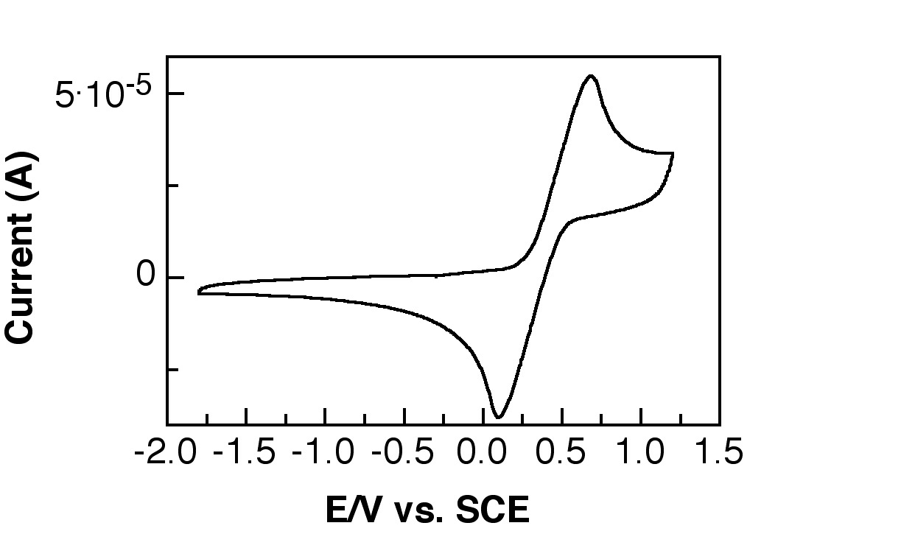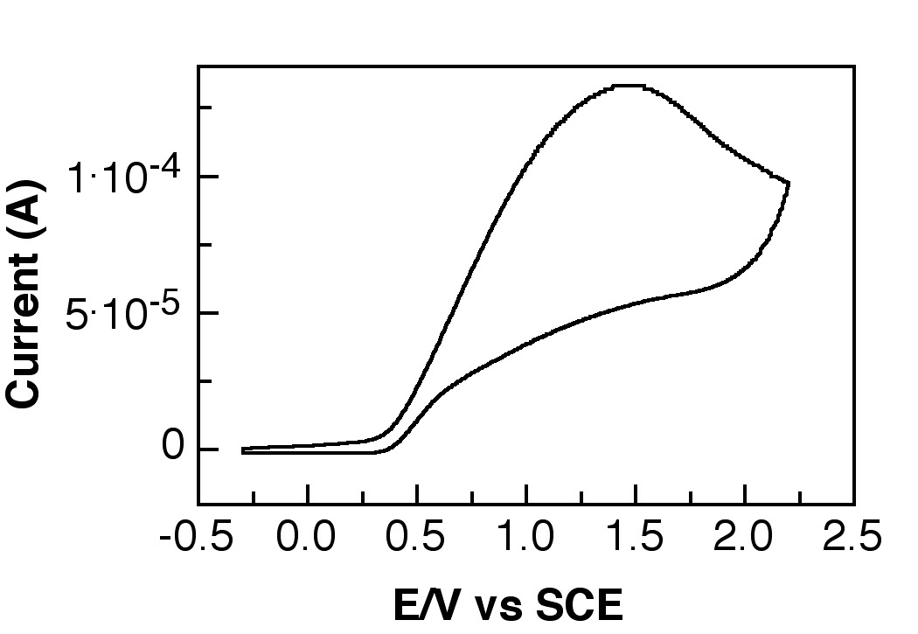

Fig. 2. The cyclic voltammograms of ferrocene (left; C = 3.4 mM, υ = 0.3 V/s) and the addition of 10 equivalents of 1 (Right; υ = 0.3 V/s) in a solution of THF and 0.1 M tetrabutyl ammonium hexafluorophosphate electrolyte. The voltammograms were referenced to SCE using ferrocene (0.40 V vs. SCE).

Supplementary Material

Isopropyl carbene 2
Opt: UB3LYP/6-31G**

---------------------------------------------------------------------
Center Atomic Atomic Coordinates (Angstroms)
Number Number Type X Y Z
---------------------------------------------------------------------
1 6 0 -0.685290 1.318514 -0.000003
2 7 0 -1.074281 -0.043485 -0.000003
3 6 0 0.000002 -0.908149 0.000014
4 7 0 1.074282 -0.043485 -0.000011
5 6 0 0.685290 1.318516 -0.000002
6 6 0 -2.476320 -0.526337 -0.000002
7 6 0 2.476322 -0.526336 -0.000015
8 6 0 1.649749 2.461594 -0.000010
9 6 0 -1.649749 2.461592 -0.000006
10 6 0 2.770267 -1.332611 -1.275863
11 6 0 2.770298 -1.332533 1.275878
12 6 0 -2.770288 -1.332550 1.275881
13 6 0 -2.770279 -1.332591 -1.275861
14 1 0 -3.105971 0.370193 -0.000018
15 1 0 3.105974 0.370193 -0.000051
16 1 0 2.300007 2.457508 0.885191
17 1 0 1.109133 3.413040 -0.000010
18 1 0 2.299998 2.457502 -0.885217
19 1 0 -2.300003 2.457499 -0.885210
20 1 0 -1.109133 3.413038 -0.000010
21 1 0 -2.300002 2.457506 0.885199
22 1 0 3.819377 -1.652509 -1.289901
23 1 0 2.578023 -0.730769 -2.171411
24 1 0 2.127452 -2.217458 -1.313886
25 1 0 3.819409 -1.652426 1.289914
26 1 0 2.127485 -2.217379 1.313967
27 1 0 2.578068 -0.730636 2.171393
28 1 0 -3.819400 -1.652440 1.289922
29 1 0 -2.578051 -0.730666 2.171404
30 1 0 -2.127479 -2.217399 1.313954
31 1 0 -3.819392 -1.652483 -1.289897
32 1 0 -2.127470 -2.217442 -1.313901
33 1 0 -2.578039 -0.730737 -2.171402
---------------------------------------------------------------------
Isopropyl radical cation [2]^{•+}

Opt: UB3LYP/6-31G**

---------------------------------------------------------------------
Center Atomic Atomic Coordinates (Angstroms)
Number Number Type X Y Z
---------------------------------------------------------------------
1 6 0 -0.690752 1.297942 -0.184470
2 7 0 -1.105599 -0.062180 -0.127965
3 6 0 0.000000 -0.811025 -0.060929
4 7 0 1.105599 -0.062181 -0.127966
5 6 0 0.690752 1.297942 -0.184471
6 6 0 -2.515634 -0.576673 -0.081449
7 6 0 2.515634 -0.576675 -0.081452
8 6 0 1.665396 2.426633 -0.238181
9 6 0 -1.665397 2.426632 -0.238176
10 6 0 2.593806 -1.913679 -0.827920
11 6 0 2.992028 -0.672913 1.376442
12 6 0 -2.992022 -0.672920 1.376446
13 6 0 -2.593812 -1.913670 -0.827927
14 1 0 -3.106818 0.172088 -0.617142
15 1 0 3.106816 0.172080 -0.617154
16 1 0 2.342324 2.428262 0.623361
17 1 0 1.133074 3.380489 -0.235039
18 1 0 2.275788 2.395950 -1.148667
19 1 0 -2.275784 2.395957 -1.148665
20 1 0 -1.133076 3.380489 -0.235022
21 1 0 -2.342329 2.428252 0.623364
22 1 0 3.629177 -2.267034 -0.834996
23 1 0 2.261981 -1.815413 -1.866145
24 1 0 1.987951 -2.681793 -0.330948
25 1 0 4.044612 -0.972573 1.397233
26 1 0 2.412716 -1.423853 1.924776
27 1 0 2.903161 0.284358 1.899589
28 1 0 -4.044606 -0.972578 1.397240
29 1 0 -2.903150 0.284348 1.899600
30 1 0 -2.412709 -1.423864 1.924774
31 1 0 -3.629184 -2.267024 -0.835002
32 1 0 -1.987955 -2.681789 -0.330964
33 1 0 -2.261991 -1.815396 -1.866153
---------------------------------------------------------------------
Dimer dication [2-2]²⁺

Opt: UB3LYP/6-31G

---------------------------------------------------------------------
Center Atomic Atomic Coordinates (Angstroms)
Number Number Type X Y Z
---------------------------------------------------------------------
1 6 0 -2.871571 -0.520535 -0.462952
2 6 0 -2.872707 0.518753 0.460608
3 7 0 -1.538327 -0.823115 -0.739386
4 7 0 -1.540182 0.823436 0.738007
5 6 0 -0.731052 0.000548 -0.000117
6 6 0 -1.012462 -1.890706 -1.675613
7 6 0 -1.017071 1.891131 1.675614
8 6 0 0.730997 0.001326 0.000651
9 7 0 1.539167 0.740416 -0.822310
10 7 0 1.539245 -0.737121 0.824103
11 6 0 2.872055 0.463376 -0.518853
12 6 0 2.872119 -0.460221 0.520404
13 6 0 1.014679 1.676681 -1.890528
14 6 0 1.014848 -1.674803 1.891099
15 6 0 -4.059371 -1.184755 -1.082038
16 6 0 -4.061860 1.181250 1.078934
17 6 0 -1.536832 -1.699912 -3.106970
18 6 0 -1.265163 -3.301510 -1.121405
19 6 0 -1.538287 1.694463 3.107311
20 6 0 -1.276894 3.302129 1.125227
21 6 0 4.060482 1.082026 -1.182354
22 6 0 4.060661 -1.079058 1.183546
23 6 0 1.539039 3.107915 -1.698900
24 6 0 1.269349 1.122450 -3.300962
25 6 0 1.273434 -1.124823 3.302481
26 6 0 1.535611 -3.106710 1.694655
27 1 0 0.068141 -1.715826 -1.679506
28 1 0 0.064288 1.720960 1.677213
29 1 0 -0.066168 1.680618 -1.717198
30 1 0 -0.066341 -1.675952 1.719823
31 1 0 -3.947258 -2.268074 -1.148525
32 1 0 -4.259919 -0.803677 -2.089853
33 1 0 -4.948298 -0.994178 -0.478501
34 1 0 -3.952423 2.264990 1.143121
35 1 0 -4.261091 0.801718 2.087606
36 1 0 -4.950551 0.987279 0.476144
37 1 0 -0.958393 -2.339775 -3.780791
38 1 0 -1.428564 -0.666388 -3.448909
39 1 0 -2.583779 -1.993304 -3.206026
40 1 0 -0.719050 -4.022035 -1.738679
41 1 0 -2.320059 -3.582829 -1.156191
42 1 0 -0.913861 -3.405105 -0.090899
43 1 0 -0.962322 2.335969 3.781696
44 1 0 -1.423982 0.660776 3.446820
45 1 0 -2.586694 1.981942 3.208529
46 1 0 -0.732288 4.023484 1.742857
47 1 0 -2.332833 3.579052 1.163188
48 1 0 -0.928444 3.409496 0.094124
49 1 0 4.949167 0.478448 -0.990808
50 1 0 4.260842 2.089982 -0.801559
51 1 0 3.949239 1.148077 -2.265804
52 1 0 4.949540 -0.476140 0.990811
53 1 0 4.260191 -2.087468 0.803452
54 1 0 3.950281 -1.144026 2.267125
55 1 0 0.961677 3.781896 -2.339571
56 1 0 2.586454 3.206747 -1.990747
57 1 0 1.429332 3.449790 -0.665501
58 1 0 0.724839 1.740152 -4.022329
59 1 0 0.917494 0.092182 -3.405196
60 1 0 2.324730 1.156516 -3.580536
61 1 0 0.728269 -1.742708 4.023197
62 1 0 0.924831 -0.093787 3.409871
63 1 0 2.329144 -1.162769 3.580266
64 1 0 0.958338 -3.781042 2.335040
65 1 0 2.583525 -3.208616 1.983659
66 1 0 1.422645 -3.445775 0.660676
---------------------------------------------------------------------

TCNE

Opt: UB3LYP/6-31G**

---------------------------------------------------------------------
Center Atomic Atomic Coordinates (Angstroms)
Number Number Type X Y Z
---------------------------------------------------------------------
1 6 0 -0.000026 -0.688762 0.001047
2 6 0 0.000039 0.688752 0.000252
3 6 0 1.219897 -1.430315 0.000832
4 6 0 -1.219990 -1.430238 0.001479
5 6 0 1.220011 1.430229 -0.000606
6 6 0 -1.219869 1.430318 -0.000246
7 7 0 2.217794 -2.047682 -0.001461
8 7 0 -2.218019 -2.047389 -0.000782
9 7 0 2.217985 2.047471 0.000517
10 7 0 -2.217814 2.047613 -0.000637
---------------------------------------------------------------------
[TCNE]^{•-}

Opt: UB3LYP/6-31G**

---------------------------------------------------------------------
Center Atomic Atomic Coordinates (Angstroms)
Number Number Type X Y Z
---------------------------------------------------------------------
1 6 0 -0.722430 0.000156 0.000634
2 6 0 0.722426 -0.000174 -0.000065
3 6 0 -1.453632 -1.207076 0.000742
4 6 0 -1.453070 1.207728 0.001206
5 6 0 1.453068 -1.207746 -0.000607
6 6 0 1.453631 1.207056 -0.000227
7 7 0 -2.073921 -2.214251 -0.001057
8 7 0 -2.072755 2.215275 -0.000605
9 7 0 2.072827 -2.215248 0.000533
10 7 0 2.073853 2.214274 -0.000314
---------------------------------------------------------------------
(TCNE)₂²⁻

Opt: UB3LYP/6-31G**

---------------------------------------------------------------------
Center Atomic Atomic Coordinates (Angstroms)
Number Number Type X Y Z
---------------------------------------------------------------------
1 6 0 -1.541691 -0.721156 0.000227
2 6 0 -1.542742 0.719587 0.000227
3 6 0 -1.664800 -1.453254 1.205287
4 6 0 -1.665360 -1.453247 -1.204787
5 6 0 -1.666999 1.451532 1.205272
6 6 0 -1.667112 1.451540 -1.204795
7 7 0 -1.816476 -2.075892 2.199008
8 7 0 -1.817689 -2.075750 -2.198494
9 7 0 -1.819018 2.074121 2.198974
10 7 0 -1.819551 2.074062 -2.198474
11 6 0 1.542601 -0.719600 -0.000403
12 6 0 1.541895 0.721146 -0.000075
13 6 0 1.665585 1.452969 1.205086
14 6 0 1.665281 1.453476 -1.204977
15 7 0 1.816839 2.076400 -2.198538
16 7 0 1.817488 2.075369 2.198925
17 6 0 1.666990 -1.451822 1.204467
18 7 0 1.819317 -2.074492 2.198067
19 6 0 1.666626 -1.451314 -1.205603
20 7 0 1.818855 -2.073693 -2.199405
---------------------------------------------------------------------

A. J. Arduengo, III, H. V. R. Dias, R. L. Harlow, and M. Kline, J. Am. Chem. Soc., 1992, 114, 5530.
N. Kuhn and T. Kratz, Synthesis, 1993, 561.

