Supplemental Figures

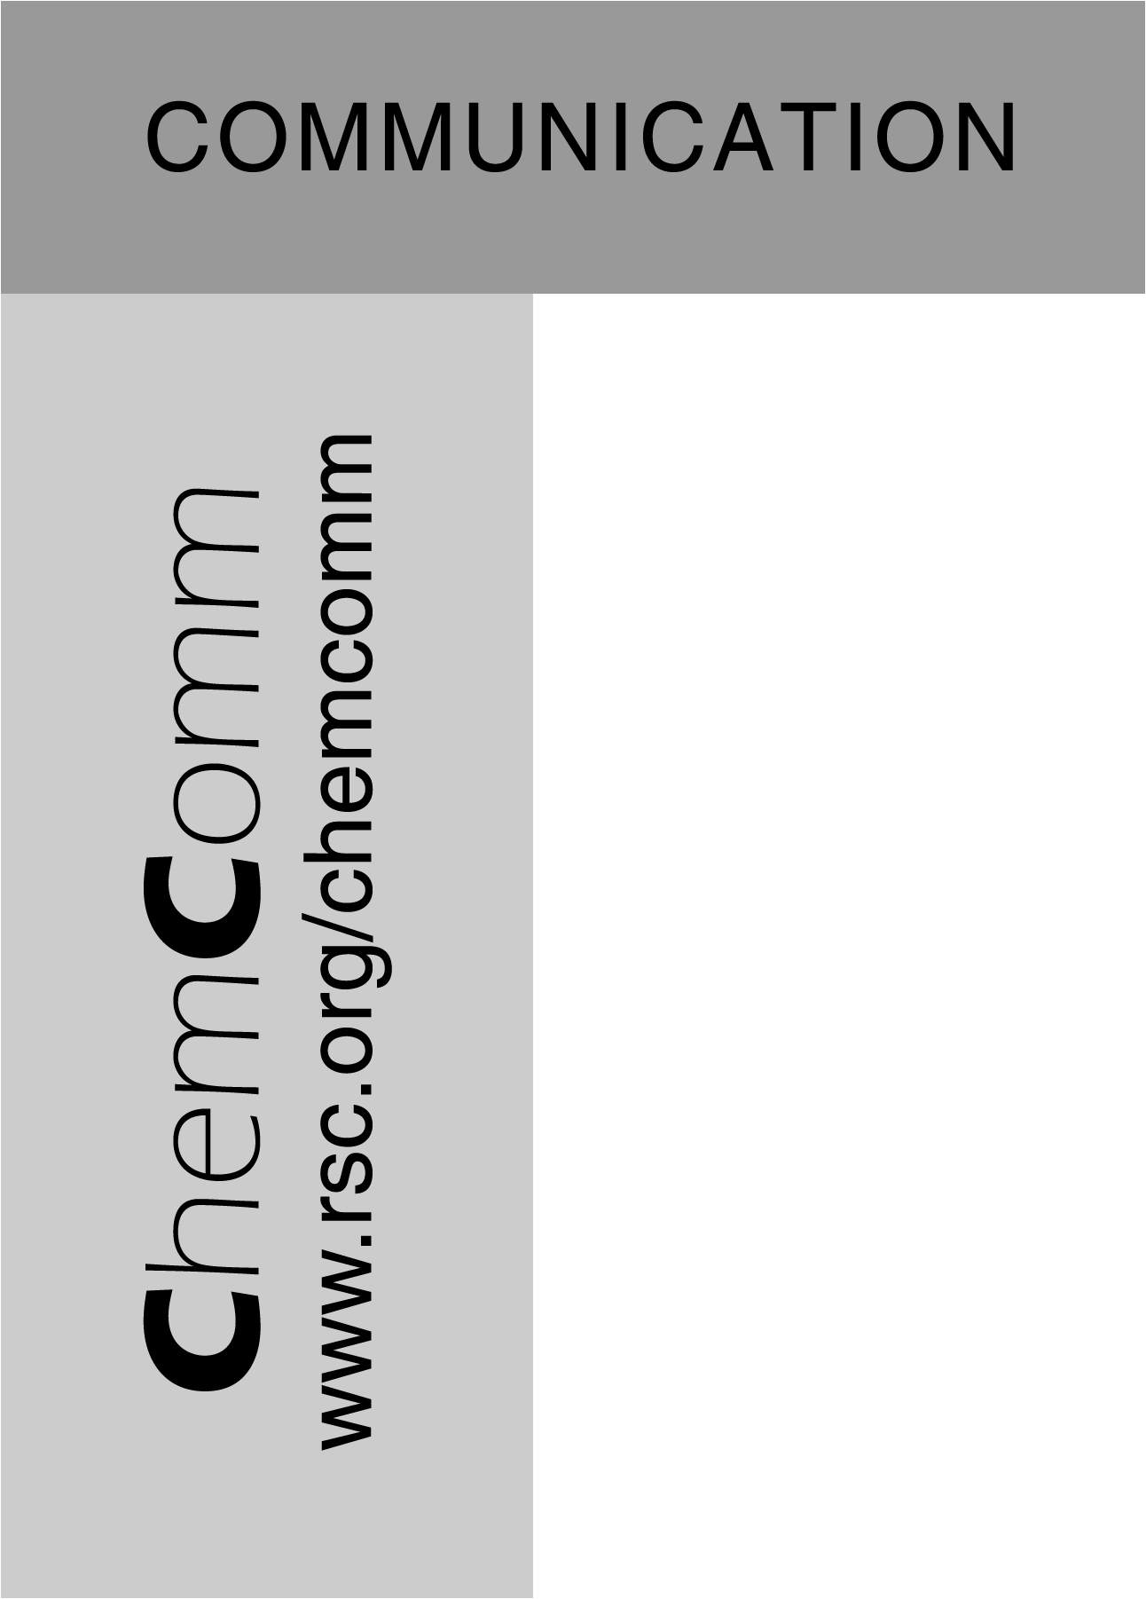
C₁ Coupling via Bromine Activation and Tandem Catalytic Condensation and Neutralization over CaO/Zeolite Composites.
Ivan Lorkovic,ª* Maria Noy,ª Mike Weiss,^{b} Jeff Sherman,^{b} Eric McFarland, ^{b,c} Galen D. Stucky,ª and Peter C. Fordª
ª.Department of Chemistry and Biochemistry, University of California, Santa Barbara, CA 93106.
Fax: 805 893 4120; Tel: 805 893 5239; E-mail: lorkovic@chem.ucsb.edu
^{b}Gas Reaction Technogies, Inc., 301B S. Wimbrow Dr. Sebastian, FL 32958
^{c}Department of Chemical Engineering, University of California, Santa Barbara, CA 93106

Figure S1. Continued methane bromination and condensation over the same Ca/ZSM-5 bed (5.0 g) used in Figure 1 past the HBr saturation limit (reached at ~100 min) of the bed. Feed: CH₄:Br₂ (5:0.5 cc/min). First Stage: Plug flow reactor (1 x 100 mm glass tube, 500º C. space time = 0.3 s. Br₂ conversion = 100%, CH₄ conversion = 8.2%). Second Stage: Fixed bed: (10 x 100 mm plug of 5 g. Ca-ZSM-5, 400 C, space time = 20 s, WHSV = 0.04 h⁻¹).
Figure S2. CH₃Br condensation to olefins over a 10 x 100 mm plug of CaO/ZSM-5 (5 g) at 400 C. Feed, CH₄:CH₃Br (5:0.6 cc/min); space time = 20 s, WHSV = 0.025 h⁻¹. Selectivity to C₂-C₅ is >70%.
.

