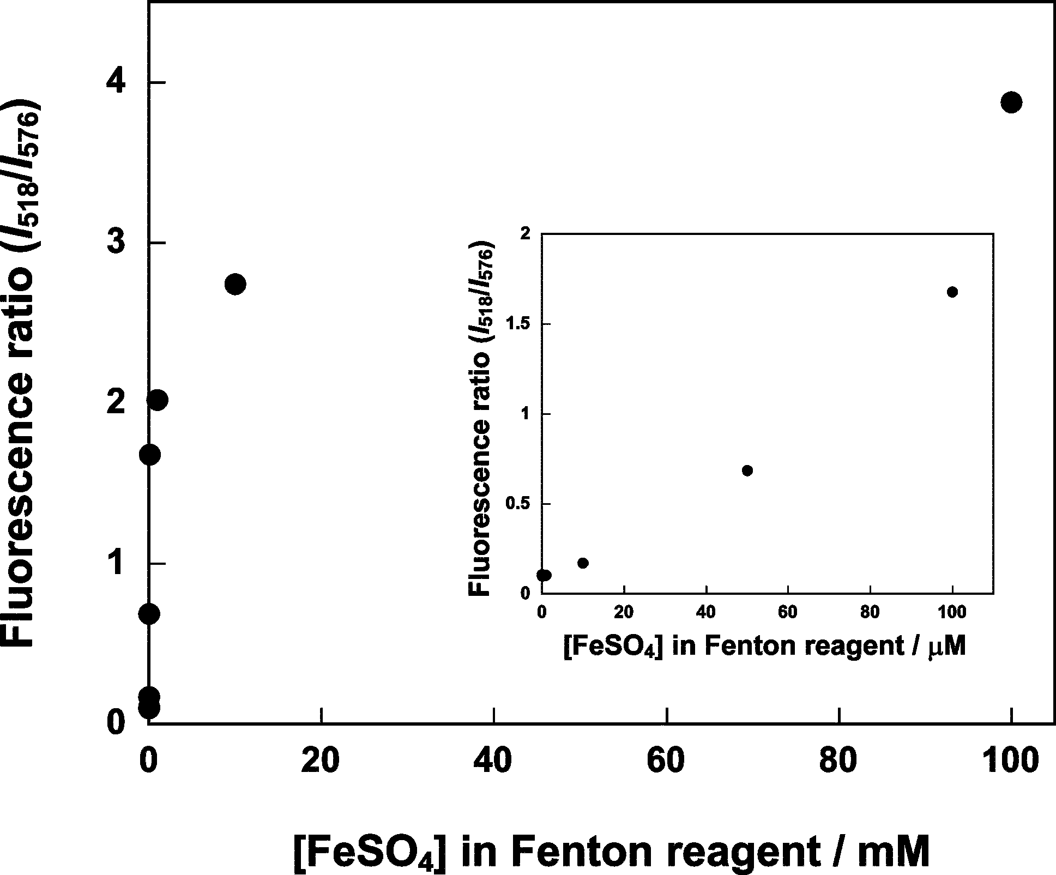

Fig. 2 Relation between the concentration of Fenton’s reagent and fluorescence intensity ratio at 518 nm to 576 nm for probe 1. The molar ratio of FeSO₄ to H₂O₂ is 1:10.

