Electronic Supplementary Information

H-bonded complexes of adenine with Rebek imide receptors are stabilised by cation-π interactions and destabilised by stacking with perfluoroaromatics †

Raffaella Faraoni,ª Ronald K. Castellano,^{a,b} Volker Gramlich^{c} and François Diederichª*
ª Laboratorium für Organische Chemie, ETH-Hönggerberg, CH-8093 Zürich, Switzerland.
E-mail: diederich@org.chem.ethz.ch
^{b} Current address: Department of Chemistry, University of Florida, Gainesville, FL 32611-7200, U.S.A.
^{c} Laboratorium für Kristallographie, ETH-Zentrum, Sonneggstrasse 5, CH-8092 Zürich, Switzerland.

I. Synthesis ESI
Table ESI 2 Synthesis of receptors 1a,b,d by acylation with 4
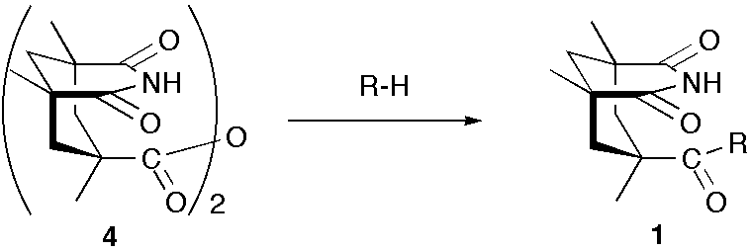
Receptor | R | Yield (%)ª
1a | 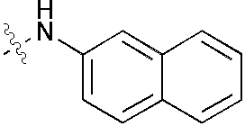 | 35%
1b | 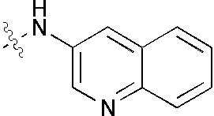 | 32%
1d | 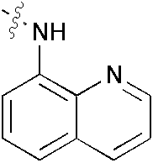 | 60%
ª Isolated yields after crystallisation or flash chromatography on silica gel.

Table ESI 1 Synthesis of Rebek imide and ester receptors 1a-i
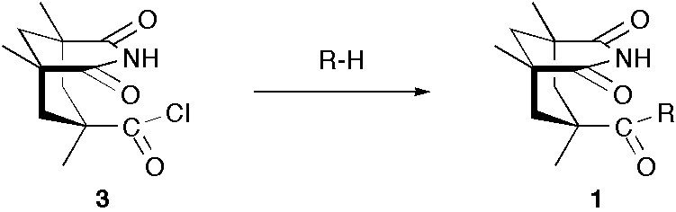
Receptor | R | Yield (%)ª
1a |  | 69%
1b |  | 61%
1d |  | 55%
1e | 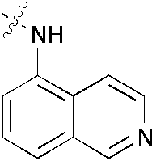 | 42%
1f | 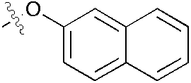 | 72%
1g | 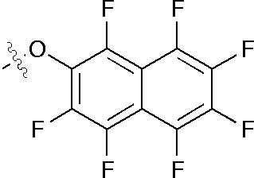 | 83%
1h | 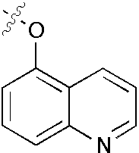 | 73%
1i | 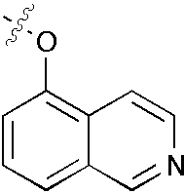 | 44%
ª Isolated yields after crystallisation or flash chromatography on silica gel.

Synthesis of receptors 1a-e:
A solution of 3 (200 mg, 0.78 mmol) in CHCl₃ (1.1 ml) was added at r.t. to a stirred solution of the primary amine (0.78 mmol) and DMAP (19 mg, 0.15 mmol) in dry pyridine (6 ml). The mixture was heated to reflux under N₂ for 8 h. After concentration in vacuo the residue was taken up in CHCl₃, washed with 10% aqueous HCl, saturated aqueous NaHCO₃ solution and saturated aqueous NaCl solution. The organic phase was dried (Na₂SO₄) and concentrated to give a light-yellow solid. The crude product was either purified by flash chromatography (SiO₂; AcOEt/CH₂Cl₂ 2:8) or recrystallised from CH₂Cl₂/hexane.

Synthesis of receptors 1f-i:
A solution of the aromatic alcohol (61 mg, 0.43 mmol) in dry THF (10 ml) was cooled to 0 °C and then treated with NaH (23 mg, 0.58 mmol 60% oil dispersion). The solution was stirred for 30 min at 0 °C prior to the dropwise addition of 3 (100 mg, 0.39 mmol) in dry THF (10 ml). After complete addition, the solution was stirred for 3 h at r.t. before H₂O (1 ml) was added. The solvent was removed in vacuo and the residue was partitioned between H₂O and CHCl₃. The organic phase was separated and the aqueous phase was extracted with CHCl₃. The combined organic phases were washed with saturated aqueous NaHCO₃ solution and saturated aqueous NaCl solution. The organic phase was dried (Na₂SO₄) and concentrated to give a yellow-white solid. The crude product was recrystalised from CH₂Cl₂/hexane or CHCl₃/MeOH/hexane to afford a white solid.

Synthesis of 4:
A solution of 3 (210 mg, 0.84 mmol) in CH₂Cl₂ (2 ml) was added at r.t. to a stirred solution of Kemp’s imide acid (200 mg, 0.84 mmol) and DMAP (21 mg, 0.17 mmol) in dry (0.23 ml) Et₃N. The mixture was heated to reflux under N₂ overnight. CHCl₃ was added and the mixture was washed with 0.5 m HCl and saturated aqueous NaCl solution, then dried (Na₂SO₄). Concentration in vacuo gave a white solid that was recrystallised from MeOH and dried under high vacuum to give 4 (289 mg, 75%) as a bright-white solid.
Synthesis of amides 1a-d:
Kemp’s anhydride 4 (70 mg, 0.15 mmol) and primary arylamine (0.15 mmol) were refluxed in DMF for 48 h. The mixture was cooled to r.t. and concentrated to dryness. The crude product was purified by flash chromatography (1a: SiO₂; MeOH/CH₂Cl₂ 1:99; 1b: SiO₂; AcOEt/CH₂Cl₂ 2:1). Recrystallisation from MeOH gave 1d.

Synthesis of 1c:
In an oven-dried sealed tube, 1b (120 mg, 0.329 mmol) was added and suspended in MeI (1,2 ml) under N₂. The mixture was heated to 120 °C and stirred for one week. The mixture was cooled to r.t. and MeI was evaporated under a flow of N₂. The residue was recrystallised from MeOH/Et₂O to give 1c (145 mg, 87%) as a bright-yellow solid. M.p. ≥ 291 °C (dec.); FT-IR (neat): 3581m, 3499m, 3209m, 3049m, 2961m, 2868m, 1721s, 1695s, 1630m, 1514s, 1429m, 1380m, 1207s, 1178s, 897m, 765m. ¹H-NMR (300 MHz, CDCl₃/MeOH 2:1) δ: 9.52 (s, 1H); 8.99 (s, 1H); 8.13-8.06 (m, 2H); 7.95 (t, J = 7.5 and 8.7, 1H); 7.77 (t, J = 7.5 and 7.8, 1H); 4.49 (s, 3H); 2.69 (d, J = 15.0, 2H); 1.84 (d, J = 13.8, 1H); 1.32-1.05 (m, 12H). ¹³C-NMR (75.41 MHz, CDCl₃/MeOH 2:1) δ: 177.19; 175.24; 144.19; 135.90; 135.71; 134.66; 133.14; 130.51; 130.16; 129.76; 117.93; 45.86; 44.08; 43.64; 43.28; 39.98; 30.05; 23.92.
HR-FT-ICR-MALDI-MS (DHB) m/z 380.1974, calc. for C₂₂H₂₆N₃O₃⁺: 380.1974.

II. Binding Studies ESI
Determination of the association constants K_{a} and the dimerisation constants K_{d}
¹H-NMR titrations and dilution experiments were performed at 295 K on a Varian Gemini 300 Spectrometer (300 MHz) in CDCl₃ (stored over 4 Å molecular sieves) or in (CDCl₂)₂ purchased from Glaser, Basel. The receptor concentration (1a-i) was kept constant at 5 mm and a solution of 2 (50 mm) was added in increments by syringe into the NMR tube. The change in chemical shift of the imide N-H proton was recorded after each of 12-14 additions. Binding isotherms were created using Associate v. 1.6^{10a} or the NMRTit HG HH GG software^{10b} on an Apple Macintosh computer. Values reported are the average of 2-3 independent runs. Uncertainty listed in K_{a} is one standard deviation from duplicate or triplicate runs. Dilution experiments were carried out with a solution of 1a-i (30-50 mm), which was progressively diluted with CDCl₃ or (CDCl₂)₂. The change in chemical shift of the imide N-H proton was recorded after each of 8-9 CDCl₃ or (CDCl₂)₂ additions. When the change in chemical shift was minimal (< 0.5 ppm) over a large range of concentrations it was concluded that the self-association was negligible. Dilution curves and K_{d} values were obtained using the NMRDil Dimer software^{10b} on an Apple Macintosh computer. Values reported are the average of 2-3 independent runs. Uncertainty listed in K_{d} is one standard deviation from duplicate or triplicate runs.

Determination of thermodynamic parameters by van’t Hoff analysis
Van’t Hoff plots were generated by measuring the chemical shift response of the receptor imide N-H proton to temperature given a fixed concentration of receptor 1a-i (5-10 mm) and 2 (20 mm). The assumption of a temperature-independent chemical shift for the fully complexed imide N-H proton was made. The initial solution concentrations were chosen such that 20-80% of the saturation curve was sampled. Samples were equilibrated for 30-45 minutes initially (258 K), for 10-15 minutes between 258-303 K, and for 5 minutes thereafter until the maximum temperature was obtained (323K).

The K_{a} values were calculated as follows. K_{a} = ([host•guest]/[host][guest]) where [host•guest] = ([1a-i]_{tot}) (δ_{obs}-δ_{r})/(δ_{1a-i•2}-δ_{r}), where [1a-i]_{tot}= the total concentration of 1a-i in solution, δ_{obs} = observed chemical shift, δ_{r} = chemical shift of the imide N-H group of 1a-i, δ_{1a-i•2} = chemical shift of the N-H group of 1a-i in the 1a-i•2 complex (estimated on the basis of NMR titration data). Values reported are the average of 2-3 independent runs.

Determination of the binding stoichiometry by Job plot analysis
The 1:1 binding stoichiometry of the 1a-i•2 complexes was confirmed as follows. Two stock solutions were prepared; solution A: 5 mm of 1 in CDCl₃ or CD₂Cl₄. Solution B: 5 mm of 2 in CDCl₃ or CD₂Cl₄. Ten 5-mm NMR tubes were filled with solutions A and B in the following volume ratios: 50:450, 100:400, 150:350, 200:300, 250:250, 300:200, 350:150, 400:100, 450:50, and 500:0 μL. ¹H-NMR spectra were recorded at 300 MHz for each mixture. The concentration of the 1a-i•2 complexes was estimated as reported above. The experiments were repeated 2-3 times to ensure accuracy.

Table ESI 3 Dimerisation
constants K_{d} of receptors 1a-iª
ª Self-association of 1d was
Receptor | K_{d} [m⁻¹]
1a | 5.5 ± 1.2
1b | 130.5 ± 39.0
1b^{b} | 30.0 ± 8.7
1c^{b} | 11.8 ± 2.9
1e | 12.4 ± 3.4
1f | 4.4 ± 1.4
1g | 2.0 ± 0.4
1h | 4.1 ± 0.4
1i^{b} | 3.9 ± 1.1
negligible. ^{b} Measured in (CDCl₂)₂.

Figure ESI 1 ¹H-NMR titration to determine the stability of complex 1c•2 at 295 K in (CDCl₂)₂.
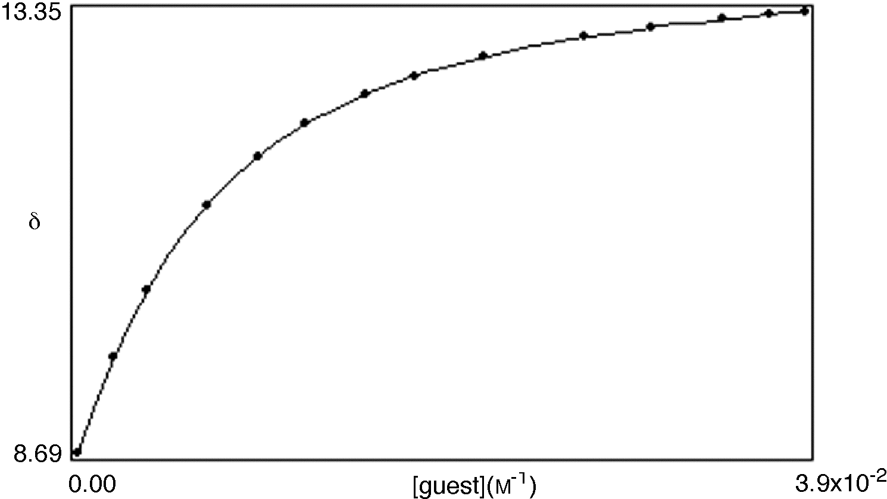
K_{a} = 221m⁻¹, [1c] = 5mm
δ_{bound} = 14.246 [2] = 50mm
δ_{dimer} fix = 9.653
δ_{dimer} dil = 12.100
ss of residuals = 2.58035724983•10⁻³
R factor = 0.303%
Min % bound = 1%
Max % bound = 84%

Figure ESI 2 Dilution curve of 1c in (CDCl₂)₂.
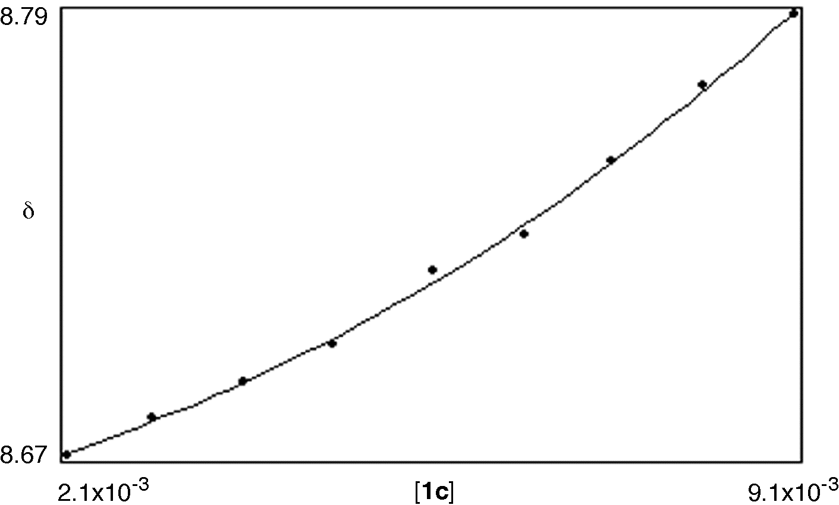
K_{d} = 13.7m⁻¹
δ_{bound} = 9.621
δ_{free} = 8.619
ss of residuals = 2.27090404223•10⁻⁵
R factor = 1.158%
Min bound = 5%
Max bound = 17%

Figure ESI 3 Van’t Hoff plot to determine the temperature dependence of the association between 1c and 2 in (CDCl₂)₂.
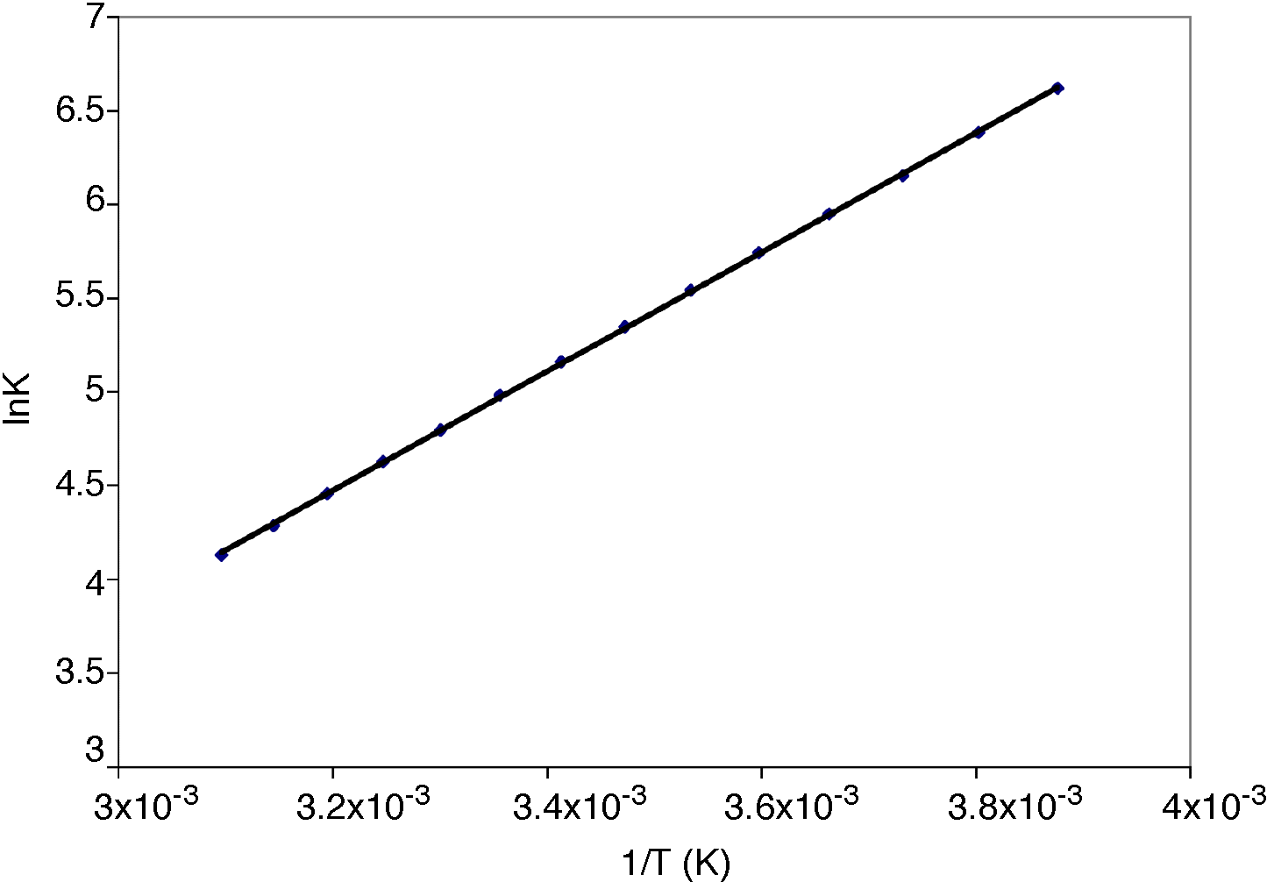
Figure ESI 4 Job plot to prove the 1:1 binding stoichiometry of complex 1c•2 in (CDCl₂)₂.
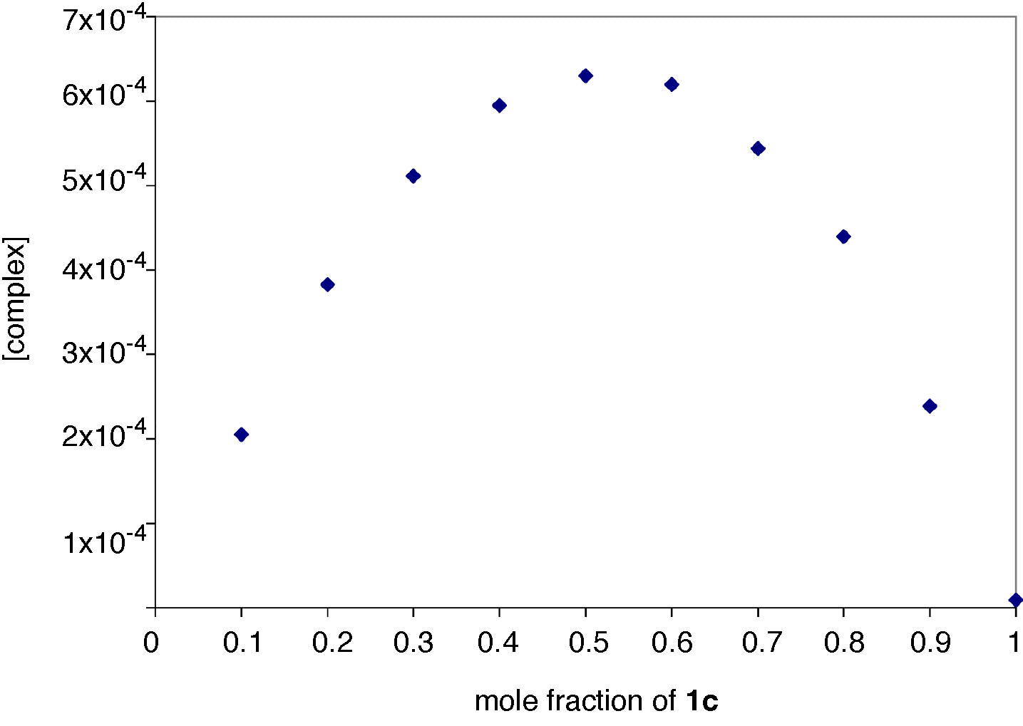

‡ Crystal data. Compound 4, C₂₄H₃₂N₂O₇·CH₂Cl₂, M = 545.44, monoclinic, a = 15.631(8), b = 16.523(11), c = 11.782(6) Å, β = 114.05(4)°, V = 2779(3) Å³, T = 293 K, space group C2/c, Z = 4, μ = 2.479 mm⁻¹, 1278 reflections collected, R₁ = 0.0834 based on F [I > 2σ(I)], wR₂(F²) = 0.2555 (all data). Complex 1d•2, C₂₁H₂₃N₃O₃·C₇H₉N₅, M = 528.62, triclinic, a = 8.097(4), b = 9.350(5), c = 18.786(9) Å, α = 76.19 (3), β = 78.45(3), γ = 85.08(3)°, V = 1352.0(12) Å³, T = 293 K, space group P-1, Z = 2, μ = 0.715 mm⁻¹, 2768 reflections collected, R₁ = 0.0436 based on F [I > 2σ(I)], wR₂(F²) = 0.1322 (all data). Complex 1c•2, C₂₂H₂₆IN₃O₃·C₇H₉N₅·H₂O, M = 688.57, triclinic, a = 8.578(2), b = 12.724(3), c = 15.621(3) Å, α = 109.03(3), β = 95.46(3), γ = 102.40(3)°, V = 1548.8(6) Å³, T = 293 K, space group P-1, Z = 2, μ = 1.081 mm⁻¹, 2457 reflections collected, R₁ = 0.0514 based on F [I > 2σ(I)], wR₂(F²) = 0.1251 (all data). The data of 4 and 1d•2 were collected on a PICKER-STOE diffractometer with CuK_{α} radiation (graphite monochromator λ = 1.54178) and for 1c•2 on a CAD4 diffractometer with MoK_{α} radiation (graphite monochromator λ = 0.71073). The structures were solved with the SHELXS program and refined by full matrix least-squares on F² with the SHELXL program.

