Electronic Supplementary Information(ESI)

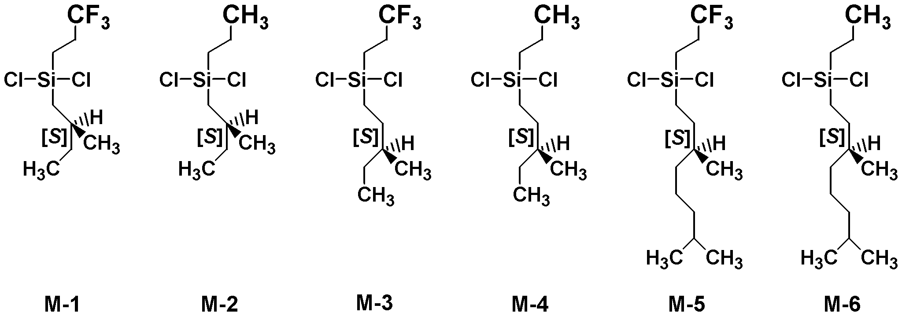Experimental Section

Synthesis of monomers
3,3,3-Trifluoropropyl-(S)-2-methylbutyldichlorosilane (M-1); (S)-2-Methylbutylchloride (20.3 g, 190 mmol) was reacted with Mg (5.5 g, 228 mmol) in dry tetrahydrofuran (100 mL) at 50 °C. The Grignard reagent was added to 3,3,3-trifluoropropyltrichlorosilane (40.0 g, 173 mmol) in dry tetrahydrofuran (100 mL) at 50 °C. The salts were removed by filtration from the reaction mixture. The crude product was purified by distillation to give the desired monomer as colorless liquid in 65% yield. b.p. = 106-108 °C (50 mmHg), ¹³C NMR in CDCl₃ (ppm) : 11.15, 13.42 (CF₃CH₂CH₂), 21.78, 27.67 (CF₃CH₂CH₂), 27.84, 30.20, 32.30, 127.00 (CF₃CH₂CH₂), ²⁹Si NMR in CDCl₃ (ppm) : 31.41, ¹⁹F NMR in CDCl₃ (ppm) : -69.61 (reference: CF₃C₆H₅(-64 ppm)), [α]_{D}²⁴ = 9.61°(neat).
M-2; b.p. = 116-118 °C (50 mmHg), ¹³C NMR in CDCl₃ (ppm) : 11.22, 16.17, 17.24, 21.82, 23.65, 28.13, 30.22, 32.35, ²⁹Si NMR in CDCl₃ (ppm) : 32.90, [α]_{D}²⁵ = 12.15°(neat).
M-3; b.p. = 110-111°C (30 mmHg), ¹³C NMR in CDCl₃ (ppm) : 11.27, 12.36 (CF₃CH₂CH₂), 17.26, 18.54, 27.60 (CF₃CH₂CH₂), 28.43, 28.64, 36.34, 127.96 (CF₃CH₂CH₂), ²⁹Si NMR in CDCl₃ (ppm) : 32.38, ¹⁹F NMR in CDCl₃ (ppm) : -69.63 (reference: CF₃C₆H₅(-64ppm)), [α]_{D}²⁴ = 6.66°(neat).
M-4; b.p. = 118-119 °C (30 mmHg), ¹³C NMR in CDCl₃ (ppm) :11.30, 16.12, 17.21, 17.56, 18.60, 22.56, 28.63, 28.68, 36.39, ²⁹Si NMR in CDCl₃ (ppm) : 33.88, [α]_{D}²⁴ = 7.72°(neat).
M-5; b.p. = 130-133 °C (10 mmHg), ¹³C NMR in CDCl₃ (ppm) :12.34 (CF₃CH₂CH₂), 17.24, 18.99, 22.58, 22.67, 24.68, 27.60 (CF₃CH₂CH₂), 27.94, 28.90, 34.72, 36.37, 39.23, 126.95 (CF₃CH₂CH₂), ²⁹Si NMR in CDCl₃ (ppm) : 32.38, ¹⁹F NMR in CDCl₃ (ppm) : -69.67 (reference: CF₃C₆H₅(-64ppm)), [α]_{D}²⁴ = 1.93°(neat).
M-6; b.p. = 139-141 °C (10 mmHg), ¹³C NMR in CDCl₃ (ppm) :16.14, 17.21, 17.54, 19.06, 22.58, 22.60, 22.70, 24.71, 27.95, 29.10, 34.77, 36.43, 39.27, ²⁹Si NMR in CDCl₃ (ppm) : 33.88, [α]_{D}²⁴ = 2.00°(neat).

Synthesis of polymers
Poly[3,3,3-trifluoropropyl-(S)-2-methylbutyldichlorosilane] (PS-1); Fleshly distilled monomer(M-1) (10 g, 37.5 mmol) was added dropwise to 1.81 g (78.7 mmol) of Na metal suspended in 30 mL of refluxing n-nonane vigorously stirred under nitrogen atmosphere. After 2 h, the reaction mixture was cooled to room temperature and 100 mL of dry tetrahydrofuran was added to reduce solution viscosity and stirring was continued for a further 30 min. The reaction mixture was passed through a 2-μm PTFE filter under nitrogen gas pressure. To the clear filtrate, 2-propanol and ethanol as precipitating solvents were added carefully. Several portions of white precipitates were collected by centrifugation and dried in vacuo at 80 °C.

 | PS-1 | PS-2 | PS-3 | PS-4 | PS-5 | PS-6
Yield (%) | 0.8 | 8.5 | 0.8 | 9.0 | 5.3 | 5.5
M_{w} | 5,000 | 4,500 | 17,000 | 1,630,000 | 330,000 | 1,540,000
M_{w}/M_{n} | 1.27 | 1.16 | 1.84 | 2.53 | 3.06 | 2.59

Measurements
UV and CD absorption spectra were recorded simultaneously on a JASCO J-725 spectropolarimeter equipped with a liquid nitrogen-controlled quartz cell with path length of 5 mm in a cryostat, ranging from 20 °C to -40 °C, or a Peltier-controlled quartz cell with path length of 10 mm, ranging from 80 °C to -5 °C. A scanning condition was as follows: a scanning rate of 200 nm per min, band width of 1 nm, response time of 1 sec, and five times accumulations. Solution temperature in the cryostat was monitored by directly immersing a thermocouple into the solution, while solution temperature in the Peltier-controlled cell was regarded as the same cell housing made of aluminum block. FL spectrum at room temperature (23 °C) was obtained with a JASCO FP-6500 spectrofluorometer equipped with a quartz cell with path length of 10 mm. A scanning condition is as follows: a scanning rate of 100 nm per min, band width of 1 nm at excitation and emission, response time of 1 sec, and single accumulation. ¹³C and ²⁹Si NMR spectra were measured in CDCl₃ with a JEOL EX-400 spectrometer using tetramethylsilane as an internal standard. Optical rotation at Na-D line was measured with a JASCO P-1020 polarimeter using a quartz cell with path length of 10 mm at room temperature (24 °C). The weight-average molecular weight of polymer (M_{w}) and number-average molecular weight of polymer (M_{n}) were determined using a gel permeation chromatography (Shimadzu A10 instruments, Plgel 10μm MIXED-B as a column and HPLC-grade tetrahydrofuran as eluent) at 40 °C, based on a calibration with polystyrene standards. IR spectra were measured with Horiba FT-730.
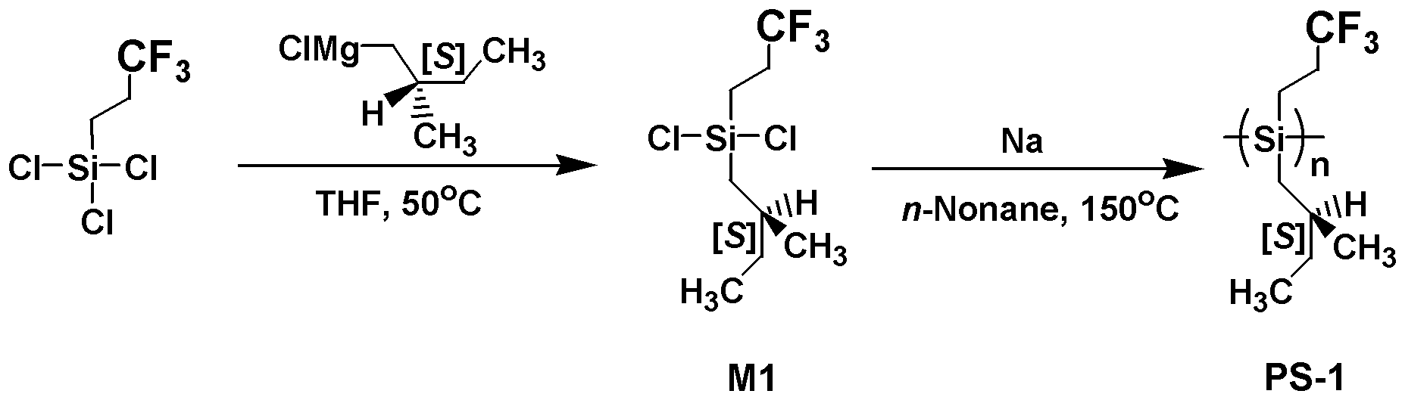

Scheme S1 Synthetic route of M1 and PS-1.

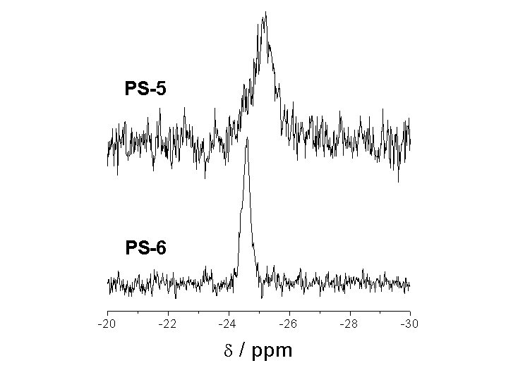
Fig. S1 ²⁹Si NMR spectra of PS-5 and PS-6 in CDCl₃ at 30 ºC.
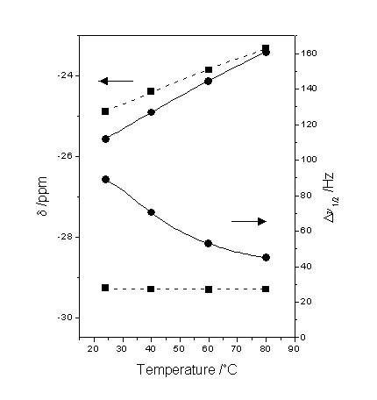
Fig. S2 Variable-temperature ²⁹Si NMR of PS-5(circles, solid line) and PS-6(squares, dash line) in toluene-d₈ (reference: Hexamethyldisilane(-20.5ppm)).

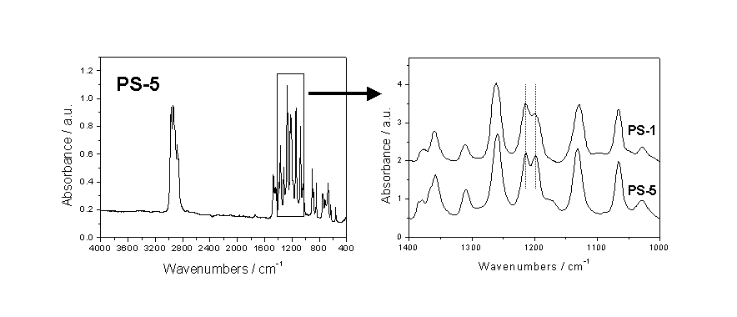
Fig. S3 IR spectra of PS-5 cast from THF solution (with that of PS-1 for comparison).
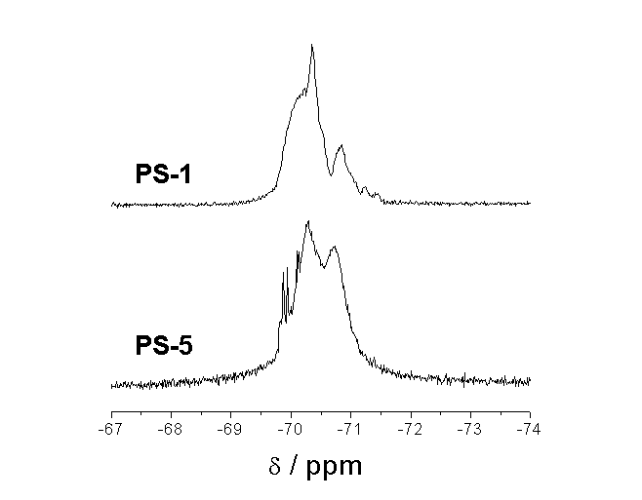

Fig. S4 ¹⁹F NMR spectra of PS-1 and PS-5 in CDCl₃ at 25 ºC, In PS-5, ⁴J_{Si-F} = 34.7 Hz at 69.9 ppm and ⁵J_{Si-F} = 13.9 Hz at 70.1 ppm.

