Supplementary Figures.
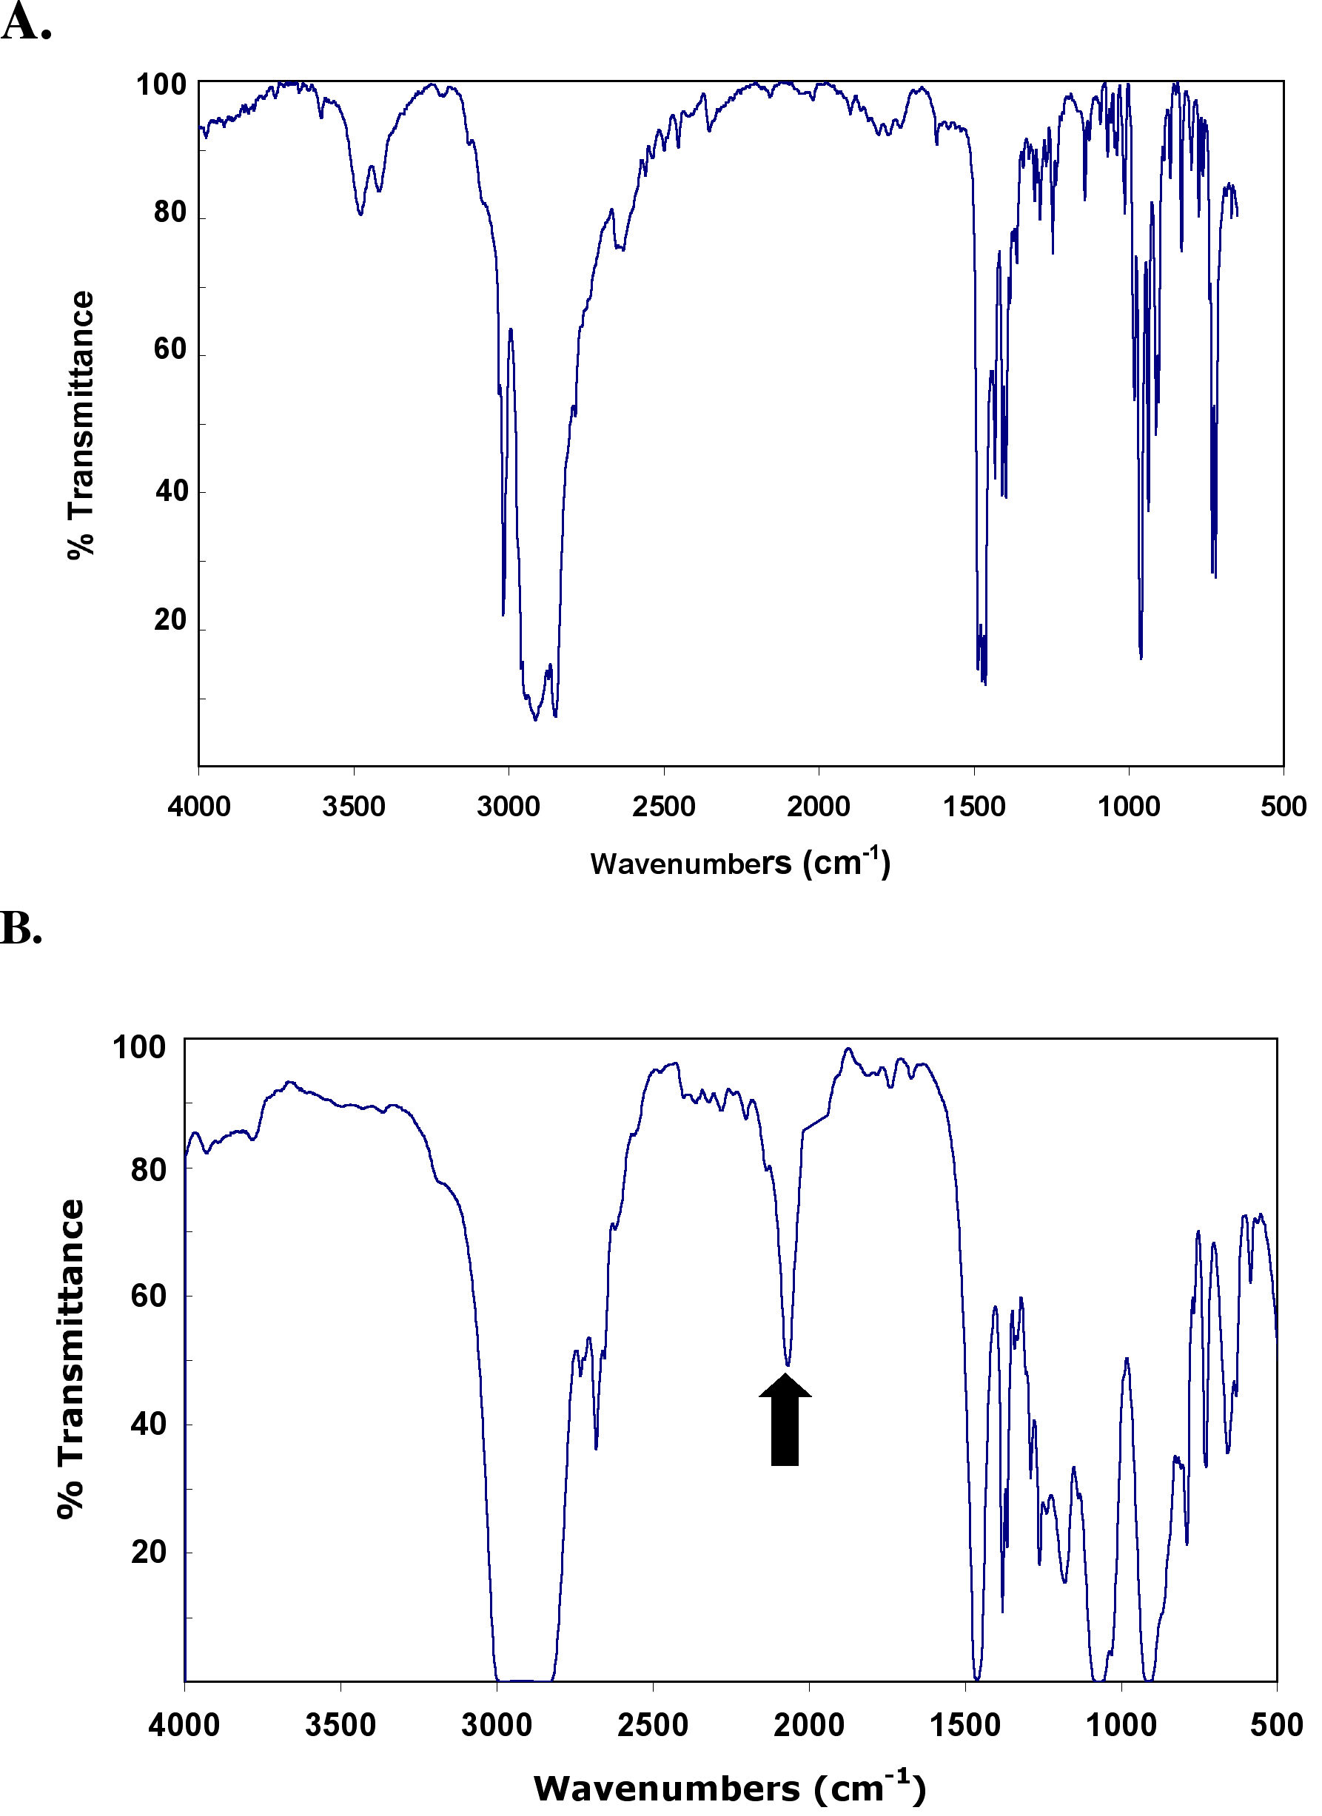
Fig. S1 A. FT-IR spectrum of a thin film of CTAB. B. FT-IR spectrum of a thin film sample of the H-terminated Ge quantum dot reaction intermediate. The arrow indicates a distinctive Ge-H stretch at 2067 cm⁻¹.
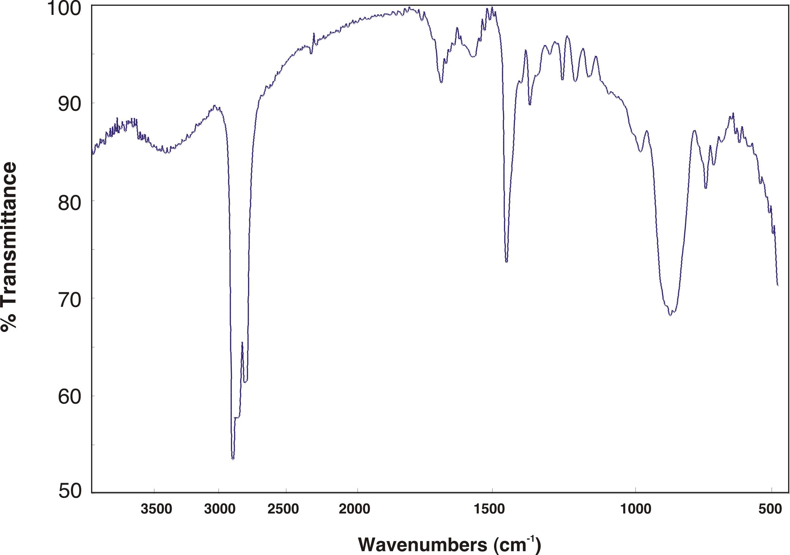
Fig. S2 FT-IR spectrum of a thin film of undecyl functionalized Ge quantum dots.

