A simple route to micropatterned polymer surfaces
Yong Wang, Zhimin Liu*, Buxing Han*, Haixiang Gao, Jianling Zhang, Xun Kuang

Electronic supporting information

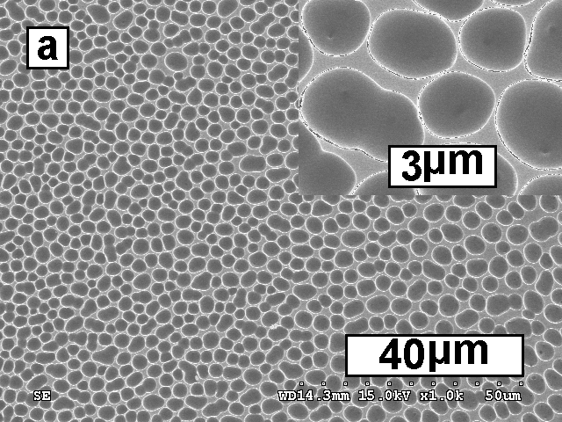

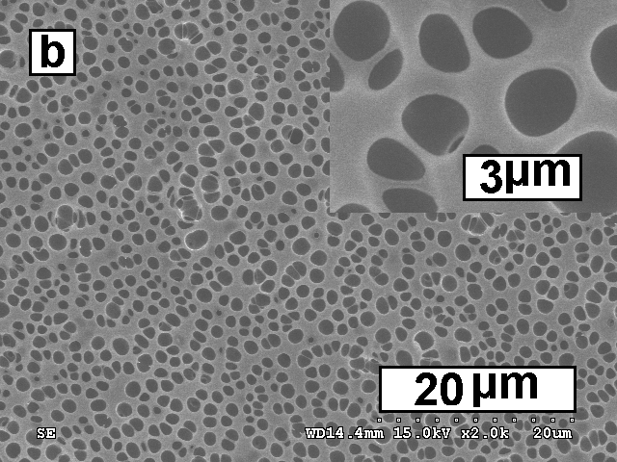
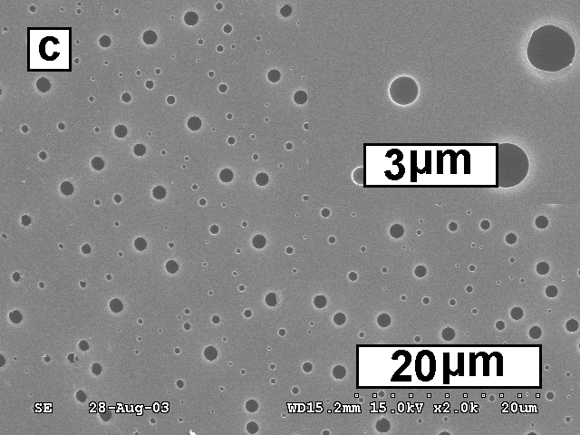
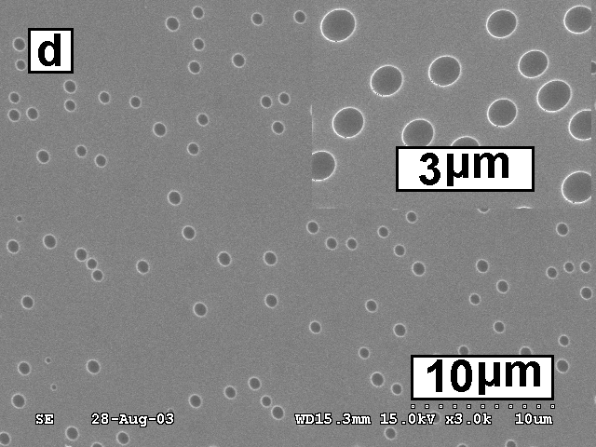

Fig. S1 SEM images of the surface patterns prepared by different polymer-solvent-nonsolvent systems: (a) 10 wt.-% poly(methyl methacrylate)(PMMA)-THF-EG, (b) 1 wt.-% poly (lactic acid)-chloroform-EG, (c) 10 wt.-% PS-THF-glycerol, (d) 10 wt.-% PS-chloroform-EG.

