Electronic Supplementary Information
A Novel Mixed-Valence Complex Containing Co^{II}₂Co^{III}₂ Molecular Squares with 4,5-Imidazoledicarboxylate Bridges

Chuan-Feng Wang, En-Qing Gao, Zheng He and Chun-Hua Yan

Scheme S1. Imidazoledicarboxylic acid (H₃IDC)
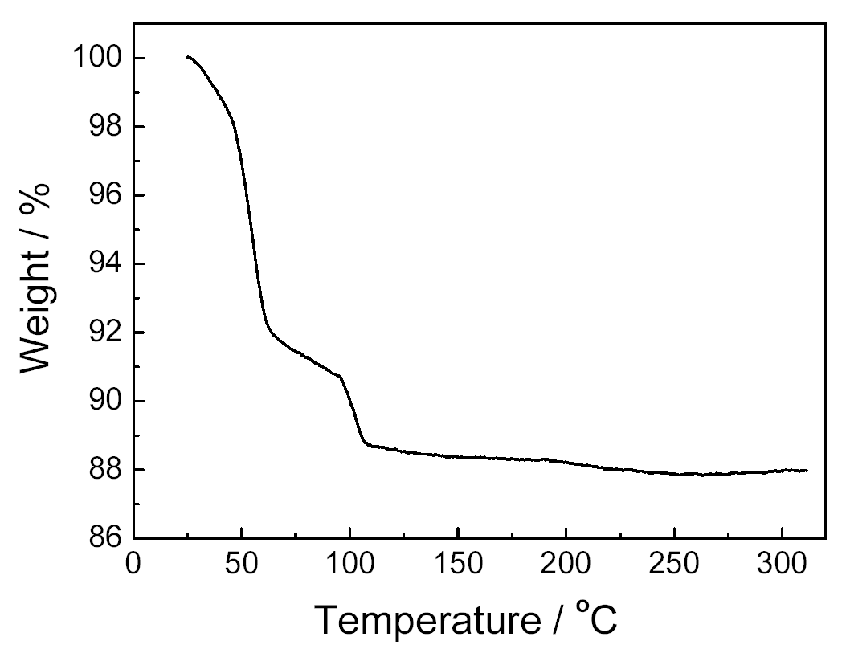
Figure S1. TGA diagram of 1.
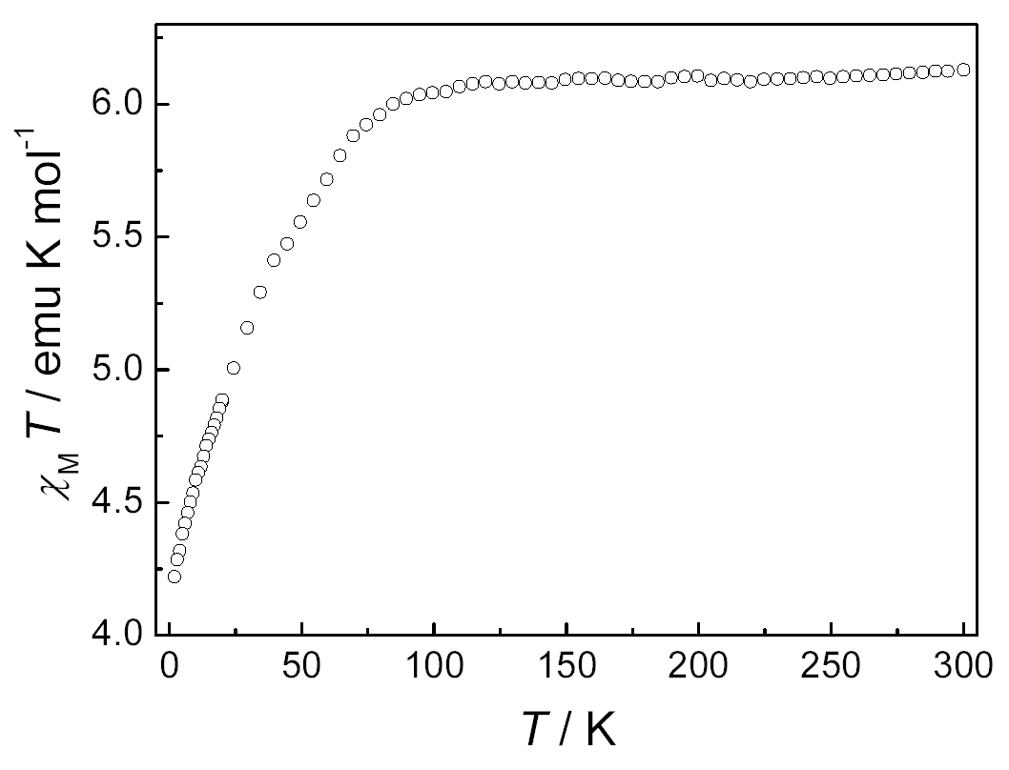
Figure S2. Temperature dependence of the χT product per square(χ is the magnetic susceptibility)

