Destruction of perfluoroalkyl surfactant aggregates by β-cyclodextrin

Gaëlle M. Nicolle and André E. Merbach*

Laboratory of Inorganic and Bioinorganic Chemistry, Swiss Federal Institute of Technology EPFL-BCH, CH-1015 Lausanne, Switzerland.

Supplementary informations

Equation S1. 2  2 exchange matrix D

Figure S1. Temperature dependence of the demicellisation rate (i.e. of the 1:1 inclusion complex formation rate), k, studied by ¹⁹F NMR at 400 MHz on the η fluorines of Y^{III} perfluoroalkyl surfactant.

Table S1. Demicellisation rate, k, obtained from the simulation of the experimental 400 MHz ¹⁹F NMR spectra of Y(III) gadofluorine 8 (for the η ¹⁹F NMR signal) measured at variable temperature with the formalism of Kubo-Sack and a 2 sites exchange matrix and extrapolated half line width of the η ¹⁹F NMR signal in the absence of exchange with β-CD (1/T_{2m}).

Table S2. Dependence of the observed longitudinal relaxation rate, R_{1,obs} versus the concentration of gadofluorine 8 (=) at 25°C and 29 MHz.

Table S3. Water proton relaxivity, r₁ (in mM⁻¹s⁻¹) of Gd(III) gadofluorine 8 in the presence of β-CD as a function of magnetic field and at T = 25 °C.

Table S4. Water proton relaxivity, r₁ (in mM⁻¹s⁻¹) of Gd(III) gadofluorine 8 in the absence of β-CD as a function of magnetic field and at T = 25 °C.

Table S5. Parameters obtained from the fitting of the ¹H NMRD data for gadofluorine 8 in the absence and presence of 1 and 2 equivalents of β-CD.

Table S6. Dependence of the water proton relaxivity, r₁ (in mM⁻¹s⁻¹) of Gd(III) gadofluorine 8 on equivalent of β-CD at 40 MHz and at T = 25 °C.

Equation S1.
The inverse of the mean lifetime of the fluorines η in the micelle, 1/τ = k, was extracted from the ¹⁹F NMR spectra by line shape analysis using the Kubo-Sack formalism with the following 2  2 exchange matrix D (eq 1) [R. Kubo J. Phys. Soc. Jpn 1954, 9, 888.
R. A. Sack Mol. Phys. 1958, 1, 163.]

D =

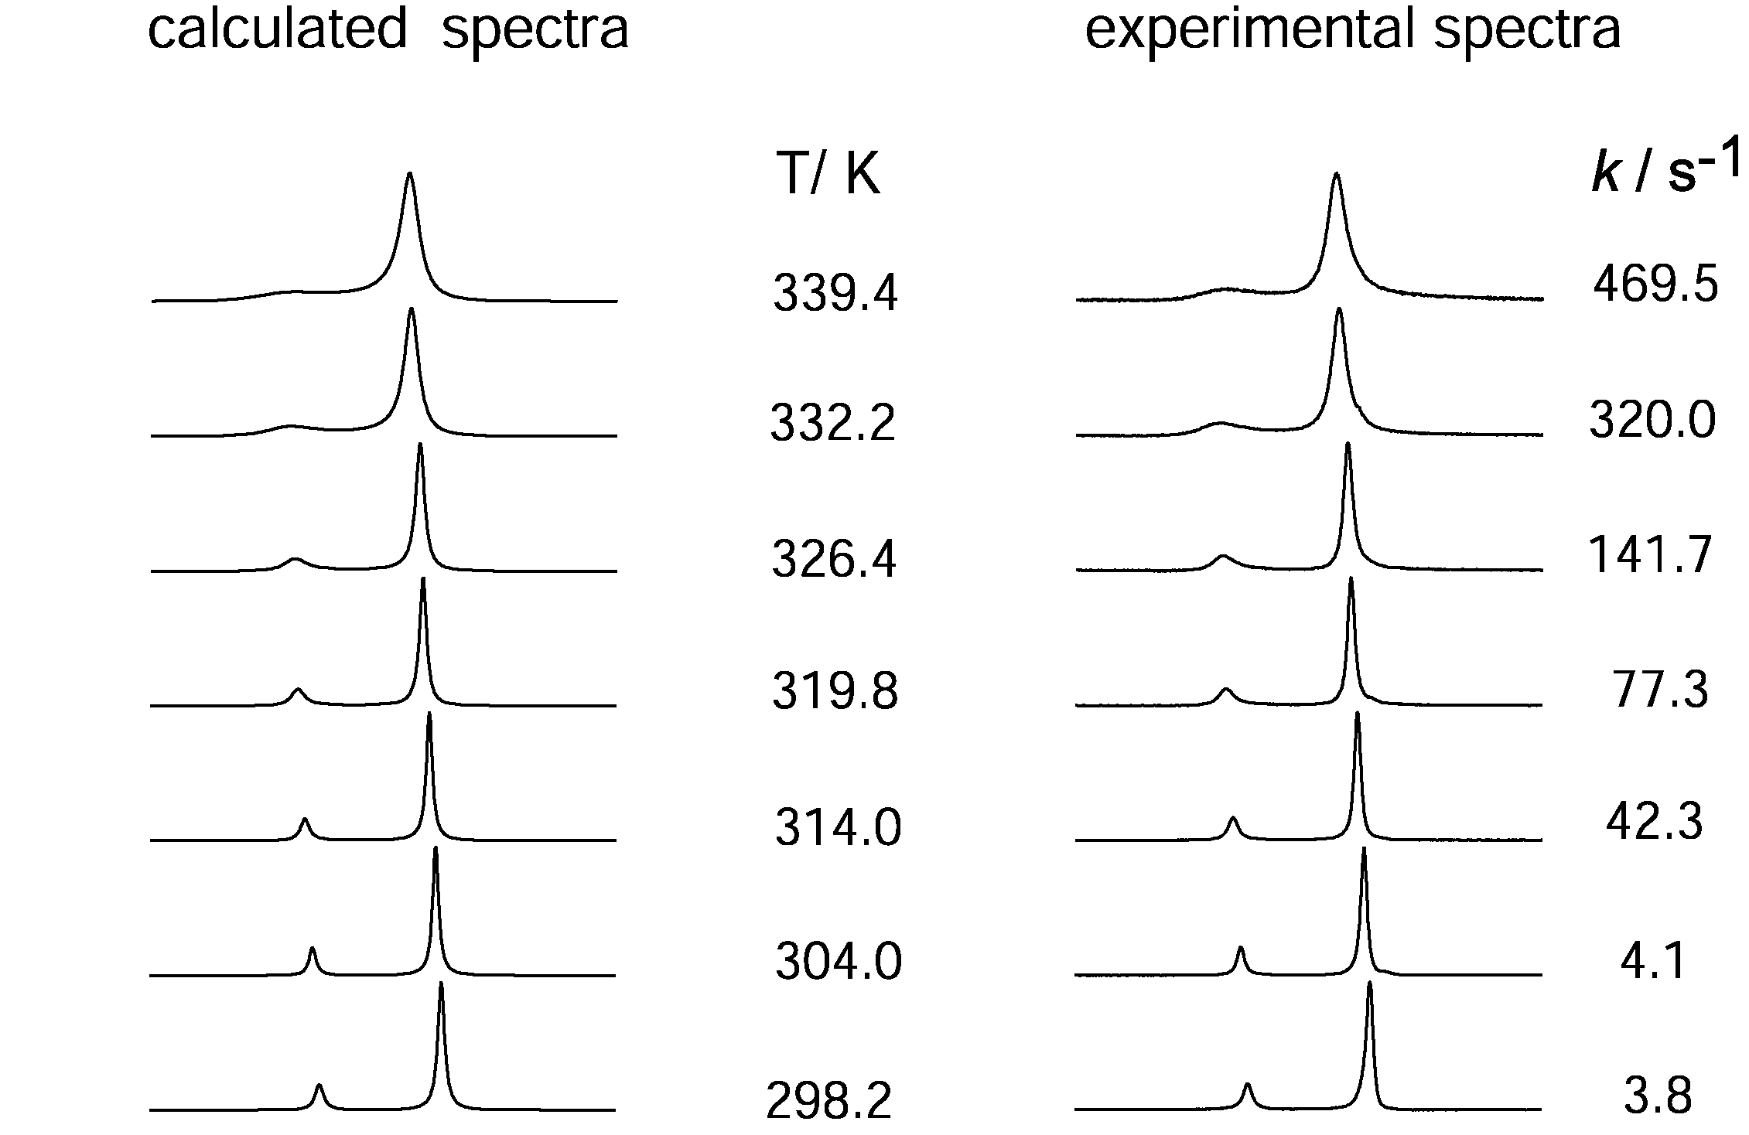
Figure S1. Temperature dependence of the demicellisation rate (i.e. of the 1:1 inclusion complex formation rate), k, studied by ¹⁹F NMR at 400 MHz on the η fluorines of Y^{III} perfluoroalkyl surfactant. C_{β-CD} / C_{Y} = 0.25 ; C_{Y} = 8.38 mM. ΔH‡ = 75 ± 8 kJ mol⁻¹. ΔS‡ = + 26 ± 3 J mol⁻¹ K⁻¹.

Table S1. Demicellisation rate, k, obtained from the simulation of the experimental 400 MHz ¹⁹F NMR spectra of Y(III) gadofluorine 8 (for the η ¹⁹F NMR signal) measured at variable temperature with the formalism of Kubo-Sack and a 2 sites exchange matrix and extrapolated half line width of the η ¹⁹F NMR signal in the absence of exchange with β-CD (1/T_{2m}).

T / °C | k / s⁻¹ | 1/T_{2m} / Hz
25.7 | 3.754 | 182.2
30.8 | 4.05 | 160.2
40.8 | 42.328 | 126.0
46.6 | 77.3 | 110.3
53.2 | 141.7 | 95.4
59 | 320.84 | 84.4
66.2 | 469.5 | 72.9

Table S2. Dependence of the observed longitudinal relaxation rate, R_{1,obs} versus the concentration of gadofluorine 8 (=) at 25°C and 29 MHz.

/ mM | T₁/ms | R_{1,obs}
83.3351 | 0.6 | 1797.2
43.9301 | 1.0 | 984.3
9.3573 | 5.3 | 187.8
4.6997 | 10.6 | 94.6
0.8785 | 66.7 | 15.0
0.0377 | 1200.0 | 0.8
0.1283 | 600.0 | 1.7
0.0033 | 4491.0 | 0.2
0.0033 | 4000.0 | 0.3
0.0033 | 3500.0 | 0.3
0.0009 | 5000.0 | 0.2

Table S3. Water proton relaxivity, r₁ (in mM⁻¹s⁻¹) of Gd(III) gadofluorine 8 in the presence of 1(a) and 2 (b) equivalents of β-CD as a function of magnetic field and at T = 25 °C. (a) = 3.23 mmol dm⁻³; (b) = 2.16 mmol dm⁻³

(a) (b)
¹H ν / MHz | r₁ / mM⁻¹s⁻¹ |  | ¹H ν / MHz | r₁ / mM⁻¹s⁻¹
0.01 | 8.23 |  | 0.01 | 10.49
0.02 | 8.33 |  | 0.02 | 10.69
0.03 | 8.41 |  | 0.03 | 10.38
0.06 | 8.18 |  | 0.05 | 10.57
0.10 | 8.47 |  | 0.09 | 10.22
0.18 | 8.39 |  | 0.15 | 10.18
0.32 | 8.16 |  | 0.26 | 10.25
0.56 | 7.89 |  | 0.45 | 9.85
1.00 | 7.41 |  | 0.79 | 9.87
1.78 | 7.06 |  | 1.36 | 9.32
3.16 | 6.47 |  | 2.34 | 8.92
5.62 | 6.08 |  | 4.03 | 7.72
10.00 | 5.55 |  | 6.95 | 7.10
12.00 | 5.65 |  | 12.00 | 7.31
14.00 | 5.42 |  | 12.00 | 7.34
16.00 | 5.28 |  | 14.00 | 7.33
18.00 | 5.46 |  | 16.00 | 7.06
20.00 | 5.51 |  | 18.00 | 7.31
40.00 | 5.83 |  | 20.00 | 7.51
 |  |  | 40.00 | 7.73

Table S4. Water proton relaxivity, r₁ (in mM⁻¹s⁻¹) of Gd(III) gadofluorine 8 in the absence of β-CD as a function of magnetic field and at T = 25 °C. = 9.49 mmol dm⁻³

¹H ν / MHz | r₁ / mM⁻¹s⁻¹
0.01 | 15.99
0.01 | 16.05
0.02 | 16.02
0.03 | 15.89
0.05 | 15.81
0.07 | 15.62
0.10 | 16.00
0.15 | 16.03
0.22 | 15.91
0.33 | 15.71
0.49 | 15.77
0.72 | 15.23
1.06 | 14.36
1.56 | 13.99
2.30 | 12.83
3.38 | 12.90
5.00 | 13.49
7.00 | 13.75
10.00 | 15.64
10.85 | 17.26
12.00 | 17.40
14.00 | 18.10
16.00 | 18.88
16.00 | 18.95
18.00 | 19.75
20.00 | 20.12
29.00 | 20.54
40.00 | 17.91
60.00 | 14.22
200.00 | 5.48

Table S5. Parameters obtained from the fitting of the ¹H NMRD data for gadofluorine 8 in the absence and presence of 1 and 2 equivalents of β-CD.^{[a]}
Parameters / species | micelles | Inclusion complex
Parameters / species | micelles | 1:1 | 2:1
/ ps | 5000 ± 500 | 140 ± 25 | 250 ± 17
/ ps | 32 ± 2 | 14 ± 3 | 17 ± 2
Δ² / 10²⁰ s⁻² | 0.11 ± 0.01 | 0.8 ± 0.2 | 0.40 ± 0.05
^{[a]}The distances between Gd^{III} and either water protons in the inner sphere or the closest water protons of the outer sphere were respectively fixed at r_{GdH} = 3.1 Å and a_{GdH} = 3.5 Å. The coefficient of diffusion of water, , and the water exchange rate at 298.2 K, , have been fixed to common values i.e. = 23 × 10⁻¹⁰ m² s⁻¹ and = 1.2 ×10⁶ s⁻¹ (k_{ex} has been fixed at a usual value for Gd^{III}-DO3A-monoamide complexes^{[11]}).

Table S6. Dependence of the water proton relaxivity, r₁ (in mM⁻¹s⁻¹) of Gd(III) gadofluorine 8 on equivalent of β-CD at 40 MHz and at T = 25 °C obtained by mixing a solution of micellar R_{F} surfactant ( = 6.75 mmol dm⁻³) and a solution of β-CD ( = 7.47 mmol dm⁻³)

C_{β-CD} / C_{Gd} | R_{1p} / C_{Gd} = r₁ (mM⁻¹s⁻¹)
0.0 | 17.06
0.2 | 15.10
0.3 | 13.39
0.5 | 11.84
0.7 | 9.86
0.8 | 8.97
0.9 | 8.18
1.0 | 7.02
1.2 | 7.21
1.4 | 7.43
1.6 | 7.58
1.8 | 7.75
2.0 | 7.73
2.1 | 7.72
2.8 | 7.77
4.0 | 7.84

