Selective Deposition of Polystyrene Nano-particles in the Nanoetchpit-Array on a Silicon Substrate

Manabu Tanaka,ª Takumi Hosaka,^{b} Takashi Tanii,^{b} Iwao Ohdomari^{b} and Hiroyuki Nishide*ª
ª Department of Applied Chemistry, Waseda University, Tokyo 169-8555, Japan.
Fax: +81 3-3209-5522; Tel: +81 3200-2669; E-mail: nishide@waseda.jp
^{b} Department of Electrical Engineering and Bioscience, Waseda University, Tokyo 169-8555, Japan.

Example of selective deposition of the polystyrene particles with smaller diameters

Selective deposition of polystyrene particles with a smaller diameter such as 80 nm on the NEPA substrate was also achieved. Atomic force microscopy (AFM) was applied to the observation for such particles with the small diameters. The AFM image shows the selective deposition of the polystyrene nano-particles with the diameter of 80±10 nm in the etchpit (diameter = 100±10 nm).
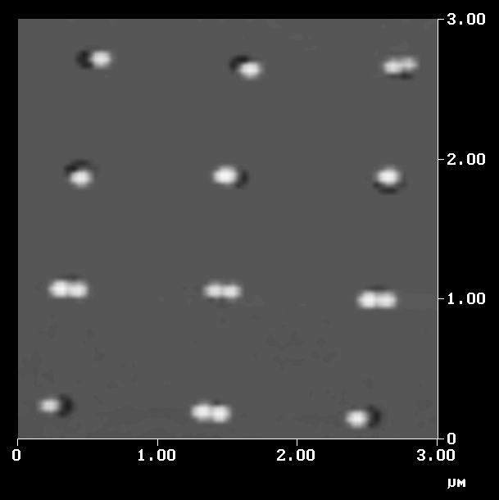

Fig. AFM Image of the polystyrene nano-particles (diameter = 80±10 nm) in the etchpits (diameter = 100±10 nm) on the NEPA substrate.

