Electronic Supplementary Information
for
Exploration of the pentacyano-cyclo-pentadienide ion, C₅(CN)₅⁻, as a weakly coordinating anion and potential superacid conjugate base. Silylation and protonation
Christopher Richardson and Christopher A. Reed

(74 pages)
Table of Contents
Pg 4 General Information
Pg 5 Experimental procedure for tetracyano-1,4-dithiin.
Pg 5 NMR Data on NEt₄[C₅CN₅]
Pg 6 Experimental procedures for Ag[C₅CN₅].
Pg 7 Experimental procedure for Ph₃C[C₅CN₅].
Pg 7 Experimental procedure for Et₃Si[C₅CN₅].
Pg 8 Experimental procedure for ^{i}Pr₃Si[C₅CN₅].
Pg 8 Experimental procedure for H[C₅CN₅].
Pg 9 Infrared spectrum of tetracyano-1,4-dithiin.
Pg 10 Infrared spectrum of HNMe₃[C₅CN₅] as a KBr pellet.
Pg 11 Infrared spectrum of Et₄[C₅CN₅] as a KBr pellet.
Pg 12 ¹H NMR spectrum of NEt₄[C₅CN₅] in acetone-d₆
Pg 13 ¹³C NMR spectrum of NEt₄[C₅CN₅] in acetone-d₆.
Pg 14 ¹H NMR spectrum of NEt₄[C₅CN₅] in acetonitrile-d₃.
Pg 15 ¹³C NMR spectrum of NEt₄[C₅CN₅] in acetonitrile-d₃.
Pg 16 Infrared spectrum of Ag[C₅CN₅] as a KBr pellet.
Pg 17 ¹³C NMR spectrum of Ag[C₅CN₅] in acetonitrile-d₃.
Pg 18 Infrared spectrum of Ph₃C[C₅CN₅] as a KBr pellet.
Pg 19 ¹H NMR spectrum of Ph₃C[C₅CN₅] in acetonitrile-d₃
Pg 20 ¹³C NMR spectrum of Ph₃C[C₅CN₅] in acetonitrile-d₃
Pg 21 Infrared spectrum of Et₃Si[C₅CN₅] as a KBr pellet
Pg 22 ¹H NMR spectrum of Et₃Si[C₅CN₅] in toluene-d₈
Pg 23 ¹³C NMR spectrum of Et₃Si[C₅CN₅] in toluene-d₈
Pg 24 ²⁹Si-¹H NMR spectrum of Et₃Si[C₅CN₅] in benzene-d₆
Pg 25 Infrared spectrum of ^{i}Pr₃Si[C₅CN₅] as a KBr pellet
Pg 26 ¹H NMR spectrum of ^{i}Pr₃Si[C₅CN₅] in toluene-d₈
Pg 27 ¹³C NMR spectrum of ^{i}Pr₃Si [C₅CN₅] in toluene-d₈
Pg 28 ²⁹Si-¹H NMR spectrum of ^{i}Pr ₃Si[C₅CN₅] in toluene-d₈
Pg 29 X-ray data for [Ph₃C][C₅(CN)₅]
Pg 45 X-ray data for Et₃Si(C₅(CN)₅))
Pg 59 X-ray data for i-Pr₃Si(C₅(CN)₅))
General Information
¹H and ¹³C NMR solution spectra were recorded on a Varian Inova 300 spectrometer. ²⁹Si NMR solution spectra were recorded on a Varian Inova 500 spectrometer. NMR spectra recorded in acetonitrile-d₃ are referenced to 2.00 ppm and 117.7 ppm for ¹H and ¹³C, respectively. NMR spectra recorded in acetone-d₆ are referenced to 2.2 ppm and 30.2 ppm for ¹H and ¹³C, respectively. NMR spectra recorded in toluene-d₈ are referenced relative to TMS in benzene-d₆ (internal capillary) at 0 ppm for ¹H, ¹³C, and ²⁹Si.
IR spectra were recorded as KBr pellets using a Shimadzu-8300 FT-IR spectrometer between 4000-400 cm⁻¹ with 32 scans and 2 cm⁻¹ resolution inside a nitrogen filled glovebox.
Metathesis reactions to produce Ph₃C[C₅CN₅], Et₃Si[C₅CN₅], ^{i}Pr₃Si[C₅CN₅] and H[C₅CN₅] were conducted in an inert atmosphere glovebox [H₂O, O₂ < 1 ppm].
NEt₄[C₅CN₅] was prepared as described by Simmons. HNMe₃[C₅CN₅] was prepared by addition of HNMe₃Cl after acidification and filtration of the aqueous reaction mixture from the reaction described by Simmons. Solvents were dried according to standard practices.[Perrin, D. D.; Armarego, W. L. F.; Perrin, D. R. Purification of Laboratory Chemicals; 2nd ed.; Pergamon Press Ltd.: Sydney, 1980.]

Tetracyano-1,4-dithiin
CS₂ (76.1 g, 1 mol) was added drop wise with vigorous magnetic stirring to finely ground NaCN (49.0 g, 1 mol) in dry DMF (300 ml) over the course of one hour. Stirring was continued until crystallization occurred. The solid was then washed into a 4 L beaker with water and the volume adjusted up to 2.5 L and left overnight. In the morning the yellow solution was decanted away from the deposited crystalline sulfur into a large conical flask. Ammonium persulfate (228.0 g, 1 mol) was dissolved in water (500 ml) and added to the stirred yellow solution drop wise over the course of one hour. The mixture was allowed to stir for 10 minutes after the end of the addition before collecting the solid formed by filtration. The tan solid was washed with water and thoroughly dried before extraction with CS₂ using a large Soxlet apparatus. The weight of material prepared this way is 45-50 g (80-90%) and usually contains around 5% by weight of sulfur. Recrystallization from toluene or dichloroethylene with a hot filtration gave a product with identical properties as that described by Simmons et al. (Simmons, H. E.; Vest, R. D.; Blomstrom, D. C.; Roland, J. R.; Cairns, T. L. J. Am. Chem. Soc., 1962, 84, 4746).

NMR Data on NEt₄[C₅CN₅]
¹H NMR (acetone-d₆) δ: 1.55, (t 12H [J_{HH} 7.2 Hz]); 3.64, (q 8H [J_{HH} 7.7 Hz]); ¹³C NMR (acetone-d₆) δ: 8.03, 53.37, 103.33, 114.19. ¹H NMR (acetonitrile-d₃) δ: 1.32, (t 12H [J_{HH} 7.2 Hz]); 3.27, (q 8H [J_{HH} 7.7 Hz]). ¹³C NMR (acetonitrile-d₃) δ: 7.10, 52.51, 102.59, 113.61.

Experimental procedures to Ag[C₅CN₅]
Ag[C₅CN₅] from NEt₄[C₅CN₅]
AgNO₃ (15 g, 88 mmol) dissolved in water (50 ml) was added drop wise to NEt₄[C₁₀N₅] (9 g, 28 mmol) dissolved in acetone (250 ml). The mixture was stirred for three days while being protected from light by aluminum foil. The tan solid which formed was collected by filtration using filter paper and washed with water and acetone (8.1 g, 95 %).

Ag[C₅CN₅] from HNMe₃[C₅CN₅]
A 500 ml round bottomed flask was charged with HNMe₃[C₅CN₅] (5.0 g, 20 mmol) and Na₂CO₃ (2.15 g, 21 mmol). Water (250 ml) is added and the round bottomed flask was connected to a rotary evaporator and a few milliliters of solution removed under reduced pressure. The contents of the flask are filtered through a fine frit and the filtrate treated with AgNO₃ (4.1 g, 24 mmol) dissolved in water (10 ml). The precipitate which formed was filtered immediately onto filter paper and washed with water and acetone (5.8 g, 97 %).
Purification of Ag[C₅CN₅]
Crude Ag[C₅CN₅] is dissolved in acetonitrile and filtered through Celite. The solution is concentrated by rotary evaporation and the product precipitated out by addition of diethyl ether. Recrystallization is achieved by suspending the silver salt in hot toluene [10 ml per 0.1 g] and adding acetonitrile until a solution is obtained. Upon cooling and acetonitrile evaporation colourless crystals of Ag[C₅CN₅].1/2CH₃CN are formed. ¹³C NMR (acetonitrile-d₃) δ: 102.54, 113.54. Anal.: Calcd for Ag[C₅CN₅]0.5CH₃CN: C, 41.48; H, 0.47; N, 24.18. Found: C, 41.36; H, 0.44; N, 24.24. After drying to a constant weight under vacuum the following analysis figures were obtained. Calcd for Ag[C₅CN₅]: C, 40.30; H, 0.0; N, 23.50. Found: C, 40.21; H, 0.10; N, 23.70.

Experimental procedure to Ph₃C[C₁₀N₅]
Triphenylmethyl bromide (2.20 g, 6.81 mmol) dissolved in dry toluene (15 ml) was added to Ag[C₁₀N₅] (2.03 g, 6.81 mmol) dissolved in dry acetonitrile (30 ml) and stirred for two hours. The stirring was stopped and the solution was left to settle before the precipitated AgCl was removed by filtration through treated Celite. The solvents were then removed in vacuo until a solid was in solution (approx. 10 ml left). The mixture was heated to near reflux and then acetonitrile was added drop wise until a solution was obtained. Upon cooling beautiful, large, orange crystals were formed and collected by filtration (2.31 g, 78%). ¹H NMR (acetonitrile-d₃) δ: 7.82, (d 6H [J_{HH} 8.7 Hz]); 7.99, (t 6H [J_{HH} 8.2 Hz]); 8.39, (t 3H [J_{HH} 7.7 Hz]). ¹³C NMR (acetonitrile-d₃) δ: 102.59, 113.59, 130.54, 140.62, 143.49, 143.54, 212.38. Anal.: Calcd for Ph₃C[C₅CN₅]: C, 80.36; H, 3.49; N, 16.16. Found: C, 80.26; H, 3.33; N, 16.38.

Experimental procedure to Et₃Si[C₅CN₅]
Triethylsilane (188.5 µl, 1.18 mmol) was added to Ph₃C[C₅CN₅] (458.2 mg, 1.06 mmol) suspended in dry toluene (10 ml) and the mixture stirred for 0.5 hours. The stirring was stopped and the clear, near-colorless solution was pipetted into a small vial. After cooling the vial to -35º C overnight the fine needles produced were recovered by filtration and washed with a small amount of dry benzene (271.0 mg, 84%). ¹H NMR (toluene-d₈) δ: 0.33, q, 6H, J_{HH} 8.2 Hz; 0.72, t, 9H, J_{HH} 8.0 Hz. ¹³C NMR (toluene-d₈) δ: 3.63, 5.90. ²⁹Si NMR (toluene-d₈) δ: 34.8. Anal.: Calcd for Et₃Si[C₅CN₅]: C, 62.93; H, 4.95; N, 22.95. Found: C, 62.72; H, 4.97; N, 23.28.

Experimental procedure to ^{i}Pr₃Si[C₅CN₅]
Triisopropylsilane (710.0 µl, 3.45 mmol) was added to Ph₃C[C₅CN₅] (998.3 mg, 2.30 mmol) suspended in dry toluene (20 ml) and the mixture stirred overnight. The solution was reduced in volume under reduced pressure until a solid appeared around the sides of the flask (approx. 10 ml left). Gentle heating re-dissolved the solid and after cooling the flask to -35º C overnight the solid produced was recovered by filtration and washed sparingly with dry hexane (580.4 mg, 73%). This material can be recrystallized by vapor diffusion of hexane into a concentrated toluene solution giving colorless blocks. ¹H NMR (toluene-d₈) δ 0.89, (m 18H); 1.12, (m 3H). ¹³C NMR (toluene-d₈) δ 11.25, 16.93. ²⁹Si NMR (toluene-d₈) δ . Anal.: Calcd for ^{i}Pr₃Si[C₅CN₅]: C, 65.67; H, 6.09; N, 20.15. Found: C, 65.47; H, 5.97; N, 20.17.

Experimental procedure to H[C₁₀N₅]
Triflic acid (51.5 µl, 0.53 mmol) was added via micro pipette to a vigorously stirred solution of ^{i}Pr₃Si[C₅CN₅] (183.9 mg, 0.53 mmol) dissolved in dry toluene (10 ml). Immediately a dark solid precipitated from solution. This was collected by filtration and washed with dry toluene (4 x 1 ml) before being dried under high vacuum (100.0 mg, 99 %). Anal.: No satisfactory analysis was obtained for this compound due to its very sensitive nature.
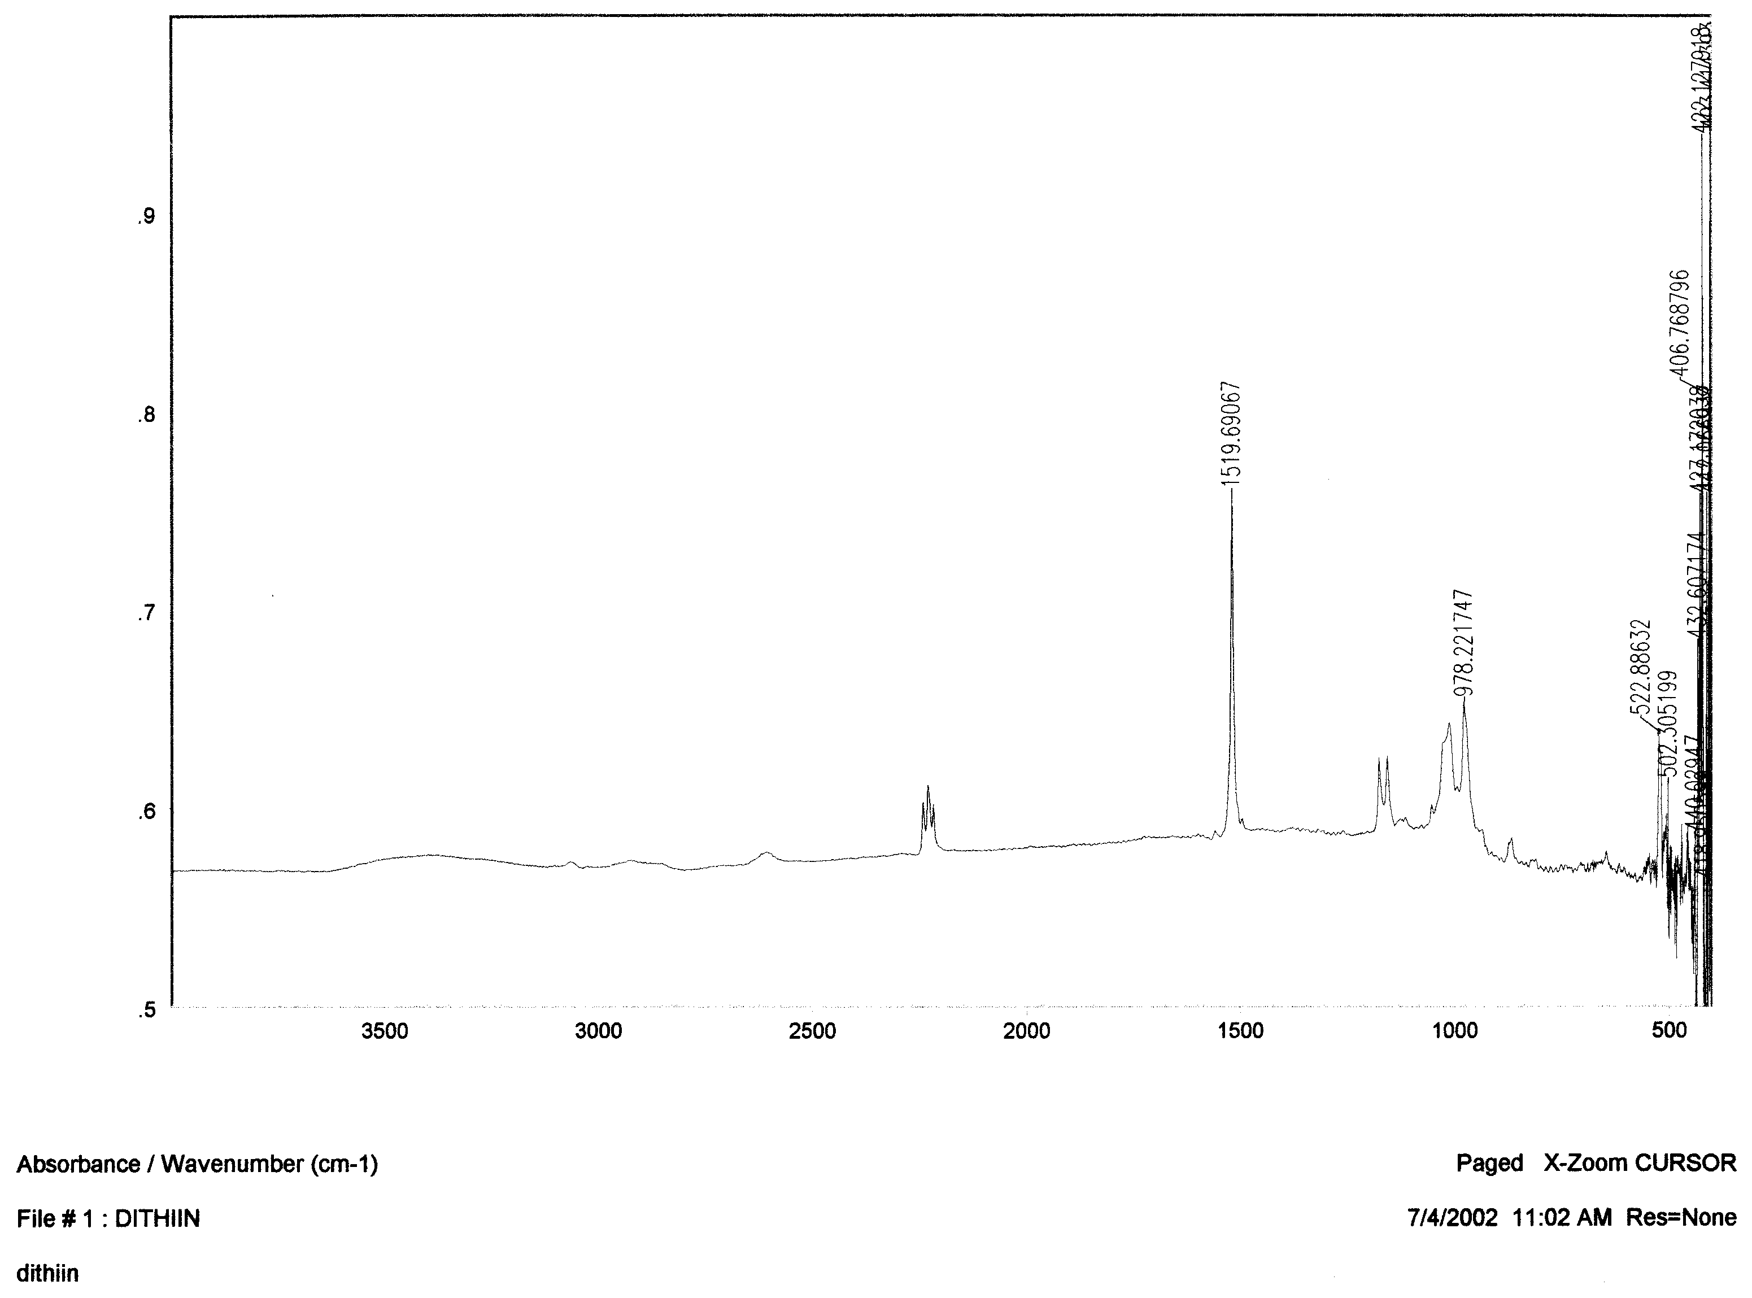
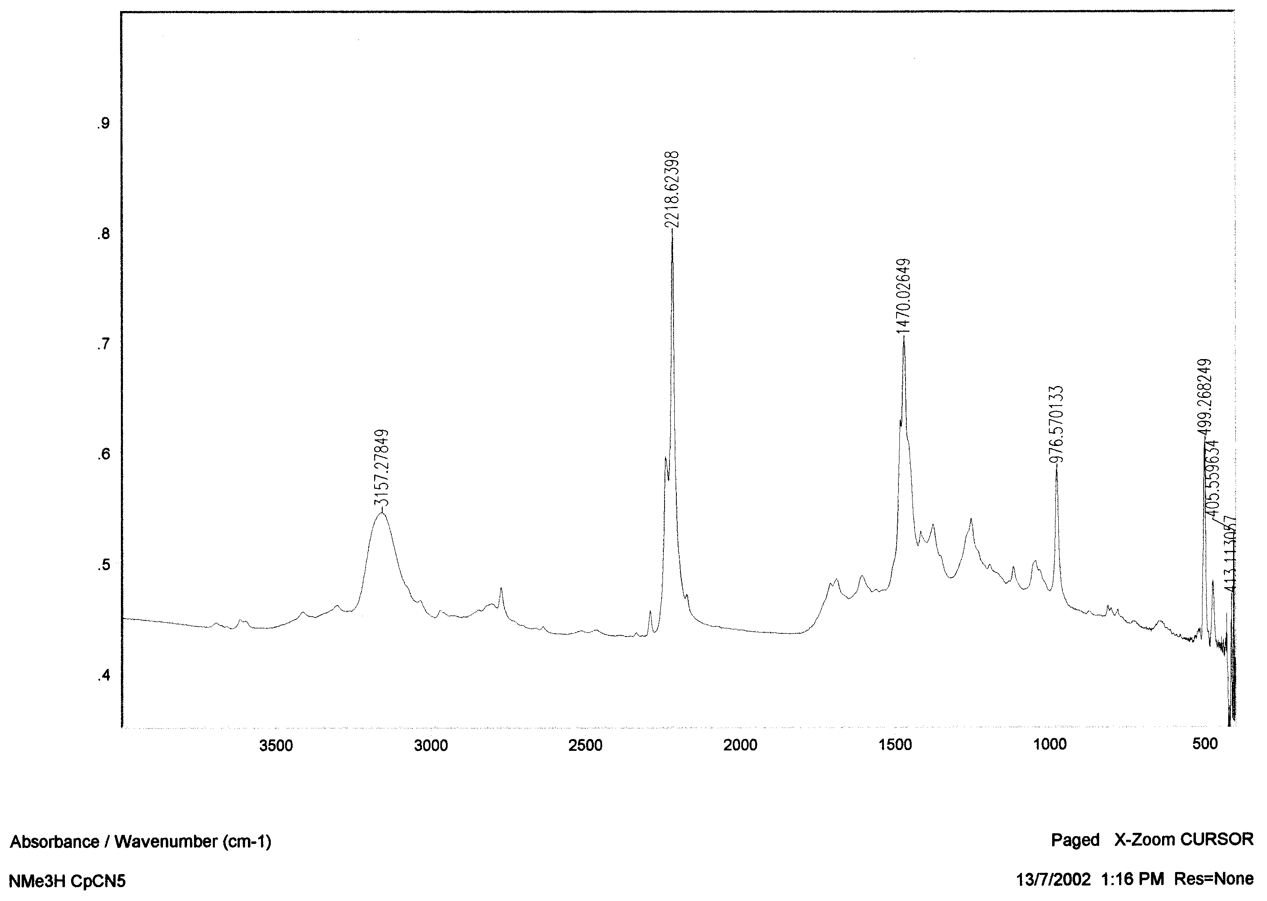
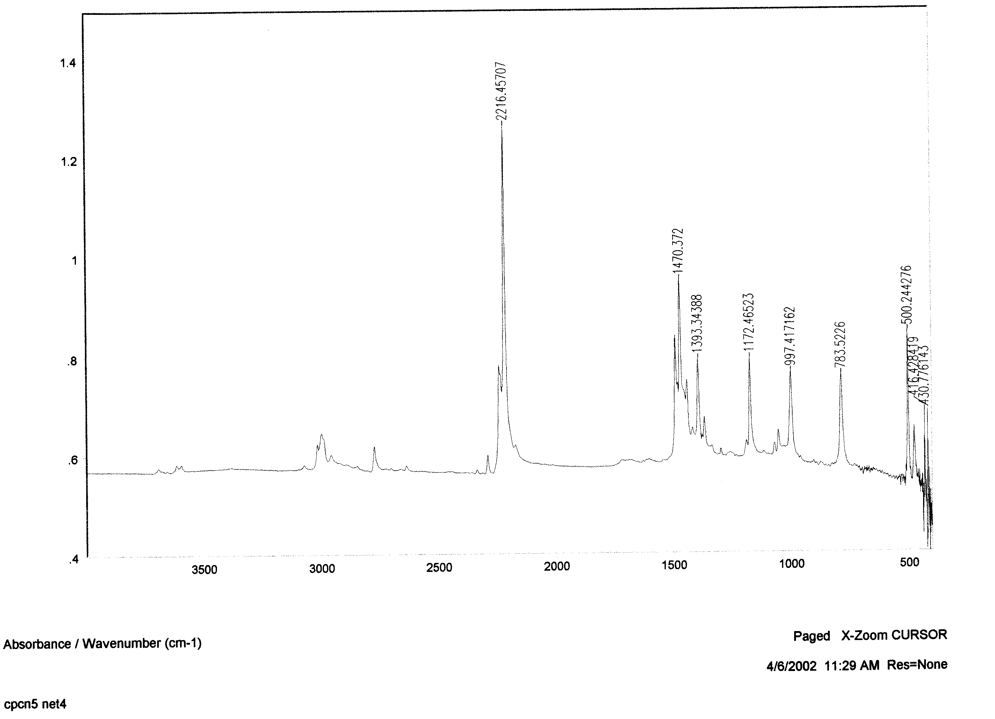

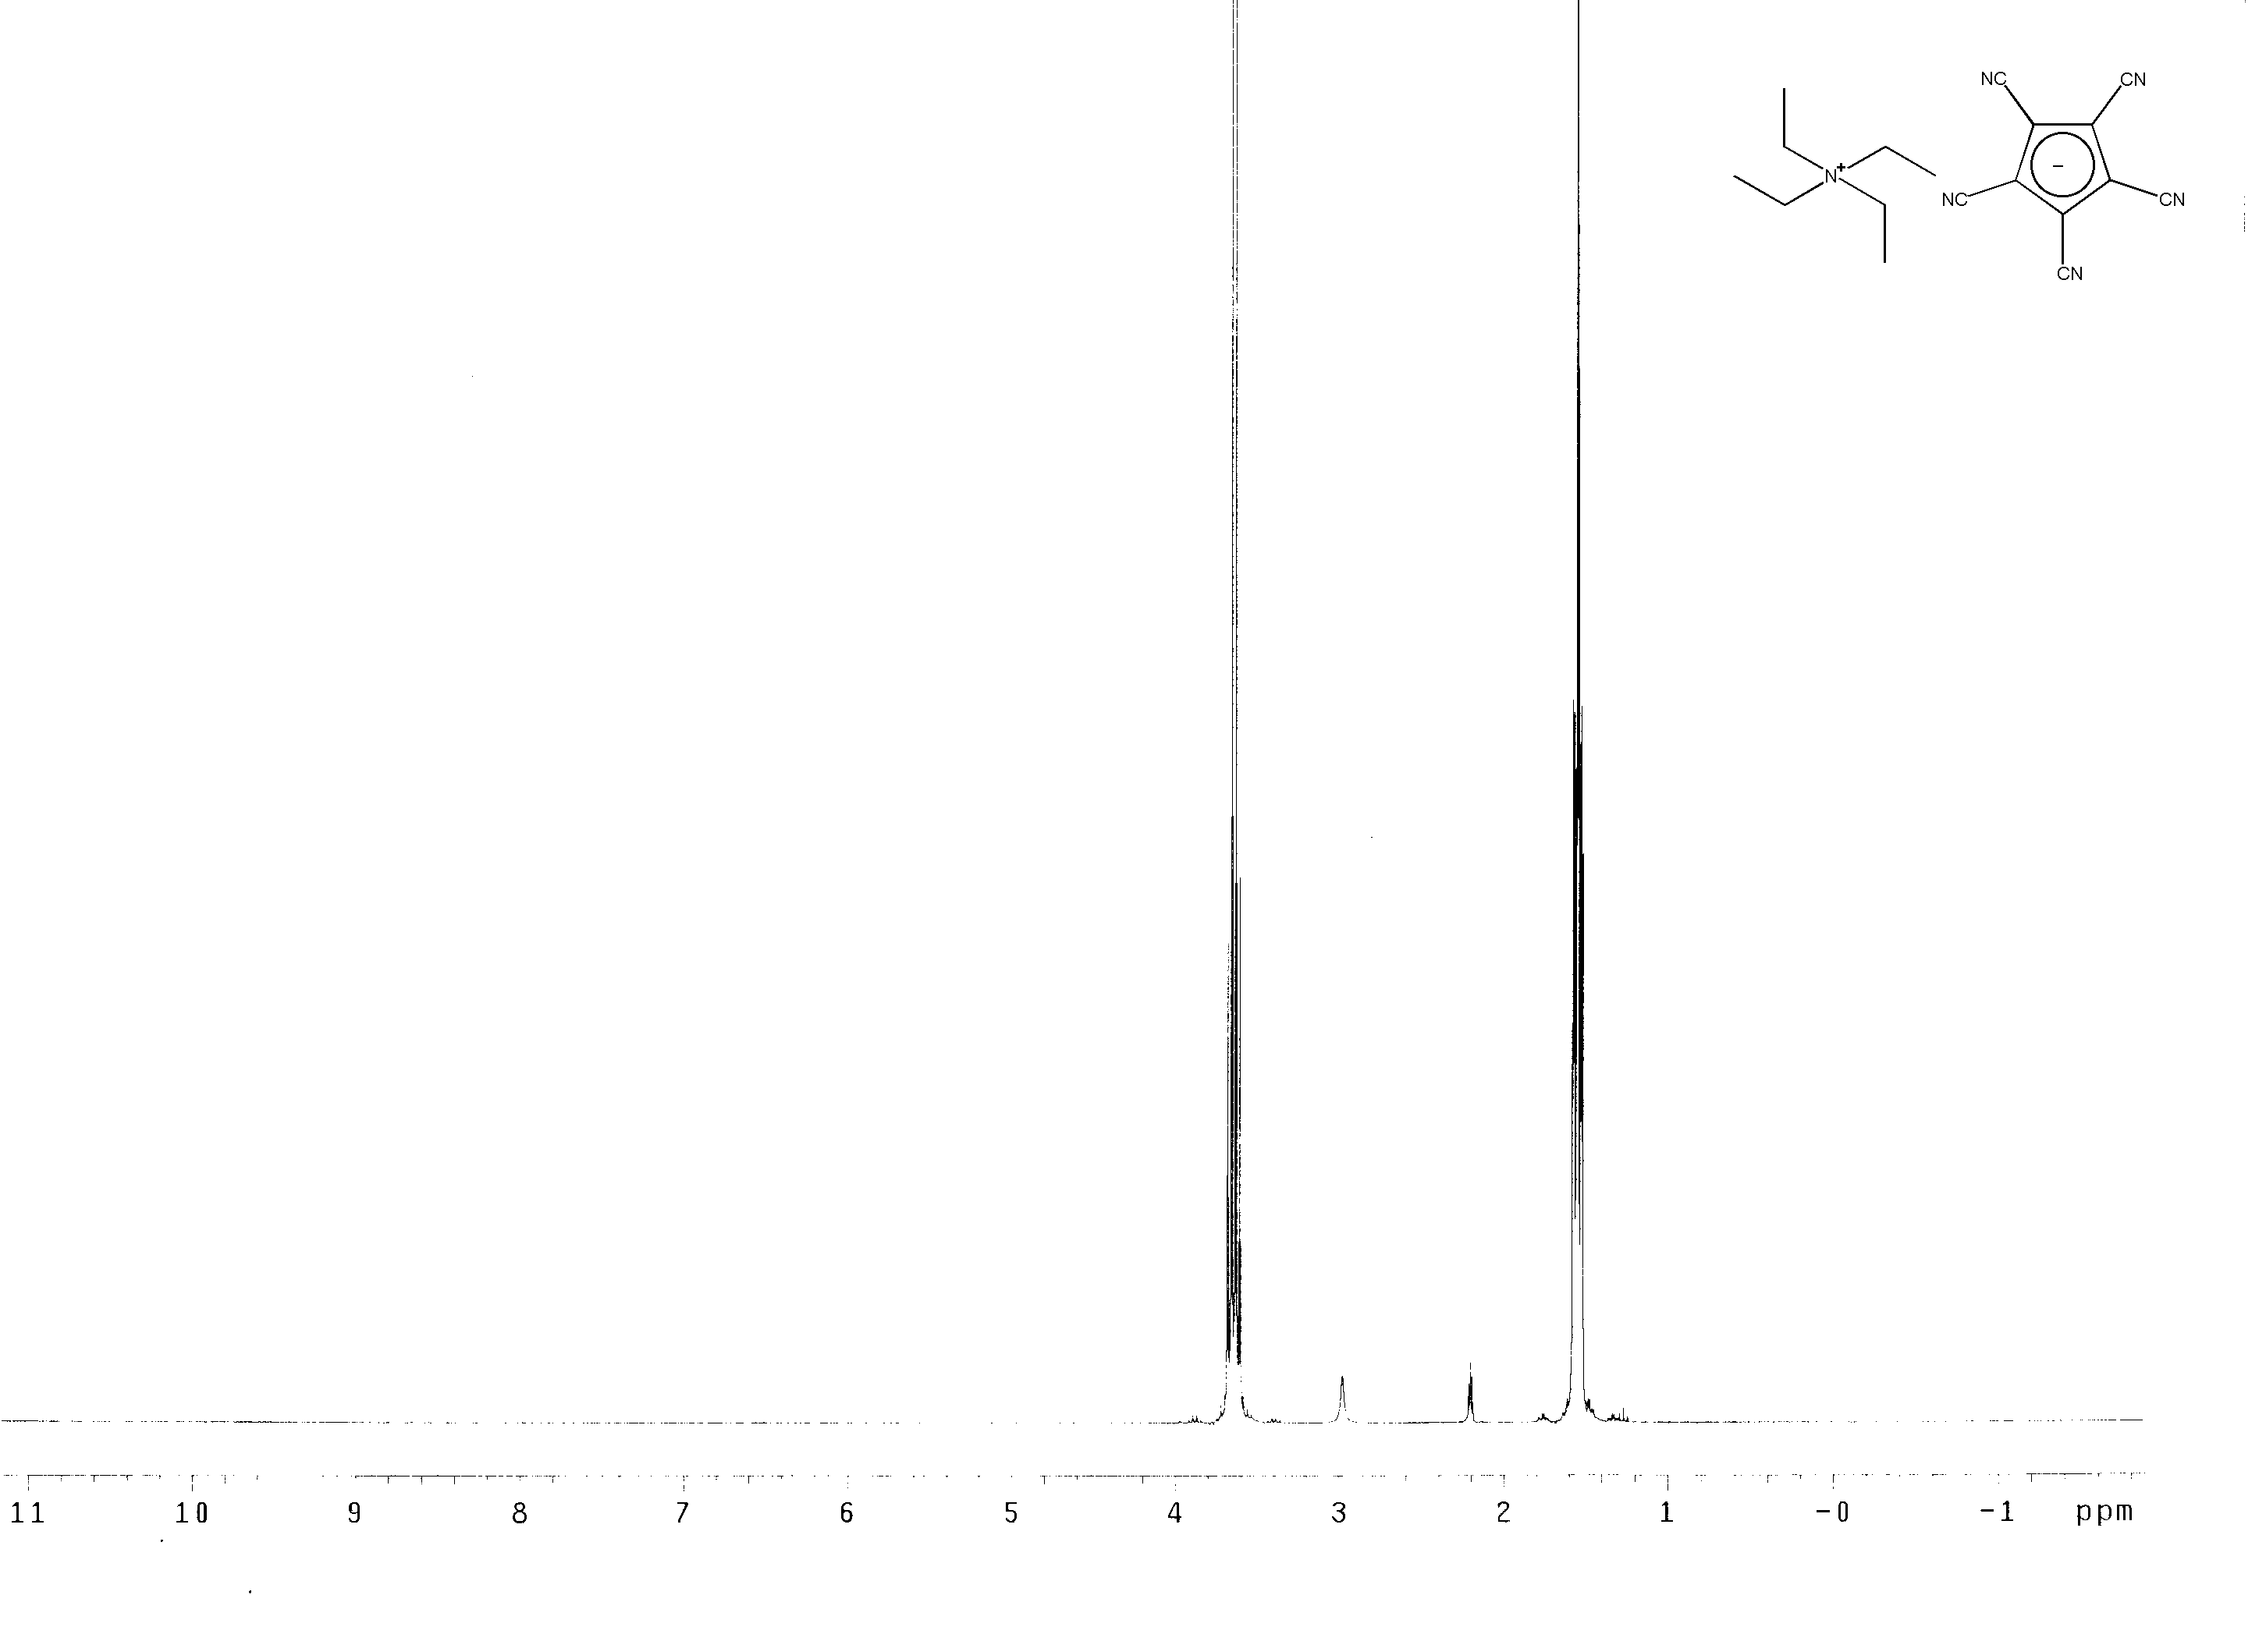
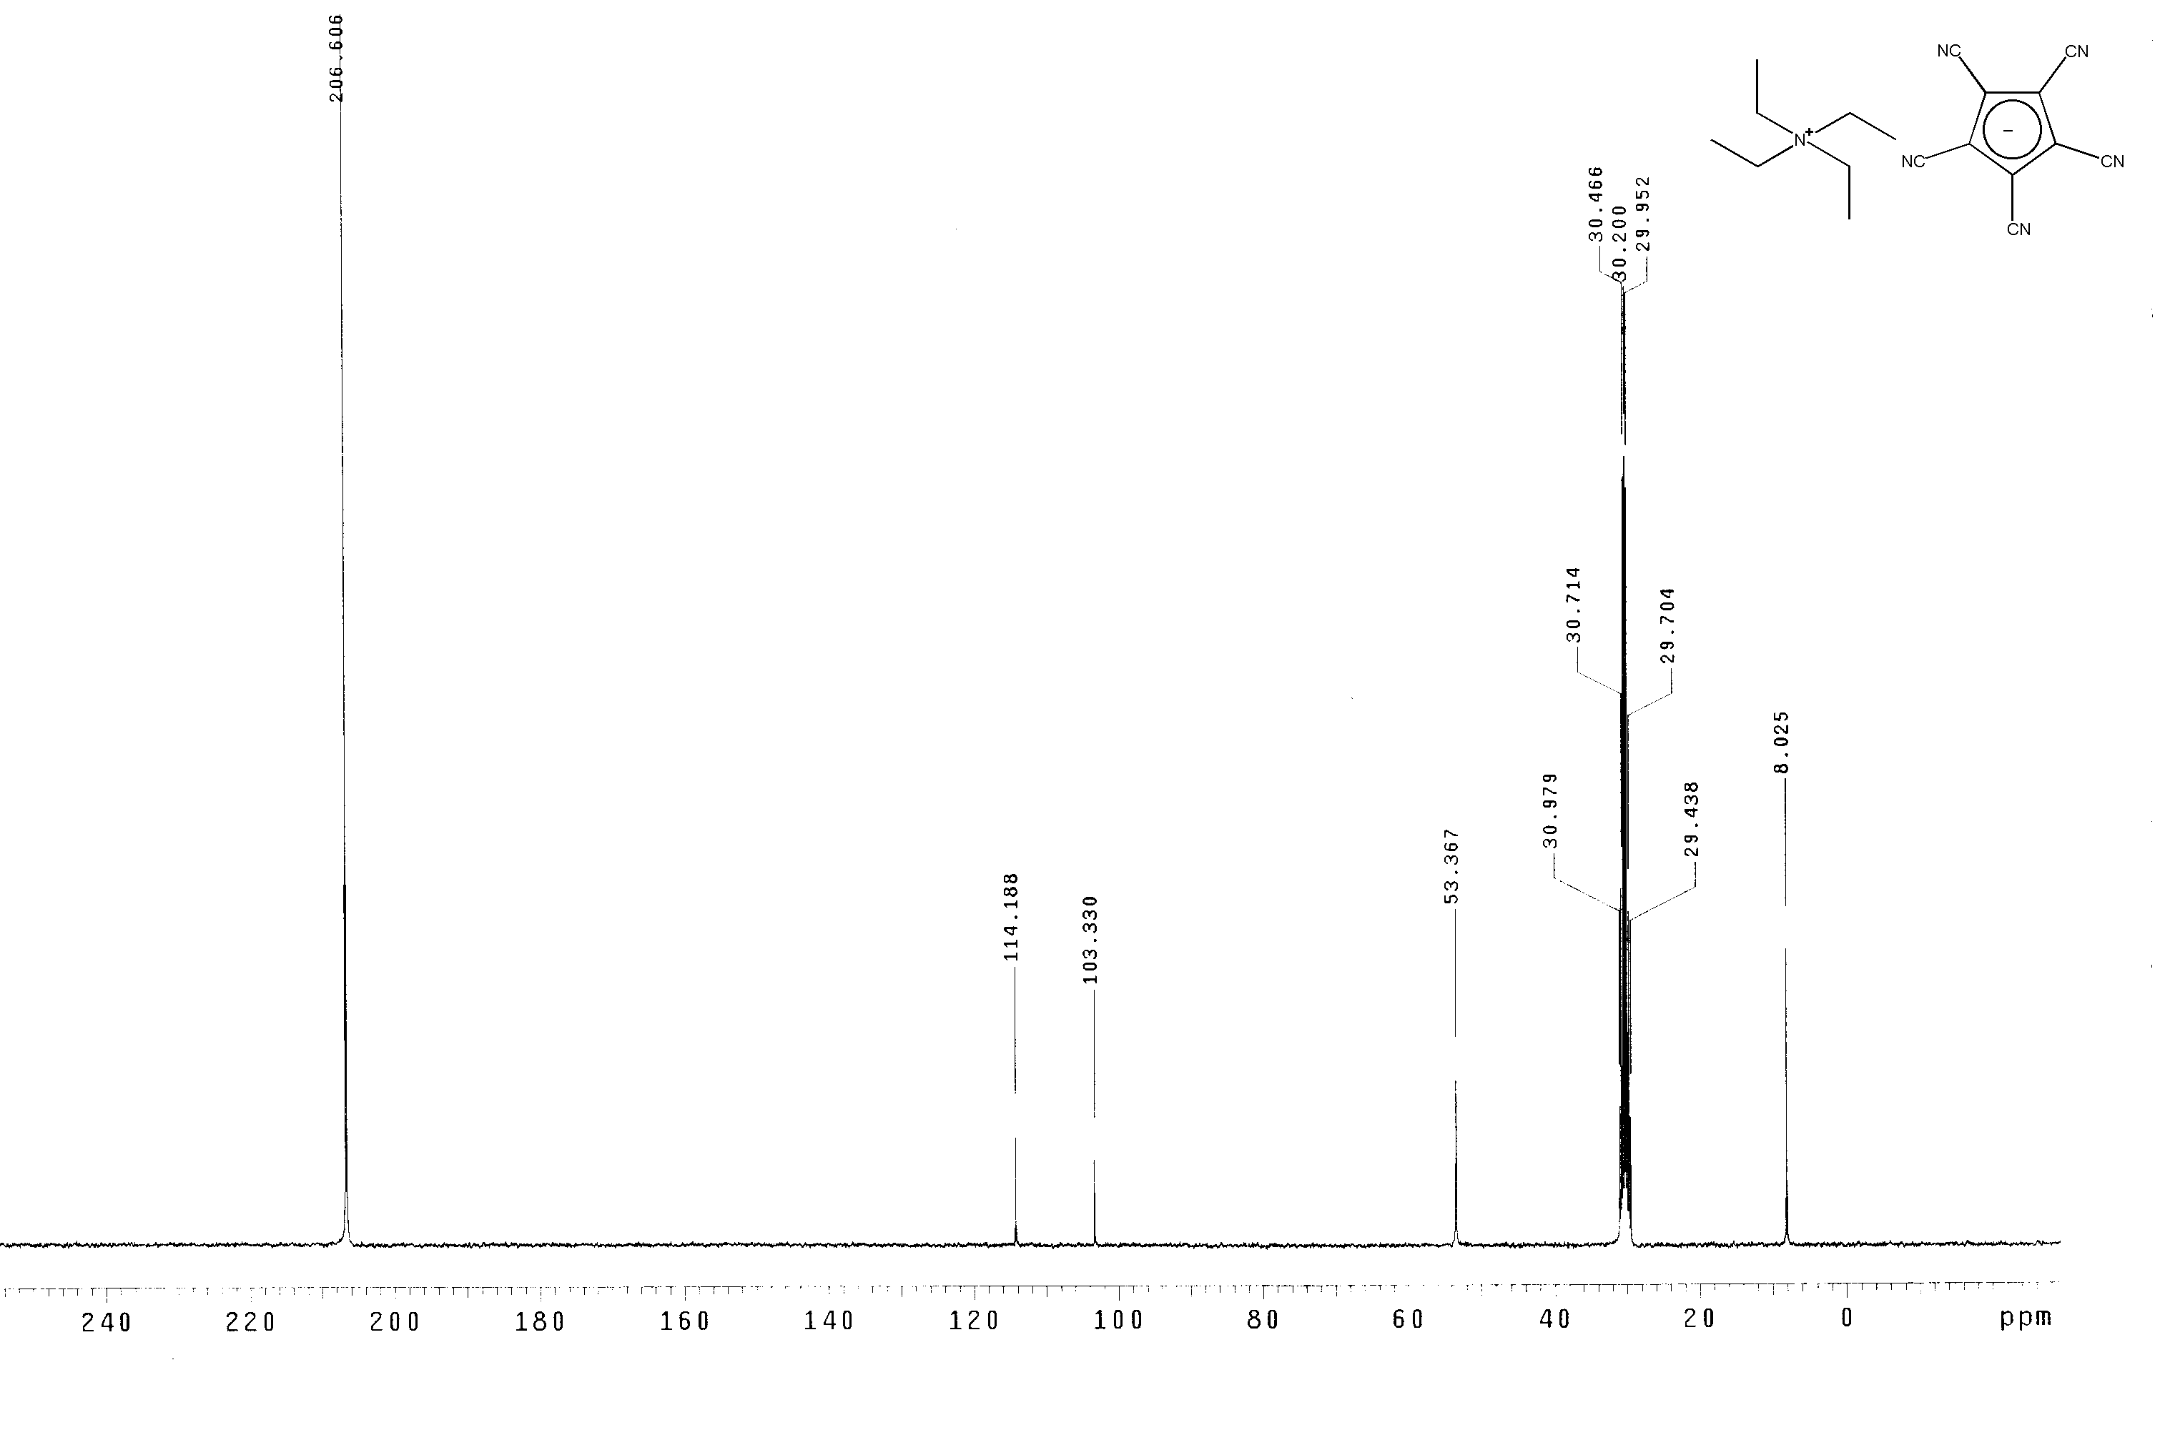
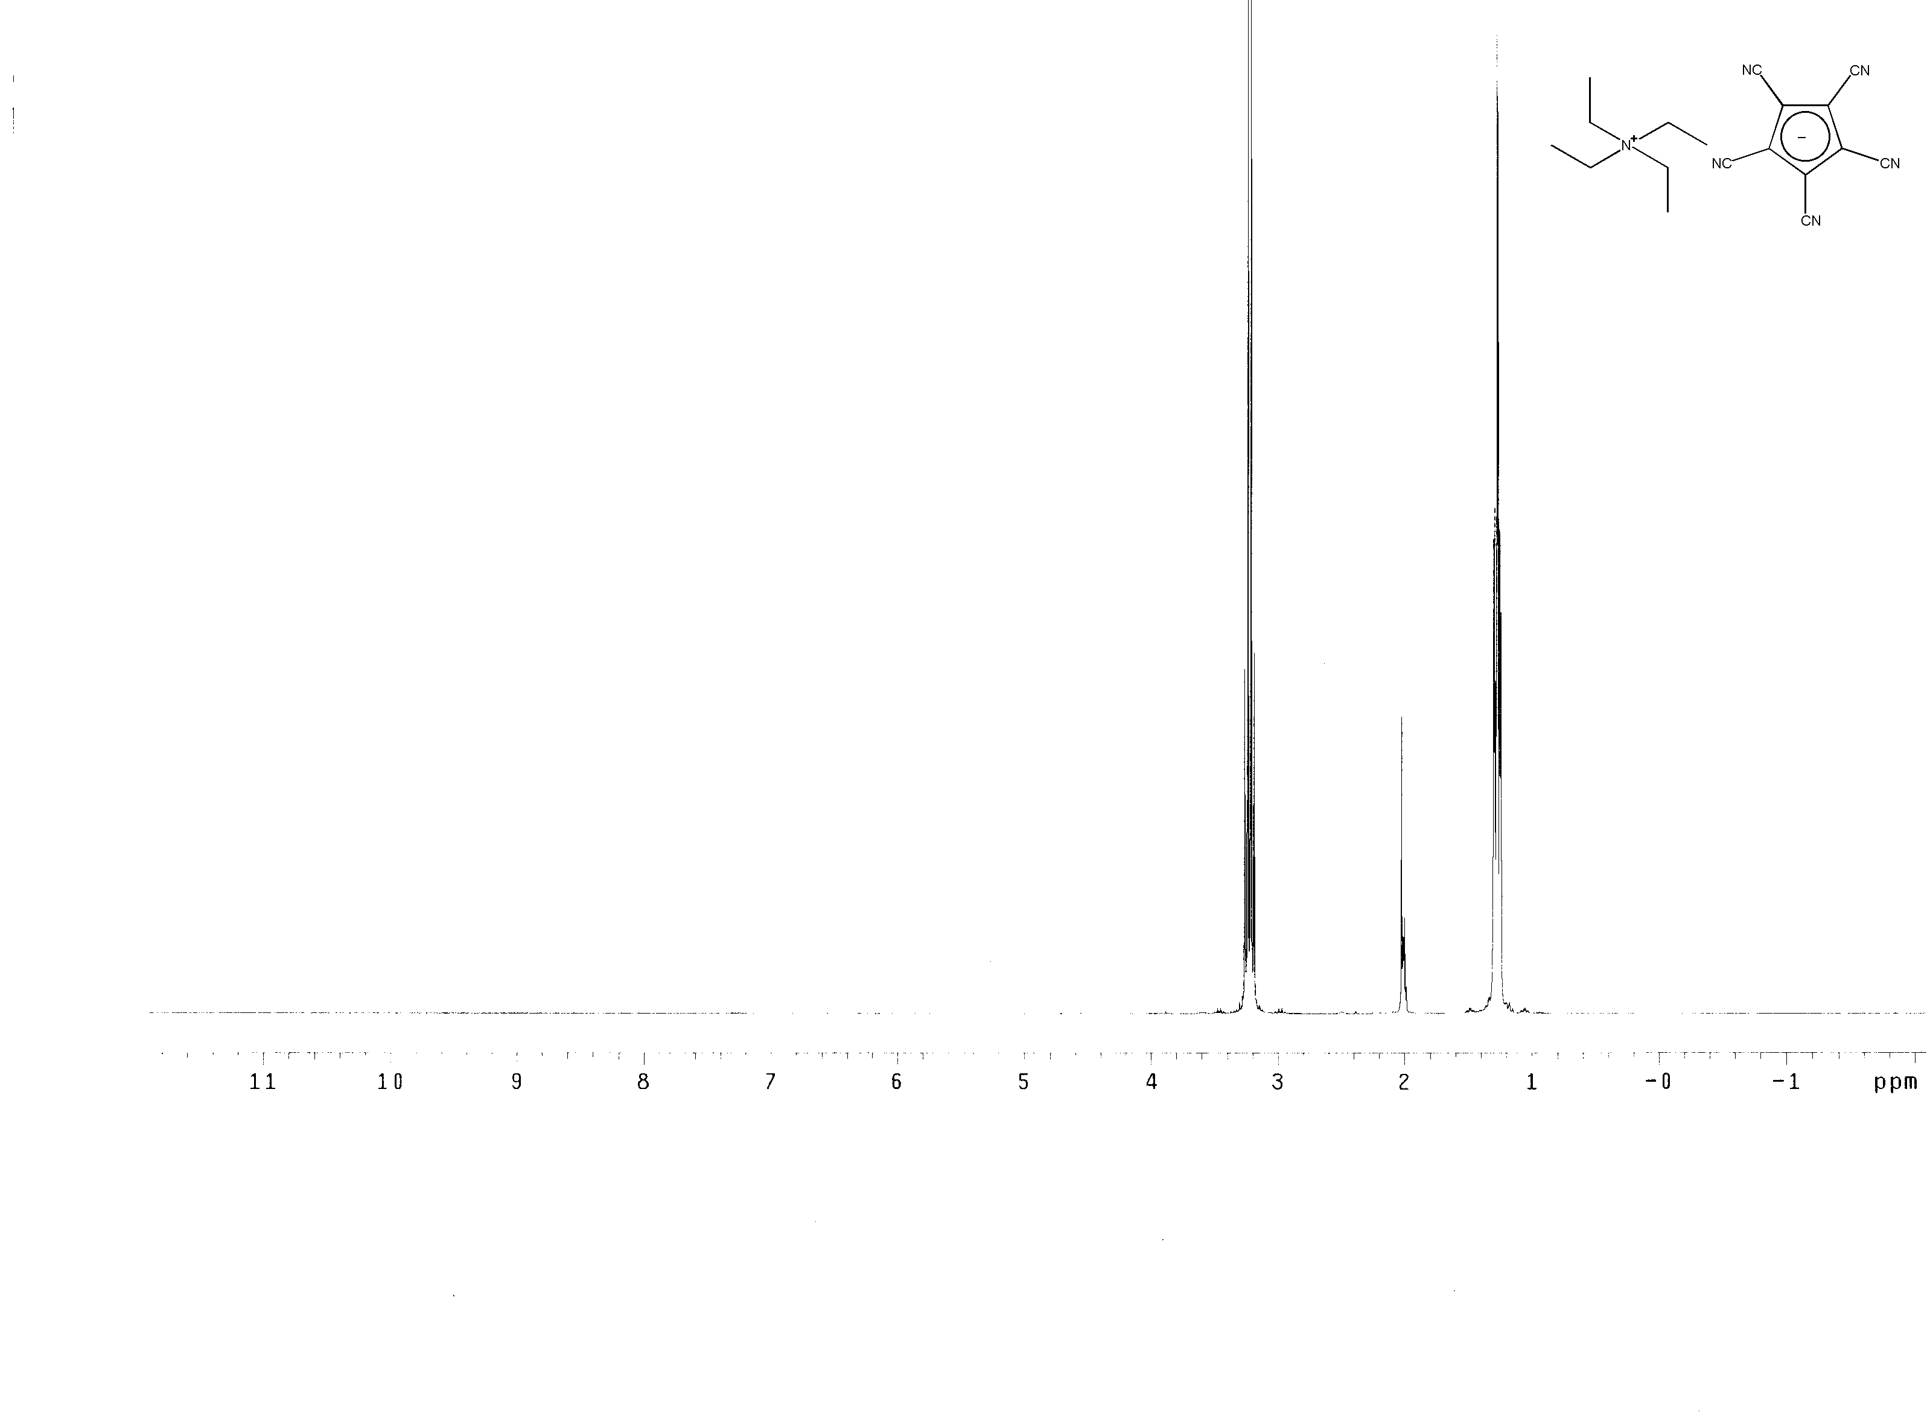
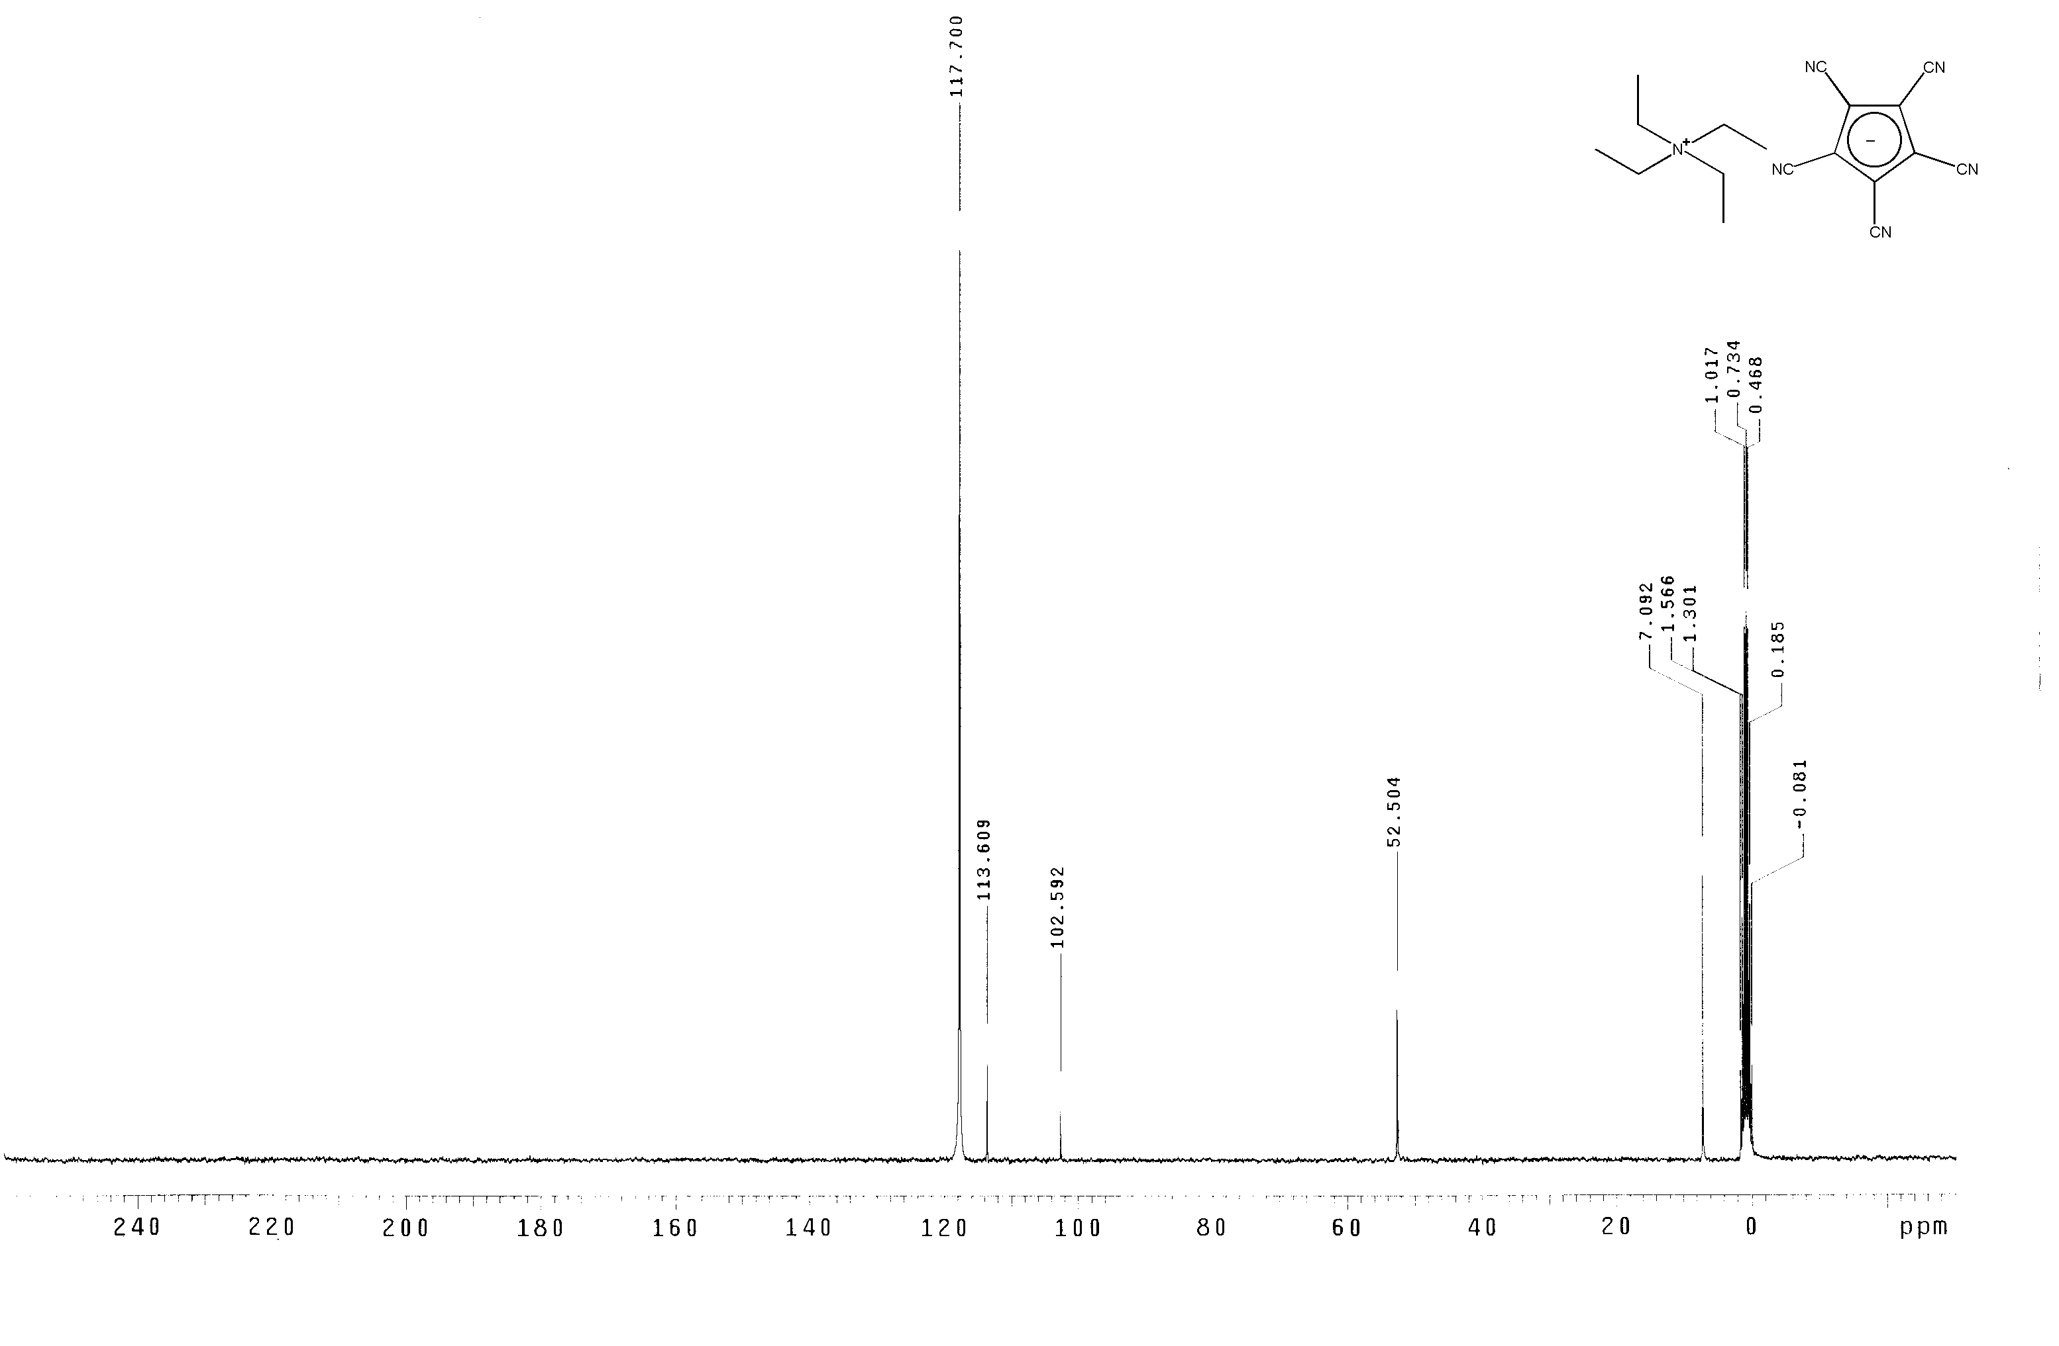
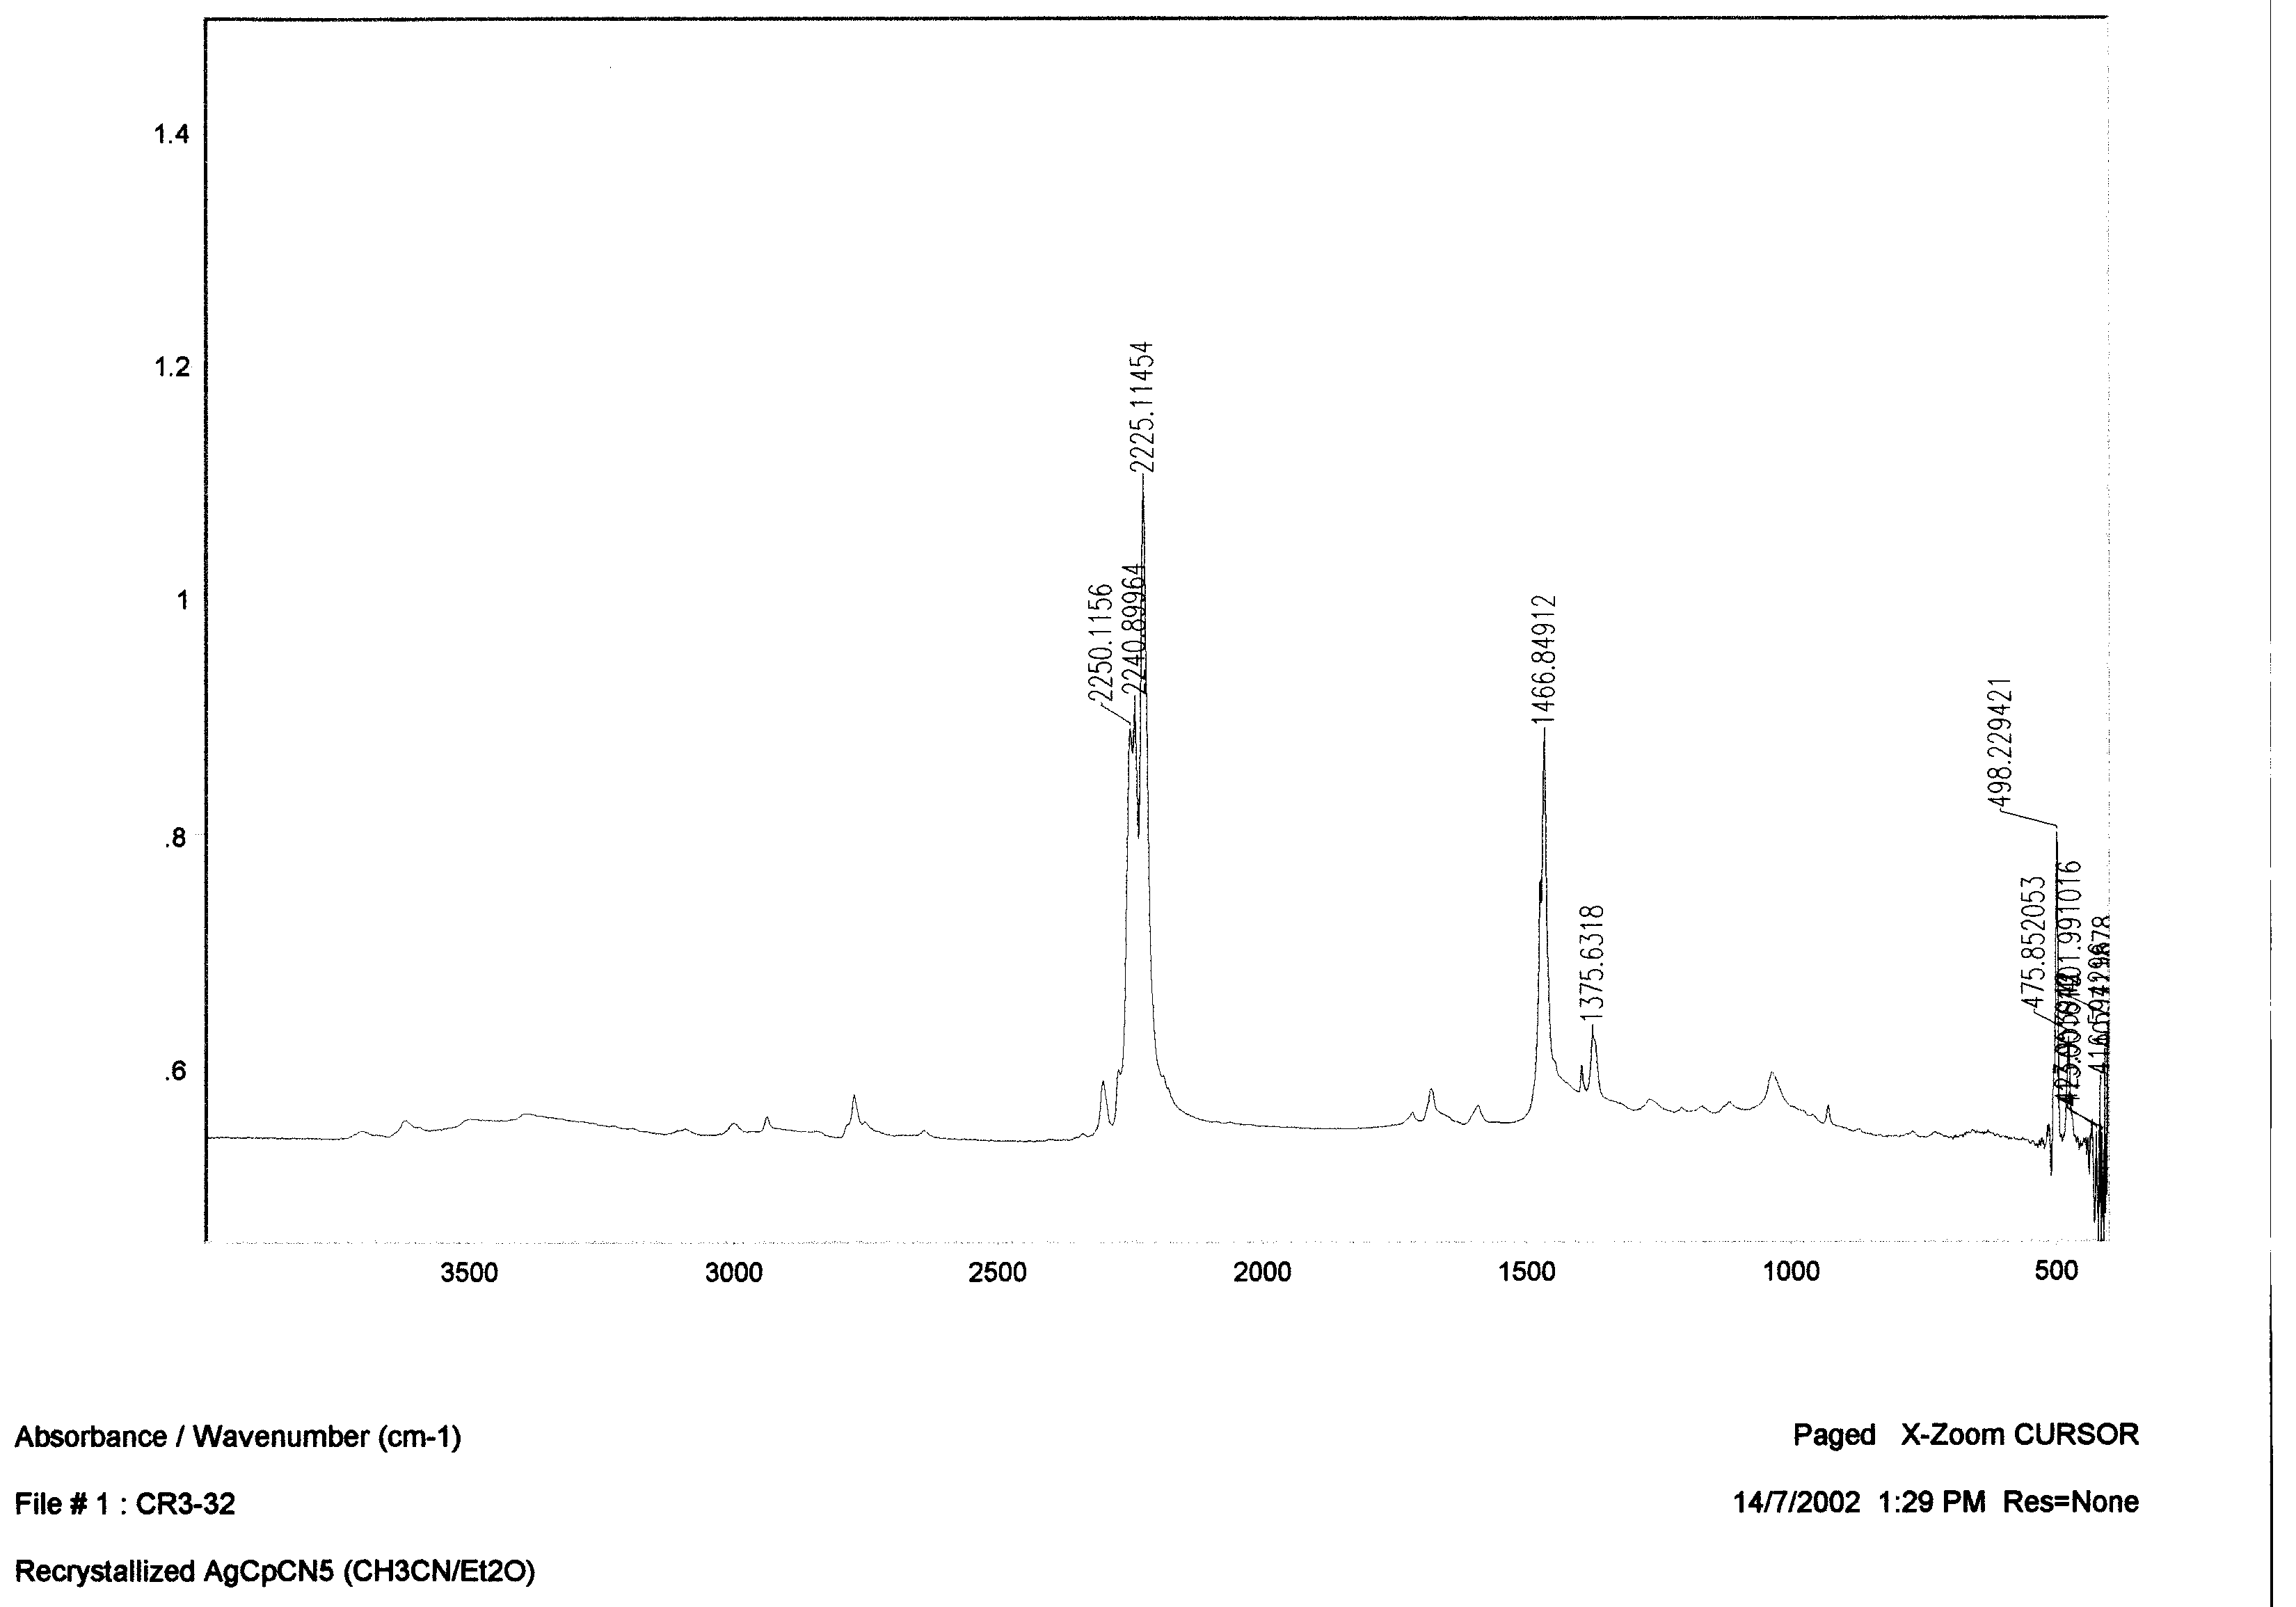
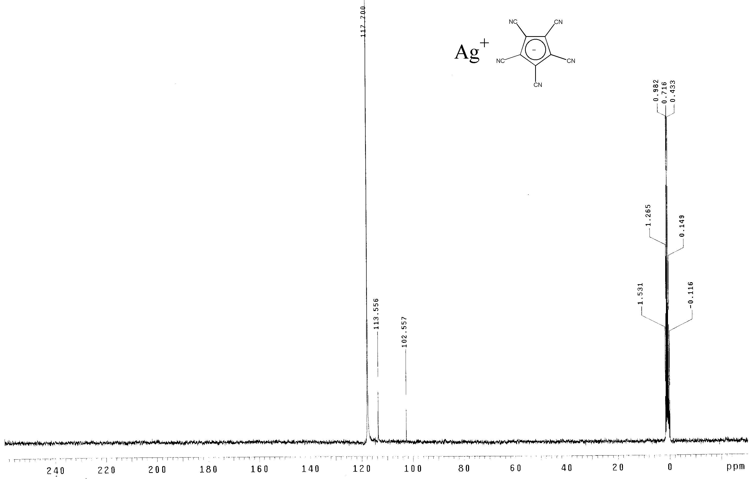
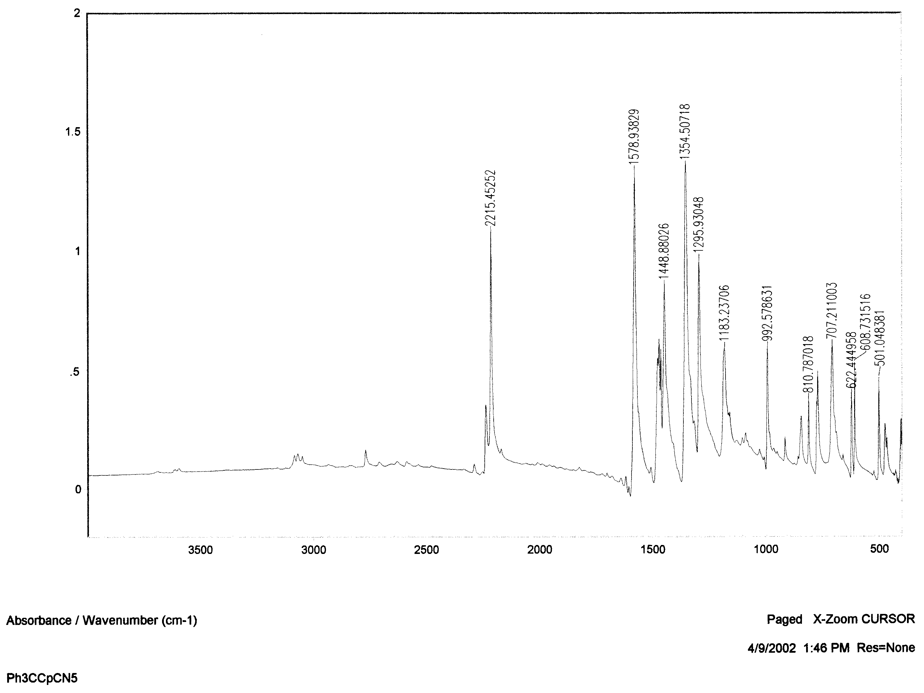
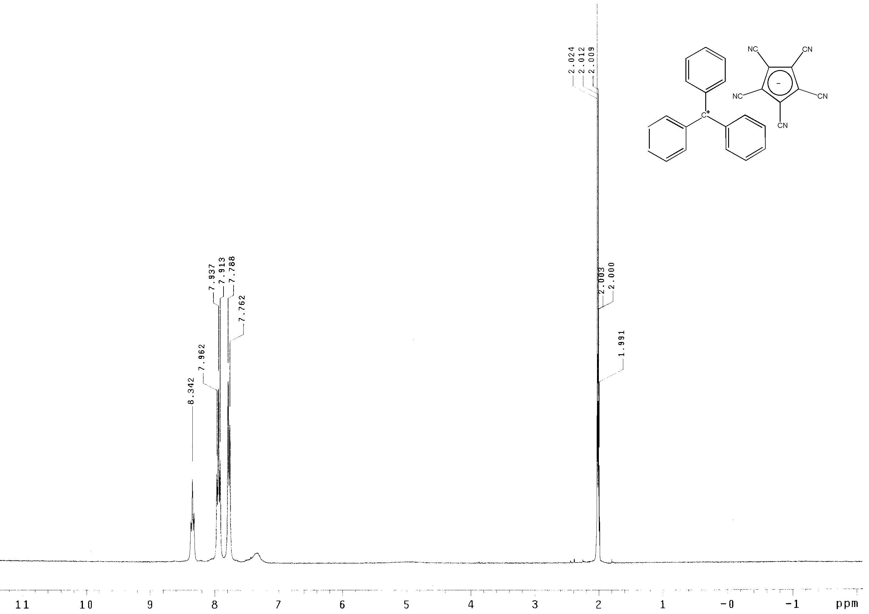

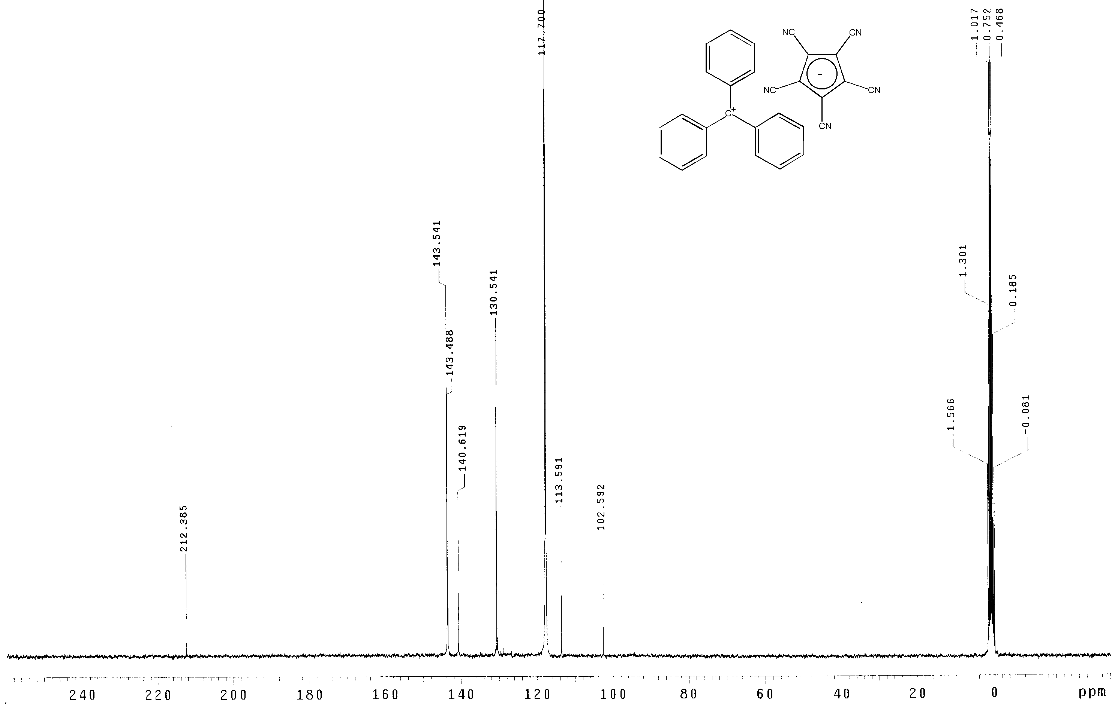
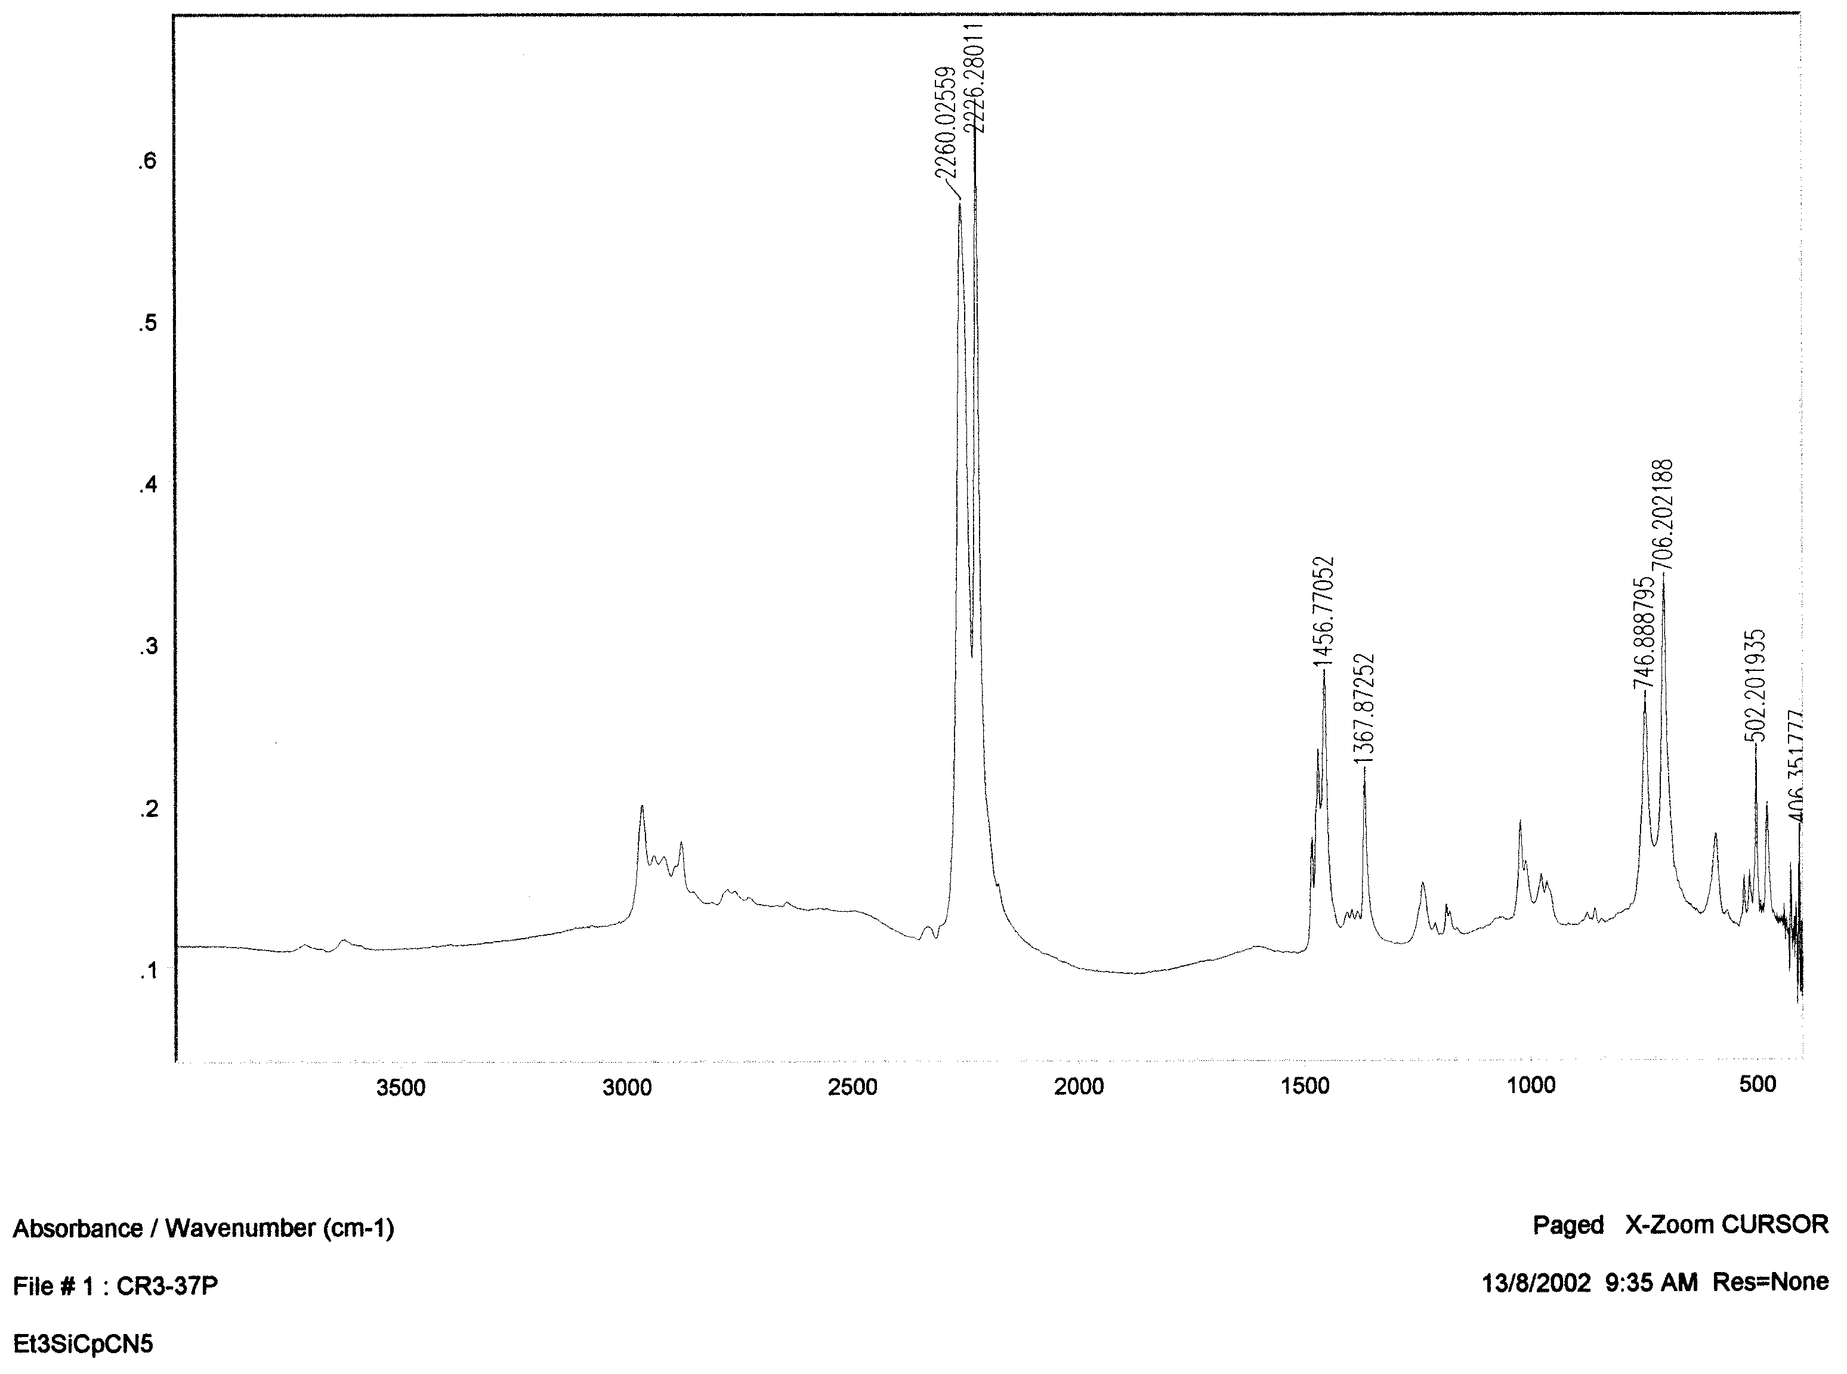
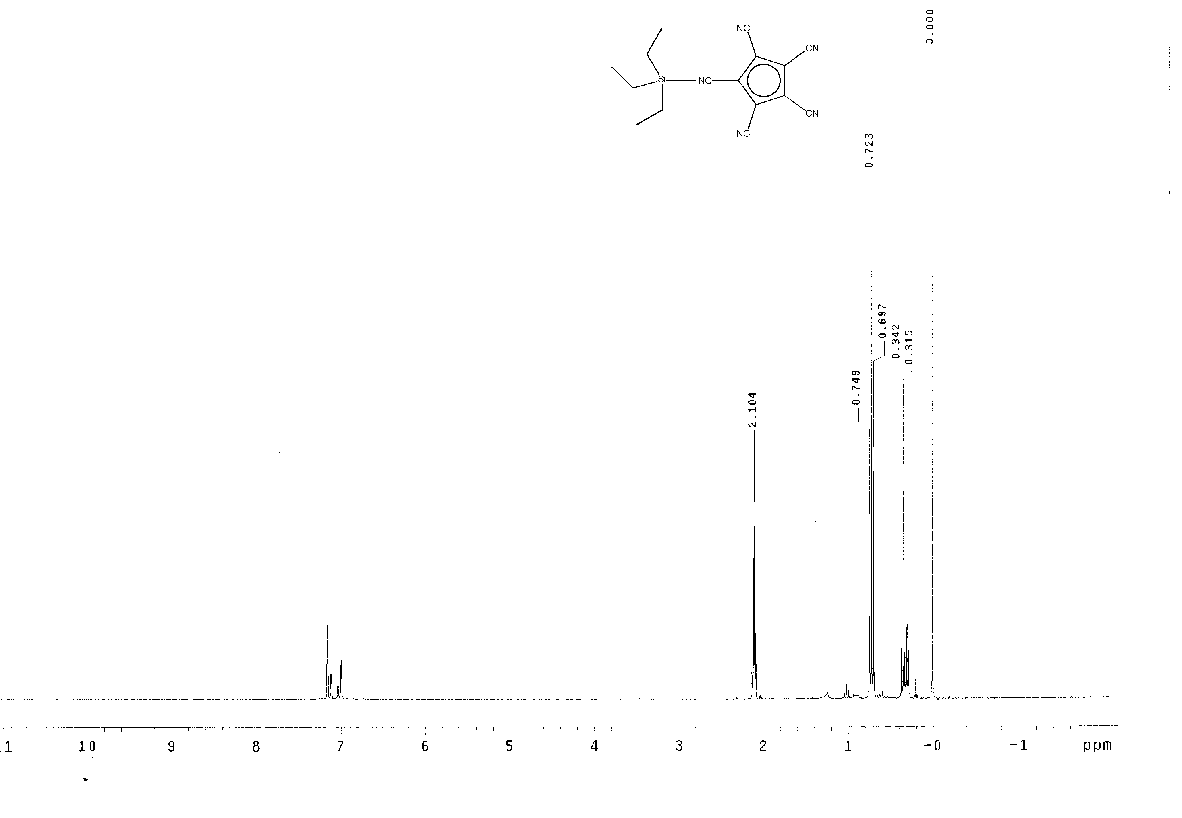
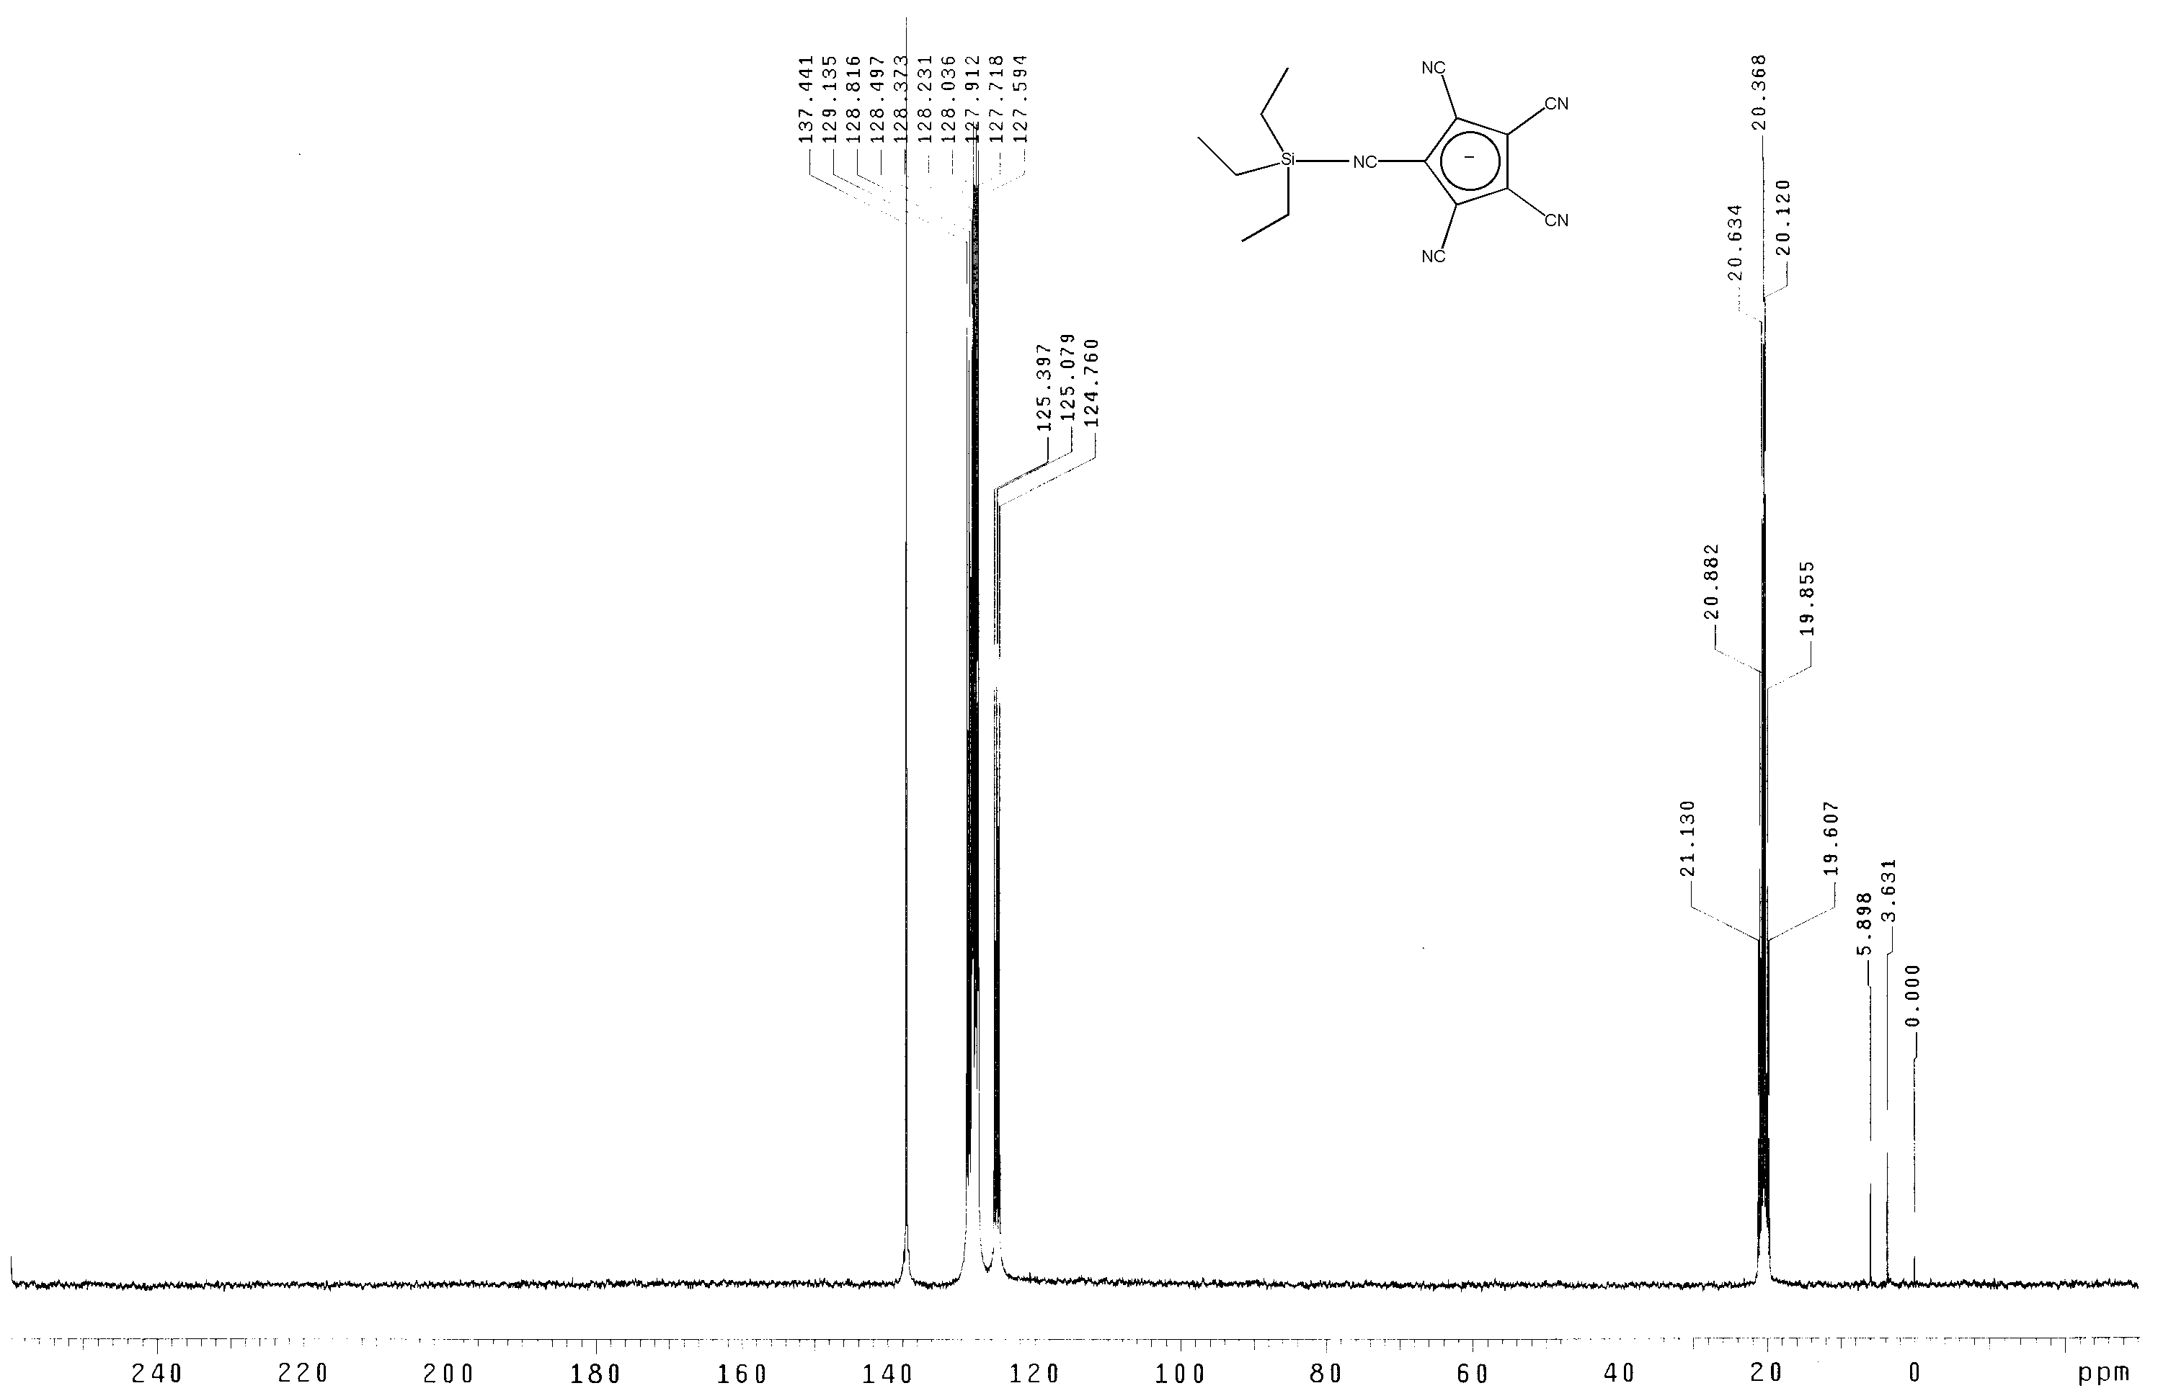

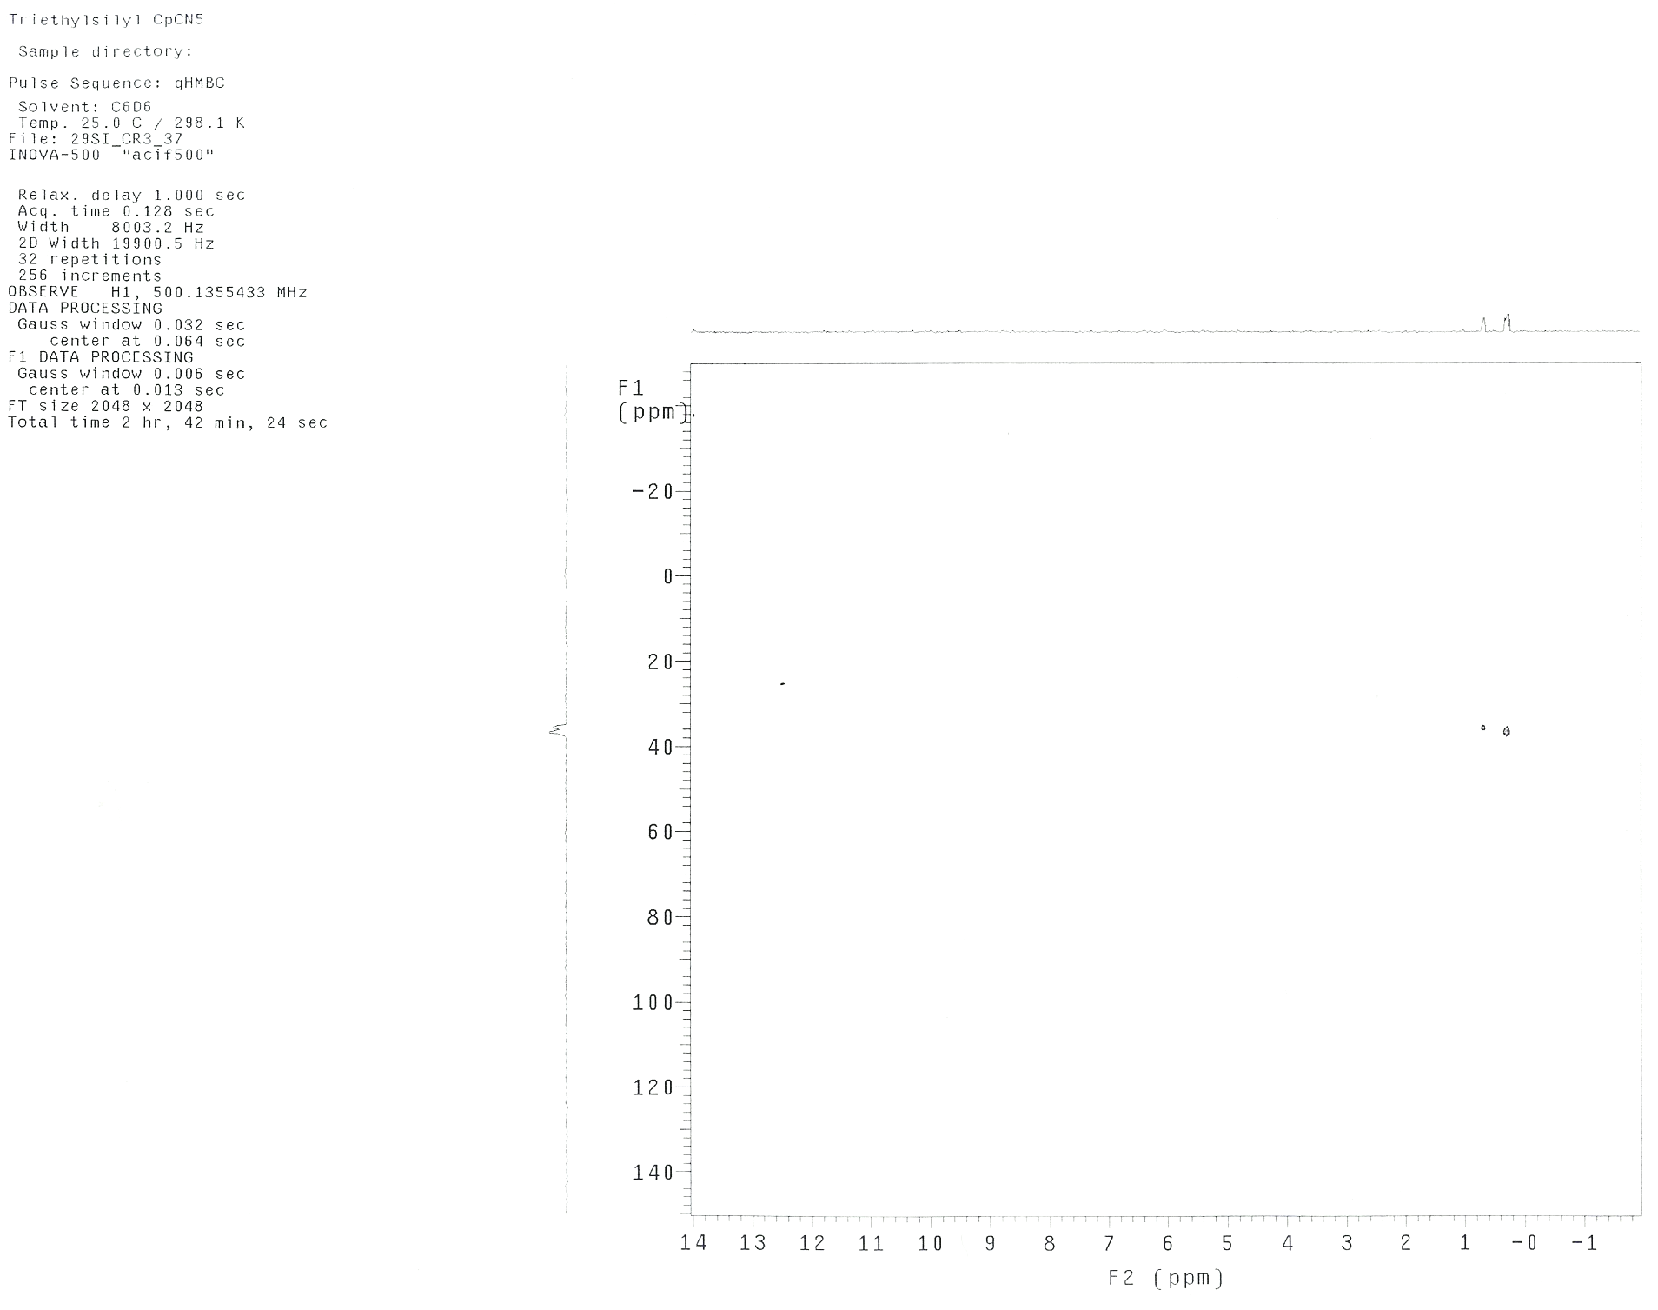
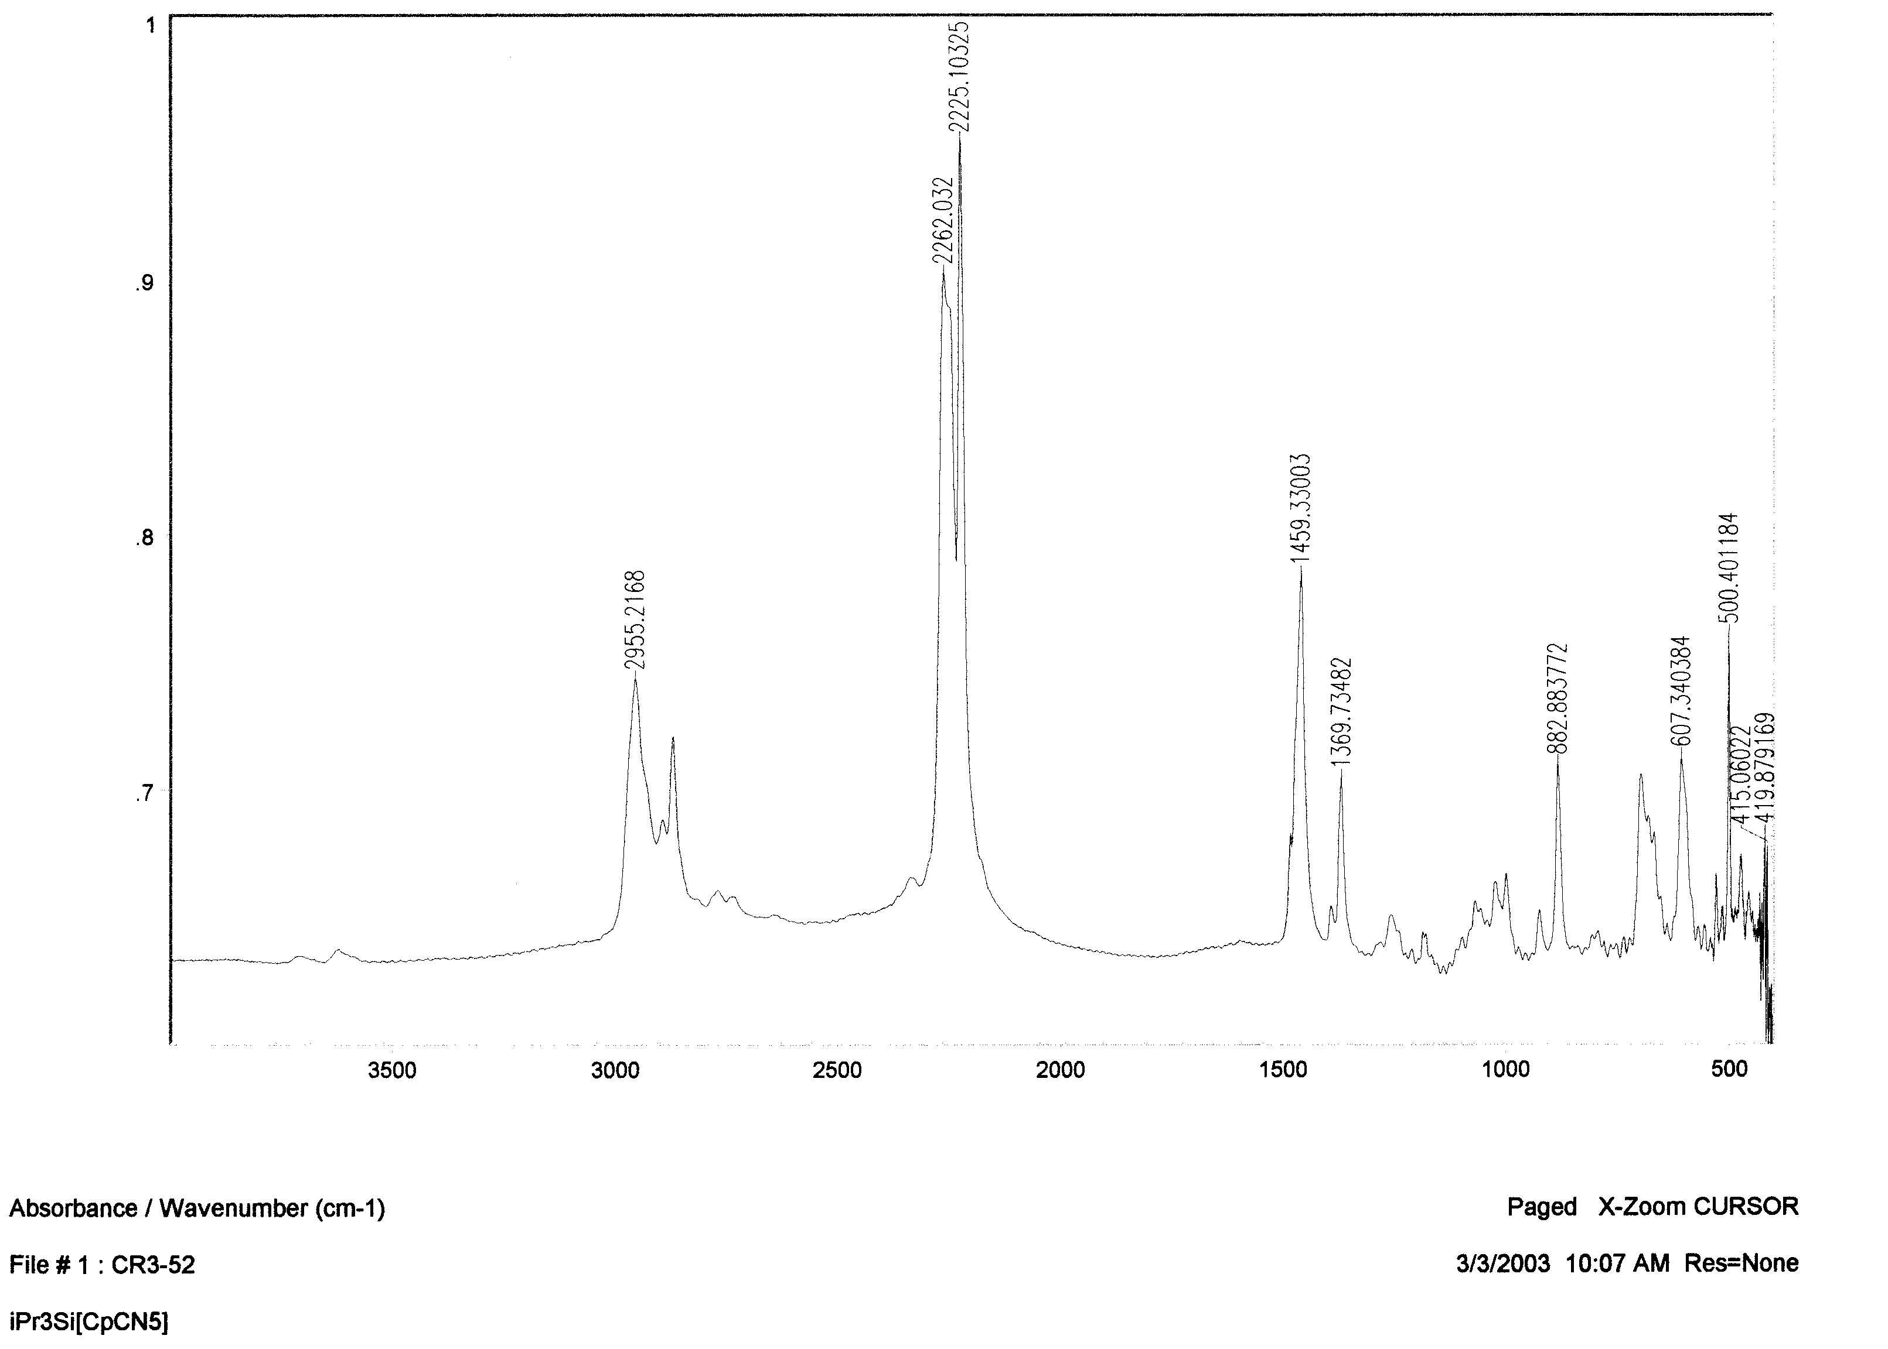
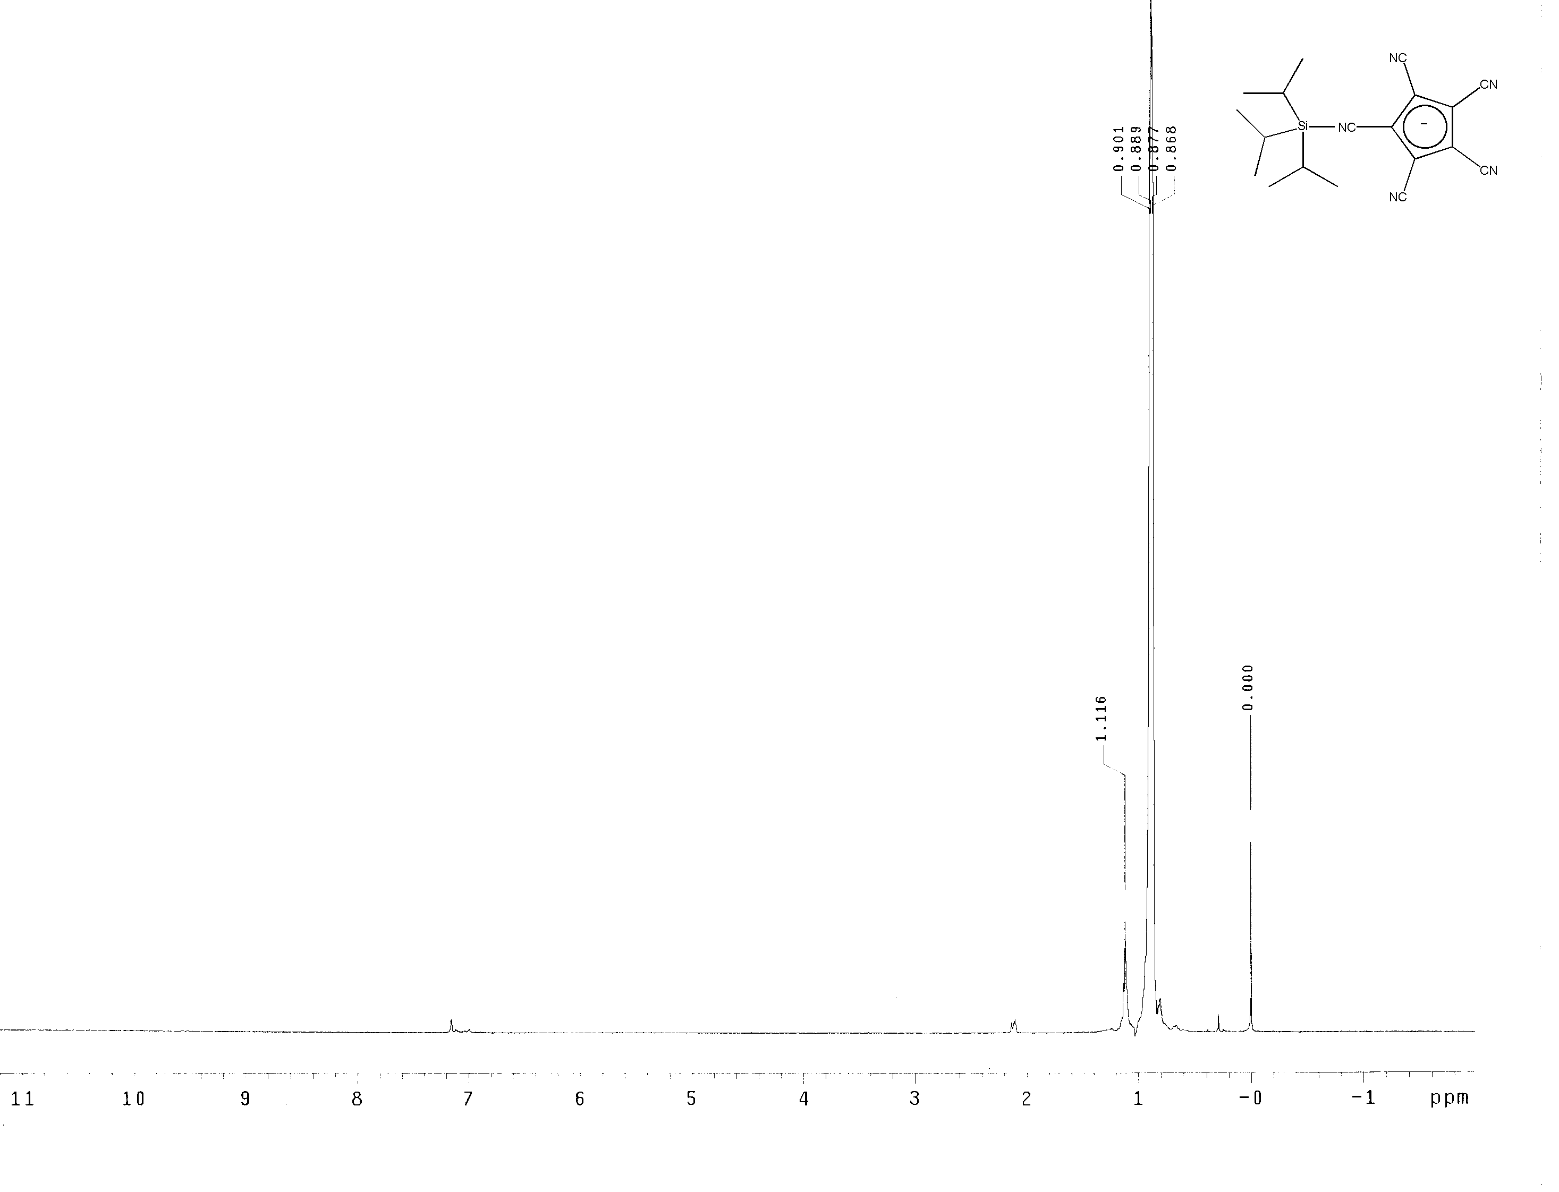
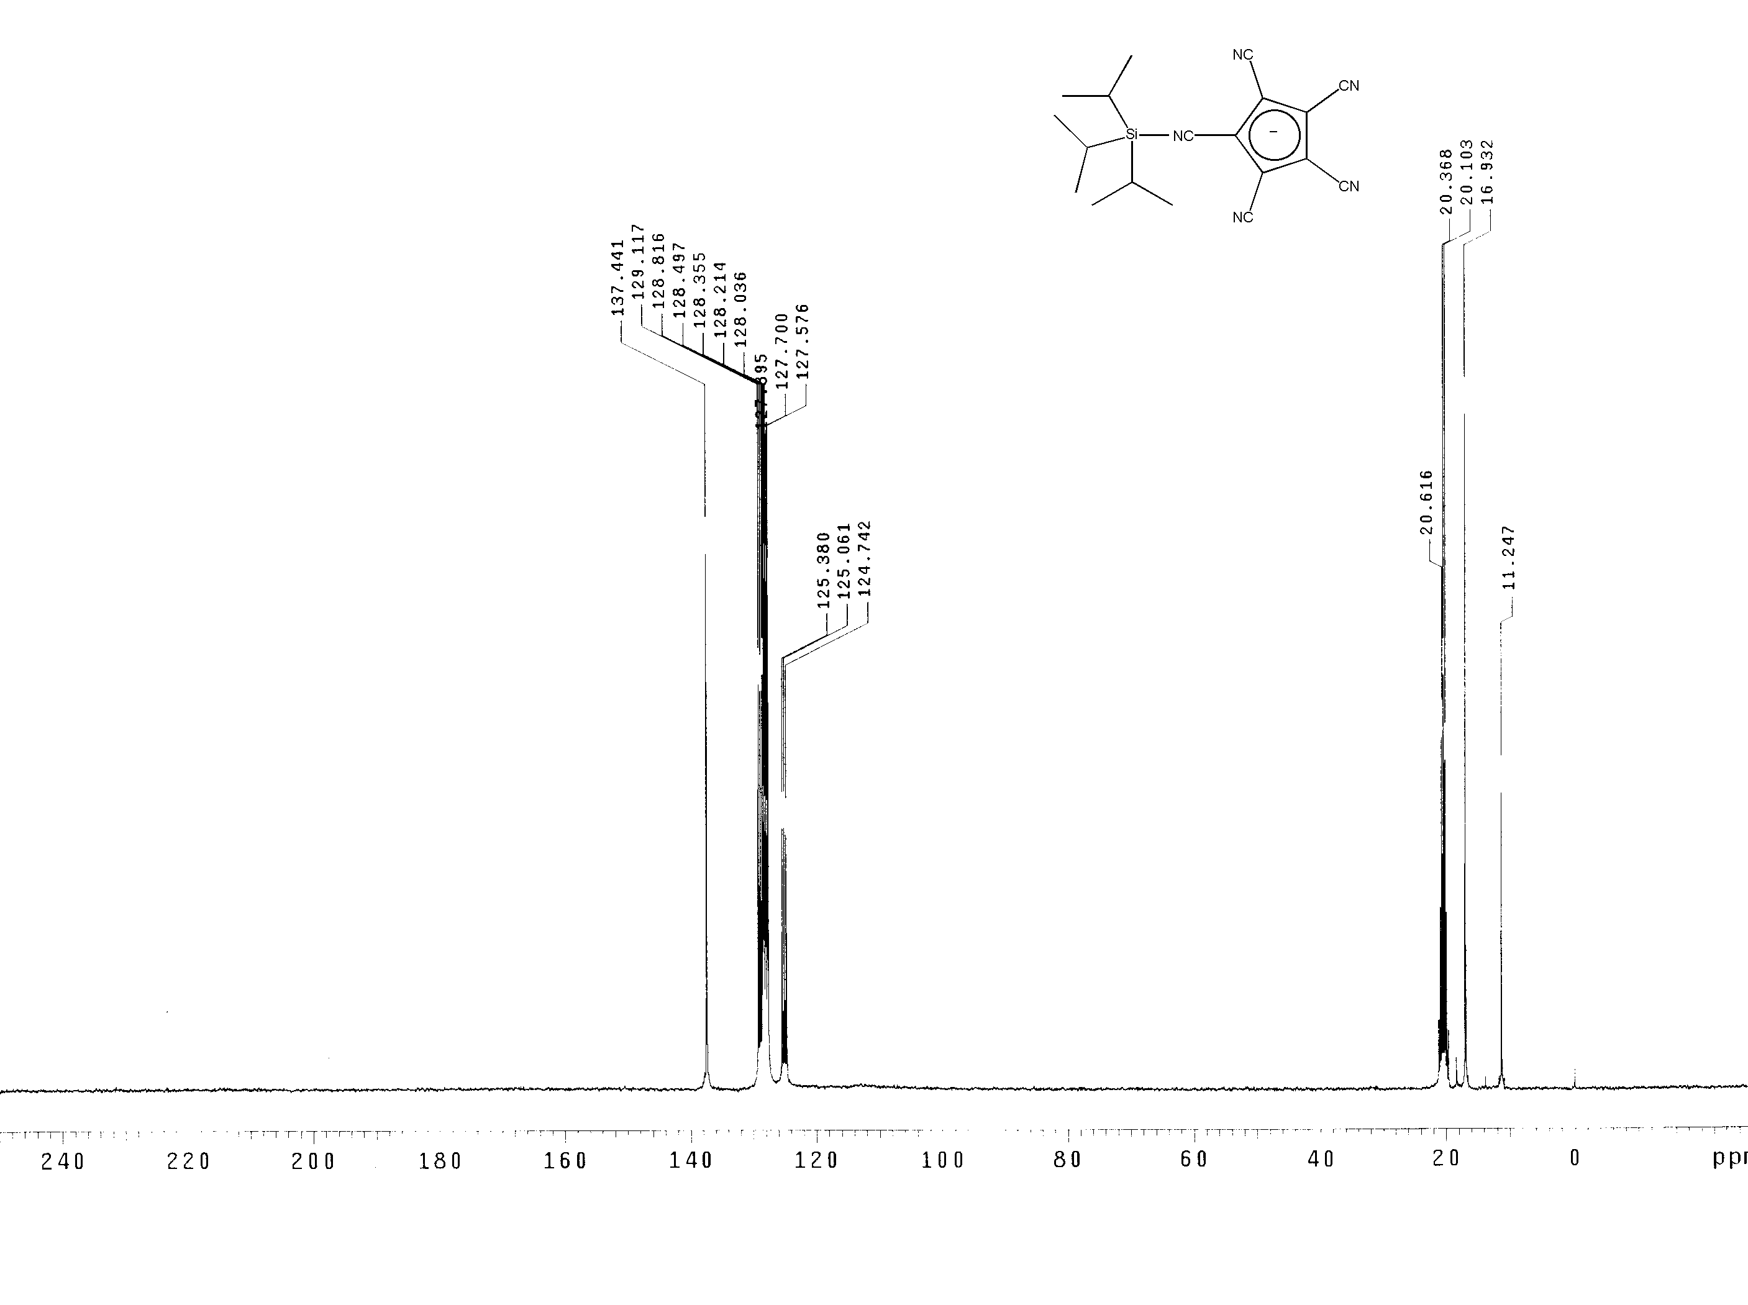
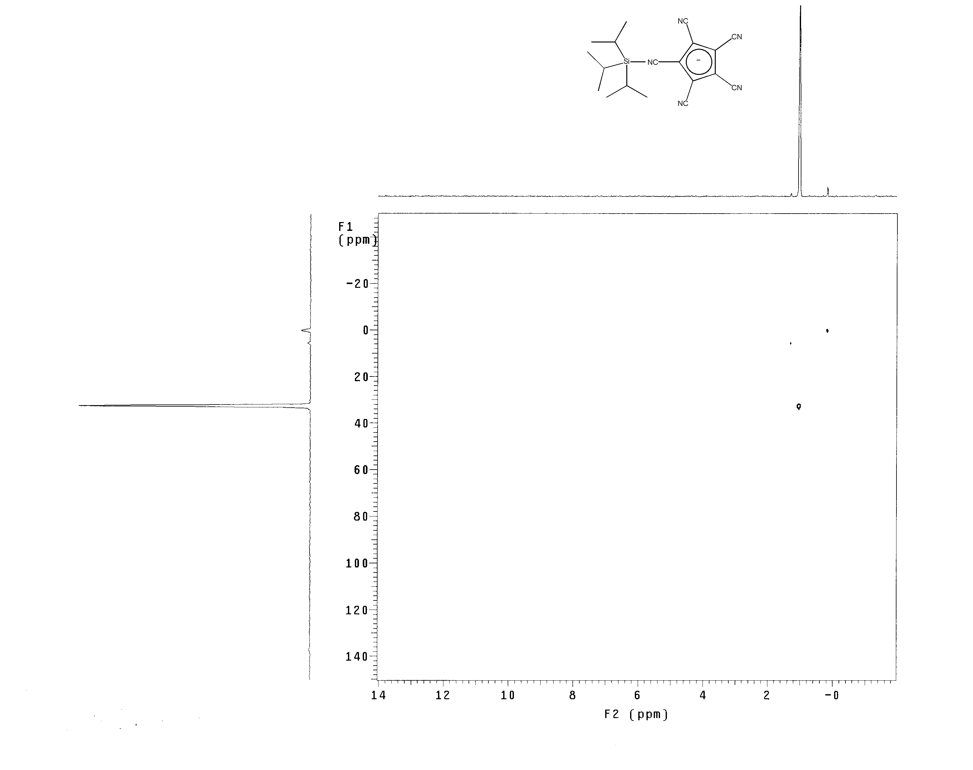
X-Ray Structure Determination of Ph₃C[C₅CN₅]

A brown fragment of a prism (0.46 x 0.37 x 0.11 mm³) was used for the single crystal x-ray diffraction study of [C₁₉H₁₅]⁺[C₁₀N₅]⁻ (sample cr131m; CR3-33). The crystal was coated with paratone oil and mounted on to a glass fiber. X-ray intensity data were collected at 223(2) K on a Bruker SMART 1000 (ref. 1) platform-CCD x-ray diffractometer system (Mo-radiation, λ = 0.71073 Å, 50KV/40mA power). The CCD detector was placed at a distance of 4.9690 cm from the crystal.

A total of 1321 frames were collected for a hemisphere of reflections (with scan width of 0.3º in ω and φ angles of 0º, 90º, 180º, and 0º for every 606, 435, 230, and 50 frames, respectively, 10sec/frame exposure time). The frames were integrated using the Bruker SAINTPLUS software package (ref. 2) and using a narrow-frame integration algorithm. Based on a monoclinic crystal system, the integrated frames yielded a total of 13042 reflections at a maximum 2θ angle of 52.74º (0.80 Å resolution), of which 4700 were independent reflections (R_{int} = 0.0297, R_{sig} = 0.0362, redundancy = 2.8, completeness = 99.8%) and 3173 (67.5%) reflections were greater than 2σ(I). The unit cell parameters were, a = 12.802(2) Å, b = 8.1247(15) Å, c = 22.816(4) Å, α = 90º, β = 103.491(5)º, γ = 90º, V = 2307.8(7) Å³, Z = 4, calculated density D_{c} = 1.248 g/cm³. Absorption corrections were applied (absorption coefficient μ = 0.076 mm⁻¹; max/min transmission = 0.9916/0.9657) to the raw intensity data using the SADABS program in the SAINTPLUS software (ref. 2).

The Bruker SHELXTL (Version 6.10) software package (ref. 3) was used for phase determination and structure refinement. The distribution of intensities (E²-1 = 1.018) and systematic absent reflections indicated one possible space group; P2(1)/n. The space group P2(1)/n was later determined to be correct. Direct methods of phase determination followed by two Fourier cycles of refinement led to an electron density map from which most of the non-hydrogen atoms were identified in the asymmetry unit of the unit cell. With subsequent isotropic refinement, all of the non-hydrogen atoms were identified. There is one cation of [C₁₉H₁₅]⁺ and one anion of [C₁₀N₅]⁻ present in the asymmetry unit of the unit cell.

Atomic coordinates, isotropic and anisotropic displacement parameters of all the non-hydrogen atoms were refined by means of a full matrix least-squares procedure on F². All H-atoms were included in the refinement in calculated positions riding on the atoms to which they were attached. The refinement converged at R1 = 0.0406, wR2 = 0.0901, with intensity, I>2σ(I). The largest peak/hole in the final difference map was 0.140/-0.195 e/Å³.

REFERENCES

- SMART Software Reference Manual, Version 5.054, Bruker Analytical X-Ray System, Inc., Madison, WI 1997-1998.

- SAINTPLUS Software Reference Manual, Version 5.02, Bruker Analytical X-Ray System, Inc., Madison, WI 1997-1998.

- SHELXTL Software Reference Manual, Version 6.10, Dec. 5th, 2000, Bruker Analytical X-Ray System, Inc., Madison, WI.
Table 1. Crystal data and structure refinement for C₂₉H₁₅N₅.
Identification code cr131m
Empirical formula C29 H15 N5
Formula weight 433.46
Temperature 223(2) K
Wavelength 0.71073 Å
Crystal system Monoclinic
Space group P2(1)/n
Unit cell dimensions a = 12.802(2) Å α= 90°.
b = 8.1247(15) Å β= 103.491(5)°.
c = 22.816(4) Å γ = 90°.
Volume 2307.8(7) Å3
Z 4
Density (calculated) 1.248 Mg/m3
Absorption coefficient 0.076 mm-1
F(000) 896
Crystal size 0.46 x 0.37 x 0.11 mm3
Theta range for data collection 1.68 to 26.37°.
Index ranges -15<=h<=16, -9<=k<=10, -28<=l<=22
Reflections collected 13042
Independent reflections 4700 [R(int) = 0.0297]
Completeness to theta = 26.37° 99.8 %
Absorption correction SADABS
Max. and min. transmission 0.9916 and 0.9657
Refinement method Full-matrix least-squares on F2
Data / restraints / parameters 4700 / 0 / 322
Goodness-of-fit on F2 1.038
Final R indices [I>2sigma(I)] R1 = 0.0406, wR2 = 0.0901
R indices (all data) R1 = 0.0700, wR2 = 0.1086
Largest diff. peak and hole 0.140 and -0.195 e.Å-3
Table 2. Atomic coordinates ( x 104) and equivalent isotropic displacement parameters (Å2x 103)
for C₂₉H₁₅N₅. U(eq) is defined as one third of the trace of the orthogonalized Uij tensor.
________________________________________________________________________________
x y z U(eq)
________________________________________________________________________________
C(1) 5924(1) 2127(2) 2032(1) 39(1)
C(2) 7026(1) 2191(2) 2380(1) 38(1)
C(3) 7881(1) 1744(2) 2120(1) 44(1)
C(4) 8925(1) 1783(2) 2456(1) 52(1)
C(5) 9146(1) 2277(2) 3052(1) 54(1)
C(6) 8323(1) 2738(2) 3315(1) 51(1)
C(7) 7273(1) 2688(2) 2988(1) 43(1)
C(8) 5049(1) 1826(2) 2317(1) 39(1)
C(9) 5180(1) 814(2) 2833(1) 47(1)
C(10) 4319(2) 477(2) 3075(1) 55(1)
C(11) 3320(2) 1151(2) 2827(1) 55(1)
C(12) 3176(1) 2164(2) 2328(1) 51(1)
C(13) 4023(1) 2499(2) 2072(1) 45(1)
C(14) 5682(1) 2337(2) 1385(1) 41(1)
C(15) 4837(1) 1437(2) 1016(1) 50(1)
C(16) 4612(2) 1606(3) 399(1) 61(1)
C(17) 5205(2) 2685(3) 139(1) 66(1)
C(18) 6029(2) 3593(3) 490(1) 59(1)
C(19) 6280(1) 3416(2) 1107(1) 47(1)
C(1') 5629(1) 7824(2) 4982(1) 40(1)
C(2') 6214(1) 7055(2) 5511(1) 40(1)
C(3') 5473(1) 6254(2) 5783(1) 40(1)
C(4') 4436(1) 6535(2) 5423(1) 40(1)
C(5') 4530(1) 7507(2) 4931(1) 40(1)
C(6') 6065(1) 8733(2) 4559(1) 45(1)
C(7') 7349(1) 7074(2) 5739(1) 47(1)
C(8') 5699(1) 5293(2) 6319(1) 47(1)
C(9') 3473(1) 5904(2) 5547(1) 44(1)
C(10') 3662(1) 8111(2) 4469(1) 45(1)
N(1') 6402(1) 9458(2) 4214(1) 62(1)
N(2') 8258(1) 7084(2) 5931(1) 67(1)
N(3') 5843(1) 4505(2) 6747(1) 66(1)
N(4') 2715(1) 5365(2) 5657(1) 60(1)
N(5') 2964(1) 8615(2) 4105(1) 63(1)
________________________________________________________________________________
Table 3. Bond lengths [Å] and angles [°] for C₂₉H₁₅N₅.
_____________________________________________________
C(1)-C(8) 1.442(2)
C(1)-C(14) 1.447(2)
C(1)-C(2) 1.450(2)
C(2)-C(7) 1.408(2)
C(2)-C(3) 1.410(2)
C(3)-C(4) 1.378(2)
C(4)-C(5) 1.384(3)
C(5)-C(6) 1.380(3)
C(6)-C(7) 1.377(2)
C(8)-C(9) 1.412(2)
C(8)-C(13) 1.413(2)
C(9)-C(10) 1.371(2)
C(10)-C(11) 1.385(3)
C(11)-C(12) 1.383(3)
C(12)-C(13) 1.373(2)
C(14)-C(19) 1.408(2)
C(14)-C(15) 1.410(2)
C(15)-C(16) 1.375(3)
C(16)-C(17) 1.381(3)
C(17)-C(18) 1.380(3)
C(18)-C(19) 1.377(2)
C(1')-C(5') 1.408(2)
C(1')-C(2') 1.409(2)
C(1')-C(6') 1.429(2)
C(2')-C(3') 1.409(2)
C(2')-C(7') 1.425(2)
C(3')-C(4') 1.408(2)
C(3')-C(8') 1.423(2)
C(4')-C(5') 1.401(2)
C(4')-C(9') 1.424(2)
C(5')-C(10') 1.427(2)
C(6')-N(1') 1.145(2)
C(7')-N(2') 1.144(2)
C(8')-N(3') 1.145(2)
C(9')-N(4') 1.145(2)
C(10')-N(5') 1.145(2)

C(8)-C(1)-C(14) 118.48(14)
C(8)-C(1)-C(2) 121.18(14)
C(14)-C(1)-C(2) 120.34(14)
C(7)-C(2)-C(3) 118.17(14)
C(7)-C(2)-C(1) 121.09(14)
C(3)-C(2)-C(1) 120.74(14)
C(4)-C(3)-C(2) 120.46(16)
C(3)-C(4)-C(5) 120.22(16)
C(6)-C(5)-C(4) 120.32(16)
C(7)-C(6)-C(5) 120.27(17)
C(6)-C(7)-C(2) 120.55(16)
C(9)-C(8)-C(13) 118.27(15)
C(9)-C(8)-C(1) 121.41(15)
C(13)-C(8)-C(1) 120.29(15)
C(10)-C(9)-C(8) 120.11(16)
C(9)-C(10)-C(11) 120.63(17)
C(12)-C(11)-C(10) 120.26(17)
C(13)-C(12)-C(11) 120.11(17)
C(12)-C(13)-C(8) 120.60(16)
C(19)-C(14)-C(15) 118.42(16)
C(19)-C(14)-C(1) 121.54(15)
C(15)-C(14)-C(1) 120.04(15)
C(16)-C(15)-C(14) 120.49(18)
C(15)-C(16)-C(17) 119.85(18)
C(18)-C(17)-C(16) 120.89(18)
C(19)-C(18)-C(17) 120.04(19)
C(18)-C(19)-C(14) 120.29(17)
C(5')-C(1')-C(2') 108.14(14)
C(5')-C(1')-C(6') 125.37(15)
C(2')-C(1')-C(6') 126.46(14)
C(1')-C(2')-C(3') 107.74(14)
C(1')-C(2')-C(7') 126.99(15)
C(3')-C(2')-C(7') 125.27(15)
C(4')-C(3')-C(2') 107.92(14)
C(4')-C(3')-C(8') 124.47(15)
C(2')-C(3')-C(8') 127.60(15)
C(5')-C(4')-C(3') 108.28(14)
C(5')-C(4')-C(9') 127.13(15)
C(3')-C(4')-C(9') 124.58(15)
C(4')-C(5')-C(1') 107.92(14)
C(4')-C(5')-C(10') 125.96(15)
C(1')-C(5')-C(10') 126.10(15)
N(1')-C(6')-C(1') 179.02(19)
N(2')-C(7')-C(2') 178.96(19)
N(3')-C(8')-C(3') 177.58(19)
N(4')-C(9')-C(4') 178.1(2)
N(5')-C(10')-C(5') 178.9(2)
_____________________________________________________________
Symmetry transformations used to generate equivalent atoms:

Table 4. Anisotropic displacement parameters (Å2x 103) for C₂₉H₁₅N₅. The anisotropic
displacement factor exponent takes the form: -2π2[ h2 a*2U11 + ... + 2 h k a* b* U12 ]
______________________________________________________________________________
U11 U22 U33 U23 U13 U12
______________________________________________________________________________
C(1) 40(1) 31(1) 45(1) -3(1) 5(1) 1(1)
C(2) 36(1) 33(1) 44(1) -2(1) 5(1) 0(1)
C(3) 42(1) 42(1) 48(1) -4(1) 8(1) 1(1)
C(4) 38(1) 52(1) 67(1) -2(1) 12(1) 3(1)
C(5) 36(1) 52(1) 65(1) 0(1) -4(1) -2(1)
C(6) 47(1) 54(1) 46(1) -3(1) -3(1) -2(1)
C(7) 42(1) 42(1) 43(1) -2(1) 6(1) 0(1)
C(8) 37(1) 39(1) 40(1) -3(1) 4(1) -2(1)
C(9) 40(1) 47(1) 51(1) 4(1) 4(1) 1(1)
C(10) 52(1) 61(1) 52(1) 10(1) 11(1) -6(1)
C(11) 44(1) 61(1) 62(1) -3(1) 17(1) -9(1)
C(12) 37(1) 54(1) 61(1) -4(1) 8(1) 1(1)
C(13) 39(1) 46(1) 45(1) -1(1) 2(1) 0(1)
C(14) 36(1) 44(1) 42(1) -4(1) 4(1) 2(1)
C(15) 39(1) 58(1) 50(1) -10(1) 4(1) -2(1)
C(16) 47(1) 81(2) 49(1) -18(1) -2(1) 4(1)
C(17) 56(1) 100(2) 40(1) -1(1) 4(1) 17(1)
C(18) 51(1) 76(1) 50(1) 12(1) 13(1) 9(1)
C(19) 41(1) 50(1) 47(1) 1(1) 6(1) 2(1)
C(1') 38(1) 42(1) 39(1) -6(1) 8(1) 1(1)
C(2') 35(1) 44(1) 41(1) -6(1) 8(1) 3(1)
C(3') 40(1) 42(1) 38(1) -6(1) 8(1) 4(1)
C(4') 38(1) 42(1) 39(1) -9(1) 10(1) 1(1)
C(5') 38(1) 44(1) 36(1) -7(1) 6(1) 3(1)
C(6') 38(1) 54(1) 42(1) -1(1) 5(1) 5(1)
C(7') 42(1) 52(1) 46(1) 0(1) 9(1) 3(1)
C(8') 39(1) 54(1) 48(1) -1(1) 10(1) 5(1)
C(9') 42(1) 52(1) 38(1) -6(1) 8(1) 3(1)
C(10') 40(1) 53(1) 40(1) -5(1) 9(1) -2(1)
N(1') 51(1) 80(1) 57(1) 14(1) 15(1) 6(1)
N(2') 42(1) 86(1) 68(1) 3(1) 3(1) 6(1)
N(3') 55(1) 80(1) 61(1) 20(1) 14(1) 7(1)
N(4') 47(1) 77(1) 56(1) 0(1) 14(1) -3(1)
N(5') 50(1) 80(1) 52(1) 2(1) -1(1) 2(1)
______________________________________________________________________________
Table 5. Hydrogen coordinates ( x 104) and isotropic displacement parameters (Å2x 10 3)
for C₂₉H₁₅N₅.
________________________________________________________________________________
x y z U(eq)
________________________________________________________________________________

H(3) 7737 1416 1713 52(5)
H(4) 9489 1472 2279 59(5)
H(5) 9860 2299 3280 63(6)
H(6) 8480 3087 3719 56(5)
H(7) 6717 2988 3172 48(5)
H(9) 5859 370 3010 45(5)
H(10) 4408 -218 3412 65(6)
H(11) 2737 918 2999 70(6)
H(12) 2498 2625 2163 65(6)
H(13) 3919 3181 1731 43(5)
H(15) 4425 716 1193 52(5)
H(16) 4056 988 156 75(6)
H(17) 5044 2802 -282 75(6)
H(18) 6421 4333 307 64(6)
H(19) 6852 4018 1344 45(5)
________________________________________________________________________________
Table 6. Torsion angles [°] for C₂₉H₁₅N₅.
________________________________________________________________
C(8)-C(1)-C(2)-C(7) -28.5(2)
C(14)-C(1)-C(2)-C(7) 152.69(16)
C(8)-C(1)-C(2)-C(3) 151.05(16)
C(14)-C(1)-C(2)-C(3) -27.8(2)
C(7)-C(2)-C(3)-C(4) 0.5(2)
C(1)-C(2)-C(3)-C(4) -179.00(16)
C(2)-C(3)-C(4)-C(5) -0.6(3)
C(3)-C(4)-C(5)-C(6) -0.1(3)
C(4)-C(5)-C(6)-C(7) 0.9(3)
C(5)-C(6)-C(7)-C(2) -0.9(3)
C(3)-C(2)-C(7)-C(6) 0.2(2)
C(1)-C(2)-C(7)-C(6) 179.76(16)
C(14)-C(1)-C(8)-C(9) 146.46(16)
C(2)-C(1)-C(8)-C(9) -32.4(2)
C(14)-C(1)-C(8)-C(13) -31.3(2)
C(2)-C(1)-C(8)-C(13) 149.83(15)
C(13)-C(8)-C(9)-C(10) 1.4(2)
C(1)-C(8)-C(9)-C(10) -176.46(16)
C(8)-C(9)-C(10)-C(11) -1.4(3)
C(9)-C(10)-C(11)-C(12) 0.5(3)
C(10)-C(11)-C(12)-C(13) 0.5(3)
C(11)-C(12)-C(13)-C(8) -0.5(3)
C(9)-C(8)-C(13)-C(12) -0.4(2)
C(1)-C(8)-C(13)-C(12) 177.45(16)
C(8)-C(1)-C(14)-C(19) 145.94(16)
C(2)-C(1)-C(14)-C(19) -35.2(2)
C(8)-C(1)-C(14)-C(15) -34.7(2)
C(2)-C(1)-C(14)-C(15) 144.18(16)
C(19)-C(14)-C(15)-C(16) 0.5(3)
C(1)-C(14)-C(15)-C(16) -178.89(16)
C(14)-C(15)-C(16)-C(17) -1.1(3)
C(15)-C(16)-C(17)-C(18) 0.5(3)
C(16)-C(17)-C(18)-C(19) 0.8(3)
C(17)-C(18)-C(19)-C(14) -1.4(3)
C(15)-C(14)-C(19)-C(18) 0.7(3)
C(1)-C(14)-C(19)-C(18) -179.87(16)
C(5')-C(1')-C(2')-C(3') 0.42(18)
C(6')-C(1')-C(2')-C(3') -178.07(16)
C(5')-C(1')-C(2')-C(7') -179.32(16)
C(6')-C(1')-C(2')-C(7') 2.2(3)
C(1')-C(2')-C(3')-C(4') -0.18(18)
C(7')-C(2')-C(3')-C(4') 179.57(16)
C(1')-C(2')-C(3')-C(8') 178.68(16)
C(7')-C(2')-C(3')-C(8') -1.6(3)
C(2')-C(3')-C(4')-C(5') -0.13(18)
C(8')-C(3')-C(4')-C(5') -179.03(15)
C(2')-C(3')-C(4')-C(9') 179.23(15)
C(8')-C(3')-C(4')-C(9') 0.3(3)
C(3')-C(4')-C(5')-C(1') 0.39(18)
C(9')-C(4')-C(5')-C(1') -178.95(16)
C(3')-C(4')-C(5')-C(10') -177.86(15)
C(9')-C(4')-C(5')-C(10') 2.8(3)
C(2')-C(1')-C(5')-C(4') -0.50(18)
C(6')-C(1')-C(5')-C(4') 178.01(15)
C(2')-C(1')-C(5')-C(10') 177.74(16)
C(6')-C(1')-C(5')-C(10') -3.7(3)
C(5')-C(1')-C(6')-N(1') -21(12)
C(2')-C(1')-C(6')-N(1') 157(12)
C(1')-C(2')-C(7')-N(2') 156(12)
C(3')-C(2')-C(7')-N(2') -23(12)
C(4')-C(3')-C(8')-N(3') 5(5)
C(2')-C(3')-C(8')-N(3') -174(100)
C(5')-C(4')-C(9')-N(4') 158(6)
C(3')-C(4')-C(9')-N(4') -22(6)
C(4')-C(5')-C(10')-N(5') 80(12)
C(1')-C(5')-C(10')-N(5') -97(12)
________________________________________________________________
Symmetry transformations used to generate equivalent atoms:

X-Ray Structure Determination of Compound 1, Et₃Si(C₅(CN)₅))

A colorless fragment of a prism (0.41 x 0.34 x 0.11 mm³) was used for the single crystal x-ray diffraction study of 1 (sample cr14fdd2; CR3-34). The crystal was coated with paratone oil and mounted on to a glass fiber. X-ray intensity data were collected at 223(2) K on a Bruker SMART 1000 (ref. 1) platform-CCD x-ray diffractometer system (Mo-radiation, λ = 0.71073 Å, 50KV/40mA power). The CCD detector was placed at a distance of 4.9690 cm from the crystal.

A total of 1321 frames were collected for a hemisphere of reflections (with scan width of 0.3º in ω and φ angles of 0º, 90º, 180º, and 0º for every 606, 435, 230, and 50 frames, respectively; 30sec/frame exposure time). The frames were integrated using the Bruker SAINTPLUS software package (ref. 2) and using a narrow-frame integration algorithm. Based on an orthorhombic crystal system, the integrated frames yielded a total of 9993 reflections at a maximum 2θ angle of 52.74º (0.80 Å resolution), of which 2822 were independent reflections (R_{int} = 0.0265, R_{sig} = 0.0261, redundancy = 3.5, completeness = 99.9%) and 2444 (86.6%) reflections were greater than 2σ(I). The unit cell parameters were, a = 23.680(4) Å, b = 14.653(2) Å, c = 20.072(3) Å, α = 90º, β = 90º, γ = 90º, V = 6964.6(18) Å³, Z = 16, calculated density D_{c} = 1.165 g/cm³. Absorption corrections were applied (absorption coefficient μ = 0.138 mm⁻¹; max/min transmission = 0.9850/0.9455) to the raw intensity data using the SADABS program in the SAINTPLUS software (ref. 2).

The Bruker SHELXTL (Version 6.10) software package (ref. 3) was used for phase determination and structure refinement. The distribution of intensities (E²-1 = 0.758) and systematic absent reflections indicated one possible space group; Fdd2. The space group Fdd2 was later determined to be correct. Direct methods of phase determination followed by two Fourier cycles of refinement led to an electron density map from which most of the non-hydrogen atoms were identified in the asymmetry unit of the unit cell. With subsequent isotropic refinement, all of the non-hydrogen atoms were identified. There was one molecule of 1 present in the asymmetry unit of the unit cell.

Atomic coordinates, isotropic and anisotropic displacement parameters of all the non-hydrogen atoms were refined by means of a full matrix least-squares procedure on F². All H-atoms were included in the refinement in calculated positions riding on the atoms to which they were attached. The refinement converged at R1 = 0.0452, wR2 = 0.1170, with intensity, I>2σ(I). The largest peak/hole in the final difference map was 0.352/-0.183 e/Å³.

REFERENCES

- SMART Software Reference Manual, Version 5.054, Bruker Analytical X-Ray System, Inc., Madison, WI 1997-1998.

- SAINTPLUS Software Reference Manual, Version 5.02, Bruker Analytical X-Ray System, Inc., Madison, WI 1997-1998.

- SHELXTL Software Reference Manual, Version 6.10, Dec. 5th, 2000, Bruker Analytical X-Ray System, Inc., Madison, WI.
Table 1. Crystal data and structure refinement for 1.
Identification code cr14fdd2
Empirical formula C16 H15 N5 Si
Formula weight 305.42
Temperature 223(2) K
Wavelength 0.71073 Å
Crystal system Orthorhombic
Space group Fdd2
Unit cell dimensions a = 23.680(4) Å α= 90°.
b = 14.653(2) Å β= 90°.
c = 20.072(3) Å γ = 90°.
Volume 6964.6(18) Å3
Z 16
Density (calculated) 1.165 Mg/m3
Absorption coefficient 0.138 mm-1
F(000) 2560
Crystal size 0.41 x 0.34 x 0.11 mm3
Theta range for data collection 1.92 to 26.37°.
Index ranges -29<=h<=28, -17<=k<=18, -25<=l<=12
Reflections collected 9993
Independent reflections 2822 [R(int) = 0.0265]
Completeness to theta = 26.37° 99.9 %
Absorption correction SADABS
Max. and min. transmission 0.9850 and 0.9455
Refinement method Full-matrix least-squares on F2
Data / restraints / parameters 2822 / 1 / 202
Goodness-of-fit on F2 1.044
Final R indices [I>2sigma(I)] R1 = 0.0452, wR2 = 0.1170
R indices (all data) R1 = 0.0547, wR2 = 0.1288
Absolute structure parameter 0.01(19)
Largest diff. peak and hole 0.352 and -0.183 e.Å-3
Table 2. Atomic coordinates ( x 104) and equivalent isotropic displacement parameters (Å2x 103)
for 1. U(eq) is defined as one third of the trace of the orthogonalized Uij tensor.
________________________________________________________________________________
x y z U(eq)
________________________________________________________________________________
C(1) 740(1) 989(2) 4994(2) 40(1)
C(2) 712(1) 21(2) 5019(2) 40(1)
C(3) 719(1) -235(2) 5690(2) 42(1)
C(4) 746(1) 558(2) 6083(2) 44(1)
C(5) 759(1) 1320(2) 5658(2) 43(1)
C(6) 723(1) 1531(2) 4421(2) 42(1)
C(7) 630(1) -565(2) 4465(2) 45(1)
C(8) 683(1) -1142(2) 5947(2) 53(1)
C(9) 741(1) 585(2) 6794(2) 58(1)
C(10) 787(1) 2253(2) 5853(2) 54(1)
N(1) 701(1) 1980(2) 3956(1) 46(1)
N(2) 548(1) -1035(2) 4021(2) 63(1)
N(3) 657(1) -1855(2) 6167(2) 77(1)
N(4) 729(2) 585(3) 7363(2) 86(1)
N(5) 818(2) 3002(2) 6006(2) 77(1)
Si(1) 602(1) 2735(1) 3231(1) 53(1)
C(11) 347(2) 3795(3) 3647(3) 89(1)
C(12) -191(3) 3682(4) 4037(3) 118(2)
C(13) 1310(2) 2814(3) 2853(2) 84(1)
C(14) 1770(2) 3129(4) 3293(4) 104(2)
C(15) 61(2) 2160(3) 2717(2) 92(1)
C(16) 183(4) 1233(4) 2507(3) 147(3)
________________________________________________________________________________
Table 3. Bond lengths [Å] and angles [°] for 1.
_____________________________________________________
C(1)-C(6) 1.398(4)
C(1)-C(5) 1.419(4)
C(1)-C(2) 1.421(4)
C(2)-C(3) 1.399(4)
C(2)-C(7) 1.418(4)
C(3)-C(4) 1.404(4)
C(3)-C(8) 1.428(4)
C(4)-C(5) 1.406(4)
C(4)-C(9) 1.428(5)
C(5)-C(10) 1.425(4)
C(6)-N(1) 1.144(4)
C(7)-N(2) 1.144(4)
C(8)-N(3) 1.137(4)
C(9)-N(4) 1.142(5)
C(10)-N(5) 1.141(4)
N(1)-Si(1) 1.843(2)
Si(1)-C(13) 1.844(4)
Si(1)-C(15) 1.847(5)
Si(1)-C(11) 1.864(4)
C(11)-C(12) 1.502(7)
C(13)-C(14) 1.478(7)
C(15)-C(16) 1.451(8)

C(6)-C(1)-C(5) 125.5(2)
C(6)-C(1)-C(2) 126.5(3)
C(5)-C(1)-C(2) 108.0(2)
C(3)-C(2)-C(7) 126.5(2)
C(3)-C(2)-C(1) 107.5(3)
C(7)-C(2)-C(1) 125.7(3)
C(2)-C(3)-C(4) 108.6(2)
C(2)-C(3)-C(8) 126.6(3)
C(4)-C(3)-C(8) 124.7(3)
C(3)-C(4)-C(5) 108.5(3)
C(3)-C(4)-C(9) 125.7(3)
C(5)-C(4)-C(9) 125.8(3)
C(4)-C(5)-C(1) 107.4(2)
C(4)-C(5)-C(10) 126.6(3)
C(1)-C(5)-C(10) 126.0(3)
N(1)-C(6)-C(1) 178.9(3)
N(2)-C(7)-C(2) 177.9(3)
N(3)-C(8)-C(3) 178.2(4)
N(4)-C(9)-C(4) 178.1(4)
N(5)-C(10)-C(5) 178.8(4)
C(6)-N(1)-Si(1) 174.8(2)
N(1)-Si(1)-C(13) 104.22(16)
N(1)-Si(1)-C(15) 104.83(16)
C(13)-Si(1)-C(15) 115.4(2)
N(1)-Si(1)-C(11) 100.80(17)
C(13)-Si(1)-C(11) 115.3(2)
C(15)-Si(1)-C(11) 114.0(3)
C(12)-C(11)-Si(1) 114.6(4)
C(14)-C(13)-Si(1) 116.4(4)
C(16)-C(15)-Si(1) 116.9(5)
_____________________________________________________________
Symmetry transformations used to generate equivalent atoms:

Table 4. Anisotropic displacement parameters (Å2x 103) for 1. The anisotropic
displacement factor exponent takes the form: -2π2[ h2 a*2U11 + ... + 2 h k a* b* U12 ]
______________________________________________________________________________
U11 U22 U33 U23 U13 U12
______________________________________________________________________________
C(1) 42(1) 42(1) 38(1) 4(1) -2(1) -3(1)
C(2) 41(1) 39(1) 41(1) 5(1) -3(1) -1(1)
C(3) 40(1) 42(1) 43(2) 9(1) -4(1) -3(1)
C(4) 44(1) 50(1) 39(2) 6(1) -2(1) -8(1)
C(5) 46(1) 45(1) 38(1) 4(1) -3(1) -8(1)
C(6) 44(1) 39(1) 44(2) 2(1) 0(1) 1(1)
C(7) 42(1) 45(1) 48(2) 3(1) 3(1) 2(1)
C(8) 55(2) 51(2) 53(2) 13(1) -1(1) -4(1)
C(9) 61(2) 68(2) 44(2) 7(2) -2(1) -15(1)
C(10) 62(2) 49(2) 51(2) 4(1) -6(1) -10(1)
N(1) 61(1) 42(1) 35(1) 9(1) 3(1) 3(1)
N(2) 62(2) 66(2) 62(2) -20(2) 2(1) -3(1)
N(3) 90(2) 57(2) 85(3) 29(2) 4(2) -8(1)
N(4) 103(3) 113(3) 42(2) 6(2) 0(2) -26(2)
N(5) 92(2) 52(2) 87(3) -10(2) -6(2) -12(1)
Si(1) 68(1) 52(1) 40(1) 14(1) 2(1) 2(1)
C(11) 124(4) 63(2) 81(3) 14(2) 14(3) 28(2)
C(12) 138(4) 105(4) 111(5) 15(3) 49(4) 44(3)
C(13) 83(3) 107(3) 62(3) 21(2) 13(2) 1(2)
C(14) 82(3) 124(4) 107(5) 15(4) -2(3) -21(2)
C(15) 118(4) 96(3) 61(2) 21(2) -13(2) -15(3)
C(16) 230(8) 128(5) 83(4) -28(4) 3(5) -54(5)
______________________________________________________________________________
Table 5. Hydrogen coordinates ( x 104) and isotropic displacement parameters (Å2x 10 3)
for 1.
________________________________________________________________________________
x y z U(eq)
________________________________________________________________________________

H(11A) 642 4014 3950 107
H(11B) 288 4265 3307 107
H(12A) -335 4278 4161 177
H(12B) -116 3328 4435 177
H(12C) -468 3368 3765 177
H(13A) 1411 2210 2681 101
H(13B) 1288 3229 2471 101
H(14A) 2113 3208 3034 157
H(14C) 1835 2680 3640 157
H(14D) 1666 3706 3495 157
H(15A) -293 2153 2968 110
H(15B) -2 2530 2317 110
H(16B) -77 1057 2156 220
H(16C) 141 823 2883 220
H(16D) 567 1199 2340 220
________________________________________________________________________________
Table 6. Torsion angles [°] for 1.
________________________________________________________________
C(6)-C(1)-C(2)-C(3) -177.6(2)
C(5)-C(1)-C(2)-C(3) -0.5(3)
C(6)-C(1)-C(2)-C(7) -3.7(4)
C(5)-C(1)-C(2)-C(7) 173.4(2)
C(7)-C(2)-C(3)-C(4) -173.4(2)
C(1)-C(2)-C(3)-C(4) 0.5(3)
C(7)-C(2)-C(3)-C(8) 4.5(4)
C(1)-C(2)-C(3)-C(8) 178.3(2)
C(2)-C(3)-C(4)-C(5) -0.2(3)
C(8)-C(3)-C(4)-C(5) -178.1(2)
C(2)-C(3)-C(4)-C(9) 177.6(3)
C(8)-C(3)-C(4)-C(9) -0.3(4)
C(3)-C(4)-C(5)-C(1) -0.1(3)
C(9)-C(4)-C(5)-C(1) -177.9(3)
C(3)-C(4)-C(5)-C(10) 179.9(3)
C(9)-C(4)-C(5)-C(10) 2.1(4)
C(6)-C(1)-C(5)-C(4) 177.5(2)
C(2)-C(1)-C(5)-C(4) 0.4(3)
C(6)-C(1)-C(5)-C(10) -2.5(4)
C(2)-C(1)-C(5)-C(10) -179.6(3)
C(5)-C(1)-C(6)-N(1) -62(18)
C(2)-C(1)-C(6)-N(1) 115(17)
C(3)-C(2)-C(7)-N(2) 87(9)
C(1)-C(2)-C(7)-N(2) -86(9)
C(2)-C(3)-C(8)-N(3) 176(100)
C(4)-C(3)-C(8)-N(3) -6(10)
C(3)-C(4)-C(9)-N(4) -24(13)
C(5)-C(4)-C(9)-N(4) 153(13)
C(4)-C(5)-C(10)-N(5) 108(20)
C(1)-C(5)-C(10)-N(5) -72(20)
C(1)-C(6)-N(1)-Si(1) -6(20)
C(6)-N(1)-Si(1)-C(13) 168(3)
C(6)-N(1)-Si(1)-C(15) -70(3)
C(6)-N(1)-Si(1)-C(11) 48(3)
N(1)-Si(1)-C(11)-C(12) -60.1(4)
C(13)-Si(1)-C(11)-C(12) -171.6(4)
C(15)-Si(1)-C(11)-C(12) 51.6(5)
N(1)-Si(1)-C(13)-C(14) -55.8(4)
C(15)-Si(1)-C(13)-C(14) -170.2(4)
C(11)-Si(1)-C(13)-C(14) 53.7(5)
N(1)-Si(1)-C(15)-C(16) -56.7(5)
C(13)-Si(1)-C(15)-C(16) 57.3(5)
C(11)-Si(1)-C(15)-C(16) -165.9(4)
________________________________________________________________
Symmetry transformations used to generate equivalent atoms:

X-Ray Structure Determination for Compound 2, i-Pr₃Si(C₅(CN)₅))

A colorless fragment of a prism (0.36 x 0.19 x 0.12 mm³) was used for the single crystal x-ray diffraction study of 2 (sample cr161m; CR3-61). The crystal was coated with paratone oil and mounted on to a glass fiber. X-ray intensity data were collected at 223(2) K on a Bruker SMART 1000 (ref. 1) platform-CCD x-ray diffractometer system (Mo-radiation, λ = 0.71073 Å, 50KV/30mA power). The CCD detector was placed at a distance of 4.9490 cm from the crystal.

A total of 1868 frames were collected for a sphere of reflections (with scan width of 0.3º in ω and φ angles of 0º, 90º, 180º, and 0º for every 606, 606, 606 and 50 frames, respectively, 40sec/frame exposure time). The frames were integrated using the Bruker SAINTPLUS software package (ref. 2) and using a narrow-frame integration algorithm. Based on a triclinic crystal system, the integrated frames yielded a total of 7359 reflections at a maximum 2θ angle of 49.42º (0.85 Å resolution), of which 3367 were independent reflections (R_{int} = 0.0233, R_{sig} = 0.0316, redundancy = 2.2, completeness = 99.8%) and 2817 (83.7%) reflections were greater than 2σ(I). The unit cell parameters were, a = 7.7909(15) Å, b = 10.198(2) Å, c = 13.425(3) Å, α = 75.481(3)º, β = 74.317(3)º, γ = 84.171(4)º, V = 993.5(3) Å³, Z = 2, calculated density D_{c} = 1.162 g/cm³. Absorption corrections were applied (absorption coefficient μ = 0.129 mm⁻¹; max/min transmission = 0.9847/0.9551) to the raw intensity data using the SADABS program in the SAINTPLUS software (ref. 2).

The Bruker SHELXTL (Version 6.10) software package (ref. 3) was used for phase determination and structure refinement. There were no systematic absent reflections. The distribution of intensities (E²-1 = 0.917) indicated two possible space groups; P1 and P-1. The space group P-1 was later determined to be correct. Direct methods of phase determination followed by two Fourier cycles of refinement led to an electron density map from which most of the non-hydrogen atoms were identified in the asymmetry unit of the unit cell. With subsequent isotropic refinement, all of the non-hydrogen atoms were identified. There was one molecule of 2 present in the asymmetry unit of the unit cell.

Atomic coordinates, isotropic and anisotropic displacement parameters of all the non-hydrogen atoms were refined by means of a full matrix least-squares procedure on F². All H-atoms were included in the refinement in calculated positions riding on the atoms to which they were attached. The refinement converged at R1 = 0.0407, wR2 = 0.1053, with intensity, I>2σ(I). The largest peak/hole in the final difference map was 0.341/-0.171 e/Å³.

REFERENCES

- SMART Software Reference Manual, Version 5.054, Bruker Analytical X-Ray System, Inc., Madison, WI 1997-1998.

- SAINTPLUS Software Reference Manual, Version 5.02, Bruker Analytical X-Ray System, Inc., Madison, WI 1997-1998.

- SHELXTL Software Reference Manual, Version 6.10, Dec. 5th, 2000, Bruker Analytical X-Ray System, Inc., Madison, WI.

Table 1. Crystal data and structure refinement for 2.
Identification code cr161m
Empirical formula C19 H21 N5 Si
Formula weight 347.50
Temperature 223(2) K
Wavelength 0.71073 Å
Crystal system Triclinic
Space group P-1
Unit cell dimensions a = 7.7909(15) Å α= 75.481(3)°.
b = 10.198(2) Å β= 74.317(3)°.
c = 13.425(3) Å γ = 84.171(4)°.
Volume 993.5(3) Å3
Z 2
Density (calculated) 1.162 Mg/m3
Absorption coefficient 0.129 mm-1
F(000) 368
Crystal size 0.36 x 0.19 x 0.12 mm3
Theta range for data collection 1.62 to 24.71°.
Index ranges -9<=h<=9, -10<=k<=11, -15<=l<=15
Reflections collected 7359
Independent reflections 3367 [R(int) = 0.0233]
Completeness to theta = 24.71° 99.8 %
Absorption correction SADABS
Max. and min. transmission 0.9847 and 0.9551
Refinement method Full-matrix least-squares on F2
Data / restraints / parameters 3367 / 0 / 253
Goodness-of-fit on F2 1.032
Final R indices [I>2sigma(I)] R1 = 0.0407, wR2 = 0.1053
R indices (all data) R1 = 0.0509, wR2 = 0.1167
Largest diff. peak and hole 0.341 and -0.171 e.Å-3
Table 2. Atomic coordinates ( x 104) and equivalent isotropic displacement parameters (Å2x 103)
for 2. U(eq) is defined as one third of the trace of the orthogonalized Uij tensor.
________________________________________________________________________________
x y z U(eq)
________________________________________________________________________________
C(1) 5076(2) 1735(2) 5914(1) 33(1)
C(2) 5733(2) 2374(2) 4825(1) 33(1)
C(3) 7007(2) 1484(2) 4365(1) 34(1)
C(4) 7136(2) 303(2) 5163(1) 33(1)
C(5) 5952(2) 443(2) 6115(1) 33(1)
C(6) 3725(2) 2225(2) 6666(1) 33(1)
C(7) 5190(3) 3676(2) 4289(2) 39(1)
C(8) 8022(3) 1688(2) 3283(2) 41(1)
C(9) 8276(3) -857(2) 5005(2) 38(1)
C(10) 5663(3) -541(2) 7102(2) 40(1)
N(1) 2599(2) 2583(2) 7302(1) 37(1)
N(2) 4763(3) 4727(2) 3859(2) 55(1)
N(3) 8848(3) 1807(2) 2423(2) 64(1)
N(4) 9193(3) -1773(2) 4858(2) 57(1)
N(5) 5434(3) -1342(2) 7886(2) 62(1)
Si(1) 731(1) 3212(1) 8249(1) 32(1)
C(11) -856(3) 1803(2) 8717(2) 45(1)
C(12) -1785(4) 1637(3) 7897(2) 71(1)
C(13) -2243(3) 1936(3) 9755(2) 59(1)
C(14) 1762(3) 3389(2) 9311(2) 43(1)
C(15) 2527(4) 2037(3) 9840(2) 65(1)
C(16) 3149(3) 4488(3) 8928(2) 63(1)
C(17) 121(3) 4853(2) 7415(2) 42(1)
C(18) -1604(3) 5473(3) 8007(2) 61(1)
C(19) 53(4) 4829(3) 6298(2) 66(1)
________________________________________________________________________________
Table 3. Bond lengths [Å] and angles [°] for 2.
_____________________________________________________
C(1)-C(6) 1.396(2)
C(1)-C(2) 1.418(3)
C(1)-C(5) 1.418(3)
C(2)-C(3) 1.398(2)
C(2)-C(7) 1.425(3)
C(3)-C(4) 1.412(3)
C(3)-C(8) 1.429(3)
C(4)-C(5) 1.391(2)
C(4)-C(9) 1.429(3)
C(5)-C(10) 1.426(3)
C(6)-N(1) 1.147(2)
C(7)-N(2) 1.147(3)
C(8)-N(3) 1.142(3)
C(9)-N(4) 1.142(2)
C(10)-N(5) 1.142(3)
N(1)-Si(1) 1.8344(16)
Si(1)-C(17) 1.861(2)
Si(1)-C(11) 1.865(2)
Si(1)-C(14) 1.868(2)
C(11)-C(12) 1.521(3)
C(11)-C(13) 1.543(3)
C(14)-C(15) 1.527(3)
C(14)-C(16) 1.532(3)
C(17)-C(19) 1.522(3)
C(17)-C(18) 1.530(3)

C(6)-C(1)-C(2) 127.17(16)
C(6)-C(1)-C(5) 124.41(16)
C(2)-C(1)-C(5) 108.31(15)
C(3)-C(2)-C(1) 107.38(16)
C(3)-C(2)-C(7) 126.06(16)
C(1)-C(2)-C(7) 126.57(16)
C(2)-C(3)-C(4) 108.15(15)
C(2)-C(3)-C(8) 127.56(18)
C(4)-C(3)-C(8) 124.28(17)
C(5)-C(4)-C(3) 108.94(16)
C(5)-C(4)-C(9) 125.82(17)
C(3)-C(4)-C(9) 125.23(17)
C(4)-C(5)-C(1) 107.22(16)
C(4)-C(5)-C(10) 126.04(17)
C(1)-C(5)-C(10) 126.74(17)
N(1)-C(6)-C(1) 177.65(19)
N(2)-C(7)-C(2) 179.5(2)
N(3)-C(8)-C(3) 177.8(2)
N(4)-C(9)-C(4) 178.7(2)
N(5)-C(10)-C(5) 179.2(2)
C(6)-N(1)-Si(1) 176.29(15)
N(1)-Si(1)-C(17) 101.73(8)
N(1)-Si(1)-C(11) 103.18(8)
C(17)-Si(1)-C(11) 119.34(10)
N(1)-Si(1)-C(14) 103.29(8)
C(17)-Si(1)-C(14) 114.22(10)
C(11)-Si(1)-C(14) 112.29(9)
C(12)-C(11)-C(13) 110.32(19)
C(12)-C(11)-Si(1) 114.78(16)
C(13)-C(11)-Si(1) 110.91(15)
C(15)-C(14)-C(16) 111.28(19)
C(15)-C(14)-Si(1) 111.91(16)
C(16)-C(14)-Si(1) 113.25(14)
C(19)-C(17)-C(18) 111.30(19)
C(19)-C(17)-Si(1) 116.00(15)
C(18)-C(17)-Si(1) 110.75(15)
_____________________________________________________________
Symmetry transformations used to generate equivalent atoms:

Table 4. Anisotropic displacement parameters (Å2x 103) for 2. The anisotropic
displacement factor exponent takes the form: -2π2[ h2 a*2U11 + ... + 2 h k a* b* U12 ]
______________________________________________________________________________
U11 U22 U33 U23 U13 U12
______________________________________________________________________________
C(1) 30(1) 34(1) 35(1) -14(1) -5(1) -1(1)
C(2) 32(1) 33(1) 35(1) -12(1) -5(1) -2(1)
C(3) 31(1) 36(1) 36(1) -15(1) -4(1) -4(1)
C(4) 29(1) 34(1) 41(1) -16(1) -9(1) 0(1)
C(5) 30(1) 35(1) 37(1) -12(1) -9(1) -2(1)
C(6) 35(1) 30(1) 34(1) -7(1) -8(1) -3(1)
C(7) 39(1) 41(1) 36(1) -13(1) -3(1) -1(1)
C(8) 39(1) 41(1) 42(1) -16(1) -4(1) -2(1)
C(9) 34(1) 40(1) 44(1) -15(1) -8(1) -1(1)
C(10) 37(1) 43(1) 40(1) -13(1) -10(1) 1(1)
N(1) 40(1) 33(1) 32(1) -7(1) -1(1) 2(1)
N(2) 63(1) 45(1) 49(1) -5(1) -8(1) 4(1)
N(3) 66(1) 73(1) 44(1) -20(1) 6(1) -6(1)
N(4) 53(1) 48(1) 68(1) -23(1) -10(1) 11(1)
N(5) 64(1) 66(1) 47(1) 0(1) -13(1) -1(1)
Si(1) 31(1) 36(1) 28(1) -10(1) -4(1) 2(1)
C(11) 43(1) 47(1) 42(1) -11(1) -2(1) -8(1)
C(12) 75(2) 86(2) 58(2) -25(1) -7(1) -37(2)
C(13) 48(1) 73(2) 49(1) -13(1) 4(1) -16(1)
C(14) 39(1) 60(1) 32(1) -15(1) -7(1) 0(1)
C(15) 63(2) 80(2) 52(1) -4(1) -27(1) 3(1)
C(16) 58(2) 87(2) 50(1) -23(1) -14(1) -21(1)
C(17) 44(1) 38(1) 43(1) -12(1) -11(1) 6(1)
C(18) 57(2) 58(2) 68(2) -24(1) -16(1) 20(1)
C(19) 90(2) 60(2) 43(1) -7(1) -25(1) 22(2)
______________________________________________________________________________
Table 5. Hydrogen coordinates ( x 104) and isotropic displacement parameters (Å2x 10 3)
for 2.
________________________________________________________________________________
x y z U(eq)
________________________________________________________________________________

H(11) -148 953 8890 50(6)
H(12A) -2472 823 8172 88(9)
H(12B) -900 1564 7246 79(8)
H(12C) -2577 2418 7750 103(12)
H(13A) -2934 2779 9627 69(8)
H(13B) -1633 1933 10298 83(9)
H(13C) -3032 1181 9994 70(7)
H(14) 788 3677 9869 50(6)
H(15A) 3461 1699 9313 63(7)
H(15B) 1587 1389 10143 90(10)
H(15C) 3018 2165 10398 98(10)
H(16A) 3655 4519 9507 80(8)
H(16B) 2582 5361 8692 98(11)
H(16C) 4089 4282 8341 72(8)
H(17) 1072 5479 7325 61(7)
H(18A) -1790 6391 7616 94(10)
H(18B) -1516 5487 8712 88(9)
H(18C) -2601 4933 8070 78(9)
H(19A) -885 4246 6340 96(11)
H(19B) 1190 4486 5926 92(10)
H(19C) -187 5741 5914 85(9)
________________________________________________________________________________
Table 6. Torsion angles [°] for 2.
________________________________________________________________
C(6)-C(1)-C(2)-C(3) -176.71(17)
C(5)-C(1)-C(2)-C(3) -0.4(2)
C(6)-C(1)-C(2)-C(7) 2.7(3)
C(5)-C(1)-C(2)-C(7) 179.09(17)
C(1)-C(2)-C(3)-C(4) 0.1(2)
C(7)-C(2)-C(3)-C(4) -179.36(17)
C(1)-C(2)-C(3)-C(8) 179.69(18)
C(7)-C(2)-C(3)-C(8) 0.2(3)
C(2)-C(3)-C(4)-C(5) 0.2(2)
C(8)-C(3)-C(4)-C(5) -179.41(17)
C(2)-C(3)-C(4)-C(9) 178.97(17)
C(8)-C(3)-C(4)-C(9) -0.6(3)
C(3)-C(4)-C(5)-C(1) -0.4(2)
C(9)-C(4)-C(5)-C(1) -179.18(17)
C(3)-C(4)-C(5)-C(10) 178.79(17)
C(9)-C(4)-C(5)-C(10) 0.0(3)
C(6)-C(1)-C(5)-C(4) 176.96(17)
C(2)-C(1)-C(5)-C(4) 0.5(2)
C(6)-C(1)-C(5)-C(10) -2.2(3)
C(2)-C(1)-C(5)-C(10) -178.73(17)
C(2)-C(1)-C(6)-N(1) 149(5)
C(5)-C(1)-C(6)-N(1) -27(5)
C(3)-C(2)-C(7)-N(2) -77(28)
C(1)-C(2)-C(7)-N(2) 103(28)
C(2)-C(3)-C(8)-N(3) -165(6)
C(4)-C(3)-C(8)-N(3) 14(6)
C(5)-C(4)-C(9)-N(4) 168(9)
C(3)-C(4)-C(9)-N(4) -10(9)
C(4)-C(5)-C(10)-N(5) -35(15)
C(1)-C(5)-C(10)-N(5) 144(15)
C(1)-C(6)-N(1)-Si(1) -118(4)
C(6)-N(1)-Si(1)-C(17) -31(2)
C(6)-N(1)-Si(1)-C(11) 93(2)
C(6)-N(1)-Si(1)-C(14) -150(2)
N(1)-Si(1)-C(11)-C(12) -71.32(19)
C(17)-Si(1)-C(11)-C(12) 40.5(2)
C(14)-Si(1)-C(11)-C(12) 178.12(18)
N(1)-Si(1)-C(11)-C(13) 162.81(15)
C(17)-Si(1)-C(11)-C(13) -85.40(17)
C(14)-Si(1)-C(11)-C(13) 52.25(19)
N(1)-Si(1)-C(14)-C(15) -60.47(17)
C(17)-Si(1)-C(14)-C(15) -170.07(15)
C(11)-Si(1)-C(14)-C(15) 50.02(18)
N(1)-Si(1)-C(14)-C(16) 66.28(17)
C(17)-Si(1)-C(14)-C(16) -43.31(19)
C(11)-Si(1)-C(14)-C(16) 176.77(16)
N(1)-Si(1)-C(17)-C(19) 43.8(2)
C(11)-Si(1)-C(17)-C(19) -68.7(2)
C(14)-Si(1)-C(17)-C(19) 154.38(18)
N(1)-Si(1)-C(17)-C(18) 171.93(15)
C(11)-Si(1)-C(17)-C(18) 59.36(18)
C(14)-Si(1)-C(17)-C(18) -77.52(18)
________________________________________________________________
Symmetry transformations used to generate equivalent atoms:

