Supplementary Material –
- Molecular Satellite Dishes: Attaching Parabolic and Planar Arenes to Heterofullerenes -

PM3-Calculations (Oribital Energies in eV)

 | C₅₉N-Corannulene (4) | C₅₉N-Coronene (3) | C₅₉N-Pyrene (2)
HOMO-1 | -9,112 (ar) | -8,442 (ar) | -8,932 (C₅₉N)
HOMO | -8,967 (C₅₉N) | -8,425 (ar) | -8,436 (ar)
LUMO | -2,909 (C₅₉N) | -2,896 (C₅₉N) | -2,888 (C₅₉N)
LUMO+1 | -2,833 (C₅₉N) | -2,819 (C₅₉N) | -2,814 (C₅₉N)

 | Corannulene | Coronene | Pyrene
HOMO-1 | -8,960 | -8,294 | -9,042
HOMO | -8,959 | -8,277 | -8,249
LUMO | -0,993 | -1,072 | -1,010
LUMO+1 | -0,992 | -1,057 | -0,336

 | C₅₉NH
HOMO-1 | -9,421
HOMO | -8,976
LUMO | -2,907
LUMO+1 | -2,834

4

LUMO+1
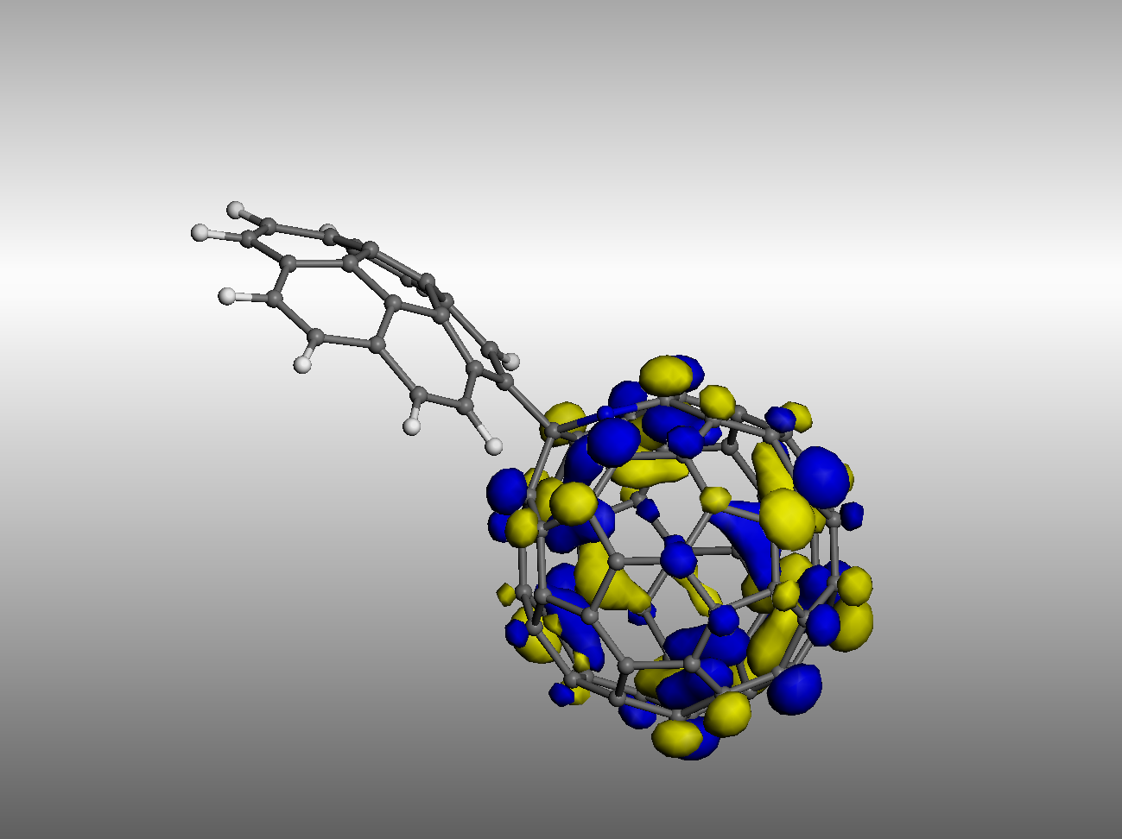
LUMO
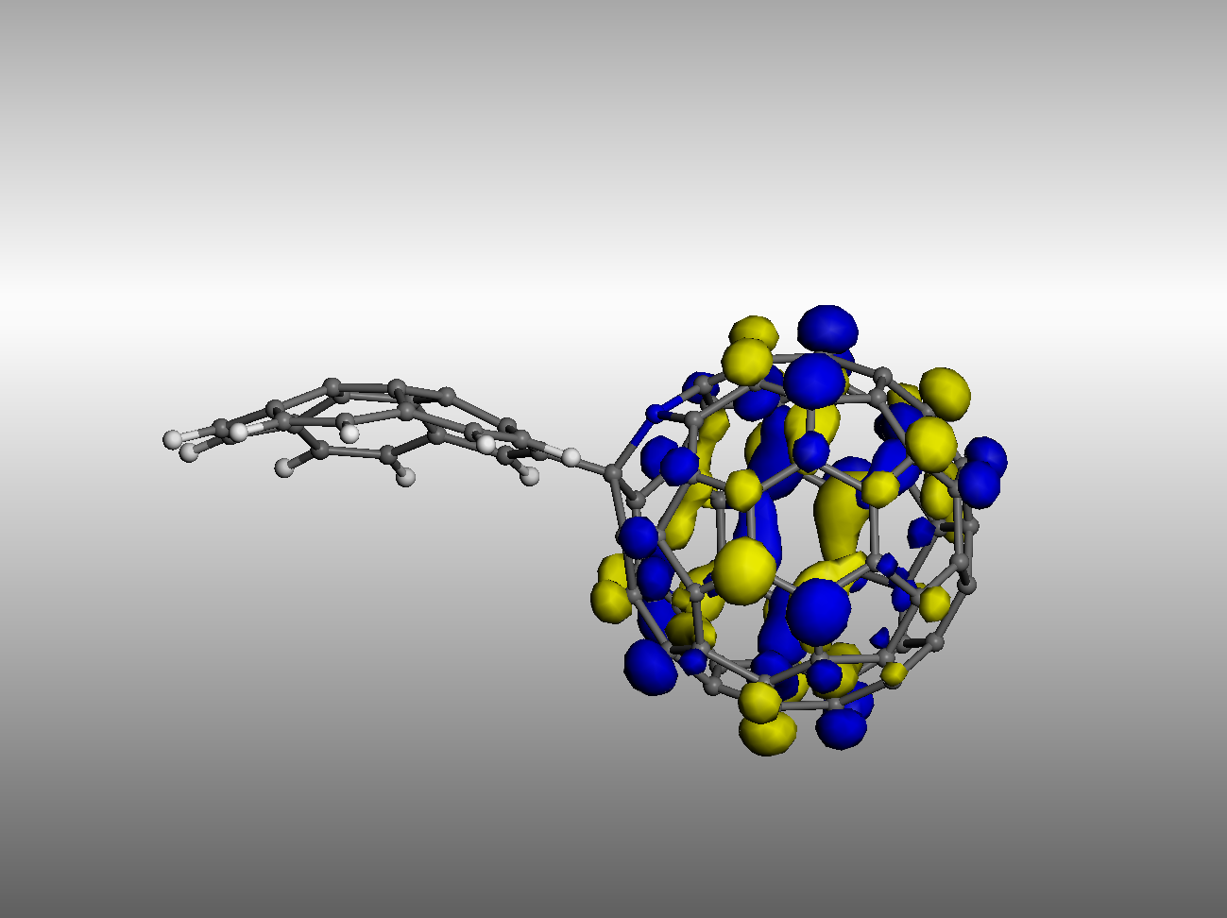
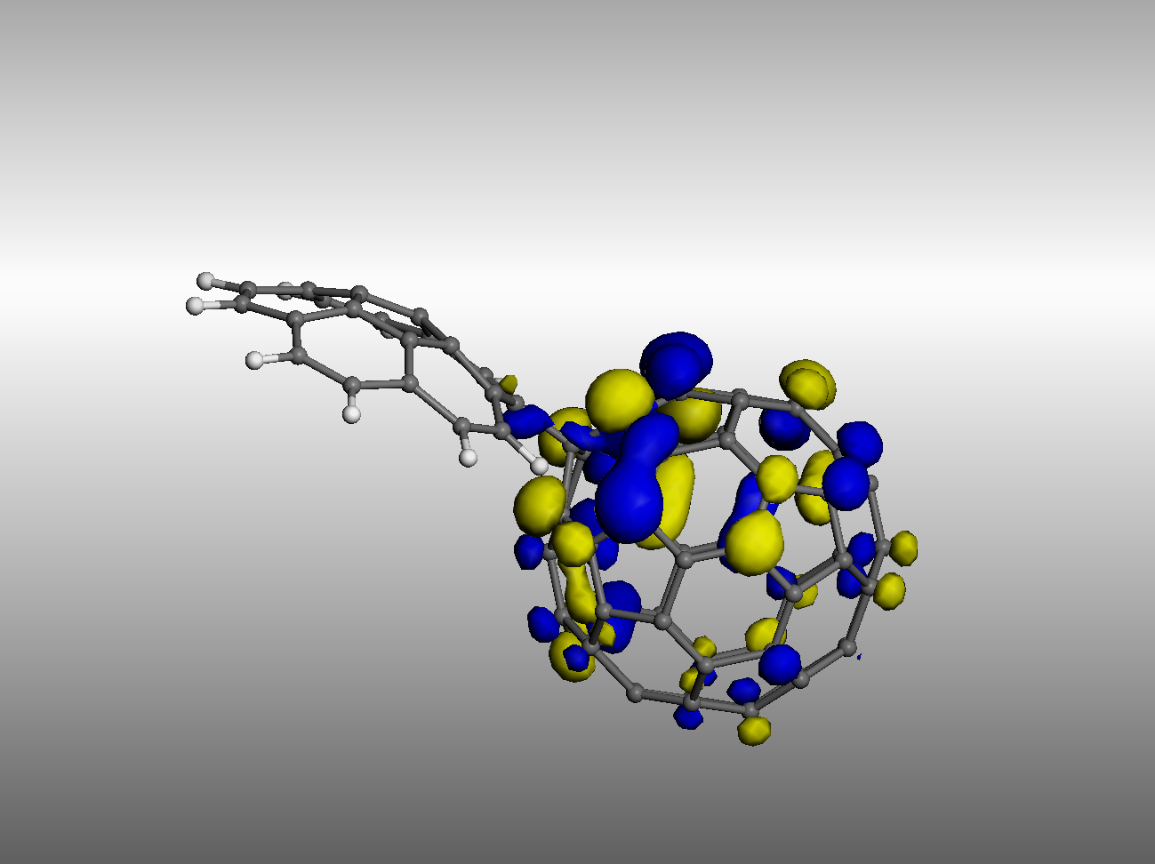
HOMO

HOMO-1
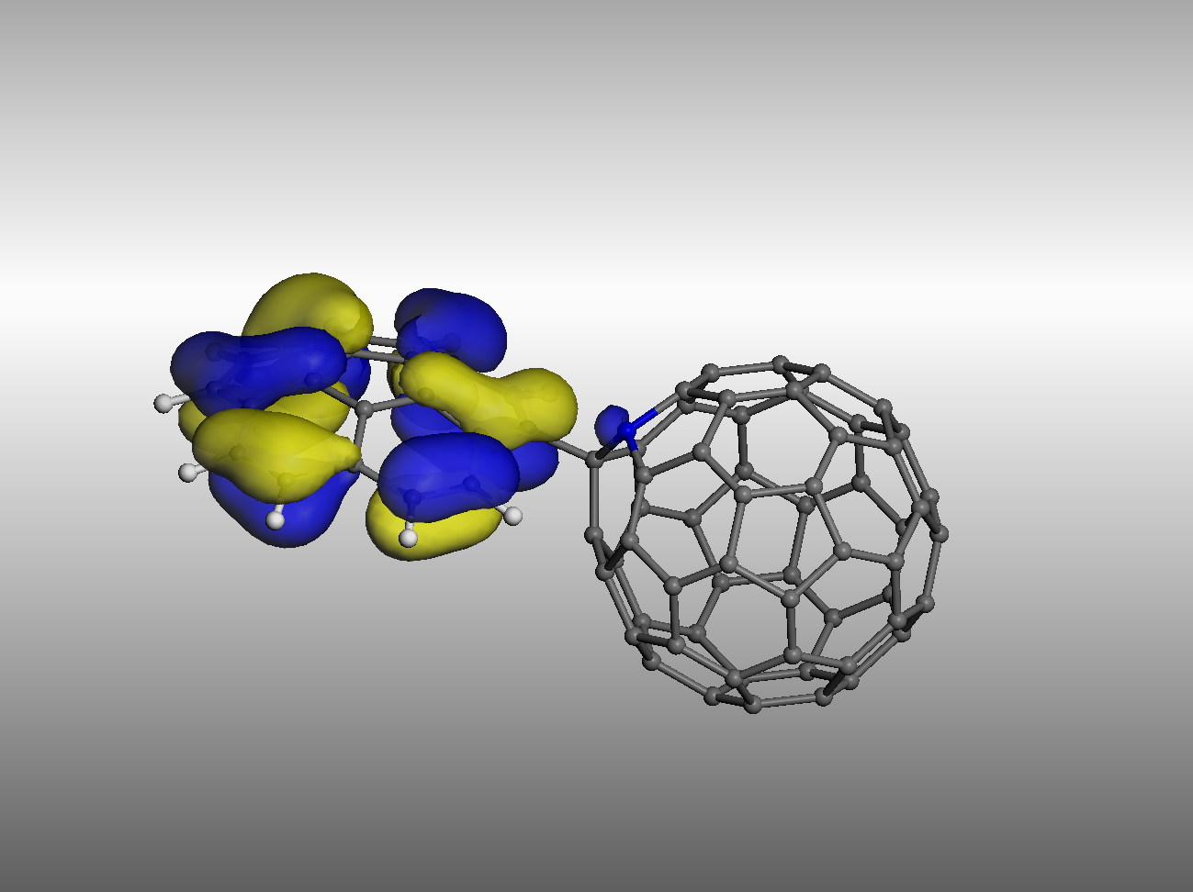
3

LUMO+1
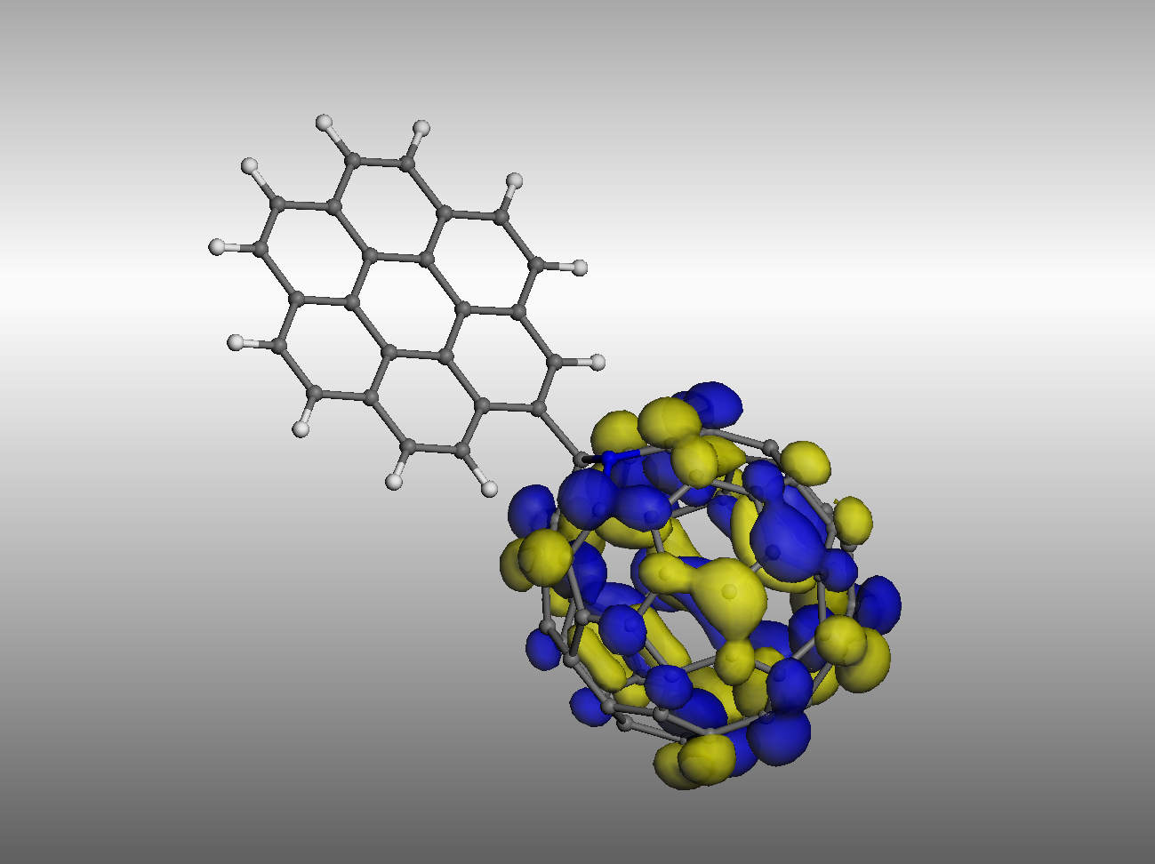
LUMO
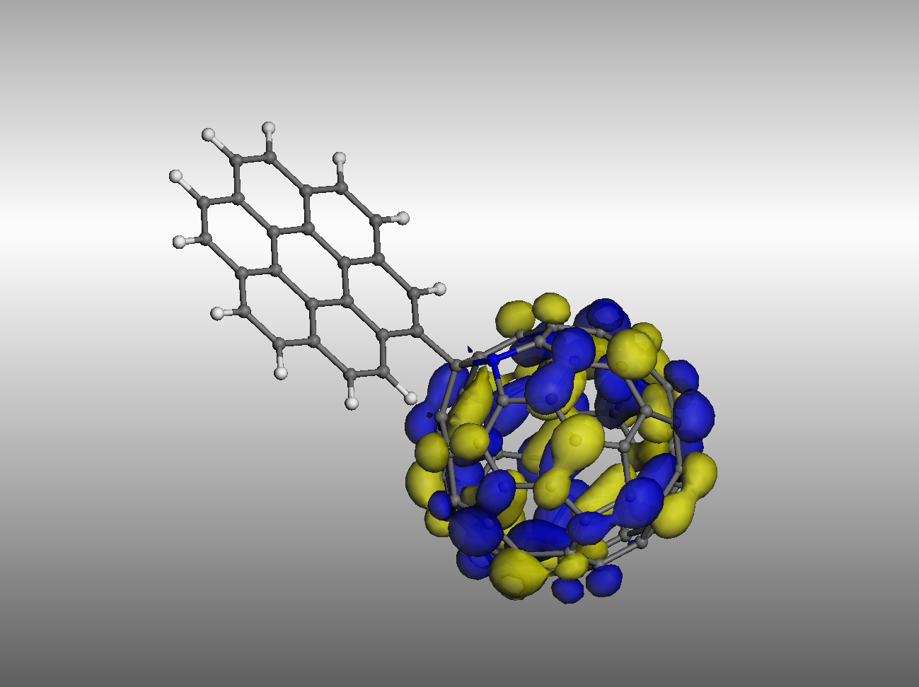
HOMO
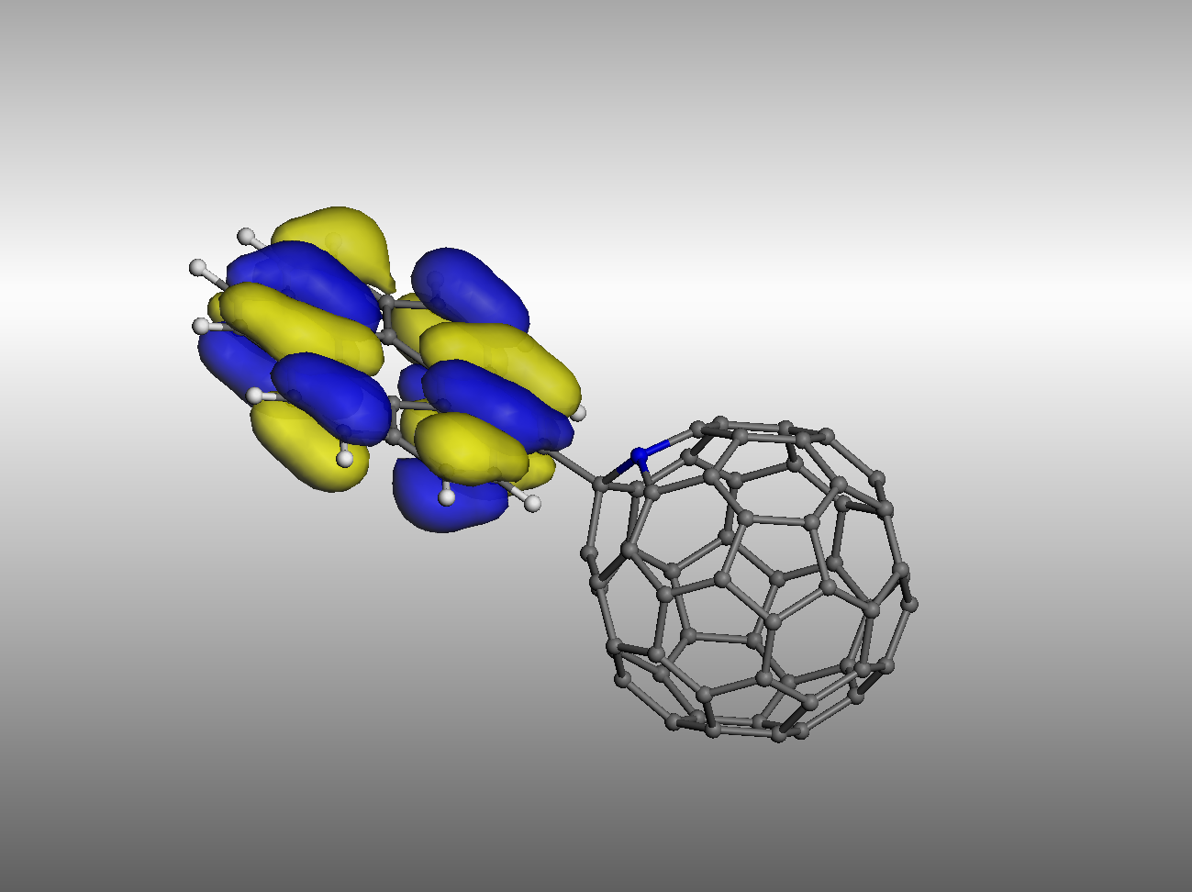
HOMO-1
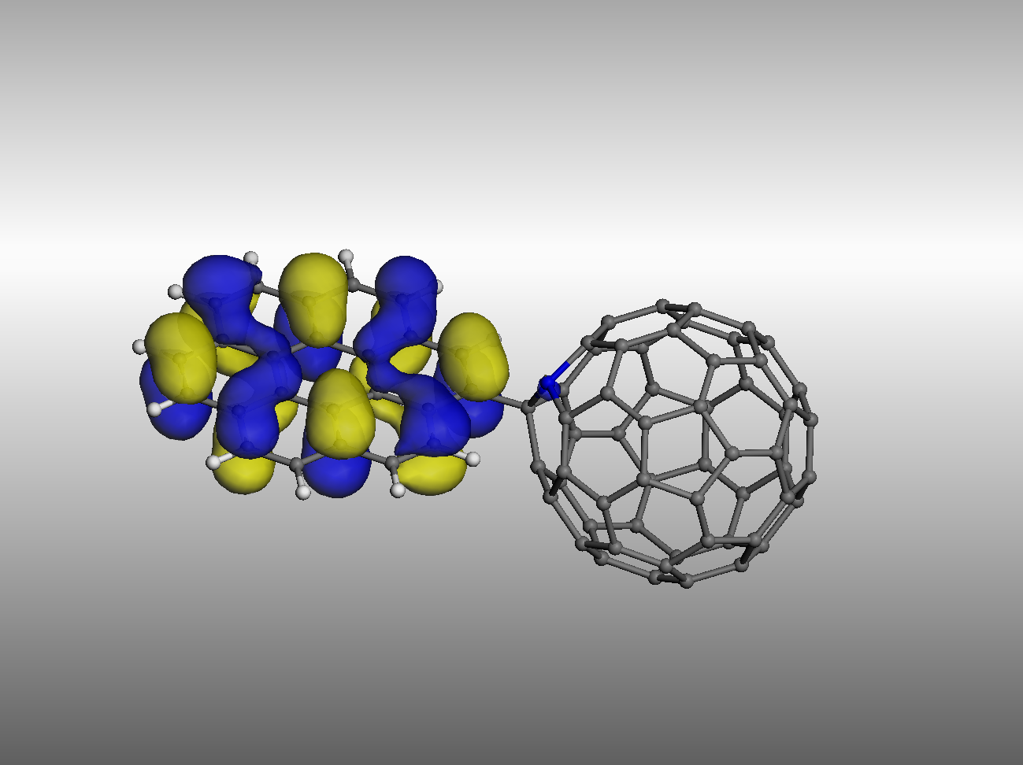
2

LUMO+1
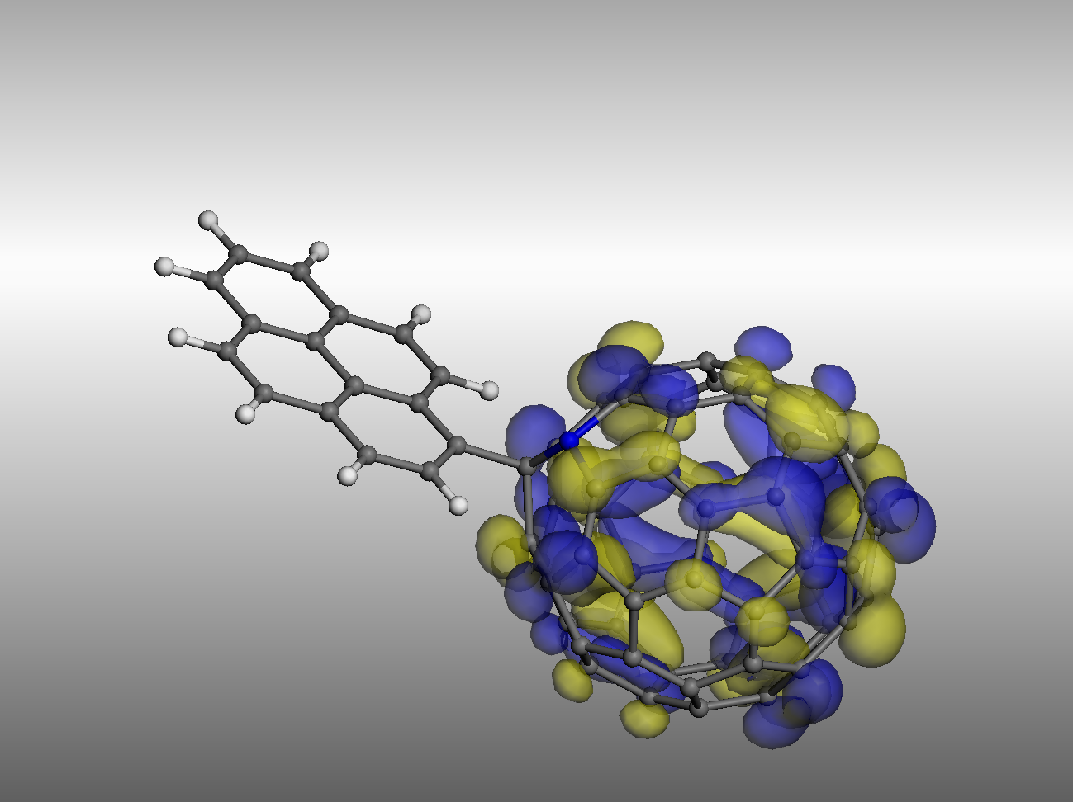
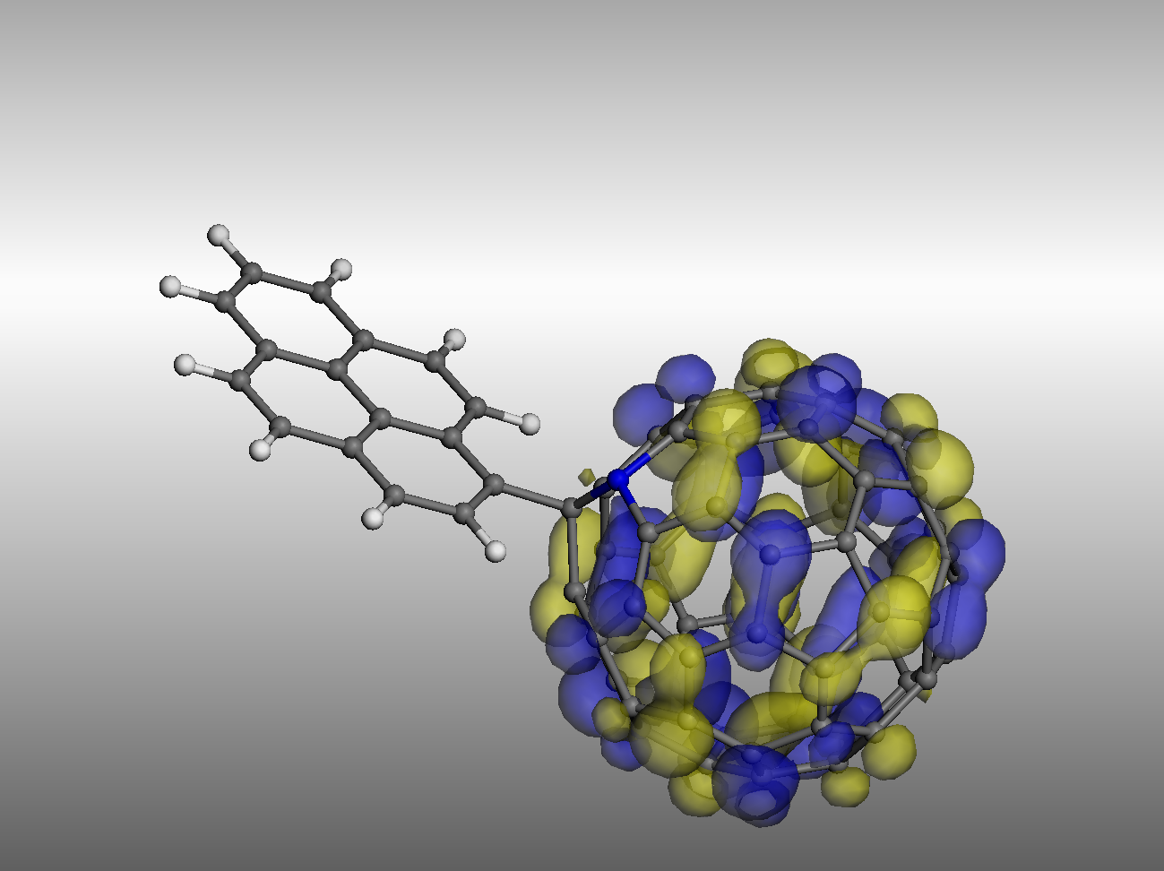
LUMO

HOMO
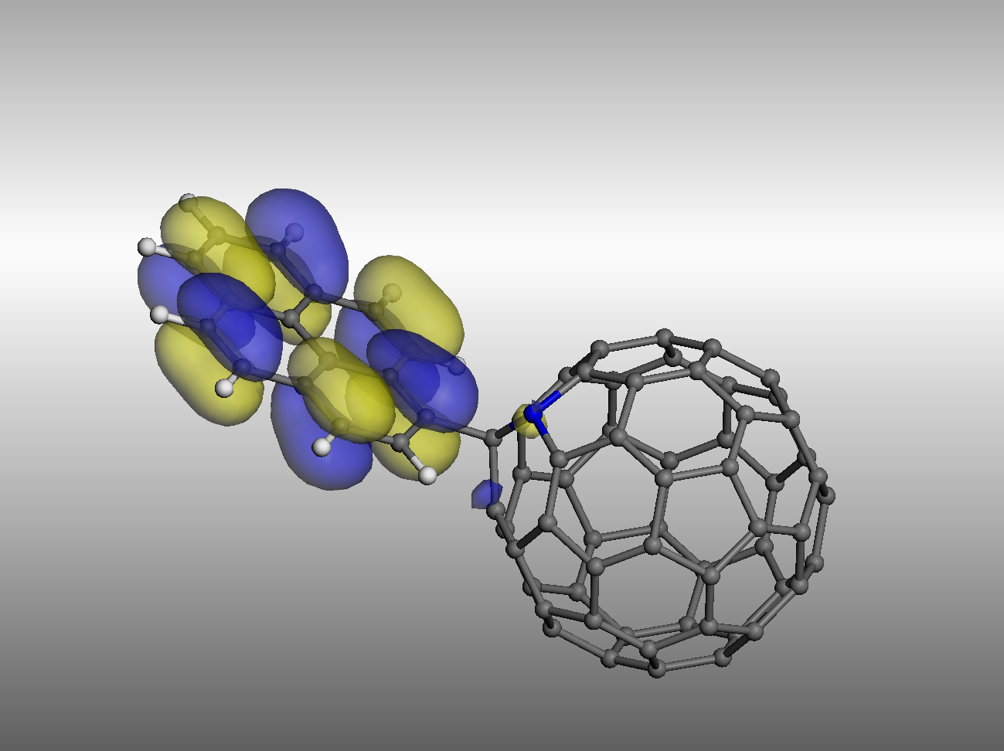
HOMO-1


