Helical supramolecular host with aquapores anchoring alternate molecules of helical water chains†
Supporting Information
Arindam Mukherjee, Manas K. Saha, Munirathinam Nethaji and Akhil R. Chakravarty*
Department of Inorganic and Physical Chemistry, Indian Institute of Science, Bangalore-560012, India. E-mail: arc@ipc.iisc.ernet.in
This submission was created using the RSC ChemComm Template (DO NOT DELETE THIS TEXT)
(LINE INCLUDED FOR SPACING ONLY - DO NOT DELETE THIS TEXT)

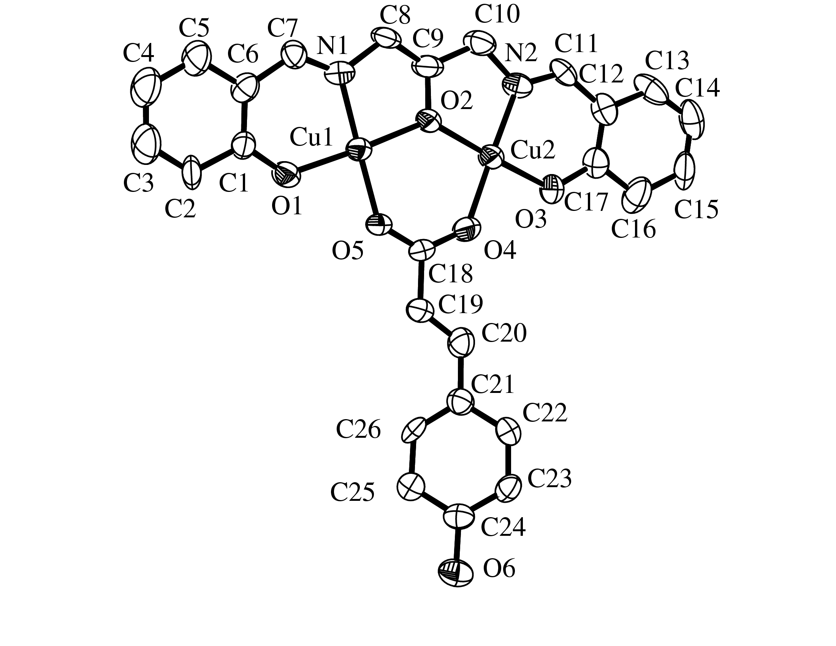
Figure S1. An ORTEP diagram of the complex in 1.2H₂O showing thermal ellipsoids at 50% probability level and the atom numbering scheme.
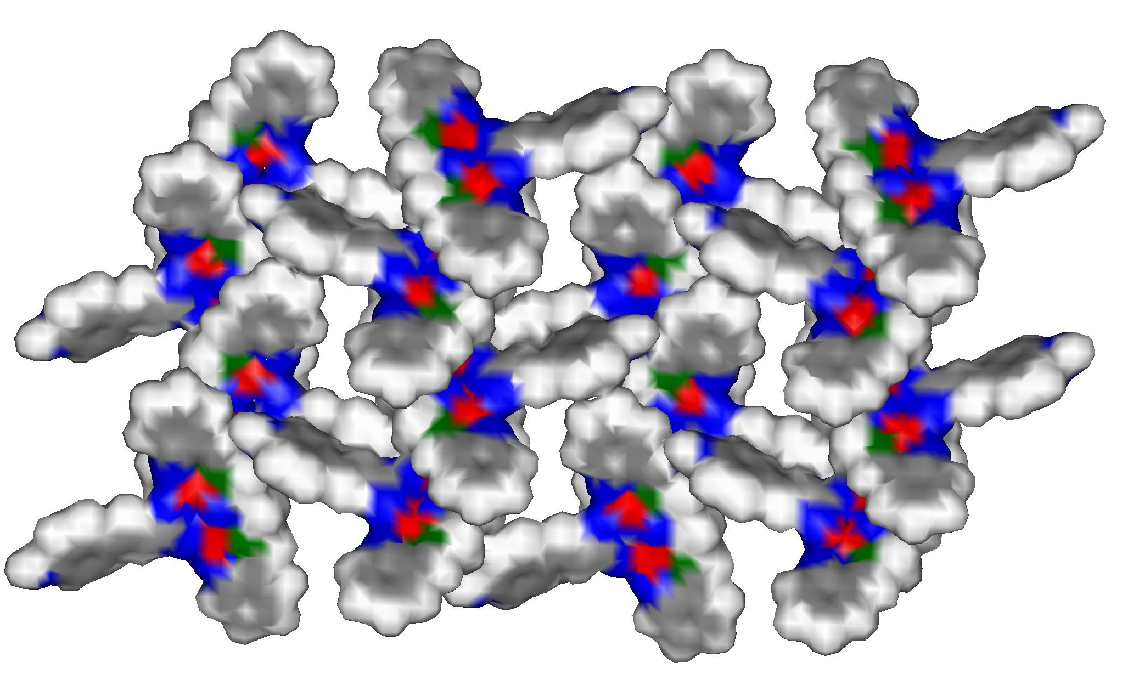
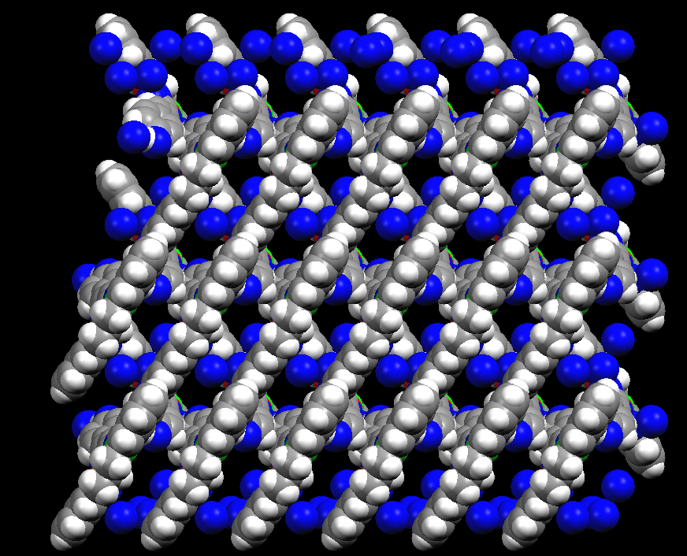
Figure S2. (a) The space filling model along a-axis displaying the channels of size 3.88 x 8.81 Å² from which the water chains are removed for clarity. (b) The space filling model along c-axis showing the empty channels of size 7.3 x 9.6 Å². Color code: copper, red; oxygen, blue; nitrogen, green; carbon, grey; hydrogen, light grey.

(a)
(b)
Figure S3. Plot showing χ_{M}T (per copper) versus T for the polycrystalline complex 1 in the temperature range 300-18 K.

Figure S4. A comparison of the XRD data of 1.2H₂O (a), the dehydrated sample (b) and the sample after rehydration (c). There is minor structural changes on removel of water molecules form the pore. The rehydrated sample shows similar pattern as of original 1.2H₂O sample.
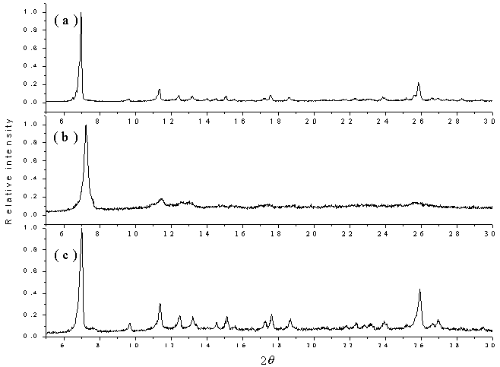
Figure S5. A comparison of the infrared spectra of the complex 1.2H₂O (blue) with the spectra recorded after dehydration (black) and rehydration of the dehydrated sample (red). The spectral features show that the helical host structure remains unaltered during dehydration and rehydration processes.
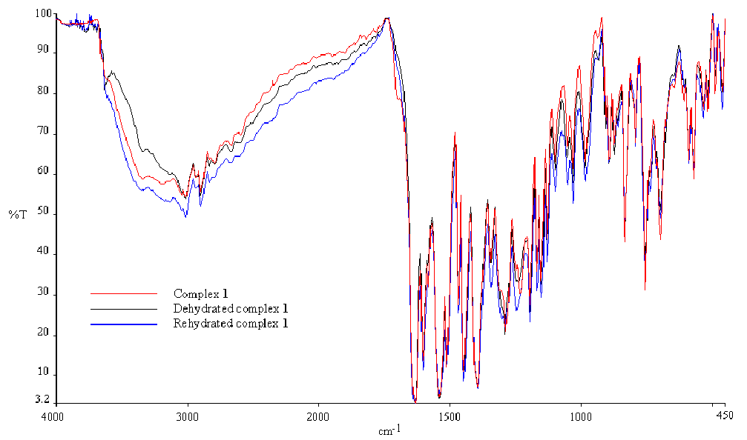
Table S1. Physicochemical data for complex 1.2H₂O

ª In KBr phase (s, strong; m, medium; w, weak; br, broad).
(1) FT-IRª , cm⁻¹ : | 3368br, 3059w, 3020w, 2931w, 2940w, 1635s, 1617m, 1534s, 1508s, 1451s, 1397s, 1296m, 1243m, 1198m, 1159m, 1129w, 987w, 897w, 840m, 760m, 703m, 566w, 456w, 429w.
(2) UV-vis in THF :  [λ_{max}, nm (ε, dm³ mol⁻¹ cm⁻¹)] | 639 (350), 377 (9,100), 277 (31,000), 247 (33,500), 227 (47,600).
(3) μ_{eff} (per Cu)^{b}, μ_{B} :  300 K  18 K | 1.67  0.36
^{b} Variable temperature magnetic susceptibility data for the polycrystall- ine sample in the temperature range 300-18 K. Theoretical fitting of the susceptibility data, shown in Fig. S3, was done by HDvV model using H = -2JS₁S₂ (S₁ = S₂ = ½) [ref: B. Bleaney and K. D. Bowers, Proc. R. Soc. London Ser. A, 1952, 214, 451; O. Kahn, Molecular Magnetism, VCH, Weinheim, 1993].
Table S2. Magnetic susceptibility data at various temperatures
T χ_{M}T
300.8212 0.34895
300.0858 0.3481
299.2899 0.35017
298.57446 0.35232
297.51414 0.35107
296.7162 0.34419
295.7793 0.34606
293.77652 0.34666
292.8897 0.34854
292.7427 0.35129
291.8865 0.33859
290.875 0.34614
289.8785 0.34496
288.11881 0.34286
287.9347 0.33976
286.20405 0.35203
284.22914 0.34392
283.34512 0.34285
281.113 0.34015
279.45545 0.34094
278.7368 0.33727
276.62659 0.34025
275.1163 0.33839
273.79774 0.33951
272.2681 0.34034
271.0038 0.33875
270.1242 0.34036
270.12253 0.34035
268.8861 0.33611
267.25601 0.33942
266.6857 0.33602
265.5942 0.33996
264.7369 0.33886
263.5703 0.33473
262.6563 0.33883
261.0866 0.33941
259.7686 0.3325
258.4577 0.32824
257.0931 0.33679
255.76379 0.32994
254.87977 0.33389
253.81895 0.3325
252.93494 0.33134
251.7038 0.32973
250.3632 0.32547
249.22207 0.33147
247.6189 0.33429
247.27723 0.33382
246.215 0.32993
244.8583 0.33056
242.50354 0.33223
242.092 0.32198
240.6597 0.3273
239.2602 0.32779
238.79066 0.32953
236.84583 0.32922

234.95523 0.32894
233.5839 0.32235
232.1809 0.32273
230.743 0.31843
229.3233 0.32335
227.8703 0.31902
227.29844 0.32276
225.58907 0.32034
224.9767 0.32172
222.58483 0.32497
222.0793 0.31757
221.70123 0.31703
220.6311 0.31771
218.8737 0.32174
216.019 0.31539
215.563 0.31472
214.98586 0.31818
213.3142 0.31357
213.21866 0.3177
212.1873 0.31192
211.3516 0.3128
211.27474 0.31691
209.2223 0.31174
208.9046 0.31127
207.9564 0.31193
207.56362 0.3155
206.6847 0.31003
205.6197 0.3146
203.208 0.31091
202.9098 0.31045
201.9184 0.30894
201.0547 0.30962
200.6245 0.30896
199.96466 0.31194
199.3135 0.30894
198.90434 0.30631
197.6013 0.30826
195.8137 0.30743
195.19321 0.30841
194.13289 0.30673
192.36569 0.30779
191.8064 0.30497
190.92 0.30547
189.1071 0.30446
188.6452 0.30372
187.51768 0.30565
186.71065 0.30247
186.3469 0.30561
183.5136 0.30096
181.93921 0.3002
180.2319 0.29918
179.11169 0.29553
178.2996 0.29419
177.802 0.30049
176.3208 0.29622
176.20226 0.29426
175.22385 0.29613
174.34025 0.29638
174.3101 0.29458
173.3425 0.29295
171.8046 0.29207
170.7793 0.29032
170.4524 0.29318
169.5688 0.29166
168.6852 0.29014
167.62488 0.28999
167.62488 0.28999
166.74128 0.28846
166.65488 0.29165
164.9621 0.28538
164.79736 0.2884
163.91376 0.28521
163.91376 0.28685
163.82603 0.2867
161.88119 0.28491
160.99717 0.28657
159.2231 0.27705
159.14232 0.28327
158.8198 0.27635
157.097 0.27806
156.3148 0.2798
156.1746 0.27799
155.16266 0.27929
153.5922 0.278
152.42696 0.27742
152.4075 0.27738
151.2051 0.27671
150.5993 0.27258
148.71583 0.27364
146.9788 0.2675
145.4611 0.26619
144.82799 0.26938
144.73126 0.26775
143.8884 0.26332
143.06079 0.26752
142.00047 0.26554
141.3759 0.26013
141.11687 0.26389
140.8071 0.26472
139.17295 0.26165
138.28935 0.26137
137.30552 0.25951
136.34543 0.25906
135.46183 0.25602
134.40151 0.25671
134.29986 0.25517
133.51791 0.25635
132.63431 0.25731
132.63431 0.25598
132.53182 0.25446
128.74647 0.25106
128.64215 0.24828
125.8133 0.24659
125.03534 0.24632
125.03534 0.24632
123.86846 0.24402
122.20782 0.24197
122.20782 0.24197
121.0396 0.23845
120.2639 0.23812
117.7414 0.23313
116.37606 0.23275
115.4173 0.22853
114.60886 0.22807
114.60886 0.23036
111.3799 0.22276
110.5363 0.21997
109.703 0.21831
107.0099 0.21723
106.2757 0.21361
105.3834 0.21182
104.18238 0.21149
103.5881 0.20821
102.6785 0.20638
101.7564 0.20453
101.35485 0.20575
100.8054 0.20363
98.52733 0.20001
96.94228 0.19485
95.91573 0.19375
94.63949 0.19212
93.86823 0.18961
93.75589 0.18939
91.74898 0.18533
90.80622 0.18252
86.15693 0.17231
86.11964 0.17052
83.70901 0.16407
83.32941 0.16583
81.25884 0.15927
80.50189 0.15778
79.87861 0.15496
79.44156 0.15412
78.52727 0.15156
77.16402 0.14815
76.61404 0.14403
75.73044 0.14465
75.63098 0.14143
73.78652 0.13872
72.60622 0.13287
71.8426 0.13219
69.33473 0.12688
68.13148 0.124
66.18756 0.11583
65.67863 0.11494
63.36004 0.10835
60.53252 0.09685
59.64892 0.09603
57.705 0.08829
55.76107 0.08141
53.81715 0.07857
52.93355 0.07464
52.04995 0.07183
50.10603 0.06564
49.22243 0.06153
48.16211 0.05924
47.27851 0.05673
46.21819 0.055
44.45099 0.04934
43.39067 0.04773
42.50707 0.04633
41.62347 0.04329
39.67955 0.03904
38.79595 0.03596
37.73563 0.03358
36.85203 0.0314
34.02451 0.02739
31.60066 0.02414
28.9604 0.02166
27.31023 0.02043
24.50495 0.01871
21.0396 0.0168
20.21452 0.01674
19.22442 0.01651
18.39934 0.01635
17.57426 0.01632

