Electronic Supplementary Information

A practical synthesis of an amphiphilic cyclodextrin fully substituted with sugar residues on the upper face†
Florenceª Sallas, Kenichi Niikura^{b} and Shin-Ichiro Nishimura^{b}*

ª Sapporo Laboratory for Glycocluster Project, Japan Bio-Industry Association, Sapporo, 001-0021 Japan. Tel/ Fax: +81-11-706-9039; E-mail: florence@glyco.sci.hokudai.ac.jp
^{b} Laboratory for Biomacromolecular Chemistry, Division of Biological Sciences, Graduate School of Science, Hokkaido University,Kita-Ku, Kita-21, Nishi-11, 001-0021, Sapporo, Japan. Fax: +81-11-706-9042; Tel: +81-11-706-9043; E-mail: shin@glyco.sci.hokudai.ac.jp

Selected data for 2: δ_{H} (CDCl₃, 400MHz) 5.28 (t, 7H, H-3), 5.03 (7H, H-1), 4.76 (dd, 7H, H-2), 3.97 (br, 7H, H-6), 3.73-3.57 (m, 21H, H-4, H-5, H-6), 2.37-2.11 (m, 28H, CH₂CO), 1.53 (s, 28H, CH₂-CH₂CO), 1.24 (s, 336H, CH₂), 0.86 (t, 7H, CH₃). δ_{C} (CDCl₃, 100MHz) 173.2, 171.7 (C=O), 96.3 (C-1), 77.2 (C-4), 70.7-70.0 (C-2, C-3, C-5), 51.4 (C-6), 34.1, 33.8 (CH₂CO), 31.9-22.7 (CH₂), 14.1 (CH₃). TOF-MASS (positive mode, trans-3-indole acrylic acid) 4667.51 [M+Na]⁺. Anal. Calc. for C₂₆₆ H₄₈₃ O₄₂ N₂₁. 2H₂O: C, 68.19 H, 10.48 N, 6.28 Found: C, 68.20 H, 10.40 N, 6.05%.

Selected data for 4: δ_{C} (pyridine d₅, 100MHz) 171.2 (C=O), 167.8 (NH-CO-NH), 102.3 (C-1, GlcNac), 78.3, 76.5(C-4, CD, GlcNac), 68.1 (O-CH₂), 62.7 (C-6, GlcNac), 57.4 (C-2, GlcNac), 40.6-39.0 (C-6, CD, CH₂-N), 35.6, 34.3 (CH₂CO), 32.3-19.4 (CH₂, CH₃NHAc), 14.1 (CH₂-CH₃). m/z (ESI) 6890.5 [M+5H]⁺ , 6687.3 [M+5H-GlcNac]⁺, 6484.2 [M+5H-2 GlcNac]⁺, calc. for C₃₇₁ H₆₇₉ O₉₁ N₂₁ M 6885.9. TOF-MASS (positive mode, trans-3-indole acrylic acid) 6926.20 [M+K]⁺. Anal. Calc. for C₃₇₁ H₆₇₉ O₉₁ N₂₁. 12H₂O: C, 62.69 H, 9.97 N, 4.14 Found: C, 62.73 H, 9.62 N, 3.94%.

Selected data for 5: TOF-MASS (positive mode, 2’, 4’, 6’-trihydroxyacetophenone monohydrate) 7094.62 [M+K]⁺.

Selected data for 6: Anal. Calc. for C₂₆₆ H₄₉₇ O₄₂ N₇. 6 H₂O: C, 69.83 H, 11.22 N, 2.14 Found: C, 69.92 H, 11.16 N, 2.05%.

Selected data for 7: δ_{H} (MeOH d₄, 400MHz) 8.30. (d, 2H, CH, Phe), 7.38 (d, 2H, CH, Phe), 4.35 (d, 1H, H-1), 3.85 (2H, m, H-3 and H-5), 3.68-3.59 (2H, m, H-2 and H-4), 3.45-3.40 (m, 2H, H-6), 2.89 (t, 2H, CH₂CO), 2.60 (t, 2H, CH₂CO), 1.95 (s, 3H, CH₃), 1.51-1.39 (m, 8H, CH₂). δ_{C} (MeOH d₄, 100MHz) 173.4, 172.0 (C=O), 126.1, 123.9 (CH, phenyl), 102.74 (C-1), 77.9, 76.1, 72.1 (C-4, C-5, C-3), 70.4 (O-CH₂), 62.8 (C-6), 57.4 (C-2), 40.4 (CH₂-N), 31.1- 26.8 (CH₂), 32.3-19.4 (CH₂), 23.0 (CH₃). m/z (FAB+) 542 [M+H]⁺, calc. for C₂₄ H₃₆ O₁₁ N₃ M 542. m/z (FABHR) 542.2368 [M+H]⁺, calc. for C₂₄ H₃₆ O₁₁ N₃ M 542.2346. TOF-MASS (positive mode, α-cyano-4-hydroxycinnamic acid) 564.13 [M+Na]⁺. calc. for C₂₄ H₃₅ O₁₁ N_{3,} M 541.23. Anal. Calc. for C₂₄ H₃₅ O₁₁ N₃. 1.5H₂O: C, 50.70 H, 6.69 N, 7.39 Found: C, 51.09 H, 6.55 N, 7.48%.

Selected data for 8: δ_{C} (pyridine d₅, 100MHz) 174.6-171.0 (C=O), 102.3 (C-1, GlcNac), 78.4, 76.6 (C-4, CD, GlcNac), 68.1 (O-CH₂), 62.8 (C-6, GlcNac), 49.0 (CH₂CO), 57.5 (C-2, GlcNac), 42.8-39.8 (C-6, CD, CH₂-N), 35.6, 34.4 (CH₂CO), 32.3-22.9 (CH_{2,} CH₃NHAc), 14.3 (CH₂-CH₃). TOF-MASS (positive mode, trans-3-indole acrylic acid) 7306.14 [M+5H+Na]⁺. Anal. Calc. for C₃₉₂ H₇₀₉ O₉₉ N₂₁. H₂O: C, 64.47 H, 9.79 N, 4.03 Found: C, 64.52 H, 9.99 N, 3.34%.

Selected data for 9: TOF-MASS (positive mode, trans-3-indole acrylic acid) 7287.07 [M+9H]⁺, 7443.2 [M+2H+Gal]⁺, 7607.8 [M+3H+2Gal]⁺, 7772.4 [M+5H+3Gal]⁺, 7931.9 [M+2H+4Gal]⁺, 8095.6 [M+2H+5Gal]⁺, 8262.1 [M+6H+6Gal]⁺, 8422.0 [M+3H+7Gal]⁺.

Preparation of liposomes.
A mixture of compound 4 or 8 and DOPC was suspended in pure water heated and sonicated at 50ºC for 15 min with a probe-type sonicator. The warm, clear suspension of liposomes was then cooled to 4ºC.

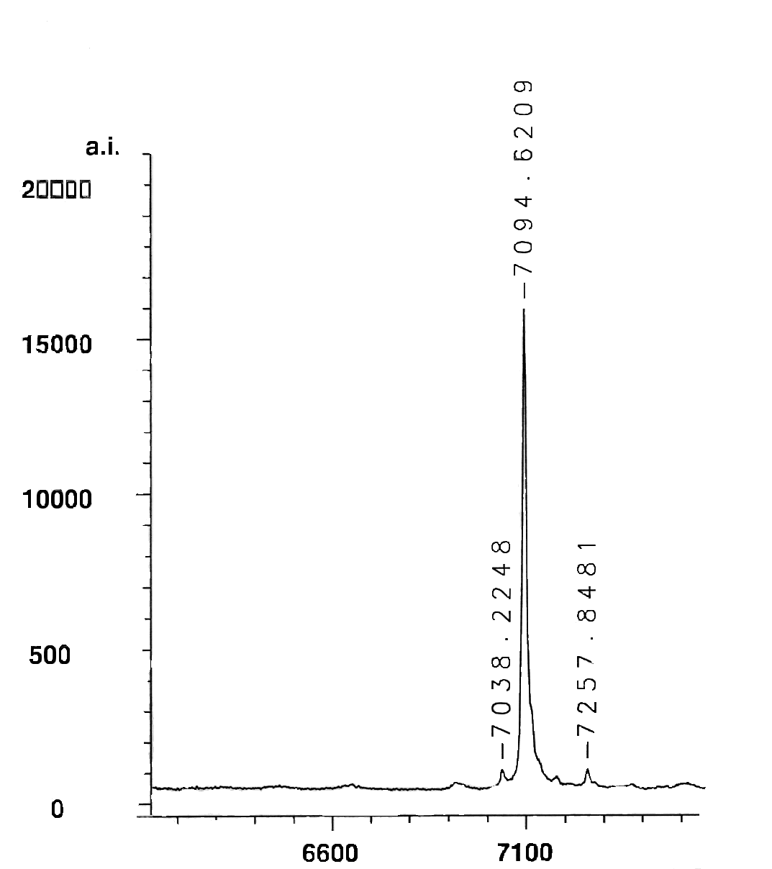

Fig 1: MALDI-TOF spectrum of 5
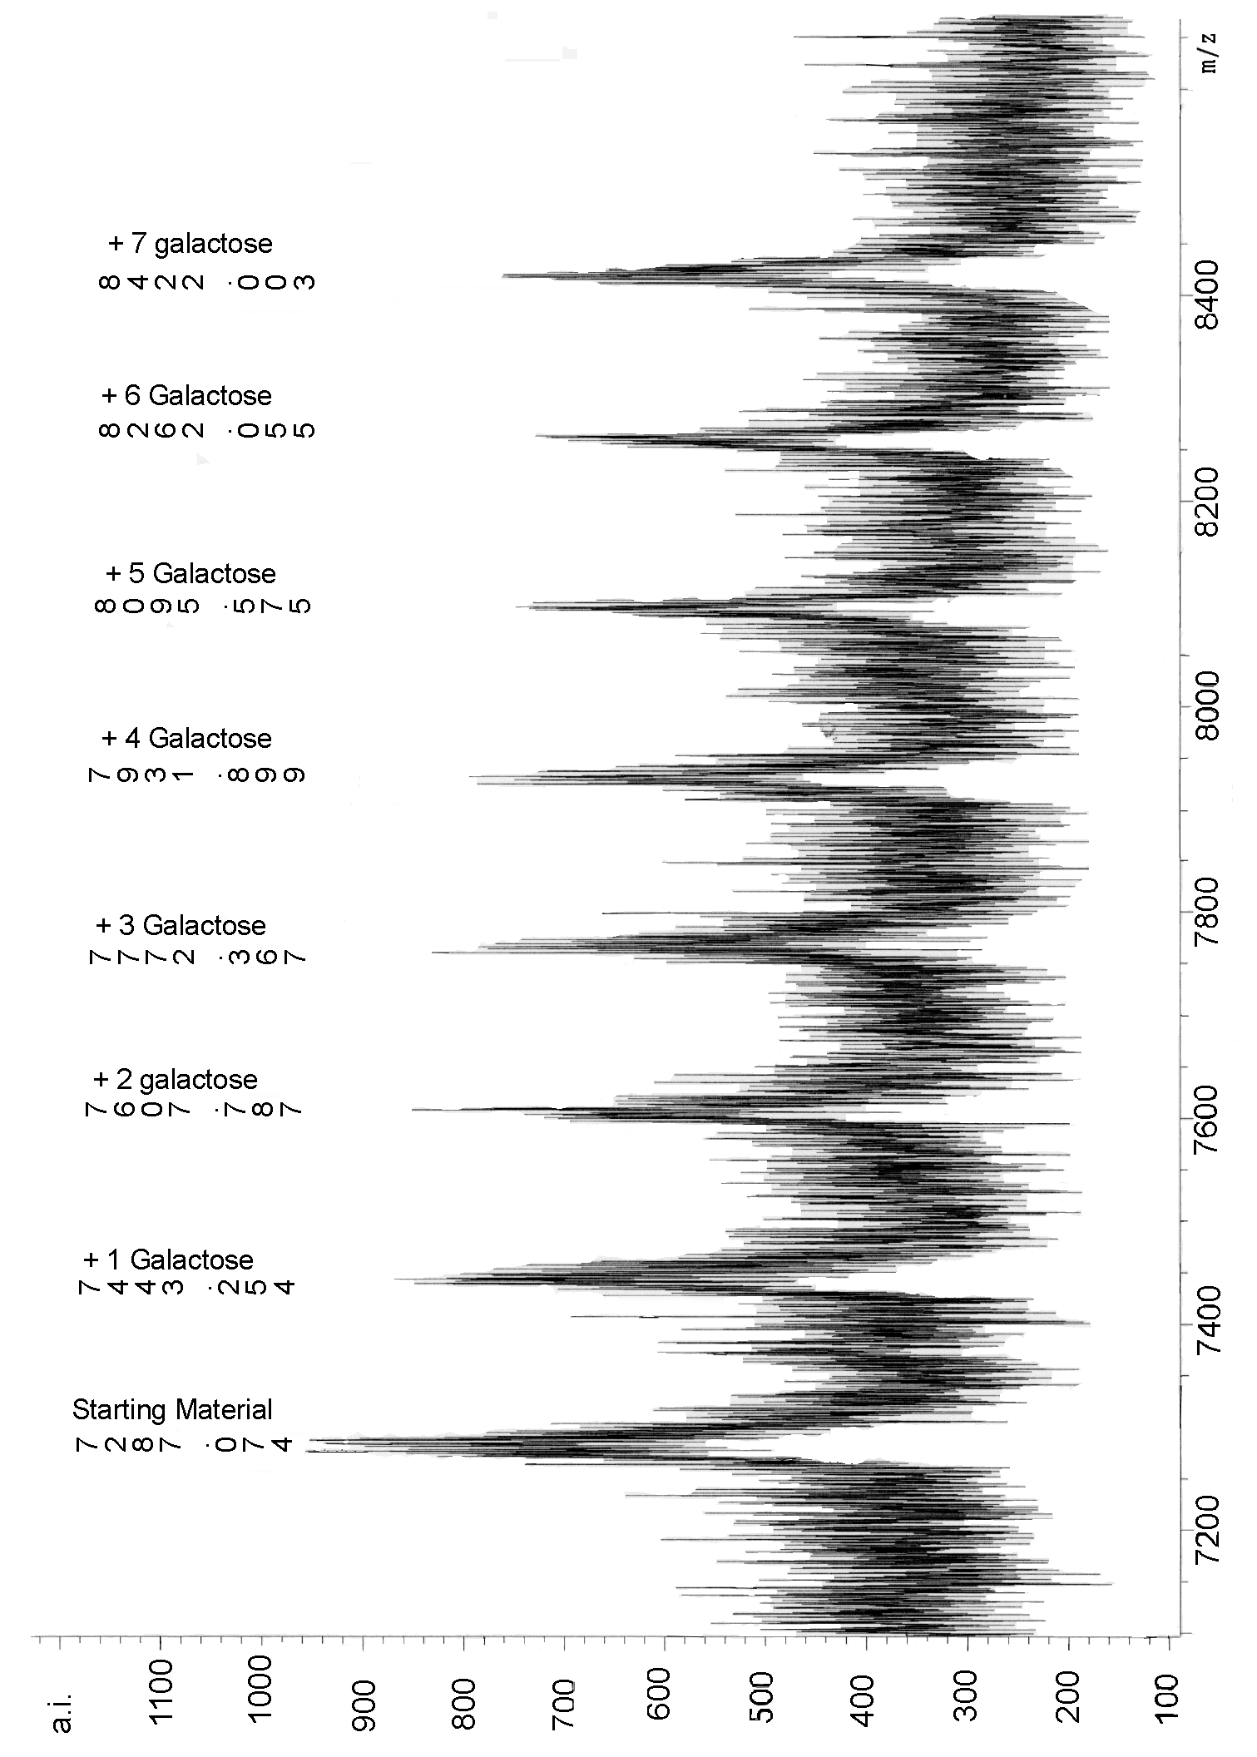

Fig 2: MALDI-TOF spectrum of 9

