Supporting information:
A powder X-Ray pattern of crystals homogenous sample (giving below) showed that all reflections are indexed in the monoclinic cell of [Cu(O₂C-(CH₂)₃-NH₃)₂]PbBr₄ given above. 1 melts at 194 °C and rapidly decomposes in two steps up to 570 °C. Single crystals EDX microanalysis (SEM) give the following average Cu, Pb, Br atomic ratio (theoretical values appear in brackets) : Cu 16.1 (16.7), Pb 16.7 (16.7); Br 67.5 (66.7)

Powder X-Ray pattern of blue-green sample of [Cu(O₂C-(CH₂)₃-NH₃]PbBr₄
(0 0 2)
(0 1 1)
(1 0 -1)
(1 1 1)
(1 1 0)
(0 0 4)
(1 0 1)
(2 0 0)
(0 1 4)
(0 2 0)
(1 1 4)
(0 0 6)
(0 1 6)
indexation of the twelve first peaks together with the highest one in the monoclinic cell a =8.4581, b=8.3703, c=26.9075, β=98.62
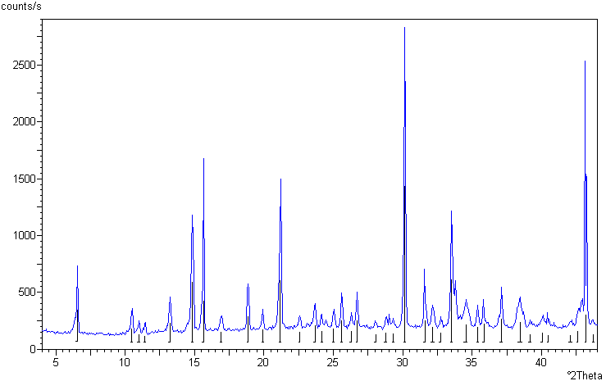
(2 2 -2)

