Electronic Supplementary Information

Energy-storable dye sensitized solar cell with a polypyrrole electrode

Hiroki Nagaiaª and Hiroshi Segawa*^{a,b}
ª Department of Applied Chemistry, Graduate School of Engineering, The University of Tokyo,
^{b} Department of Chemistry, Graduate School of Arts and Sciences, The University of Tokyo, 3-8-1 Komaba, Meguro-ku, Tokyo 153-8902, Japan

- Surface SEM image of TiO₂ film.

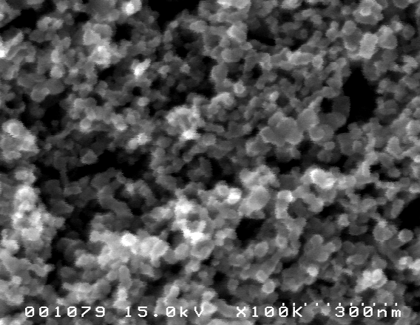

- Photocurrent-voltage curve of the DSSC and ES-DSSC. Polymerization electricity of polypyrrole film is 200mC/cm².

- Several charging/discharging cycles of the ES-DSSC. Polymerization electricity of polypyrrole film is 50mC/cm². Each photo-charging time is 15min.

