Supplementary data

Preparation and Structure Characterization:
1⋅Er: The pH value of an aqueous solution (10 ml) of Er(ClO₄)₃⋅6H₂O (0.574g, 1mmol) and glycine (0.150g, 2mmol) was adjusted to about 7.0 by slow addition of 0.1 M NaOH solution. After two hours of being heated and stirred at 60°C, Cu(ClO₄)₂⋅6H₂O (0.741g, 2mmol) was added. Then the pH value of the solution was again adjusted to about 6.6. After two hours of stirring, the solution was filtrated and placed in a desiccator filled with phosphorus pentaoxide. Blue crystals were obtained several weeks later. Yield: 0.31g, 23%. Element analysis (%) calcd for C₄₀H₂₁₀Cl₂₄Cu₂₇Er₆N₂₀Na₂O₂₁₆: C 5.97, H 2.63, N 3.48; found: C 5.74, H 2.49, N 3.79.
Crystal data of 1⋅Er: Na₂[Er₆Cu₂₇(Gly)₂₀(μ₃-OH)₃₀ (H₂O)₂₂(ClO₄)] (ClO₄)₂₃ (H₂O)₂₈, Mr = 8044.20, triclinic, P-1, a = 17.3348(3), b = 18.0854(2), c = 20.76920(10) Å, α = 106.9130(10), β = 100.5850(10), γ= 105.8490(10)°, V= 5742.67(12) Å³, Z= 1, ρ = 2.326 g cm⁻³, 2θ_{max} = 50.12°, (-20 ≤ h ≤10, -21 ≤ k ≤ 21, -24 ≤ l ≤ 24), T = 293(2)K, 29441 measured reflections. R1= 0.0735 for 15070 reflections (I>2σ(I)), ωR2 = 14.80 for 19927 independent reflections (all data) and 1527 parameters. Gof = 1.146. Several oxygen atoms from ClO₄⁻ were treated to be isotropic. Hydrogen atoms on carbon and nitrogen atoms were added geometrically and not refined, no attempt was made to locate the hydrogen atoms of water.
Intensity data were collected on a Siemens Smart/CCD area-detector diffractometer with Mo-Kα radiation (λ=0.71073Å). Data reductions and cell refinements were performed with Smart-CCD software ^{[1]}. The structures were solved by direct methods using SHELXS-97^{[2]} and were refined by full-matrix least squares methods using SHELXL-97.

[1] XSCANS (Version 2.1), Siemens Analytical X-Ray Instruments Inc., Madison, WI, 1994.
[2] G. M. Sheldrick, SHELXL-97, Program for X-ray Crystal Structure Refinement; University of Göttingen: Göttingen, (Germany), 1997.

Structure Figures:

Figure S1. Coordination polyhedron of Er³⁺ ion.
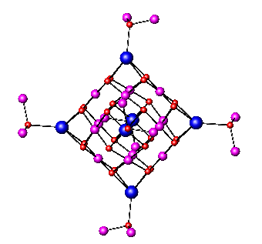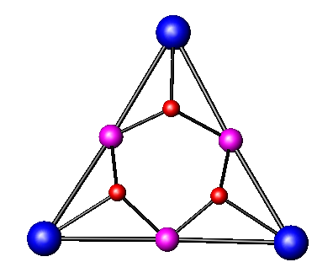
(a) (b)
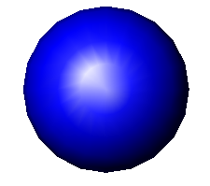, Er;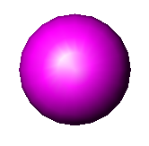, Cu; 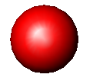, O
Figure S2. (a) The metal-hydroxide framework of the Er₆Cu₂₄ node of 1⋅Er; (b) the structure of one of the faces of the octahedron.

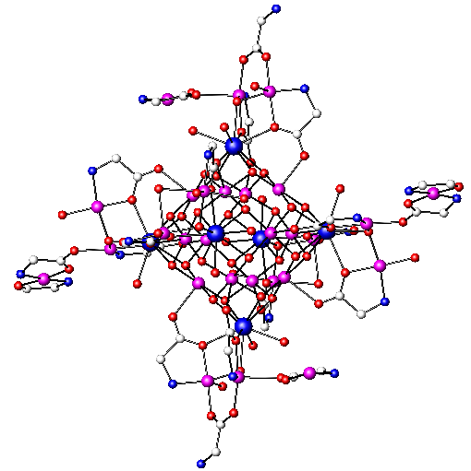
, Er;, Cu; 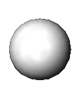, C; 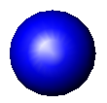, N; , O
Figure S3. The structure of the cation of 1⋅Er (the captured ClO₄⁻ ion is omitted for clarity).

Figure S4. The structure of one of vertices (Er1) of the octahedron of 1⋅Er. (ellipsoids at 25% probability).

Figure S5. The structure of one of vertices (Er2) of the octahedron of 1⋅Er. (ellipsoids at 25% probability).

Figure S6. The structure of one of vertices (Er3) of the octahedron of 1⋅Er. (ellipsoids at 25% probability).

Physical Properties
Figure S7. Temperature dependence of the electrical conductivity of 1⋅Er.

Figure S8. Temperature dependence of magnetic susceptibility of 1⋅Er. : 2-300K at 5000G : 2-300K at 2000G.

