Electronic Supplementary Information
Controlled Protein Assembly On A Switchable Surface
Ying Liu, Li Mu, Baohong Liu, Song Zhang, Pengyuan Yang, Jilie Kong*
.Department of Chemistry, Fudan University, Shanghai 200433, P.R.China

1. Preparation of LD-MHA-SAMs-n ( low-density-MHA-SAM)
1.1 Chemicals and Reagents
The following chemicals were used as obtained: The β-CD was purchased from shanghai chemical reagents company of China, α-,γ-CD was from Fluka Chemical, 16-Mercaptohexa-decanoic acid (MHA) was purchased from ALDRICH. All others were analytical reagents. Ultra-purified water ( >18 MΩ) was used in all experiments.
1.2 Synthesis of the inclusive complexes (n-CD-MHA)
20 mg MHA was added into the aqueous solution of 270 mg α-CD (for β-CD was 315 mg and for γ-CD was 360 mg) with a molar ratio of 1:4. The resulting mixture was kept in an oil bath (40±0.1℃) with stirring for more than 48 h, and then cooled to room temperature and filtered for further using.
  - ¹H NMR spectra of α, β, γ-CD and MHA-n-CD
The high-resolution ¹H NMR spectra were recorded on a Bruker-500 MHz Spectrometer at room temperature. n-CD-MHA and n-CD were dissolved in D₂O.

Evidences of the inclusive compounds.

Figure SI-1. ¹H NMR spectra of β-CD and MHA-β-CD.

β-CD

MHA-β-CD

The signals recorded in Figure SI-1 showed the significant up-field shift for the internal H-3 and H-5 protons (in Scheme SI-1) , which were more sensitive to the complexation effect than the H-1,H-2,H-4 protons located on the outside of the host cavity. The signals of the H-6a and H-6b were also shifted upfield but less than for the H-3 and H-5 protons. The shifts of these protons to high field displayed increasing shielding during complex formation of MHA-β-CD, as a result of the release of the water molecules from the cavity which were replaced by the apolar alkyl chain of the guest, i.e. MHA. This was basically consistent with the phenomena observed by Bojinova T. et al.( Bojinova T.; Coppel Y.; Viguerie N. L.; Milus A.; Rico-Lattes I.; Lattes A. Langmuir 2003, 19, 5233-5339.) For MHA-α-CD and MHA-γ-CD, similar up-field shift were also observed as shown in Figure SI-2 and Figure SI-3. Detailed data for all three inclusive compounds were listed in Table SI-1.
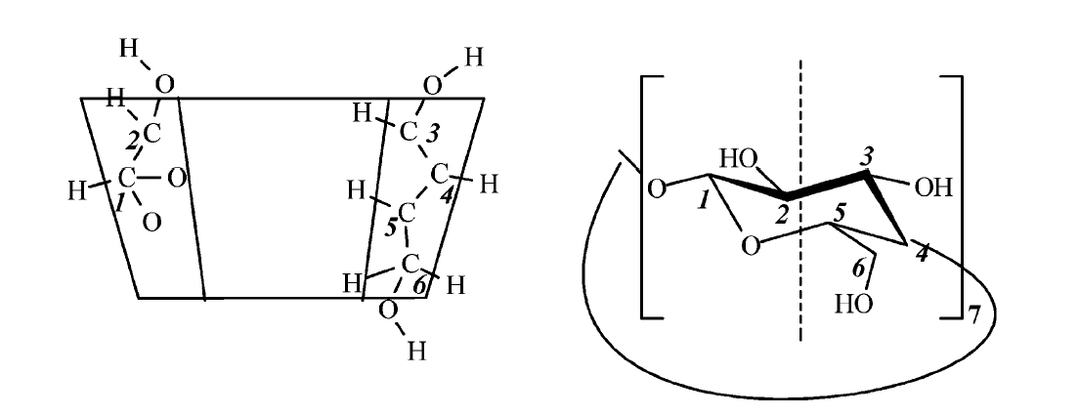

Scheme SI-1. Structure for β-CD and the inside/outside orientation of the protons.

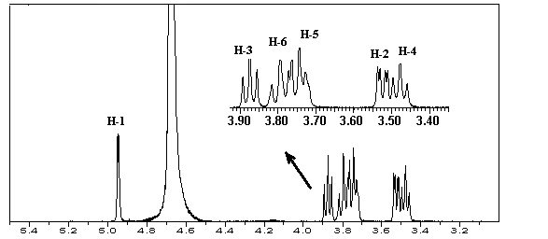
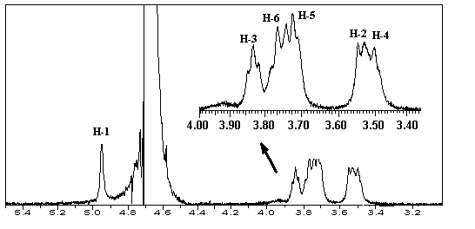
α-CD
MHA-α-CD

Figure SI-2. ¹H NMR spectra of α-CD and MHA-α-CD

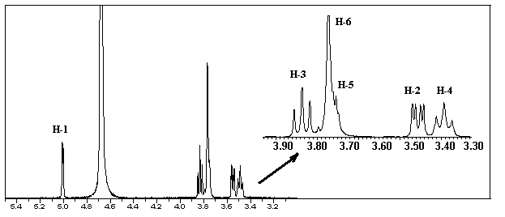
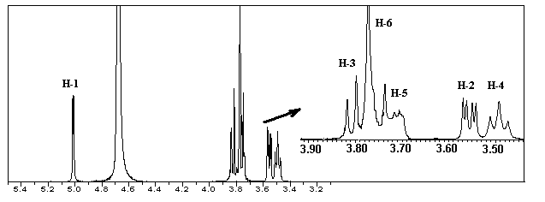
Figure SI-3. ¹H NMR spectra of γ-CD and MHA-γ-CD
γ-CD

MHA-γ-CD

Table SI-1. Chemical shifts in ppm of the protons of n-CD alone and upon inclusion complexation of MHA from ¹H NMR (500 MHz) Analysis in D₂O.

n-CD H | H-1 | H-2 | H-3 | H-4 | H-5 | H-6
α-CD | 4.9484 | 3.5366 | 3.8928 | 3.4773 | 3.7437 | 3.7633
MHA-α-CD | 4.9482 | 3.5362 | 3.8322 | 3.4825 | 3.6855 | 3.7599
β-CD | 4.9380 | 3.5444 | 3.8685 | 3.4992 | 3.7290 | 3.7527
MHA-β-CD | 4.9369 | 3.5202 | 3.7094 | 3.4871 | 3.5884 | 3.6452
γ-CD | 5.0108 | 3.5636 | 3.8506 | 3.5059 | 3.7496 | 3.7676
MHA-γ-CD | 5.0065 | 3.5598 | 3.7852 | 3.5016 | 3.6792 | 3.7583

1.4 Assembly of n-CD-MHA on Au surface to get n-CD-MHA-SAM
The QCM oscillators (purchased from CH Instrument, with gold disk area of A = 0.2043 cm²) were used as Au electrodes to prepare all SAMs in this work. The assembly of n-CD-MHA was realized by layer-by-layer procedure, i.e. immersing Au in 3.466 mM n-CD-MHA for 16 hours followed by thoroughly washing by distilled water and stored for further using.
  - Removal of n-CD to get LD-MHA-SAM-n
Different kinds of organic solvent ( including DMSO, n-butanol, ethanol and etc.) were tested for the dissociation of the inclusive complexes following the similar strategy reported previously. [(1). Connors K. A.; Sun S.. J. Am. Chem. Soc. 1971,.93,7239-7244. (2) Pitha J.; Hoshino T. Int J Pharm.1992, 80, 243-251.]. The n-CD were found efficiently washed out with absolute ethanol by continually rinsing for more than 5 min. followed by immersing in absolute ethanol for another 25 min. Then the resulting LD-MHA-SAM-n were blown dry with nitrogen gently for further experiments. The removal of n-CD was confirmed by QCM (see Figure 4) , CV (see Figure SI-5) , IMP (see Figure SI-6a,6b,6c) , FL ( see Figure SI-7a, 7b) and MALDI-TOF-MS (see Figure SI-8, 9, 10).

  - Protein assembly at controlled potential on LD-MHA-SAM-n
The prepared LD-MHA-SAM-n were immersed in PBS buffer (pH = 7.4) containing 1.0 mg/L Avidin and 0.5 mg/L Streptavidin at applied potential of –0.3 V, + 0.3 V and at open circuit for 30 min respectively and then thoroughly rinsed by ultra purified water and blow it dry with N₂ for further QCM and FL measurements.

2. Characterization of LD-MHA-SAM-n and Protein-LD-MHA-SAM
2.1 QCM measurement
The QCM measurement was performed with CHI-400 Electrochemical Crystal Microbalance (CH Instrument, Austin, TX, USA).
Figure SI-4. QCM measurement response for LD-MHA-SAM-2 (line a) and HD-MHA-SAM (line b) upon rinsed in absolute ethanol for 30 min.

Table.SI-2 Absolute mass change for the surface loading of protein assembled

Protein Assembly  Types of SAM |  | Mass change for the surface loading of protein assembled
 |  | Avidin |  |  | Streptavidin
 |  | Eappl=0.3V | Eappl=0V | Eappl=-0.3V | Eappl=0.3V | Eappl=0V | Eappl=-0.3V
MHA-SAM-1 | Δf(Hz) | 19.2 | 63.2 | 104.3 | 49.7 | 34.5 | 29.3
MHA-SAM-1 | Γ₂(ng/cm²) | 122.2 | 402.2 | 664.3 | 316.3 | 219.5 | 186.4
MHA-SAM-2 | Δf(Hz) | 14.4 | 42.2 | 73.2 | 30.6 | 25.1 | 18.9
MHA-SAM-2 | Γ₂(ng/cm²) | 91.6 | 268.5 | 465.8 | 194.7 | 159.7 | 120.3
MHA-SAM-3 | Δf(Hz) | 10.7 | 23.4 | 58.6 | 17.0 | 11.2 | 7.30
MHA-SAM-3 | Γ₂(ng/cm²) | 68.1 | 148.9 | 372.9 | 108.2 | 71.3 | 46.5
HD-SAM | Δf(Hz) | 135.3 | 137.1 | 140.7 | 75.0 | 71.7 | 70.4
HD-SAM | Γ₂(ng/cm²) | 861.4 | 872.7 | 895.8 | 477.3 | 456.2 | 448.1

2.2 CV and IMP
CV
After being cleaned thoroughly, the gold electrode was immediately immersed in the inclusive complexes solution for 24 h at –4℃. The n-CD was removed from the solution and rinsed vigorously with distilled water, and blown dry with nitrogen gently.
The CV measurements were carried out with CHI-1030 Electrochemical Workstation with three electrodes, and Hg∣Hg₂Cl₂∣KCl as the reference electrode, a platinum wire as the counter electrode and the modified electrode(or bare gold electrode)as working electrode. The solution containing 2.5 mM K₃Fe(CN)₆ / K₄Fe(CN)₆ and 0.1 M KCl was used as electrolyte.
The modified electrode was measured after being rinsed in absolute ethanol for 1 min, 5 min, respectively.

4
3
2
1
Figure SI-5. Cyclic voltammograms for LD-MHA-SAM-2 rinsed in absolute ethanol for 0 min (1), 1 min (2), 5 min (3) and for bare Au (4).

IMP
Ac impedance analysis was performed using an impedance gain/phase analyzer from EG&G PRINCETON APPLIED RESEARCH INSTRUMENTS (Potentiostat Galvanostat Model-273A). All data were recorded at amplitude of 5 mV. The magnitude of the impedance/Z(f)/ and the phase angle Φ(f) between voltage and current were recorded in the frequency range from 10⁻¹ Hz to 10⁴ Hz. Data analysis was carried out by nonlinear least square (NLLS) fitting using the EQUIVCTR.PAS (EQU) program based on R(RC) model.
All impedance spectra of the n-CD-MHA-SAM and the MHA-SAM-n were taken in a solution composed of 2.5 mM K₄[F_{e}(CN)₆],2.5 mM K₃[F_{e}(CN)₆], and 0.1 MKCl. After the consequent dissociation of n-CD during the time interval of 30 s, 1 min,2 min, 5 min, 10 min, 30 min, the data of the impedance analysis system was determined in turn.

Figure SI-6a. IMP spectra of α-CD-MHA-SAM rinsed in absolute ethanol for different time.

Figure SI-6b. IMP spectra of β-CD-MHA-SAM rinsed in absolute ethanol for different time.

Figure SI-6c. IMP spectra of γ-CD-MHA-SAM rinsed in absolute ethanol for different time.

2. 3 FL spectrometry
The FL spectra were recorded with SM-300 CCD Fluorescent Spectrometer (CVI Spectral Co. Ltd, Putnam, CT, USA). The detection wavelength was set at 508 nm and the excitation wavelength was at 499 nm for Avidin, for Streptavidin, the detection wavelength was at 460 nm and the excitation wavelength was at 365 nm.
a
(-)

(0)

(+)
(-)

(0)

(+)

Figure SI-7a. FL emission spectra for Avidin-MHA-SAM-n at controlled applied potentials of (-), (+) and at open circuit state (0).

(+)
(0)
(-)

(+)
(0)
(-)

Figure SI-7b. FL emission spectra for Streptavidin-MHA-SAM-n at controlled applied potentials of (-), (+) and at open circuit state (0).

b
b

2.4 Contact angle measurement
Contact angle measurements were performed on Phoenix-300 (SEO Co. Ltd, Korea) with MHA-SAM-modified oscillators as working electrode coupled with a fine silver wire (φ = 0.1 mm) and a platinum wire (φ = 0.2 mm) employed as a quasi-reference electrode and a counter electrode, in situ electrochemical modulations was performed by CHI-600 electrochemical workstation. The applied potential was controlled at the values calibrated by SCE. A 100 μL droplet of PBS buffer (pH =7.4) was used as electrolyte and the image of the droplet was taken to measure the contact angle at different potential applied. A 1 cm × 1cm
Au slide, on which the same MHA-SAM was prepared, was also used as working electrode to measure the contact angle to compare with the results obtained on Au oscillator.

Table SI-2. Contac measurement results of MHA-SAM-n
SAM | Droplet | Contact angle ( º )
SAM | Droplet | State of MHA-SAM-n
SAM | Droplet | (0) | (─) | (+)
MHA-SAM-1 | n-hexane | 82.40.9
MHA-SAM-2 | n-hexane | 77.5 0.5
MHA-SAM-3 | n-hexane | 75.41.5
MHA-SAM-1 | buffer | 33.71.2 | 21.30.7 | 580.6
MHA-SAM-2 | buffer | 31.50.9 | 22.60.3 | 551.5
MHA-SAM-3 | buffer | 30.71.5 | 25.30.5 | 522.1

2.5 MALDI-TOF-MS
4700 Proteomics analyzer bought from ABI Instrumental Company was employed for all MS measurements in this work. Ionization was performed with an Nd:YAG laser with an emission wavelength of 355 nm. It produced pulses of 3 to 7 ns duration. Laser emission rate was 200 Hz. The acceleration voltage was kept at 6 KV. Ions were detected as positive on a time-of-flight mass detector in the reflector mode.

Sample preparation for MALDI-MS
The matrix solution contained α-CHCA (5 mg/ml) in 50% acetonitrile solution and 0.1% tetrahydrofuran solution (THF). 2 μL of the matrix solution was added directly onto the Au oscillator assembled with n-CD-MHA-SAM or LD-MHA-SAM-n. After being dried, the Au chip was attached directly onto a MALDI sample plate and loaded into the 4700 Proteomics Analyzer.

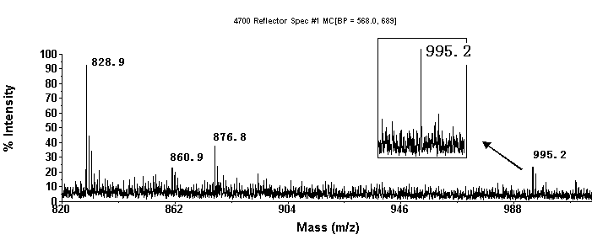
（a）

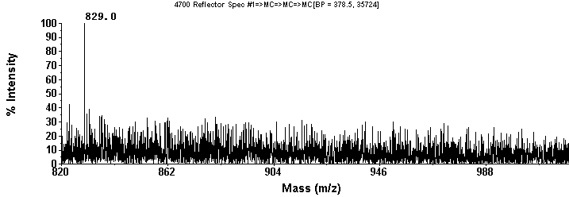
(b)
Figure SI-8 MALDI-TOF-TOF-MS for α-CD-MHA-SAM before (a) and after (b) removal of α-CD.

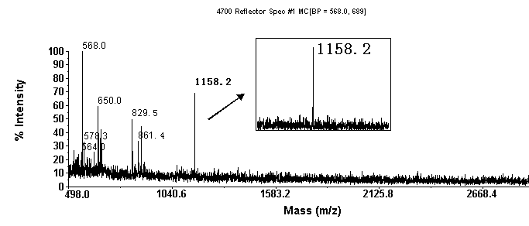

（a）

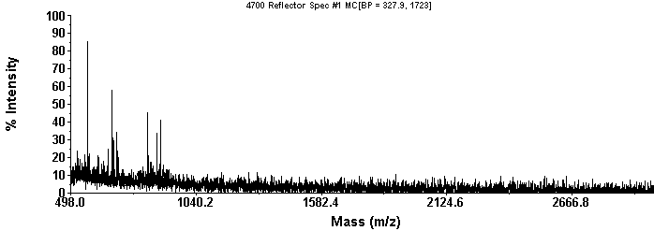
(b)

Figure SI-9 MALDI-TOF-TOF-MS for β-CD-MHA-SAM before (a) and after (b) removal of β-CD.

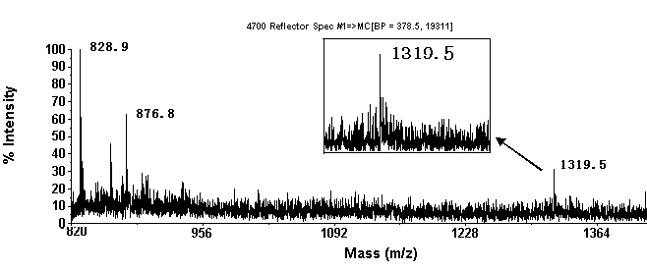
（a）

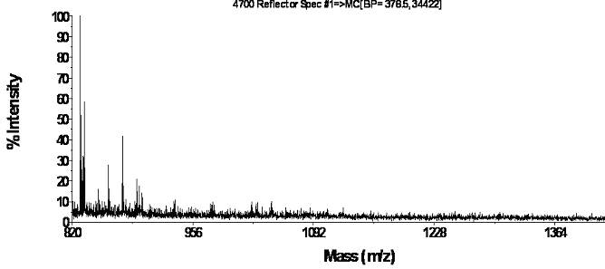
(b)

Figure SI-10 MALDI-TOF-TOF-MS for γ-CD-MHA-SAM before (a) and after (b) removal of γ-CD.

