Electronic Supplementary Information for

Growth of poly(pseudorotaxane) on gold using host-stabilized charge-transfer interaction

Kyungpil Kim, Dongwoo Kim, Jae Wook Lee, Young Ho Ko and Kimoon Kim*

National Creative Research Initiative Center for Smart Supramolecules, and Department of Chemistry, Division of Molecular and Life Sciences, Pohang University of Science and Technology, San 31 Hyojadong, Pohang 790-784, Republic of Korea

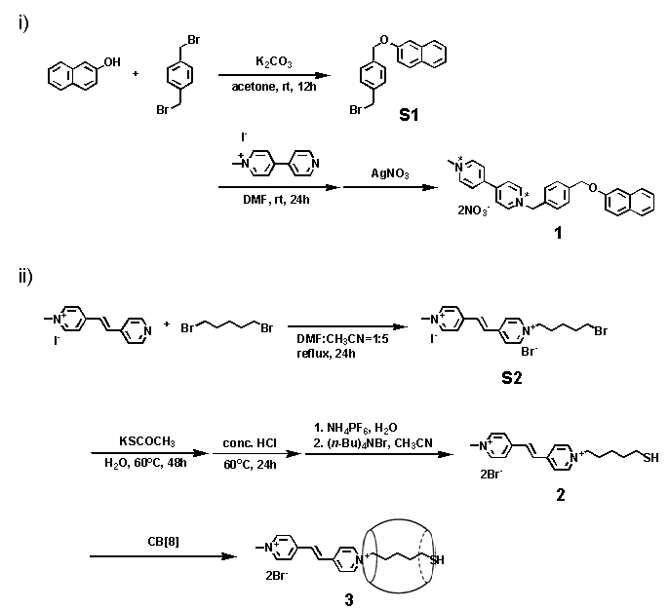

General Methods. All the NMR data were recorded on a Bruker DRX500 spectrometer. All chemical shifts are reported in parts per million downfield from internal tetramethylsilane (TMS). All chemicals were of reagent grade and used without further purification except as noted below. High-purity deionized water was obtained with a Milli-Q water system (Millipore).

Synthesis of S1. α,α΄-Dibromo-p-xylene (1.00 g, 3.79 mmol) was added to a solution of 2-hydroxynaphthalene (0.71 g, 4.92 mmol) and K₂CO₃ (3.40 g, 24.6 mmol) in dry acetone (30 mL). After stirring for 20 h at room temperature, the mixture was filtered. After removal of the solvent from the filtrate, the resulting solid was purified by column chromatography on silica gel using hexane/ethylacetate (7/1) as an eluent to yield S1 as a white solid (0.43 g, 35%). mp 103 ºC; ¹H NMR (500 MHz, CDCl₃): δ= 7.75 (m, 2H), 7.70 (d, J=8.2 Hz, 1H), 7.43 (m, 5H), 7.32 (m, 1H), 7.21 (m, 2H), 5.16 (s, 2H), 4.50 (s, 2H); ¹³C NMR (125 MHz, CDCl₃): δ= 157.0, 137.9, 137.6, 134.8, 129.7, 129.6, 129.5, 128.2, 128.1, 127.9, 127.3, 124.2, 119.3, 107.5, 69.9, 33.5; MS (EI): m/z 326 [M⁺]; elemental analysis calcd (%) for C₁₈H₁₅BrO: C, 66.07; H, 4.62; found: C, 66.33; H, 4.42.

Synthesis of 1. N-methyl-4,4΄-bypyridinium iodide¹ (0.10 g, 0.34 mmol) was added to a solution of S1 (0.12 g, 0.37 mmol) in DMF (5 mL). The reaction mixture was stirred for 24 h at room temperature. The resulting precipitate was collected and washed with CH₃CN several times. The halide counter anions were exchanged with nitrate by dissolving the crude product in water and adding 1 eq. of AgNO₃ to the solution. Removal of precipitated AgBr and AgI followed by solvent evaporation yielded 1 as an orange solid (0.14 g, 71%). mp 177 ºC (dec);¹H NMR (500 MHz, D₂O): δ= 9.13 (d, J=6.5 Hz, 2H), 8.99 (d, J=6.5 Hz, 2H), 8.38 (d, J=6.5 Hz, 2H), 8.34 (d, J=6.5 Hz, 2H), 7.68 (d, J=8.2 Hz, 2H), 7.61 (m, 4H), 7.36 (d, J=8.2 Hz, 1H), 7.13 (m, 4H), 5.92 (s, 2H), 5.33 (s, 2 H), 4.49 (s, 3H); ¹³C NMR (125 MHz, D₂O): δ= 155.4, 149.8, 149.0, 146.4, 145.5, 139.3, 134.0, 132.7, 130.04, 130.01, 129.3, 128.8, 127.6, 127.0, 126.9, 126.8, 126.5, 124.5, 118.8., 108.7, 69.4, 64.9, 48.6; MS (ESI): m/z 209.2 [M²⁺], 480.2 [M²⁺+NO₃⁻]; elemental analysis calcd (%) for C₂₉H₂₆N₄O₇3H₂O: C, 58.38; H, 5.41; N, 9.39; found: C, 58.43; H, 5.26; N, 9.46.

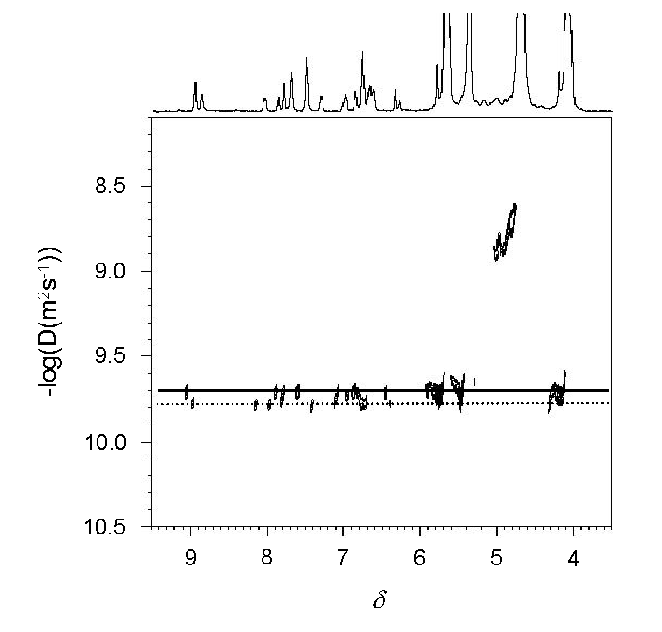
Fig. S1 2D Diffusion-ordered NMR spectrum of a 2 mM solution of CB[8] and 1 in D₂O. The complex between CB[8] and 1 is a mixture of a 2:2 complex (solid) and a polymeric species (dot) in a 3:2 ratio. The formation of 2:2 complex and poly(pseudorotaxane) in solution has been reported for other supramolecular polymers.²

Synthesis of S2. 1,5-Dibromopentane (0.64 g, 2.8 mmol) was added to a solution of 1-(4-pyridyl)-2-[4-N-(methyl)pyridinio]ethylene iodide³ (0.30 g, 0.93 mmol) in DMF (2 mL)/CH₃CN (10 mL). The resulting mixture was heated at reflux for 48 h, and then cooled to room temperature. The precipitate was collected and washed with CH₃CN several times to yield S2 as an orange solid (0.44 g, 86%). mp 230 ºC (dec); ¹H NMR (500 MHz, D₂O): δ= 8.88 (d, J=6.6 Hz, 2H), 8.80 (d, J=6.6 Hz, 2H), 8.28 (d, J=6.6 Hz, 2H), 8.25 (d, J=6.6 Hz, 2H), 7.90 (s, 2H), 4.65 (t, J=6.9 Hz, 2H), 4.40 (s, 3H), 3.53 (t, J=6.9 Hz, 2H), 2.10 (m, 2H), 1.94 (m, 2H), 1.54 (m, 2H); ¹³C NMR (125 MHz, DMSO-d₆): δ= 151.3, 150.8, 146.8, 146.0, 134.9, 134.6, 126.3, 125.9, 61.0, 48.4, 35.6, 32.2, 30.4, 24.8. For mass and elemental analysis, the halide anions were exchanged with PF₆ˉ. MS (FAB): m/z 346.0 [M⁺], 490.9 [M²⁺+PF₆⁻]; elemental analysis calcd (%) for C₁₈H₂₃BrF₁₂N₂P₂2H₂O: C, 32.11; H, 4.04; N, 4.16; found: C, 31.72; H, 3.54; N, 4.37.

Synthesis of 2. Potassium thioacetate (0.25 g, 2.2 mmol) was added to a solution of S2 (0.79 g, 1.4 mmol) in water (50 mL). The resulting mixture was stirred for 48 h at 60C. After a catalytic amount of conc. HCl was added, the mixture was further stirred for 24 h at 60C under nitrogen atmosphere. The crude product obtained by adding 4 eq. of NH₄PF₆ to the solution was collected by filtration. It was redissolved in CH₃CN and treated with 2 eq. of (n-Bu)₄NBr to yield 2 as a pale yellow solid (0.28 g, 28%). mp 232 ºC (dec); ¹H NMR (500 MHz, D₂O): δ= 8.86 (d, J=6.6 Hz, 2H), 8.80 (d, J=6.6 Hz, 2H), 8.29 (d, J=6.6 Hz, 2H), 8.25 (d, J=6.6 Hz, 2H), 7.90 (s, 2H), 4.63 (t, J=7.0 Hz, 2H), 4.40 (s, 3H), 2.57 (t, J=7.0 Hz, 2H), 2.08 (m, 2H), 1.67 (m, 2H), 1.43 (m, 2H); ¹³C NMR (125 MHz, DMSO-d₆): δ= 151.3, 150.8, 146.8, 146.0, 134.9, 134.7, 126.3, 125.9, 61.1, 48.4, 33.3, 30.8, 24.9, 24.3; MS (FAB): m/z 300.1 [M⁺], 379.0 [M²⁺+Br⁻]; elemental analysis calcd (%) for C₁₈H₂₄Br₂N₂SH₂O: C, 45.20; H, 5.48; N, 5.86; found: C, 45.04; H, 5.32; N, 6.02.

Formation of pseudorotaxane 3. To a solution of 2 (2.3 mg, 5 μmol) in D₂O (5 mL) was added CB[8]⋅(2H₂SO₄)⋅30H₂O (10 mg, 5 μmol) and the resulting mixture was sonicated with occasional heating until all the solid materials were dissolved. The formation of pseudorotaxane 3 was confirmed by ¹H NMR and mass spectroscopy. The freshly prepared pseudorotaxane 3 was used for the growth of poly(pseudorotaxane) on gold. ¹H NMR (500 MHz, D₂O): δ= 8.82 (m, 3H), 8.61 (br s, 2H), 8.33 (br s, 2H), 7.82 (m, 1H), 7.24 (m, 2H), 5.78 (d, J=12 Hz, 16H), 5.57 (s, 16H), 4.37 (s, 3H), 4.24 (d, J=12 Hz, 16H), 3.96 (br s, 2H), 1.53 (br s, 2H), 1.33 (br s, 2H), 0.65 (br s, 2H), 0.49 (br s, 2H); MALDI-MS: m/z 1628 [M⁺].

Preparation of gold substrates for FT-IR experiments. Evaporated gold substrates (Silicon (100) wafer, 2 nm Ti, 250 nm Au) were purchased from Metallhandel Schroer (Lienen, Germany). Gold substrates with a size of about 10×25 mm were used without annealing. Before preparing SAM, the substrates were rinsed with ethanol and immersed for 30 s in freshly prepared “piranha” solution (3H₂SO₄: 1H₂O₂, Caution: this mixture reacts violently with organic materials. It should not be stored in closed containers). The substrates were rinsed thoroughly with water followed by ethanol and dried under a stream of N₂ gas. The self-assembled monolayer (SAM) of pseudorotaxane 3 on the gold surface was formed by immersing the substrate in an aqueous solution of 3 for 60 h. The substrate was then washed copiously with water and dried with a gentle flow of N₂ gas. It was immersed again in an aqueous solution of CB[8] and 1 for a day. The growth of the poly(pseudorotaxane) was monitored by reflectance FT-IR spectroscopy.

FT-IR measurements. Reflectance FT-IR measurements were performed using a Perkin-Elmer Spectrum GX FT-IR spectrophotometer equipped with a Harrick Scientific Segull variable angle reflectance accessory and a liquid N₂ cooled MCT detector. All spectra were obtained at 4 cm⁻¹ resolution using a p-polarized light with an incident angle of 83° (a bare gold spectrum was used as a background).

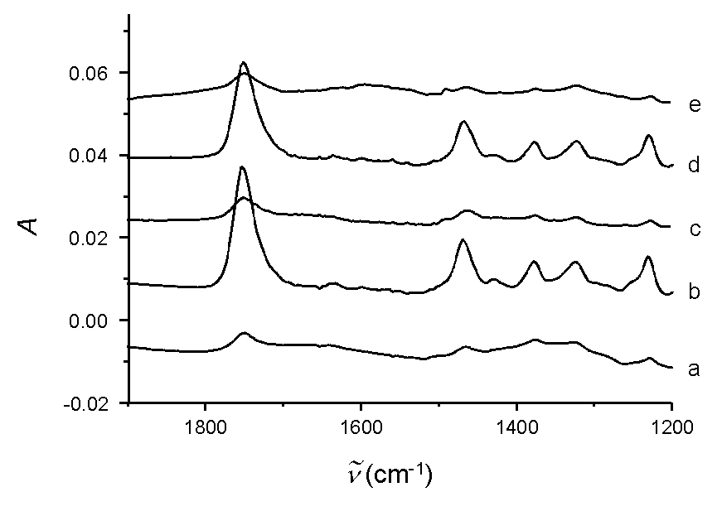
Fig. S2 A series of FT IR spectra showing the polymerization and depolymerizatrion of the poly(pseudorotaxane) occur reversibly on gold. FT-IR spectra of a) the SAM of pseudorotaxane 3 and b) the poly(pseudorotaxane) grown by dipping the substrate in a 2mM monomer solution for a day. A series of FT-IR spectra taken c) after dipping the substrate in water, d) after dipping in a 2 mM monomer solution again, and e) after dipping in water again.

Surface plasmon resonance (SPR) measurements. Surface plasmon resonance (SPR) experiments were carried out at 25 ºC using a BIACore 2000 and Pioneer Sensor Chip J1 (plain gold surface) which has a gold substrate with a size of 7 mm × 7 mm. SPR measures the angle of light (θ) reflected from the backside of the gold substrate that is a minimum in intensity. Changes in this angle (θ) are linearly related to the index of refraction of the solution above the surface and therefore to the density of adsorbed molecules (θ of 0.10° = 1ng/mm² = 1000 RU). SPR experiments were performed at the constant flow rate of 10 μL min⁻¹ over gold surfaces at 25C. The SAM of pseudorotaxane 3 was formed by injecting 1 mM aqueous solution of 3 for 10 min. Then a 1 mM aqueous solution of CB[8] and 1 was injected for 30 min, which was repeated 6 times because of the limit of a maximum injection volume (325 μL) for each injection. After each injection, the gold surface was washed with distilled water.

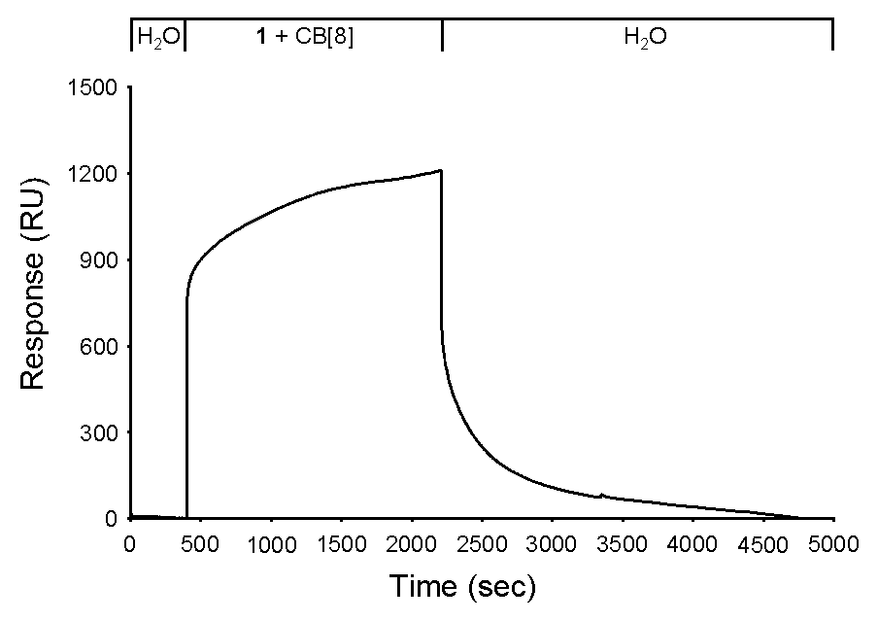
Fig. S3 SPR sensorgram taken in the absence of SAM of 3. The top X-axis represents the successive flow of water, a 1 mM aqueous solution of CB[8] and 1 (1:1), and water.

Preparation of gold substrates for AFM experiment. Gold substrates were prepared by evaporating gold on the Si(100) substrate. The SAM of pseudorotaxane 3 on gold was formed by immersing gold substrate in a 1 mM aqueous solution of 3 for 60 h. Then the substrate was washed copiously with water and dried with a gentle flow of N₂ gas. It was immersed again in a 1 mM aqueous solution of CB[8] and 1. The growth of the poly(pseudorotaxane) was monitored by AFM.

AFM experiment. A Nanoscope IIIa Multimode AFM with a JV scanner (Digital Instruments, Santa Barbara CA) was used to image all substrates. Gold substrates were prepared by evaporating gold on a Si(100) substrate. To evaluate the thickness of the polymer grown on the substrate a step edge of gold in the substrate, which was freshly prepared by scratching the substrate with forceps just before the experiments, was used as an internal standard (14 nm). The height was measured using the tapping mode under the ambient condition. All images with a scan size of 2×2 µm were recorded using a resolution of 256×256 lines at a scan rate of 1 Hz and flattened to remove background curvature.

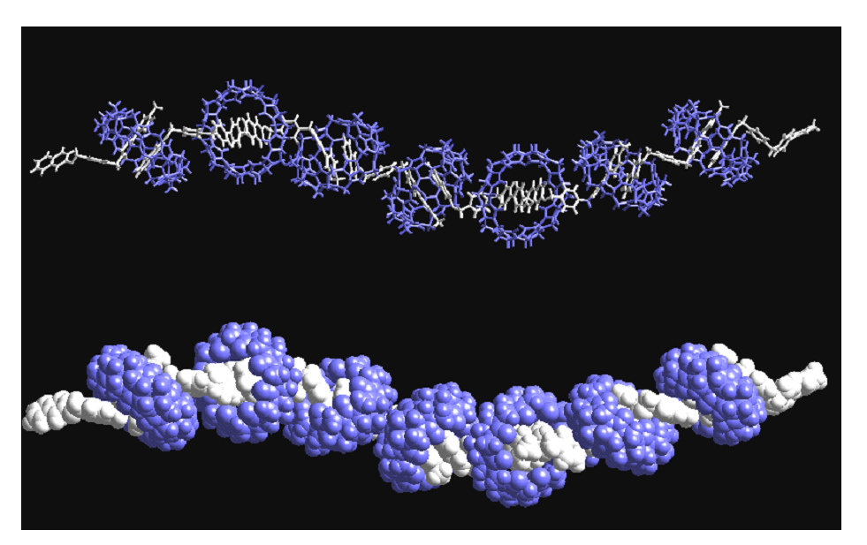
Fig. S4 An energy-minimized structure of the poly(pseudorotaxane). Molecular mechanics calculations were carried out using Cerius².

References

1. S. Peter, F. Peter, R. Richard and R. Hermann, J. Chromatogr., 1988, 449, 299.
2. (a) S. J. Cantrill, G. J. Youn and J. F. Stoddart, J. Org. Chem., 2001, 66, 6857; (b) H. W. Gibson, N. Yamaguchi and J. W. Jones, J. Am. Chem. Soc., 2003, 125, 3522 and references therein.
3. J. Vansant, G. Smets, J. P. Declercq, G. Germain and M. V. Meerssche, J. Org. Chem., 1980, 45, 1557.

