SUPPORTING INFORMATION

⁷Li,³¹P Shift correlation. Application to the structural assignment of N-methyl-N-phosphinylbenzyllithium complexes

Ignacio Fernández and Fernando López Ortiz*
Área de Química Orgánica, Universidad de Almería, Carretera de Sacramento, 04120, Almería. Spain

Contents:
- General NMR experimental conditions.
- ¹H, ³¹P HMQC NMR rows at the chemical shifts of the ³¹P signals I, II, and III at -105 ºC in Et₂O-d₁₀ (Figure S1)
- Analysis of the monomer-dimer equilibrium (Figure S2)
- ¹³C{¹H, ³¹P} NMR spectrum showing expansion of the lithiated carbons region at -105 ºC (Figure S3)
General NMR experimental conditions
Spectra measured on a Bruker Avance 500 spectrometer equipped with a third radiofrequency channel. A 5 mm triple probe head was used. The outer coil was doubly tuned for ¹H and ³¹P, and the inner coil was tunable in the frequency range ¹⁰⁹Ag to ³¹P. The 90º pulse widths and operating frequencies were: 85 μs (¹H, 500 MHz), 15.7 μs (⁷Li, 194.37 MHz), 31 μs (³¹P, 202.46 MHz). The attenuation levels used were 15 dB for the proton channel and 0 dB for the heteronuclei. The spectral references used were, 85% H₃PO₄ for ³¹P and 1M LiBr in D₂O for ⁷Li. A set of two complementary ³¹P/⁷Li selective band pass/stop frequency filters were used for the acquisition of the ³¹P{⁷Li,¹H} and ⁷Li {³¹P,¹H} NMR spectra.

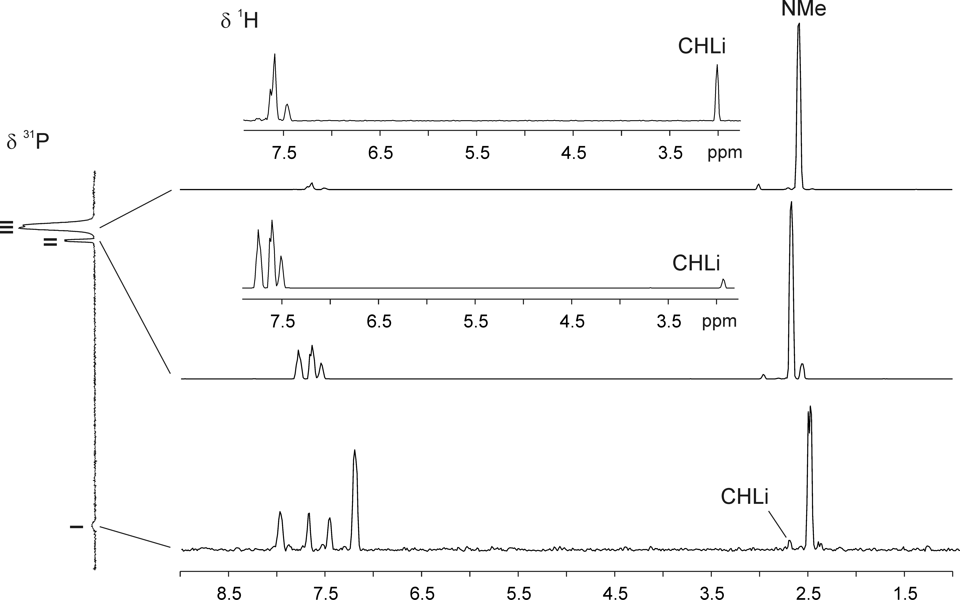
Figure S1. Rows extracted from ³¹P,¹H gHMQC spectrum (202.46 MHz) of Li⁺1⁻ at -90 ºC in Et₂O-d₁₀. The expansions above the rows corresponding to the chemical shifts of the ³¹P signals II and III highlight the correlation with the methyne proton. General parameters: spectral width, 4500 Hz for ¹H and 3450 Hz for ³¹P; 128 increments recorded; final matrix after zero filling, 2048x512; evolution delay of ^{n}J_{PH}  60  ms; 32 scans per increment in F1; sine multiplication of 2π in both dimension prior to transformation (magnitude mode). Repetition delay of 1 s. The spectrum was acquired without ^{n}J_{PH} refocusing delay.
Monomer-Dimer equilibrium. Concentration and relative integrals obtained from ³¹P NMR spectra of Li⁺1⁻ measured at different concentrations and at –105 ºC in Et₂O-d₁₀ are shown below. The ³¹P NMR spectra were acquired using the inverse-gated pulse sequence, with a pulse width of 15º and a recovery delay of 3 s. Signals I and III were assigned to dimer species D₁ and D₂, respectively, whereas II represents the monomer (M).

Sample | Concentration | I (D₁) | II (M) | III (D₂) | Sum (M +D)ª
1 | 0.197 M | 0.05 | 0.12 | 1 | 1.17
2 | 0.102 M | 0.05 | 0.14 | 1 | 1.19
3 | 0.0530 M | 0.04 | 0.16 | 1 | 1.20
4 | 0.0281 M | 0.04 | 0.20 | 1 | 1.24
a) D= (D₁ + D₂)
Linear Regression for the equilibrium I-III-II: y = A + Bx
Parameter |  | Value |  | Error
A |  | -2-27187 |  | 0.03084
B |  | 1.49266 |  | 0.02498
R | SD |  | N |  | P
0.99972 | 0.01625 |  | 4 |  | 2,79856E-4

Figure S2. Benzylic anions monomer-dimer linear fit.
The magnitude of K calculated from the linear regression equation is 0.0053.

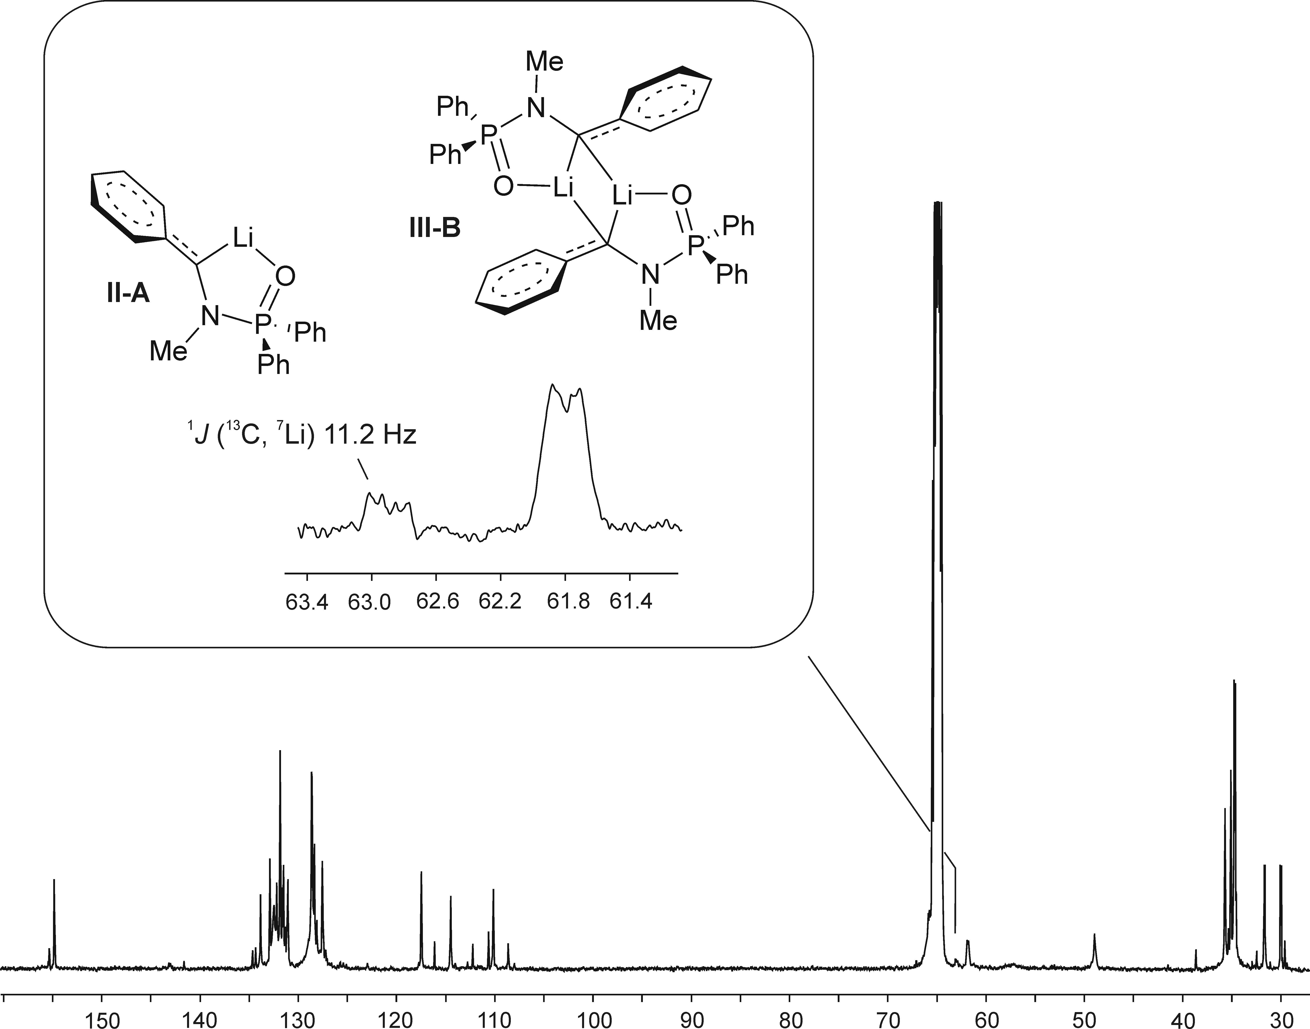
Figure S3. ¹³C {¹H, ³¹P} NMR spectrum (125.75 MHz) of Li⁺1⁻ measured at -105 ºC in Et₂O-d₈. General parameters: 12450 Hz of spectral width, 9216 scans accumulated, exponential multiplication of the FID (LB= 2) was performed previous to the Fourier transformation.

