Supplementary Information

Toshiaki Kusakari, Takehiko Sasaki and Yasuhiro Iwasawa

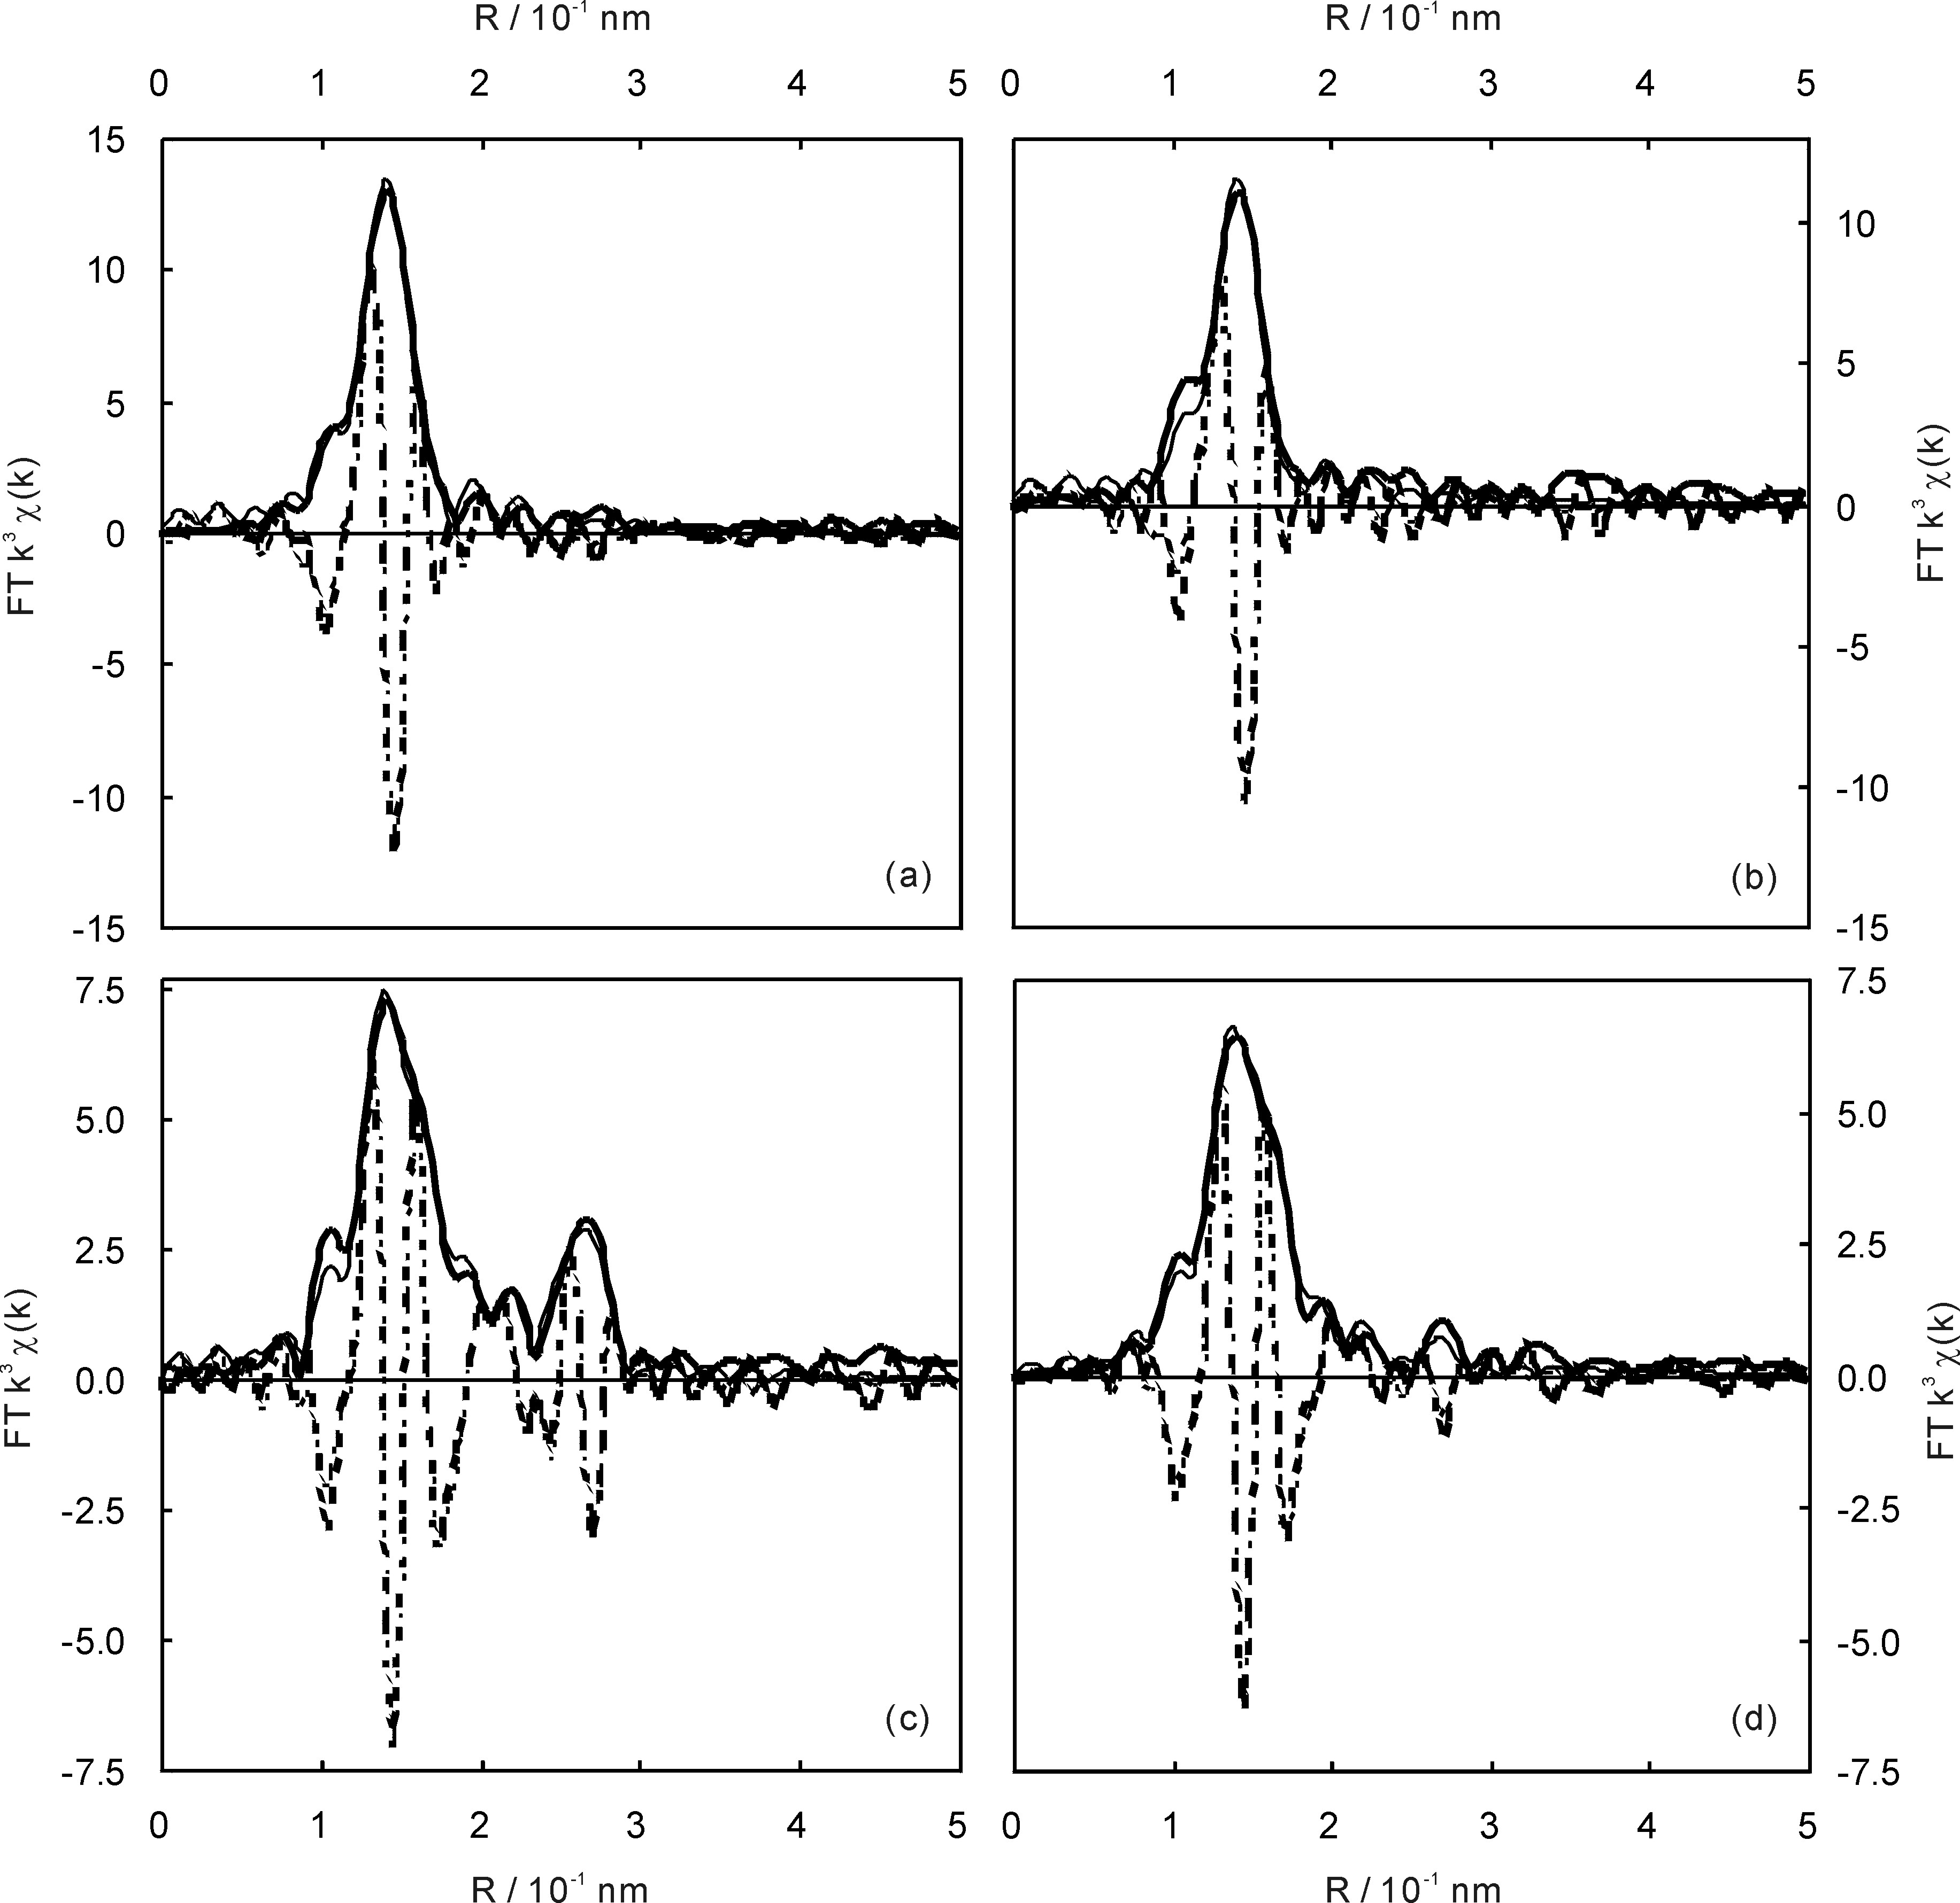

The Fourier transformed EXAFS functions at Re L_{III}-edge; (a) ReO_{x}/H-ZSM-5/CVD(SiO₂/Al₂O₃ = 39.4) before the reaction, (b) ReO_{x}/H-ZSM-5/CVD(SiO₂/Al₂O₃ = 39.4) after the reaction under 0.54 MPa NH₃, (c) ReO_{x}/H-Mordenite/CVD(SiO₂/Al₂O₃ = 220) before the reaction, (d) ReO_{x}/H-Mordenite/CVD(SiO₂/Al₂O₃ = 220) after the reaction under 0.10 MPa NH₃. Thick line: observed, thin line: curve-fitted.

