A Novel Supramolecular Assembly in a Iron(III) compound Exhibiting Magnetic Ordering at 70 K

Donatella Armentano ª, Giovanni De Munno*ª, Teresa F. Mastropietro ª, Miguel Julve*^{b} and Francesc Lloret^{b}

ª Dipartimento di Chimica, Università degli Studi della Calabria, 87030 Arcavacata di Rende, Cosenza, Italy. E-mail: demunno@unical.it

^{b} Departament de Química Inorgànica/Instituto de Ciencia Molecular, Faculat de Química de la Universitat de València, Avda. Dr. Moliner 50, 46100 Burjassot,(València) Spain. E-mail: miguel.julve@uv.es

Supplementary Material

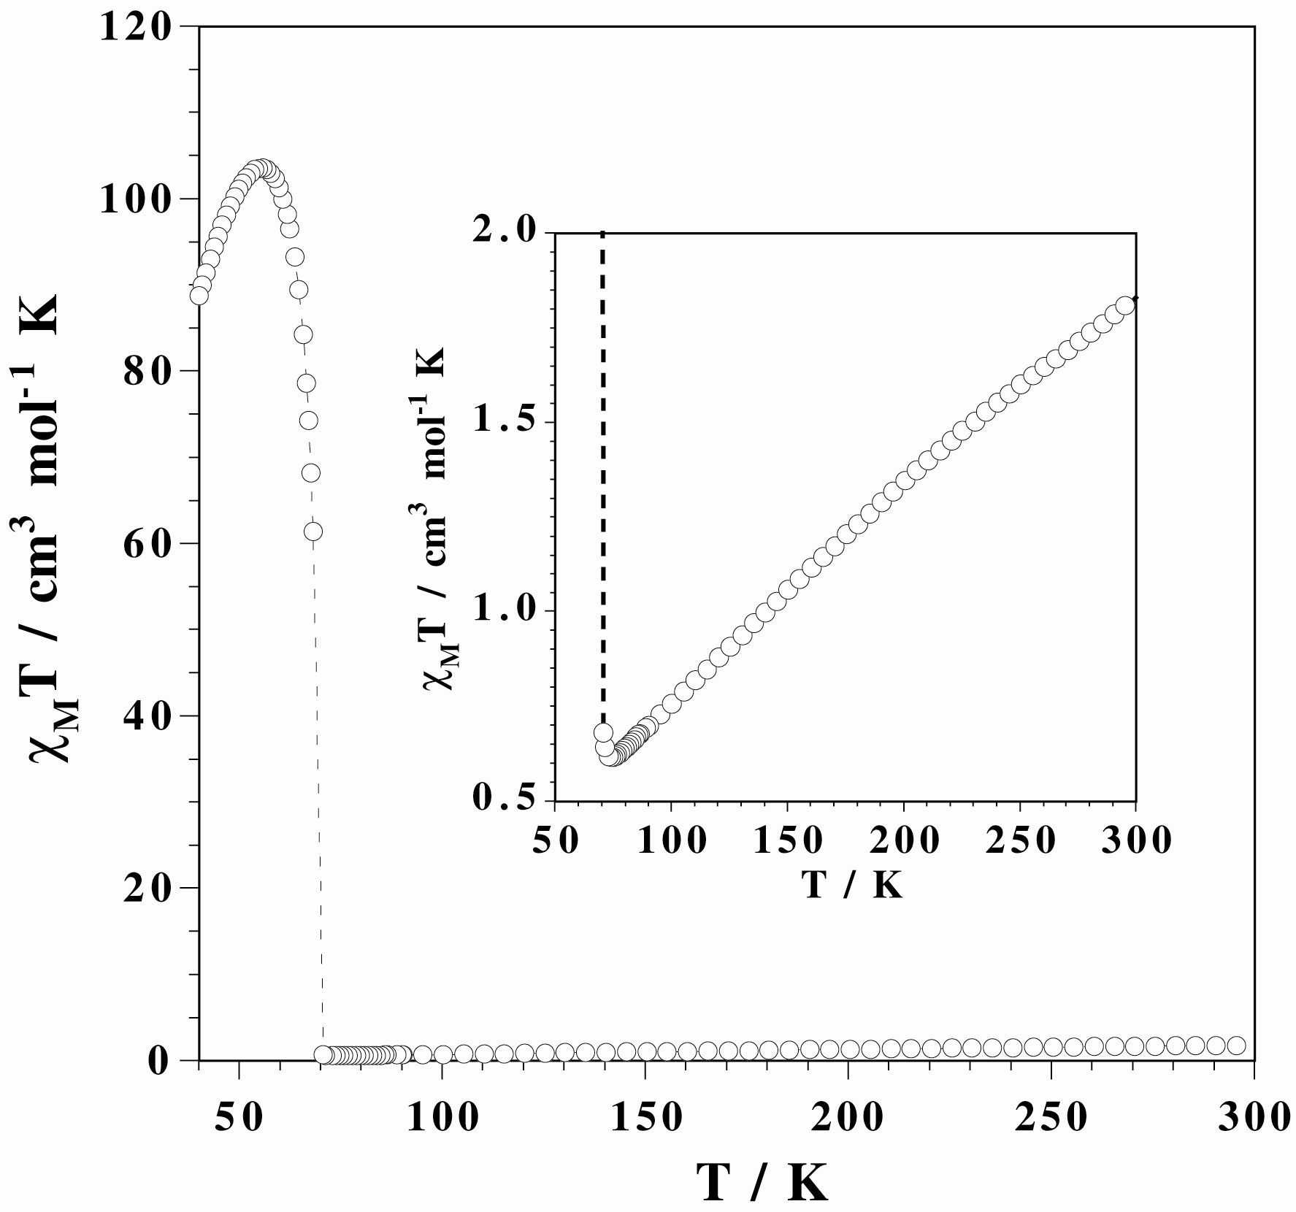

Figure S1. Thermal dependence of χ_{M}T (o) per mol of iron(III) for 2 under an applied field of 50 Oe. The inset shows the higher temperature range including the minimum of χ_{M}T. The dashed line is a guideline.

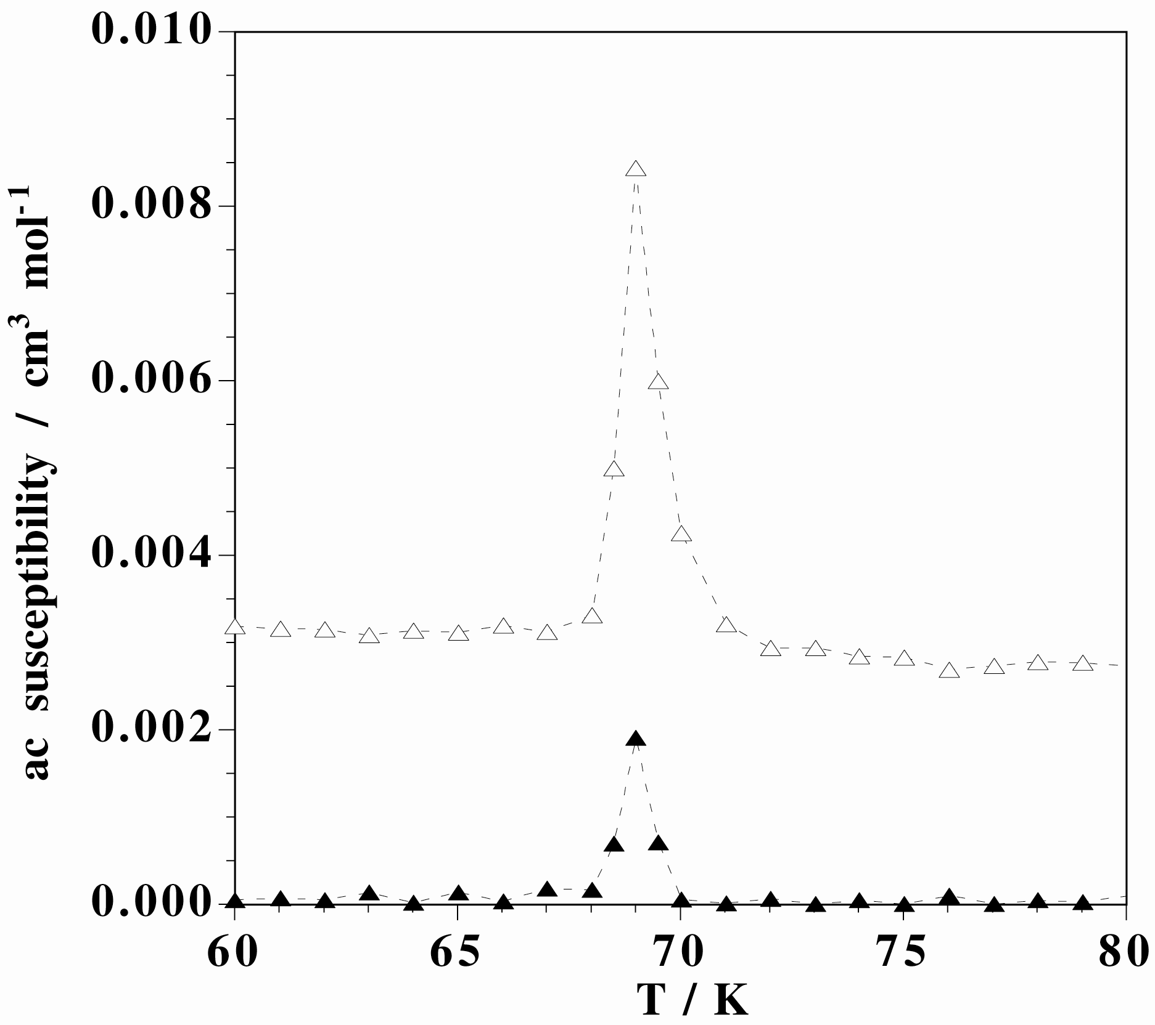
Figure S2. Temperature dependence of the in-phase (top) and out-phase (bottom) components of the ac susceptibility of 2 at 100 Hz in zero applied static field and under an oscillating field of 1 Oe.

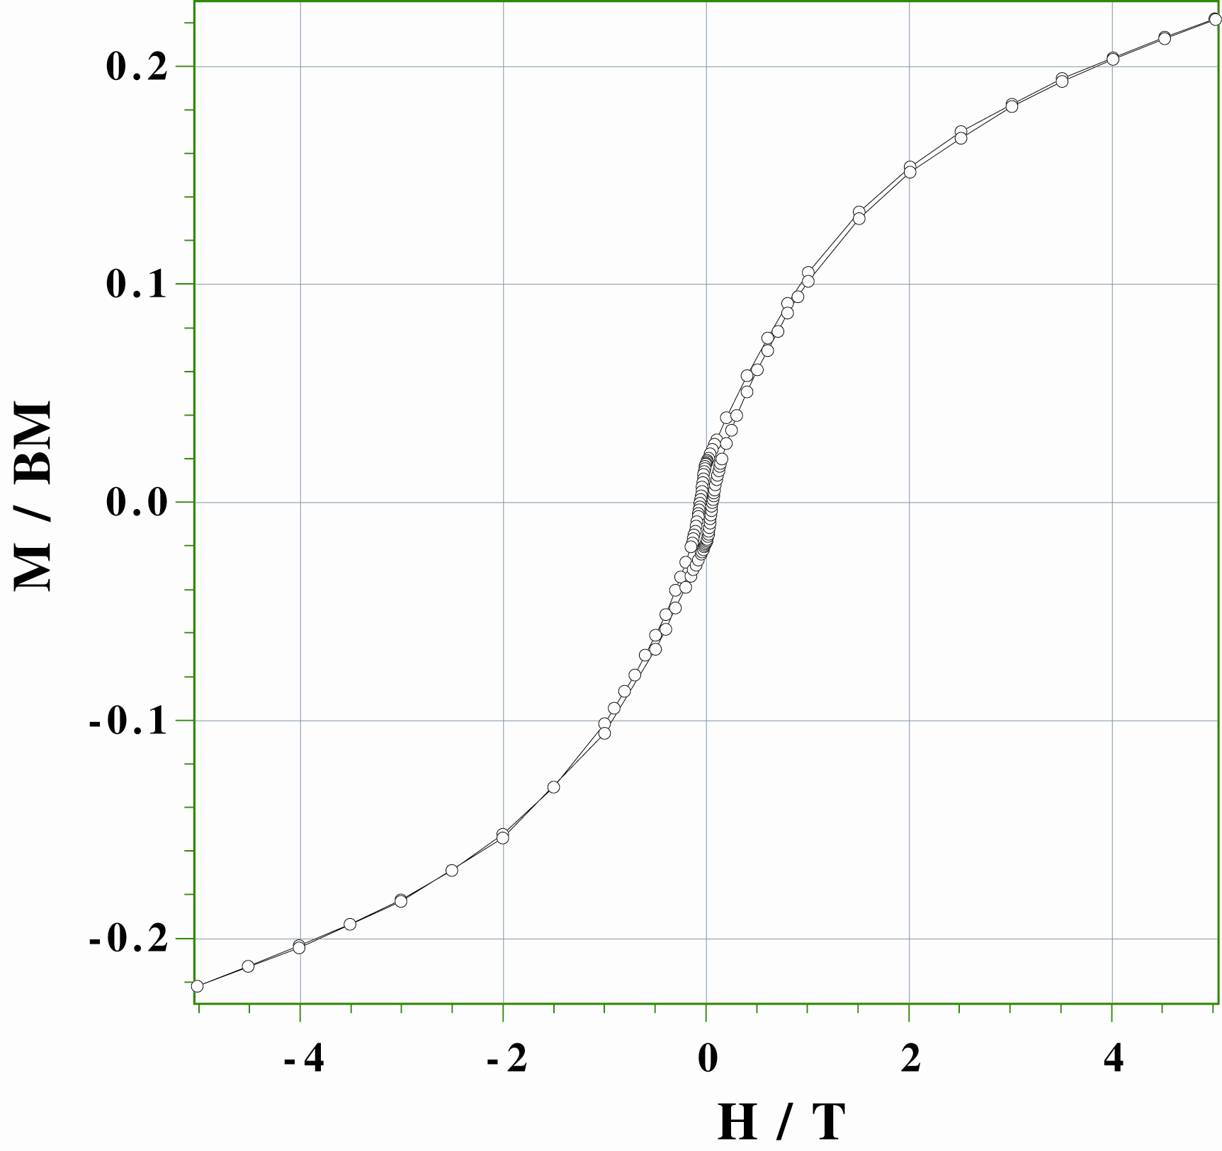
Figure S3. Hysteresis loop of 2 at 2.0 K between ±5 T.

