Supplementary Information for:
The single-step synthesis of a DNA tetrahedron
Russell Goodman*, Richard Berry and Andrew Turberfield
University of Oxford, Department of Physics, Clarendon Laboratory, Parks Road, Oxford OX1 3PU, UK. Fax: 44 (0)1865 272400; Tel: 44 (0)1865 272331; E-mail: russell.goodman@physics.ox.ac.uk

Stoichiometry Control

To verify that only a single copy of each oligonucleotide was present in the tetrahedral construct, the construct was formed in the absence and presence of oligonucleotides of higher molecular weight than originally described. For each oligonucleotide, three experiments were performed. The construct was first formed as originally described. The construct was then formed with one of the original oligonucleotides replaced with an oligonucleotide of higher molecular mass. The higher molecular weight oligonucleotide was identical in sequence to the original oligonucleotide save for a 12 bp 3’ extension. This extension was designed to allow the formation of the tetrahedral construct with a ‘dangling’ 12 bp single stranded extension to produce a gel retardation effect. Finally, the construct was formed in the presence of equal amounts (50% of the concentration of the other components) of the original and higher molecular weight oligonucleotides.

Should only a single copy of an oligonucleotide be present in the construct, formation of the construct in the presence of a mixture of the higher and lower molecular weight versions should result in the formation of two bands. If more than one copy of an oligonucleotide is present in the construct, a more complicated banding pattern is expected. For example, if two copies of an oligonucleotide were present in the construct three bands would be expected: a band corresponding to a product containing two copies of the shorter oligonucleotide, a more slowly moving band corresponding to two copies of the extended oligonucleotide, and an intermediate band of corresponding to a product containing one copy of each oligonucleotide. As both versions of the oligonucleotide are expected to be incorporated with approximately equal probability the intensity of the intermediate band would be expected to be twice that of the higher or lower molecular weight bands.

Fig. ES1 illustrates the results of such an experiment. The presence of two bands in lane 4 indicates that the oligonucleotide is present only once in the construct. Similar experiments confirm that all four oligonucleotides are present only once in the construct.

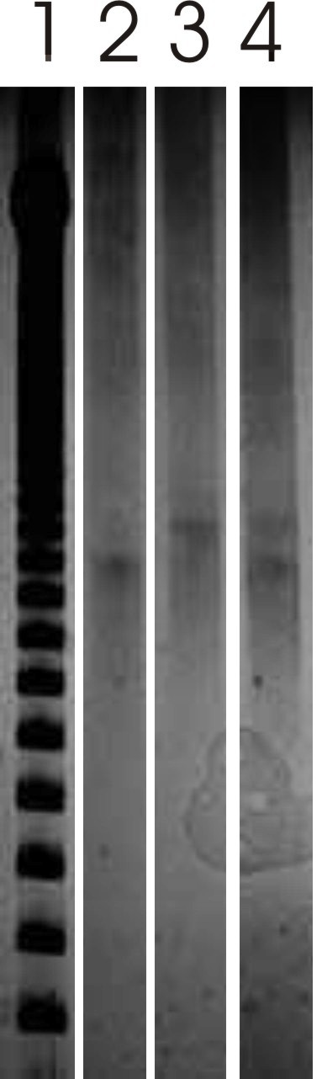

Fig ES1. Gel shift analysis to confirm stoichiometry. Lane 1: 50 bp ladder. Lane 2: original tetrahedral (no extended oligonucleotides). Lane 3: tetrahedral formed with extended strand 3. Lane 4: tetrahedra formed with equal concentrations of the original and extended strands 3.

Fig./Scheme XX Caption.

