Design and synthesis of imidazolium salt derived from (L)-Valine. Investigation of their potential in Chiral Molecular Recognition.

Hervé Clavier, Loïse Boulanger, Nicolas Audic, Loïc Toupet, Marc Mauduit* and Jean-Claude Guillemin*

H. Clavier, L. Boulanger, N. Audic, Dr. M. Mauduit, Dr. J.C. Guillemin
UMR CNRS 6052, Ecole Nationale Supérieure de Chimie, Institut de Chimie de Rennes, 35700 Rennes (France)
Fax : 33 (0)2 23 23 81 08
E-mail : marc.mauduit@ensc-rennes.fr
L. Toupet, UMR CNRS 6626, Université de Rennes 1, 35700 Rennes (France)

General. ¹H (400 MHz), ¹³C (100 MHz), ³¹P (162 MHz) and ¹⁹F (376.5 MHz) NMR spectra were recorded on a Bruker ARX400 spectrometer with complete proton decoupling for nucleus other than ¹H. Chemical shifts are reported in ppm from tetramethylsilane with the solvent resonance as the internal standard (CDCl₃, ¹H: δ 7.27 ppm, ¹³C: δ 77.0 ppm, CD₂Cl₂, ¹H: δ 5.31 ppm, ¹³C: δ 53.7 ppm and (CD₃)₂CO: ¹H: δ 2.05 ppm, ¹³C: δ 205.1 ppm). Data are reported as follows: chemical shift (δ) in ppm, multiplicity (s = singlet, d = doublet, t = triplet, q = quadruplet, sept = septuplet, hept = heptuplet, bd = broad, m = multiplet), coupling constants (Hz), integration and attribution. High-resolution mass spectra (HRMS) were recorded at the Centre Régional de Mesures Physiques de l’Ouest (CRMPO), Université de Rennes 1 on a Micromass ZABSpecTOF instrument. Melting points were measured on a heating microscope Reichert and were uncorrected. Optical rotations were recorded using a polarimeter Perkin-Elmer 341.

Materials. All non-aqueous reactions were performed under an argon atmosphere using oven-dried glassware. Toluene was distilled from sodium metal under nitrogen. Tetrahydrofuran and diethyl ether were distilled from sodium metal/benzophenone ketyl under nitrogen. Dichloromethane, methanol and N-methylmorpholine were distilled from calcium hydride under nitrogen. The 2N anhydrous HCl/solution was prepared by addition, at 0°C, of acetyl chloride to dry methanol. All others chemical reagents and solvents were obtained from commercial sources and used without further purification. Analytical TLC were performed on Merck silica gel 60F₂₅₄ plates, and visualized under UV-light. Chromatographic purifications were performed on a column with 230-400 mesh silica gel (Merck 9385) using the indicated solvent system.

[1-(2-tert-Butyl-phenylcarbamoyl)-2-methyl-propyl]-carbamic acid tert-butyl ester :
To a solution of BOC-L-Valine 1 (2.37 g, 10 mmol) in dry THF (50 mL) was added N-methylmorpholine (1.16 mL, 10.5 mmol, 1.05 equiv.). The mixture was cooled to -15°C then isobutyl chloroformate (1.37 mL, 10.5 mmol, 1.05 equiv.) was added dropwise. After 30 min stirring, 2-tert-butylaniline (1.64 mL, 10.5 mmol, 1.05 equiv.) was added, and the resulting solution was stirred for 48h at room temperature. After evaporation of the solvent, the residue was dissolved in AcOEt and washed successively with saturated NaHCO₃ solution, 0.1N HCl solution and brine. The organic layer was dried over MgSO₄, filtered and concentrated in vacuo. The resulting solid was purified by washing with cold pentane to afford the amide as a white solid (2.76 g, 79 %).
Mp = 143°C (pentane).
[α]_{D}²⁰ = -49.2 (c = 1 in chloroform).
¹H NMR (400 MHz, CDCl₃): δ = 7.98 (s, 1H, ArNH), 7.67-7.14 (m, 4H, 4CH_{ar}), 5.02 (bd s, 1H, NH) 4.14 (dd, J(H,H) = 5 and 9 Hz, 1H, 1CH), 2.47 (m, 1H, 1CH), 1.47 (s, 9H, 3CH₃), 1.41 (s, 9H, 3CH₃), 1.07 (d, J(H,H) = 7 Hz, 3H, CH₃), 0.99 (d, J(H,H) = 7 Hz, 3H, CH₃).
¹³C NMR (100 MHz, CDCl₃): δ = 170.0, 155.9, 134.93 (2C), 126.8, 126.5 (2C), 126.0, 80.4, 60.9, 34.4, 30.6 (3C), 29.9, 28.3 (3C), 19.6 (2C).
HRMS (EI, M⁺), calcd for C₂₀H₃₂N₂O₃: 348.2412, found: 348.2413.

N¹-(2-tert-Butyl-phenyl)-3-methyl-butane-1,2-diamine (2):
To a solution of amide (3.48 g, 10 mmol) in dry methanol (40 mL) was added dropwise a 2N anhydrous HCl/methanol solution (50 mL, 100 mmol, 10 equiv.) at 0°C. The mixture was warmed to room temperature and stirred overnight. After evaporation of the solvent, the resulting salt was dissolved in water and treated by 1N NaOH solution to reach a basic pH. The aqueous layer was saturated with sodium chloride and extracted with dichloromethane. The combined organic layers were dried over MgSO₄ and concentrated in vacuo to afford the corresponding free amine as an anamorphous solid which was directly dissolved in dry THF and slowly added to a suspension of LiAlH₄ (2.28 g, 60 mmol, 6 equiv.) in dry THF at 0°C. The resulting mixture was heated to reflux and stirred for 48h. After cooling to 0°C, water and 15% NaOH solution were added dropwise and the resulting solid material was removed by filtration. The filtrate was concentrated in vacuo and the residue was purified by flash chromatography (CH₂Cl₂/methanol 95/5) to afford the diamine 2 as yellow oil (1.8 g, 78%, two steps).
[α]_{D}²⁰ = +12.8 (c = 1 in chloroform).
¹H NMR (400 MHz, CDCl₃): δ = 7.28 (dd, J(H,H) = 1.5 and 8 Hz, 1H, 1CH_{ar}), 7.16 (dt, J(H,H) = 1.5 and 8 Hz, 1H, 1CH_{ar}), 6.82 (m, 2H, 2CH_{ar}), 4.73 (bd s, 1H, NH), 3.32 (d, J(H,H) = 10 Hz, 1H, 1CH), 2.99 (m, 2H, 1CH₂), 1.74 (hept, J(H,H) = 7 Hz, 1H, 1CH), 1.48 (s, 9H, 3CH₃), 1.19 (bd s, 2H, NH₂), 1.03 (d, J(H,H) = 7 Hz, 3H, CH₃), 1.01 (d, J(H,H) = 7 Hz, 3H, CH₃).
¹³C NMR (100 MHz, CDCl₃): δ = 146.9, 133.4, 127.0, 126.1, 116.6, 111.5, 56.3, 48.2, 34.2, 32.9, 29.8 (3C), 19.4, 18.0.
HRMS (EI, M⁺), calcd for C₁₅H₂₆N₂: 234.2096, found: 234.2098.

1-(2-tert-Butyl-phenyl)-4-isopropyl-4,5-dihydro-1H-imidazole (3):
To a solution of diamine 2 (5 mmol) in dry diethyl ether (25 mL) was added dropwise, at 0°C, a 2N anhydrous HCl/methanol solution (2.5 mL, 5mmol, 1 equiv.). A white precipitate was immediately formed. After 10 min. stirring, the solvent was evaporated to afford the corresponding chlorhydrate of diamine in quantitative yield. The salt was dissolved in dry toluene (15 mL) , trimethylorthoformate (2.75 ml, 25 mmol, 5 equiv.) was added and the mixture was heated to 90°C for 12h. After cooling to room temperature, dichloromethane (100 mL) and 1N NaOH aq. solution (60mL) were added. The organic layer was washed with brine, dried over MgSO₄ and concentrated in vacuo. The residue was purified by flash chromatography (CH₂Cl₂/methanol 95/5) to afford the imidazole 3 as colorless needles (1.05 g, 86%, two steps).
Mp = 43-45°C (AcOEt).
[α]_{D}²⁰ = -12.6 (c = 1 in chloroform).
¹H NMR (400 MHz, CDCl₃): δ = 7.46-7.43 (m, 1H, 1CH_{ar}), 7.26-7.22 (m, 2H, 2CH_{ar}), 7.04-7.02 (m, 1H, 1CH_{ar}), 6.81 (d, J(H,H) = 2 Hz, 1H, 1CH), 3.94 (dt, J(H,H) = 2 and 10 Hz, 1H, 1CH), 3.68 (t, J(H,H) = 10 Hz, 1H, 1CH), 3.19 (t, J(H,H) = 10 Hz, 1H, 1CH), 1.87 (hept, J(H,H) = 7 Hz, 1H, 1CH), 1.41 (s, 9H, 3CH₃), 1.10 (d, J(H,H) = 7 Hz, 3H, CH₃), 0.97 (d, J(H,H) = 7 Hz, 3H, CH₃).
¹³C NMR (100 MHz, CDCl₃): δ = 156.8, 149.1, 141.9, 129.6, 127.8, 127.5, 127.3, 73.2, 58.2, 35.4, 33.1, 31.3 (3C), 19.5, 18.8.
HRMS (EI, M⁺), calcd for C₁₆H₂₄N₂: 244.1939, found: 244.1923

3-(2-tert-Butyl-phenyl)-5-isopropyl-1-methyl-d3-4,5-dihydro-3H-imidazol-1-ium hexafluoro phosphate (4a):
Imidazole 3 (1.2 g, 5 mmol) was dissolved in acetone (5 mL) and iodomethane (375 μL, 6 mmol, 1.2 equiv.) was added and the reaction mixture was stirred at room temperature for 2h. The reaction mixture was concentrated to dryness and the white residue dissolved in dry acetone. KPF₆ (1.1 g, 6 mmol, 1.2 equiv.) was added at room temperature. After 30 min. stirring, the solvent was evaporated under reduced pressure; the residue was dissolved in dichloromethane and washed with brine. The organic layer was dried over MgSO₄ and concentrated in vacuo. Purification by flash chromatography (CH₂Cl₂/acetone 3/1) afforded the imidazolium salt 4a as a white solid (1.91 g, 94%, two steps).
Mp = 136-138°C (AcOEt/pentane).
[α]_{D}²⁰ = -1.6 (c = 1 in chloroform).
¹H NMR (400 MHz, CDCl₃): δ = 7.89 (s, 1H, 1CH), 7.51 (d, J(H,H) = 8 Hz, 1H, 1CH_{ar}), 7.40 (m, 1H, 1CH_{ar}), 7.28 (m, 2H, 2CH_{ar}), 4.52 (dt, J(H,H) = 4 and 11 Hz, 1H, 1CH), 4.25 (t, J(H,H) = 12 Hz, 1H, 1CH), 3.93 (t, J(H,H) = 11 Hz, 1H, 1CH), 3.30 (s, 3H, 1CH₃), 2.38 (hept, J(H,H) = 4 Hz, 1H, 1CH), 1.38 (s, 9H, 3CH₃), 1.03 (d, J(H,H) = 7 Hz, 3H, CH₃), 1.00 (d, J(H,H) = 7 Hz, 3H, CH₃).
¹³C NMR (100 MHz, CDCl₃): δ = 159.1, 147.3, 134.4, 130.6, 130.3, 128.7, 128.3, 67.1, 55.3, 35.7, 31.9 (3C), 26.8, 25.6, 18.0, 14.6.
¹⁹F NMR (376.5 MHz, CDCl₃): δ = -72.7 (d, J(F,P) = 712.8 Hz).
³¹P NMR (162 MHz, CDCl₃): δ =-143.2 (sept, J(P,F) = 712.8 Hz).
HRMS (FAB), calcd for C⁺: C₁₇H₂₄D₃N₂: 262.2363, found:262.2367; calcd for 2C⁺,PF₆⁻: C₃₄H₄₈D₆F₆N₄P: 669.4367, found: 669.4377.

3-(2-tert-Butyl-phenyl)-5-isopropyl-1-octyl-4,5-dihydro-3H-imidazol-1-ium hexafluoro phosphate (4b):
Imidazole 3 (1.2 g, 5 mmol) was dissolved in acetone (5 mL) and 1-bromooctane (1.73 mL, 10 mmol, 2 equiv.) was added and the reaction mixture was stirred at reflux for 48h. KPF₆ (1.1 g, 6 mmol, 1.2 equiv.) was added at room temperature. After 30 min. stirring, the solvent was evaporated under reduced pressure; the residue was dissolved in dichloromethane and washed with brine. The organic layer was dried over MgSO₄ and concentrated in vacuo. Purification by flash chromatography (CH₂Cl₂/acetone 3/1) afforded the imidazolium salt 4b as a limpid oil (2.23 g, 70%, two steps).
[α]_{D}²⁰ = +6.0 (c = 1.08 in chloroform).
¹H NMR (400 MHz, CDCl₃): δ = 7.88 (s, 1H, 1CH), 7.52 (dd, J(H,H) = 1 and 8 Hz, 1H, 1CH_{ar}), 7.40 (dt, J(H,H) = 1 and 8 Hz, 1H, 1CH_{ar}), 7.29 (dt, J(H,H) = 1 and 8 Hz, 1H, 1CH_{ar}), 7.20 (d, J(H,H) = 8 Hz, 1H, 1CH_{ar}), 4.56 (dt, J(H,H) = 3 and 11 Hz, 1H, 1CH), 4.31 (t, J(H,H) = 12 Hz, 1H, 1CH), 3.91 (t, J(H,H) = 11 Hz, 1H, 1CH), 3.76 (m, 1H, 1CH), 3.46 (m, 1H, 1CH), 2.35 (hept, J(H,H) = 3 Hz, 1H, 1CH), 1.70 (m, 2H, 1CH₂), 1.38 (s, 9H, 3CH₃),1.35-1.25 (m, 10H, 5CH₂), 1.05 (d, J(H,H) = 7 Hz, 3H, CH₃), 0.99 (d, J(H,H) = 7 Hz, 3H, CH₃), 0.87 (m, 3H, CH₃).
¹³C NMR (100 MHz, CDCl₃): δ = 158.0, 147.1, 134.0, 130.7, 130.0, 128.7, 128.3, 64.8, 54.7, 46.2, 35.7, 31.9, 31.6, 29.0, 28.8, 27.1, 26.8, 26.3, 22.5, 17.8, 14.4, 14.0.
¹⁹F NMR (376.5 MHz, CDCl₃): δ = -72.9 (d, J(F,P) = 712.8 Hz).
³¹P NMR (162 MHz, CDCl₃): δ = -143.2 (sept, J(P,F) = 712.8 Hz).

3-(2-tert-Butyl-phenyl)-1-(2-hydroxy-ethyl)-5-isopropyl-4,5-dihydro-3H-imidazol-1-ium bis(trifluoromethylsulfonyl)imide (4c):
Imidazole 3 (1.2 g, 5 mmol) was dissolved in acetone (5 mL) and 2-bromoethanol (705 μL, 10 mmol, 2 equiv.) was added and the reaction mixture was stirred at reflux for 48h. After being cooled to room temperature, LiNTf₂ (1.7 g, 6 mmol, 1.2 equiv.) was added at room temperature. After 30 min. stirring, the solvent was evaporated under reduced pressure; the residue was dissolved in dichloromethane and washed with brine. The organic layer was dried over MgSO₄ and concentrated in vacuo. Purification by flash chromatography (CH₂Cl₂/acetone 3/1) afforded the imidazolium salt 4c as a yellow oil (1.75 g, 62%, two steps).
[α]_{D}²⁰ = +16.8 (c = 1 in chloroform).
¹H NMR (400 MHz, CDCl₃): δ = 8.08 (s, 1H, 1CH), 7.55 (dd, J(H,H) = 1 and 7 Hz, 1H, 1CH_{ar}), 7.43 (dt, J(H,H) = 1 and 7 Hz, 1H, 1CH_{ar}), 7.32 (dt, J(H,H) = 1 and 7 Hz, 1H, 1CH_{ar}), 7.18 (d, J(H,H) = 7 Hz, 1H, 1CH_{ar}), 4.62 (dt, J(H,H) = 2 and 12 Hz, 1H, 1CH), 4.30 (t, J(H,H) = 12 Hz, 1H, 1CH), 3.95 (dt, J(H,H) = 1 and 11 Hz, 1H, 1CH), 3.90-3.80 (m, 3H, 1CH₂ and 1CH), 3.60-3.51 (m, 1H, 1CH), 3.26 (bd s, 1H, OH), 2.39 (hept, J(H,H) = 3 Hz, 1H, 1CH), 1.39 (s, 9H, 3CH₃), 1.07 (d, J(H,H) = 7 Hz, 1H, 1CH₃), 1.01 (d, J(H,H) = 7 Hz, 1H, 1CH₃).
¹³C NMR (100 MHz, CDCl₃): δ = 159.2, 147.4, 134.1, 130.7, 129.5, 128.8, 128.1, 119.1 (q, J(C,F) = 321.2 Hz), 65.0, 57.3, 54.8, 47.7, 35.6, 31.7 (3C), 26.7, 17.7, 14.4.
¹⁹F NMR (376.5 MHz, CDCl₃): δ = -79.9.
HRMS (FAB), calcd for C⁺: C₁₈H₂₉N₂O: 289.2280, found: 289.2280.

3-(2-tert-Butyl-phenyl)-1-(3-hydroxy-propyl)-5-isopropyl-4,5-dihydro-3H-imidazol-1-ium hexafluoro phosphate (4d):
Imidazole 3 (1.2 g, 5 mmol) was dissolved in acetone (5 mL) and 3-iodo-1-propanol (960 μL, 10 mmol, 2 equiv.) was added and the reaction mixture was stirred at reflux for 12h. After being cooled to room temperature, KPF₆ (1.1 g, 6 mmol, 1.2 equiv.) was added at room temperature. After 1h stirring, the solvent was evaporated under reduced pressure; the residue was dissolved in dichloromethane and washed with brine. The organic layer was dried over MgSO₄ and concentrated in vacuo. Purification by flash chromatography (CH₂Cl₂/acetone 3/1) afforded the imidazolium salt 4d as a white solid (1.34 g, 60%, two steps).
Mp = 88-90°C (AcOEt).
[α]_{D}²⁰ = +14.3 (c = 1 in chloroform).
¹H NMR (400 MHz, CD₂Cl₂): δ = 7.95 (s, 1H, 1CH), 7.58 (dd, J(H,H) = 2 and 7 Hz, 1H, 1CH_{ar}), 7.45 (dt, J(H,H) = 1 and 7 Hz, 1H, 1CH_{ar}), 7.34 (dt, J(H,H) = 1 and 7 Hz, 1H, 1CH_{ar}), 7.16 (dd, J(H,H) = 1 and 8 Hz, 1H, 1CH_{ar}), 4.60 (dt, J(H,H) = 3 and 11 Hz, 1H, 1CH), 4.28 (t, J(H,H) = 12 Hz, 1H, 1CH), 3.93 (t, J(H,H) = 11 Hz, 1H, 1CH), 3.90 (m, 1H, 1CH), 3.77 (m, 2H, 1CH₂), 3.59 (m, 1H, 1CH), 2.39 (hept, J(H,H) = 4 Hz, 1H, 1CH), 1.99-1.91 (m, 2H, 1CH₂), 1.39 (s, 9H, 3CH₃), 1.04 (d, J(H,H) = 8 Hz, 1H, 1CH₃), 1.00 (d, J(H,H) = 8 Hz, 1H, 1CH₃).
¹³C NMR (100 MHz, CD₂Cl₂): δ = 158.9, 147.8, 134.5, 131.0, 130.1, 129.3, 128.4, 65.2, 60.0, 55.3, 44.4, 35.9, 31.9, 28.9, 26.9, 18.0, 14.5.
¹⁹F NMR (376.5 MHz, CD₂Cl₂): δ = -73.0 (d, J(F,P) = 711.1 Hz).
³¹P NMR (162 MHz, CD₂Cl₂): δ = -143.3 (sept, J(P,F) = 711.1 Hz).

3-(2-tert-Butyl-phenyl)-1-(8-hydroxy-octyl)-5-isopropyl-4,5-dihydro-3H-imidazol-1-ium hexafluoro phosphate (4e):
Imidazole 3 (1.2 g, 5 mmol) was dissolved in acetone (5 mL) and 8-bromo-1-octanol (1.71 mL, 10 mmol, 2 equiv.) was added and the reaction mixture was stirred at reflux for 72h. After being cooled to room temperature, KPF₆ (1.1 g, 6 mmol, 1.2 equiv.) was added at room temperature. After 2h stirring, the solvent was evaporated under reduced pressure; the residue was dissolved in dichloromethane and washed with brine. The organic layer was dried over MgSO₄ and concentrated in vacuo. Purification by flash chromatography (CH₂Cl₂/acetone 3/1) afforded the imidazolium salt 4e as a white solid (1.26 g, 50%, two steps).
[α]_{D}²⁰ = +1.7 (c = 1.05 in chloroform).
¹H NMR (400 MHz, CD₂Cl₂): δ = 7.93 (s, 1H, 1CH), 7.59 (dd, J(H,H) = 1 and 8 Hz, 1H, 1CH_{ar}), 7.46 (dt, J(H,H) = 1 and 8 Hz, 1H, 1CH_{ar}), 7.35 (dt, J(H,H) = 1 and 8 Hz, 1H, 1CH_{ar}), 7.17 (d, J(H,H) = 8 Hz, 1H, 1CH_{ar}), 4.49 (dt, J(H,H) = 3 and 11 Hz, 1H, 1CH), 4.29 (t, J(H,H) = 12 Hz, 1H, 1CH), 3.95 (t, J(H,H) = 12 Hz, 1H, 1CH), 3.70 (m, 1H, 1CH), 3.56 (m, 2H, 1CH₂), 3.48 (m, 1H, 1CH), 2.37 (hept, J(H,H) = 4 Hz, 1H, 1CH), 1.78-1.63 (m, 2H, 1CH₂), 1.55-1.47 (m, 2H, 1CH₂) 1.39 (s, 9H, 3CH₃), 1.39-1.30 (m, 8H, 4CH₂), 1.05 (d, J(H,H) = 7 Hz, 1H, 1CH₃), 0.99 (d, J(H,H) = 7 Hz, 1H, 1CH₃).
¹³C NMR (100 MHz, CD₂Cl₂): δ = 158.2, 147.6, 134.3, 131.1, 130.0, 129.3, 128.4, 65.1, 62.8, 55.0, 36.0, 32.8, 32.0, 29.3, 29.0, 27.3, 27.0, 26.4, 25.7, 17.9, 14.4.
¹⁹F NMR (376.5 MHz, CD₂Cl₂): δ = -72.9 (d, J(F,P) = 712.8 Hz).
³¹P NMR (162 MHz, CD₂Cl₂): δ = -143.2 (sept, J(P,F) = 712.8 Hz).

Representative procedure for NMR Experiment.
Without 18C6: 12.5 mg of (Rac)-potassium-2-methoxy-2-(trifluoromethyl)phenylacetate 5 and imidazolium salt 4 (3.3 equiv.) were dissolved in 0.4 mL of acetone d6 and the spectrum was recorded. Recovery of imidazolium salt can be realised after dilution in dichloromethane following by repeating washing with water. The organic layer was then dried over MgSO₄ and concentrated in vacuo to afford the pure imidazolium salt without any trace of Mosher salt.
With 18C6: the Mosher salt 5 was previously dissolved in 0.4 mL of CD₂Cl₂ in presence of 12.1 mg (1 equiv.) of crown ether 18C6, then imidazolium salt 4 (3.3 equiv.) was introduced and the spectrum was recorded.

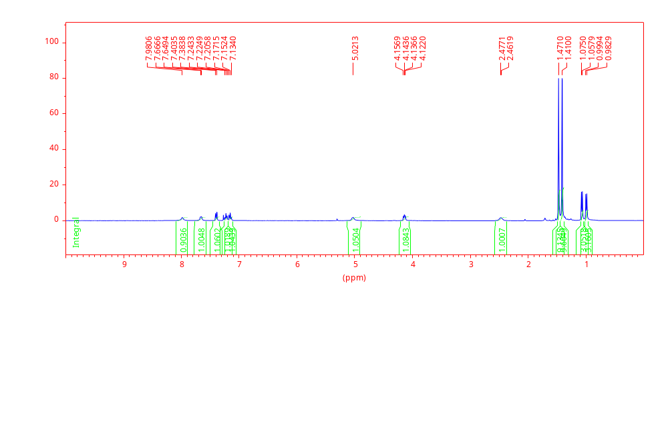
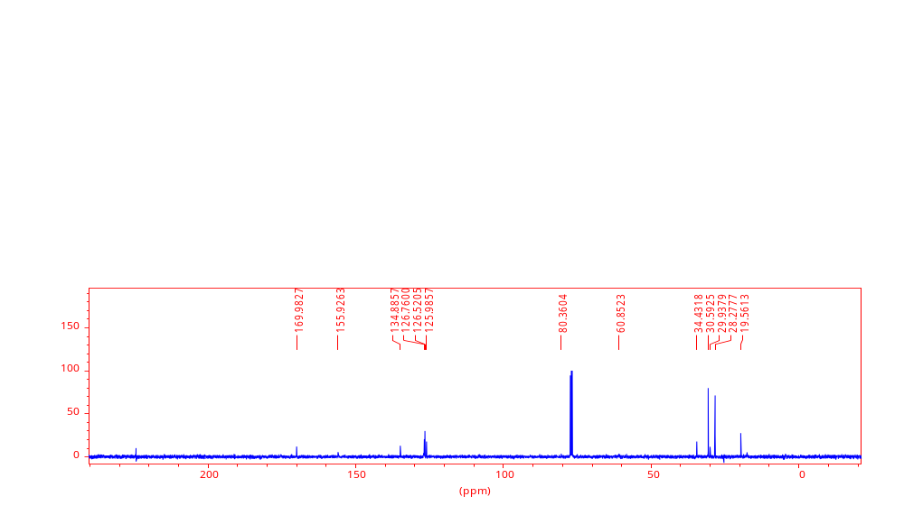
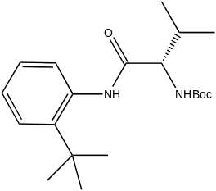
¹H NMR CDCl₃
¹³C NMR CDCl₃
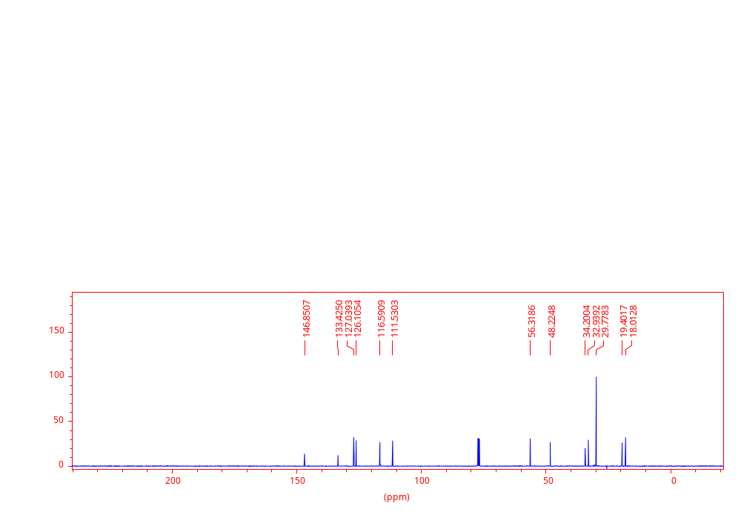
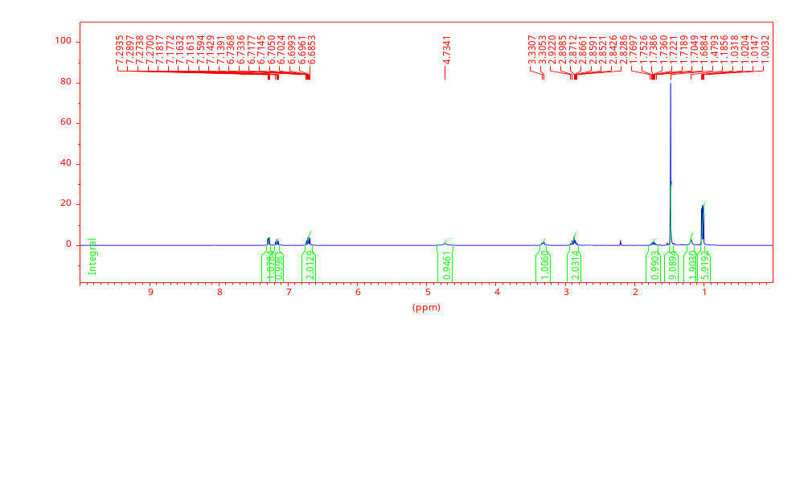
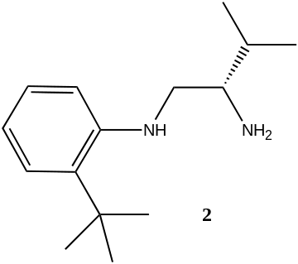
¹³C NMR CDCl₃
¹H NMR CDCl₃
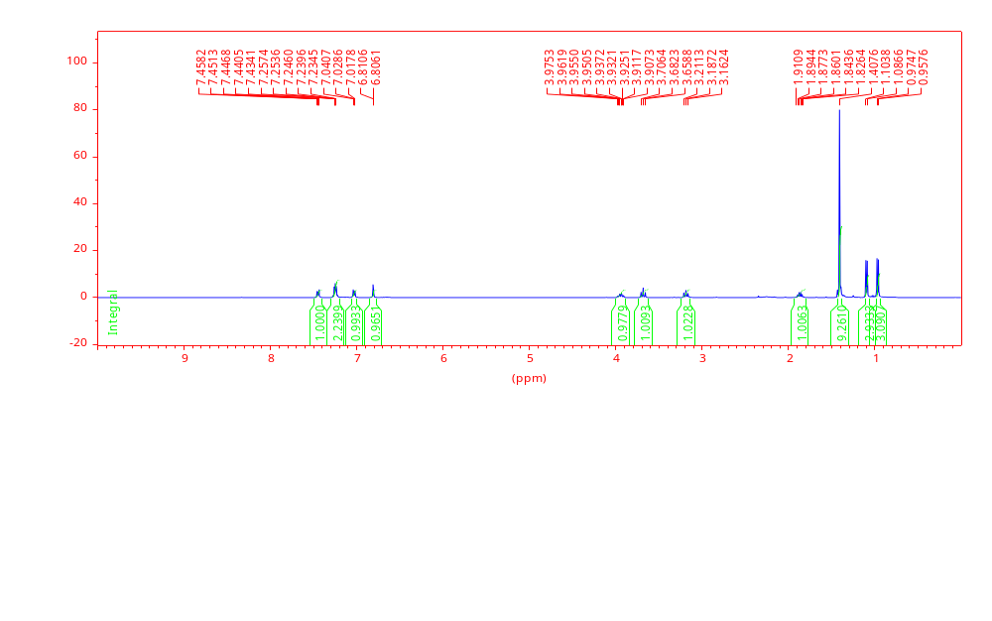
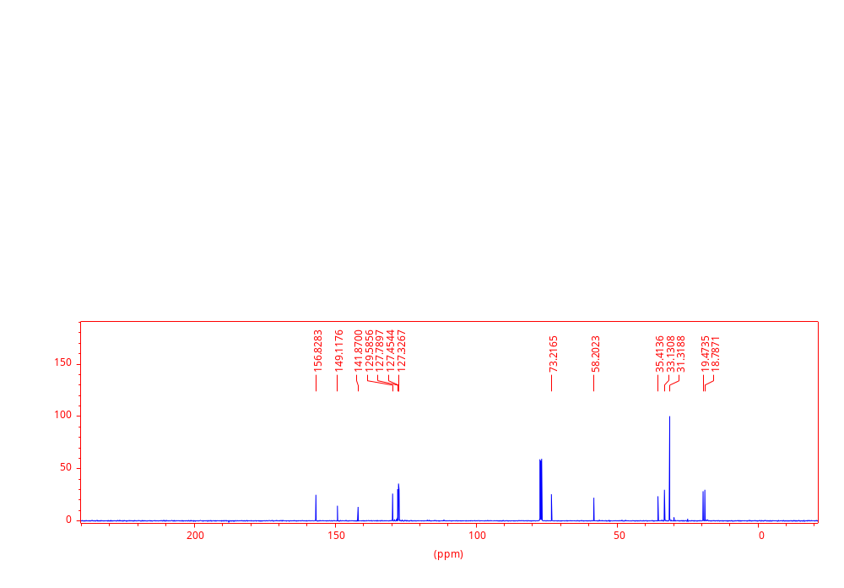
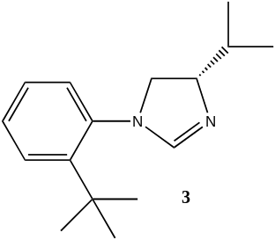
¹³C NMR CDCl₃
¹H NMR CDCl₃
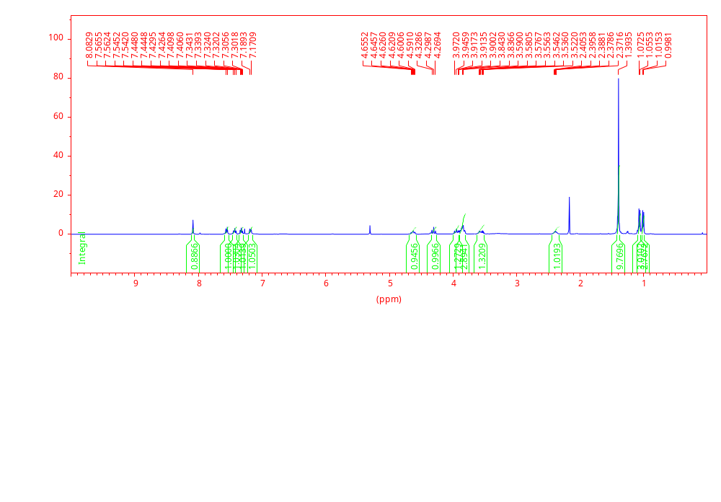
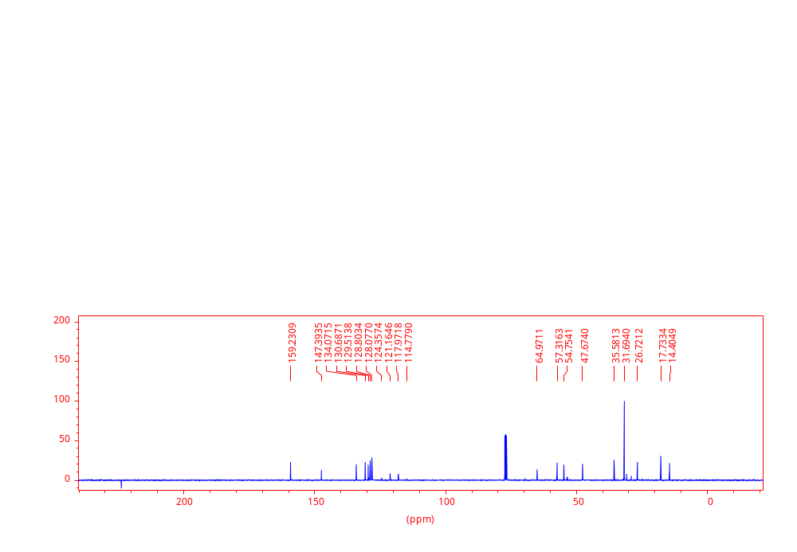
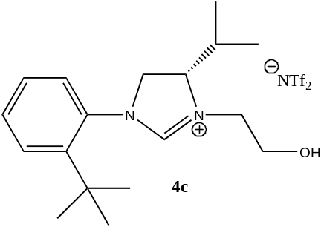
¹H NMR CDCl₃
¹³C NMR CDCl₃
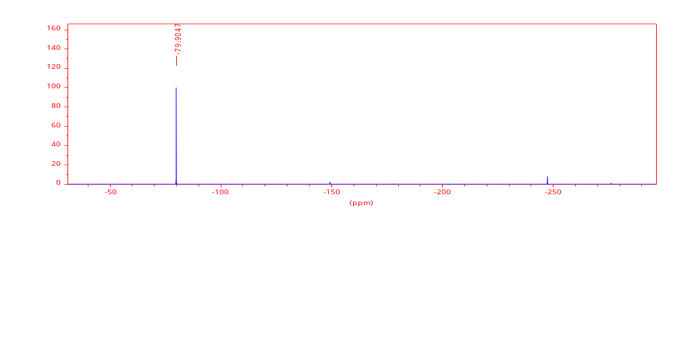
¹⁹F NMR CDCl₃
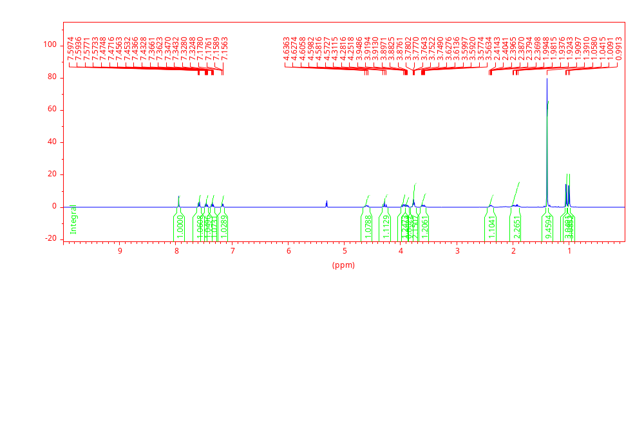
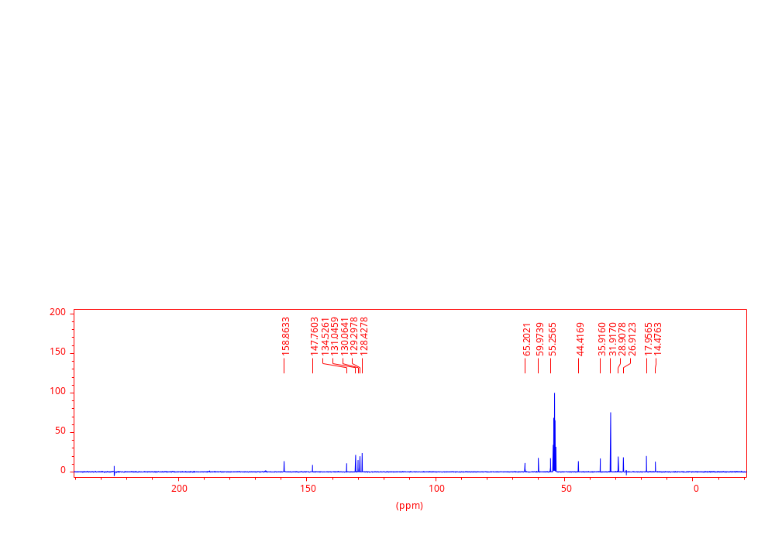
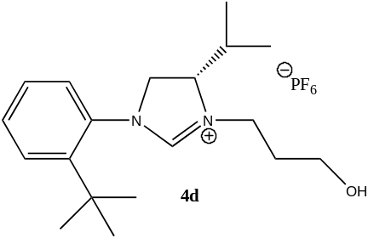
¹H NMR CD₂Cl₂
¹³C NMR CD₂Cl₂
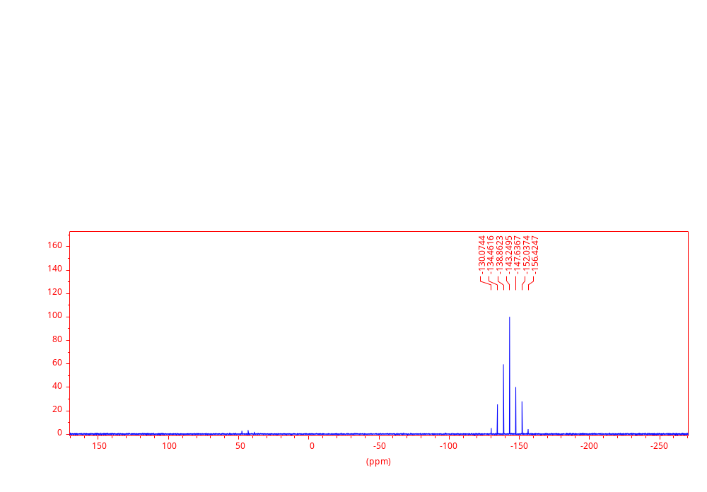
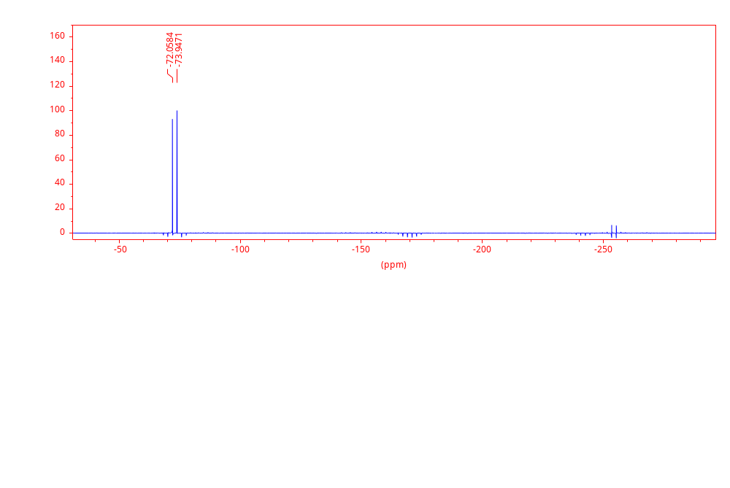
¹⁹F NMR CD₂Cl₂
³¹P NMR CD₂Cl₂
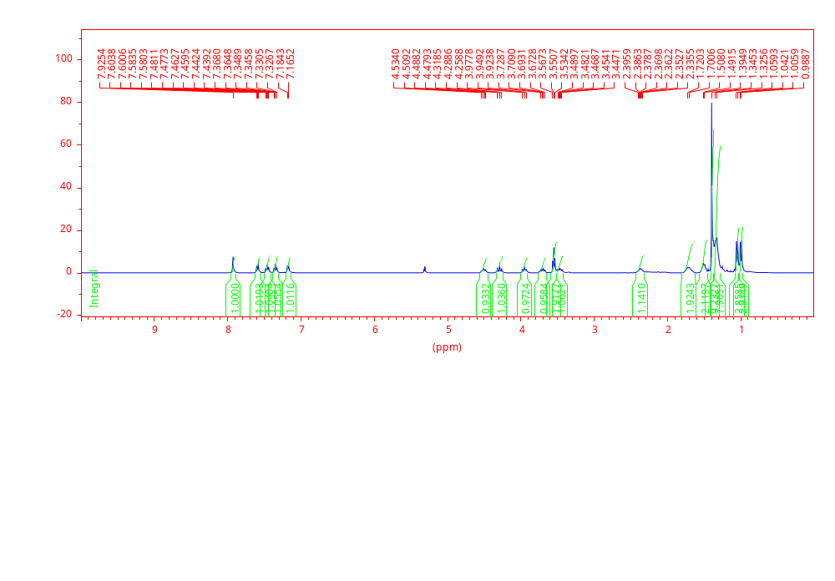
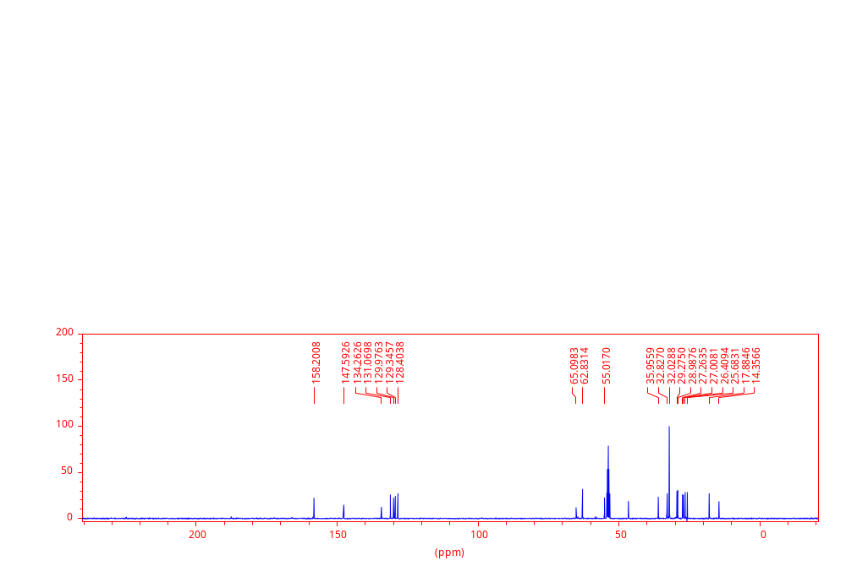
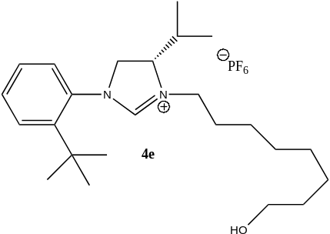
¹H NMR CD₂Cl₂
¹³C NMR CD₂Cl₂
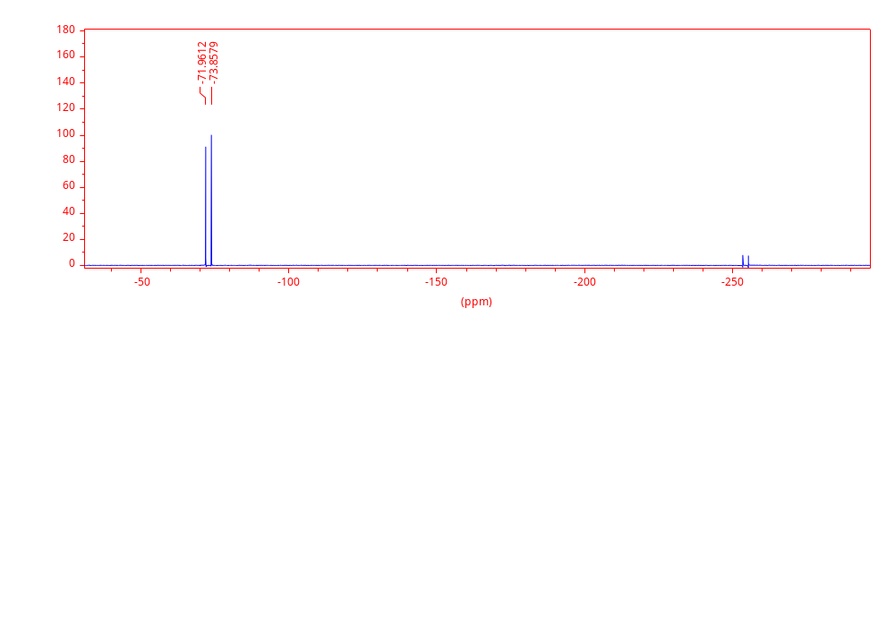
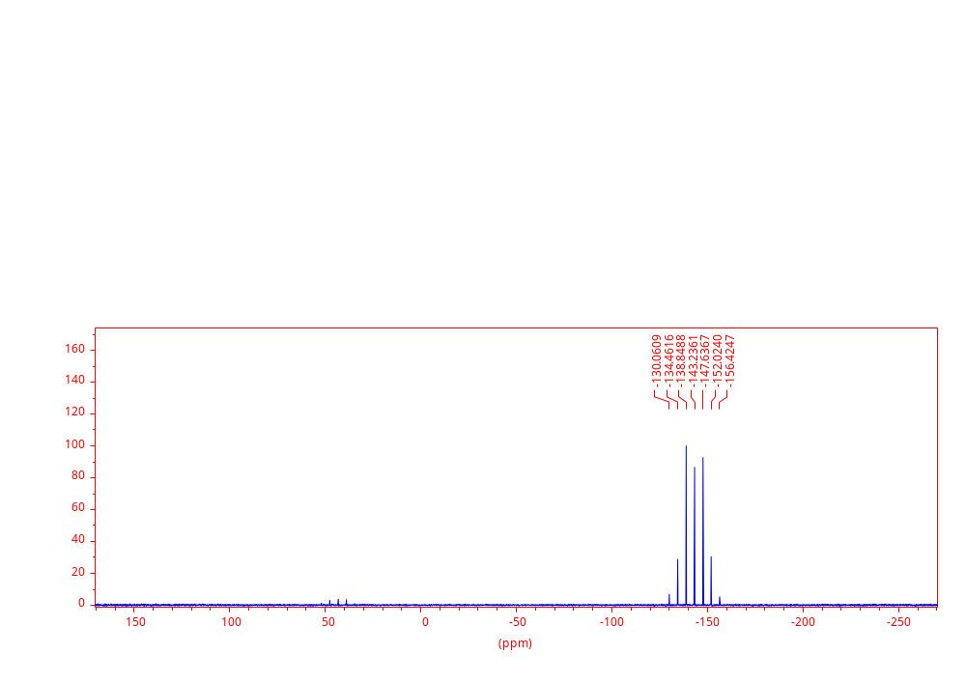
¹⁹F NMR CD₂Cl₂
³¹P NMR CD₂Cl₂
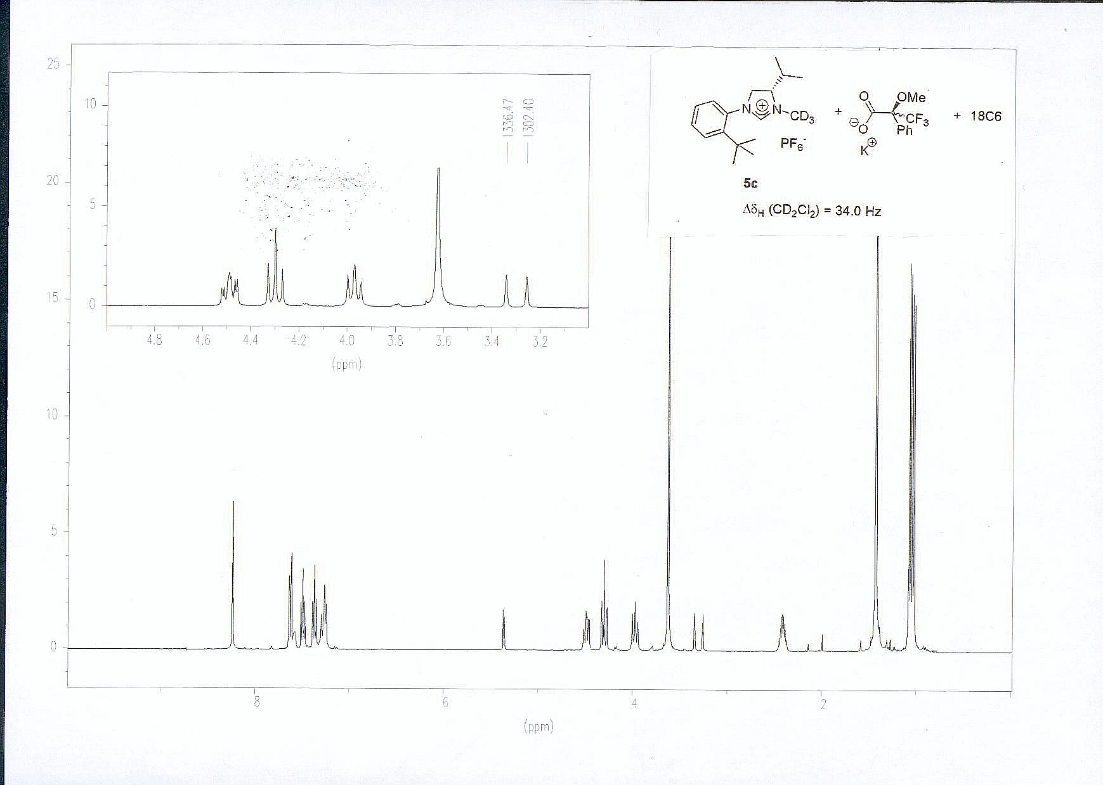
4a
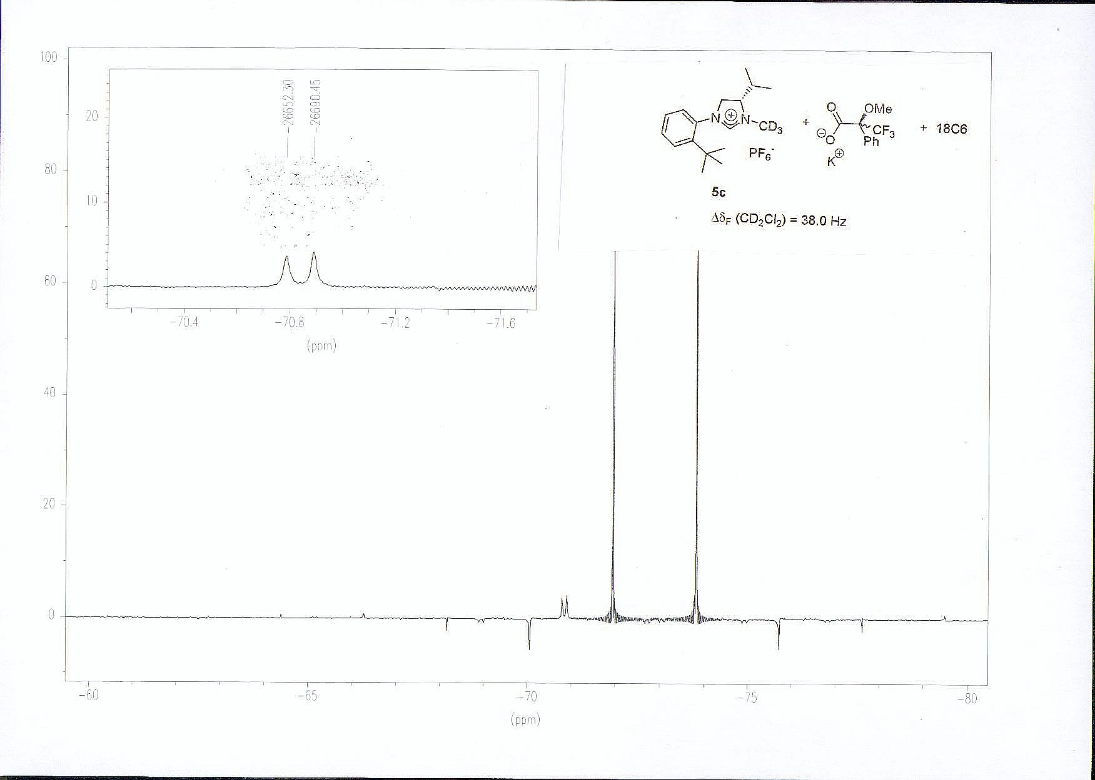
4a
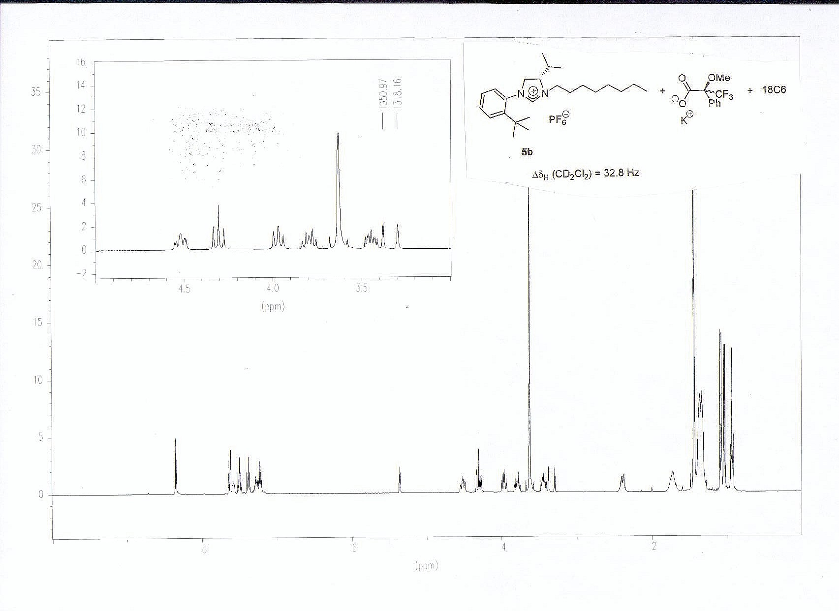
4b
4b
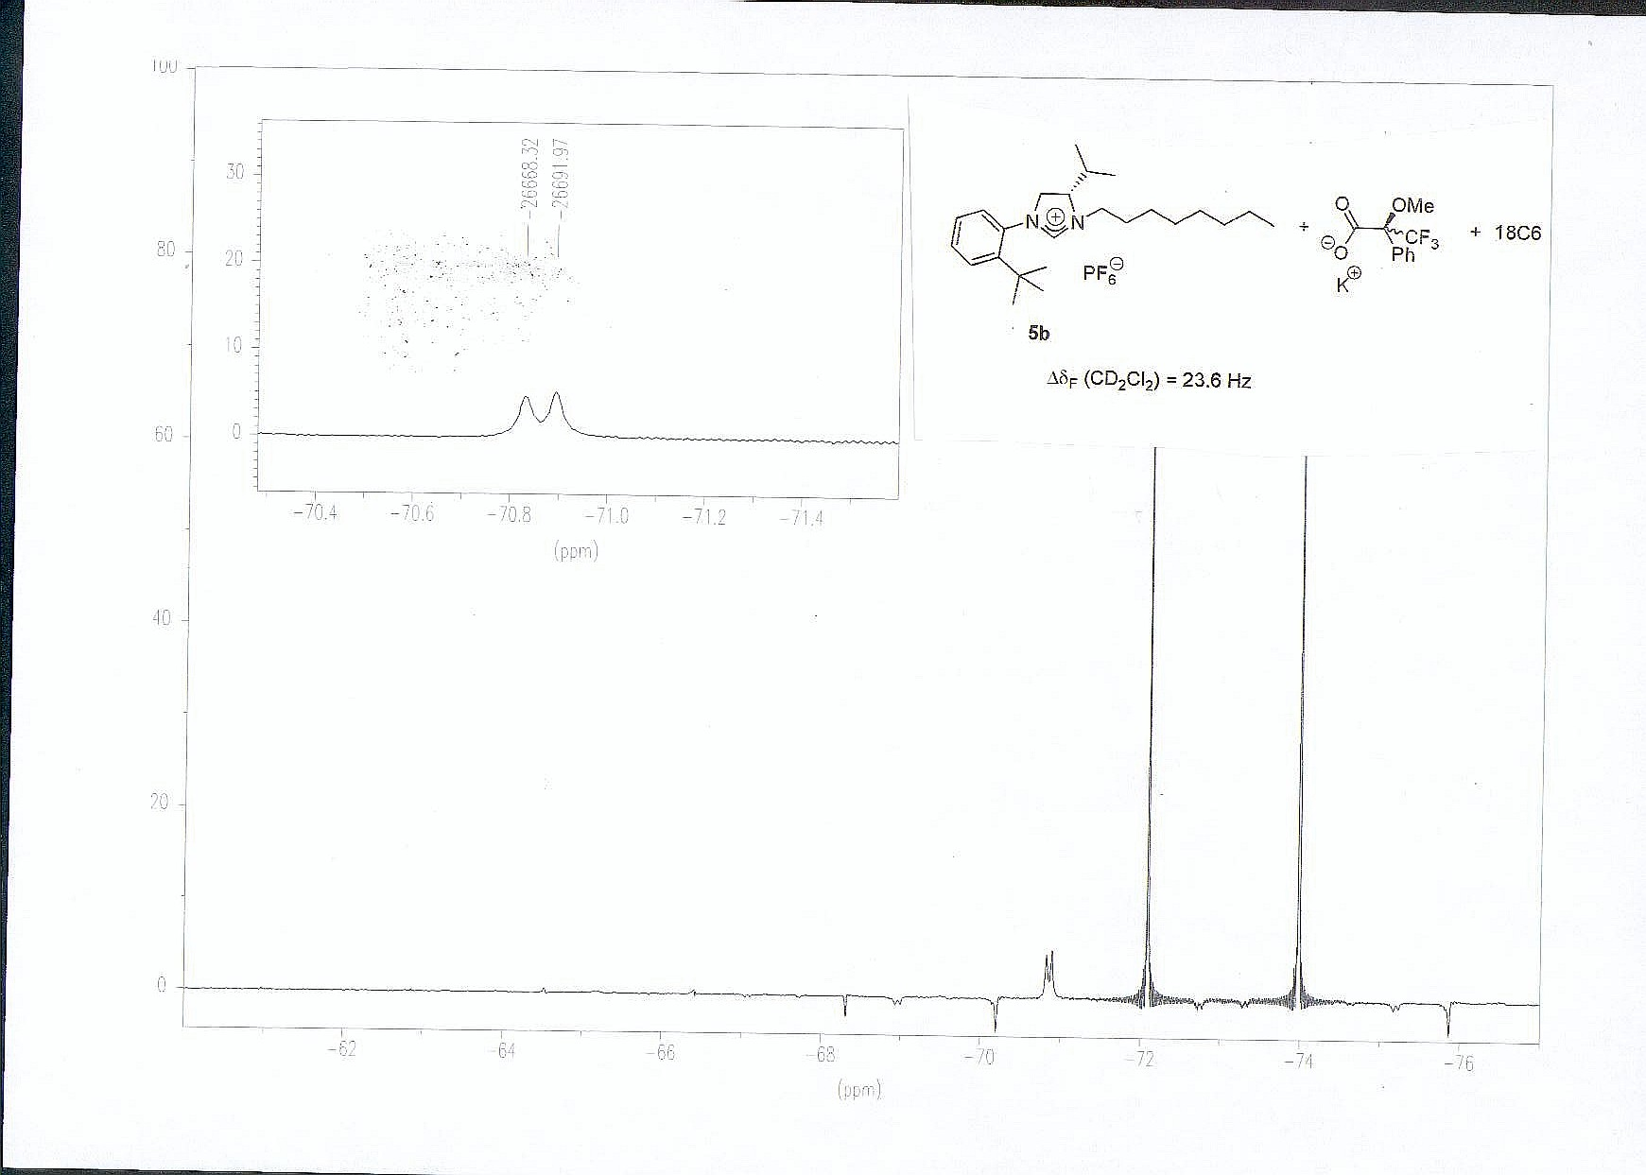
4b
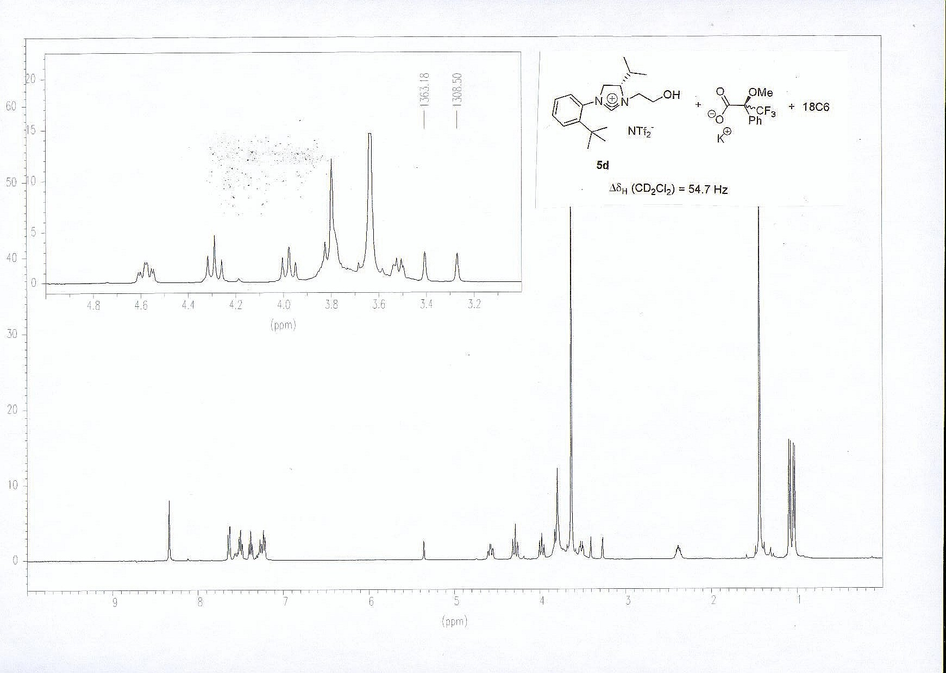
4c
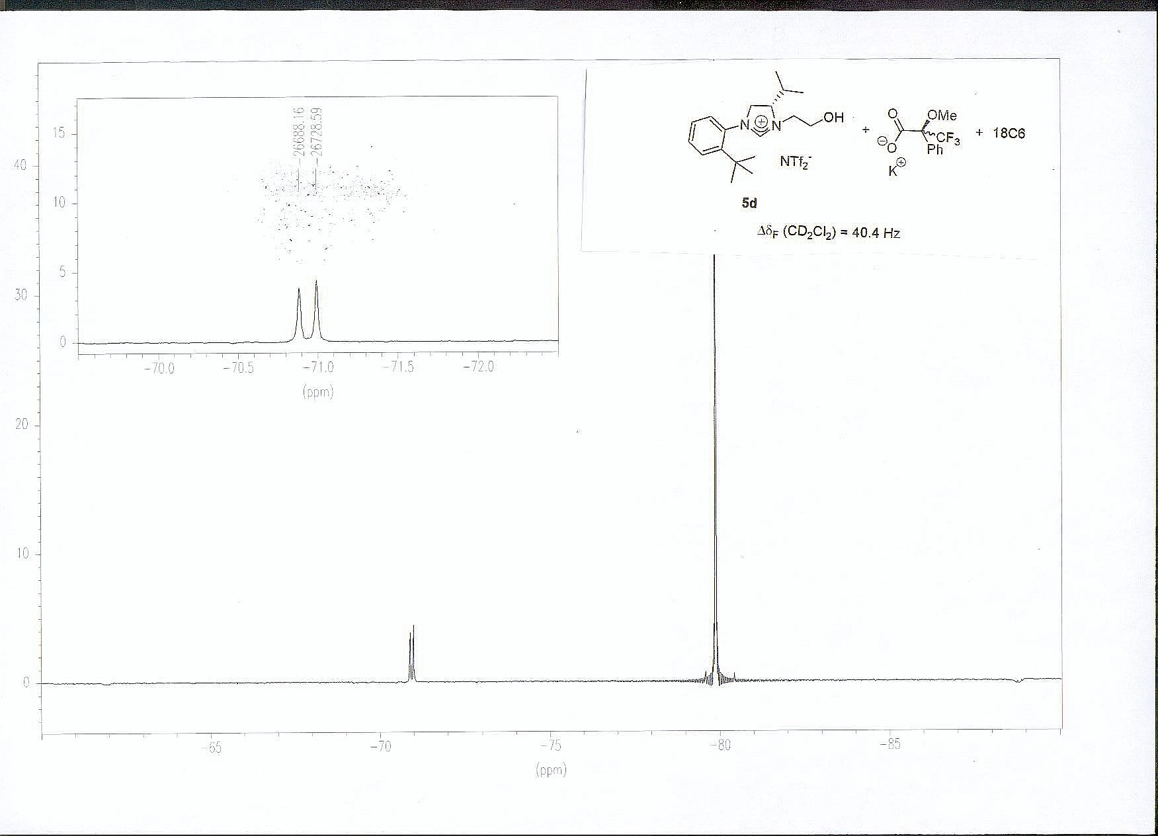
4c
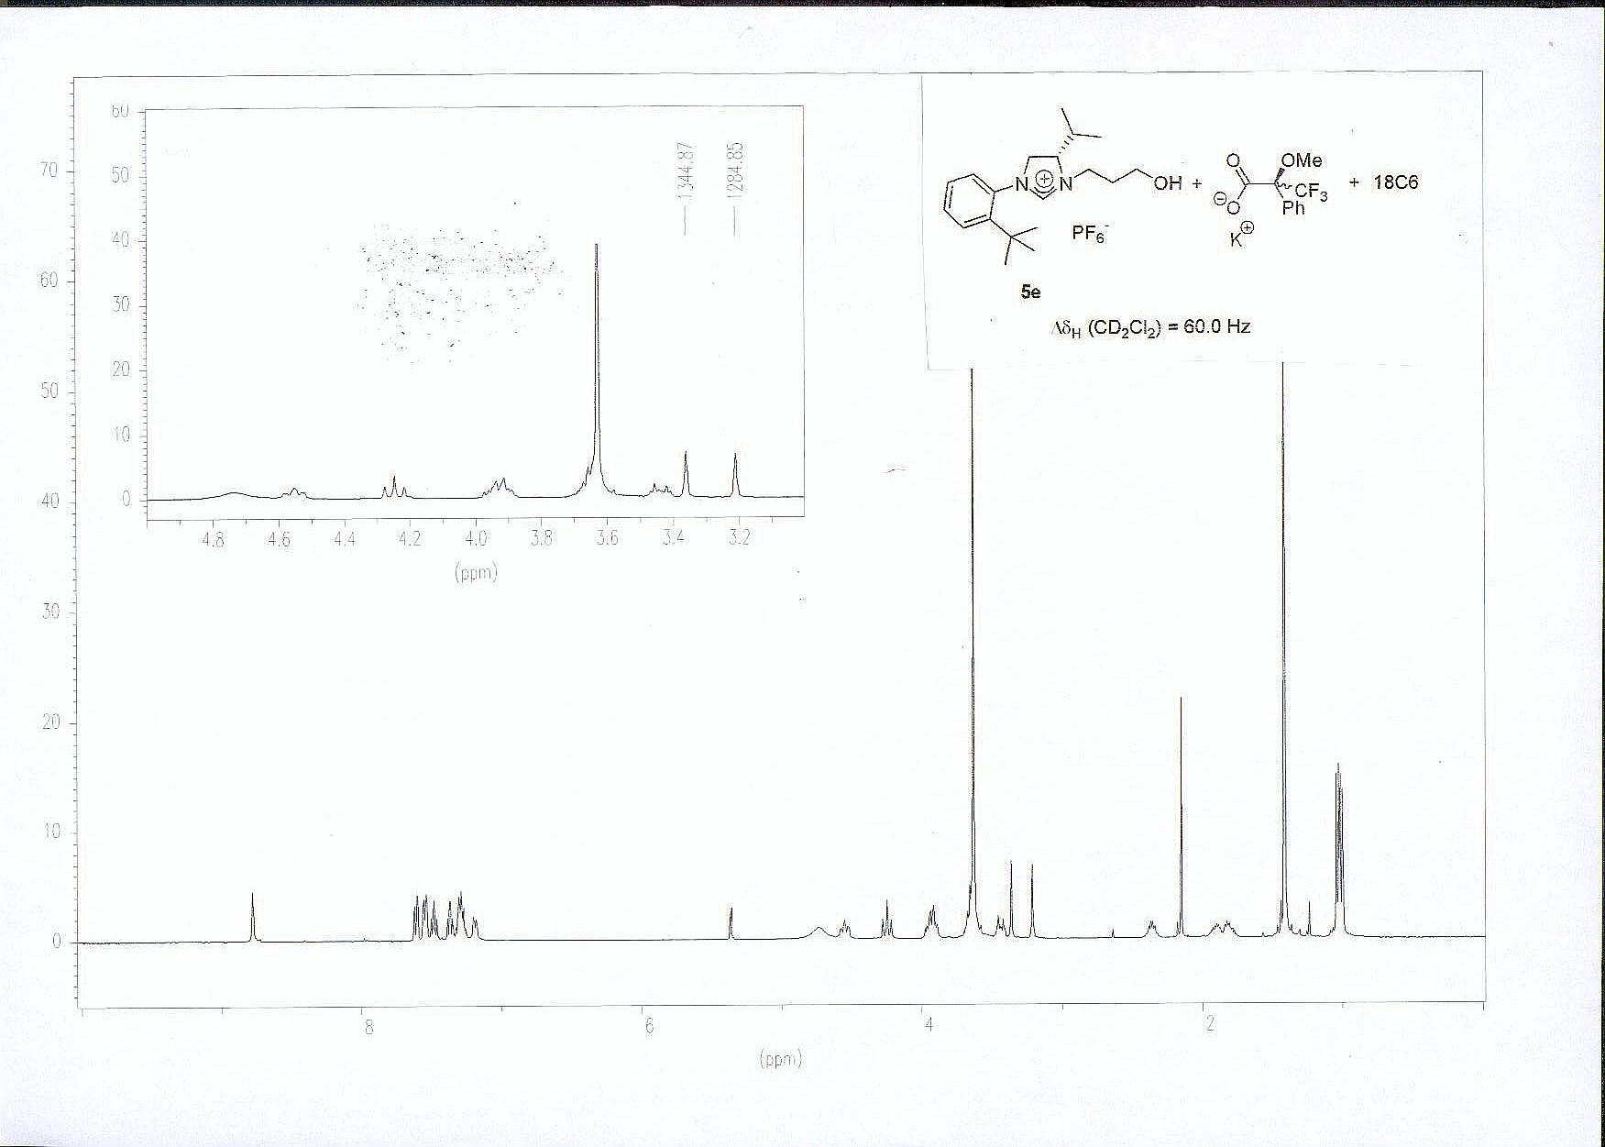
4d
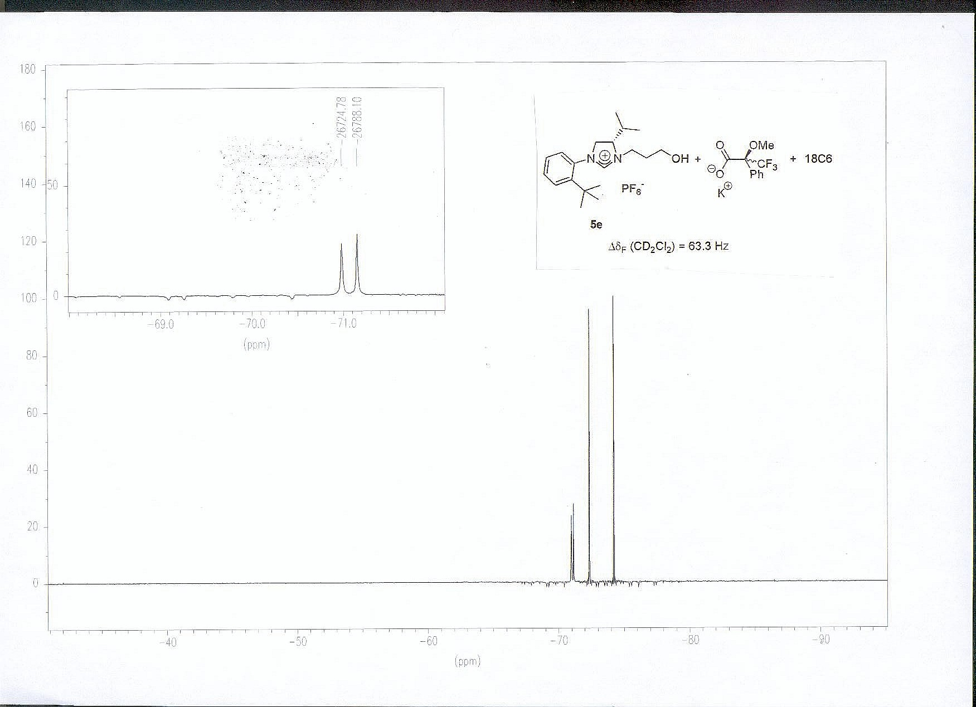
4d
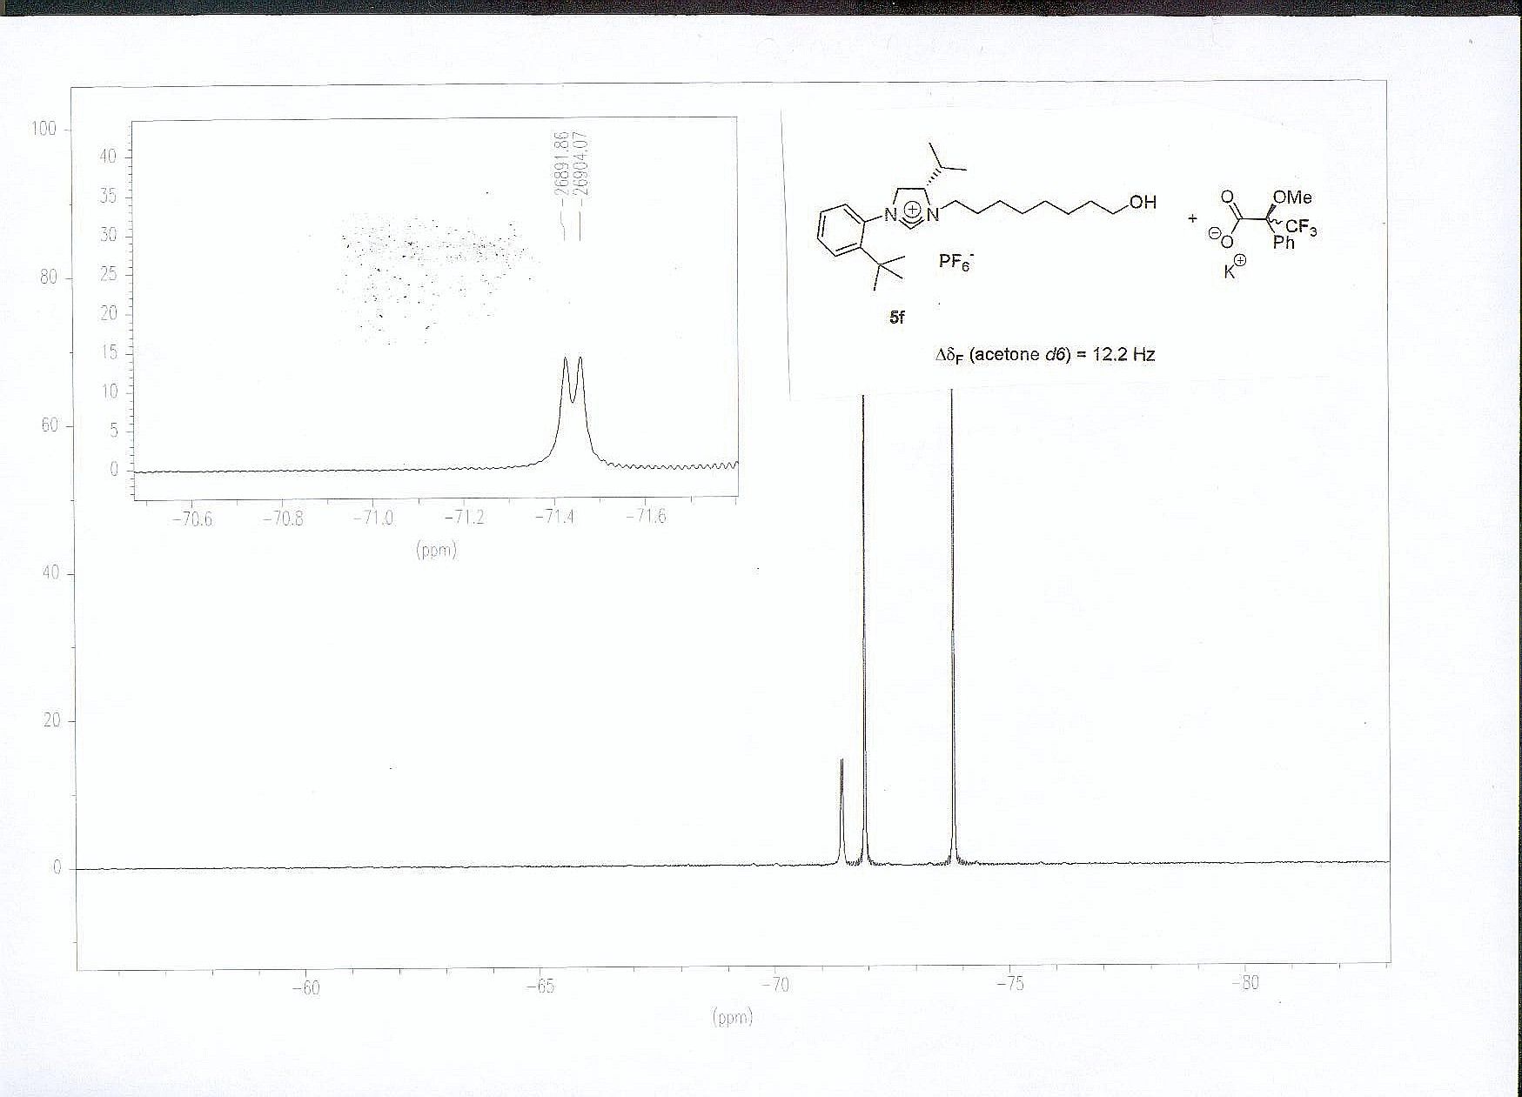
4e
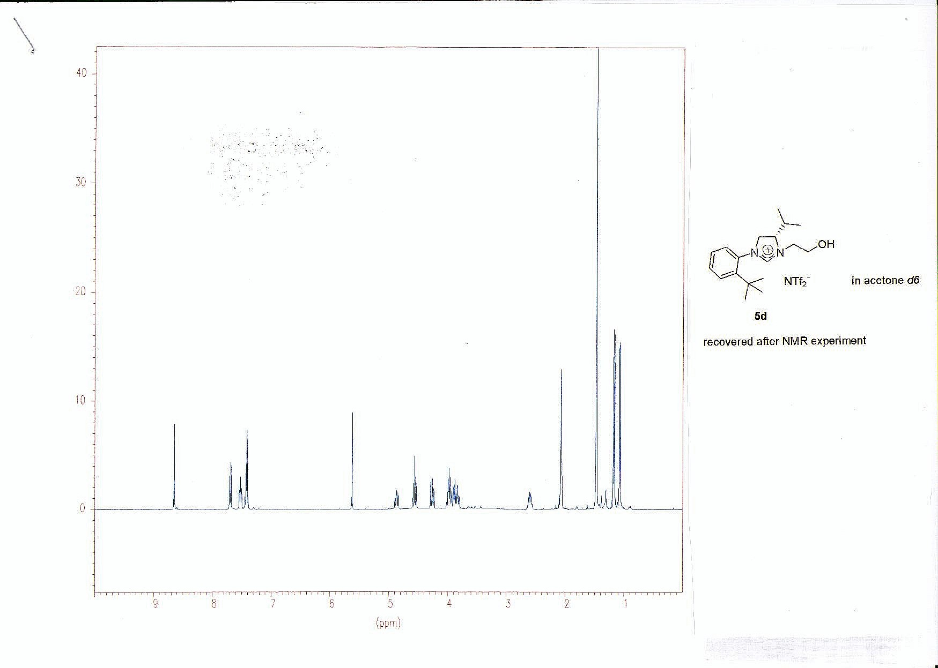
4c
4c
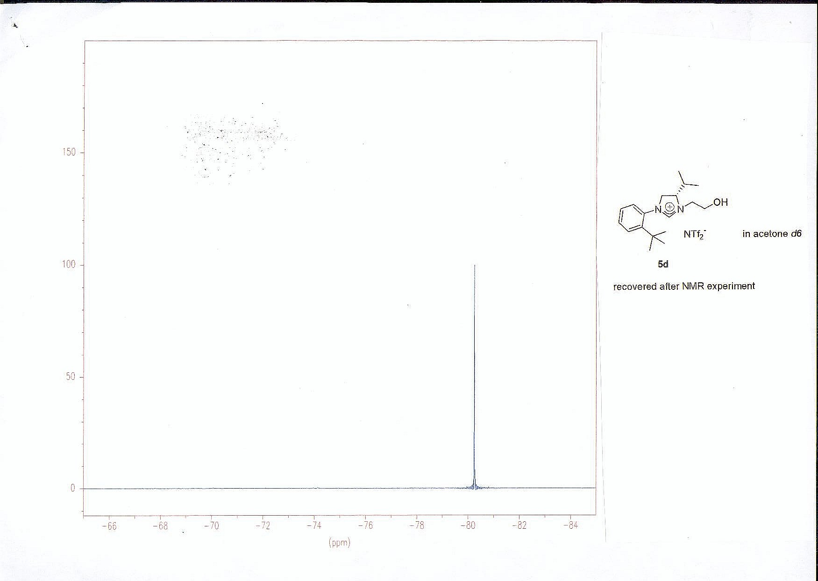
4c
4c
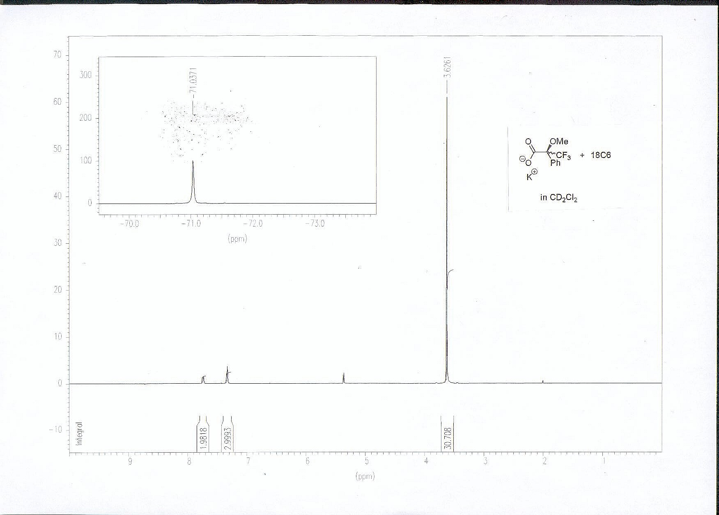
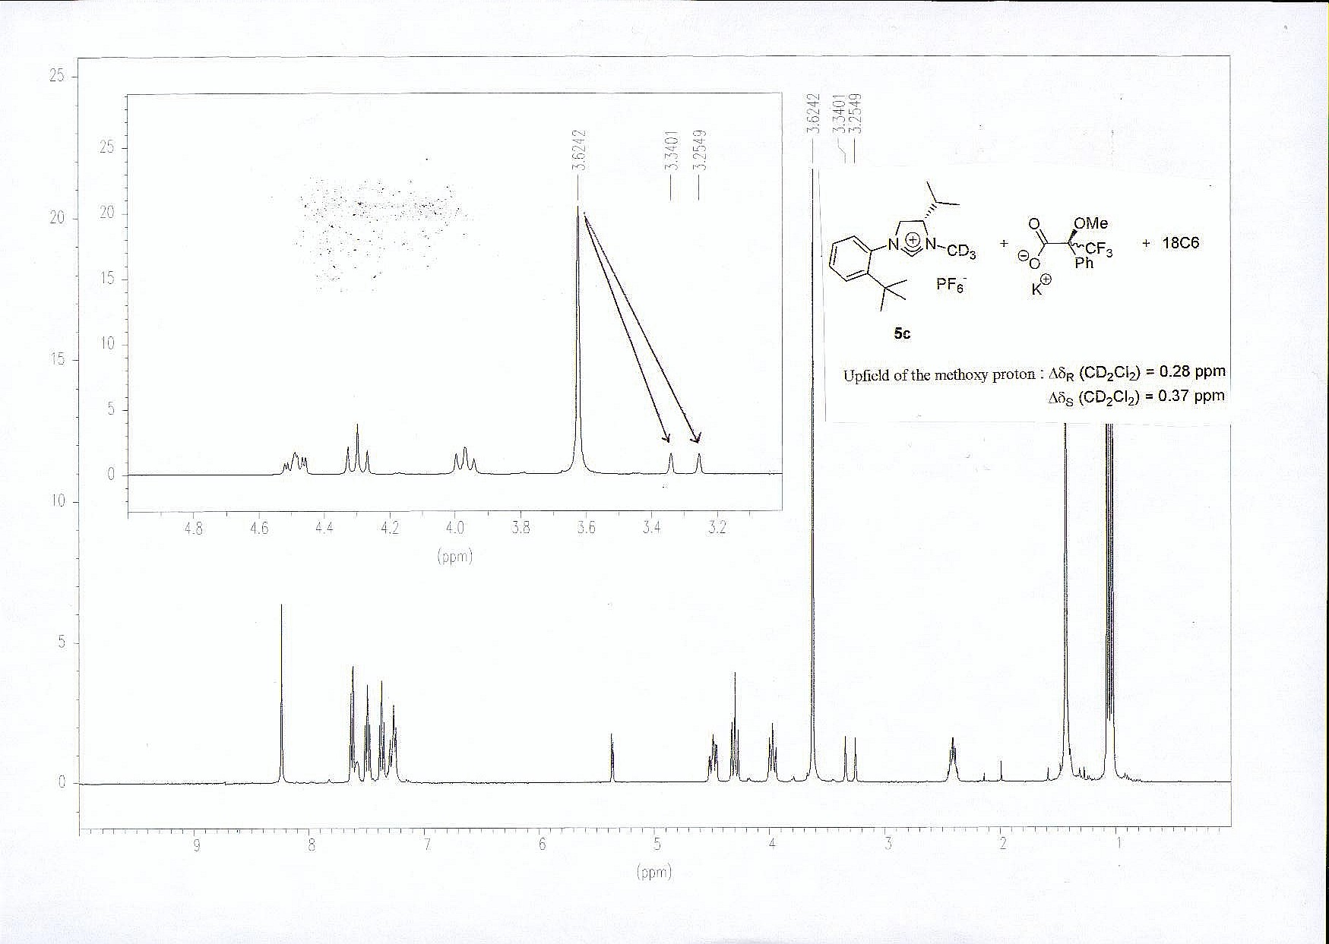
4a

