Electronic Supplementary Information
for
Template Synthesis of Multi-Macrocycles by Metathesis-Reaction
Myroslav O. Vysotsky, Anca Bogdan, Leyong Wang and Volker Böhmer*

¹H NMR spectra of multi-macrocyclic calix[4]arenes 4 and 5.

(9 pages)

Figure S1. ¹H NMR (400 MHz, THF-d₈, 25 °C) of 4a. The chemical shifts of residual signals of the solvent are not indicated.
Figure S2. ¹H NMR (400 MHz, THF-d₈, 25 °C) of 4b. The chemical shifts of residual signals of the solvent are not indicated.
Figure S3. ¹H NMR (400 MHz, THF-d₈, 25 °C) of 5a. The chemical shifts of residual signals of the solvent are not indicated.
Figure S4. ¹H NMR (400 MHz, THF-d₈, 25 °C) of 5b. The chemical shifts of residual signals of the solvent are not indicated.
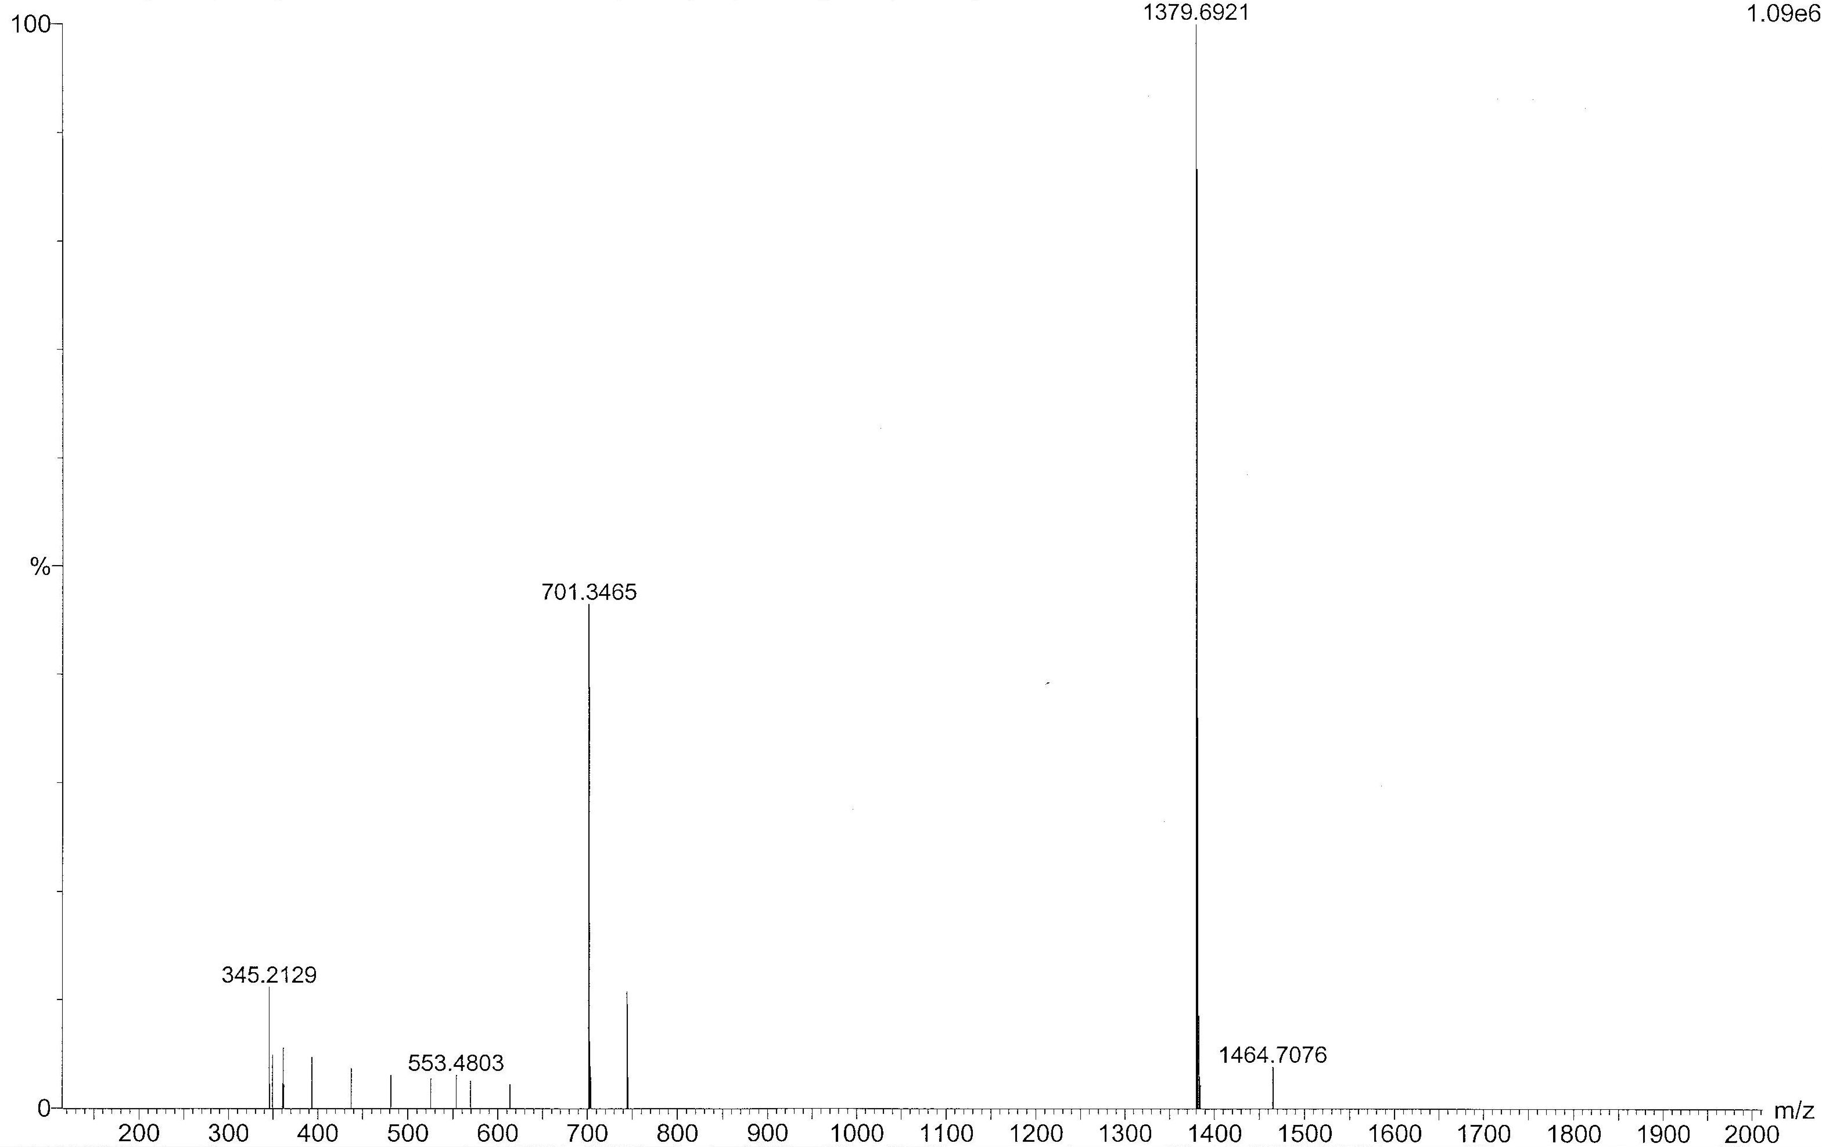
Figure S5. ESI-MS Spectrum of 4a. Calc. for C₈₀H₉₂N₈NaO₁₂ (M+Na⁺): 1379.6964.
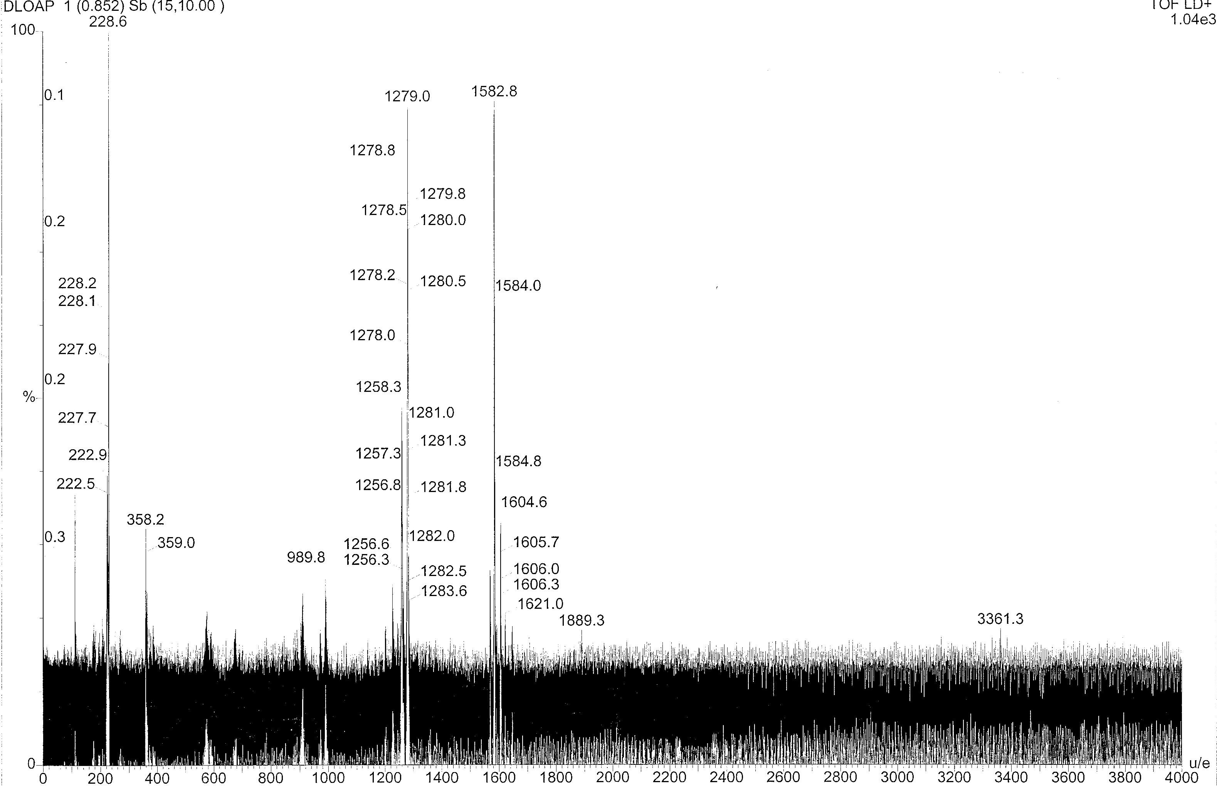
Figure S6. MALDI-TOF MS Spectrum of 4b. Calc. for C₉₆H₁₂₅N₈O₁₂ (MH⁺): 1581.9.
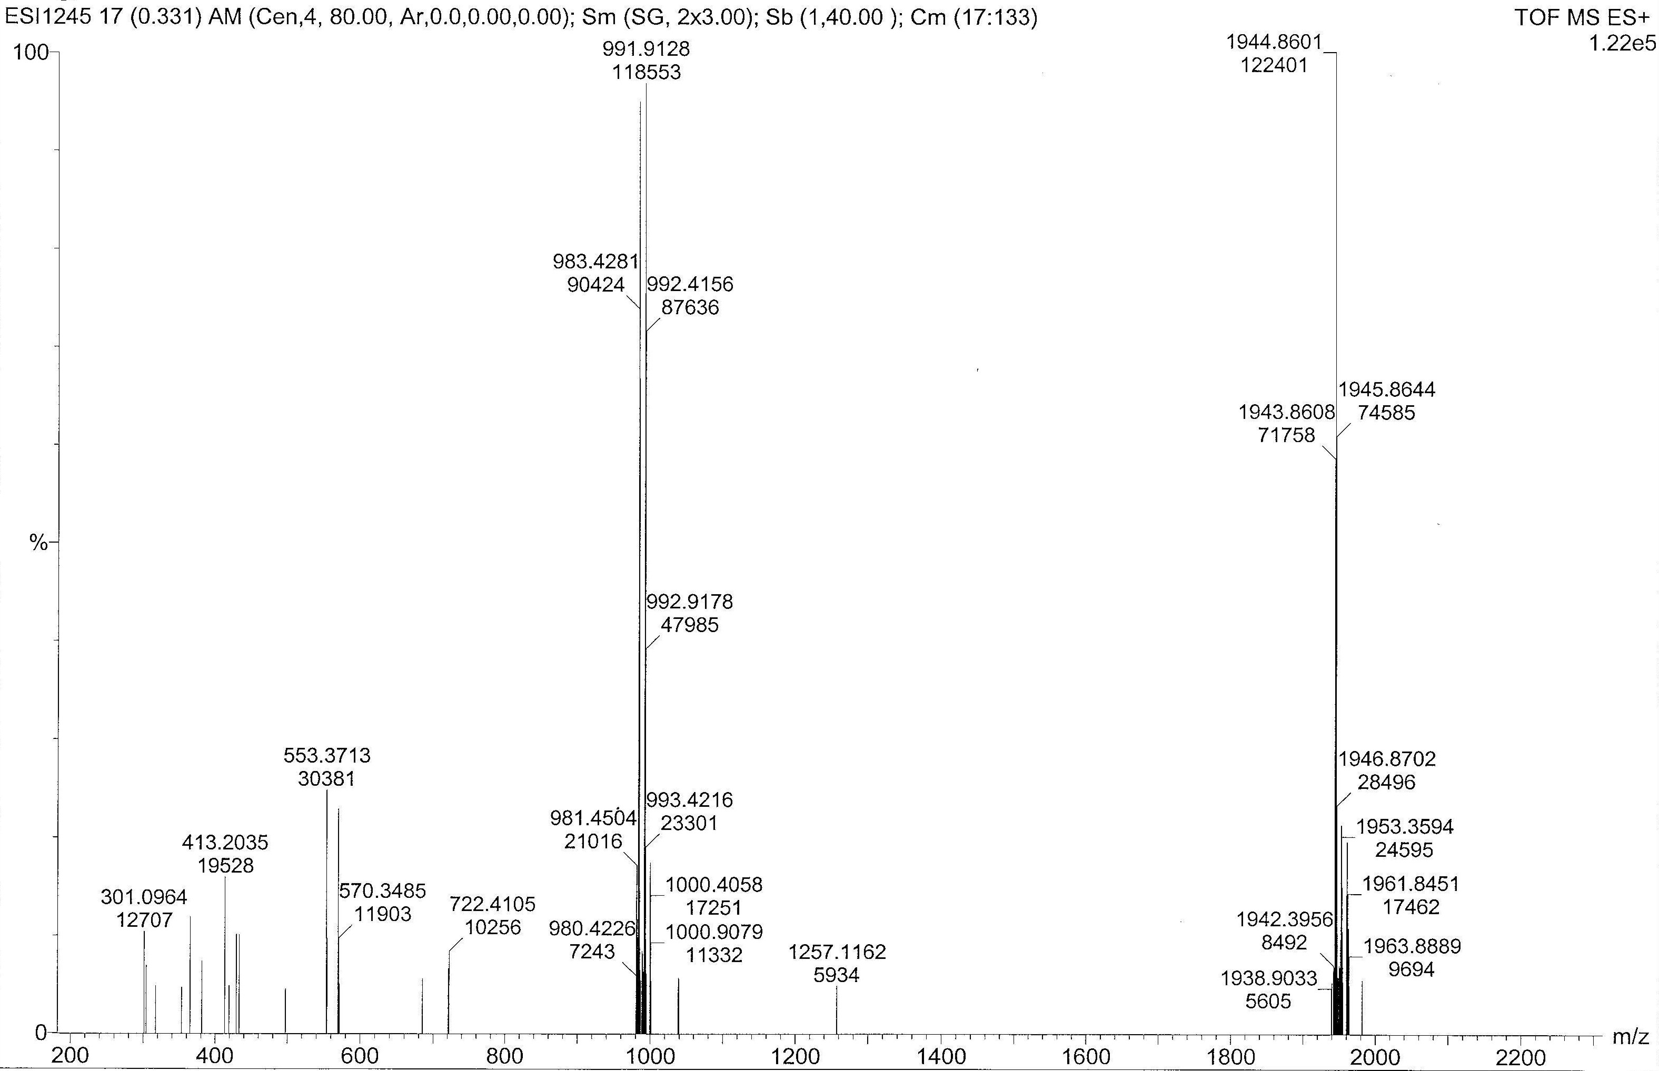
Figure S7. ESI-MS Spectrum of 5a. Calc. for C₁₁₆H₁₆₀N₈NaO₁₂ (M+Na⁺): 1944.1912.
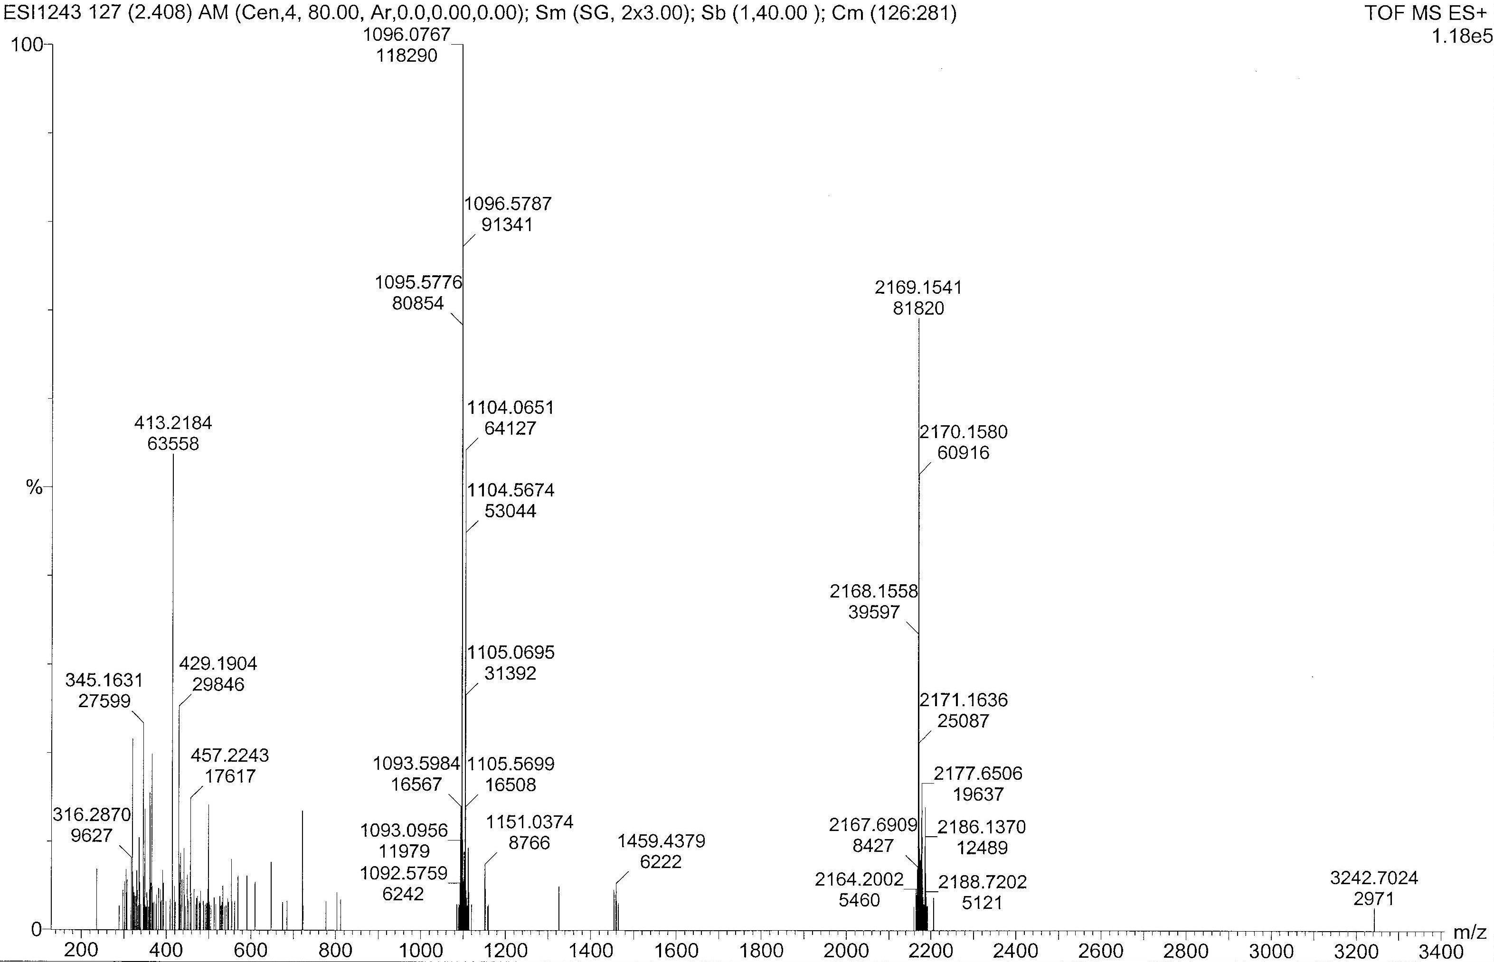
Figure S8. ESI-MS Spectrum of 5b. Calc. for C₁₃₂H₁₉₂N₈NaO₁₂: 2168.4408.

