Electronic Supplementary Information (ESI)
Inter- and Intramolecular H-Bonds Induced Different Nanostructures from a Multi-H-Bonding (MHB) Amphiphile: Nanofibers and Nanodisks
Peng Gao,^{a,b} Chuanlang Zhan,^{a,}* Lizhu Liu,^{b} Yanbiao Zhou,ª Minghua Liu^{a,}*
ª CAS Key Laboratory of Colloid and Interface Science, Center for Molecular Science, Institute of Chemistry, The Chinese Academy of Sciences, Beijing 100080, P.R. China
^{b} College of Material Science and Engineering ,Harbin University of Science and Technology, Heilongjiang,150080, P.R. China

Selected characteristic data of C₁₈-Glu: ¹H-NMR spectrum (DMSO-d₆, δ, ppm)：1.16 (t, 3H), 1.22 (s, 28H), 1.46 (t, 2H), 1.74 and 1.93 (m, 2H, directly linked to chiral center), 2.09 (m, 2H), 2.28 (m, 2H, directly linked to carboxyl), 4.18 (m, 1H, chiral center), 8.05 (d, 1H, -NH-). Elemental analysis: Calculated for C₂₃H₄₃NO₅: C, (66.79); H, (10.48); N, (3.39). Found: C, (66.50); H, (10.58); N, (3.57).

For measurements of AFM, SEM, Circular Dichroism (CD), and FT-IR and temperature-dependent ¹H-NMR spectra, and X-ray diffraction (XRD), the samples were prepared as follows. Upon heating, a freshly cleaved mica or silicon or silica or CaF₂ plate was put into the solvent mixed with C₁₈-Glu and was then allowed to cool down to the room temperature. The organogels were in-situ prepared onto the above substrates and subjected for the above measurements. For measurements of temperature-dependent ¹H-NMR spectra, either the organogel I formed with CDCl₃ or the xerogel II suspended in CDCl₃ in a NMR tube was used.

Fig. 1. ¹H-NMR spectrum of the xerogel II suspended in CDCl₃ at 334 K. In which the peaks at 3.7 and 4.2 ppm are all corresponding to the proton of chiral center. The separation of chiral center supports the strong interaction between inter-molecules through amide and carboxylic acid groups.
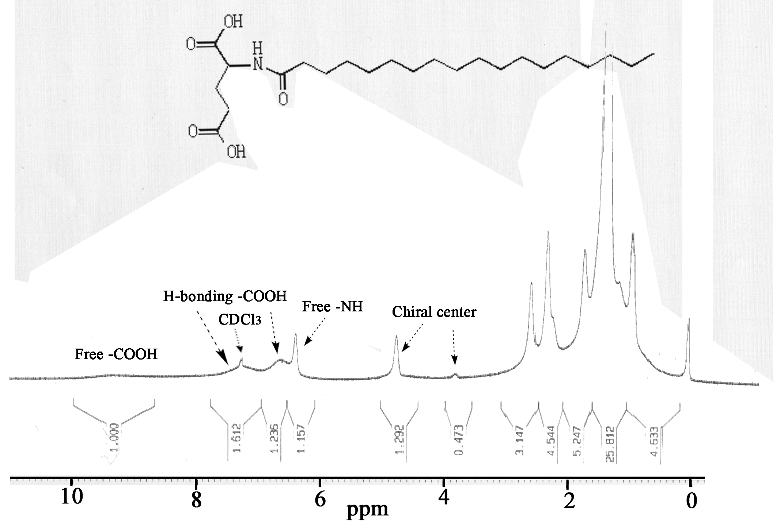
Fig. 2. Additional SEM and AFM height images of nanofibers of the organogel I from chloroform.

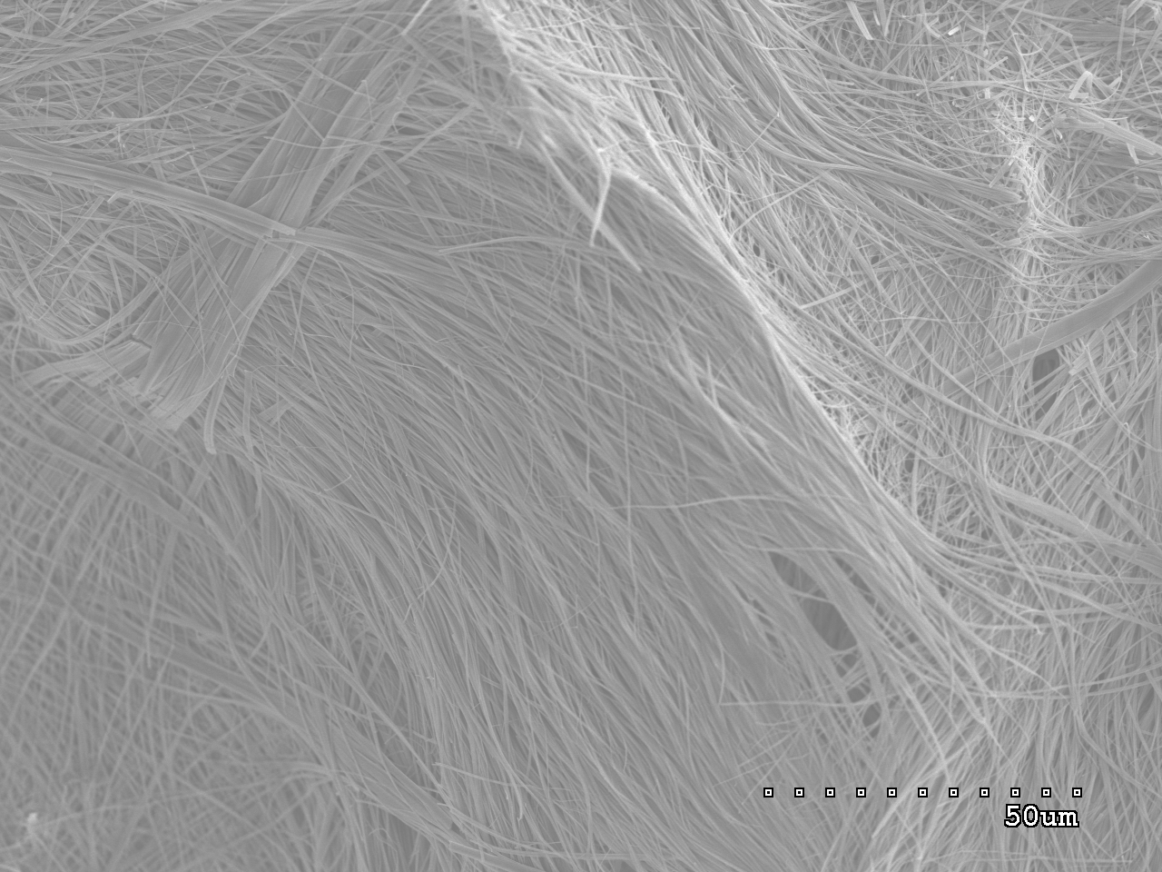

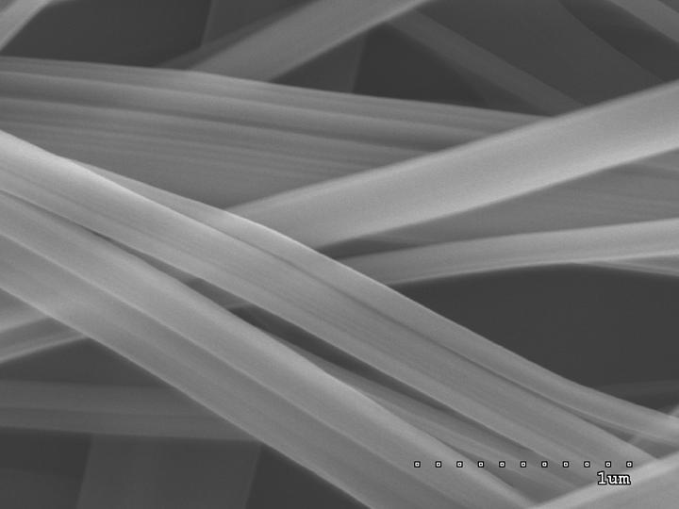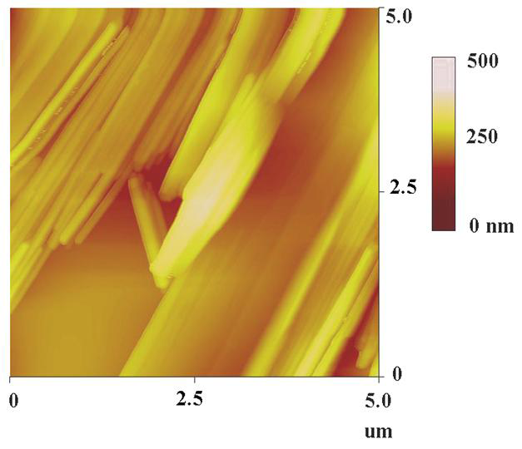

Fig. 3. XRD patterns of xerogels I and II of C₁₈-Glu formed from 1:1 mixed water/ethanol (a) and chloroform (b), respectively.
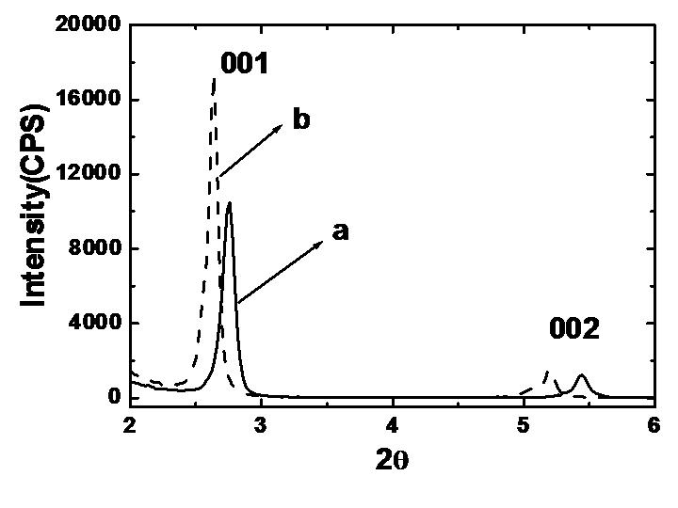

Fig. 4. FT-IR spectra of xerogels I and II of C₁₈-Glu formed from 1:1 mixed water/ethanol (a) and chloroform (b), respectively.
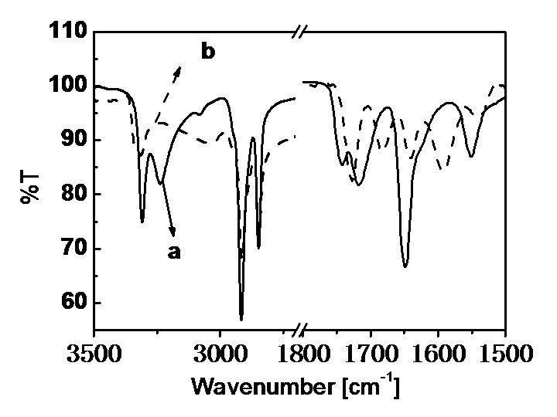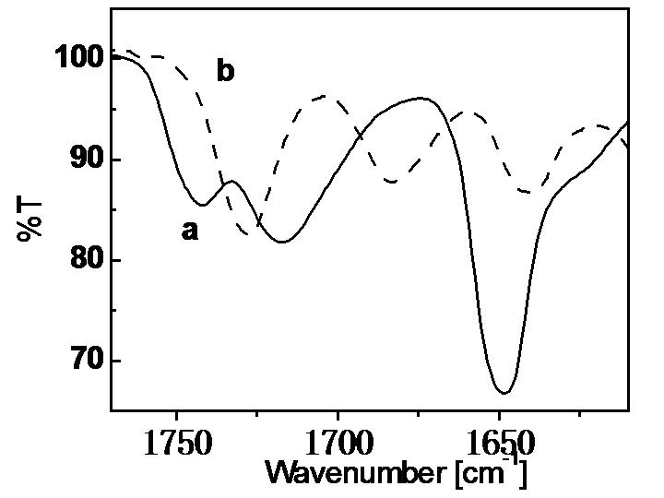

Fig.5. CD spectra of xerogels I and II of C₁₈-Glu formed from 1:1 mixed water/ethanol (a) and chloroform (b), respectively.
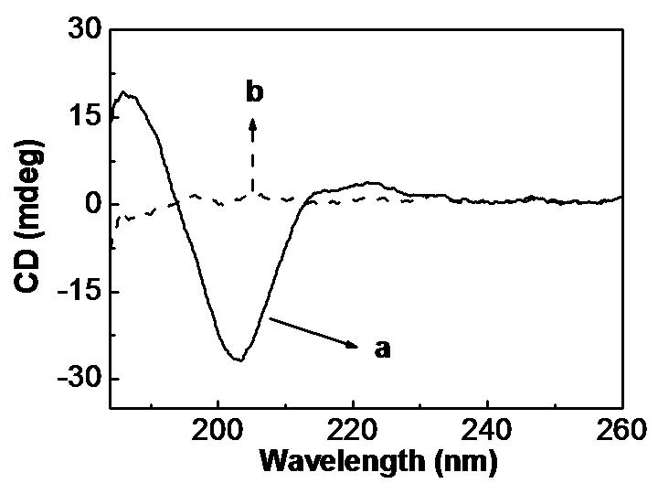

Fig. 6. PCMODEL minimizing energies and structures for two kinds of intramolecular H-bonds between amid and –COOH and between –COOH groups, from which one can see that kind I is stable compared to kind II in molecular energy.


