Supporting Information

Solvent Tuned Excited State Configuration Mixing in a π-Conjugated
Metal-Organic Oligomer

Shengxia Liu and Kirk S. Schanze*

Department of Chemistry, University of Florida
PO Box, 117200, Gainesville, FL 32611-7200

* Author to whom correspondence should be addressed

TEL: 352-392-9133
FAX: 352-392-2395
e-mail: kschanze@chem.ufl.edu

Synthesis and Characterization of T1-Ru (Refer to Scheme S-1 and S-2 for Structures and Acronyms)
Materials. Ethyl ether and tetrahydrofuran were distilled from sodium benzophenone and stored under argon. Copper(I) iodide, Pd(PPh₃)₂Cl₂, Pd(PPh₃)₄, 4,4-diiodobiphenyl, 3-octylthiophene and 2,2’-bithiophene were obtained from Aldrich Chemical Co. and used without further purification. Trimethylsilylacetylene and 2-methyl-3-butyn-2-ol were purchased from GFS Chemicals and were also used without further purification. All coupling reactions using Pd compounds as a catalyst were carried out on a Schlenk line. Silica gel (Merck, 230-400 mesh) was used for chromatography. NMR spectra were obtained on a GE QE 300-MHz spectrometer unless noted otherwise. cis-Dichloro-bis-(2,2’-bipyridine) ruthenium(II) was prepared by the literature method.¹
Compound 1a. 4,4’-Diiodophenyl (15.0 g, 36.7 mmol), tetrahydrofuran (47 mL), diisopropylamine (47 mL), Pd(PPh₃)₂Cl₂ (0.78 g, 1.10 mmol) and CuI (0.70 g, 3.64 mmol) were combined in a 100 mL Schlenk flask and degassed with argon for 0.5 hr. The mixture was heated to 70 °C whereupon trimethylsilylacetylene (5.17 mL, 36.7 mmol) was added. At this point the mixture turned bright yellow. After 2 hrs 2-methyl-3-butyn-2-ol (10 mL, 36.7 mmol) was added dropwise over 0.5 hr period. The reaction mixture then became black and opaque and it was stirred at 70 °C overnight. After the solvent was removed under reduced pressure, the crude product was purified by column chromatography with silica gel using 3:1 CH₂Cl₂/hexane to afford 1a as a white solid. The product (3.7 g) was obtained in 25% yield.
Spectral data: ¹H NMR (CDCl₃, 300 MHz, ppm) δ 0.27 (s, 9H), 1.751 (t, 1H), 4.54 (d, 2H), 7.53 (m, 8H).
Compound 1b. A mixture of methanol (25 mL), KOH (1.47 g, 26.25 mmol), tetrahydrofuran (40 mL) and 1a (3 g, 9.85 mmol) was stirred at room temperature for 4 hrs. The mixture was diluted with 20 mL of water and extracted with 30 mL CHCl₃. The organic layer was separated and dried with MgSO₄. After removal of the solvent 1b (1.8 g) was obtained in 80 % yield.
Spectral data: ¹H NMR (CDCl₃, 300 MHz, ppm) δ 1.75 (t, 1H), 3.14 (s, 1H), 4.53 (d, 2H), 7.54 (m, 8H).
1,4-Diiodo-2,5-heptyloxybenzene. 1,4-heptyloxybenzene (11.40 g, 36.0 mmol)² was placed in a 250 mL round bottom flask containing 125 mL acetic acid, 4 mL concentrated sulfuric acid, and 12 mL of water. Iodine (10 g, 39.0 mmol) was added to the solution and it was stirred under reflux for 24 hrs. The solution was allowed to cool to room temperature and diluted with 100 mL of water. It was cooled further by immersion in an ice water bath. The precipitate was collected by filtration and then it was dissolved in CH₂Cl₂. The product was decolorized by addition of active carbon followed by filtration. The crude product was obtained after evaporation of the solvent, and it was purified by recrystallization from EtOH to afford the pure product (14.24 g) as a white solid in 74% yield.
Spectral data: ¹H NMR (CDCl₃, 300 MHz, ppm) δ 0.82 (br t, 6H), 1.3 (br s, 12H), 1.5 (br m, 4H), 1.75 (br m, 4H), 3.90 (t, 4H), 6.9 (s, 4H).
Compound 2. A solution of 1,4-diiodo-2,5-diheptyloxybenzene (4.33 g, 7.75 mmol) and 1b (1.8 g, 7.75 mmol) in THF (80 mL) and diisopropylamine (80 mL) was prepared in a Schlenk flask. The solution was degassed for 0.5 hr under argon. While maintaining the argon atmosphere bis(triphenylphosphine) dichloropalladium (0.16 g, 0.23 mmol) was added, followed immediately by addition of copper(I) iodide (88.0 mg, 0.05 mmol). The mixture was heated overnight at 75 °C. After cooling to room temperature, the solvent was removed under reduced pressure, and the crude product was purified by column chromatography with 4:1 CH₂Cl₂/hexane. The product (1.89 g) was obtained in 37% yield.
Spectral data: ¹H NMR (CDCl₃, 300 MHz, ppm) δ 0.88 (br t, 6H), 1.31 (m, 8H), 1.53 (m, 8H), 1.83 (m, 4H), 3.98 (m, 4H), 4.52 (s, 2H), 6.92 (s, 1H), 7.313 (s, 1H), 7.55 (m, 8H).
Compound 3a. A solution of 5-ethynyl-2,2’-bipyridine³ (100 mg, 0.55 mmol) and 2 (330 mg, 0.5 mmol) in a mixture of THF (6 mL) and diisopropylamine (2 mL) was prepared in a Schlenk flask. The solution was degassed for 0.5 hr under argon. While maintaining the argon atmosphere, bis(triphenylphosphine) dichloropalladium (21.3 mg, 0.03 mmol) and copper(I) iodide (11.4 mg, 0.06 mmol) were added to the solution, and then it was heated overnight at 75 °C. After cooling to room temperature, the solvent was removed under reduced pressure and the crude product was purified by column chromatography with 3:1 ether/hexane as an elutant. The product (260 mg) was obtained in 73% yield.
Spectral data: ¹H NMR (CDCl₃, 300 MHz, ppm) δ 0.88 (br t, 6H), 1.31 (m, 8H), 1.53 (m, 8H), 1.87 (m, 4H), 4.05 (m, 4H), 4.53 (s, 2H), 7.05 (s, 2H), 7.33 (t, 1H), 7.58 (m, 8H), 7.84 (t, 1H), 7.93 (d, 1H), 8.42 (d, 2H), 8.69 (d, 1H), 8.83 (s, 1H).
Compound 3b. activated MnO₂ (290 mg, 3.3 mmol) and powered KOH (94 mg, 1.6 mmol) were added in four portions, one every hour, to a solution of 3a (150 mg, 0.2 mmol) dissolved in a mixture of dry diethyl ether (8 mL) and dry tetrahydrofuran (8 mL). The suspension was stirred at room temperature while being shielded from light. The reaction was monitored by TLC (hexane/THF, 65:35 v/v). Filtration of the reaction mixture through a short column of silica gel with a 2:1 mixture of hexane and THF respectively afforded compound 3b (91 mg) as a yellow solid in 95% yield.
Spectral data: ¹H NMR (CDCl₃, 300 MHz, ppm) δ 0.88 (br t, 6H), 1.31 (m, 8H), 1.53 (m, 8H), 1.87 (m, 4H), 3.15 (s, 1H), 4.05 (m, 4H), 7.05 (s, 2H), 7.33 (t, 1H), 7.58 (m, 8H), 7.84 (t, 1H), 7.93 (d, 1H), 8.42 (d, 2H), 8.69 (d, 1H), 8.83 (s, 1H).
2,5-dibromo-3-octylthiophene. N-Bromosuccinimide (1.02 g, 5.72 mmol) was added in 10 portions during a 10 min period to a mixture of 3-octylthiophene (561.6 mg, 2.86 mmol) in chloroform and acetic acid (50:50, v/v, 15 mL) at 30 °C. The resulting mixture was refluxed and stirred for 30 min. The suspension was allowed to cool to room temperature. It was diluted with water and extracted with chloroform. The organic layer was separated, washed twice with aqueous 2 M KOH, and dried with MgSO₄. The residue obtained after removal of the solvent was purified by column chromatography on silica gel with hexane to afford 2,5-dibromo-3-octylthiophene (500 mg) as a colorless oil in 50% yield.
Spectral data: 1H NMR (CDCl₃, 300 MHz, ppm) δ 0.88 (t, 3H), 1.26 (m, 10H), 1.54 (m, 2H), 2.50 (t, 2H), 6.77 (s, 1H).
Oligomer T1. A solution of 2,5-dibromothiophene (9.4 mg, 0.026 mmol) and 3b (40 mg, 0.06 mmol) in THF (3 mL) and diisopropylamine (3 mL) was prepared in a Schlenk flask. The solution was degassed for 0.5 hr under argon. While maintaining the argon atmosphere, bis(triphenylphosphine) dichloropalladium (2 mg, 0.003 mmol) and copper(I) iodide (1 mg, 0.005 mmol) were added to the solution. The reaction mixture was heated overnight at 75 °C. After cooling to room temperature, the solvent was removed under reduced pressure and the crude product was purified by column chromatography with diethyl ether as the eluant. The product (20 mg) was obtained in 50% yield.
Spectral data: ¹H NMR (CDCl₃, 300 MHz, ppm) δ 0.88 (m, 15H), 1.31-1.53 (m, 32H), 1.70 (m, 2H), 1.87 (m, 8H), 2.78 (t, 2H), 4.05 (m, 8H), 7.06 (s, 4H), 7.10 (s, 1H), 7.33 (m, 2H), 7.62 (m, 16H), 7.84 (m, 2H), 7.93 (m, 2H), 8.42 (m, 4H), 8.69 (m, 2H), 8.83 (m, 2H).
Complex T1-Ru. Oligomer T1 (80 mg, 0.05 mmol) was dissolved in 5 mL of 2-methoxyethanol and the solution was heated to 100 °C whereupon a mixture of cis-dichlorobis(2,2’-bipyridine) ruthenium(II) hydrate (46.8 mg, 0.10 mmol) in 4 mL ethanol was added dropwise. The ethanol was then removed by evaporation and the resulting mixture was stirred at 140 °C for 3 hrs. After the reaction mixture was cooled to room temperature it was added dropwise into a solution of NH₄PF₆ (0.20 g) in 25 mL water. The product precipitated as an orange solid and it was collected by filtration and washed several times with diethyl ether to afford the crude T1-Ru. The product was purified by column chromatography on alumina using pure acetonitrile as the eluant. The product (54 mg) was obtained in 58% yield.
Spectral data: ¹H NMR (CDCl₃, 300 MHz, ppm) δ 0.88 (m, 15H), 1.31-1.53 (m, 42H), 1.60 (m, 2H), 1.87 (m, 8H), 2.78 (t, 2H), 4.05 (m, 8H), 7.01 (s, 2H), 7.19 (s, 2H), 7.31 (s, 1H), 7.60-7.74 (m, 18H), 7.80-7.83 (m, 12H), 8.02-8.15 (m, 8H), 8.26 (m, 12H), 8.86 (m, 12H). ESI-MS Cacl’d for C₁₄₈H₁₄₄O₄N₁₂Ru₂S₁(+4) 597.2320, found 597.2310 (see Figure S-1 for ESI-MS spectrum).
References for Supporting Information
(1) Sullivan, B.P.; Salmon. D. J.; Meyer, T. J. Inorg. Chem. 1978, 17, 3334.
(2) Li, Y., Ph.D. Dissertation, University of Florida, 2001, pp. 92-93, http://www.chem.ufl.edu/~kschanze/dissertations.htm.
(3) Grosshenny, V.; Romero, F. M.; Ziessel, R. J. Org. Chem. 1997, 62, 1491.

Scheme S-1: Structures

Scheme S-2: Synthesis of T1-Ru Oligomer Complex

i) TMS-C≡CH (1 eq.), Pd/Cu (cat.), heat 3 hrs then add HC≡CCH₂OH (excess), heat 17 hrs; ii) KOH, THF/MeOH; iii) 1,4-diiodoheptyloxybenzene (1 eq.), Pd/Cu (cat.); iv) 5-ethynyl-2,2’-bipyridine (1 eq.), Pd/Cu (cat.); v) MnO₂ (10 eq.), KOH (5 eq.); vi) 3-octyl-2,5-dibromothiophene (0.5 eq.), Pd/Cu (cat.); vii) Ru(bpy)₂Cl₂ (2 eq.), AgOTf (excess), acetone, 2-methoxyethane, heat 24 hrs.

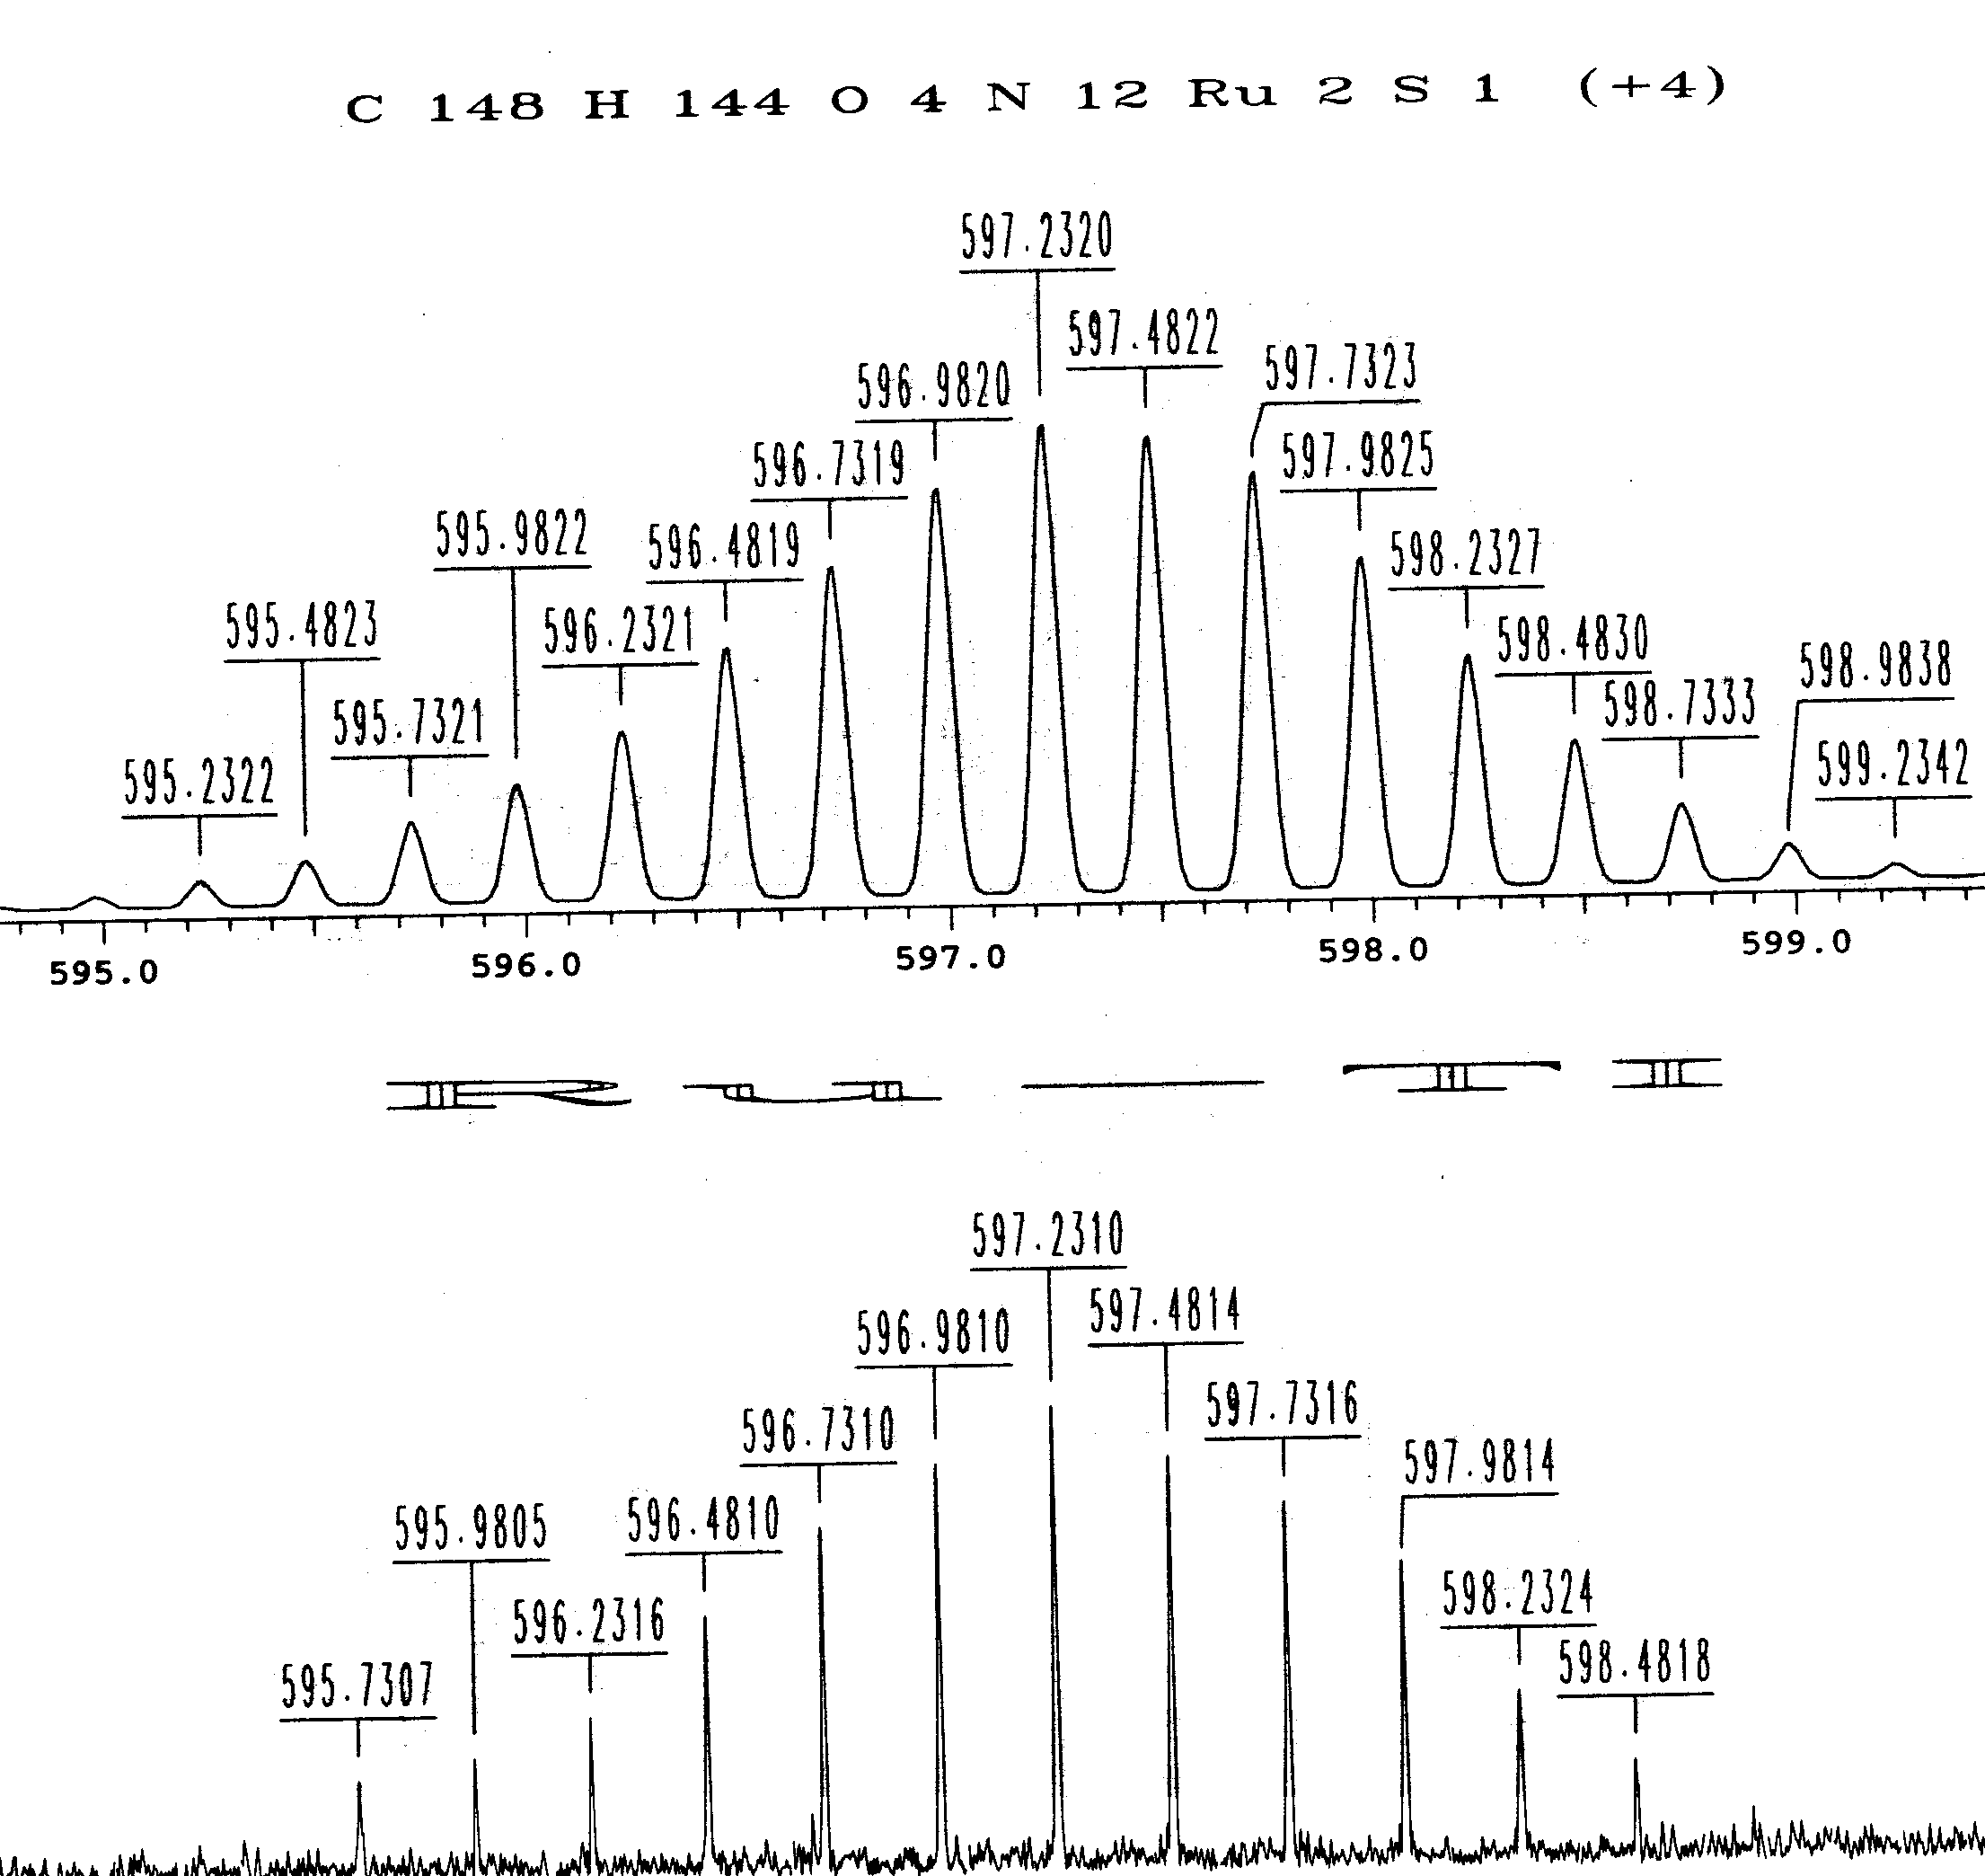

Figure S-1. Electrospray mass spectrum of T1-Ru.

