Supporting Information

for the manuscript

Titanocene and zirconocene complexes of a phosphorus analog of an Arduengo’s carbene: Application in the synthesis of 1,3-diphosphafulvenes.
by

Thibault Cantat, Nicolas Mézailles, Nicole Maigrot, Louis Ricard and Pascal Le Floch*ª

ª Laboratoire “Hétéroéléments et Coordination”, UMR CNRS 7653, Departement de Chimie, Ecole Polytechnique, 91128 Palaiseau cedex, France. Fax: (33).01.69.33.39.90; Tel: (33).01.69.33.45.70; E-mail: lefloch@poly.polytechnique.fr.

Content

1°) General considerations.
2°) Syntheses and characterizations of carbene complexes 2a and 2b.
3°) Syntheses and characterizations of carbene complexes 4a,b and 5a,b.
4°) General procedure and characterizations of 1,3-diphosphafulvenes 6, 7 8, 9, 10.
5°) X-ray crystal structure of 1,3-diphosphafulvene 6a.
6°) X-ray crystal structure of 1,3-diphosphafulvene 8b.
7°) X-ray crystal structure of 1,3-diphosphafulvene 9a.
8°) Theoretical data for complex meso and rac-[ZrCp₂(C₃H₄P₂)].

1°) General considerations.

All reactions were routinely performed under an inert atmosphere of argon or nitrogen by using Schlenk and glove-box techniques and dry deoxygenated solvents. Dry THF, ether and hexanes were obtained by distillation from Na/benzophenone. Dry dichloromethane was distilled on P₂O₅. Nuclear magnetic resonance spectra were recorded on a Bruker AC-200 SY spectrometer operating at 300.0 MHz for ¹H, 75.5 MHz for ¹³C and 121.5 MHz for ³¹P. Solvent peaks are used as internal reference relative to Me₄Si for ¹H and ¹³C chemical shifts (ppm); ³¹P chemical shifts are relative to a 85% H₃PO₄ external reference. Coupling constants are given in Hertz. The following abbreviations are used: s, singlet; d, doublet; t, triplet; m, multiplet. Elemental analyzes were performed by the “Service d’analyses du CNRS” at Gif sur Yvette.

2°) Syntheses and characterizations of carbene complexes 2a and 2b.

Diphospholene 1 200 mg, (0.8 mmol) was added to a solution of the [TiCp₂(P(OMe)₃)₂] complex (0.08 mmol) prepared according to ref. 9 in THF (10 mL). The resulting mixture turned purple instantaneously and a ³¹P NMR spectrum showed the completion of the reaction.
2a: ³¹P NMR (121.5 MHz, THF, 25°C, 85% H₃PO₄ as external standard): δ 174.4 (t, ³J_{PP}=22.2 Hz; P(OMe)₃), 78.5 (d, ³J_{PP}=22.2 Hz; PCP).
2b: ³¹P NMR (121.5 MHz, THF, 25°C, 85% H₃PO₄ as external standard): δ 173.7 (dd, ³J_{PP}=7.6 Hz, ³J_{PP}=21.6 Hz; P(OMe)₃), 117.8 (dd, ²J_{PP}=36.0 Hz, ³J_{PP}=7.6 Hz; PCP), 109.1 (dd, ²J_{PP}=36.0 Hz, ³J_{PP}=21.6 Hz; PCP).

3°) Syntheses and characterizations of carbene complexes 4a,b and 5a,b.

BuLi (2.1 mL, 1.5 M in hexanes, 3.2 mmol) was added to a a solution of Cp₂ZrCl₂ (460 mg, 1.6 mmol) in THF (30 mL) at -78°C. The mixture was stirred at –78°C for one hour and warmed to 0°C. This mixture was then transferred by cannula to a Schlenk flask containing 1 (340 mg, 0.8 mmol). The resulting burgundy red mixture was warmed to room temperature then stirred for 3 hours. Complexes 4a,b are highly water sensitive and decompose when taken to dryness. NMR data were recorded on the crude mixture by evaporating the most part of the solution (2 mL remaining) and by adding d₆-benzene (1 mL) as internal reference.
Selected data: 4a (meso): ³¹P NMR (121.5 MHz, C₆D₆, 25°C, 85% H₃PO₄ as external standard): δ 87.1 (s); ¹³C NMR (75.5 MHz, C₆D₆, 25°C): δ 142.4 (t, ¹J_{CP}=12.7 Hz; PCP).
Complexes 5a,b were obtained by adding PMe₃ (165 µL, 1.6 mmol, 2 equiv.) to the crude mixture prepared as above. Formation of complexes 5a,b is instantaneous as shown by ³¹P NMR spectroscopy. The mixture was taken to dryness for a short period of time and d₆-benzene was added to record NMR spectra.
Selected data: 5a: ³¹P NMR (121.5 MHz, C₆D₆, 25°C, 85% H₃PO₄ as external standard): δ -9.92 (t, ³J_{PP}=7.3 Hz, PMe₃), 75.3 (d, ³J_{PP}=7.3 Hz, PCP); ¹³C NMR (75.5 MHz, C₆D₆, 25°C): δ 220.2 ppm (dt, ¹J_{CP}=87.3 Hz, ²J_{CP}=11.5 Hz; PCP). 5b: ³¹P NMR (121.5 MHz, C₆D₆, 25°C, 85% H₃PO₄ as external standard): δ -11.21 (t, ³J_{PP}=6.1 Hz, PMe₃), 114.4 (broad, PCP), 119.3 (broad, PCP); ¹³C NMR (75.5 MHz, C₆D₆, 25°C): δ 212.3 (m; PCP).

4°) General procedure and characterizations of 1,3-diphosphafulvenes 6, 7 8, 9, 10.

Crude 4 was prepared as above and ketone or aldehyde (1.6 mmol, 2 equiv.) was added. An immediate discoloration of the mixture was observed and ³¹P NMR spectroscopy showed the complete formation of the corresponding fulvene derivatives a (meso) and b (rac). After evaporation of the solvent, the compounds were purified by column chromatography using toluene/hexane (3:7) as mixture and recovered as a solid for 6a/6b (70%), 7a/7b (70%), 8a/8b (95%), 9a/9b (80%), 10a/10b (60%).
Selected data: 6a: ¹H NMR (300 MHz, CD₂Cl₂, 25°C): δ 1.25-2.0 (12H, CH, CH₂), 3.0 (s, 2H, CH), 7.0-7.4 (m, 20H, H of phenyl); ³¹P NMR (121.5 MHz, CD₂Cl₂, 25°C, 85% H₃PO₄ as external standard): δ 20.71 (s); ¹³C NMR (75.5 MHz, CD₂Cl₂, 25°C): δ 28.0 (s, CH), 28.3 (s, CH), 37.0 (s, CH₂), 38.7 (s, CH₂), 39.0 (s; CH₂), 41.7 (pseudo-t, ³J_{CP}=12.9 Hz, CH), 127.1-137.9 (phenyl), 139.1 (t, ²J_{CP}=12.0 Hz, C), 148.2 (s), 169.1 (t, ¹J_{CP}=21.9 Hz , PCP); MS (70 eV): m/z (%): 540 [M+] (100). 6b: ³¹P NMR (121.5 MHz, CD₂Cl₂, 25°C, 85% H₃PO₄ as external standard): δ 46.29 (s). Anal. Calcd for C₃₇H₃₀P₂: C 82.82, H 5.64; Found: C 82.55, H 5.85.
7a: ¹H NMR (300 MHz, CDCl₃, 25°C): δ 1.61 (m, 4H), 2.28 (m, 2H), 6.87-7.57 (m, 20H; H of phenyl); ³¹P NMR (121.5 MHz, CDCl₃, 25°C, 85% H₃PO₄ as external standard): δ 24.3 (s); ¹³C NMR (75.5 MHz, CDCl₃, 25°C): δ 26.5 (s), 36.3 (t, ³J_{CP}=9.1 Hz), 125.3-129.8 (phenyl), 133.6 (t, ²J_{CP}=9.4 Hz), 148.2 (s), 165.1 (t, ¹J_{CP}=23.0 Hz). 7b: ¹H NMR (300 MHz, CDCl₃, 25°C): δ  1.49 (m, 4H; CH₂), 2.06 (m, 4H; CH₂), 6.87-7.57 (m, 20H; H of phenyl); ³¹P NMR (121.5 MHz, CDCl₃, 25°C, 85% H₃PO₄ as external standard): δ 48.3 (s); ¹³C NMR (75.5 MHz, CDCl₃, 25°C): δ 27.2 (s), 35.6 (t, ³J_{CP}=8.8 Hz), 125.3-129.8 (phenyl), 133.6 (t, ²J_{CP}=10.4 Hz), 147.4 (s), 163.2 (t, ¹J_{CP}=19.2 Hz). Anal. Calcd for C₃₂H₃₈P₂: C 81.00, H 5.95; Found: C 81.34, H 5.77.
8a: ³¹P NMR (121.5 MHz, CDCl₃, 25°C, 85% H₃PO₄ as external standard): δ  27.3 (s). 8b: ¹H NMR (300 MHz, CDCl₃, 25°C): δ 6.93-7.34 (m, 20H, H of phenyl); ³¹P NMR (121.5 MHz, CDCl₃, 25°C, 85% H₃PO₄ as external standard): δ 51.5 (s); ¹³C NMR (75.5 MHz, CDCl₃, 25°C): δ 78.8 (t, ¹J_{CP}=28.0 Hz), 127.9-134.3 (phenyl), 132.9 (t, ²J_{CP}=11.5 Hz), 145.3 (AXX’, ΣJ_{CP}=122.8 Hz). Anal. Calcd for C₄₀H₃₀P₂: C 83.90, H 5.28; Found: C 83.50, H 5.35.
9a: ¹H NMR (300 MHz, CDCl₃, 25°C): δ 6.86-7.79 (m, 28H; H of phenyl); ³¹P NMR (121.5 MHz, CDCl₃, 25°C, 85% H₃PO₄ as external standard): δ 33.7 (s, meso); ¹³C NMR (75.5 MHz, CDCl₃, 25°C): δ 126.6 (t, ³J_{CP}=5.9 Hz), 137.9 (t, ²J_{CP}=12.5 Hz), 137.9 (t, ¹J_{CP}=16.2 Hz), 147.4 (s), 152.3 (s). 9b:¹H NMR (300 MHz, CDCl₃, 25°C): δ 6.93-7.85 (m, 28H, H of phenyl); ³¹P NMR (121.5 MHz, CDCl₃, 25°C, 85% H₃PO₄ as external standard): δ 59.9 (s); ¹³C NMR (75.5 MHz, CDCl₃, 25°C): δ 126.2 (t, ³J_{CP}=4.1 Hz), 137.5 (t, ²J_{CP}=12.0 Hz), 142.1 (t, ¹J_{CP}=18.0 Hz), 145.8 (broad), 152.4 (s). Anal. Calcd for C₄₀H₂₈OP₂: C 81.90, H 4.81; Found: C 81.70, H 4.77.
10a: ³¹P NMR (121.5 MHz, CDCl₃, 25°C, 85% H₃PO₄ as external standard): δ 21.6 (d, ²J_{PP}=40.8 Hz), 30.42 (d, ²J_{PP}=40.8 Hz). 10b: ³¹P NMR (121.5 MHz, CDCl₃, 25°C, 85% H₃PO₄ as external standard): δ 4.6 (d, ²J_{PP}=25.6 Hz), 52.6 (d, ²J_{PP}=25.6 Hz); MS (70 eV): m/z (%): 596 [M+] (100). Anal. Calcd for C₄₂H₃₀P₂: C 84.55, H 5.07; Found: C 84.65, H 5.15.

5°) X-ray crystal structure of 1,3-diphosphafulvene 6a.

Crystal data for compound 6a (C₃₈H₃₆Cl₂P₂): space group Pī, a = 10.067(1), b = 12.325(1), c = 13.669(1) Å, α = 72.220(1), β = 77.590(1), γ = 80.800(1)°, V = 1569.1(2) Å³, Z = 2, ρ_{calcd} = 1.324 g.cm⁻³, F(000) = 656, Mo_{Kα} radiation (λ = 0.71069 Å), μ = 0.336 cm⁻¹. Data collection was performed on a Nonius KappaCCD single crystal diffractometer at T = 150K. The crystal structure was solved with SIR97,^{[1]} refinement against F2 (SHELXL97^{[2]}) with anisotropic thermal parameters for all non-hydrogen atoms, calculated hydrogen positions with riding isotropic thermal parameters. Crystal dimensions 0.20x0.20x0.16. hkl ranges : -13 14 ; -17 17 ; -19 17. 14286 data collected, 9134 unique data (Rint = 0.0152, KappaCCD diffractometer), 7563 data with I > 2(I), 380 refined parameters. GOF(F2) = 1.061 , final R indices (R1 = Σ|Fo|-|Fc||/ Σ|Fo|, wR2 = [Σw(Fo2-Fc2)2/ Σ w(Fo2)2]1/2, R1 = 0.0385, wR2 = 0.1104, max/min residual electron density 0.388(0.049) / -0.522(0.049) eÅ³.
Crystallographic data for the structure reported in this paper have been deposited with the Cambridge Crystallographic Data Centre as supplementary publication no. CCDC-227151. Copies of the data can be obtained free of charge on application to CCDC, 12 Union Road, Cambridge CB21EZ, UK (fax (+44)1223-336-033; e-mail : deposit@ccdc.cam.ac.uk).
1) Altomare, M. C. Burla, M. Camalli, G. Cascarano, C. Giacovazzo, A. Guagliardi, A. G. G. Moliterni, G. Polidori, R. Spagna, SIR97, an integrated package of computer programs for the solution and refinement of crystal structures using single crystal data, 1999.
2) M. Sheldrick, SHELXL-97; Universität Göttingen, Göttingen, Germany, 1998.
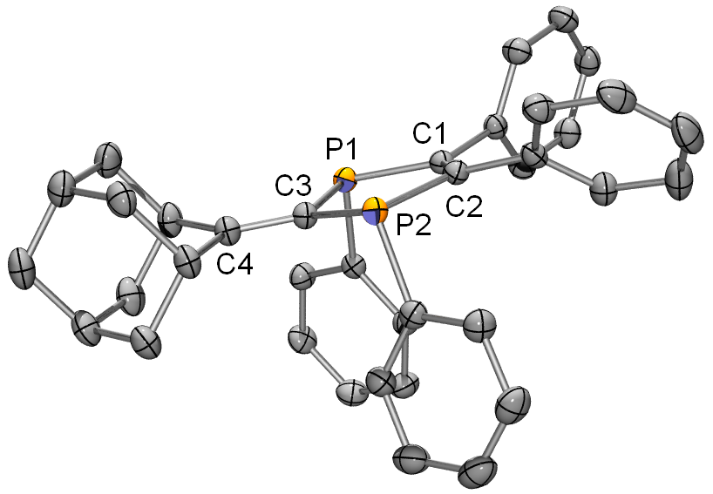

7°) X-ray crystal structure of 1,3-diphosphafulvene 8b.

Crystal data for compound 8b (C₄₀H₃₀P₂): space group P21/c, a = 11.7340(10), b = 6.3270(10), c = 40.956(2) Å, b = 91.3540(10)°, V = 3039.8(6) Å³, Z = 4, ρ_{calcd} = 1.251 g cm-3, F(000) = 1200, Mo_{Kα} radiation (λ = 0.71073 Å), μ = 0.171 cm⁻¹; crystal dimensions 0.22x0.12x0.06 mm. Data collection was performed on a Nonius KappaCCD single crystal diffractometer at T = 150K. The crystal structure was solved with SIR97,^{[1]} refinement against F2 (SHELXL97^{[2]}) with anisotropic thermal parameters for all non-hydrogen atoms, calculated hydrogen positions with riding isotropic thermal parameters. hkl ranges : -12 13, -7 6, -45 45; 7293 data collected, 4288 unique data (Rint = 0.0363 ), 3070 data with I > 2σ(I), 379 parameters refined, GOF(F2) = 1.006 , final R indices (R1 = Σ|Fo|-|Fc||/ Σ|Fo|, wR2 = [Σw(Fo2-Fc2)2/ Σ w(Fo2)2]1/2, R1 = 0.0552, wR2 = 0.1561, max/min residual electron density 0.633(0.049) / -0.240(0.049) eÅ³. Crystallographic data for the structure reported in this paper have been deposited with the Cambridge Crystallographic Data Centre as supplementary publication no. CCDC-227151. Copies of the data can be obtained free of charge on application to CCDC, 12 Union Road, Cambridge CB21EZ, UK (fax (+44)1223-336-033; e-mail : deposit@ccdc.cam.ac.uk).

1) Altomare, M. C. Burla, M. Camalli, G. Cascarano, C. Giacovazzo, A. Guagliardi, A. G. G. Moliterni, G. Polidori, R. Spagna, SIR97, an integrated package of computer programs for the solution and refinement of crystal structures using single crystal data, 1999.
2) M. Sheldrick, SHELXL-97; Universität Göttingen, Göttingen, Germany, 1998.

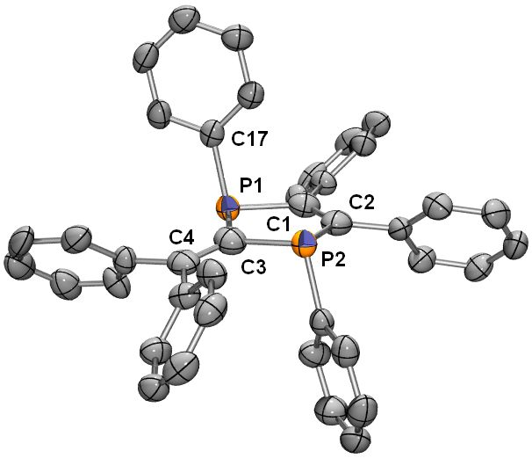

7°) X-ray crystal structure of 1,3-diphosphafulvene 9a.

Crystal data for compound 9a: (C₄₀H₂₈OP₂): space group Pī, a = 9.324(1), b = 17.429(1), c = 19.246(1) Å, α = 101.240(1), β = 96.960(1), γ = 98.770(1)°, V = 2994.8(4) Å³, Z = 4, ρ_{calcd} = 1.301 g.cm⁻³, F(000) = 1224, Mo_{Kα} radiation (λ = 0.71073 Å), μ = 0.178 cm⁻¹, crystal dimensions 0.22x0.12x0.06 mm, Data collection was performed on a Nonius KappaCCD single crystal diffractometer at T = 150K. The crystal structure was solved with SIR97,^{[1]} refinement against F2 (SHELXL97^{[2]}) with anisotropic thermal parameters for all non-hydrogen atoms, calculated hydrogen positions with riding isotropic thermal parameters. hkl ranges : -11 9 ; -20 20 ; -23 22, 16597 data collected, 10913 unique data (Rint = 0.0265 ), 7270 data with I > 2σ(I), 775 parameters refined, GOF(F2) = 0.997 , final R indices (R1 = Σ|Fo|-|Fc||/ Σ|Fo|, wR2 = [Σw(Fo2-Fc2)2/ Σ w(Fo2)2]1/2, R₁ = 0.0430, ^{w}R₂ = 0.1065, max/min residual electron density 0.236(0.046) / -0.400(0.046) eÅ³. Crystallographic data for the structure reported in this paper have been deposited with the Cambridge Crystallographic Data Centre as supplementary publication no. CCDC-227151. Copies of the data can be obtained free of charge on application to CCDC, 12 Union Road, Cambridge CB21EZ, UK (fax (+44)1223-336-033 ; e-mail : deposit@ccdc.cam.ac.uk).

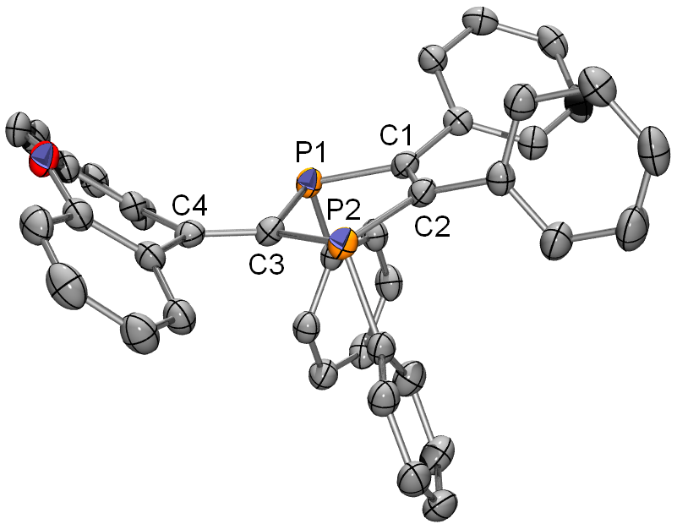

8°) Theoretical data for complex meso and rac-[ZrCp₂(C₃H₄P₂)].

All calculations were carried out using the Gaussian 03W package.¹ Geometry optimizations were carried out using the Density Functional Theory (DFT) ^{2,3} by means of pure gradient-corrected exchange functional and the Lee-Yang-Parr non local correlation functional BLYP ⁴ as implemented in the Gaussian program. A quasirelativistic effective core potential operator was used to represent the electron core of zirconium atom. The basis set for the metal was that associated with the pseudopotential with a standard double-ζ LANL2DZ contraction. ⁵ All the other atoms (C, H and P) were represented by the 6-31G* basis set. Population analysis was carried out using the NBO program implemented in Gaussian.⁶
1) Frisch, M. J.; Trucks, G. W.; Schlegel, H. B.; Scuseria, G. E.; Robb, M. A.; Cheeseman, J. R.; Zakrzewski, V. G.; Montgomery, J. J. A.; Stratmann, R. E.; Burant, J. C.; Dapprich, S.; Millam, J. M.; Daniels, A. D.; Kudin, K. N.; Strain, M. C.; Farkas, O.; Tomasi, J.; Barone, V.; Cossi, M.; Cammi, R.; Mennucci, B.; Pomelli, C.; Adamo, C.; Clifford, S.; Ochterski, J.; Petersson, G. A.; Ayala, P. Y.; Cui, Q.; Morokuma, K.; Malick, D. K.; Rabuck, A. D.; Raghavachari, K.; Foresman, J. B.; Cioslowski, J.; Ortiz, J. V.; Baboul, A. G.; Stefanov, B. B.; Liu, G.; Liashenko, A.; Piskorz, P.; Komaromi, I.; Gomperts, R.; Martin, R. L.; Fox, D. J.; Keith, T.; Al-Laham, M. A.; Peng, C. Y.; Nanayakkara, A.; Challacombe, M.; Gill, P. M. W.; Johnson, B.; Chen, W.; Wong, M. W.; Andres, J. L.; Gonzalez, C.; Head-Gordon, M.; Replogle, E. S.; Pople, J. A. In; Revision A-11 ed.; Gaussian, Inc.: Pittsburgh PA, 1998.
2) Parr, R. G.; Yang, W. Density Functional Theory of Atoms and Molecules; Oxford University Press: Oxford, U. K., 1989.
3) Ziegler, T. Chemical Review 1991, 91, 651-667.
4) (a) Becke, A. D. Phys. Rev. A 1988, 38, 3098-3108. (b) Perdew, J. P. Phys. Rev. B . 1986, 33, 8822-8832.
5) Hay, P. J.; Wadt, W. R. J. Chem. Phys. 1985, 82, 299-310.
6) A.E.Reed, L. A. Curtiss, F. Weinhold, Chem. Rev. 1988, 88, 899-926.

MESO COMPLEX
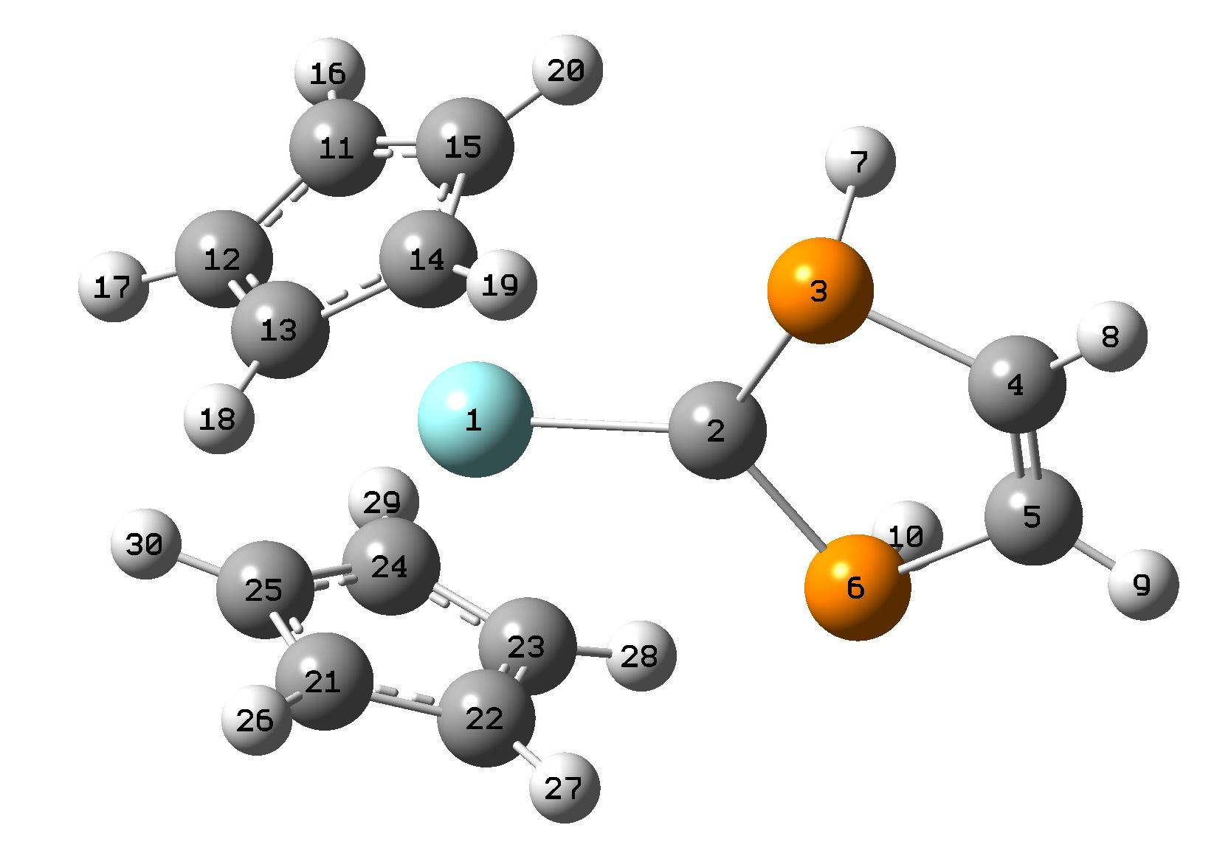
Input orientation:
---------------------------------------------------------------------
Center Atomic Atomic Coordinates (Angstroms)
Number Number Type X Y Z
---------------------------------------------------------------------
1 40 0 -0.007887 -0.124148 -0.779211
2 6 0 0.003826 -0.136190 1.329801
3 15 0 1.515328 -0.133311 2.394266
4 6 0 0.690865 -0.075301 4.034257
5 6 0 -0.647901 -0.038270 4.041899
6 15 0 -1.492964 -0.050100 2.411438
7 1 0 1.869900 -1.527855 2.440021
8 1 0 1.287501 -0.013547 4.944762
9 1 0 -1.229786 0.056083 4.959131
10 1 0 -1.923537 -1.422926 2.461672
11 6 0 2.081864 -1.038694 -1.970883
12 6 0 1.663402 0.069370 -2.747755
13 6 0 1.805645 1.239694 -1.952762
14 6 0 2.347367 0.859281 -0.693045
15 6 0 2.514633 -0.552505 -0.702074
16 1 0 2.102962 -2.072687 -2.297646
17 1 0 1.282623 0.028671 -3.760215
18 1 0 1.576265 2.251099 -2.266443
19 1 0 2.591768 1.514070 0.131655
20 1 0 2.939479 -1.146790 0.094956
21 6 0 -1.756484 1.338360 -1.932342
22 6 0 -2.304013 0.988002 -0.666433
23 6 0 -2.549185 -0.412371 -0.673202
24 6 0 -2.158461 -0.921261 -1.946746
25 6 0 -1.688254 0.162267 -2.728617
26 1 0 -1.475116 2.335652 -2.248867
27 1 0 -2.502409 1.654988 0.160838
28 1 0 -2.997128 -0.982557 0.128771
29 1 0 -2.240433 -1.952378 -2.272994
30 1 0 -1.321877 0.100962 -3.745344
---------------------------------------------------------------------

RAC COMPLEX

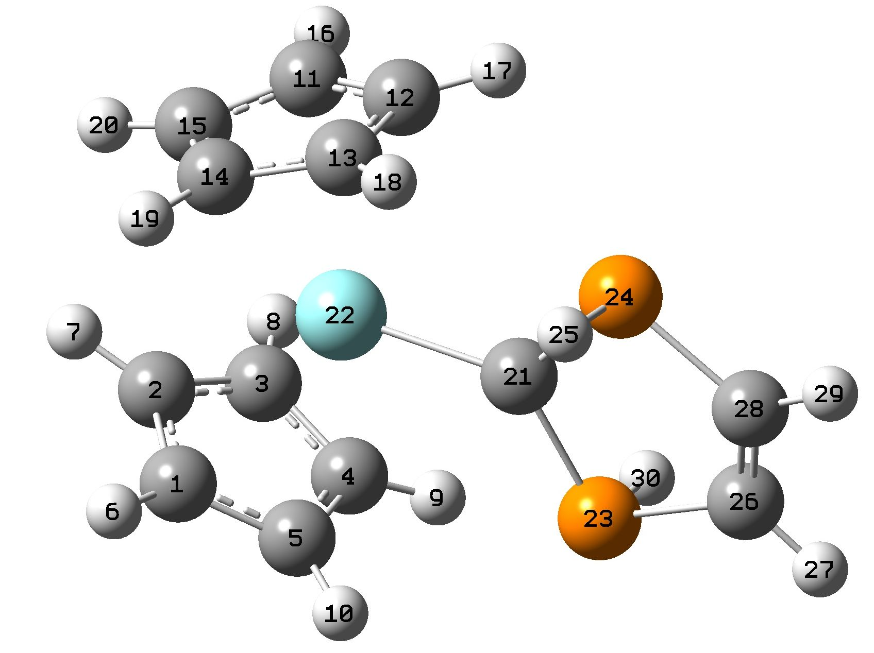

Input orientation:
---------------------------------------------------------------------
Center Atomic Atomic Coordinates (Angstroms)
Number Number Type X Y Z
---------------------------------------------------------------------
1 6 0 0.012303 -0.008785 0.001502
2 6 0 0.019520 -0.007464 1.421029
3 6 0 1.371180 -0.001937 1.851883
4 6 0 2.203777 0.036037 0.695698
5 6 0 1.361989 0.027404 -0.450589
6 1 0 -0.870050 -0.008983 -0.628604
7 1 0 -0.852464 -0.027966 2.062145
8 1 0 1.709344 0.014573 2.881793
9 1 0 3.283141 0.097672 0.691469
10 1 0 1.699666 0.052584 -1.477522
11 6 0 0.383739 -3.723111 2.651428
12 6 0 0.916903 -4.598836 1.663436
13 6 0 0.031287 -4.588561 0.550671
14 6 0 -1.042388 -3.701093 0.852492
15 6 0 -0.833738 -3.185513 2.157580
16 1 0 0.817513 -3.522435 3.624641
17 1 0 1.826122 -5.179531 1.736644
18 1 0 0.134842 -5.177860 -0.349805
19 1 0 -1.893162 -3.489614 0.214676
20 1 0 -1.479010 -2.488618 2.676973
21 6 0 2.648997 -2.958838 -0.548610
22 40 0 1.068611 -2.254463 0.659821
23 15 0 3.929778 -1.906882 -1.373709
24 15 0 2.986013 -4.732064 -0.960835
25 1 0 2.020939 -4.976377 -1.993555
26 6 0 4.924002 -3.242925 -2.149204
27 1 0 5.818108 -2.997955 -2.722565
28 6 0 4.440032 -4.487310 -2.056677
29 1 0 4.917943 -5.343873 -2.532155
30 1 0 4.820170 -1.628784 -0.284036
---------------------------------------------------------------------

