SUPPORTING INFORMATION
FOR
New P^O ligand gratfed on periodically organised mesoporous silicas for one pot bifunctionnal catalysis : Coupling of base catalysed Knoevenagel condensation with in situ Rh catalysed hydrogenation.
Frédéric Goettmann,^{ab} David Grosso,ª François Mercier,^{b} François Mathey, ^{b} and Clément Sanchez*ª
ª Laboratoire de Chimie de la Matière Condensée, UPMC-CNRS, 4 place Jussieu, 75005 Paris, France. Fax: 33 1 44 27 47 69; Tel 33 1 44 27 55 34;* E-mail: clems@ccr.jussieu.fr
^{b} Laboratoire Hétéroéléments et coordination, Ecole polytechnique, 91128 Palaiseau, France. Fax: 33 1 69 33 39 90; Tel 33 1 69 33 40 79.

NMR data for ligand 2.
Spectrum 1: ¹H NMR spectrum. Page 2

NMR data for complex 3.
Spectrum 1: ¹H NMR spectrum. Page 2
Spectrum 2: ¹H NMR spectrum at -80°C. Page 3

Data for Pm3n
Nitrogen adsorption/desorption. Page 3
TEM image. Page 3

Data for p6m
Nitrogen adsorption/desorption. Page 4
TEM image. Page 4

Data for 2@Pm3n
Nitrogen adsorption/desorption. Page 5
Thermogravimetric analysis. Page 5
CP MAS ¹H NMR spectrum. Page 6
CP MAS ³¹P NMR spectrum. Page 6

Data for 2@p6m
Thermogravimetric analysis. Page 7

Data for 3@Pm3n
CP MAS ³¹P NMR spectrum. Page 7

Data for [2+N]@p6m
Thermogravimetric analysis. Page 8
NMR data for ligand 2.
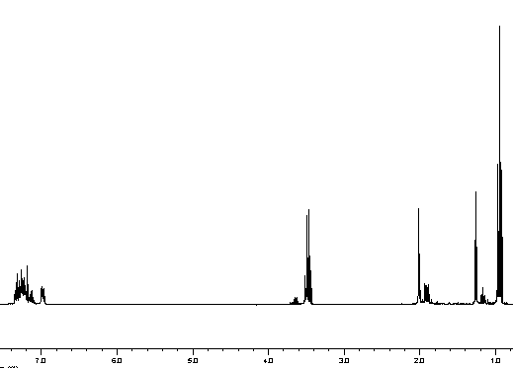
1H NMR spectrum of 2 in CDCl₃

NMR data for complex 3.

¹H NMR spectrum of 5 at room temperature

¹H NMR spectrum of 5 at room temperature (left) and at -80°C (right), magnification of the region from 2.3 to 3.3 ppm. The multiplet at the left end of the spectra corresponds to the methylene of the ethoxy moieties. The doublet of doublet at the right end of the spectra corresponds to the two proton of the bridge.

Data for Pm3n

Low angle X-Ray diffraction.

100 nm
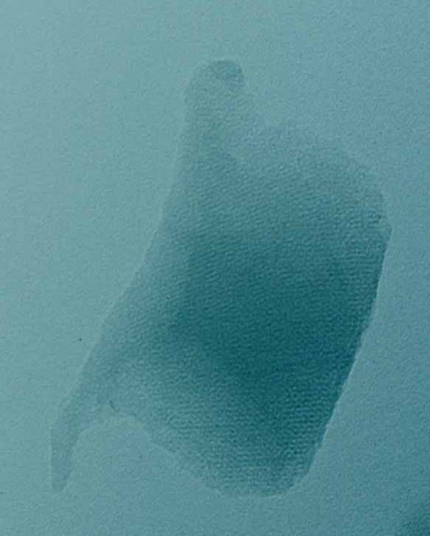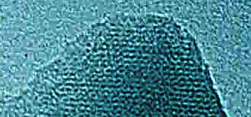
10 nm
TEM photographs of Pm3n.

Data for p6m

Nitrogen adsorption/desorption isotherm.
50 nm
20 nm
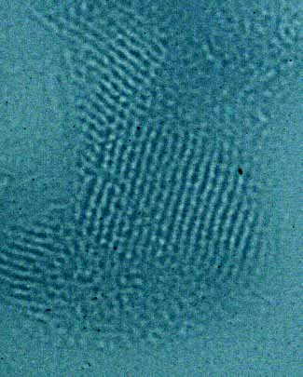
TEM photographs of p6m.

Data for 2@Pm3n

Nitrogen adsorption/desorption.

Thermogravimetric analysis.

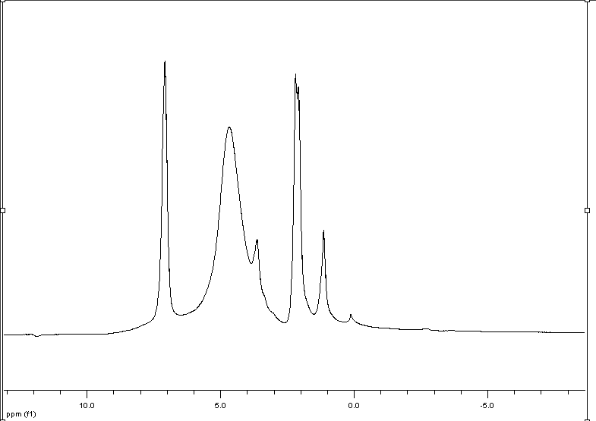

CP MAS ¹H NMR spectrum. The red star stands for the two methyl moieties of 2, the blue one for the residual ethoxy moieties.
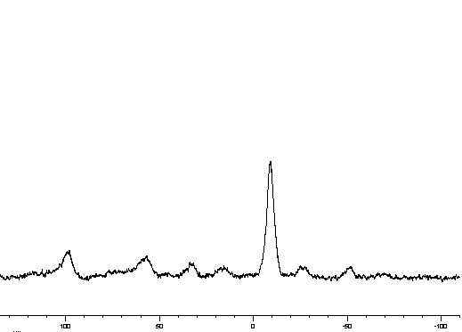
CP MAS ³¹P NMR spectrum (at 10kHz). The red star stands for the grafted ligand 2, the blue one for the grafted oxidation product of 2

Data for 2@p6m

Thermogravimetric analysis.

Data for 3@Pm3n

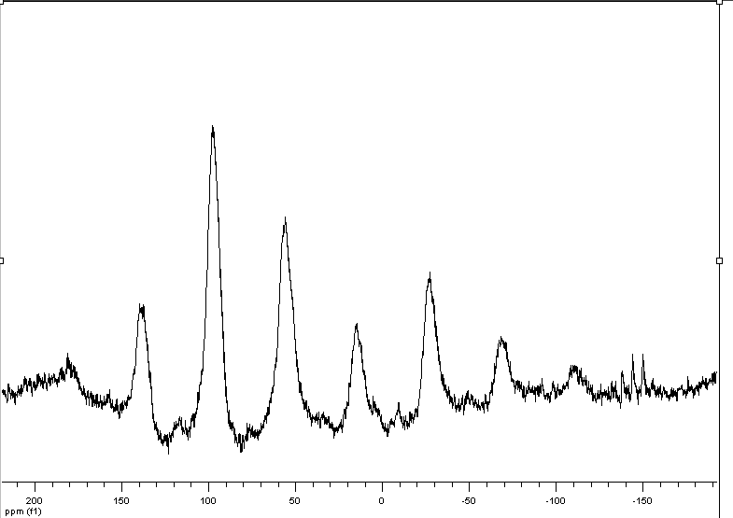
CP MAS ³¹P NMR spectrum. The red star stands for the main peak corresponding to the P^O complex, the blue one for the residual PF₆⁻.

Data for [2+N]@p6m

Thermogravimetric analysis.

