Supporting Information: Aerobic oxidation of methanol by a Ni(II)-O₂ reaction
Sara E. Edison, Richard P. Hotz, Michael J. Baldwin

Materials: All chemicals were reagent grade and obtained from either Fisher/Acros or Aldrich and used without further purification, unless specified otherwise. No significant differences in reactivity were observed when experiments were carried out with distilled versus nondistilled solvents.

Synthesis of tris(2-hydroxyiminopropyl)amine (TRISOXH₃) and [Ni(TRISOXH₃)(NO₃)(H₂O)](NO₃)• (H₂O) (1). The ligand and the nickel complex were prepared according to published literature procedures.¹

Oxidation of methanol and formaldehyde quantitation. Reactions were perfomed with 2, 0.5 and 0.1 mM 1 in distilled methanol. A typical 0.5 mM reaction consists of 6.7 mg (0.0149 mmol) 1 dissolved in 30 mL of methanol that was distilled from calcium hydride. 0.05 mL of 1.0 M tetrabutylammonium hydroxide (in methanol) was added to form 3 and initiate the reaction with dioxygen, which is characterized by a rapid color change from purple to dark brown. The reaction was allowed to proceed for a designated amount of time and then stopped by removing a 1.0 mL aliquot of the sample and adding it to 1.0 mL of the Hantzsch reagent², which consists of 3.8 g ammonium acetate, 75 μL acetic acid, and 50 μL acetyl acetone dissolved in 25 mL of deionized water. The sample containing the Hantzch reagent and the nickel sample was diluted to about 90 mL with deionized water in a 100 mL volumetric flask. The pH was adjusted to 6.0 using dilute acetic acid and dilute sodium hydroxide and then the solution was diluted to the mark with deionized water. The solution was stored in the dark overnight as a bright yellow color developed (signifying the formation of diacetyldihydrolutidine). The UV/vis spectrum of each sample was collected and the absorbance monitored at 412 nm (the literature value of ε = 8000 M⁻¹ cm⁻¹ was used for quantitation; experimental values ranging from 7800-8100 M⁻¹ cm⁻¹ were obtained while constructing the calibration curve that is shown in Figure S1. The standards used for the calibration curve were prepared by adding 1.0 mL of known concentrations of formaldehyde to 1.0 mL of the Hantzsch reagent and 1.0 mL of a 0.5 mM methanolic solution of 1, and then following the above procedure for preparation of diacetyldihydrolutidine.) From this, the concentration of formaldehyde present at different time points of the 3 + O₂ reaction was determined.

Manometry. The manometric apparatus consists of a U-shaped tube partially filled with Hg, open to the atmosphere on one end and connected to a closed system. The system consists of a 250 mL round bottom flask as the oxygen reservoir and a 50 mL Schlenk type flask (with a side arm and stopcock) as the sample vessel, connected via a T-shaped adapter. The total volume of closed system is is 0.344 L. In a typical experiment 30 mg (6.68 x 10⁻⁵ mol) of 1 is dissolved in 30 mL of solvent (either methanol or acetonitrile) and placed into the manometer sample flask. In the experiments using methanol as the solvent, 0.2 mL of 1.0 M KOH (in methanol) was added to the solution via syringe through the open stopcock, which was then immediately closed. When acetonitrile was used as the solvent, an excess amount of crushed KOH (generally 35 mg) was added to the purple solution and the system was sealed. Pressure changes were then measured, and the amount of O₂ consumed was calculated using the ideal gas law, taking into account the partial pressure of the solvent.

Oxidation of benzylamine and N-benzylidene benzylamine quantitation. In a typical reaction 27 mg (6 x 10⁻⁵ mol) of 1 was dissolved in 30 mL of acetonitrile. Hydroxide was not added to this reaction as the amine is basic enough to deprotonate the oximes. 1.3 mL (0.012 mol, ~200 equivalents per nickel) of benzylamine were added to the sample and exposed to the air. The solution turned a dark brown color as oxidative deamination³ occurred, producing benzaldehyde and ammonia. The aldehyde was never actually observed, as it immediately underwent the favorable Schiff base reaction with excess benzylamine to form N-benzylidene benzylamine. After 1 and 24 hour time periods a portion of the reaction mixture was submitted for ESI-MS analysis and a major peak was observed at 196.1 (the +1 ion of N-benzylidenebenzylamine), which can be seen in Figure S2. The remaining sample was run through a 1-2 cm column of silica gel to remove the nickel complex and a known amount of the solution was diluted to 2.0 mL with dichloromethane. This sample was analyzed by gas chromatography. Calibration curves were prepared from known standards where the concentration of benzylamine (and N-benzylidene benzylamine in a separate plot) was plotted versus the area of the benzylamine (and N-benzylidene benzylamine) peak divided by the area of the dichloromethane peak, which served as an internal standard. To determine the amount of N-benzylidene benzylamine formed, the following equation was used:
[A]=(area of peak A / area of peak B) / (slope of standard curve of A)
where A = N-benzylidene benzylamine and B = CH₂Cl₂. The concentration of benzylamine present at the end of the reaction was calculated in the same fashion, using the ratio area of the benzylamine peak divided by the dichloromethane peak, followed by division by the slope of the line from the standard curve of benzylamine. Next, the moles of N-benzylidene benzylamine were calculated according to this equation:
Moles of A = (moles of C added at the beginning)([A]) / ([C] + [A])
where A = N-benzylidene benzylamine and C = benzylamine. The moles of N-benzylidene benzylamine were then divided by the number of moles of 1 added to the reaction to determine the number of equivalents per Ni (this number was multiplied by two to determine the number of equivalents per Ni dimer). The calibration curves for benzylamine and N-benzylidene benzylamine can be seen in Figures S3 and S4, respectively.
The other product of the deamination reaction, ammonia, was observed colorimetrically using the indophenol method.⁴ A 5 mL aliquot of the reaction mixture was separated from the sample and run through a 1-2 cm column of silica gel to remove the nickel complex. A 0.5 mL aliquot of this solution was removed and added to 10 mL acetonitrile, 5 mL of dilute NaOCl (Clorox bleach) and then 5 mL of a 4% solution of phenol was added. This solution was then heated for 2 minutes in a boiling water bath, causing a deep blue color to form. This response was not seen for benzylamine or N-benzylidene benzylamine alone.

Oxidation of N-methylbenzylamine and N-benzylidene benzylamine quantitation. In a typical reaction 9 mg (2 x 10⁻⁵ mol) of 1 was dissolved in 10 mL of acetonitrile. Hydroxide was not added to this reaction as the amine is basic enough to deprotonate the oximes. 0.52 mL (0.004 mol, ~200 equivalents per nickel) of N-methylbenzylamine were added to the sample and exposed to the air. The solution turned a dark brown color as oxidative deamination⁵ occurred, producing benzylimine and dimethylamine. The imine was never actually observed, as it immediately underwent the favorable Schiff base reaction with excess benzylamine to form N-benzylidene benzylamine. After 1 and 24 hour time periods a portion of the reaction mixture was submitted for TOF-MS analysis and the major peaks observed were at 194.1 and 195.1 (M.W. N-benzylidene benzylamine = 195.1), which can be seen in Figure S5. The remaining sample was run through a 1-2 cm column of silica gel to remove the nickel complex and a known amount of the solution was diluted to 2.0 mL with dichloromethane. This sample was analyzed by gas chromatography. Calibration curves were prepared from known standards where the concentration of N-methylbenzylamine (and N-benzylidene benzylamine in a separate plot) was plotted versus the area of the N-methylbenzylamine (and N-benzylidene benzylamine) peak divided by the area of the dichloromethane peak, which served as an internal standard. The product was quantitated in the same manner as described for the benzylamine reaction, using N-methylbenzylamine and N-benzylidene benzylamine as standards. Calibration curves for N-methylbenzylamine and N-benzylidene benzylamine can be seen in Figures S6 and S4, respectively.

Oxidation of ethanol and acetaldehyde quantitation. Reactions were performed with 2 mM 1 in distilled ethanol. A typical reaction consists of 27 mg (0.06 mmol) 1 dissolved in 30 mL of ethanol that was distilled from calcium hydride. 0.4 mL of 0.5 M tetrabutylammonium hydroxide (in ethanol) was added to form 3 and initiate the reaction with dioxygen, which is characterized by a rapid color change from purple to dark brown. After 1 and 24 hours a 1.0 mL aliquot of the reaction mixture was run through a 1-2 cm silica gel column, diluted to 2.0 mL with dichloromethane, and analyzed by gas chromatography. The product was quantitated in the same manner as described for the benzylamine reaction benzylamine, using ethanol and acetaldehyde as standards. Calibration curves for ethanol and acetaldehyde can be seen in Figures S7 and S8, respectively.

Oxidation of benzyl alcohol and quantitation of benzaldehyde. Reactions were performed with 2 mM 1 in distilled benzyl alcohol. A typical reaction consists of 27 mg (0.06 mmol) 1 dissolved in 30 mL of benzyl alcohol that was distilled from calcium hydride. 0.4 mL of 0.5 M tetrabutylammonium hydroxide (in benzyl alcohol) was added to form 3 and initiate the reaction with dioxygen, which is characterized by a rapid color change from purple to dark brown. After 1 and 24 hours, a known amount of solution was diluted to 5.0 mL with dichloromethane and run through a 1-2 cm column of silica gel to remove the nickel complex. The sample was analyzed by gas chromatography. The number of equivalents of benzaldehyde formed was calculated in the same way as described for N-benzylidene benzylamine. The calibration curves for benzylalcohol and benzaldehyde can be seen in Figures S9 and S10, respectively.

Chemical detection of hydrogen peroxide. A titanium sulfate test reagent was prepared by digesting 1 g of anhydrous titanium dioxide with 100 mL of sulfuric acid for 16 hours on a sand bath at 150° C. The solution was cooled, diluted with 4 parts of distilled water, and filtered through a thin layer of celite prior to use. 1.0 mL of this indicator was added to 10.0 mL of solution containing no more than 18 ppm hydroden peroxide, causing a yellow color to appear as pertitanic acid forms (ε = 690 M⁻¹ cm⁻¹ at 407 nm) .⁶

Disproportionation of hydrogen peroxide. Standard reaction conditions are 11.1 mg (2.47 X 10⁻⁵ mol) of 1 dissolved in 50 mL of a 99 mM H₂O₂ methanolic solution (~200 equivalents of H₂O₂ per nickel). 0.1 mL of 1.0 M Bu₄NOH in methanol was added to the solution to initiate the reaction. Bubbles were observed as the color changed from purple to brown. After approximately 15 minutes the bubbling ceased and a 2.0 mL aliquot of the sample was removed and added to 100.0 mL of deionized water. Next, 10.0 mL of a Ti(SO₄)₂ indicator was added. If hydrogen peroxide were present in the sample a bright yellow color would appear, as it did in the control experiment substituting [Zn(TRISOXH₃)Cl₂] in place of 1. The solution containing 3 remained colorless upon addition of the indicator.
The manometric apparatus consists of a U-shaped tube partially filled with Hg, open to the atmosphere on one end and connected to a 200 mL Schlenk flask (with a side arm and stopcock) as the sample vessel. The total volume of the manometer is 0.318 L. In a typical experiment, 13 mg (2.90 x 10⁻⁵ mol) of 1 and 0.61 mL of 9.9M aq. H₂O₂ (6.0 x 10⁻³ mol) are dissolved in 30 mL methanol and placed into the manometer sample flask. The solution was purged with argon for 15 minutes. The reaction was initiated by adding 0.1 mL of 1.0 M tetrabutylmmonium hydroxide (in methanol) via syringe through the stopcock that was immediately closed. Pressure changes were then measured, and the amount of O₂ generated was calculated using the ideal gas law, taking in to account the partial pressure of the solvent. A plot of H₂O₂ disproportionated monitored by O₂ production is shown in Figure S11.

Physical Measurements. UV/vis absorption data were collected on a Hewlett Packard Model 8453 spectrometer or a Spectral Instruments, Inc. 400 Series dip probe CCD-array spectrometer. Mass spectral data were collected on a Micromass Q-TOF-II instrument with electrospray sample introduction. Gas chromatography was performed on a Shimadzu 17A in dichloromethane.
Figure S1. Calibration curve of the reaction of formaldehyde with the Hantzsch reagent to form diacetyldihydrolutidine. Standards contained known amounts of formaldehyde, Hantzsch reagent, and 1 dissolved in methanol.

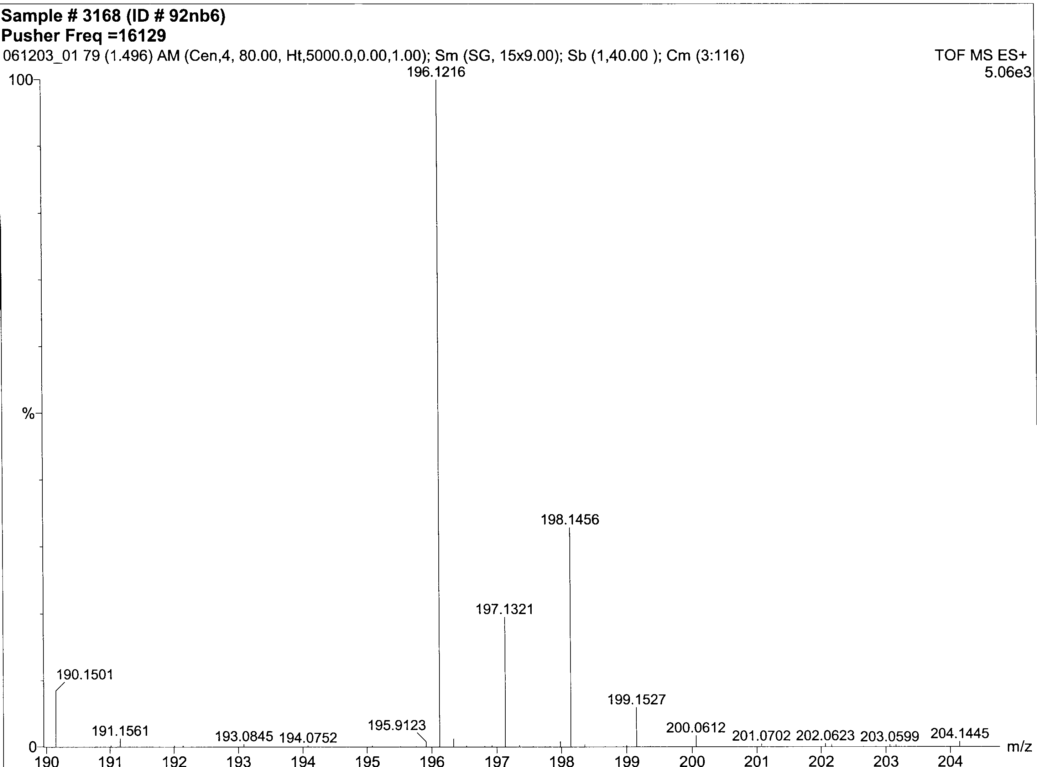

Figure S2. Mass spectrum of reaction product from reaction of 3 with benzylamine in acetonitrile showing the M+1 (196.1216) peak of N-benzylidenebenzylamine.

Figure S3. Calibration curve of benzylamine in dichloromethane using gas chromatography.

Figure S4. Calibration curve of N-benzylidenebenzylamine in dichloromethane using gas chromatography.

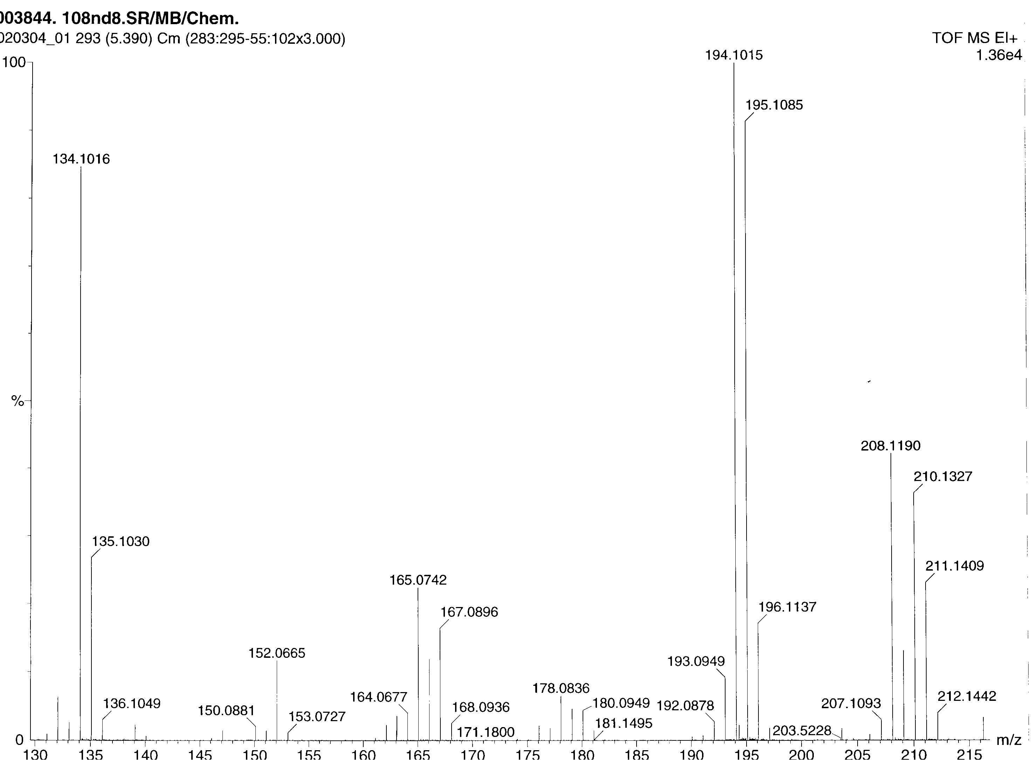

Figure S5. Mass spectrum of reaction product from reaction of 3 with N-methylbenzylamine in acetonitrile showing the 195.1085 peak of N-benzylidenebenzylamine.
Figure S6. Calibration curve of N-methylbenzylamine in dichloromethane using gas chromatography.

.
Figure S7. Calibration curve of ethanol in dichloromethane using gas chromatography.
Figure S8. Calibration curve of acetaldehyde in dichloromethane using gas chromatography.

Figure S9. Calibration curve of benzyl alcohol in dichloromethane using gas chromatography.

Figure S10. Calibration curve of benzaldehyde in dichloromethane using gas chromatography.

Figure S11. Disproportionation of 200 equivalents of hydrogen peroxide by 3 in methanol as observed by manometry (monitoring the production of O₂).

References:

- Goldcamp, M. J.; Robison, S. E.; Krause Bauer, J. A.; Baldwin, M. J. Inorg. Chem. 2002, 41, 2307-2309.
- Nash, T. Biochem. J. 1953, 55, 416-421.
- Mure, M.; Klinman, J. P. J. Am. Chem. Soc.; 1995, 117, 8698-8706.
- Yoe, J. H. Photometric Chemical Analysis (Colorimetry and Nephelometry); Wiley: New York, 1928, Vol. I, 307-308.
- Murahashi, S.-I.; Yoshimura, N.; Tsumiyama, T.; Kojima, T.; J. Amer. Chem. Soc., 1983, 105, 5002-5011.
- Eisenburg, G. M. Indust. and Eng. Chem. 1943, 15, 327-328.
- Clapp, P. A.; Evans, D. F.; Sheriff, T. S. S. Anal. Chim. Acta. 1989, 218, 331-334.

