A new type of oxygen bridged Cu^{II}₃₆ aggregate formed around a central {KCl₆}⁵⁻ unit

Muralee Murugesu, Rodolphe Clérac, Christopher E. Anson and Annie K. Powell

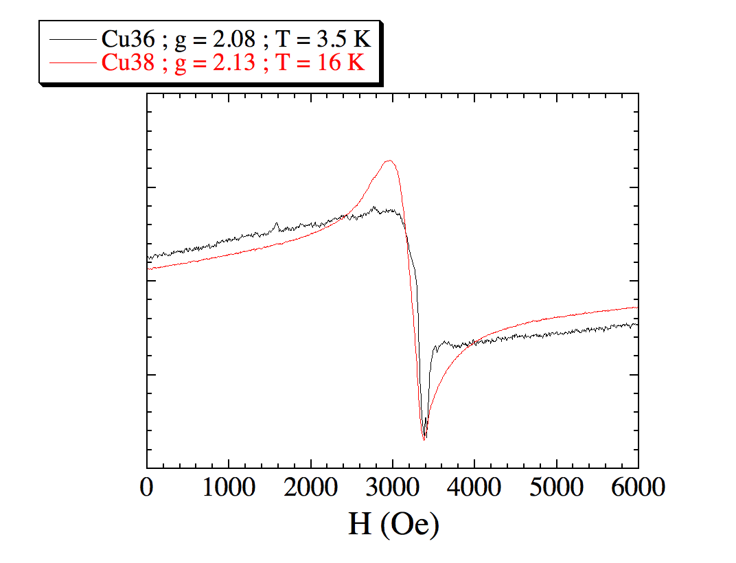
Figure SM1: X-band EPR spectra of a polycrystalline sample of {K₄(μ-MeOH)₄}1•Cl•23MeOH and {Cu^{I}₂K₄Cl₃(H₂O)₃}2•18MeOH•8H₂O.

