Synthesis of novel dendrimer-like star block copolymers with definite number of arms by combination of ROP and ATRP
Youliang Zhao, Xintao Shuai, Chuanfu Chen and Fu Xi*
State Key Laboratory of Polymer Physics & Chemistry, Center for Molecular Science, Institute of Chemistry, Chinese Academy of Sciences, Beijing 100080, China

Experimental

Materials
The dendrimer initiators with terminal benzyl alcohol (CMGn-OH, n = 1-3, with functionality of 6, 12, and 24, respectively) were synthesized according to a recent publication (See Y. L. Zhao, Y. M. Chen, C. F. Chen and F. Xi, J. Polym. Sci., Part A: Polym. Chem., revised). First, methyl ester-terminated dendritic polyarylether benzyl bromides (MGn-Br, n = 1-3) were prepared according to the procedure described by Hawker et al. (See C. J. Hawker, K. L. Wooley and J. M. J. Fréchet, J. Chem. Soc. Perkin Trans 1, 1993, 1287), by using methyl 4-bromomethylbenzoate and 3,5-dihydroxybenzyl alcohol as raw materials. Coupling of MGn-Br with 1,3,5-tri(4-hydroxyphenoxy)benzene in the presence of potassium carbonate and 18-C-6 in acetone afforded methyl ester-terminated dendritic polyarylethers CMGn. After reduction of CMGn using LiAlH₄ in absolute THF, the dendritic benzyl alcohol CMGn-OH with quantitative yield was obtained. FTIR, ¹H NMR and elemental analysis demonstrated that the dendrimer initiators possessed the chemical structure of objective products and high purity. L-Lactide (Aldrich) was purified by recrystallization in dry toluene. Toluene and tetrahydrofuran (THF) were distilled from metallic sodium and benzophenone. tert-Butyl acrylate (tBA), styrene (St), methyl methacrylate (MMA) and pentamethyldiethylenetriamine (PMDETA) were stirred overnight over CaH₂ and distilled under reduced pressure prior to use. Triethylamine (TEA) was distilled over p-toluenesulfonyl chloride. Methylene chloride was dried over CaH₂ and distilled before use. CuBr was purified by stirring in acetic acid, washing with ethanol and then dried in vacuo. All the other reagents were of analytical grade and used as received.

CMGn-OH dendrimer for the synthesis of star polylactides
The solution of CMGn-OH dendrimer (n = 1-3) in absolute THF was accurately weighed and placed into a dried glass tube, then evaporated under vacuum at 50 ˚C for 8 h to remove residual solvent and water completely. After L-lactide and stannous octoate were added, the tube was purged three times with dry nitrogen and sealed under vacuum. The bulk polymerization was carried out at 120 ˚C in an oil bath with stirring. After reaction, the crude product was dissolved in chloroform, microfiltered through a 0.45-μm-pore membrane filter, and precipitated into cold methanol twice. The polymer CMGn-PLLA was obtained as white fine powders.
CMG3-PLLA: FTIR (KBr): 3200-3600, 2998, 2947, 1759, 1615, 1502, 1456, 1386, 1365, 1268, 1215, 1186, 1133, 1089, 1045, 869, 757, 691 cm⁻¹. ¹H NMR (CDCl₃): δ 7.38 and 7.35 (ABq, PhH), 6.90 and 6.87 (ABq, PhH), 6.67 (s, ArH), 6.55 (d, ArH), 6.20 (s, ArH), 5.17 (q, CH in PLLA), 5.01 (s, PhCH₂O), 4.97 (s, ArCH₂O), 4.37 and 4.34 (ABq, terminal CH in PLLA), 2.64 (d, terminal OH in PLLA), 1.59 (d, CH₃ in PLLA). ¹³C NMR (CDCl₃): 175.0 (terminal OCOCH(CH₃)OH), 169.6 (CO PLLA), 160.0 (ArC), 141.0 (ArC), 135.8 (PhC-CH₂OPLLA), 134.0 (ArC), 128.5 (PhC), 127.8 (PhC), 121.4 (PhC), 114.2 (PhC), 106.6 (ArC), 101.4 (ArC), 70.1 (ArCH₂O), 69.6 (ArCH₂O), 69.0 (CH PLLA), 66.7 (terminal CH(CH₃)OH), 66.0 (PhCH₂OPLLA), 20.5 (terminal CH(CH₃)OH), 16.6 (CH₃ PLLA).

Synthesis of macroinitiator CMGn-PLLABr
CMGn-PLLA was dissolved in dry methylene chloride under stirring. To this solution was added triethylamine (TEA), then 2-bromoisobutyryl bromide (BIBB) was added dropwise ([OH]:[TEA]:[BIBB] = 1:1.5:1.5). The mixture was stirred 30 h at room temperature before it was washed with water. The combined organic layer was dried overnight, concentrated, and the product CMGn-PLLABr was isolated from methanol.
CMG3-PLLABr: FTIR (KBr): 2997, 2947, 1758, 1616, 1502, 1455, 1384, 1363, 1268, 1186, 1132, 1092, 1047, 869, 757, 701 cm⁻¹. ¹H NMR (CDCl₃): δ 7.40 and 7.35 (ABq, PhH), 6.96 and 6.93 (ABq, PhH), 6.68 (s, ArH), 6.55 (s, ArH), 6.19 (s, ArH), 5.17 (q, CH in PLLA), 5.03 (s, PhCH₂O), 4.96 (s, ArCH₂O), 1.98 (s, CH₃ in functional end group), 1.58 (d, CH₃ in PLLA).

Block copolymerization initiated with CMG3-PLLABr via ATRP
CMG3-PLLABr (M_{n} = 27.5 kg/mol, M_{w}/M_{n} = 1.08) was used as macroinitiator to prepare star block copolymers via ATRP with CuBr/PMDETA catalytic system. The materials were accurately weighed and placed into a dry glass tube. The reaction mixture was degassed with three freeze-evacuate-thaw cycles and polymerized in a sealed tube at the predetermined temperature. At timed intervals, the glass tube was removed and cooled to room temperature. The contents were dissolved in chloroform and then passed through an alumina column. The polymer was precipitated from a large amount of methanol (for CMG3-PLLA-b-PSt and CMG3-PLLA-b-PMMA) or 1:1 methanol/water mixture (for CMG3-PLLA-b-PtBA).
CMG3-PLLA-b-PSt: FTIR (KBr): 3060, 3026, 2999, 2924, 2850, 1759, 1602, 1494, 1452, 1382, 1362, 1302, 1267, 1185, 1131, 1091, 1047, 870, 756, 699 cm⁻¹. ¹H NMR (CDCl₃): δ 7.40 and 7.34 (ABq, PhH), 6.2-7.2 (m, PhH in PSt and ArH in dendrimer core), 5.17 (q, CH in PLLA), 5.03 (s, PhCH₂O), 4.96 (s, ArCH₂O), 4.2-4.5 (m, terminal CH(Ph)Br), 1.0-2.5 (m, CH₃ in PLLA, CH and CH₂ in PSt).
CMG3-PLLA-b-PtBA: FTIR (KBr): 2978, 2935, 1759, 1728, 1615, 1478, 1452, 1390, 1367, 1256, 1210, 1182, 1150, 1094, 1046, 915, 846, 756, 691 cm⁻¹. ¹H NMR (CDCl₃): δ 7.40 and 7.34 (ABq, PhH), 6.96 and 6.93 (ABq, PhH), 6.68 (s, ArH), 6.55 (s, ArH), 6.19 (s, ArH), 5.17 (q, CH in PLLA), 5.03 (s, PhCH₂O), 4.96 (s, ArCH₂O), 4.0-4.2 (m, terminal CHBr), 2.23 (s, CH in PtBA), 1.82 (m, CH₂ in PtBA), 1.57 (d, CH₃ in PLLA), 1.44 (m, CH₃ in PtBA).
CMG3-PLLA-b-PMMA: FTIR (KBr): 2997, 2951, 1761, 1733, 1615, 1483, 1453, 1385, 1363, 1271, 1242, 1187, 1148, 1091, 1048, 989, 844, 753, 697 cm⁻¹. ¹H NMR (CDCl₃): δ 7.40 and 7.34 (ABq, PhH), 6.95 and 6.93 (ABq, PhH), 6.68 (s, ArH), 6.55 (s, ArH), 6.19 (s, ArH), 5.17 (q, CH in PLLA), 5.02 (s, PhCH₂O), 4.96 (s, ArCH₂O), 3.74 (s, terminal COOCH₃), 3.60 (s, COOCH₃ in PMMA), 2.62 (s, CH₂ in terminal group), 1.36-2.20 (m, CH₃ in PLLA and CH₂ in PMMA), 0.7-1.3 (m, CH₃ in PMMA).

Characterization
Fourier transform infrared spectroscopic (FTIR) analyses were performed on a Perkin-Elmer 2000 spectrometer. ¹H and ¹³C NMR spectra were recorded on a BRUKER DPX (300 MHz for ¹H and 75 MHz for ¹³C) spectrometer in CDCl₃ or THF-d₈ at room temperature. The molecular weight and molecular weight distribution were measured on a Waters 150-C gel permeation chromatography equipped with Ultrastyragel columns (HT2, HT3 and HT4) at 35 ˚C. THF was used as eluent and polystyrene standards were used as calibrations. The molecular weight of CMGn-PLLAs determined by ¹H NMR spectra (M_{n,NMR}) was obtained by combination of arm number and average chain length which was determined by comparison of the average signal intensity ratios of methine protons of PLLA (5.19 ppm) to the terminal methine protons (4.35 ppm). The absolute weight-average molecular weight (M_{w,SLS}) was calculated on a DLS-700 light scattering photometer equipped with a RM-102 differential refractormeter in chloroform at 25˚C.

Scheme S1. Synthesis of novel star block copolymers by mechanism transformation

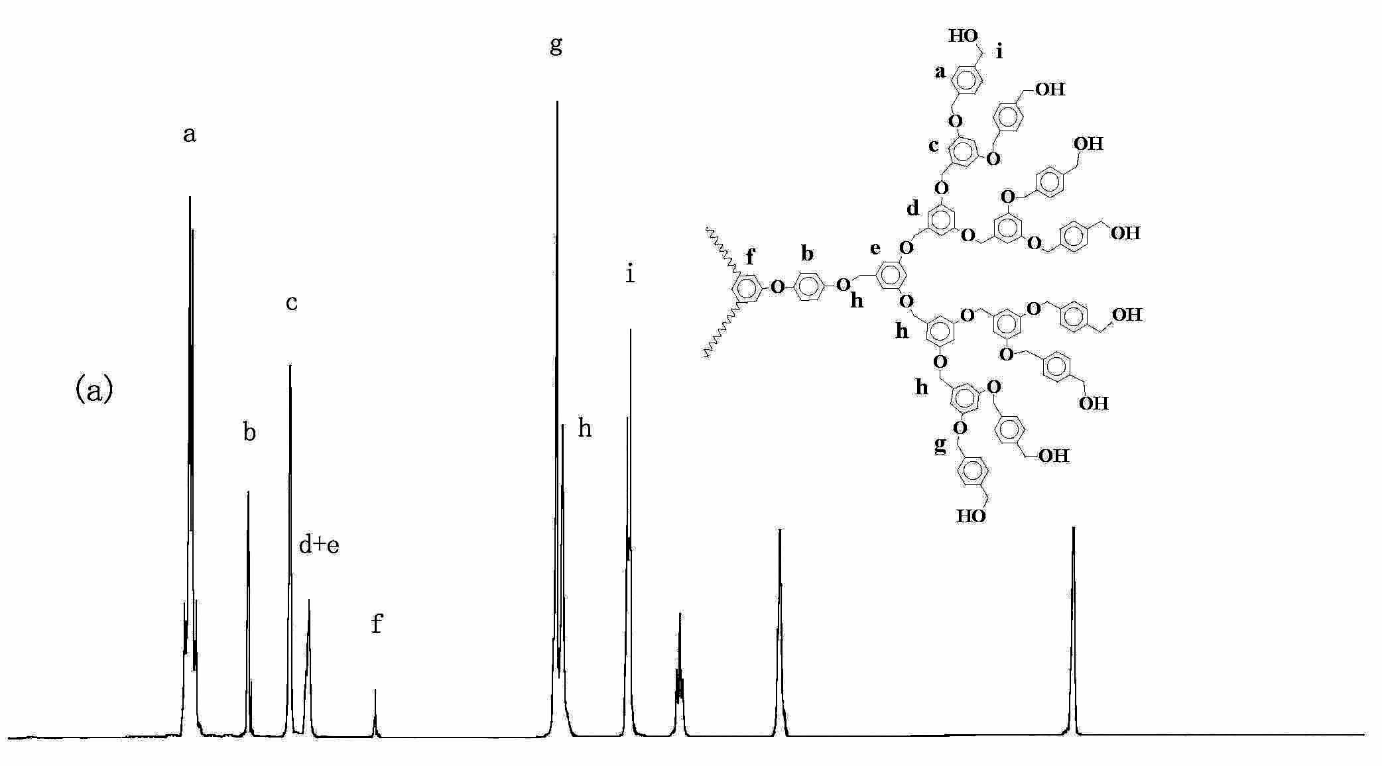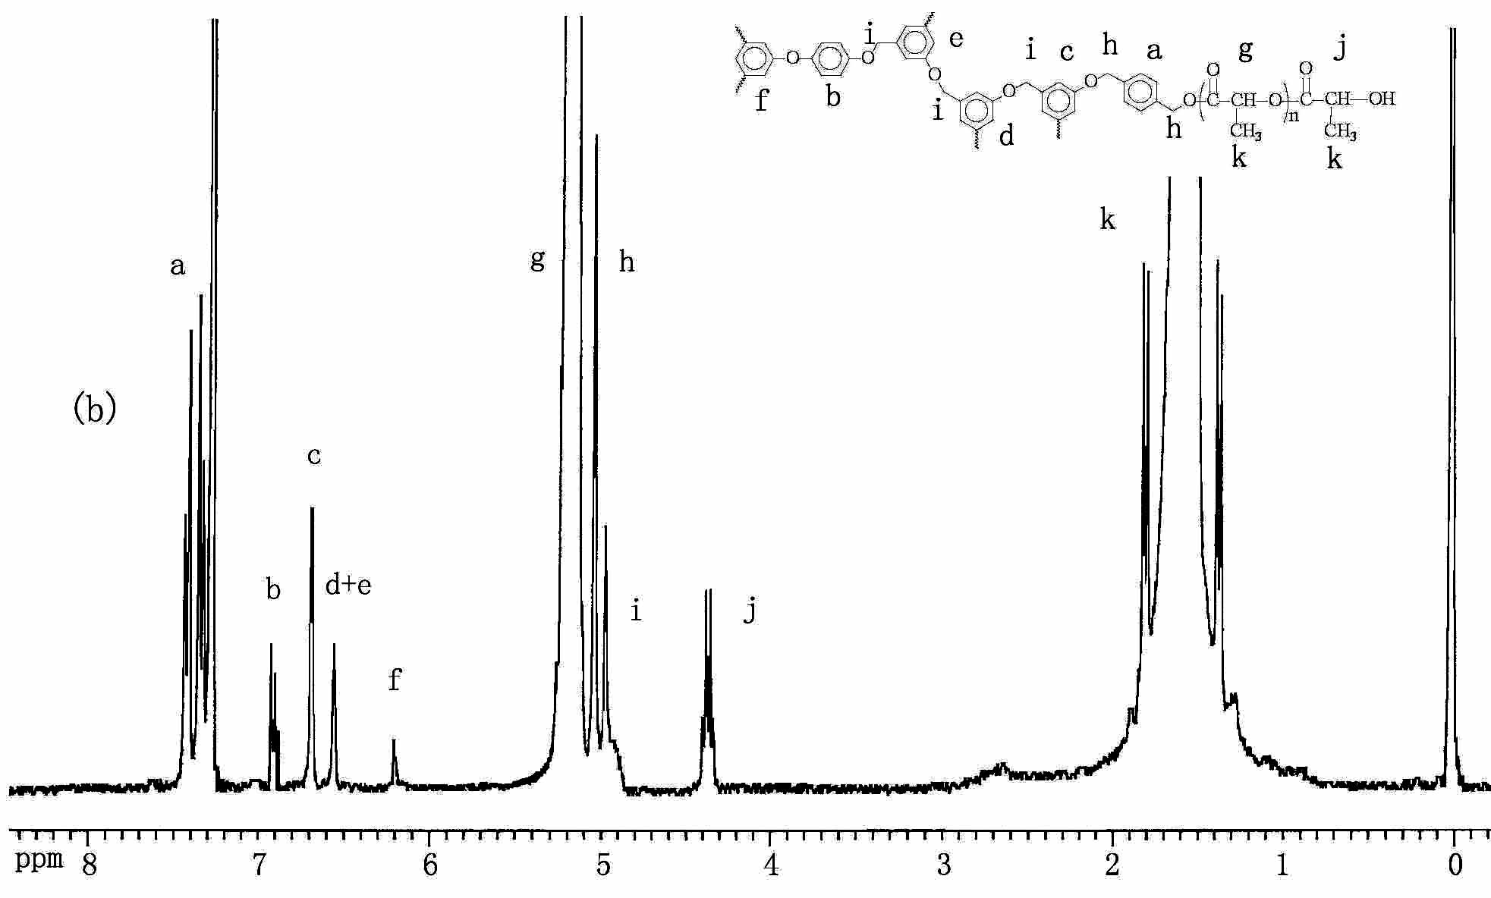
Fig. S1 Comparison of ¹H NMR spectra of CMG3-OH in THF-d₈ (a) and CMG3-PLLA in CDCl₃ (b).

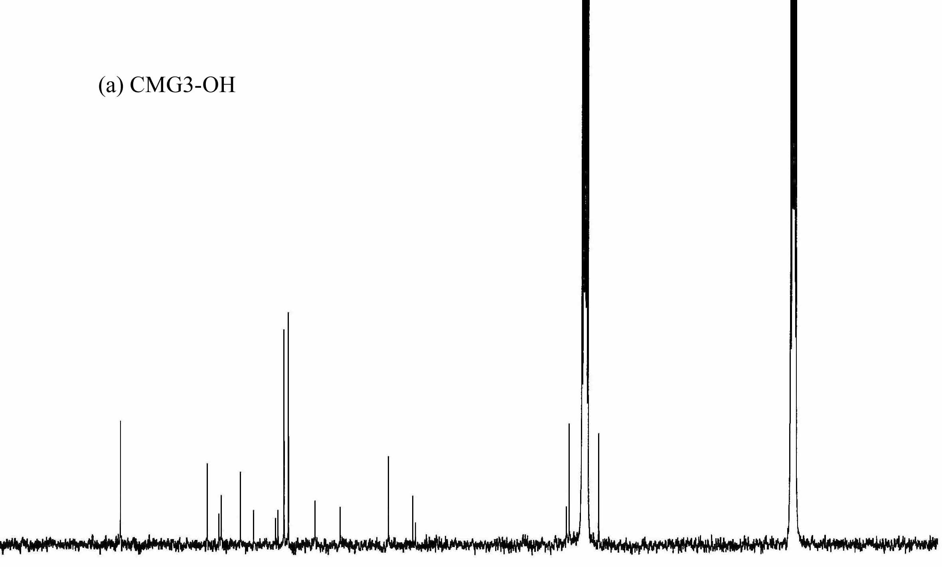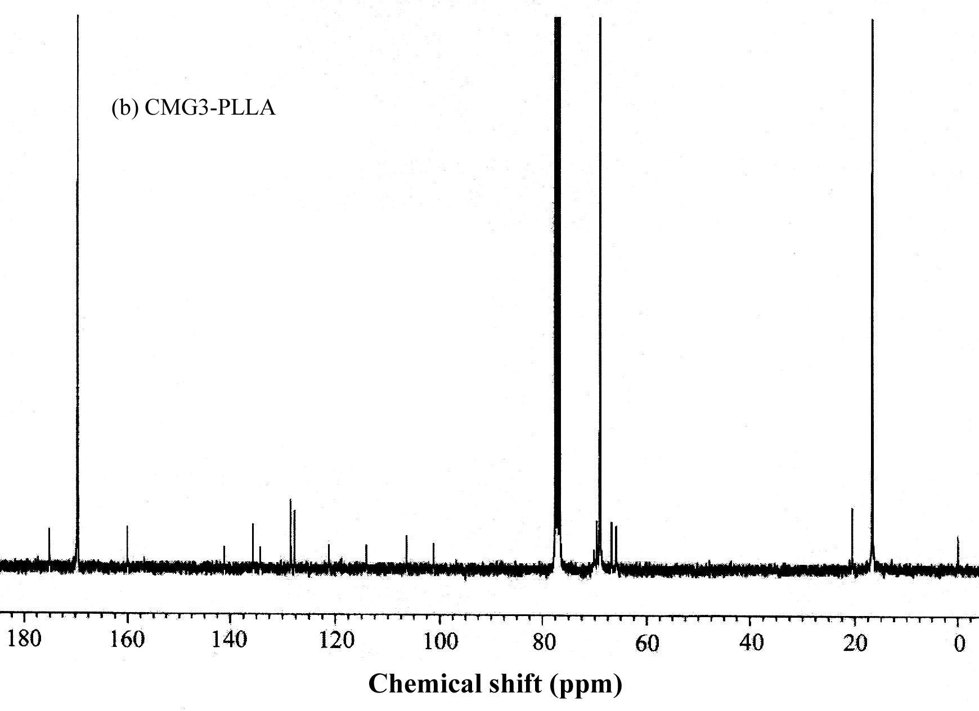
Fig. S2 Comparison of ¹³C NMR spectra of CMG3-OH in THF-d₈ (a) and CMG3-PLLA in CDCl₃ (b).

