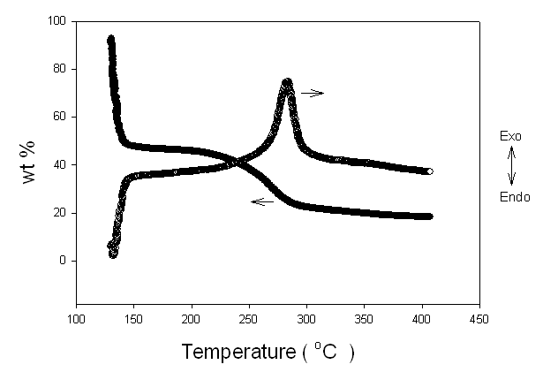
Fig. S1 TG-DTA curve of the mixed sol, prepared with a molar ratio of 1 TiCl₄ : 44.6 EtOH : 0.0645 polyoxyethylene (20) cetyl ether

Figure S1 shows the thermogravimetry-differential thermal analysis(TG-DTA) of the mixed sol, prepared with a molar ratio of 1 TiCl₄ : 44.6 EtOH : 0.0645 polyoxyethylene (20) cetyl ether. In this figure, the curves can be divided into two regions. Below 150°C, about 50% of mass reduction is mainly due to the thermal desorption of ethanol, while from 220 to 280°C, the mass reduction of 20% is attributed to the combustion of Brij58 template. In two regions, exothermic peaks obviously agree with TG curve. Because heat treatment at high temperature is generally accompanied by a large shrinkage of the structure, low-temperature treatment is advantageous to well-organized structures. For low-T treatment, we used two-step process; the first step implies the thermal desorption of ethanol and soft condensation at 150°C, and remains are calcined and the network condensation occur at 300°C.

