Interstrand communication between 2’-N-(pyren-1-yl)methyl-2’-amino-LNA monomers in nucleic acid duplexes: directional control and signalling of full complementarity

Patrick J. Hrdlicka,ª B. Ravindra Babu,ª Mads D. Sørensen,^{b} and Jesper Wengel*ª

ª Nucleic Acid Center, Department of Chemistry, University of Southern Denmark,
DK-5230 Odense M, Denmark

^{b} Department of Chemistry, University of Copenhagen, Universitetsparken 5,
DK-2100 Copenhagen, Denmark

Electronic supplementary information (ESI)

Synthesis of Oligonucleotides Containing Monomer X
Synthesis of 2’-N-(pyren-1-yl)methyl-2’-amino-LNAs (Table 1) was performed on an automated DNA synthesizer using the 2’-N-(pyren-1-yl)methyl-2’-amino-LNA-T phosphoramidite (M. D. Sørensen, M. Pedersen and J. Wengel, Chem. Commun., 2003, 2130) and standard DNA phosphoramidites. Coupling yields were approximately 99% for modified (0.2 µmol scale, 10 min coupling time, 1H-tetrazole as activator, iodine as oxidant) and unmodified phosphoramidites. After deprotection and cleavage from the solid support (32% aq. NH₃, 12 h, 55 ºC), the oligonucleotides were desalted, and their purity (>80%) and composition verified by capillary gel electrophoresis and MALDI-MS analysis, respectively.

Table S1. MALDI-MS data for new oligonucleotides.

Oligonucleotide | Found m/z [M-H]⁻ | Calculated m/z [M-H]⁻
ON4 | 2920 | 2923
ON5 | 2920 | 2923
ON8 | 3966 | 3965
ON9 | 4033 | 4037
ON10 | 4927 | 4930
ON11 | 4757 | 4761

Conditions for Thermal Denaturation Studies and Fluorescence Measurements
Melting temperatures (T_{m} values) were measured as the maximum of the first derivative of the melting curve (A₂₆₀ vs. temperature; increase 1 or 2 ºC min⁻¹) and recorded in medium salt buffer (10 mM sodium phosphate, 100 mM sodium chloride, 0.1 mM EDTA, pH 7.0) using 1.0 µM concentration of both strands. All steady-state fluorescence emission spectra were recorded in the buffer (argon-saturated) described for T_{m} measurements. ONs were heated to 80 °C and subsequently cooled before recording emission spectra at 19 ºC ±0.1 ºC. Excitation wavelength λ_{ex} = 340 nm, emission slit width 2.50 and excitation slit width 4.00 were used. In Table 1 and in Figure 4, “A^{L}”, “G^{L}” and “^{Me}C^{L}” denote an LNA adenin-9-yl, guanin-9-yl and 5-methylcytosin-1-yl monomer, respectively.

Steady-State Fluorescence Emission Spectra
Fig S1. Steady-state fluorescence emission spectra of pyrene-modified ONs from dual probe assay. Results from the introduction of mismatches at position 11 (left) and 12 (right) are shown (see Figure 4 in the paper for sequences). Curves “11-G” and “12-T” are identical and fully complementary to the 17-mer target.

Molecular Modelling Procedure
A standard A-type DNA-DNA duplex was build using the SPARTAN ‘02 program and subsequently modified within the MacroModel V7.2 suite of programs (R. D. Mohamadi, N. G. J. Richards, W. C. Guida, R. Liskamp, M. Lipton, C. Caufield, C. Chang, T. Hendrickson and W. C. Still, J. Comput. Chem., 1990, 11, 1301). All atoms except those introduced by the modifications were frozen, and the duplex minimized using the all-atom AMBER force field (S. J. Weiner, P. A. Kollmann, D. Case, U. C. Singh, C. Ghio, G. Alagona, S. Profeta and P. K. Weiner, J. Am. Chem. Soc., 1984, 106, 765) applying a dielectric constant of 80 relative to vacuum. Electrostatics were treated without cut-offs. The minimized structure was then (using the same constraints as described above) submitted to 5 ns of stochastic dynamics (1000 K, timestep of 2 fs, SHAKE all H), during which 1000 structures were sampled and minimized.

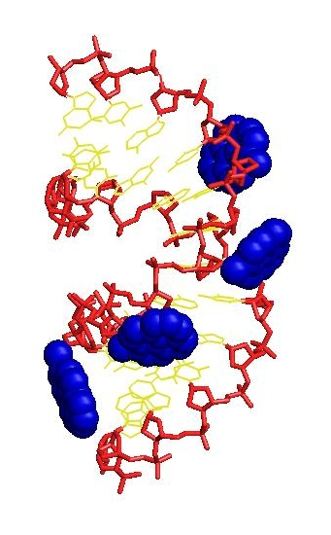
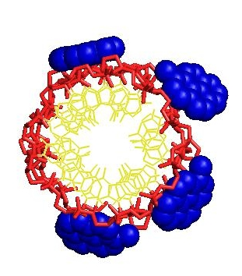
Molecular Modelling of Duplex ON8+ON11
Fig S2. Two representations of lowest energy structure from molecular modelling of ON8+ON11 viewed into minor groove (left) or from the top (right). Coloring scheme is: nucleobases, yellow; sugar-phosphate backbone, red; pyrenyl moieties, blue.

