Asymmetric Lithium(I) and copper(II) alkoxy-N-heterocyclic carbene complexes; crystallographic characterisation and Lewis acid catalysis
Polly L. Arnold,* Mark Rodden, Kate M. Davis, Andrew C. Scarisbrick, Alexander J. Blake, and Claire Wilson
School of Chemistry, University of Nottingham, University Park, Nottingham, NG7 2RD, UK.

Procedure for synthesis of 1a,b,d,e: A high pressure ampoule was charged with imidazole (3g, 41mmol) and epoxide (1.0 mol equiv). The resulting mixture was stirred at 50°C for 12h. Acetonitrile (10mL) and alkyl halide (1.0 mol equiv) were added and the mixture was stirred at 80°C for 2h. The solvent was then removed to yield the product as a pale brown solid, and recrystallised from dichloromethane or acetonitrile.

Data for 1a: colourless powder, yield 86%, mp 97-98°C δ_{H} (300 MHz, D₂O): 8.85 (s, 1H, NCHN), 7.63 (s,1H, CHCH), 7.51 (s, 1H, CHCH), 4.69 (m, 1H, NCH), 4.20 (s, 2H, NCHH), 1.64, 1.58(d, 6H, COH(CH₃)₂), 1.26(s,6H, NCH(CH₃)₂. δ_{C} 134.9 (NCHN) 124.0 (NCHCH) 120.1(NCHCH) 69.7 (C_{q}) 59.3 (NCH₂) 53.3 (NCH) 25.6 (CH3) 22.1 (CH3). MS (ES): m/z 183 ([M-I]⁺, 100%). IR (nujol mull) 3331br (OH), 3128, 3074, 1641, 1555, 1335, 1183.

Data for 1b: colourless powder, yield 98%, mp 64-66°C δ_{H} (300MHz, D₂O): 8.75 (s, 1H, NCHN), 7.53 (s,1H, CHCH), 7.47 (s, 1H, CHCH), 4.09 (sept, 1H, CH(CH₃)₂), 4.52, 4.47 (dd, 1H, NCHH, coupling), 3.65, 3.61(dd, 1H, NCHH, coupling), 3.93(s, 3H, NCH₃) 1.01(s, 9H, C(CH₃)₃). δ_{C} 136.5 (NCHN) 123.5 (NCHCH) 122.8(NCHCH) 77.8 (CH(OH)) 51.8 (NCH₂) 36.0 (NCH₃) 34.0(C(CH₃)₃) 25.1 (C(CH₃)) MS (ES): m/z 183 ([M-I]⁺, 100%) Anal. Calcd for C₁₀H₁₉IN₂O: C 38.72, H 6.17, N 9.03. Found 38.35, H 6.06, N 8.84. IR (neat) 3353br (OH), 3145, 3081, 2959, 2869, 1574, 1478, 1450, 1366.

Data for 1d colourless powder, yield 97%, mp 102-103°C δ_{H} (300 MHz, D₂O) 8.69 (s, 1H, NCHN), 7.42 (m, 2H, CHCH) 4.14 (s, 2H, NCH₂) 3.87 (s, 3H, NCH₃) 1.19 (s, 6H, COH(CH₃)₂) δ_{C} 138.0 (NCHN) 124.7 (CHCH) 123.6 (CHCH) 69.7 (COH) 59.3 (NCH₂) 36.7 (NCH₃) 27.5 (COH(CH₃)₂) m/z 155 ([M-I]⁺, 100%) Anal. Calcd for C₈H₁₅IN₂O: C 34.06, H 5.36, N 9.93. Found 34.00, H 5.25, N 9.68. IR (nujol mull) 3264br (OH), 3103, 3067, 1560, 1161.

Data for 1e colourless powder, yield 82%, 85-86°C δ_{H} (300 MHz, CDCl₃) 9.58 (s, 1H, NCHN) 7.58 (s,1H, CHCH) 7.42(s, 1H, CHCH), 4.70 (sept, 1H, CH(C(CH₃)₃), J=6.70Hz) 4.46, 4.42 (dd, 1H, NCHH, ²J_{HH} 1.7Hz , ³J_{HH} 13.7Hz) 4.15 (m, 1H, CH(OH)) 3.68, 3.65 (d, 1H, NCHH, ³J_{HH} 9.8) 1.59, 1.56 (d, 6H, CH(CH₃)₂) 0.95 (s, 9H, C(CH₃)₃) δ_{C} 135.2 (NCHN) 123.8 (CHCH) 119.8 (CHCH) 76.7 (CHOH) 53.4 (NCH(CH₃)₂) 52.2 (NCH₂) 34.7 (C(CH₃)₃) 26.2 (C(CH₃)₃) 23.2 (NCH(CH3)2) MS (ES): m/z 211 ([M-I]⁺, 100%) Anal. Calcd for C₁₂H₂₃N₂OI: C 42.61, H 6.85, N 8.28. Found C 42.35, H 6.74, N 8.34. IR (neat) 3352br (OH), 3130, 3072, 2963, 2870, 1730, 1560, 1478, 1367.

Synthesis of 1c: A high pressure ampoule was charged with 1-tert-buytlimidazole (3g, mmol) and 2-phenyl-2-methyloxirane (2.94g, mmol). The mixture was stirred at 80°C for 15h resulting in the formation of a dark brown oil. On addition of THF, a colourless solid precipitated.

Data for 1c: colourless powder, yield 98%, mp 64-66°C. δ_{H} (300MHz, CDCl₃): 10.37(s, 1H, NCHN), 7.39-7.23 (m, 5H, aromatic H), 6.98 (s,1H, CHCH), 6.58 (s, 1H, CHCH), 5.28, 5.23 (d, 1H, NCHH, J=13.5Hz) 4.36, 4.32(d, 1H, NCHH, J=13.5Hz) 1.77 (s, 3H, CH₃) 1.65 (s, 9H, C(CH₃)₃). MS (ES): m/z 258 ([MH]⁺, 100%) Anal. Calcd for C₁₆H₂₄ClN₂O: C 64.96, H 8.17, N 9.47. Found C 64.87, H 7.86, N 9.49.

General procedure for synthesis of copper compounds:

A flame-dried Schlenk tube under a nitrogen atmosphere was charged with imidazolium salt 1 (1mmol) and THF (5mL) at –78°C. To this was added a solution of lithium hexamethyldisilazide (2mmol for all except 1c; 1mmol) in THF. The mixture was allowed to slowly warm to room temperature and was stirred for 2 h. After this time, this solution of 2, the LiI adduct of the lithium salt, was added to a suspension of copper salt (1mmol or 0.5mmol) in THF at –78°C. The resulting mixture was allowed to slowly warm to room temperature and was stirred for 2 h, then filtered through celite. The solvent was removed under reduced pressure to yield the crude copper compound.

Data for 2b colourless solid δ_{H} (300MHz, C₆D₆): 6.28 (s,1H, NCHCH) 6.15 (s,1H, NCHCH) 3.36 (s, 3H, NCH₃) 3.56, 3.53 (d, 2H, NCH₂) 1.28 (s, 9H, C(CH₃)₃) δ_{C} 199.8 (NCN) 119.7 (NCHCHN) 119.3 (NCHCHN) 83.8 (CH(C(CH₃)₃)) 58.1 (NCH2) 37.7 (NCH₃) 36.3 (C(CH₃)₃) 25.2 (C(CH₃)₃) δ7_{Li} 1.28. Anal. Calcd for C₁₀H₁₇CuN₂OLi₂I.Et₂O: C, 42.66; H, 6.39; N, 7.11. Found C, 42.47; H, 6.59; N, 7.21.

Data for 3b Extracted from the crude with toluene; recrystallised from CH₂Cl₂; pale green solid yield 63% UV-vis (THF, 298K) λ_{max} [nm] (ε [dm³mol⁻¹cm⁻¹]) 256(27.6) 301 (52.8) 356 (57.7) 391 (81.1).

Data for 4a Extracted from the crude with toluene; recrystallised from CH₂Cl₂/hexane; purple solid yield 69% MS (ES): m/z 427 ([MH]⁺, 19%) EPR (X-band): frozen 2-methyl thf: approximately axial with g_{zz}=2.13, g_{yy}=1.97, and g_{xx}=1.95. Metal hyperfine coupling resolved in the g_{zz} region of A= 201G. X-band, powder: g║ 2.15 g┴ 2.05. Anal. Calcd. for C₂₀H₃₄CuN₄O₂.LiI: C, 42.90; H, 6.12; N, 10.00. Found: C, 41.78; H, 6.02; N, 9.49.

Data for 4b Extracted from the crude with toluene; recrystallised from toluene; purple solid yield 76%. MS (ES): m/z 427 ([MH]⁺, 86%) EPR (X-band): frozen toluene: approximately axial with g_{zz}=2.16, g_{yy}=2.035, and g_{xx}=2.03. Metal hyperfine coupling resolved in the g_{zz} region of A= 202G. X-band, powder: g║ 2.11 g┴ 1.96. UV-vis (THF, 298K) λ_{max} [nm] (ε [dm³mol⁻¹cm⁻¹]) 256 (84.9) 311 (127) 345 (74.6) Anal. Calcd. for C₂₀H₃₄CuN₄O₂.2.5C₇H₈.2LiI: C, 48.74; H, 5.89; N, 6.06. Found C, 49.05; H, 5.27; N, 6.74.

Data for 4c green solid yield 78% MS (ES): m/z 579 ([MH]⁺, 43%) EPR (X-band) 298K, CH₂Cl₂/toluene: approximately axial with g_{zz}=2.10, g_{yy}=2.05, and g_{xx}=2.043. Metal hyperfine coupling resolved in the g_{zz} region of A= 100 G. X-band, powder: g║ 2.20 g┴ 2.07. UV-vis (THF, 298K) λ_{max} [nm] (ε [dm³mol⁻¹cm⁻¹]) 257 (355) 300 (547) 357 (445) 382 (475).

X-band EPR Spectra for complex 4

4a EPR (X-band, Methf frozen)
powder rt

4b EPR (X-band, toluene frozen)

4b powder rt

4c EPR (CH₂Cl₂/toluene)
powder

Complex 5:
Scheme Aeriel oxidation of Cu(I) NHC complex to Cu(II)

The dimeric Cu(I)-NHC ligand [Cu{OC(Ph)(CH₂{1-C[NCHCHNBu^{t}])₂}]₂ ([CuLº]₂) starting material was synthesised according to the literature procedure. A dark red sample of [CuLº]₂ was dissolved in CH₂Cl₂ (10 mg, 1.5 ml) under an inert atmosphere, and transferred by cannula into the smaller of two stacked, N₂-flushed vials. Dry diethylether (2 ml) was added to the gap between the two vials, and the larger vial capped. The diffusion set-up was stored at 20 °C in the dark for two weeks, during which time, a mixture of blue crystalline material formed in the inner vial, intermixed with 5 % of dark orange crystals characterised as [{(μ-O)[CuClLº]₂}₂]. The latter were found suitable for single crystal X-ray diffraction studies. The complex formed has abstracted an oxygen atom from water or air, and four chloride ligands from the dichloromethane solvent from which it was crystallised.
Figure Comparison of Cu(I)-NHC and Cu(II)-NHC fragments
After correcting for the ionic radii difference between the two oxidation states of copper, the average Cu-C_{carbene} bond lengths are 0.05 Å longer for the Cu(II) complex 5 than for its precursor [CuLº]₂. The late d-block metal – NHC bond is known to be strong with only rare suggestions of backbonding interactions.

General procedure for conjugate addition. A flame-dried Schlenk tube under a nitrogen atmosphere was charged with copper catalyst (5mol%) and THF (5ml). The solution was cooled to –30°C, Et₂Zn (0.68mL, 1.1M in toluene, 1.5 mol equiv) was added slowly followed by 2-cyclohexen-1-one (48µL, 0.5mmol). The resulting mixture was stirred at –30°C for 2h. The reaction was then quenched with 2M hydrochloric, allowed to warm to room temperature and diethyl ether (5mL) was added. The organic layer was filtered through silica. Yields were determined by GC and ¹H nmr spectroscopy. The ee was determined by chiral GC.

Gas Chromatography conditions:

Column : Lipodex A (He, 12psi)
Injector oven temperature: 250°C
Column oven temperature: 75°C (isothermal)
FID oven temperature: 280°C
T_{R} (R enant.) = 10.1 min; T_{R} (S enant.) = 10.4 min

Crystallography
In each case, a crystal was mounted in a film of RS3000 perfluoropolyether on a dual-stage glass fibre and transferred to the diffractometer.

IMIOHI 1a
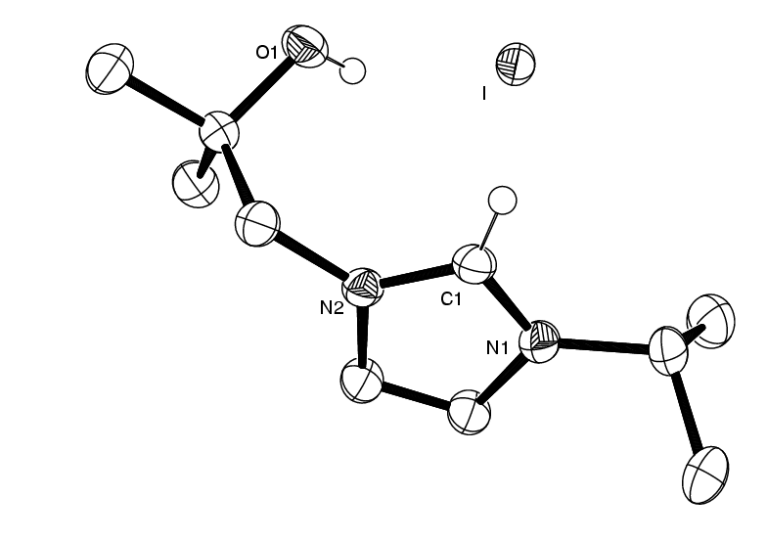
Table 1. Crystal data and structure refinement for imiohi.
Identification code imiohi
Empirical formula C10 H19 I N2 O
Formula weight 310.17
Temperature 293(2) K
Wavelength 0.71073 Å
Crystal system Monoclinic
Space group P2(1)/c
Unit cell dimensions a = 10.297(2) Å α= 90°.
b = 11.516(2) Å β= 90.408(3)°.
c = 11.439(2) Å γ = 90°.
Volume 1356.4(4) Å3
Z 4
Density (calculated) 1.519 Mg/m3
Absorption coefficient 2.338 mm-1
F(000) 616
Crystal size 0.38 x 0.18 x 0.16 mm3
Theta range for data collection 2.51 to 27.49°.
Index ranges -13<=h<=13, 0<=k<=14, 0<=l<=14
Reflections collected 3074
Independent reflections 3074 [R(int) = 0.0000]
Completeness to theta = 27.49° 99.2 %
Absorption correction Integration
Max. and min. transmission 0.649 and 0.455
Refinement method Full-matrix least-squares on F2
Data / restraints / parameters 3074 / 0 / 132
Goodness-of-fit on F2 0.896
Final R indices [I>2sigma(I)] R1 = 0.0210, wR2 = 0.0471
R indices (all data) R1 = 0.0278, wR2 = 0.0481
Largest diff. peak and hole 0.597 and -0.334 e.Å-3

__

Table 2. Bond lengths [Å] and angles [°] for imiohi.
____________________________________
O(1)-C(8) 1.431(2)
N(2)-C(1) 1.327(2)
N(2)-C(3) 1.375(2)
N(2)-C(7) 1.466(2)
N(1)-C(1) 1.325(3)
N(1)-C(2) 1.378(2)
N(1)-C(4) 1.486(2)
C(4)-C(6) 1.513(3)
C(4)-C(5) 1.514(3)
C(7)-C(8) 1.527(3)
C(8)-C(10) 1.517(3)
C(8)-C(9) 1.521(3)
C(3)-C(2) 1.348(3)

C(1)-N(2)-C(3) 108.37(16)
C(1)-N(2)-C(7) 125.40(16)
C(3)-N(2)-C(7) 126.14(15)
C(1)-N(1)-C(2) 108.61(16)
C(1)-N(1)-C(4) 125.40(17)
C(2)-N(1)-C(4) 125.87(17)
N(1)-C(4)-C(6) 110.16(18)
N(1)-C(4)-C(5) 109.16(17)
C(6)-C(4)-C(5) 112.29(19)
N(2)-C(7)-C(8) 113.83(17)
O(1)-C(8)-C(10) 110.67(17)
O(1)-C(8)-C(9) 105.79(17)
C(10)-C(8)-C(9) 111.57(18)
O(1)-C(8)-C(7) 109.65(15)
C(10)-C(8)-C(7) 112.35(17)
C(9)-C(8)-C(7) 106.52(17)
N(1)-C(1)-N(2) 108.83(17)
C(2)-C(3)-N(2) 107.36(17)
C(3)-C(2)-N(1) 106.83(18)
___________________________________________
Symmetry transformations used to generate equivalent atoms

PHIMBU 1c.HCl
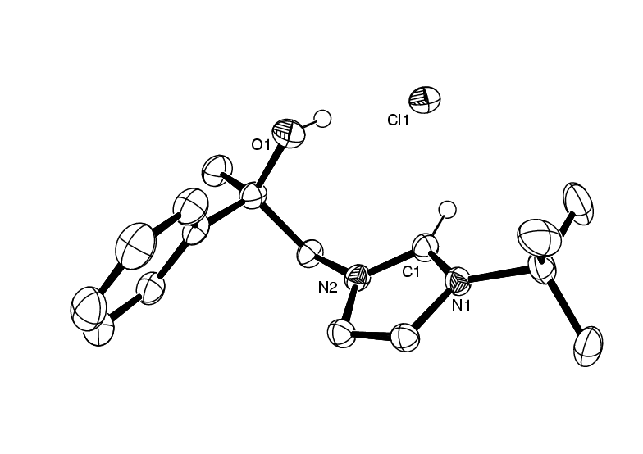
Crystal data and structure refinement for phimbu.
Identification code phimbu
Empirical formula C16 H23 Cl N2 O
Formula weight 294.81
Temperature 150(2) K
Wavelength 0.71073 Å
Crystal system Triclinic
Space group P-1
Unit cell dimensions a = 11.2459(6) Å α= 108.942(2)°.
b = 11.3574(6) Å β= 91.217(2)°.
c = 14.0301(7) Å γ = 102.273(2)°.
Volume 1648.29(15) Å3
Z 4
Density (calculated) 1.188 Mg/m3
Absorption coefficient 0.230 mm-1
F(000) 632
Crystal size 0.50 x 0.45 x 0.15 mm3
Theta range for data collection 2.04 to 29.07°.
Index ranges -15<=h<=14, -15<=k<=14, -19<=l<=18
Reflections collected 15603
Independent reflections 7953 [R(int) = 0.0417]
Completeness to theta = 27.50° 98.2 %
Absorption correction None
Refinement method Full-matrix least-squares on F2
Data / restraints / parameters 7953 / 0 / 363
Goodness-of-fit on F2 1.069
Final R indices [I>2sigma(I)] R1 = 0.0386, wR2 = 0.1086
R indices (all data) R1 = 0.0443, wR2 = 0.1124
Largest diff. peak and hole 0.381 and -0.190 e.Å-3

__

Table 3. Bond lengths [Å] and angles [°] for phimbu.
__________________________________________
O(1')-C(5') 1.4206(14)
N(1')-C(1') 1.3275(15)
N(1')-C(2') 1.3818(15)
N(1')-C(4') 1.4649(14)
C(1')-N(2') 1.3340(15)
N(2')-C(3') 1.3849(15)
N(2')-C(7') 1.4996(16)
C(2')-C(3') 1.3523(17)
C(4')-C(5') 1.5447(17)
C(5')-C(51') 1.5272(16)
C(5')-C(6') 1.5334(17)
C(7')-C(9') 1.519(2)
C(7')-C(10') 1.5268(19)
C(7')-C(8') 1.530(2)
C(51')-C(56') 1.3893(17)
C(51')-C(52') 1.3901(17)
C(52')-C(53') 1.3878(19)
C(53')-C(54') 1.384(2)
C(54')-C(55') 1.376(2)
C(55')-C(56') 1.3925(18)
O(1)-C(5) 1.4214(15)
N(1)-C(1) 1.3306(15)
N(1)-C(2) 1.3849(15)
N(1)-C(7) 1.4969(15)
C(1)-N(2) 1.3296(15)
N(2)-C(3) 1.3820(15)
N(2)-C(4) 1.4661(14)
C(2)-C(3) 1.3473(17)
C(4)-C(5) 1.5445(16)
C(5)-C(51) 1.5285(17)
C(5)-C(6) 1.5339(17)
C(7)-C(9) 1.522(2)
C(7)-C(8) 1.5231(18)
C(7)-C(10) 1.525(2)
C(51)-C(56) 1.3886(18)
C(51)-C(52) 1.3940(19)
C(52)-C(53) 1.381(2)
C(53)-C(54) 1.382(2)
C(54)-C(55) 1.382(2)
C(55)-C(56) 1.394(2)

C(1')-N(1')-C(2') 108.64(10)
C(1')-N(1')-C(4') 123.96(10)
C(2')-N(1')-C(4') 127.26(10)
N(1')-C(1')-N(2') 108.87(10)
C(1')-N(2')-C(3') 108.33(10)
C(1')-N(2')-C(7') 126.55(10)
C(3')-N(2')-C(7') 125.08(10)
C(3')-C(2')-N(1') 107.12(11)
C(2')-C(3')-N(2') 107.04(11)
N(1')-C(4')-C(5') 111.47(9)
O(1')-C(5')-C(51') 107.45(9)
O(1')-C(5')-C(6') 109.81(10)
C(51')-C(5')-C(6') 112.26(10)
O(1')-C(5')-C(4') 110.22(9)
C(51')-C(5')-C(4') 109.54(10)
C(6')-C(5')-C(4') 107.57(10)
N(2')-C(7')-C(9') 107.91(11)
N(2')-C(7')-C(10') 108.61(10)
C(9')-C(7')-C(10') 110.75(13)
N(2')-C(7')-C(8') 106.87(11)
C(9')-C(7')-C(8') 112.16(12)
C(10')-C(7')-C(8') 110.37(12)
C(56')-C(51')-C(52') 118.41(11)
C(56')-C(51')-C(5') 121.48(11)
C(52')-C(51')-C(5') 120.04(11)
C(53')-C(52')-C(51') 121.03(12)
C(54')-C(53')-C(52') 119.89(13)
C(55')-C(54')-C(53') 119.71(12)
C(54')-C(55')-C(56') 120.42(12)
C(51')-C(56')-C(55') 120.49(12)
C(1)-N(1)-C(2) 108.27(10)
C(1)-N(1)-C(7) 126.93(10)
C(2)-N(1)-C(7) 124.73(10)
N(2)-C(1)-N(1) 108.90(10)
C(1)-N(2)-C(3) 108.47(10)
C(1)-N(2)-C(4) 123.88(10)
C(3)-N(2)-C(4) 127.55(10)
C(3)-C(2)-N(1) 107.20(10)
C(2)-C(3)-N(2) 107.15(10)
N(2)-C(4)-C(5) 111.46(9)
O(1)-C(5)-C(51) 107.69(10)
O(1)-C(5)-C(6) 110.01(10)
C(51)-C(5)-C(6) 112.15(10)
O(1)-C(5)-C(4) 110.04(10)
C(51)-C(5)-C(4) 109.09(10)
C(6)-C(5)-C(4) 107.85(10)
N(1)-C(7)-C(9) 107.86(11)
N(1)-C(7)-C(8) 108.59(10)
C(9)-C(7)-C(8) 110.59(13)
N(1)-C(7)-C(10) 107.36(11)
C(9)-C(7)-C(10) 111.59(11)
C(8)-C(7)-C(10) 110.71(12)
C(56)-C(51)-C(52) 118.74(13)
C(56)-C(51)-C(5) 121.41(12)
C(52)-C(51)-C(5) 119.66(11)
C(53)-C(52)-C(51) 120.92(13)
C(52)-C(53)-C(54) 119.95(15)
C(55)-C(54)-C(53) 119.99(14)
C(54)-C(55)-C(56) 120.10(14)
C(51)-C(56)-C(55) 120.30(14)
__________________________________________
Symmetry transformations used to generate equivalent atoms:

IIMAOL 1d
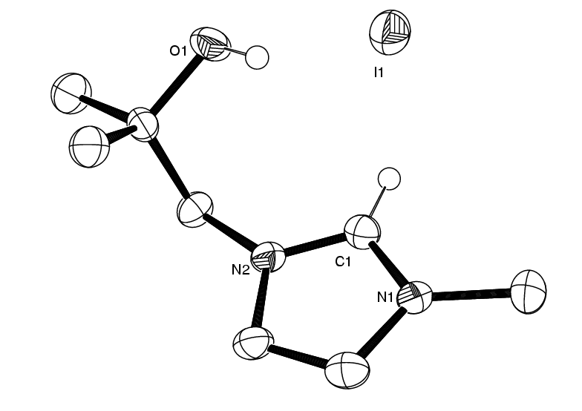
Table 1. Crystal data and structure refinement for iimaol.
Identification code iimaol
Empirical formula C8 H15 I N2 O
Formula weight 282.12
Temperature 150(2) K
Wavelength 0.71073 Å
Crystal system Orthorhombic
Space group P n a 21
Unit cell dimensions a = 15.347(3) Å α= 90°.
b = 7.6309(14) Å β= 90°.
c = 9.725(2) Å γ = 90°.
Volume 1138.9(4) Å3
Z 4
Density (calculated) 1.645 Mg/m3
Absorption coefficient 2.776 mm-1
F(000) 552
Crystal size 0.31 x 0.20 x 0.17 mm3
Theta range for data collection 2.65 to 27.60°.
Index ranges -19<=h<=19, -9<=k<=9, -12<=l<=12
Reflections collected 9715
Independent reflections 2611 [R(int) = 0.018]
Completeness to theta = 27.50° 99.9 %
Absorption correction Multi-scn
Max. and min. transmission 0.620 and 0.497
Refinement method Full-matrix least-squares on F2
Data / restraints / parameters 2611 / 1 / 113
Goodness-of-fit on F2 1.024
Final R indices [I>2sigma(I)] R1 = 0.0141, wR2 = 0.0363
R indices (all data) R1 = 0.0144, wR2 = 0.0365
Absolute structure parameter -0.016(14)
Largest diff. peak and hole 0.300 and -0.261 e.Å-3

Table 3. Bond lengths [Å] and angles [°] for iimaol.
___________________________________________

N(1)-C(1) 1.326(2)
N(1)-C(3) 1.381(2)
N(1)-C(4) 1.466(2)
C(1)-N(2) 1.335(2)
O(1)-C(6) 1.433(2)
N(2)-C(2) 1.383(2)
N(2)-C(5) 1.470(2)
C(2)-C(3) 1.354(3)
C(5)-C(6) 1.543(3)
C(6)-C(8) 1.515(3)
C(6)-C(7) 1.530(2)

C(1)-N(1)-C(3) 109.40(15)
C(1)-N(1)-C(4) 125.01(15)
C(3)-N(1)-C(4) 125.46(16)
N(1)-C(1)-N(2) 108.23(15)
C(1)-N(2)-C(2) 108.60(14)
C(1)-N(2)-C(5) 125.86(15)
C(2)-N(2)-C(5) 125.53(16)
C(3)-C(2)-N(2) 107.21(16)
C(2)-C(3)-N(1) 106.55(17)
N(2)-C(5)-C(6) 113.34(14)
O(1)-C(6)-C(8) 110.89(16)
O(1)-C(6)-C(7) 106.29(13)
C(8)-C(6)-C(7) 110.8(2)
O(1)-C(6)-C(5) 109.22(16)
C(8)-C(6)-C(5) 112.84(13)
C(7)-C(6)-C(5) 106.52(19)
_____________________________________________________________
Symmetry transformations used to generate equivalent atoms:

LICBOE 2b
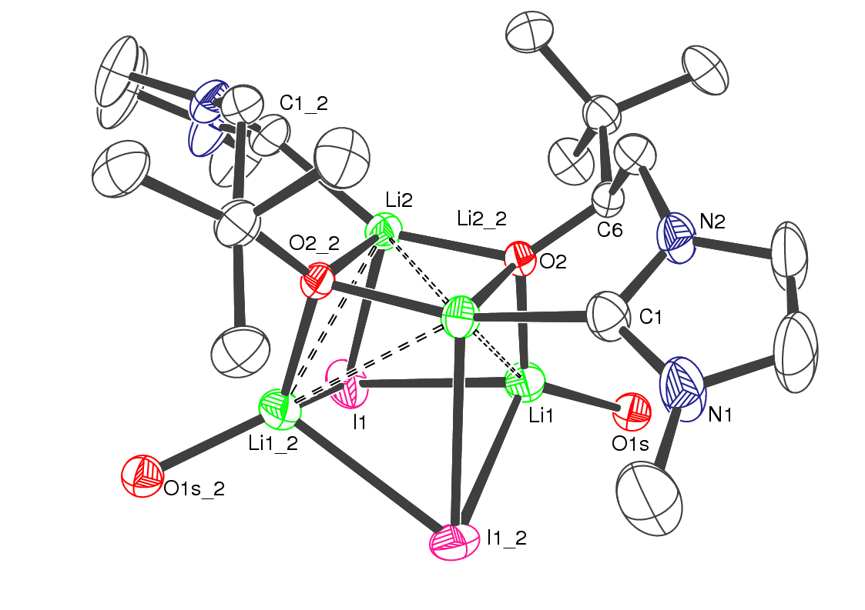
Table 1. Crystal data and structure refinement for licboe.
Identification code licboe
Empirical formula C28 H54 I2 Li4 N4 O4
Formula weight 792.31
Temperature 150(2) K
Wavelength 0.71073 Å
Crystal system Monoclinic
Space group C2/c
Unit cell dimensions a = 12.8799(15) Å α= 90°.
b = 15.655(2) Å β= 93.239(2)°.
c = 19.034(2) Å γ = 90°.
Volume 3831.8(8) Å3
Z 4
Density (calculated) 1.373 Mg/m3
Absorption coefficient 1.674 mm-1
F(000) 1600
Crystal size 0.08 x 0.20 x 0.40 mm3
Theta range for data collection 2.05 to 27.51°.
Index ranges -16<=h<=16, -14<=k<=20, -24<=l<=22
Reflections collected 11901
Independent reflections 4326 [R(int) = 0.031]
Completeness to theta = 27.50° 98.0 %
Absorption correction Semi-empirical from equivalents
Max. and min. transmission 1.000 and 0.748
Refinement method Full-matrix least-squares on F2
Data / restraints / parameters 4326 / 80 / 186
Goodness-of-fit on F2 0.922
Final R indices [I>2sigma(I)] R1 = 0.0362, wR2 = 0.0854
R indices (all data) R1 = 0.0574, wR2 = 0.0975
Largest diff. peak and hole 0.896 and -0.389 e.Å-3

CUIMSM 5
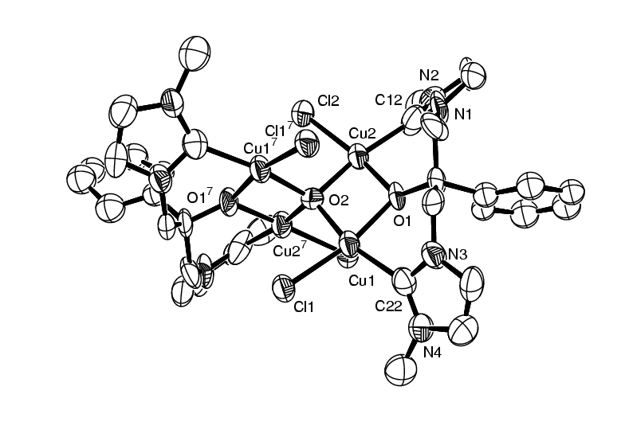

Crystal Data for 6
Table 1. Crystal data and structure refinement.
Identification code CUIMSM(local code)
Empirical formula C48.4 H65.6 Cl4 Cu4 N8 O3.6
Formula weight 1215.46
Temperature 150(2) K
Wavelength 0.71073 Å
Crystal system Tetragonal
Space group P 41 21 2
Unit cell dimensions a = 14.763(3) Å α= 90°.
b = 14.763 Å β= 90°.
c = 27.053(6) Å γ = 90°.
Volume 5896(4) Å3
Z 4
Density (calculated) 1.369 Mg/m3
Absorption coefficient 1.649 mm-1
F(000) 2509
Crystal size 0.21 x 0.18 x 0.08 mm3
Theta range for data collection 1.95 to 25.00°.
Index ranges -19<=h<=12, -19<=k<=16, -35<=l<=35
Reflections collected 36171
Independent reflections 7023 [R(int) = 0.189]
Completeness to theta = 25.00° 99.9 %
Absorption correction Semi-empirical from equivalents
Max. and min. transmission 1.10 and 0.45
Refinement method Full-matrix least-squares on F2
Data / restraints / parameters 5208 / 40 / 310
Goodness-of-fit on F2 1.054
Final R indices [I>2sigma(I)] R1 = 0.0645, wR2 = 0.147
R indices (all data) R1 = 0.165, wR2 = 0.214
Absolute structure parameter 0.35(5)
Extinction coefficient No
Largest diff. peak and hole 0.49 and -0.48 e.Å-3

__

__

P. L. Arnold, A. C. Scarisbrick, A. J. Blake, C. Wilson, Chem. Commun. 2001, 2340.
(a) J. C. Green, R. G. Scurr, P. L. Arnold, F. G. N. Cloke, Chem. Commun. 1997, 1963. (b) X. L. Hu, Y. J. Tang, P. Gantzel, K. Meyer, Organometallics 2003, 22, 612. Cu(I)-NHC complexes show a greater range of Cu-C distances than sigma-alkyl adducts, 1.88-99 Å.

