Supplementary Data:

Figure 1a: Simultaneous TG/DTA of [Hf(O^{i}Pr)₂(tbaoac)₂] (sample weight= 10 mg, Heating rate: 5°C/min, N₂ flow rate= 300 ml/min)

Figure 1b: Isothermal TG studies on [Hf(O^{i}Pr)₂(tbaoac)₂] at different vaporisation temperatures.

Figure 2: RBS spectra of a HfO₂ film deposited from [Hf(O^{i}Pr)₂(tbaoac)₂] at 500°C

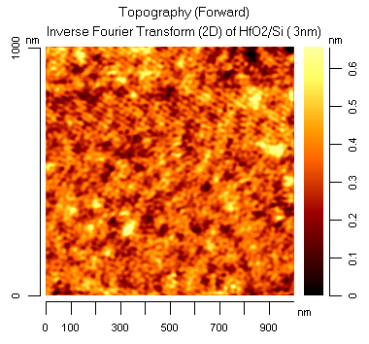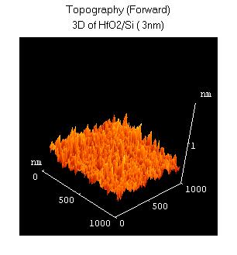

Figure 3: AFM images of a HfO₂ film deposited from [Hf(O^{i}Pr)₂(tbaoac)₂] at 700°C (thickness = 3 nm, average RMS roughness of 0.1nm)

