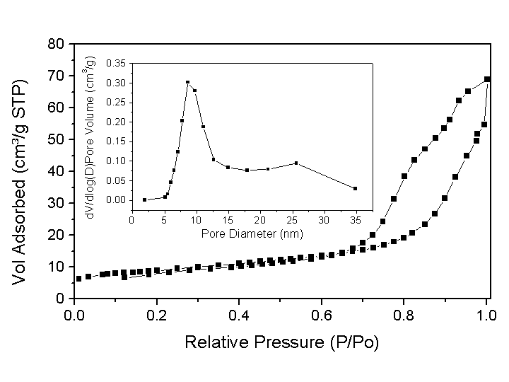

Supporting information, Smått et al. “Hierachically Porous Nanocrystalline Cobalt Oxide Monoliths Through Nanocasting”.

Nitrogen sorption isotherm measured at 77 K for the Co₃O₄ monolith after removal of the silica mold. Inset: BJH desorption pore size distribution plot.

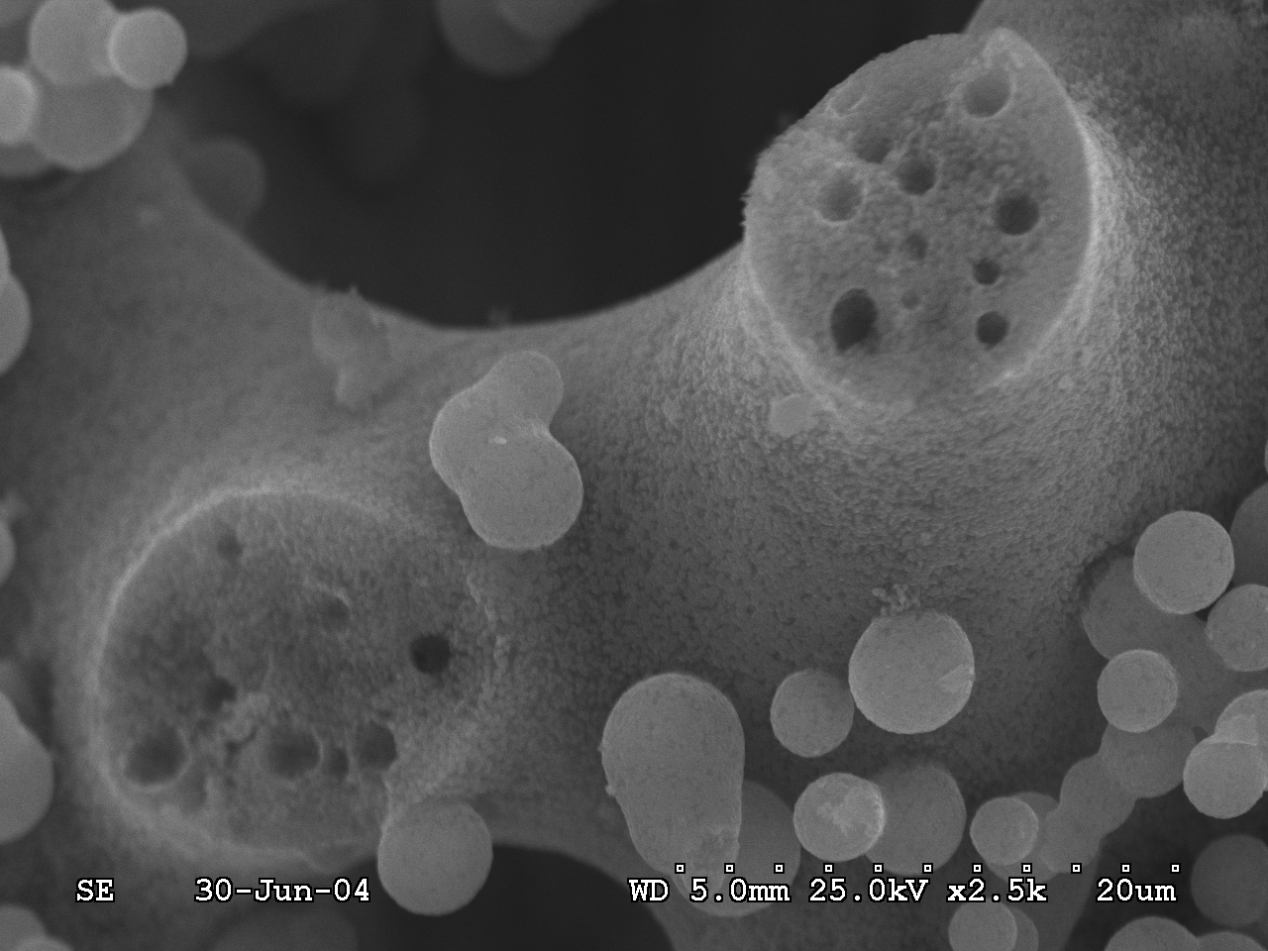

SEM image of the silica-Co₄O₄ composite after calcination showing the retained macroporous structure of the monolith after impregnation. Note that some larger Co₃O₄ particles are formed on top of the host silica structure.

