Electronic Supplementary Information

Zn^{II}-induced conformational control of amphiphilic cavitands in Langmuir monolayers

Markus Frei, Federica Marotti and François Diederich*
Laboratorium für Organische Chemie, ETH-Hönggerberg, CH-8093 Zürich, Switzerland.
E-mail: diederich@org.chem.ethz.ch

I. Characterisation ESI

Cavitand 1
Mp >300 ºC;  ν_{max}(neat)/cm⁻¹ 2950w, 1732s, 1608w, 1574w, 1483s, 1415s, 1365m, 1332s, 1260m, 1222m, 1165s, 1116m, 1071m, 1007m; δ_{H}(300 MHz; CDCl₃) 8.18 (4 H, s), 7.82-7.75 (8 H, m), 7.50-7.43 (8 H, m), 7.29 (4 H, s), 5.65 (4 H, t, J 8.1), 3.73 (12 H, s), 2.53 (8 H, t, J 6.9), 2.43-2.32 (8 H, m), 1.82-1.68 (8 H, m); δ_{C}(75 MHz; CDCl₃) 174.1, 152.8, 152.6, 139.8, 135.7, 129.2, 127.9, 123.6, 119.1, 51.8, 34.5, 33.7, 31.8, 23.5; HR-MALDI-MS (DHB): calcd for C₈₀H₆₄N₈O₁₆Na⁺ ([M + Na]⁺): 1415.4333; found 1415.4332.

Velcrand 2
Mp >300 °C; ν_{max}(neat)/cm⁻¹ 2950w, 1732s, 1567w, 1409s, 1364m, 1331s, 1235s, 1165s, 1141s, 1069s, 1015m; δ_{H}(300 MHz; CDCl₃) 7.78 (4 H, d, J 7.8), 7.66 (4 H, t, J 7.7), 7.46 (4 H, t, J 7.5), 7.17 (4 H, d J 8.1), 6.85 (2 H, s), 6.20 (2 H, s), 3.6-3.5 (4 H, m), 3.39 (12 H, s), 3.14 (6 H, s), 2.26 (6 H, s), 2.25-2.14 (8 H, m), 2.13-1.98 (4 H, m), 1.88-1.72 (4 H, m), 1.59-1.44 (4 H, m), 1.42-1.28 (4 H, m); δ_{C}(75 MHz; CDCl₃) 173.2, 152.5, 150.7, 148.9, 145.7, 138.0, 137.2, 133.7, 129.1, 129.0, 128.5, 128.2, 127.5, 127.1, 122.8, 118.7, 117.1, 51.4, 37.9, 33.1, 31.1, 22.3; HR-MALDI-MS (DHB): calcd for C₈₄H₇₂N₈O₁₆Na⁺ ([M + Na]⁺): 1471.4959; found 1471.4974.

II. Langmuir Studies ESI
Data were collected with a NIMA system (611D/2B/1PTFE/WIN/CAB) using a Teflon trough and symmetrical hydrophilic barriers. All isotherms were taken at room temperature. The ultrapure water (ρ = 18.2 MΩ cm) used for the subphase was obtained from the Milli-Q Plus Ultra-pure water system from Millipore. Surface pressure was measured with a platinum plate. Solutions of 2.2 mg/cm³ (cavitand 1) and 0.32 mg/cm³ (velcrand 2) concentration were prepared in chloroform. Usually, 0.025 cm³ of these solutions was spread on the water surface using a microsyringe. Films were left to equilibrate for 30 min before any measurements were started. The monolayers were compressed at a typical speed of 20 cm²/min. The experiments were repeated three times to ensure accuracy.

Langmuir experiments performed with trifluoroacetic acid (TFA) in the water subphase
The experiments were performed by dispersing 0.025 cm³ of spreading solution of cavitand 1, prepared by dissolving the compound in CHCl₃ (1.6 x 10⁻³ mM), on the water subphase at pH = 7 (black curve), and on the acidic water subphase at different pH (addition of TFA): pH = 3 (blue curve), pH = 2 (green curve) and pH = 1 (red curve) (Fig. ESI 1). The limiting area per cavitand molecule 1, obtained on the neutral water subphase (black curve) was approximately 125 Å² and corresponds to the calculated value (120 Å²) for the vase conformation. When the concentration of TFA increases, the area per molecule increases to ca. 225 Å² (red curve, obtained at pH = 1). This value is in good agreement with the calculated value corresponding to the kite conformation (290 Å²); the difference presumably arises from the fact that, under the experimental conditions, not all cavitands are fully protonated and, hence, fully conformationally switched.

Fig. ESI 1 Pressure-area (Π-A) isotherms of a monolayer of cavitand 1 on a Millipore water subphase at pH = 7 (black line), pH = 3 (blue line), pH = 2 (green line) and pH = 1 (red line).
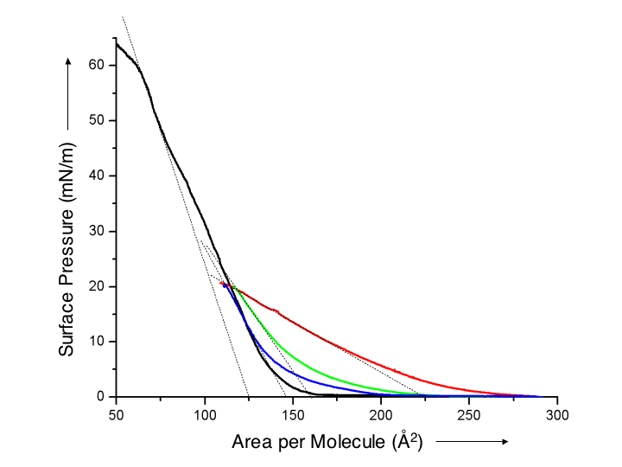
III. Determination of the binding stoichiometry by Job Plot analysis ESI
The 1:2 stoichiometry of the 3•(Zn^{II})₂ complexes in the kite form was confirmed as follows. Two stock solutions were prepared; solution A: 5 mM of 3 in CDCl₃; solution B: 5 mM of ZnI₂ and 12.5 mM of CD₃OD in CDCl₃. Ten 5-mm NMR tubes were filled with solutions A and B in the following ratios: 60:540, 120:480, 180:420, 240:360, 300:300, 360:240, 420:180, 480:120, 540:60, 600:0 cm³. ¹H NMR spectra were recorded at 300 MHz for each mixture. The concentration of the 3•(Zn^{II})₂ complexes was calculated as follows: [host•guest] = ([3]_{tot}) (δ_{obs}- δ_{r})/( δ₃- δ_{r}), where [3]_{tot} = the total concentration of 3 in solution, δ_{obs} = observed chemical shift, δ_{r} = chemical shift of the methine proton of 3, δ₃ = chemical shift of the methine proton of 3 in the 3•(Zn^{II})₂ complex (measured value at saturation). The experiments were repeated three times to ensure accuracy.

Fig. ESI 2 Job plot to prove the 1:2 binding stoichiometry of the kite complex 3•(Zn^{II})₂ in CDCl₃.
