Supporting Information for “Stereoelective Polymerization of D,L-Lactide Using N-Heterocyclic Carbene Based Compounds”

Tryg R. Jensen, Laurie E. Breyfogle, Marc A. Hillmyer,* William B. Tolman*

Table of Contents:
2 Experimental
5 Figure S1. Polymerization of D,L-LA by A.
6 Figure S2. MALDI-TOF-MS of an A catalyzed PLA sample.
7 Figure S3. DSC of PLA made with B (Table 1, entry 3).
8 Figure S4. ¹H NMR spectrum of Table 1, entry 1.
9 Figure S5. ¹H NMR spectrum of Table 1, entry 2.
10 Figure S6. ¹H NMR spectrum of Table 1, entry 3.
11 Figure S7. ¹H NMR spectrum of Table 1, entry 4.
12 Figure S8. ¹H NMR spectrum of Table 1, entry 5.
13 Figure S9. ¹³C NMR spectrum of Table 1, entry 1.
14 Figure S10. ¹H NMR peak deconvolution for spectrum in Figure S6.
Experimental
General Methods and Materials. All reactions were performed under a nitrogen atmosphere, using either standard Schlenk techniques or a dinitrogen-filled MBraun glovebox. All solvents and reagents were obtained from commercial sources and used as received unless otherwise stated. Pentane, dichloromethane, tetrahydrofuran and toluene were passed through purification columns (Glass Contour, Laguna, CA). Deuterated solvents (all 99 atom %D) were purchased from Cambridge Isotope Laboratories, dried over calcium hydride, distilled under vacuum, and stored under nitrogen. Benzyl alcohol was distilled from calcium hydride. Diethyl zinc (1 M in hexanes) was distilled immediately prior to use. D,L-Lactide and L-lactide were purified by recrystallization from toluene, followed by repeated (2-3x) vacuum sublimation. 1,3-di-tert-butylimidazol-2-ylidene was purchased from Strem and used as received. 1,3-dimesitylimidazol-2-ylidene and 1,3-bis(2,6-diisopropylphenyl)imidazol-2-ylidene were prepared as previously described. Diethylzinc·1,3-dimesitylimidazol-2-ylidene adduct was prepared by an established procedure.

Physical Methods. NMR spectra were collected with a Varian VI-300, Varian VXR-300, or Varian VXR-500 spectrometer. Chemical shifts for ¹H and ¹³C spectra were referenced using internal solvent resonances and are reported relative to tetramethylsilane. Elemental analyses were determined by Robertson Microlit Laboratories Inc., Madison, NJ. IR spectra for characterization were recorded on a Thermo Nicolet Avatar 370 FT-IR spectrometer, by ATR with a Ge crystal. Molecular weights (M_{n} and M_{w}) and polydispersities (M_{w}/M_{n}) were determined by size exclusion chromatography. Size exclusion chromatography (SEC) was performed using a Hewlett-Packard 1100 series liquid chromatograph with THF as the mobile phase. This SEC was equipped with three Jordi divinylbenzene columns (pore sizes 500, 10³, and 10⁴ Å; column temperature 40 °C), and output was detected with an HP1047A differential refractive index detector, an eluent flow rate of 1 mL/min, and a 50 μL injection loop. This instrument was calibrated using narrow polydispersity polystyrene standards (Polymer Laboratories) with molecular weights ranging from 5000 to 1 x 10⁶ g/mol. Differential scanning calorimetry (DSC) was performed using a TA Differential Scanning Calorimeter 1000 that was calibrated using high purity indium at a heating rate of 10 °C/min. Melting points were determined from the second scan following slow cooling (to remove the influence of thermal history) at a heating rate of 10 °C/min.
MALDI-TOF Measurements. Matrix assisted laser desorption mass spectrometry was performed using a Bruker Reflex III MALDI-TOF mass spectrometer (Bruker Daltonics, Billerica, MA). The laser employed was a pulsed nitrogen laser operating at 337 nm with a maximum average power of 6 mW. Typically, the laser power was attenuated by 40-60 dB in order to obtain satisfactory spectra for the samples analyzed. The instrument was operated in reflectron mode using delayed extraction techniques to improve resolution. Ions below m/z 350 were removed with pulse deflection and 1000 transients were summed. 2,5-Dihydroxybenzoic acid (DHB) was used as the matrix material and tetrahydrofuran was used as the solvent. Insulin (from Bovine Pancreas) and Angiotensin II (acetate salt) were used as the calibration standards. Sodium trifluoroacetate was used as the cationizing agent. Polymer M_{n} from MALDI data was determined using the Bruker Xmass Bio TOF 6.0.0 software.

General Polymerization Procedure. Glassware used for polymerizations was oven or flame-dried, treated with a 1.0 M solution of (CH₃)₂SiCl₂, then oven dried for a minimum of 3 h. In the glovebox the treated vial was charged with D,L-LA (180 mg, 1.25 mmol) and the appropriate volume of a catalyst solution. The vial was tightly capped, then brought out of the glovebox and stirred while immersed in a temperature-controlled bath at 25 °C. After an appropriate time, the reaction mixture was poured into pentane to precipitate the polymer. Excess pentane was removed be decantation and the polymer mixture was dried at 80 °C prior to characterization by SEC and ¹H NMR spectroscopy.

Kinetics. The polymerization of D,L-LA by A and B was monitored by IR spectroscopy using a Mettler Toledo ReactIR 4000 spectrometer. For the 25 °C runs, a reaction flask was charged with LA and CH₂Cl₂ in the glovebox (the total volume varied, but the average total volume was approximately 3 mL). The ReactIR probe was then attached to the flask via a ground glass joint, and the apparatus was removed from the glovebox and attached to the IR spectrometer so that the reaction flask was immersed in a temperature controlled bath at 25 °C. The solution temperature was allowed to equilibrate over 5 min, and A (as a CH₂Cl₂ stock solution prepared in the glovebox) was injected through a septum via syringe. Peaks due to LA at 1774 and 1250 cm⁻¹ and peaks due to PLA at 1750 and 1090 cm⁻¹ were monitored; analysis of LA decay and PLA growth gave very similar results. Conversion, as observed by IR spectroscopy, was confirmed by ¹H NMR spectroscopy for all kinetic runs. The observed rate constants (k_{obs}) were extracted by fitting an exponential curve to the plot of absorbance versus time using A_{t} = (A₀ - A∞)e^{-kt} + A∞, allowing A₀, A_{t}, and k to vary freely. The data were analyzed over at least three half-lives. All linear and nonlinear curve fits were performed with KaleidaGraph.

Di(benzyloxy)zinc·1,3-dimesitylimidazol-2-ylidene adduct (A).
In a 19 mL vial with a magnetic stir bar in the glove box diethylzinc·1,3-dimesitylimidazol-2-ylidene adduct (0.519 g, 1.21 mmol) was dissolved in toluene (10 mL) and cooled to -40 °C. A different vial was charged with benzyl alcohol (0.250 g, 2.32 mmol, 1.9 equiv.) and toluene (5 mL), and cooled to -40 °C. The benzyl alcohol solution was slowly added to the zinc adduct with stirring over 1 min. The solution is stirred at room temperature over 3 h. A white precipitate slowly appears. The solution was filtered off the solid which was dried in vacuo (0.50 g, 0.86 mmol, 71 % yield). A second crop can be recrystallized yielding additional compound (final yield 0.65 g, 1.1 mmol, 92 %). Single crystals for x-ray diffraction were grown by slow cooling a toluene solution. ¹H NMR (500 MHz, CD₂Cl₂) δ 1.809 (s, ArCH₃, 12H), 2.112 (s, ArCH₃, 6H), 4.918 (s, ZnCH₂, 4H), 6.332 (s, ArH, 4H), 6.782 (s, NCH, 2H), 7.032 (m, OAr, 4H), 7.284 (m, OAr, 2H), 7.376 (m, OAr, 2H). Anal. Calc. for C₃₅H₃₈N₂O₂Zn: C, 71.97; H, 6.56; N, 4.80. Found: C, 71.78; H, 6.81; N, 4.68.

Diethylzinc·1,3-Bis(2,6-diisopropylphenyl)imidazol-2-ylidene adduct ((C)ZnEt₂).
In a 50 mL round bottom flask in the glove box 1,3-bis(2,6-diisopropylphenyl)imidazol-2-ylidene (1.68 g, 4.79 mmol) was dissolved in toluene (10 mL). Diethylzinc (0.88 M in hexanes) was added by syringe (24 mL, 21 mmol, 4.3 equiv.). The solution was stirred at room temperature over 20 min. A solid precipitated over 12 h at -40 ºC, and the solvent was decanted off the solid. The solid was dried in vacuo to yield an off white powder (1.8 g, 3.5 mmol, 73 % yield). ¹H NMR (300 MHz, C₆D₆) δ -0.049 (q, J = 8.1 Hz, ZnCH₂, 4H), 1.040 (d, J = 6.9 Hz, CH(CH₃)₂, 12H), 1.324 (d, J = 6.9 Hz, CH(CH₃)₂, 12H), 1.520 (t, J = 8.1 Hz, ZnCH₂CH₃, 6H), 2.734 (sept, J = 6.9 Hz, CH(CH₃)₂, 4H), 6.444 (s, NCH, 2H), 7.10 (d, J = 7.5 Hz, ArH, 4H), 7.23 (t, J = 7.5 Hz, ArH, 2H). ¹³C{¹H} NMR (75MHz, C₆D₆, 22 °C) δ 5.330 (s, ZnC), 14.731 (s, CH₂CH₃), 24.029 (s, CH₃), 25.313 (s, CH₃), 29.184 (s, C(CH₃)₂), 123.379 (s, NCC), 124.587 (s, meta-C), 130.655 (s, para-C), 135.944 (s, ipso-C), 145.867 (s, ortho-C), 192.136 (s, NCN). Anal. Calc. for C₃₁H₄₆N₂Zn: C, 72.71; H, 9.05; N, 5.47. Found: C, 72.07; H, 9.77; N, 5.39.

NMR experiment: Reaction of (C)ZnEt₂ with Benzyl Alcohol.
A screw top NMR tube (J. Young) was charged with (C)ZnEt₂ (5.0 mg, 9.8 μmol) and toluene-d⁸ (1 mL). After taking the ¹H NMR spectrum, benzyl alcohol (1.1 mg, 10 μmol) was added in the glove box. After 5 minutes the ¹H and ¹³C NMR spectrum indicated that > 70 % of the carbene existed as free (uncoordinated) C.

Figure S1. Polymerization of D,L-LA by A. There are two linear fits to the data shown below. One of them is forced through a zero intercept and the other is not.

Figure S2. MALDI-TOF-MS of an A catalyzed PLA sample ([La]₀/[A]₀ = 290, 7.4% conversion, assuming 4 initiators per A, predicted M_{n} = 3090 g⋅mol⁻¹). The M_{n} was calculated from the region of 1350 to 5000 yielding a value of M_{n} = 2840 g⋅mol⁻¹. The predicted molecular mass for a given polymer chain is consistent with our benzyl alcohol endgroup assignment (e.g. a chain with a DP = 10, m/z^{calc} = 1571 g⋅mol⁻¹ = 23 (sodium) + 108 (BnOH) + 10 × 144 (LA), and the observed value is 1572.6 g⋅mol⁻¹). The peaks are separated by half a lactide unit (72 g⋅mol⁻¹); this indicates there must be some transesterification occurring throughout the polymerization although not enough to adversely affect polymerization control.

Figure S3. DSC of PLA made with B (Table 1, entry 3). This figure is from the second scan; after the first heating to 190 °C, the cooling profile cooled the sample at 10 °C /min to 90 °C, annealed the sample for 10 min at 90 °C (~T_{c}), cooled at a rate of 1 °C/min to 10 °C (below the T_{g}), and then cooled at 5 °C/min to -40 °C prior to the heating scan shown below (ramp rate of 10 °C/min).

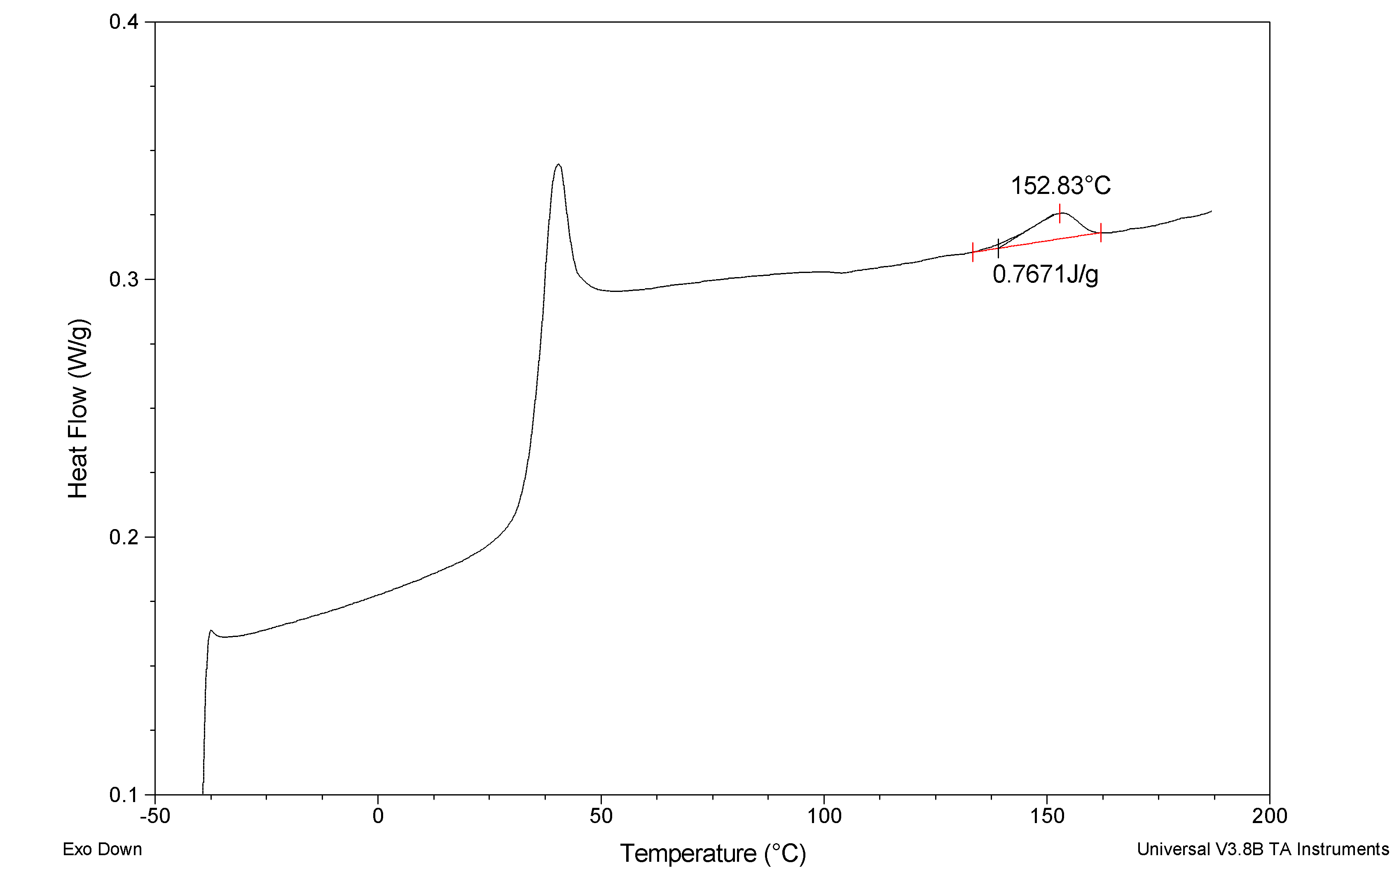

Figure S4. ¹H NMR spectrum (500 MHz, CDCl₃) of the PLA methine resonances with selective decoupling of the PLA methyl resonances from the sample made in Table 1, entry 1. The experimental integration values shown were determined by deconvoluting the overlapping peaks using the line fitting procedure of the MestRe-C 3.6.9 software application and then normalizing the total of the five peaks to be one. On the bottom is a table showing various predicted Bernoulian integration percentages for a given P_{m} (at left in table).

Figure S5. ¹H NMR spectrum (500 MHz, CDCl₃) of the PLA methine resonances with selective decoupling of the PLA methyl resonances from the sample made in Table 1, entry 2. The experimental integration values shown were determined by deconvoluting the overlapping peaks using the line fitting procedure of the MestRe-C 3.6.9 software application and then normalizing the total of the five peaks to be one. On the bottom is a table showing various predicted Bernoulian integration percentages for a given P_{m} (at left in table).

Figure S6. ¹H NMR spectrum (500 MHz, CDCl₃) of the PLA methine resonances with selective decoupling of the PLA methyl resonances from the sample made in Table 1, entry 3. The experimental integration values shown were determined by deconvoluting the overlapping peaks using the line fitting procedure of the MestRe-C 3.6.9 software application and then normalizing the total of the five peaks to be one. On the bottom is a table showing various predicted Bernoulian integration percentages for a given P_{m} (at left in table).

Figure S7. ¹H NMR spectrum (500 MHz, CDCl₃) of the PLA methine resonances with selective decoupling of the PLA methyl resonances from the sample made in Table 1, entry 4. The experimental integration values shown were determined by deconvoluting the overlapping peaks using the line fitting procedure of the MestRe-C 3.6.9 software application and then normalizing the total of the five peaks to be one. On the bottom is a table showing various predicted Bernoulian integration percentages for a given P_{m} (at left in table).

Figure S8. ¹H NMR spectrum (500 MHz, CDCl₃) of the PLA methine resonances with selective decoupling of the PLA methyl resonances from the sample made in Table 1, entry 5. The experimental integration values shown were determined by deconvoluting the overlapping peaks using the line fitting procedure of the MestRe-C 3.6.9 software application and then normalizing the total of the five peaks to be one. On the bottom is a table showing various predicted Bernoulian integration percentages for a given P_{m} (at left in table).

Figure S9. ¹³C NMR spectrum (125 MHz, CDCl₃) of the sample from Table 1, entry 1. The small peak at δ 69.56 ppm is assigned to the forbidden "mrr" resonance and is consistent with some transesterification occurring in the polymerization.

Figure S10. An illustrative line fit of the spectra in Figure S6 (Table 1, entry 3). The fits were done using the line fitting procedure of the MestRe-C 3.6.9 software application. The black line is the actual spectra. The grey line is the total fit, and the red and green lines are the separte, assigned peak fits. The areas of these peaks were than normalized with the total of all five peaks being equal to one in order to obtain the relative integrations.

A. J. Arduengo, III, R. Krafczyk, R. Schmutzler, H. A. Craig, aJ. R. Goerlich, W. J. Marshall, M. Unverzagt, Tetrahedron, 1999, 55, 14523.
A. J. Arduengo, III, H. V. Rasika Dias, F. Davidson, and R. L. Harlow, J. Organomet. Chem., 1993, 462, 13.

