Supplementary Material to Chem. Commun., Ref.: B405613B

Acidic Peptides Acting as Growth Modifiers of Calcite Crystals
Dirk Volkmer,* Marc Fricke, Thomas Huber and Norbert Sewald

*Faculty of Chemistry (AC 1), University of Bielefeld, PO Box 100 131, 33501 Bielefeld, Germany. Fax: +49 (0)521 106-6003; Tel: +49 (0)521 106-6142; E-mail: dirk.volkmer@uni-bielefeld.de

Experimental Section

Abbreviations
DCM - dichloromethane; DIPEA - diisopropylethylamine; DMF - N,N-dimethylformamide; Fmoc - 9-fluorenylmethoxycarbonyl; MALDI-ToF MS - matrix assisted laser desorption/ionization-time of flight mass spectrometry; MeCN - Acetonitril; RP-HPLC - reversed phase-high pressure liquid chromatography; TBTU - 2-(1H-Benzotriazol-1-yl)-1,1,3,3-tetramethyluronium tetrafluoroborate; TFA - trifluoroacetic acid; TIS - triisopropylsilane.

¹H NMR spectra were recorded on a Bruker DRX 500 spectrometer in DMSO-D₆ at room temperature. MALDI ToF mass spectra were recorded with an Applied Biosystems Voyager spectrometer. For HPLC separations, a Phenomenex Jupiter Proteo 90A analytical column (Nacalai Tesque, 4.6 × 250 mm, flow rate 0.8 mL/min) or a Phenomenex Jupiter C18 300A preparative column (21.2 × 250 mm, flow rate 10mL/min) was employed, and eluted products were detected by UV at 220 or 254 nm. A solvent system consisting of 95% H₂O, 4.9% MeCN and 0.1% TFA solution (v/v, solvent A) and 95% MeCN, 4.9% H₂O and 0.1% TFA (v/v, solvent B) were used for HPLC elution.

Synthesis strategy
Routine peptide synthesis was carried out by the combination of standard Fmoc/tBu solid phase protocols on a 2-chlorotrityl chloride resin with TBTU/DIPEA as coupling reagent.

General procedure for synthesis of linear peptides
2.0 equivalents of a suitable protected amino acid (relative to resin capacity) are dissolved in DCM (approximately 10 mL per gram of resin). This solution is added to the resin followed by 4.0 equivalents of DIPEA. The mixture is agitated at room temperature for 90 min under argon. The resin is filtered off and washed with DCM (3x), methanol (3x), DMF (3x), DCM (3x), and dried under vacuum.
Cleavage of the Fmoc protective group:
A solution of 2 % DBU and 6% piperazine in DMF (5 mL) is added. The mixture is shaken for 5 min at room temperature and filtered off. An additional portion of the solution of 6 % piperazine in DMF (5 mL) is added. The mixture is shaken at room temperature for 20 min, filtered off, washed with DMF (8x), and dried in vacuum. The Fmoc-amino acids were coupled by treatment of 1.5 equivalents of Fmoc-amino acid with 1.5 equivalents of TBTU and 3.0 equivalents of DIPEA in DMF (5mL) for 1 h. The resin is washed with DMF (4x).
Before peptide cleavage and deprotection the resin is washed with DCM. A mixture of 95 % TFA, 2.5 % water and 2.5 % TIS (2 mL/0.2 mmol peptide) is added and the reaction mixture is shaken for 3h at room temperature. The solution is filtered and concentrated in vacuum. The peptide is precipitated with diethylether, the residue is centrifuged and purified by preparative RP-HPLC.
H-Phe-Asp-Phe-Asp-OH (FDFD, 1)

MALDI-ToF MS, m/z:
Calcd.: 543.2 [M+H]⁺,
Found: 543.9 [M+H]⁺, 565.99 [M+Na]⁺, 581.95 [M+K]⁺.

¹H NMR (500 MHz, DMSO-D₆), δ = 2.49 (m, 1H, C^{β}H), 2.57 (dd, ³J = 6.6 Hz, ²J = -16.6 Hz, 1H, C^{β}H_{a}H_{b}), 2.68 (dd, ³J = 6.3 Hz, ²J = -16.3 Hz, 1H, C^{β}H_{a}H_{b}), 2.71 (dd, ³J = 5.0 Hz, ²J = -17.0 Hz, 1H, C^{β}H_{a}H_{b}), 2.77-2.80 (dd, ³J = 9.1 Hz, ²J = -14.1 Hz, 2H, C^{β}H_{a}H_{b}), 3.04 (dd, ³J = 3.5 Hz, ²J = -14.1 Hz, 2H, C^{β}H_{a}H_{b}), 3.96 (dd, ³J = 4.4 Hz, ³J = 8.7 Hz, 1H, C^{α}H), 4.52 (m, 2 H, C^{α}H), 4.61 (ddd, ³J = 5.0 Hz, ³J = 8.2 Hz, ³J = 8.2 Hz, 1H, C^{α}H), 7.10-7.31 (m, 10H, arom. H), 8.02 (s, br, 3H, NH₃), 8.13 (d, ³J = 8.2 Hz, 1H, NH), 8.35 (d, ³J = 8.2 Hz, 1H, NH), 8.76 (d, ³J = 7.5 Hz, 1H, NH), 12.56 (s, br, 2H, COOH).

H-(Phe-Asp)₄-OH (FDFDFDFD, 2)
MALDI-ToF MS, m/z:
Calcd.: 1067.4 [M+H]⁺,
Found: 1067.1 [M+H]⁺, 1089.1 [M+Na]⁺.

¹H NMR (500 MHz, DMSO-D₆), δ = 2.38-2.47 (m, 2H, C^{β}H), 2.56 (m, 1H, C^{β}H), 2.61-2.83 (m, 8H, C^{β}H), 2.92-3.06 (m, 4H, C^{β}H), 3.95 (dd, ³J = 8.8 Hz, ³J = 4.4 Hz, 1H, C^{α}H), 4.44-4.56 (m, 6H, C^{α}H), 4.60 (ddd, ³J = 7.1 Hz, ³J = 7.1 Hz, ³J = 6.1 Hz, 1H, C^{α}H), 7.07-7.30 (m, 20H, arom. H), 7.82 (d, ³J = 8.1 Hz, 1H, NH), 7.83 (d, ³J = 7.5 Hz, 1H, NH), 8.0 (s, br, 3H, NH₃), 8.14 (d, ³J = 8.1 Hz, 1H, NH), 8.25 (d, ³J = 7.5 Hz, 1H, NH), 8.35 (d, ³J = 8.1 Hz, 1H, NH), 8.75 (d, ³J = 7.5 Hz, 1H, NH), 12.46 (s, br, 3H, COOH).

Crystal growth experiments
Stock solutions of 1 and 2 were prepared in water (1 = 4 mM, 2 = 100 µM). A drop of (NH₄)₂CO₃ was added to a solution of 2 to facilitate dissolution. Crystallization of CaCO₃ was performed by slow diffusion of (NH₄)₂CO₃ vapor into Nunc multiwell plates containing glass cover slips overlaid by 310 µL of 7 mM CaCl₂ solution and 90 µL of stock solution (final concentration of 1 = 1 mM). 1000 µL of stock solution were added into 1000 µL of a solution of 7 mM CaCl₂ (final concentration of 2 = 50 µM). For control experiments similar volumes of water were added. Each well was enclosed with parafilm punctured by a needle. The multiwell plate was placed in a closed desiccator for 1 to 96 hours.
All crystallization experiments were repeated three to five times. After crystallization the supernatants were discarded and the glass slides were removed from the multiwell plates and dried in air.

FTIR Spectroscopy
Crystals were removed from glass cover slips and mounted in KBr pellets. Infrared spectra were obtained using a Shimadzu FTIR-8300 spectrometer.

Microscopy
Crystals were studied by optical microscopy (Olympus IX70). The cover slips were also mounted on SEM specimen tubs. A Phillips XL30 ESEM operating at 30 keV was used. The calcite crystals were sputtered with Au prior to examination.

X-ray Diffraction
The glass cover slips containing CaCO₃ crystals were removed and examined with a Philips PW 1050/70 X-ray powder diffractometer (2θ scans, Bragg-Brentano para-focussing geometry) using CuK_{α} radiation (λ = 1.54 Å).

Assignment of CaCO₃ Crystal Faces

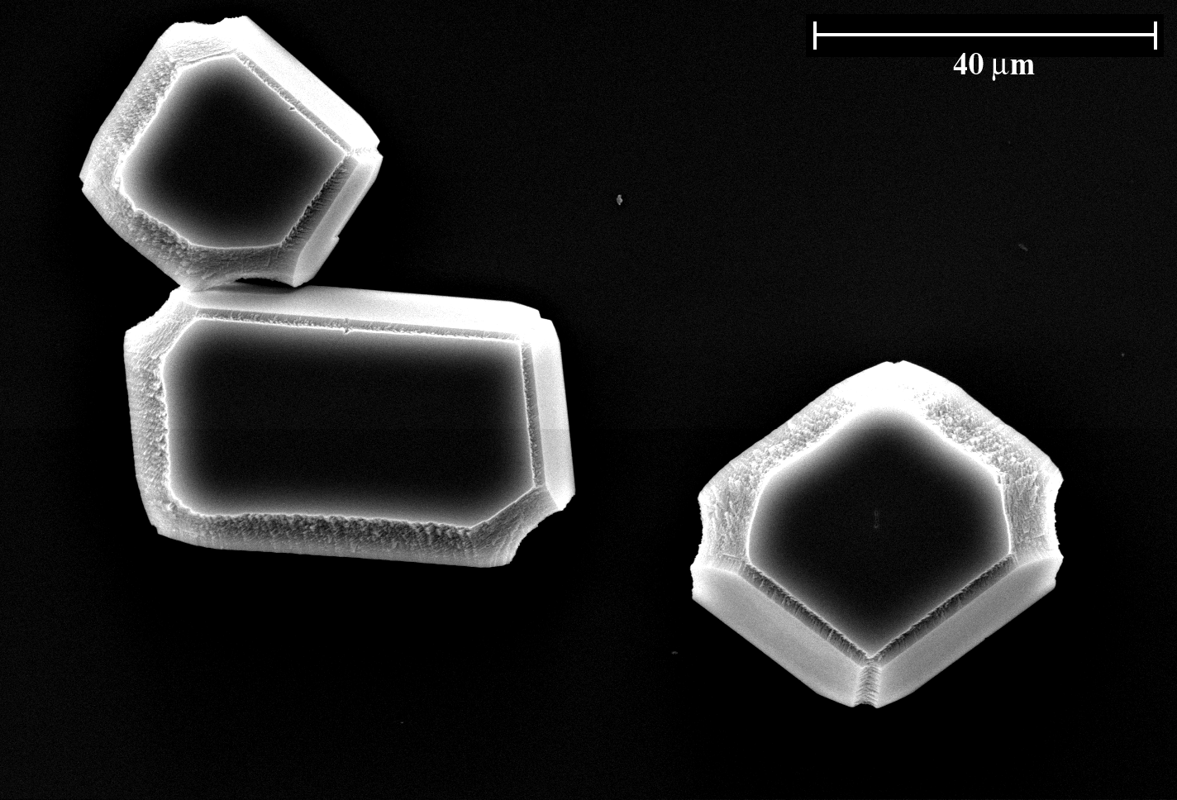

Fig. S1: Representative scanning electron micrograph of calcite crystals grown in the presence of 2 (ratio 2/Ca = 1/180). (Crystals isolated after 5h, no image manipulation performed).

CaCO₃ crystals grown in the presence of peptides 1 or 2 were found to be highly uniform in appearance (Fig. S1), showing the typical calcite rhombohedron morphology with smooth {10.4} faces and additional crystal faces possessing a stepped surface. Most of the crystals were found to be attached to the glass slide with one of their symmetry-equivalent {10.4} faces. Therefore, the collection of crystal specimen were examined for isolated crystal specimen showing a suitable pre-alignment and the sample holder was adjusted such that the viewing direction was exactly perpendicular to one of the newly formed {hk.l} crystal faces (Fig. S2). Interfacial angles were measured employing digital image analysis (Soft Imaging System, analySiS V3.0). Experimentally determined angle values were compared to calculated interfacial angles employing wire models of suitably truncated CaCO₃ rhombohedra (Shape Software, Shape V7.1).
Example: In the scanning electron micrograph Fig. S2 the {11.0} crystal face of the calcite crystal is parallel to the image plane. The calculated angles between edges in the {11.0} face form are 109.07° and 70.93°. The experimentally determined angles are 71°(±2°), and 109°(±2°), respectively. Please note that replacing the {01.2} faces by a set of {02.3} faces would lead to a similarly truncated calcite crystal. However, in this case the calculated interfacial angles in the {11.0} face form would be 100.92° and 79.08°, respectively, and these values are in much worse agreement with experimental values which were independently determined from three different crystal specimen.
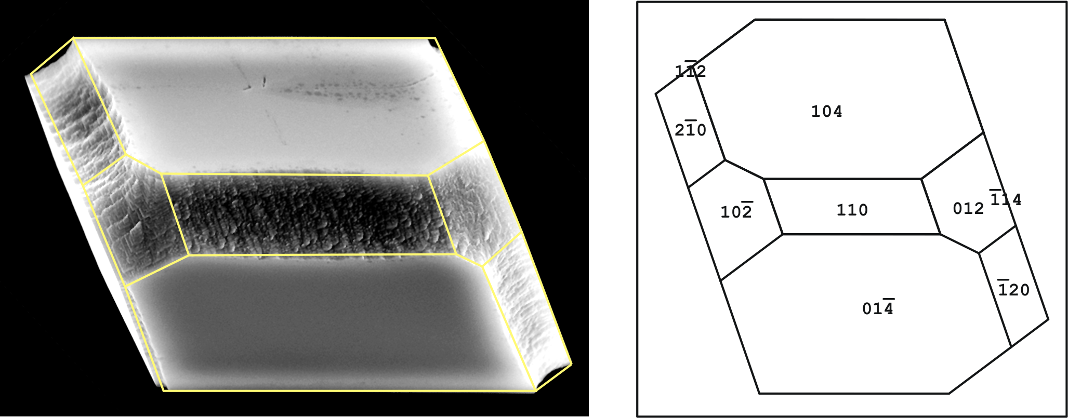

Fig. S2. Left: Scanning electron micrograph of a calcite crystal grown in the presence of 2 (ratio 2/Ca = 1/180) with superimposed surface net. Right: Wire model of the outline of a calcite crystal displaying the set of symmetry equivalent {10.4}, {11.0} and {01.2} crystal faces.

