Electronic Supplementary Information

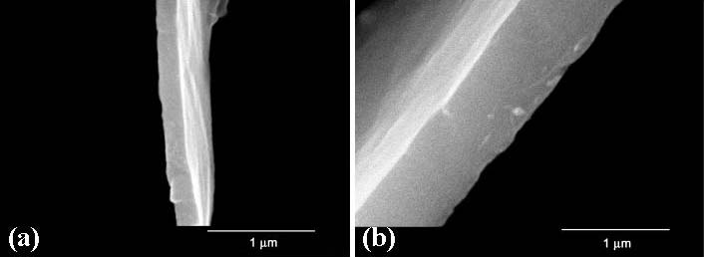
Fig. S1 SEM images of the magnified edge part of the as-synthesized PMO film grown at air-water interface at 95 ºC for (a) 30 min and (b) 24 h (KEVEX Sigma microscope, operated at 20 kV).

Fig. S2 Nitrogen adsorption-desorption isotherms for surfactant-extracted PMO film (Micromeritics Instrument Corp., ASAP 2010). Inset shows the pore size distribution obtained using desorption branch by BJH method.

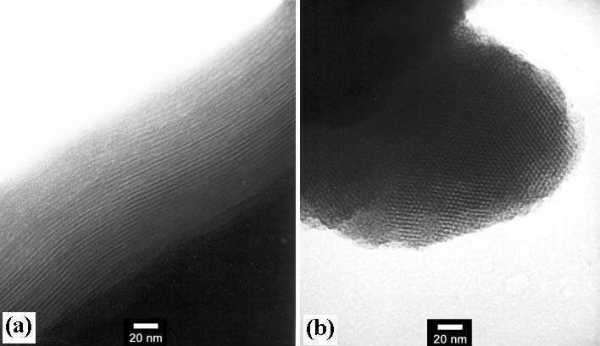
Fig. S3 TEM images of PMO film calcined at 400 ºC for 2 h in N₂ (JEOL JEM-2010 microscope, operated at 200 kV), showing (a) a highly ordered periodic structure consistent with a hexagonal close-packed arrangement of channels running parallel to the surface of the PMO film, and (b) hexagonal basal plane with a well-ordered hexagonal array.

Fig. S4 (a) ²⁹Si MAS NMR spectrum and (b) ¹³C cross-polarization (CP) MAS NMR spectrum of surfactant-extracted PMO film. The spectra were obtained on a Bruker DSX400 spectrometer at room temperature with a 4 mm zirconia rotor spinning at 6 kHz (Resonance frequencies of 79.5 MHz and 100.6 MHz for ²⁹Si and ¹³C CP MAS NMR, respectively; 90º pulse width of 5 μs, contact time 2 ms, recycle delay 3 s for both ²⁹Si and ¹³C CP MAS NMR)
Table S1. The relative yields of the bulk product PMO and the PMO film as a function of reaction times.

Yield  Reaction time | Total Yield  (mol %) | Relative Yields (mol %)
Yield  Reaction time | Total Yield  (mol %) | Bulk product PMO* | PMO film
30 min | 34.6 | 98.8 | 1.2
8 h | 59.5 | 97.9 | 2.1
24 h | 70.0 | 97.3 | 2.7
* The bulk product PMO precipitated on the bottom of the PP bottle during the PMO synthesis.

