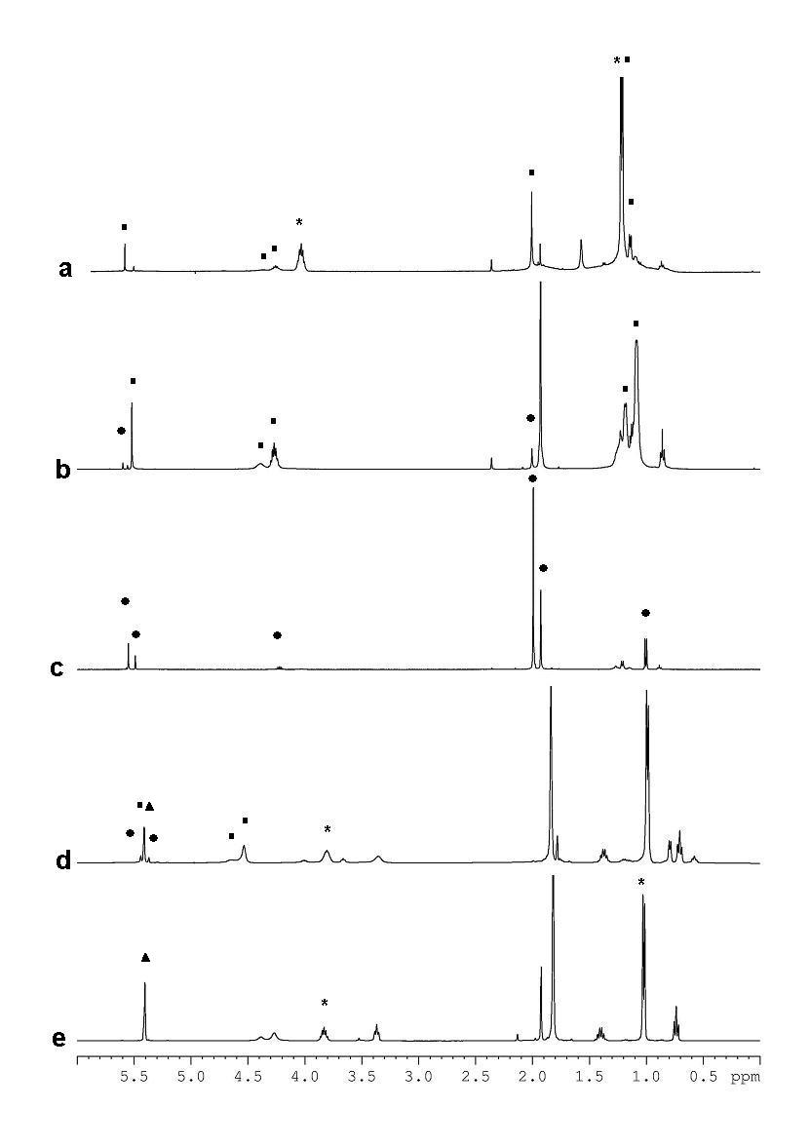
The proton NMR spectra (a) and (b) are zirconium isopropoxide with 0.5 and 1 mol equivalent of acetylacetone. Spectra (c) was obtained from Zr(O^{i}Pr)(acac)₃ crystals. Mixed ligand precursor after 15 minutes (d) and 16 hours (e) after addition of 2 mol equivalent mol acetylacetone.
The signals corresponding to Zr(O^{i}Pr)₃(acac) are marked with (), to Zr(O^{i}Pr)(acac)₃ – with (), and to Zr(O^{i}Pr)₃(^{i}PrOH) – with (), Zr(acac)₄ – with ().

