Proton transfer and N⁽⁺⁾–H⋅⋅⋅S^{(–)} hydrogen bonds in the crystal structure of 4-aminothiophenol
Ram K. R. Jetti,ª Roland Boese,ª* Tejender S. Thakur,^{b} Venu R. Vangala,^{b} and Gautam R. Desiraju^{b}*
ªInstitut für Anorganische Chemie, Universität Duisburg-Essen, Universitätsstrasse 5−7, 45177 Essen, Germany.
^{b}School of Chemistry, University of Hyderabad, Hyderabad 500 046, India,
Email: desiraju@uohyd.ernet.in

Supplementary Material (ESI)

(16 pages)

(i) ORTEP plot drawn at 50 % probability level for non−H atoms.

(ii) Difference Fourier map for the H-atom positions around the N-atom.

(iii) Pertinent intermolecular interactions for compound 1.

(iv) A CSD search on N−H⋅⋅⋅S interactions.

(v) Computational details.

(vi) Structure refinement parameters.

(vii) Computation related references.

(viii) IR spectra recorded at variable temperatures.

(i) ORTEP plot of compound 1 drawn at 50% probability level for non−H atoms.

(ii) Difference Fourier map for the H-atom positions around the N-atom.
Given below is the difference Fourier for the H-atom positions calculated only in the plane of idealised and normalised (1.009 Ǻ) H-atoms at the nitrogen. The contour spacing is 0.05 e Å^{–3}. The maximum contour line is 0.35 e Å^{–3}.

(iii) Table 1. Pertinent intermolecular interactions for compound 1.

Compound | Interaction | d (Å) | D (Å) | θ °
1 | N−H⋅⋅⋅S | 2.2175(5) | 3.1913(13) | 161.72(8)
 | N−H⋅⋅⋅S | 2.2256(5) | 3.2032(13) | 162.75(8)
 | N−H⋅⋅⋅S | 2.1362(7) | 3.1428(17) | 175.24(8)

(iv) A CSD search on N−H⋅⋅⋅S interactions.

A search of the CSD (Version 5.25, November 2003) for error free N−H⋅⋅⋅S organic, non polymeric structures with R<0.10 were carried out. ‘No co-ordinates present’ structures were excluded from the search. Of the 1932 hits with N−H⋅⋅⋅S (neutral and ionic) interactions in the subset, 59 hits with the N⁽⁺⁾−H⋅⋅⋅S⁽⁻⁾ [distance (D) and angle (θ) range: 2.8−4.3 Å, 120−180°] were found.
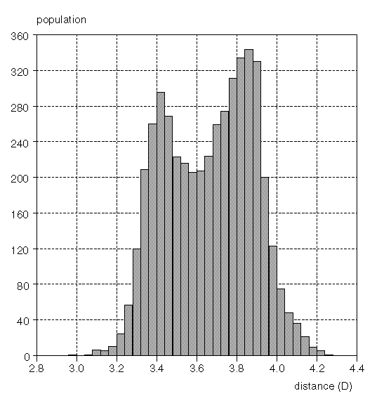  a | 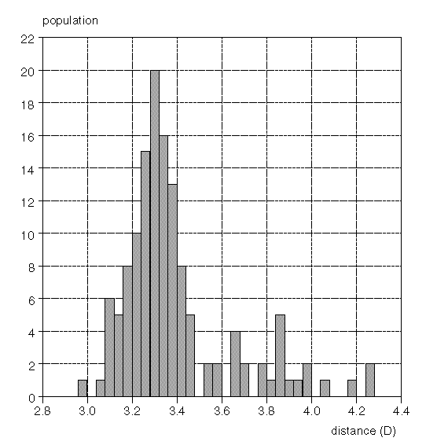  b
Fig. 1 Histogram of (a) N⋅⋅⋅S distance (D) plot for both neutral and ionic N−H⋅⋅⋅S interactions and (b) N⁽⁺⁾⋅⋅⋅S⁽⁻⁾ distance (D) plot for only ionic interactions.

Refcodes for aromatic amine thiolates.
CETPAS, GETQEB, HOXYOI, HUZHEP, POXKIW, POXKOC, PUJDUT, REGPIC, WADQUO, WIRPIW, ZIKSIV.

(V) Computational details.

Table 2. Spartan¹ RHF/6-31G** computations for the S−H⋅⋅⋅N interaction.
S.No. | Complex | ΔE  (kcal mol⁻¹) | d (Å) | D (Å) | θ °
1 | HSH⋅⋅⋅NH₃ | −3.532 | 2.30 | 3.633 | 178.5
2 | HSH⋅⋅⋅NH₂CH₃ | −3.475 | 2.30 | 3.636 | 177.0
3 | HSH⋅⋅⋅NH(CH₃)₂ | −3.218 | 2.30 | 3.633 | 180.0
4 | HSH⋅⋅⋅N(CH₃)₃ | −3.105 | 2.31 | 3.639 | 176.0
5 | HSH⋅⋅⋅NH₂C₆H₅ | −2.594 | 2.43 | 3.764 | 179.3
6 | CH₃SH⋅⋅⋅NH₂CH₃ | −2.666 | 2.39 | 3.716 | 178.4
7 | CH₃SH⋅⋅⋅NH(CH₃)₂ | −2.245 | 2.23 | 3.560 | 179.0
8 | CH₃SH⋅⋅⋅N(CH₃)₃ | −2.366 | 2.40 | 3.726 | 177.3
9 | CH₃SH⋅⋅⋅NH₂C₆H₅ | −2.227 | 2.59 | 3.895 | 166.5
10 | NH₂C₆H₄SH⋅⋅⋅NH₃ | −2.667 | 2.39 | 3.637 | 155.2
11 | NH₂C₆H₄SH⋅⋅⋅NH₂CH₃ | −2.572 | 2.35 | 3.680 | 173.9
12 | NH₂C₆H₄SH⋅⋅⋅NH(CH₃)₂ | −2.461 | 2.37 | 3.694 | 174.5
13 | NH₂C₆H₄SH⋅⋅⋅NH(CH₃)₃ | −2.494 | 2.38 | 3.701 | 170.4
14 | NH₂C₆H₄SH⋅⋅⋅ NH₂C₆H₅ | −1.603 | 2.55 | 3.848 | 164.4

Table 3. GAMESS−02² RHF/6-311G** level calculations on the IBM-AIX 32 processor machine.

S.No. | Complex | E_{HF} (a. u.) | ΔE  kcal mol⁻¹ | d (Å) | D (Å) | θ °
1 | HS⁻⋅⋅⋅⁺NH₄ | −454.375602 | −194.8630 | 1.726 | 2.8490 | 156.45
2 | HS ⁻⋅⋅⋅⁺NH₃CH₃ | −493.920791 | −345.1748 | 1.702 | 2.9384 | 172.45
3 | HS ⁻⋅⋅⋅⁺NH₂(CH₃)₂ | −532.961667 | −113.1820 | 1.844 | 2.9699 | 174.36
4 | HS ⁻⋅⋅⋅⁺NH (CH₃)₃ | −572.002205 | −108.6301 | 1.899 | 2.9151 | 176.33
5 | CH₃S ⁻⋅⋅⋅⁺NH (CH₃)₃ | −611.030973 | −109.6422 | 1.671 | 2.9093 | 172.91
6 | HS ⁻⋅⋅⋅⁺NH₃C₆H₅ | −684.463195 | −111.0391 | 1.746 | 2.9025 | 157.60
7 | C₆H₅S ⁻⋅⋅⋅⁺NH₃C₆H₅ | −914.046990 | −102.8249 | 1.671 | 2.9302 | 168.24
8 | NH₂C₆H₄S⁻⋅⋅⋅⁺NH₃C₆H₄SH | −1366.628377 | −107.7434 | 1.662 | 2.9346 | 168.76
9 | HSH⋅⋅⋅NH₃ | −454.919126 | −3.4989; −2.84# | 2.374 | 3.7095 | 176.38
10 | HSH⋅⋅⋅NH₂CH₃ | −493.951284 | −3.4826; −2.67# | 2.383 | 3.7198 | 179.59
11 | HSH⋅⋅⋅NH(CH₃)₂ | −532.986793 | −3.2888; −2.45# | 2.387 | 3.7211 | 175.06
12 | HSH⋅⋅⋅N(CH₃)₃ | −572.023759 | −3.0566; −2.24# | 2.389 | 3.7238 | 175.77
13 | CH₃SH⋅⋅⋅N(CH₃)₃ | −611.061897 | −3.8887; −1.55# | 2.478 | 3.8099 | 176.48
14 | HSH⋅⋅⋅NH₂C₆H₅ | −684.507949 | −2.4862 | 2.501 | 3.8331 | 133.41
15 | C₆H₅S H⋅⋅⋅NH₂C₆H₅ | −914.092488 | −2.5460 | 2.652 | 3.8771 | 152.09
16 | NH₂C₆H₄SH⋅⋅⋅NH₂C₆H₄SH | −1366.677061 | −2.7002 | 2.979 | 3.8850 | 151.99
# BSSE corrected interaction energies calculated at 6-31G** level.

Table 4. Infrared spectra of 4-aminothiophenol at room temperature vs simulated spectra performed on Gaussian−03³ at RHF/6-31++G(d, p) level of theory.

S.No. | Mode of vibration | Experimental | Simulated spectra at RHF/6−31++G(d, p)
 |  |  | Neutral monomer | Zwitterionic  monomer | Zwitterionic dimer
1 | N−H asymmetric stretch | 3430 | 3918.4 | 3747.7 | 3756, 3749
2 | N−H symmetric stretch | 3371 | 3809.3 | 3708.5 | 3689, 3681
3 | N−H stretch | 3211 | − | − | 3292
4 | C−H aromatic stretch | 3026 | 3340.5 | 3305.6 | 3423-3324
5 | S−H stretch | 2553 | 2863 | − | −
6 | N−H bend(scissoring) | 1886 | 1816.3 | 1809 | 1805-1782
7 | NH₃⁺ bending (deformation) | 1598 | − | 1628.4 | 1670,1624
8 | C=C aromatic stretch | 1626, 1499,  1423 | 1757, 1664, 1573 | 1733, 1616,  1562 | 1748-1729, 1617-1553, 1313-1311
9 | C−N stretch | 1289 | 1392.8 | 1238 | 1245,1228
10 | C−H in plane bending | 1178, 1089 | 1202, 1296.4 | 1215, 1287.5 | 1279
11 | C−H out of plane bending | 830 | 920 | 886 | 887
12 | C−S stretch | 696 | 770 | 677 | 738
13 | N−H out of plane bending (wagging) | 636 | 433 | − | −
14 | C=C out of plane bending | 522 | 464 | 455 | 509-452

Table 5. Corresponding coordinates for calculation² of the energy of the N⁽⁺⁾−H⋅⋅⋅S⁽⁻⁾ interaction (See Table 1 in the main paper).

complex | X⁽⁺⁾−H⋅⋅⋅A⁽⁻⁻⁾ at θ = 157.6° | X⁽⁺⁾−H⋅⋅⋅A⁽⁻⁻⁾ at θ ~ 90°
HS ⁻⋅⋅⋅⁺NH₃C₆H₅ | N 3.600614 0.258273 3.349317  S 1.151276 -1.277719 3.091997  H 0.093259 -0.545145 2.725532  H 2.511241 -0.183507 3.057793  H 3.949030 -0.521328 3.880713  H 3.434481 1.005042 3.994803  C 4.548599 0.644957 2.327553  C 5.566283 1.521848 2.678976  C 6.516605 1.879801 1.741832  C 6.446577 1.349196 0.464412  C 5.434112 0.468430 0.123967  C 4.469060 0.107494 1.051846  H 5.608418 1.901341 3.684315  H 7.306001 2.564515 1.975640  H 7.166550 1.634119 -0.273962  H 5.406245 0.079115 -0.876073  H 3.686907 -0.570376 0.788957 | C 4.702568 0.209781 0.744631  C 4.574470 0.669802 2.060673  C 5.556802 1.502509 2.609874  C 6.667233 1.875195 1.843031  C 6.795331 1.415175 0.526989  C 5.812999 0.582468 -0.022212  N 3.432315 0.286467 2.849426  S 0.969099 -0.787790 3.946364  H -0.068012 -1.231952 4.443856  H 2.482138 0.296546 2.359193  H 3.381633 -0.698292 3.179520  H 3.203996 0.763363 3.688847  H 5.457160 1.860338 3.633568  H 7.431345 2.522922 2.270230  H 7.659085 1.705071 -0.069506  H 5.912641 0.224638 -1.045906  H 3.938456 -0.437946 0.317431

complex | X⁽⁺⁾−H⋅⋅⋅A⁽⁻⁻⁾ at θ = 168.2° | X⁽⁺⁾−H⋅⋅⋅A⁽⁻⁻⁾ at θ ~ 90°
C₆H₅S ⁻⋅⋅⋅⁺NH₃C₆H₅ | N 3.342102 0.194168 3.848806  S 0.971128 -1.246126 2.905376  C -0.399909 -1.583249 3.994079  H 2.296395 -0.482510 3.577392  H 3.854595 -0.290673 4.564368  H 2.984139 1.042890 4.259568  C 4.211150 0.512677 2.721973  C 5.246350 1.409957 2.915947  C 6.090231 1.728435 1.867686  C 5.887837 1.156326 0.624437  C 4.858081 0.253719 0.440137  C 4.008593 -0.076482 1.487112  H 5.378056 1.851370 3.887575  H 6.901249 2.418476 2.027740  H 6.525478 1.418471 -0.204051  H 4.704028 -0.201304 -0.526134  H 3.205158 -0.772161 1.329500  C -1.515931 -2.234011 3.454423  C -2.609089 -2.555287 4.235965  C -2.634925 -2.237204 5.585905  C -1.544433 -1.570574 6.130877  C -0.446364 -1.248887 5.343617  H -1.522562 -2.488738 2.406871  H -3.450719 -3.050330 3.785189  H -3.487234 -2.477240 6.193763  H -1.547166 -1.288475 7.163336  H 0.379194 -0.731810 5.797230 | C -1.228777 -1.448725 6.227806  C -0.976216 -1.624886 4.862090  C -1.901197 -2.305351 4.061235  C -3.078741 -2.809656 4.626091  C -3.331303 -2.633496 5.991807  C -2.406319 -1.953030 6.792665  S 0.462071 -1.008915 4.172157  N 2.948751 0.075576 3.064769  C 4.090908 0.458910 2.276017  C 5.073239 1.291618 2.825217  C 6.183669 1.664304 2.058374  C 6.311767 1.204284 0.742332  C 5.329436 0.371576 0.193131  C 4.219005 -0.001111 0.959974  H 1.998575 0.085655 2.574537  H 2.898070 -0.909183 3.394863  H 2.720433 0.552471 3.904190  H 4.973597 1.649447 3.848911  H 6.947783 2.312031 2.485573  H 7.175522 1.494180 0.145837  H 5.429078 0.013746 -0.830562  H 3.454892 -0.648838 0.532774  H -1.704740 -2.442379 2.998903  H -3.798246 -3.338962 4.003140  H -4.247263 -3.025773 6.431187  H -2.602776 -1.816003 7.854995  H -0.509272 -0.919422 6.850759

complex | X⁽⁺⁾−H⋅⋅⋅A ⁽⁻⁻⁾ at θ = 168.8° | X⁽⁺⁾−H⋅⋅⋅A⁽⁻⁻⁾ at θ ~ 90°
NH₂C₆H₄S⁻⋅⋅⋅⁺NH₃C₆H₄SH | N 2.984795 0.729827 3.745493  S 0.959789 -1.188725 2.834162  C -0.398401 -1.593262 3.921758  H 2.471924 1.592564 3.774310  H 2.063925 -0.129172 3.483152  H 3.332946 0.540485 4.667967  C 4.060162 0.782960 2.776378  C 5.199785 1.530514 3.019570  C 6.198300 1.602664 2.064534  C 6.071279 0.925289 0.856803  C 4.944713 0.153874 0.630843  C 3.944364 0.086209 1.584909  H 5.312791 2.064474 3.944830  H 7.081676 2.190057 2.266118  S 7.389981 1.061340 -0.328817  H 4.839158 -0.405931 -0.271873  H 3.071998 -0.520612 1.398840  C -1.488921 -2.293647 3.397559  C -2.545022 -2.679703 4.194100  C -2.569715 -2.383472 5.552021  C -1.499295 -1.678024 6.081799  C -0.428711 -1.302806 5.275923  H -1.490152 -2.567188 2.358182  H -3.355475 -3.255381 3.769642  N -3.613122 -2.879562 6.356549  H -1.472074 -1.452885 7.135409  H 0.409690 -0.803156 5.733888  H -3.676325 -2.443938 7.249005  H -4.500667 -2.866040 5.907101  H 6.770219 0.483955 -1.350373 | N 3.295983 0.217862 2.875637  H 3.162797 0.750938 3.721369  S 0.740945 -0.709420 4.260459  C -0.705497 -1.198494 5.156998  C -0.832362 -0.961955 6.521939  C -1.966601 -1.332399 7.224706  C -3.028129 -1.957057 6.584708  C -2.908092 -2.210645 5.224619  C -1.772415 -1.834596 4.529540  H -1.712152 -2.030696 3.474434  H -3.710113 -2.705396 4.702077  N -4.174920 -2.365043 7.296730  H -5.001832 -2.333342 6.740040  H -4.315985 -1.837375 8.130965  H -2.023777 -1.130262 8.281784  H -0.029597 -0.470436 7.041167  H 3.292920 -0.750771 3.184588  H 2.403381 0.299824 2.393453  C 4.459655 0.624064 2.104625  C 4.605360 0.177531 0.807311  C 5.716623 0.563291 0.082040  C 6.677862 1.390522 0.649739  C 6.512943 1.827907 1.957176  C 5.403748 1.444702 2.685498  H 5.283968 1.788851 3.697548  H 7.248096 2.468786 2.407638  H 5.827238 0.217288 -0.927897  H 3.865594 -0.462379 0.359084  S 8.127574 1.928492 -0.220606  H 7.890529 1.307528 -1.370515

Calculation of the energy of herringbone interaction of 4-aminothiophenol with its nearest neighbours.

4-Aminothiophenol has been taken for calculating the stabilization of herringbone interactions. In the crystal structure of 1, three different herringbone interactions are present. Using the crystal geometry at these ring plane distances and corresponding ring plane angles, the herringbone energies were calculated at the RHF/6-311G (2d, 2p)³ level taking into account BSSE with the counterpoise correction.
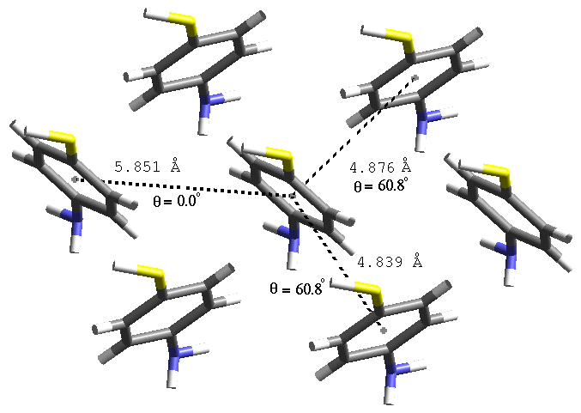
Fig. 2 Showing the three different herringbone interactions

Table 7. Herringbone energy between three different phenyl planes.

 | r (Å) | θ ° | E (a. u.) |  |  | ΔE (kcal mol⁻¹)
 |  |  | RHF | MP2 |  | RHF | MP2
monomer | − | − | −683.260152 | −684.462967 |  | − | −
dimer1 | 4.876 | 60.8 | −1366.522229 | −1368.935332 |  | −0.8776 | −5.8972
dimer2 | 5.851 | 0.0 | −1366.521431 | −1368.934861 |  | −0.3769 | −5.6016
dimer3 | 4.839 | 60.8 | −1366.522499 | −1368.981251 |  | −1.0471 | −3.3363
 |  |  |  | Total |  | −2.3016 | −14.8351

Total herringbone stabilization per molecule = 2 x −14.8351 = −29.6702 kcal mol⁻¹. Hence the estimated potential energy barrier for one proton transfer could be around 14.83 kcal mol⁻¹.

(vi) Structure Refinement Parameters: Atomic co-ordinates, Bond lengths, angles and Anisotropic displacement parameters for compound 1.

Table 1. Crystal data and structure refinement for compound 1.

Identification code 1

Empirical formula C6 H7 N S
Formula weight 125.19
Temperature 203(2) K
Wavelength 0.71073 Å
Crystal system, space group Monoclinic, Pc

Unit cell dimensions a = 7.2305(12) Å alpha = 90°
b = 5.8513(10) Å beta =107.364(3)°
c = 7.7552(13) Å gamma = 90°.

Volume 313.15(9) Å³
Z, Calculated density 2, 1.328 Mg/m³

Absorption coefficient 0.399 mm⁻¹

F(000) 132

Crystal size 0.24 x 0.18 x 0.05 mm

Theta range for data collection 3.48 to 28.31°.

Limiting indices -9<=h<=9, -7<=k<=7, -10<=l<=10

Reflections collected / unique 3386 / 1518 [R(int) = 0.0201]

Completeness to theta = 28.31 99.2 %

Absorption correction Bruker AXS SADABS program
multiscan v2.03 R.H. Blessing,
Acta Cryst. (1995) A51 33-38)

Max. and min. transmission 1.00 and 0.87

Refinement method Full-matrix least-squares on F²

Data / restraints / parameters 1518 / 2 / 86

Goodness-of-fit on F^2 1.072

Final R indices [I>2sigma(I)] R1 = 0.0277, wR2 = 0.0757

R indices (all data) R1 = 0.0283, wR2 = 0.0767

Absolute structure parameter 0.02(8)

Largest diff. peak and hole 0.237 and -0.164 e.A⁻³
Table 2. Atomic coordinates ( x 10⁴) and equivalent isotropic
displacement parameters (A² x 10³) for compound 1. U(eq) is defined
as one third of the trace of the orthogonalized Uij tensor.
______________________________________________________________
x y z U(eq)
______________________________________________________________

S(1) 8044(1) 2598(1) 8716(1) 37(1)
N(1) -591(2) 2413(2) 5232(2) 33(1)
C(1) 5529(2) 2564(2) 7645(2) 26(1)
C(2) 4341(2) 4324(2) 7939(2) 33(1)
C(3) 2354(2) 4285(2) 7125(2) 34(1)
C(4) 1518(2) 2471(2) 5996(2) 28(1)
C(5) 2662(2) 728(2) 5663(2) 33(1)
C(6) 4659(2) 784(2) 6483(2) 33(1)
______________________________________________________________

Table 3. Bond lengths [A] and angles [deg] for compound 1.
___________________________________________________________

S(1)-C(1) 1.7598(17)
N(1)-C(4) 1.462(2)
N(1)-H(1A) 1.05(3)
N(1)-H(1B) 1.00(3)
N(1)-H(1C) 0.91(3)
C(1)-C(6) 1.3977(18)
C(1)-C(2) 1.4031(19)
C(2)-C(3) 1.3860(19)
C(2)-H(2) 0.9400
C(3)-C(4) 1.3937(19)
C(3)-H(3) 0.9400
C(4)-C(5) 1.385(2)
C(5)-C(6) 1.3934(18)
C(5)-H(5) 0.9400
C(6)-H(6) 0.9400

C(4)-N(1)-H(1A) 112(2)
C(4)-N(1)-H(1B) 112.4(17)
H(1A)-N(1)-H(1B) 111(3)
C(4)-N(1)-H(1C) 105(2)
H(1A)-N(1)-H(1C) 109(3)
H(1B)-N(1)-H(1C) 108(2)
C(6)-C(1)-C(2) 118.18(15)
C(6)-C(1)-S(1) 121.06(10)
C(2)-C(1)-S(1) 120.77(11)
C(3)-C(2)-C(1) 121.01(13)
C(3)-C(2)-H(2) 119.5
C(1)-C(2)-H(2) 119.5
C(2)-C(3)-C(4) 119.67(13)
C(2)-C(3)-H(3) 120.2
C(4)-C(3)-H(3) 120.2
C(5)-C(4)-C(3) 120.45(16)
C(5)-C(4)-N(1) 121.06(12)
C(3)-C(4)-N(1) 118.44(12)
C(4)-C(5)-C(6) 119.50(13)
C(4)-C(5)-H(5) 120.2
C(6)-C(5)-H(5) 120.3
C(5)-C(6)-C(1) 121.17(12)
C(5)-C(6)-H(6) 119.4
C(1)-C(6)-H(6) 119.4
_____________________________________________________________

Symmetry transformations used to generate equivalent atoms:

Table 4. Anisotropic displacement parameters (A² x 10³) for compound 1.
The anisotropic displacement factor exponent takes the form:
-2 pi² [ h² a*² U11 + ... + 2 h k a* b* U12 ]

______________________________________________________________________
U11 U22 U33 U23 U13 U12
______________________________________________________________________

S(1) 22(1) 31(1) 51(1) -1(1) 2(1) 0(1)
N(1) 21(1) 28(1) 46(1) 1(1) 3(1) 2(1)
C(1) 21(1) 25(1) 31(1) 2(1) 6(1) 0(1)
C(2) 31(1) 26(1) 42(1) -7(1) 8(1) -1(1)
C(3) 30(1) 29(1) 44(1) -6(1) 9(1) 2(1)
C(4) 22(1) 25(1) 34(1) 2(1) 4(1) 1(1)
C(5) 29(1) 29(1) 39(1) -6(1) 5(1) -1(1)
C(6) 29(1) 27(1) 42(1) -5(1) 111(1) 2(1) _______________________________________________________________________

Table 5. Hydrogen coordinates ( x 10⁴) and isotropic displacement parameters (A² x 10³) for compound 1.

____________________________________________________________________

x y z U(eq)
____________________________________________________________________

H(1A) -1110(50) 3870(60) 4460(40) 83(9)
H(1B) -1050(40) 1000(50) 4510(30) 60(7)
H(1C) -1040(50) 2410(30) 6210(40) 58(9)
H(2) 4900 5549 8701 40
H(3) 1575 5475 7333 41
H(5) 2095 -484 4890 40
H(6) 5434 -396 6251 40
____________________________________________________________________

(vii) Computation related references.

- Spartan Pro 1.0.1, Wave Function Inc., 18401 von Karman Avenue, Suite 370, Irvine, CA 92612.
- M.W. Schmidt, K. K. Balridge, J. A. Boatz, S. T. Elbert, M. S. Gordon, J. H. Jensen, S. Koseki, N. Matsunaga, K. A. Nguyen, S. J. Su, T. L. Wndus, M. Dupuis and J. A. Montgomery, J. Comput. Chem., 1993, 14,1347.
- M. J. Frisch, G. W. Trucks, H. B. Schlegel, G. E. Scuseria, M. A. Robb, J. R. Cheeseman, J. A. Montgomery, Jr., T. Vreven, K. N. Kudin, J. C. Burant, J. M. Millam, S. S. Iyengar, J. Tomasi, V. Barone, B. Mennucci, M. Cossi, G. Scalmani, N. Rega, G. A. Petersson, H. Nakatsuji, M. Hada, M. Ehara, K. Toyota, R. Fukuda, J. Hasegawa, M. Ishida, T. Nakajima, Y. Honda, O. Kitao, H. Nakai, M. Klene, X. Li, J. E. Knox, H. P. Hratchian, J. B. Cross, C. Adamo, J. Jaramillo, R. Gomperts, R. E. Stratmann, O. Yazyev, A. J. Austin, R. Cammi, C. Pomelli, J. W. Ochterski, P. Y. Ayala, K. Morokuma, G. A. Voth, P. Salvador, J. J. Dannenberg, V. G. Zakrzewski, S. Dapprich, A. D. Daniels, M. C. Strain, O. Farkas, D. K. Malick, A. D. Rabuck, K. Raghavachari, J. B. Foresman, J. V. Ortiz, Q. Cui, A. G. Baboul, S. Clifford, J. Cioslowski, B. B. Stefanov, G. Liu, A. Liashenko, P. Piskorz, I. Komaromi, R. L. Martin, D. J. Fox, T. Keith, M. A. Al-Laham, C. Y. Peng, A. Nanayakkara, M. Challacombe, P. M. W. Gill, B. Johnson, W. Chen, M. W. Wong, C. Gonzalez, and J. A. Pople, Gaussian, Inc., Pittsburgh PA, 2003.

(viii) IR spectra recorded at variable temperatures (−63, −38, 25 and 33°C).

