Single-Walled Carbon Nanotubes Acquire a Specific Lectin-affinity through Supramolecular Wrapping with Lactose-appended Schizophyllan

Teruaki Hasegawa, Tomohisa Fujisawa, Munenori Numata, Mariko Umeda, Takahiro Matsumoto, Taro Kimura, Shiro Okumura, Kazuo Sakurai, and Seiji Shinkai*

Supporting Information

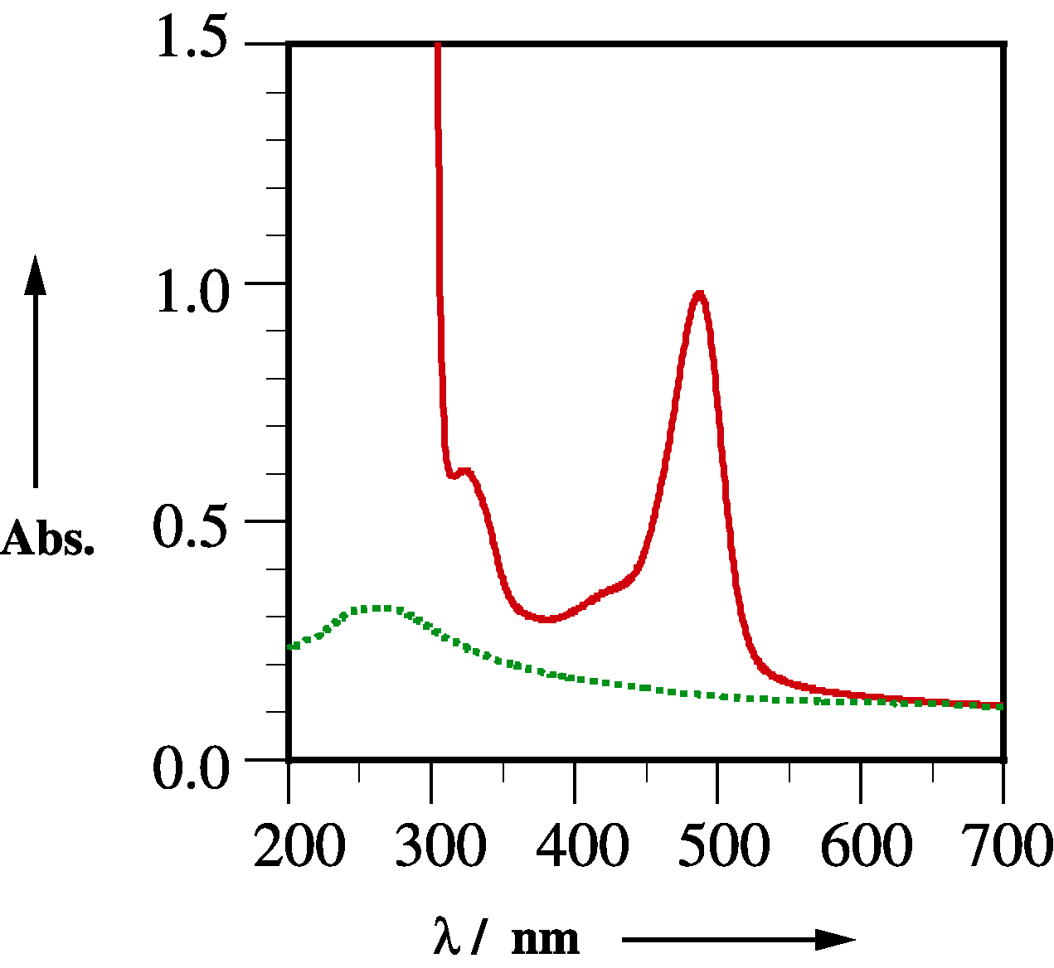

Fig. S1. UV-vis spectra of SPG-Lac/SWNTs composite in water (dotted line) and in phenol/sulfuric-acid mixture (1 : 5 v/v) (plane line): 20 °C, d = 1.0.

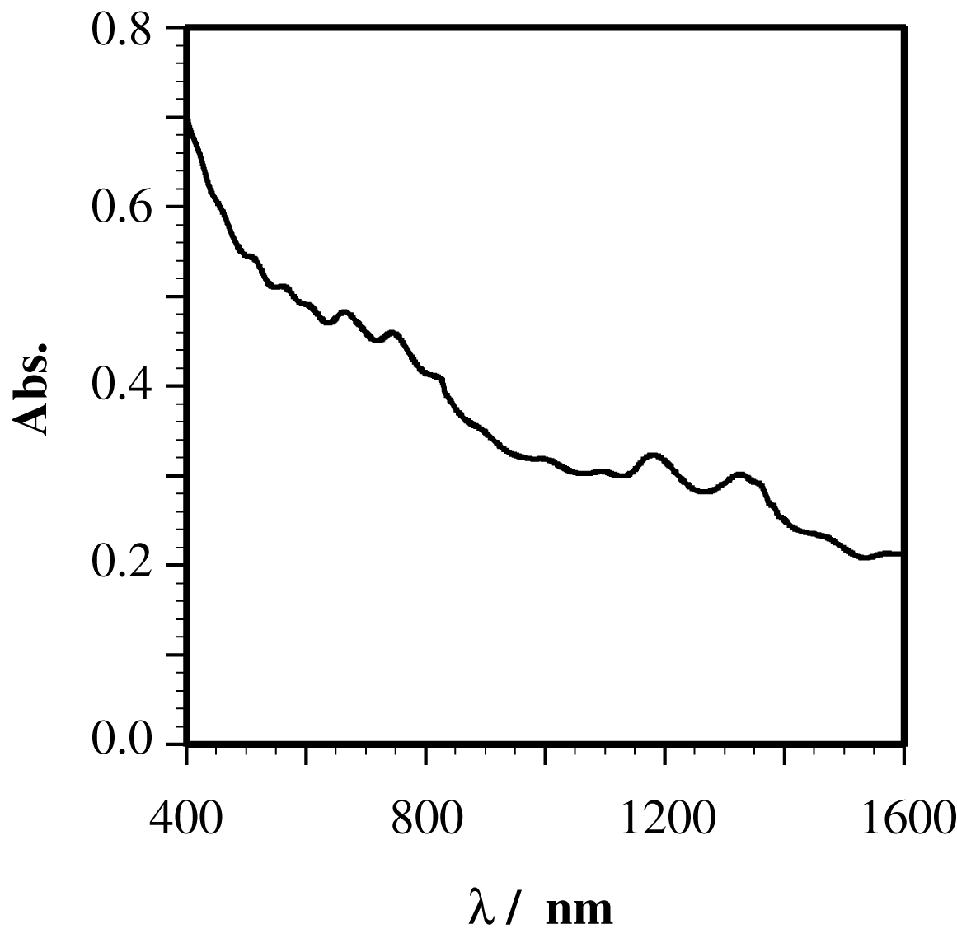
Fig. S2. NIR spectra of SPG-Lac/SWNTs composite in D₂O: 20 °C, d = 1.0.

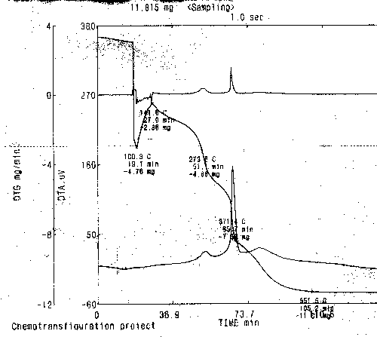

Fig. S3. TGA profile of SPG-Lac/SWNTs composites
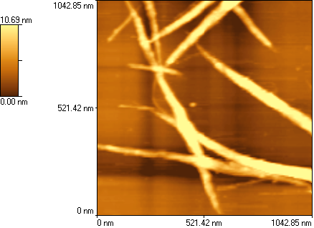

Fig. S4. AFM image of free SWNTs: on mica.

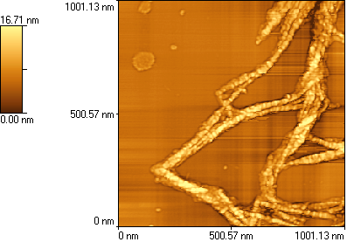

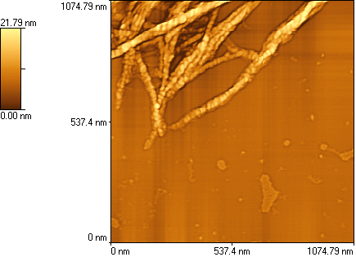

Fig. S5. AFM images of SPG-Lac/SWNTs composite incubated with (top) ConA, and (bottom) WGA: on mica.

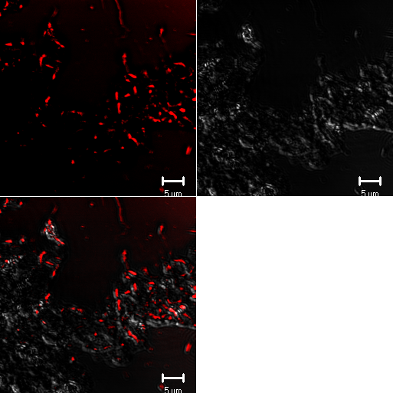

Fig. S6. CLSM images of SPG-Lac/SWNTs composite incubated with FITC-RCA₁₂₀: (top left) fluorescence and (top right) microscopic images, and (bottom left) their superimpose: on glass.
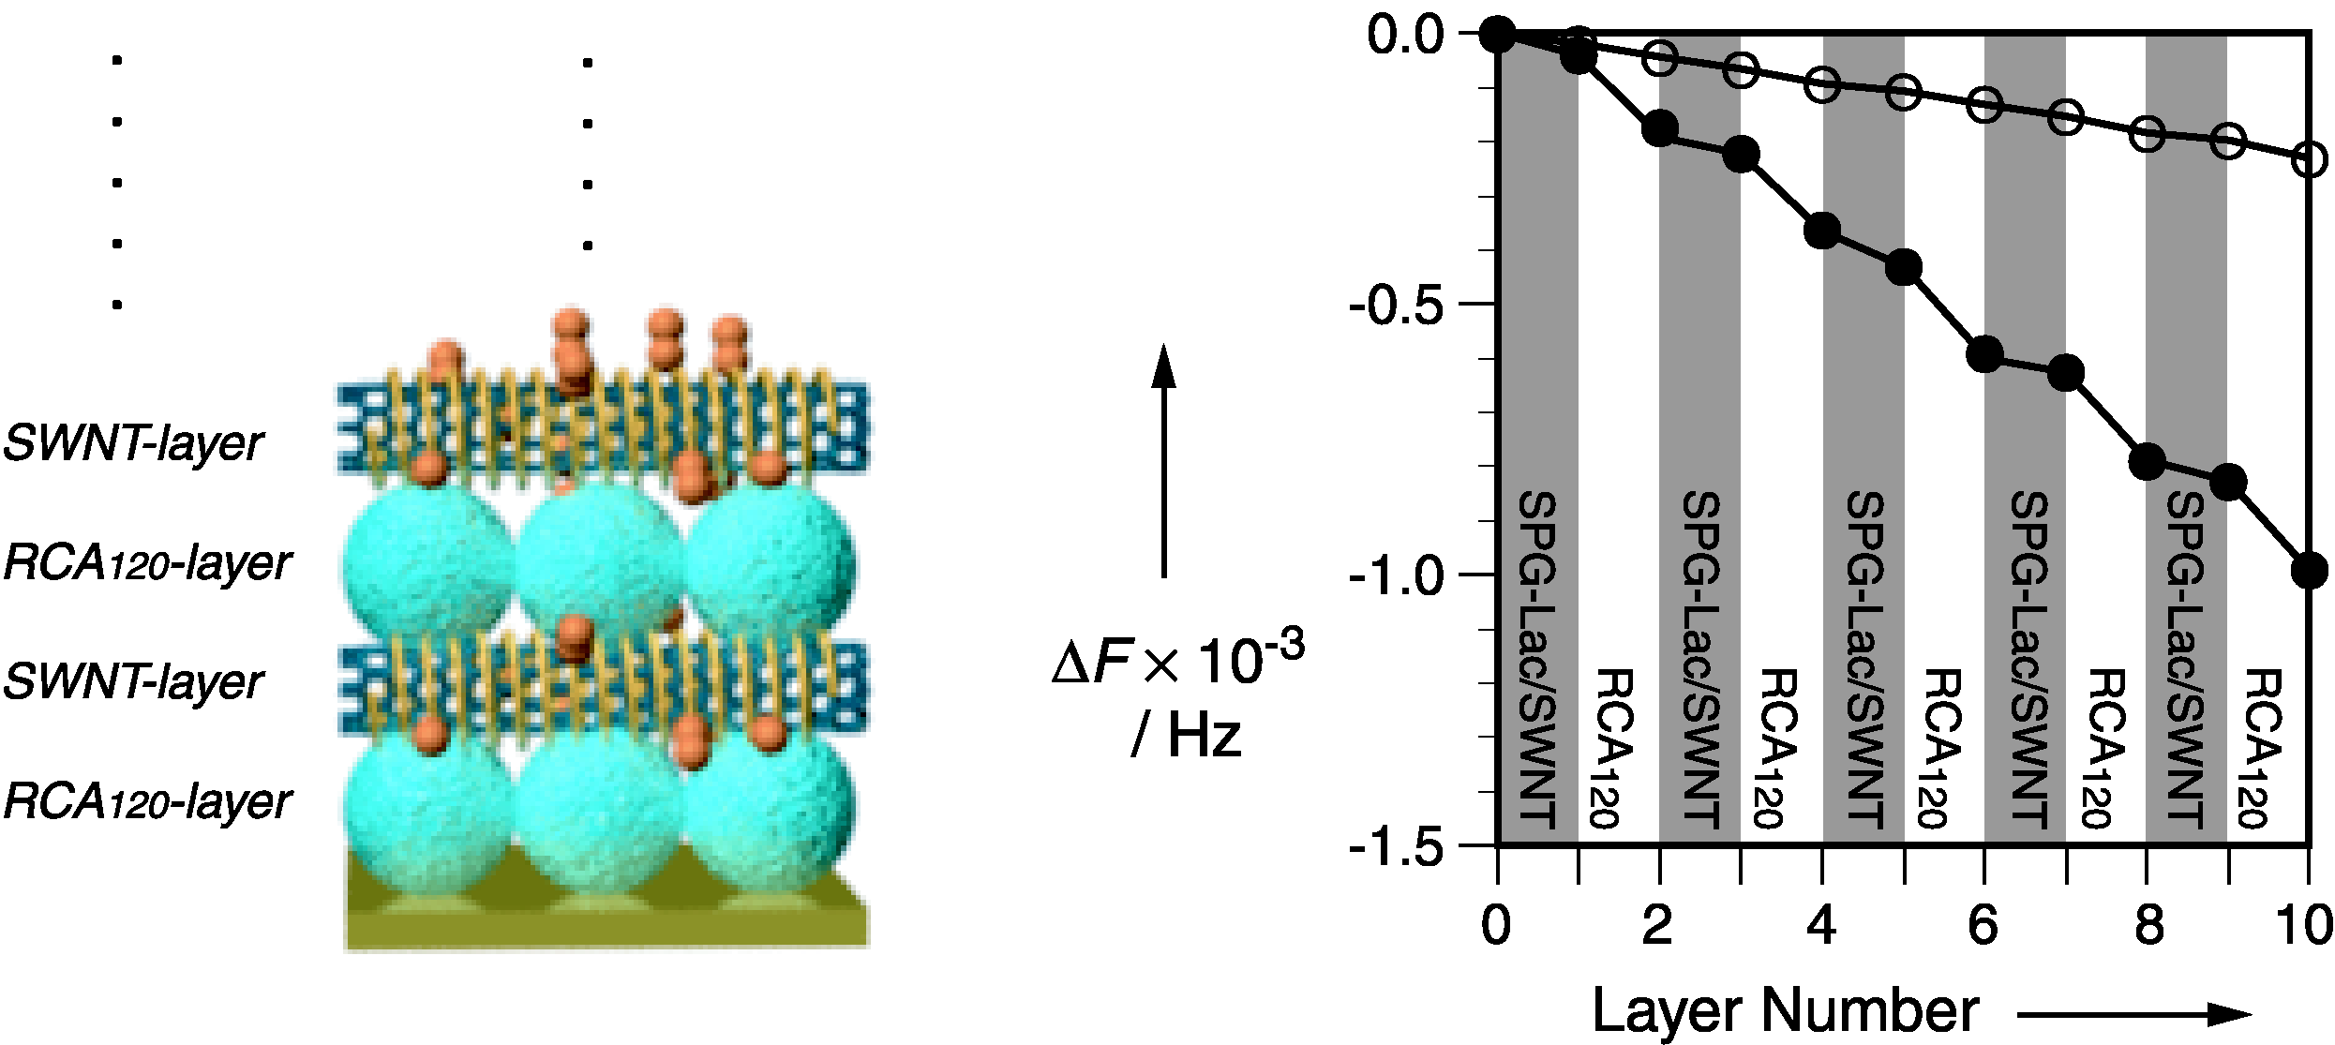

Fig. S7. Frequency changes (ΔF) of QCM upon layer-by-layer assembling of RCA₁₂₀ (0.28 mg ml⁻¹) and SPG-Lac/SWNT (filled circle) or SPG/SWNT (open circle): [SWNT] = 0.7 mg ml⁻¹, Tris-HCl buffer (pH 7.2, 1.0 mM, [CaCl₂] and [MnCl₂] = 10 mM), 25 °C.

