# Supplementary Material (ESI) for Chemical Communications
# This journal is © The Royal Society of Chemistry 2004

Electronic supporting information file (ESI)

Towards mesomorphism in tetrahedral luminescent zinc complexes

Raquel Giménez, Ana Belén Manrique, Santiago Uriel, Joaquín Barberá and José Luis Serrano.

Characterization data of the novel complexes:

L₂m: Elemental analysis (%) calcd. for C₇₁H₁₀₄N₄O₄: C, 79.13; H, 9.73; N, 5.20. Found: C, 79.17; H, 9.68; N: 5.16. MS (FAB-LSIMS): 1078 [M+1⁺]⁺. ¹H NMR (300 MHz, CDCl₃) δ = 0.89 (t, 12H), 1.29-1.49 (m, 56 H), 1.77-1.85 (m, 8H), 3.98 (t, J = 6.6 Hz, 4H), 4.02 (t, J = 6.6 Hz, 4H), 6.17 (s, 2H), 6.51 (s,2H), 6.91 (d, J = 8.8 Hz, 4H), 7.02 (d, J = 8.8 Hz, 4H), 7.73 (d, J = 8.8 Hz, 4H), 7.87 (d, J = 8.8 Hz, 4H).

L₂e: Elemental analysis (%) calcd. for C₇₂H₁₀₆N₄O₄: C, 79.22; H, 9.79; N, 5.13. Found: C, 79.22; H, 9.75; N, 5.07. MS (FAB-LSIMS): 1092 [M]⁺. ¹H NMR (300 MHz, CDCl₃) δ = 0.91 (t, 12H), 1.22-1.49 (m, 56 H), 1.67-1.81 (m, 8H), 3.69 (t, J = 6.6 Hz, 4H), 3.97 (t, J = 6.6 Hz, 4H), 4.56 (s, 4H), 6.31 (s,2H), 6.65 (d, J = 8.8 Hz, 4H), 6.86 (d, J = 8.8 Hz, 4H), 6.89 (d, J = 8.8 Hz, 4H), 7.59 (d, J = 8.8 Hz, 4H).

[ZnL₂Cl₂]: Elemental analysis (%) calcd. for C₇₀H₁₀₄Cl₂N₄O₄Zn: C, 69.95; H, 8.72; N, 4.66. Found: C, 69.87; H, 8.70; N, 4.60. MS (LSIMS): 1164 [M-Cl]⁺. ¹H NMR (300 MHz, DMSO-d6) δ = 0.86 (t, 12H), 1.20-1.42 (m, 56 H), 1.68-1.76 (m, 8H), 3.98 (t, J = 6.3 Hz, 4H), 4.00 (t, J = 6.3 Hz, 4H), 6.95 (s, 2H), 6.96 (d, J = 8.6 Hz, 4H), 7.01 (d, J = 8.6 Hz, 4H), 7.69 (d, J = 8.6 Hz, 4H), 7.75 (d, J = 8.6 Hz, 4H).

[Zn(L₂m)Cl₂]: Elemental analysis (%) calcd. for C₇₁H₁₀₄Cl₂N₄O₄Zn: C, 70.25; H, 8.64; N, 4.62. Found: C, 70.24; H, 8.65; N, 4.58. MS (LSIMS): 1175 [M-Cl]⁺. ¹H NMR (300 MHz, CDCl₃) δ = 0.85-0.90 (m, 12H), 1.25-1.49 (m, 56 H), 1.70-1.85 (m, 8H), 3.93 (t, J = 6.2 Hz, 4H), 3.94 (t, J = 6.2 Hz, 4H), 6.45 (s, 4H), 6.74 (d, J = 8.8 Hz, 4H), 6.94 (d, J = 8.8 Hz, 4H), 7.01 (d, J = 8.8 Hz, 4H), 7.73 (d, J = 8.8 Hz, 4H).

[Zn(L₂e)Cl₂]: Elemental analysis (%) calcd. for C₇₂H₁₀₆Cl₂N₄O₄Zn: C, 70.42; H, 8.70; N, 4.56. Found: C, 70.45; H, 8.76; N, 4.58. MS (Electrospray): 1250 [M+Na]⁺. ¹H NMR (300 MHz, CDCl₃) δ = 0.86-0.90 (m, 12H), 1.28-1.44 (m, 56 H), 1.75-1.85 (m, 8H), 3.86 (t, J = 6.3 Hz, 4H), 3.96 (t, J = 6.3 Hz, 4H), 4.69 (s, 4H), 6.35 (s, 2H), 6.84 (d, J = 8.6 Hz, 4H), 6.91 (d, J = 8.6 Hz, 4H), 7.07 (d, J = 8.6 Hz, 4H), 7.67 (d, J = 8.6 Hz, 4H).

Microphotograph under polarised light of the texture displayed by compound [Zn(L₂e)Cl₂] at 152ºC (SmA).

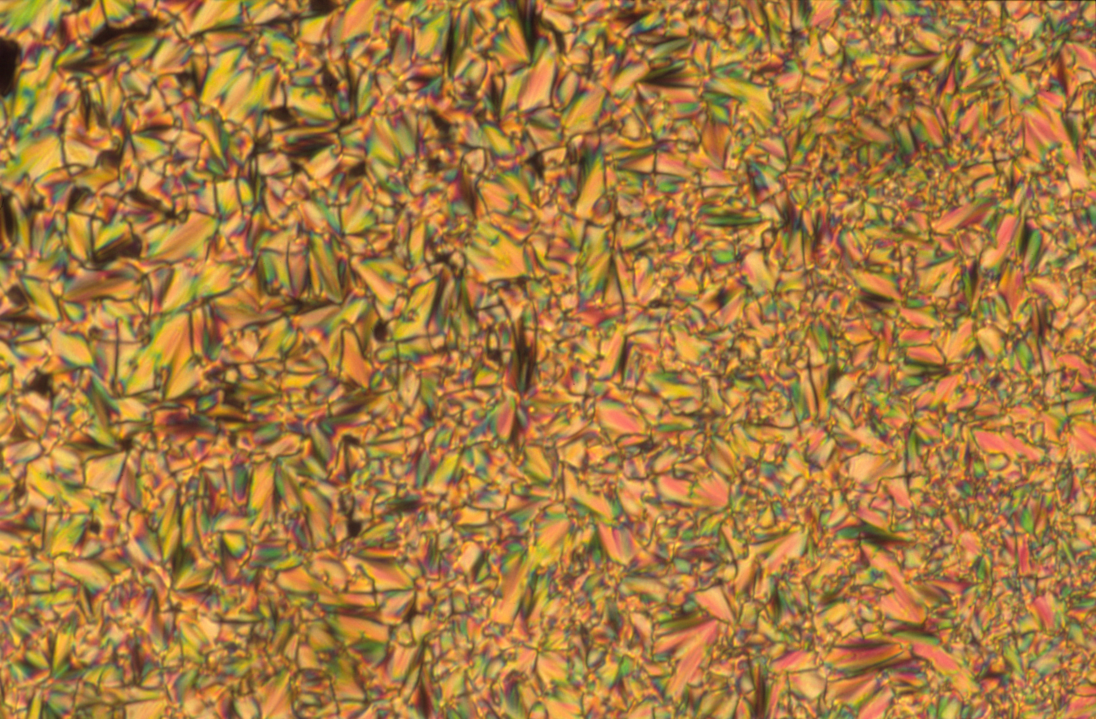

Microphotograph under polarised light of the texture displayed by compound [Zn(L₂e)Cl₂] at 132ºC (SmC).



