Electronic supplementary information (ESI)

Selective formation of siloxane-based hybrid cages with methylene groups in the frameworks
Atsushi Shimojima and Kazuyuki Kuroda

Experimental Section
Bis(triethoxysilyl)methane (1) was synthesized following the procedure reported in the literature (R. J. P. Corriu, M. Granier, G. F. Lanneau, J. Organomet. Chem., 1998, 562, 79). Hydrolysis and polycondensation of 1 were performed in the mixture of EtOH, H₂O, and TMAOH·5H₂O at the molar ratio of 1/EtOH/H₂O/TMAOH = 1:20:20:3. Also, the reactions in the aqueous solutions containing various tetraalkylammonium hydroxides (R₄NOH, R = Me, Et, Pr, and Bu) were performed at the molar ratios of 1/H₂O/R₄NOH = 1:80:3. The mixtures were stirred at 25 °C for 5 days so that the reaction almost reached equilibrium.
Liquid-state ²⁹Si NMR spectra were obtained on a JEOL Lambda-500 spectrometer with a resonance frequency of 99.25 MHz. Ethanol-d₆ or D₂O (~10% as EtOH and H₂O, respectively) were used to obtain lock signals. A small amount of Cr(acac)₃ was added for the relaxation of ²⁹Si nuclei, and a pulse width of 6.5 µs and a recycle delay of 30 s were used to obtain quantitative data. Hexamethyldisilane (–19.85 ppm) was used as an internal standard for quantitative analysis.
Trimethylsilylation was performed by the addition of 5 mL of the reaction mixture (1/EtOH/H₂O/TMAOH = 1:20:20:3) to a solution of an excess of trimethylchlorosilane (30 mL) in THF (30 mL). After stirring for 30 min, the volatile components were removed in vacuo, yielding white solids containing silylated-derivatives and TMACl. Extraction with hexane (50 mL) followed by removal of the solvent in vacuo afforded crystalline solids which are soluble in common organic solvents. Colorless crystals of 3a were finally isolated by GPC (yield: 85% based on 1).: ¹H NMR (500 MHz, CDCl₃): δ –0.12 (s, 2H), –0.09 (s, 2H), 0.07 (s, 2H), 0.13 (s, 18H; CH₃), 0.14 ppm (s, 36H; CH₃) (some signals may overlap with the large signal of methyl protons); ¹³C NMR (125.7 MHz, CDCl₃): δ –0.46, 0.58, 1.581 ppm; ²⁹Si NMR (99.3 MHz, CDCl₃): δ –64.99, –61.09, 10.10, 10.59 ppm; HRMS (FAB): m/z calcd for ¹²C₂₁¹H₆₁¹⁶O₁₂²⁸Si₁₂ ([M+H]⁺) 841.1394, found 841.1369.

3b was obtained as a viscous and colorless liquid by using dimethylvinylchlorosilane as the silylating agent in the above procedure (yield: 73% based on 1).: ¹H NMR (500 MHz, CDCl₃): δ –0.12 (s, 2H), –0.09 (s, 2H), 0.05 (s, 2H), 0.13 (s, 18H; CH₃), 0.14 ppm (s, 36H; CH₃); ¹³C NMR (125.7 MHz, CDCl₃): δ –0.46, 0.05, 0.08, 0.64, 132.21, 138.55, 138.59 ppm; ²⁹Si NMR (99.3 MHz, CDCl₃): δ –64.93, –61.01, –1.52, –1.18 ppm; HRMS (FAB): m/z calcd for ¹²C₂₇¹H₆₀¹⁶O₁₂²⁸Si₁₂ (M⁺) 912.1316, found 912.1310.

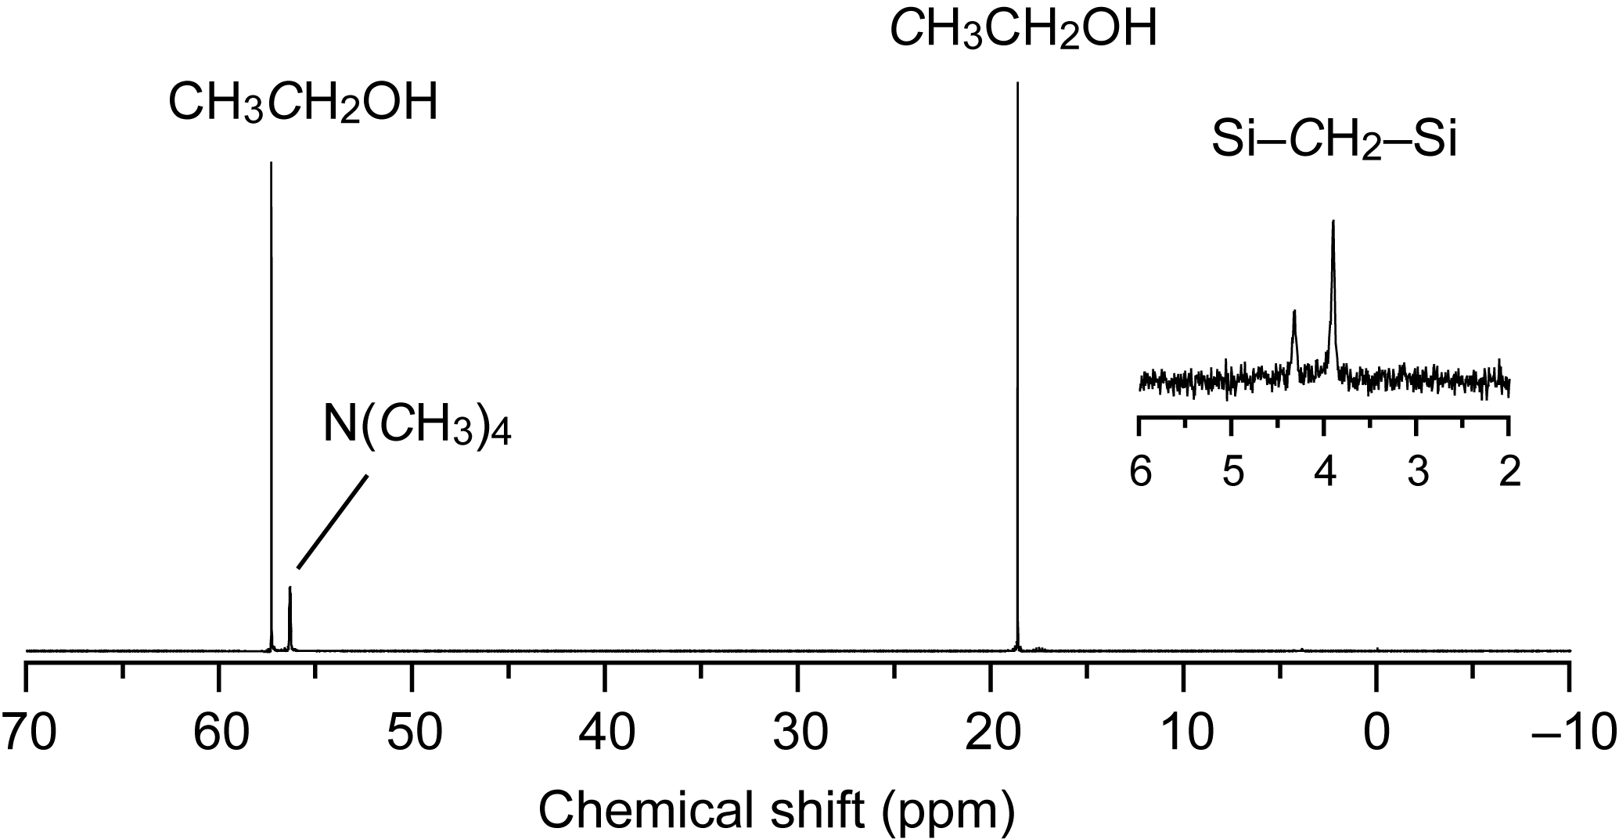

Fig. S1 Liquid-state ¹³C NMR spectrum of the solution after hydrolysis and condensation in the 1/EtOH (10% ethanol-d₆)/H₂O/TMAOH system. The spectrum was obtained on a JEOL Lambda-500 spectrometer with a resonance frequency of 125.65 MHz.

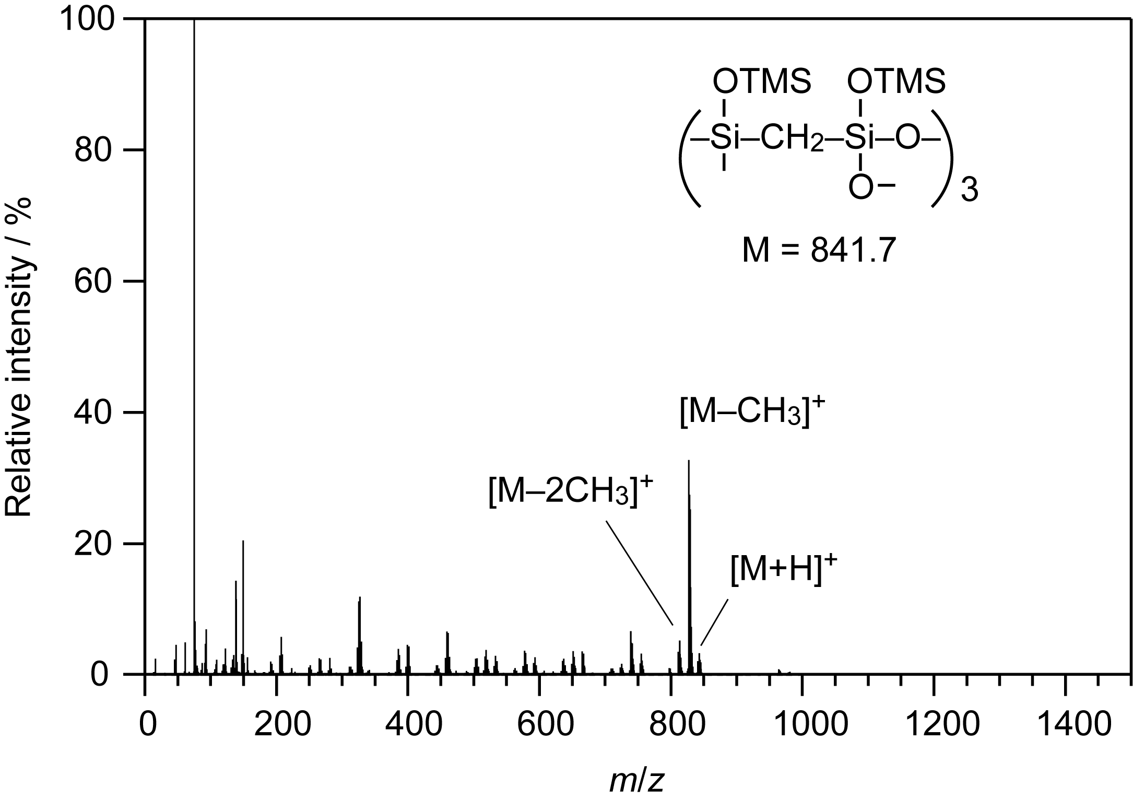

Fig. S2 Fast-atom bombardment (FAB) mass spectrum of the trimethylsilylated-derivative (3a) obtained from the 1/EtOH/H₂O/TMAOH = 1:20:20:3 system.

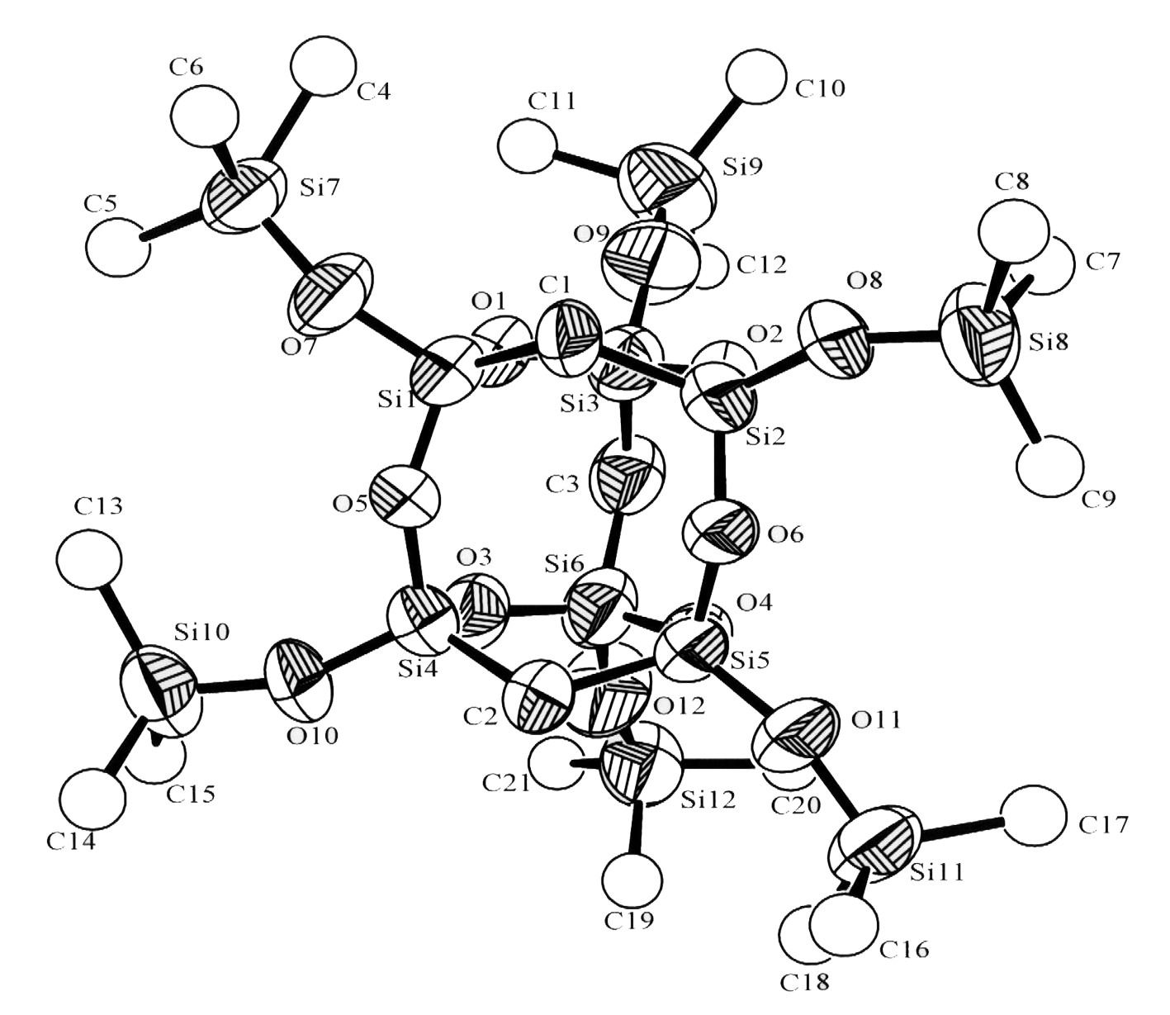

Fig. S3 ORTEP plot of 3a with 30% probability thermal ellipsoids. All hydrogen atoms and the disorder in the methyl groups are omitted for clarity, and all carbon atoms in the Si(CH₃)₃ groups (C4–C21) are displayed as spheres. Selected bond lengths (Å) and angles (°): Si1–C1 1.846(2), Si1–O1 1.614(2), Si1–O5 1.593(2), Si1–O7 1.586(2), Si3–C3 1.808(2), Si3–O1 1.638(2), Si3–O9 1.572(2), Si1–C1–Si2 109.59(9), Si3–C3–Si6 118.65(9), Si1–O5–Si4 147.7(1), Si1–O1–Si3 133.3(1).

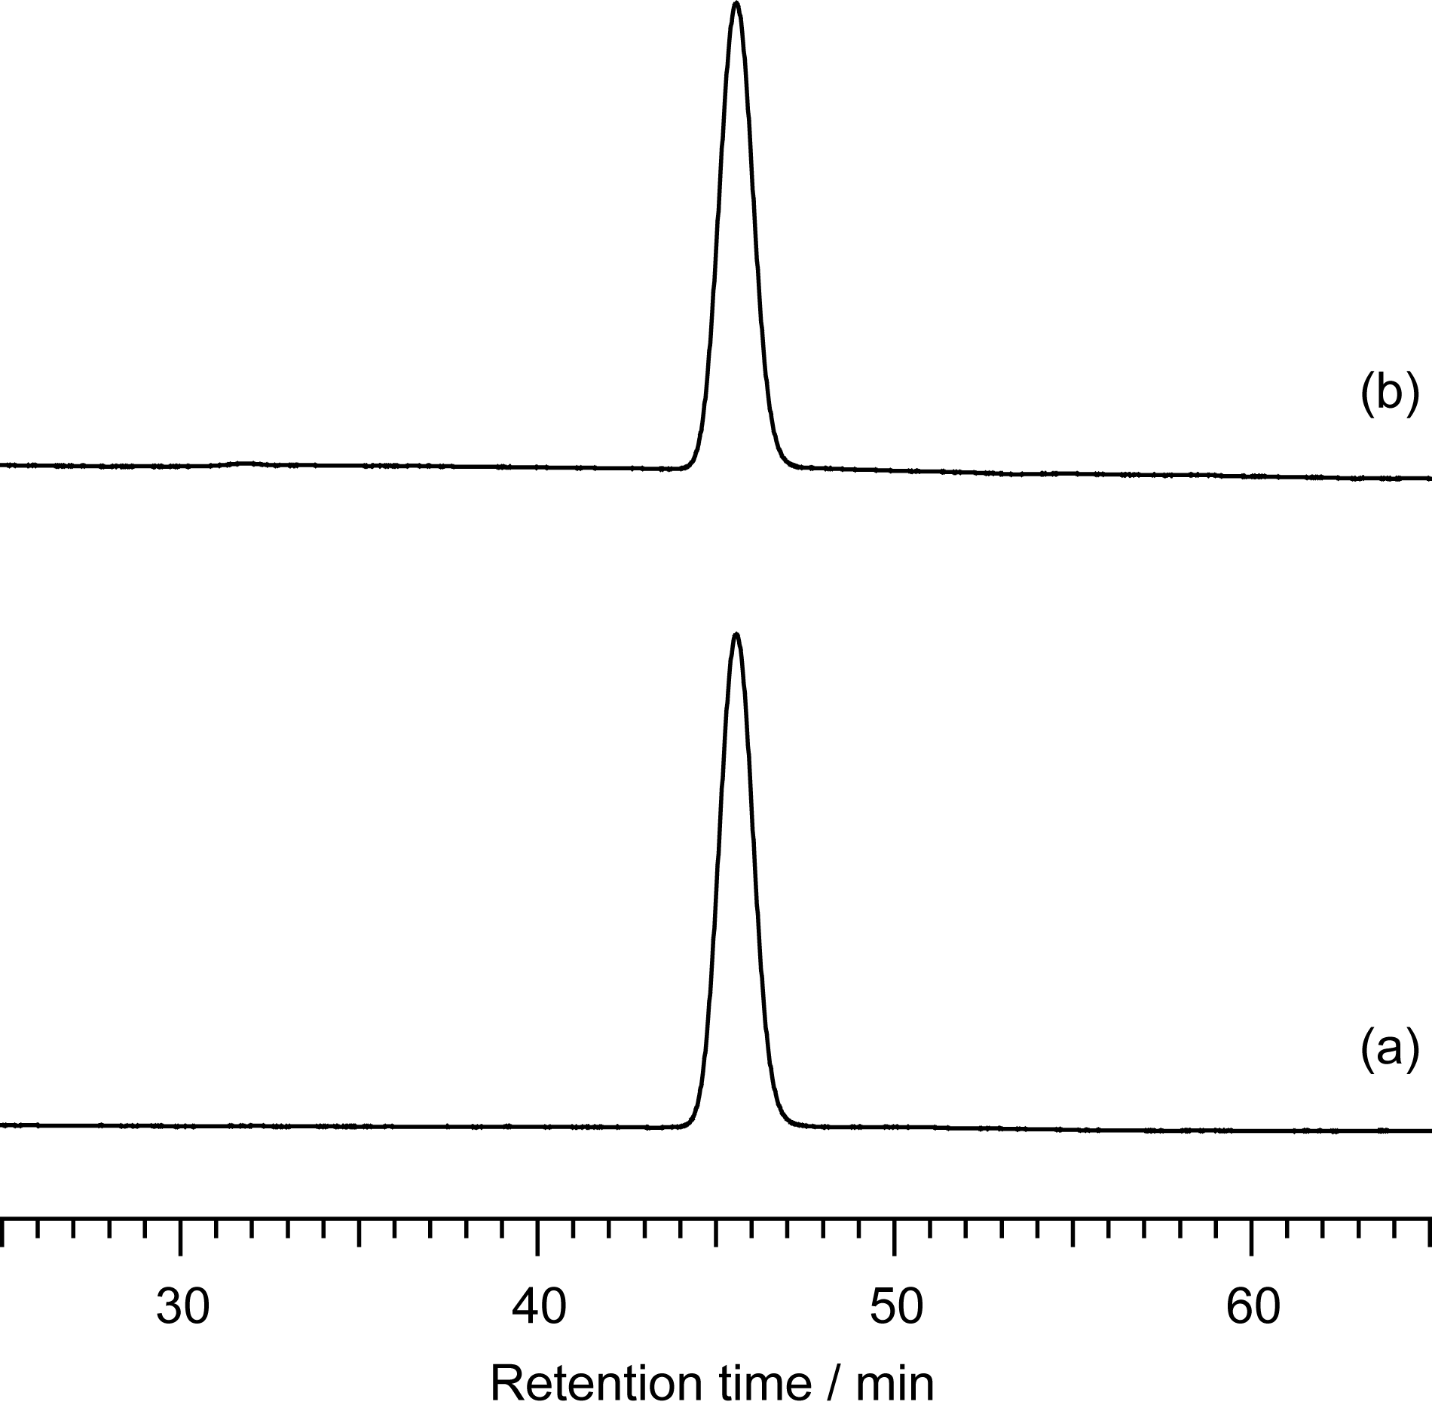

Fig. S4 GPC chromatograms of (a) 3a and (b) the trimethylsilylated-derivatives obtained from the 1/H₂O/TMAOH = 1:80:3 system. These were measured using a LC-918 HPCL system (Japan Analytical Industry Co., Ltd.), equipped with an RI detector and a JAIGEL column set (20 × 600 mm, High resolution 1H and 2H). The system was calibrated using polystyrene standards. Chloroform was used as the eluent, at a flow rate of 3.5 mL/min.

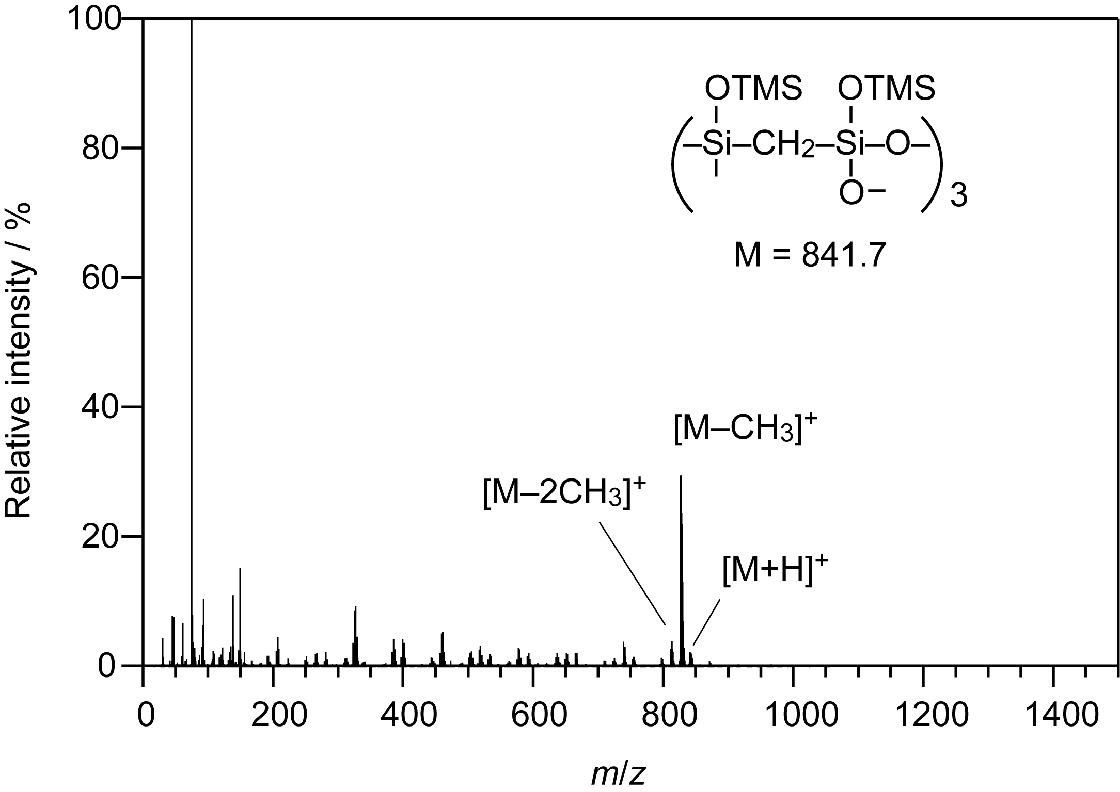

Fig. S5 FAB-MS spectrum of the trimethylsilylated-derivatives (mixture of 3a and 3b) obtained from the 1/H₂O/TMAOH = 1:80:3 system.

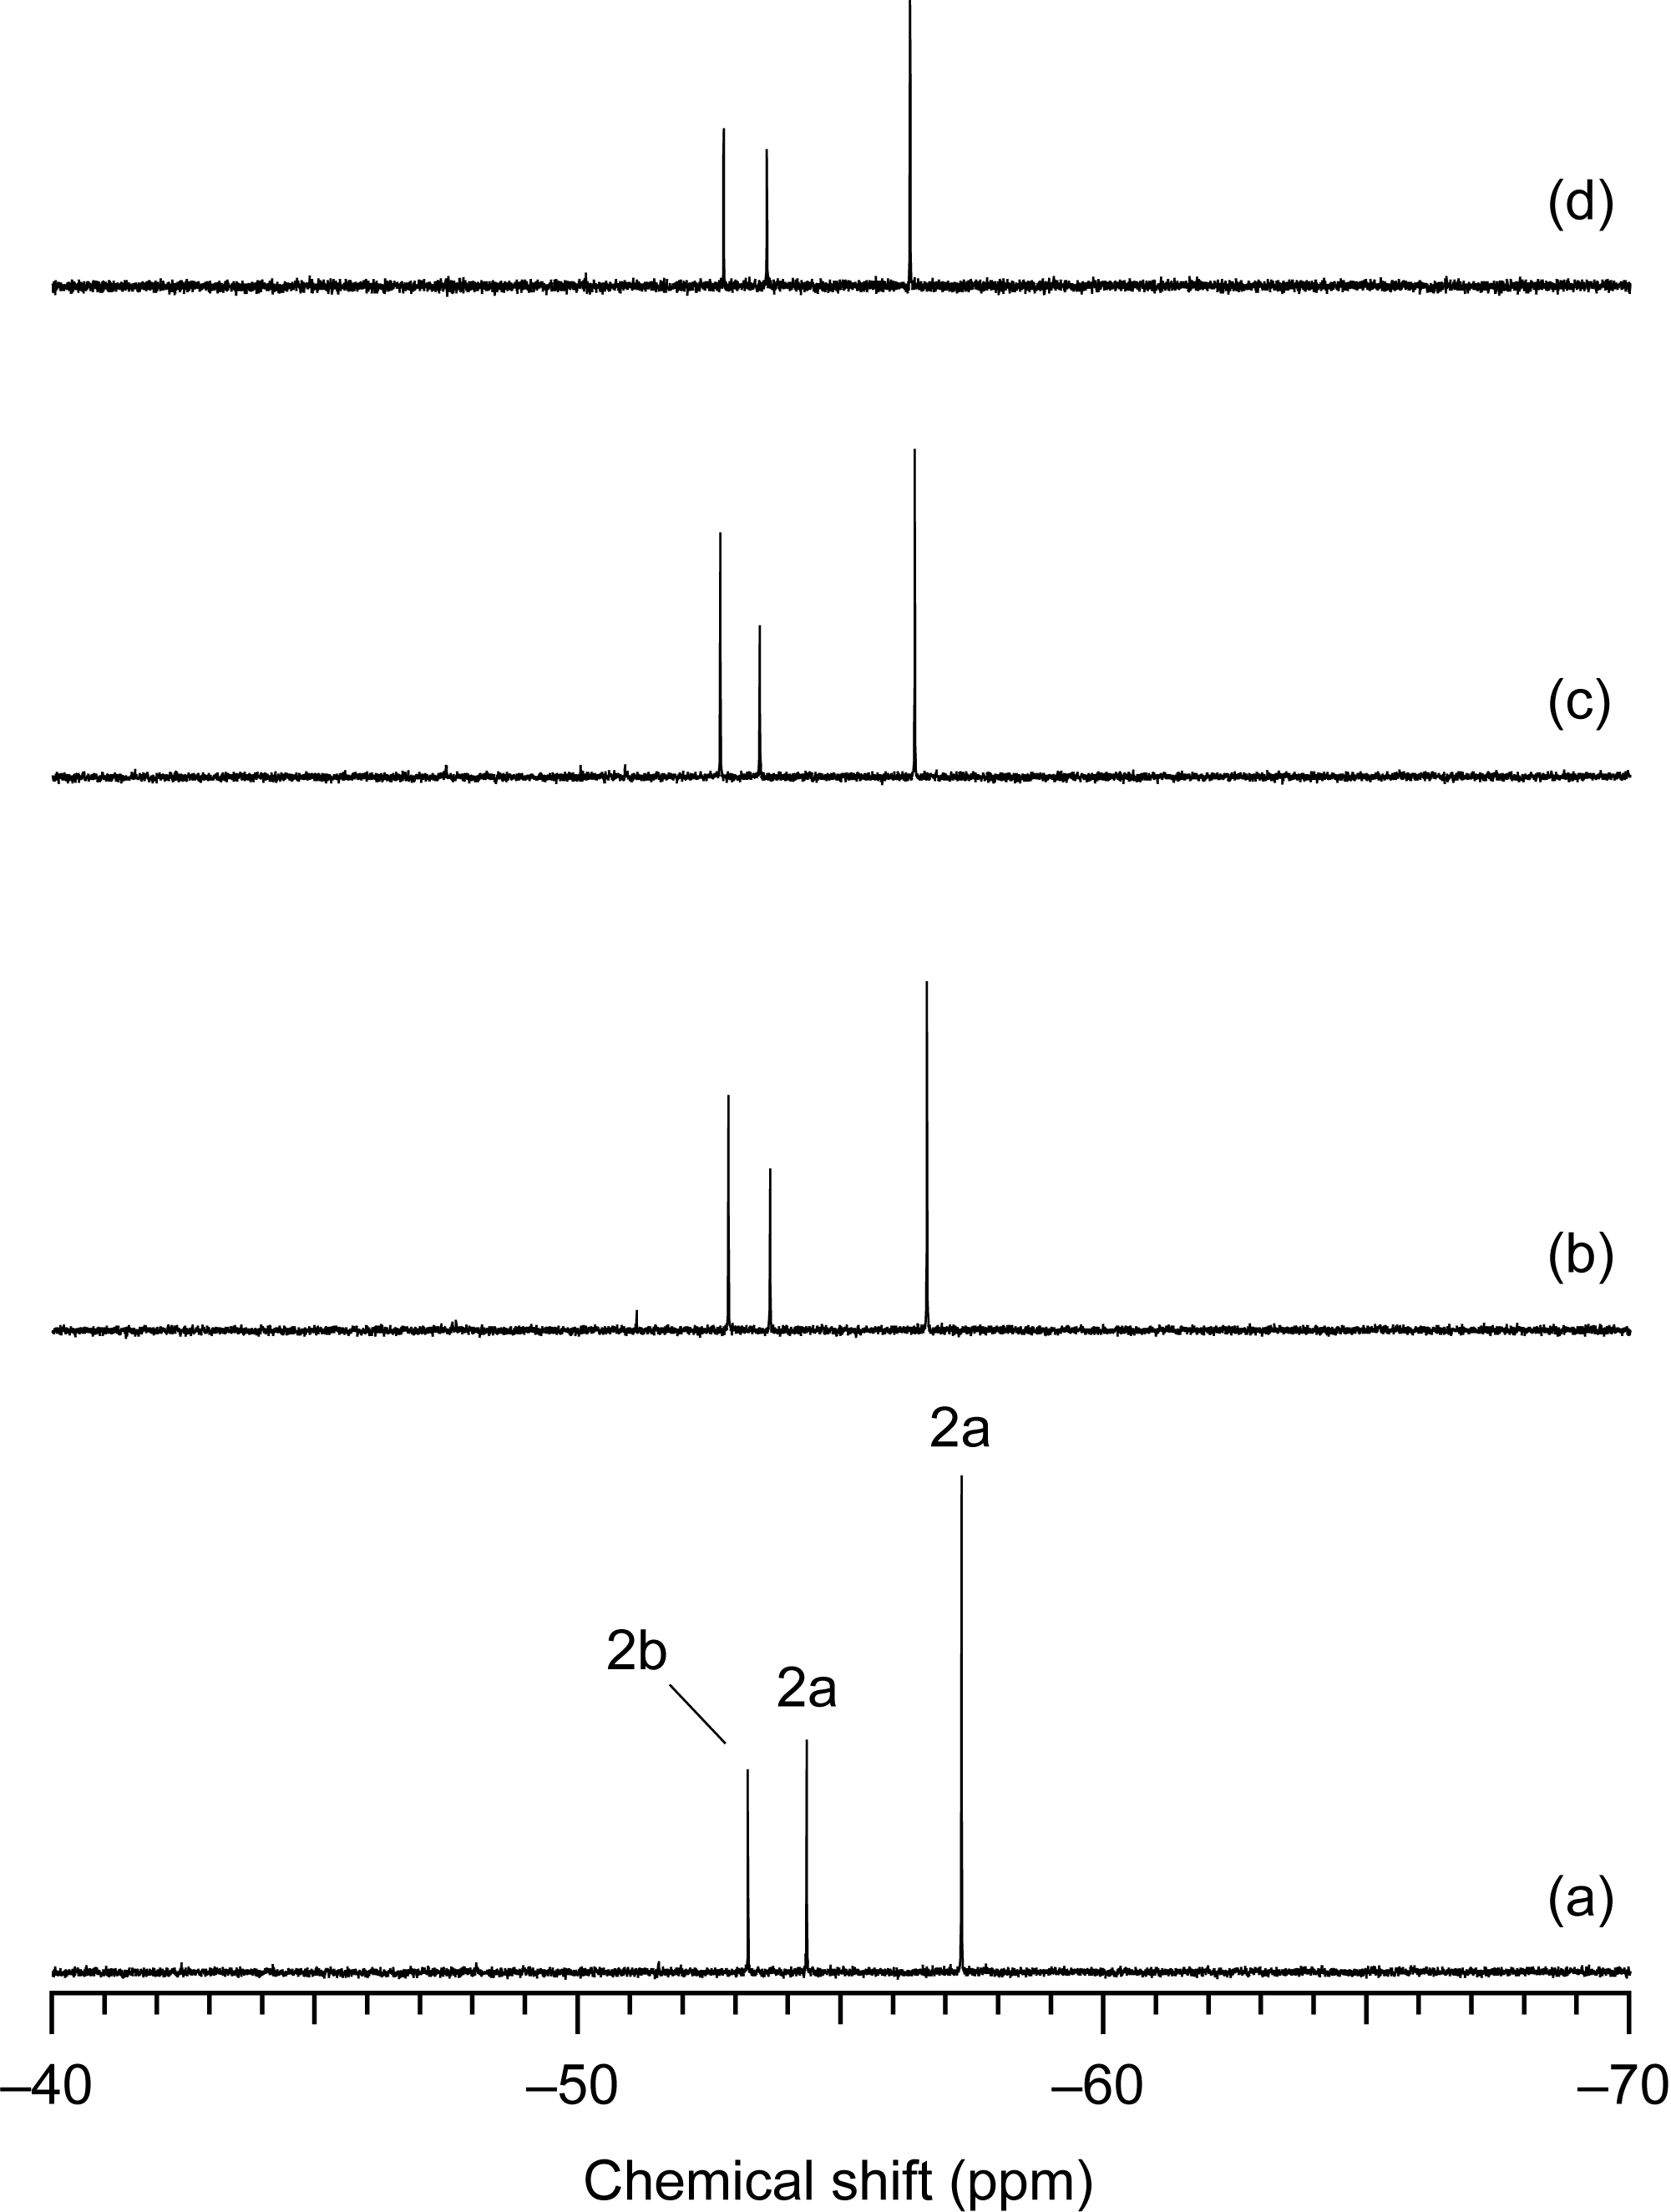

Fig. S6 Liquid-state ²⁹Si NMR spectra of the solutions after 5 days of the reactions in the 1/H₂O (10% D₂O)/R₄NOH = 1:80:3 systems; (a) R = CH₃, (b) C₂H₅, (c) C₃H₇, and (d) C₄H₉.

