Formation of helical superstructures:
supramolecuar assembly from a semi-fluorinated alkoxysilane through a surface and solution self-assembly process
Guanglei Cui, Hai Xu, Wei Xu,* Deqing Zhang, Lei Jiang*, Daoben Zhu*
Laboratory of Organic Solids, Center for Molecular Sciences, Institute of Chemistry, Chinese Academy of Sciences, Beijing 100080, P.R. China
Email: wxu@iccas.ac.cn; jianglei@iccas.ac.cn.

Experimental details:
1H,1H,2H,2H-perfluorooctyltriethoxysilane(C₆F₁₃(CH₂)₂Si(OEt)₃) (Alfa Aesar) was purchased from Johnson Matthey Company. Silicon wafers (100) was purchased commercially from the Institute of Youyan (China).
The process of self-assembled suprahelices: Silicon wafers (100) was immersed and rinsed in hot acetone at 40℃ for ten minutes. Then these silicone wafers was rinsed with water and hydroxylated by immersing them in a piranha solution ( a mixture of 7:3 (V/V) 98% H₂SO₄ and 30% H₂O₂ ) at 90℃ for 30 min. After rinsing with ultra-pure water ( treated with Milli-Q, 18.2MΩ) , these silicone wafers was immersed in an ethanol solution of 1H,1H,2H,2H-perfluorooctyltriethoxysilane (5.0 wt %) for a week at 5 ℃. After gently rinsed with ethanol these modified wafers was immersed and self-assembled in aqueous solution of pH ranging from 5.0 to 7.0 more than one month in 18 ℃.
Characterization of suprahelices:
The water solution was dropped onto polyvinyl carbon film coated copper grids for TEM (H-600A, HITACHI Inc.) investigation. The water solution was dropped on silicon wafers and the silicon wafers that have been immersed in water were submitted for SEM (Jeol JSM 6700F) and AFM characterization (Nanoscope IIIa, Digital Instrument Inc., in tapping mode and the commercial silicon cantilever (Mode: #RTESP7 , Freq: 300kHz) was used for imaging in air).
The water solution was condensed and transferred onto silicone wafer for XPS measurement. XPS results was recorded using an Escalab 220I-XL spectrometer (VG scientific). Al_{ka} radiation (photo energy, 1486.6 eV ) was used.
After the sample was parched for five hours by the infared ray lamp, the IR Spectrum was recorded plated with KBr in Tensor-27 (Bruker Inc.). The Uv-vis spectrum was recorded in condensed aqueous solution by U-3010 (Hitachi Inc.).
Dynamic light-scattering (DLS) spectrum was recorded by ALV-5000 (He-Ne laser, 632.8 nm , 22 mW) at 30°angle for the aqueous solution at 298.4 K.
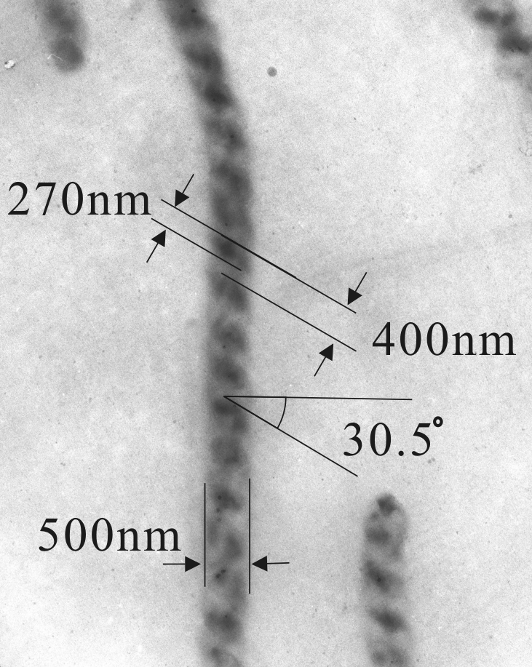
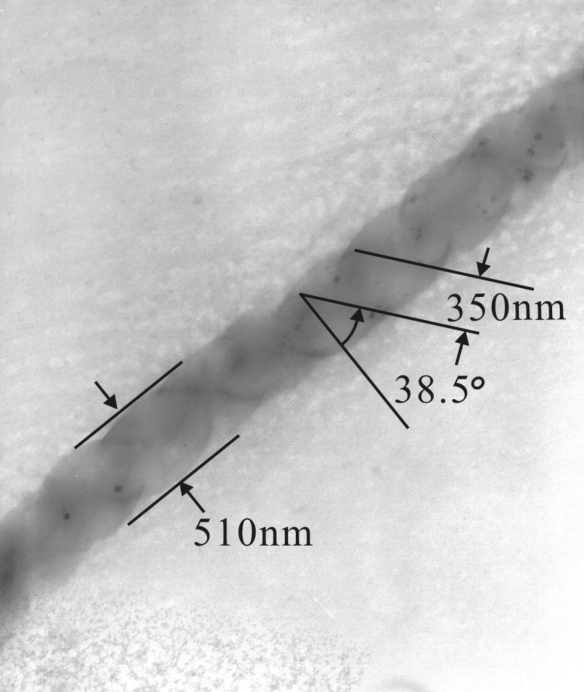
Other Figures and captains:
Figure 1s. TEM images of suprahelices from a semi-fluorinated alkoxysilane through a surface and solution self-assembly process. (a) the images of left-handed suprahelices . The suprahelix have diameter about 500 nm and a pitch of 270 nm. (b) the images of the right-handed double helix. These helices have diameters about 510 nm and a pitch of 350 nm.
a
b

Figure 2S. Small-angle diffraction data of the film assembled from an ethanol solution at 5 ℃ for a week . A peak at 9.68° can be observed.

Figure 3S. Dynamic light-scattering (DLS) spectrum of the assembly in the water solution. The size distribution of these aggregations calculated from the DLS data are mainly focusing on three parts as follows R_{H} = 192.6 nm (the distribution 3.55%), 1210 nm (the distribution: 21.68%) and 19880 nm (the distribution: 74.46%) (R_{H}, the average apparent hydrodynamic radius). Because these aggregations do not have sphere shapes, the calculated sizes do not match what obtained from the TEM measurement exactly. Tens or even hundreds of microns long coil topography should mainly contribute to larger R_{H}.

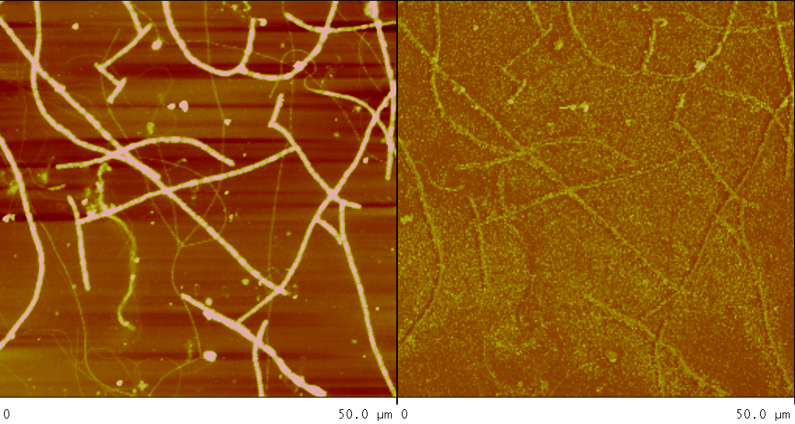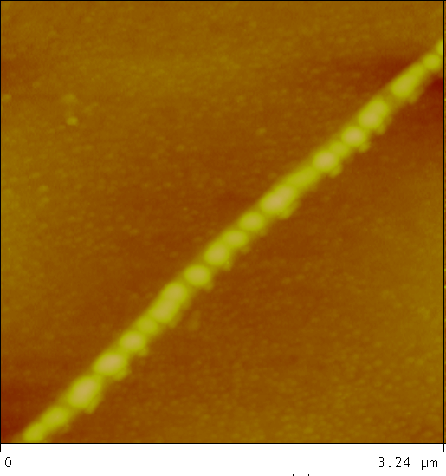
a
b
c

Figure 4S. AFM images of the coils and super-coils from an achiral semi-fluorinated alkoxysilane through a surface and solution self-assembly process. (a). the typical topography images of the coils and super-coils. (b). the typical phase images of the coils and super-coils(Data scale: 50µm ×50 µm). (c). the AFM images of the right-handed coils with diameters about 190 nm(Data scale: 3.24 µm ×3.24 µm) .

Infrared spectroscopy (IR) spectroscopy gave us some information about the structure. The singlet 898 cm⁻¹ is assigned to Si-OH stretching mode[1], which establishes the presence of silanol groups. And the peak at 1631.7 cm⁻¹ is assigned to the bending mode of water agreed with the literature reported by A. N. Parikh et al..^{[2]} This presence further confirmed the existence of silanol groups and thus shows the SiO_{x} network cross-linking is incomplete. The intense broad feature with maxima at 1121cm⁻¹ and 1074 cm⁻¹ is assiged to the Si-O-Si anti-symmetric stretching mode. The peaks at 1383 cm⁻¹, 1315 cm⁻¹,1240 cm⁻¹,1209 cm⁻¹ and 1143 cm⁻¹ were assigned to the stretching modes of –CF₂-, -CF₃.^{[3]} The high-frequency transmission spectrum of the assembly shows the presence of three distinct peaks at 2856 cm⁻¹,2924 cm⁻¹ and 2955 cm⁻¹, which are straightforwardly assigned to CH₂ symmetric and asymmetric stretching vibrations respectively. The peak of 648cm⁻¹ was assigned to the CF₂ wagging vibration in the helical conformation.^{[4]} Compared with IR of the monomer, CH₂ symmetric and asymmetric stretching vibrations shifted to a lower frequency.
Figure 5S. IR spectrum of the condensed assembly plated with KBr (red solid line)and its monomer film spread on KBr ( black solid line).
The well-defined suprahelices was also characterized by XPS (see Figure 7s). The binding energy of F1s (687.65 eV ), Si2p (102.30 eV and 97.2 eV ), O1s (532.00 eV) and C1s( from 290.4 eV to 284.6 eV) are clearly observed. The signal of F1s and Si2p (102.30 eV) are from the assembly. And Si2p (binding energy 97.2 eV) are from the the silicon wafer. The signal of O1s and C1s are from the assembly and absorbed substance. The peaks of C1s (292.4 eV), (290.5 eV), ( 289.6 eV) and 284.6 eV are belonged to –CF₂CH₂-, -CF₂CF₂-,CF₃CF₂- and –SiCH₂- [5].
a
b
Figure6S. XPS spectra of full region and carbon 1s region of the assembly on a silicon substrate.
References:
(1). Ballamy, L. J. The Infrared spectra of Complex Molecules; Chapman and Hall; London, 1975; pp 374-383.
(2). Parikh, A. N.; Schivley, M. A.; Koo, E.; Seshadri, K.; Aurentz, D.; Mueller, K.; Allara, D. L. J. Am. Chem. Soc. 1997, 119, 3135.
(3).Christopher, E.;Dominic, L. Langmuir 1990,6,682.
(4). Wang, J.; Ober, C. Liquid Crystals,1999, 5, 637.
(5). Ton-That, C.; Teare, D. O. H; Campbell, P. A.; Bradley. R. H. Surf. Sci. 1999, 433, 278. Detailed information on reference style can be found in The ACS Style Guide, 2nd ed., available from Oxford Press.

