Supplementary Information


Structural Inversion in 3-D Hexagonal Organization of Coil-Rod-Coil Molecule

Long Yi Jin, Jin-Young Bae, Jong-Hyun Ahn, and Myongsoo Lee*
Center for Supramolecular Nano-Assembly
and Department of Chemistry
Yonsei University, Seoul 120-749, Korea.

* To whom all correspondence should be addressed.
FAX; 82-2-393-6096
E-Mail; mslee@yonsei.ac.kr

Experimental section

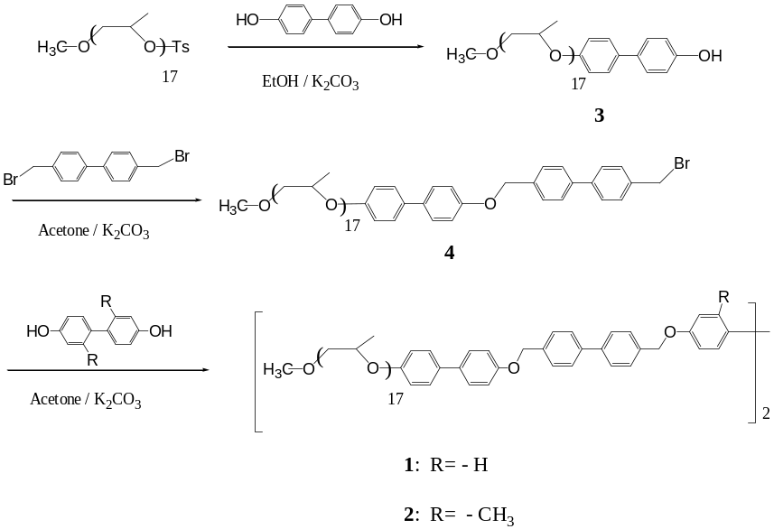
Scheme 1. Synthetic route of 1 and 2

Materials.
Methyl iodide, toluene-p-sulfonyl chloride (98%), 4, 4'-dihydroxybiphenyl (99%) and 4,4'-bis(bromomethyl)biphenyl (99%) from Tokyo Kasei were used as received. Poly(propylene glycol) ({DP} 17) from Aldrich and the other conventional reagents were used as received. 2,2'-Dimethyl-4,4'-biphenol was prepared according to the similar procedures described elsewhere.^{1,2}

Techniques.

¹H-NMR spectra were recorded from CDCl₃ solutions on a Bruker AM 250 spectrometer. A Perkin Elmer Pyris Diamond differential scanning calorimeter equipped with 1020 thermal analysis controller was used to determine the thermal transitions, which were reported as the maxima and minima of their endothermic or exothermic peaks. In all cases, the heating and cooling rates were 10 ºC min⁻¹. A Nikon Optiphot 2-pol optical polarized microscopy (magnification: 100 x) equipped with a Mettler FP 82 hot-stage and a Mettler FP 90 central processor was used to observe the thermal transitions and to analyze the anisotropic texture. Microanalyses were performed with a Perkin Elmer 240 elemental analyzer at Organic Chemistry Research Center. X-ray scattering measurements were performed in transmission mode with synchrotron radiation at the 3C2 X-ray beam line at Pohang Accelerator Laboratory, Korea. Molecular weight distributions (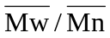) were determined by gel permeation chromatography (GPC) with a Waters instrument equipped with Stragel HR 3, 4 and 4E columns, M7725i manual injector, column heating chamber and 2010 Millennium data station. Polystyrene was used as the calibration standard. Measurements were made by using an UV detector, CHCl₃ as solvent (1.0 mL min⁻¹). The TEM was performed at 120 kV using JEOL JEM 2010. The sample was annealed at corresponding liquid crystalline state and quickly quenched in liquid nitrogen, microtomed at -65 ºC using a cyro-ultramicrotome then stained with RuO₄. The molecular density measurements were performed in an aqueous sodium chloride solution at 25 ºC. The densities of poly(propylene oxide) coils were used as ρ_{PPO} =1.0 g/cm³.³ The rod densities (ρ_{rod}) of each molecule were calculated on the basis ρ and ρ_{PPO.}

Synthesis of 2,2'-dimethyl-4,4'- biphenol
2,2'-dimethyl-4,4'-biphenol was synthesized using a similar procedure described previously.^{1,2} yield 25%, mp; 152 ºC. ¹H NMR (250 MHz, CDCl₃, δ, ppm): 6.98 (m, 2Ar-H, o to methyl), 6.73 (m, 4Ar-H, o to –OH), 2.0 (s, 6H phenyl–CH₃).

Synthesis of compounds 1-4
Compounds 1-4 were synthesized using a similar procedure described previously.³
1: yield 65%; ¹H NMR (250 MHz, CDCl₃, ‰, ppm) 7.43-7.65 (m, 28Ar-H, m to OCH₂-phenyl, m to OCH₂CH or OCH(CH₃), o to CH₂O-phenyl and m to CH₂O-phenyl), 6.95-7.06 (m, 12Ar-H, o to OCH₂-phenyl, o to OCH₂CH or OCH(CH₃)), 5.14 (s, 8H, OCH₂-phenyl), 4.53 (m, phenyl-OCH₂CH(CH₃) or CH CH(CH₃)O-phenyl), 3.16-3.83 m, OCH₂CH(CH₃) and OCH₃), 0.82-1.58 (m, 102H, CH-(CH₃)O); =1.04 (GPC). Anal. Calcd for C₁₆₈H₂₅₈O₄₀: C, 69.15; H, 8.91. Found: C, 69.09; H, 9.03.

2: yield 63%; ¹H NMR (250 MHz, CDCl₃, ‰, ppm) 7.43-7.65 (m, 26Ar-H, m to OCH₂-phenyl, m to OCH₂CH or OCH(CH₃), o to CH₂O-phenyl and m to CH₂O-phenyl), 6.95-7.06 (m, 12Ar-H, o to OCH₂-phenyl, o to OCH₂CH or OCH(CH₃)), 5.14 (s, 8H, OCH₂-phenyl), 4.53 (m, phenyl-OCH₂CH(CH₃) or CH CH(CH₃)O-phenyl), 3.16-3.83 m, OCH₂CH(CH₃) and OCH₃), 2.04 (s, 6H, phenyl-CH₃), 0.82-1.58 (m, 102H, CH-(CH₃)O); =1.04 (GPC). Anal. Calcd for C₁₇₀H₂₆₂O₄₀: C, 69.31; H, 8.96. Found: C, 69.27; H, 8.91.

3: yield 75%; ¹H NMR (250 MHz, CDCl₃, δ, ppm): 7.38-7.44 (m, 4Ar-H, m to OH, m to OCH₂H or OCH(CH₃)), 6.87-6.97 (m, 4Ar-H, o to OH, o to OCH₂CH or OCH(CH₃)), 4.52 (m, phenyl-OCH₂CH-(CH₃) or CH₂CH(CH₃)O-phenyl), 3.18-3.90 (m, CH₃O and OCH₂-CH(CH₃)), 0.83-1.40 (m, 51H, CH(CH₃)O).

4: yield 65%; ¹H- NMR (250 MHz, CDCl₃, δ, ppm): 7.43-7.63 (m, 12Ar-H, m to OCH₂phenyl, m to OCH₂CH or OCH(CH₃), o to CH₂O-phenyl, m to CH₂O-phenyl, o to CH₂Br and m to CH₂Br), 6.96-7.06 (m, 4Ar-H, o to OCH₂₋phenyl, o to OCH₂CH or OCH(CH₃)), 5.14 (s, 2H, OCH₂-phenyl), 4.45-4.53 (m, phenyl-OCH₂CH(CH₃) or CH₂CH(CH₃)O-phenyl, OCH₂Br), 3.18-3.82 (m,OCH₂CH(CH₃) and OCH₃), 0.85-1.58 (m, CH(CH₃)O).

References for Experimental Section

1. Percec, V.; Zhao, M.; Bae, J.-Y.; Hill, D. H. Macromolecules, 1996, 29, 3727-3735.
2. Lee, M.; Park, K.-S. Polym. Bull., 1997, 39, 149.
3. Lee, M.; Cho, B.-K.; Jang, Y.-G.; Zin, W.-C. J. Am,Chem, Soc.,2000, 122, 7449-7455.

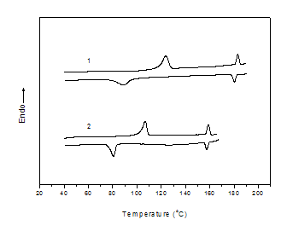

Fig. S1. DSC traces exhibited during the second heating scan
and the first cooling scan by 1 and 2

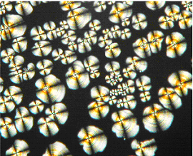

Fig. S2. Representative optical polarized micrograph (100x) of the texture exhibited by 3-D hexagonal mesophase of 2 at the transition from the isotropic liquid state at 155 °C.

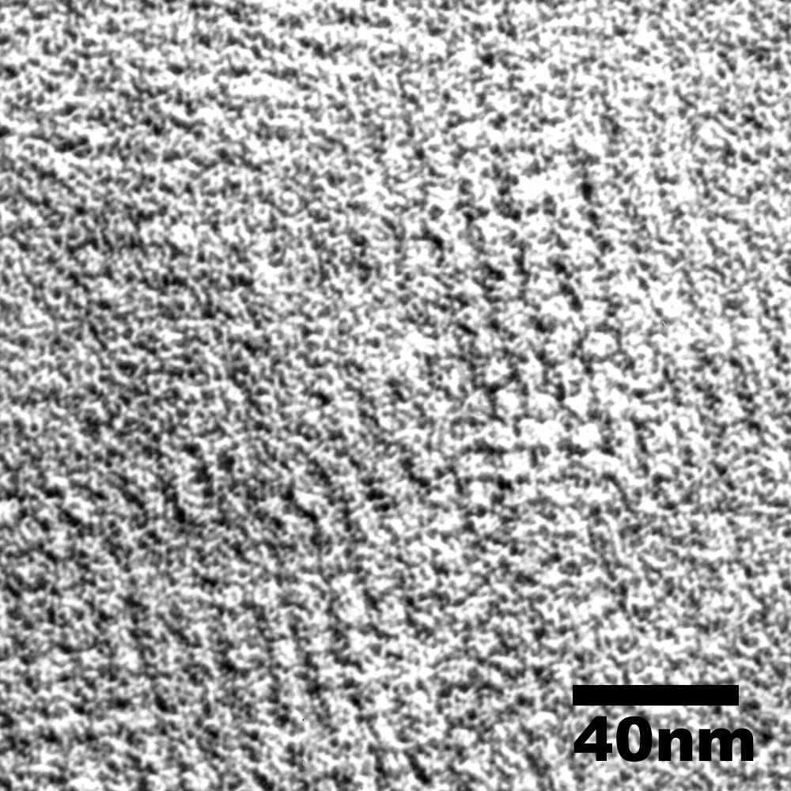

Fig. S3. Transmission electron micrograph of ultramicrotomed thin film of the molecule 1 which was annealed at 145 ℃ and stained with RuO4, revealing the formation of a well-ordered hexagonal perforated layer structure with nanoscale dimensions. The light regions correspond to the coil domains, the dark regions to the rod matrix.

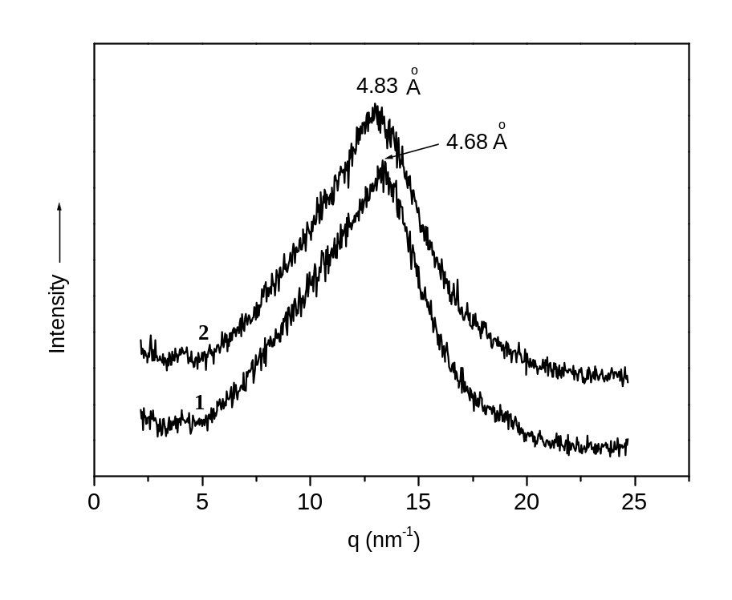
Fig. S4. Wide Angle X- ray Scattering (WAXS) diffraction patterns of 1 and 2 measured at 150°C.

Table S1. Characterization of Coil-Rod-Coil Molecules 1 and 2 by Small-Angle X-ray Scattering

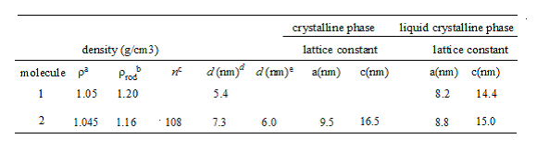

ρª = molecular density; ρ_{rod}^{b} = density of rod segment; n^{c} Number of molecules in a bundle; d (nm)^{d} Diameter of hole consisting of coil segment in HPL sturcture; d (nm)^{e} Diameter of rod bundle in HCP structure.

Table S2. Thermal transitions of the coil-rod-coil 1 and 2 (data from second heating and first cooling scans)ª.
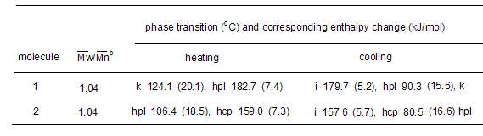
ª k=crystalline, hpl=hexagonal perforated layer, hcp=hexagonal closed-packed structure, i=isotropic
^{b} determined from GPC
Table S3. Small-angle X-ray diffraction data for 3-D hexagonal perforated layer structure
of the molecule 1 at 160 ºC ª
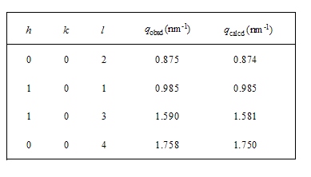
ª q_{obsd} and q_{calcd} are the scattering vectors of the observed reflections, and calculated for the hexagonal perforated
layer structure (P6₃/mmc space group symmetry) with lattice parameters a = 8.2 and c = 14.4 nm.

Table S4. Small-angle X-ray diffraction data for 3-D hexagonal perforated layer structure
of the molecule 2 at 72 ºC ª

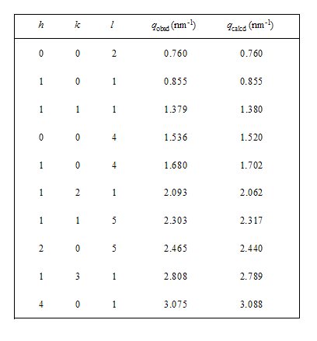

ª q_{obsd} and q_{calcd} are the scattering vectors of the observed reflections, and calculated for the hexagonal
perforated layer structure (P6₃/mmc space group symmetry) with lattice parameters a = 9.5 and c = 16.5 nm.

Table S5. Small-angle X-ray diffraction data for 3-D hexagonal close-packed structure
of coil-rod-coil 2 at 145 ºC ª
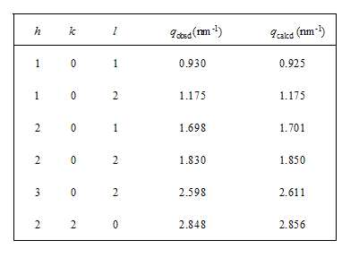
ª q_{obsd} and q_{calcd} are the scattering vectors of the observed reflections, and calculated for the hexagonal
close-packed structure (P6₃/mmc space group symmetry) with lattice parameters a = 8.8 and c = 15.0 nm.

